

The ARRIVE Guidelines Checklist
Animal Research: Reporting In Vivo Experiments
Carol Kilkenny¹, William J Browne², Innes C Cuthill³, Michael Emerson⁴ and Douglas G Altman⁵
¹The National Centre for the Replacement, Refinement and Reduction of Animals in Research, London, UK, ²School of Veterinary Science, University of Bristol, Bristol, UK, ³School of Biological Sciences, University of Bristol, Bristol, UK, ⁴National Heart and Lung Institute, Imperial College London, UK, ⁵Centre for Statistics in Medicine, University of Oxford, Oxford, UK.

 |  | ITEM | RECOMMENDATION | Section/  Paragraph
 |  |  |  | Title
 |  |  |  | Abstract
 | INTRODUCTION
 | 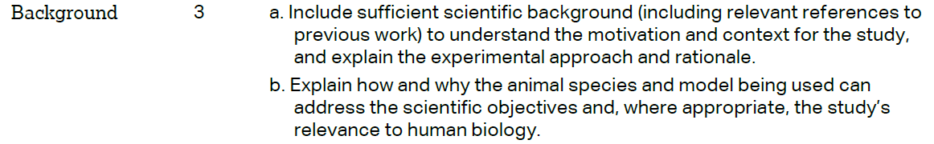 |  |  | Background Paragraph 1-4
 |  |  |  | Background Paragraph 4
 | METHODS
 |  |  |  | Declarations Paragraph 1
 | 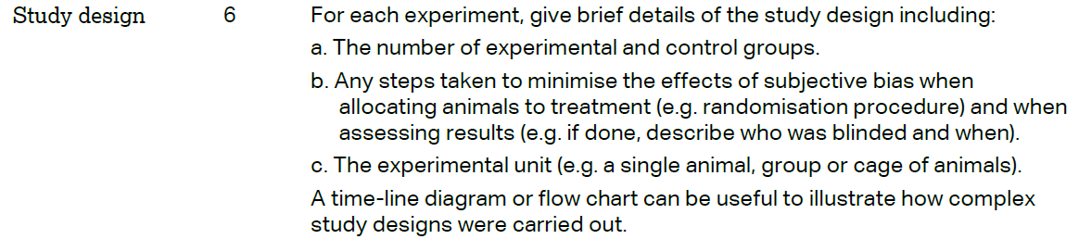 |  |  | Methods Paragraph 1
 | 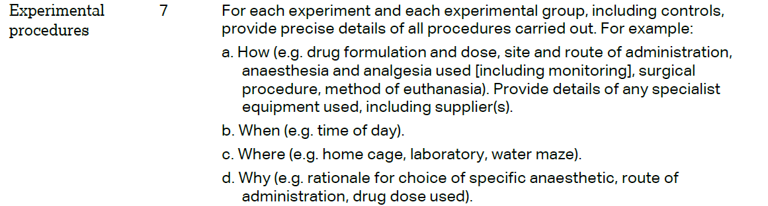 |  |  | Methods Paragraph 1-5
 | 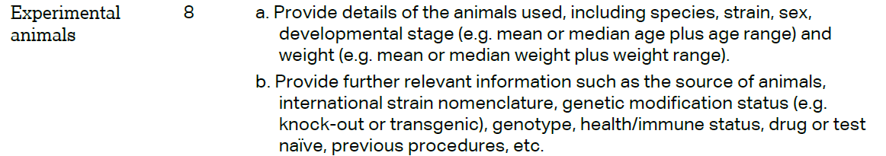 |  |  | Methods Paragraph 1
The ARRIVE guidelines. Originally published in PLoS Biology, June 2010¹
 | 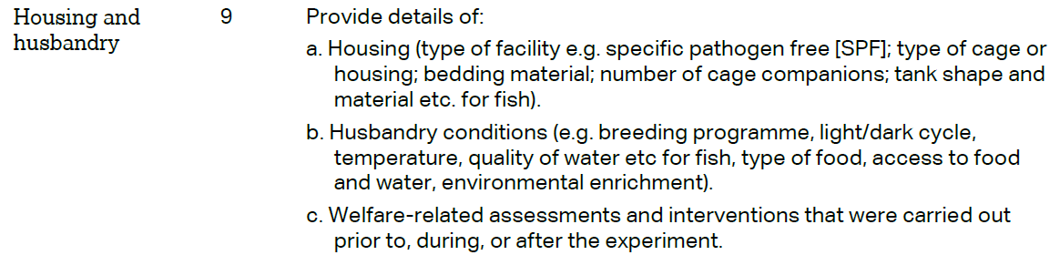 | Methods Paragraph 1
 | 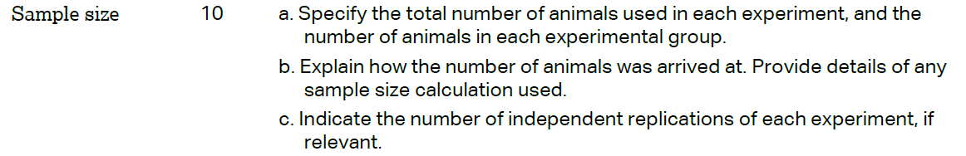 | Methods Paragraph 1
 | 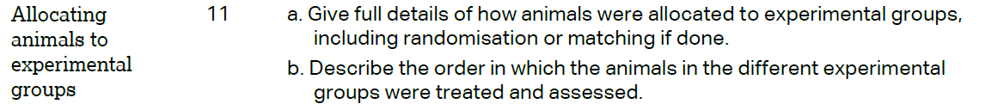 | Methods Paragraph 1
Results Paragraph 1-7
Figures 1-6
 | 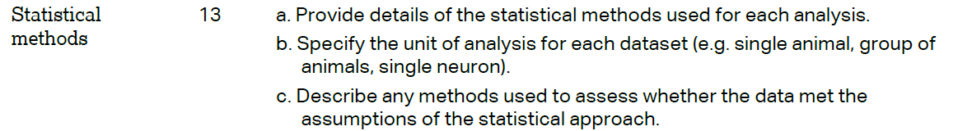 | Methods Paragraph 6
 | RESULTS
 |  | Methods Paragraph 1
 |  | Methods Paragraph 1
 |  | Results 1-7 Figures 1-6
 |  | Methods Paragraph 1
 | DISCUSSION
 | 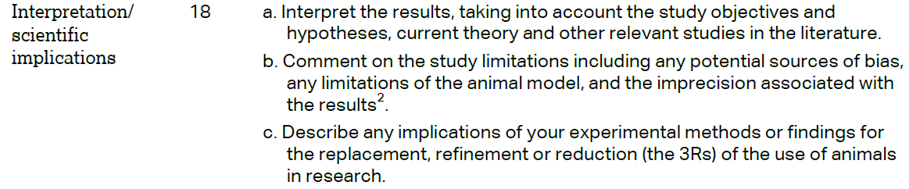 | Discussion Paragraph 1-8
 |  | Discussion Paragraph 1-8
 |  | Declarations Paragraph 5

