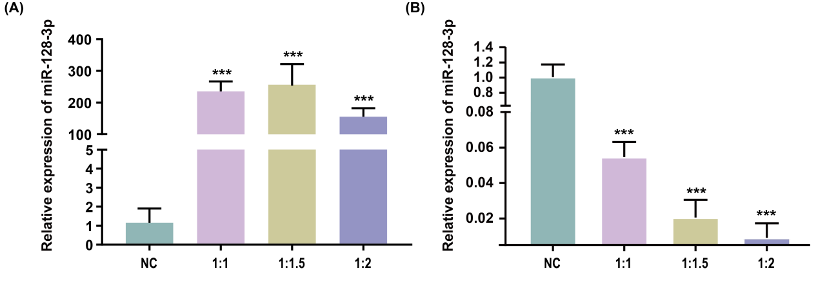
Fig. S1 Detection of miR-128-3p overexpression interference efficiency Q-PCR primer sequences.
- Detection of overexpression efficiency of miR-128-3p B.Detection of overexpression efficiency of miR-128-3p
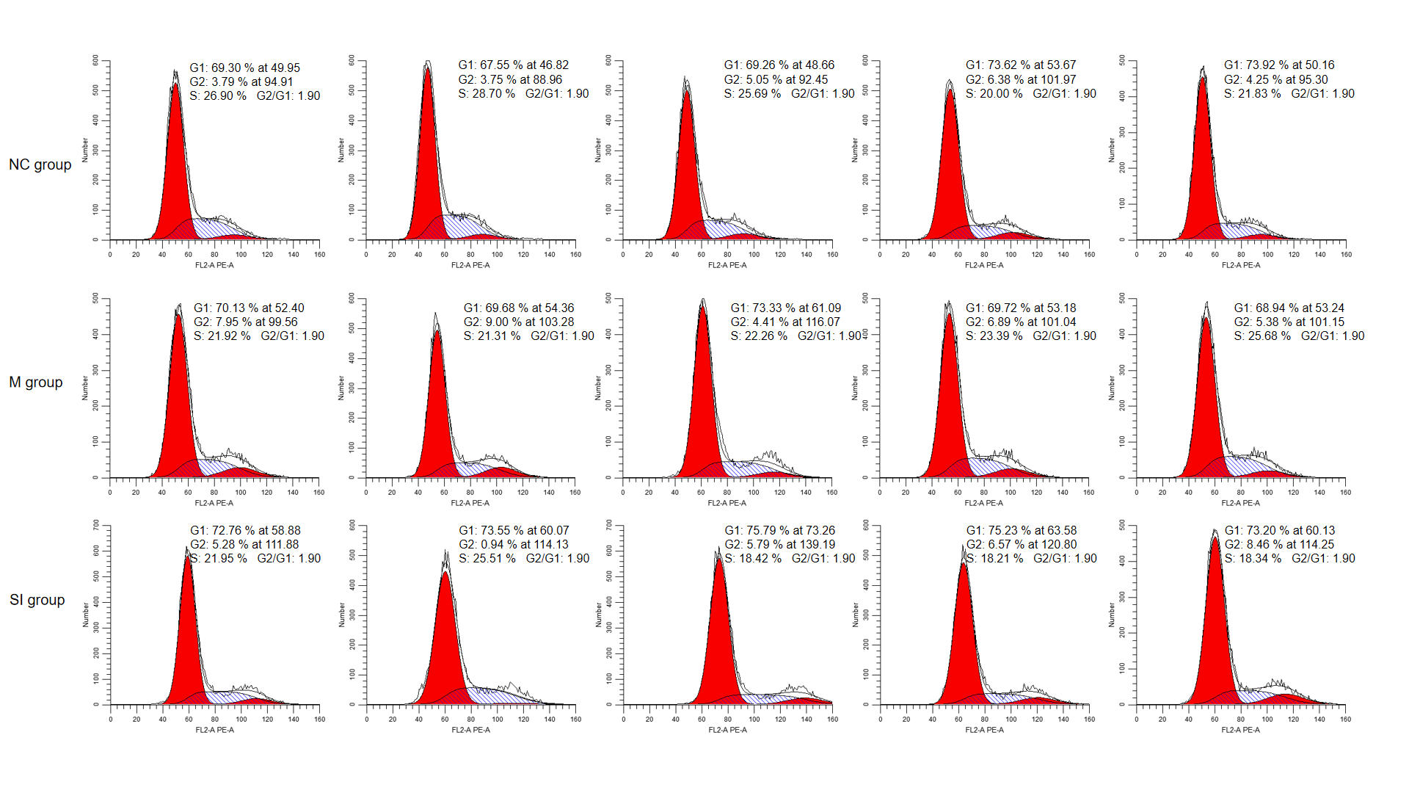
Fig. S2 Flow cytometry detection. Cell cycle analysis via flow cytometry after overexpression or interference of miR-128-3p. The figure shows NC group, M group (mimics-treated group), and SI group (inhibitor-treated group) from top to bottom (n = 5).

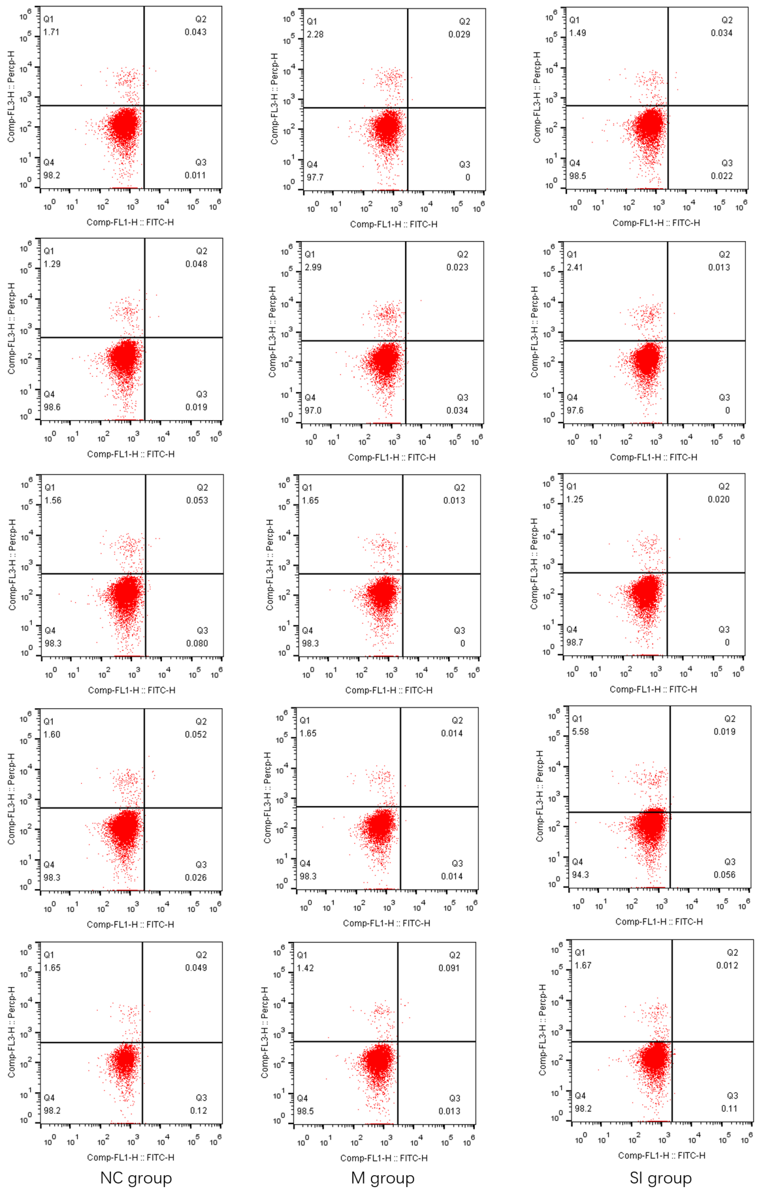
Fig. S3 Apoptosis detection. Cell apoptosis assay via flow cytometry after overexpression and interference of miR-128-3p.The Fig. shows NC group, M group (mimics-treated group), and SI group (inhibitor-treated group) from left to right (n = 5).
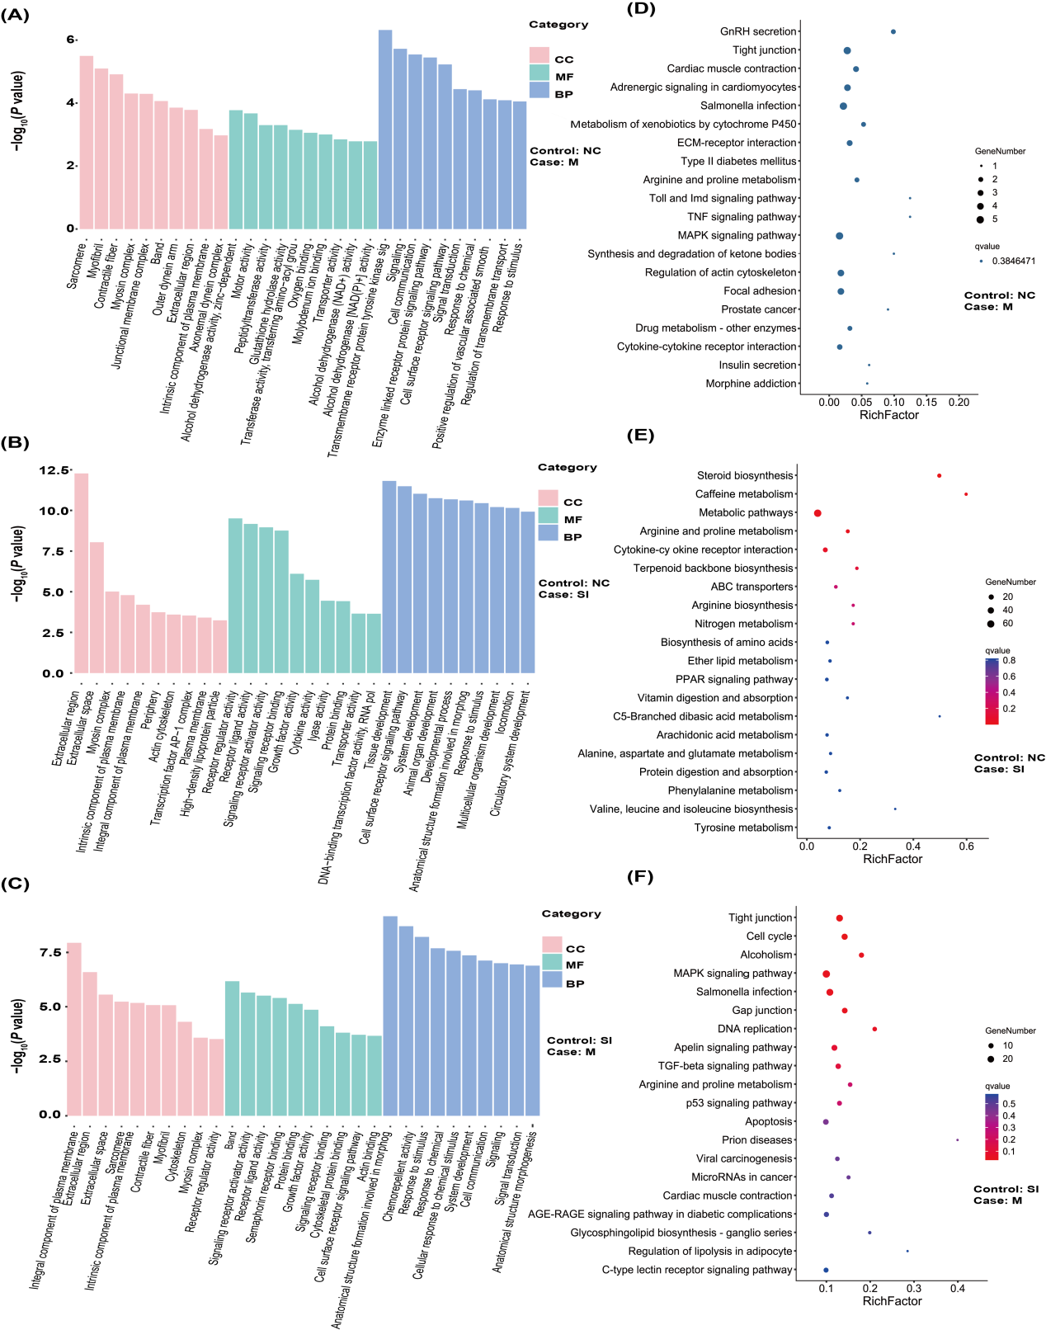
Fig. S4 GO-KEGG enrichment analysis.(A-C). GO enrichment for DEGs from three groups of pairwise comparisons (A: NC vs. M, B: NC vs. Si, and C: M vs. Si). The x-axis presents rich factor of DEGs in a category. The y-axis shows the specific GO term. The top 20 enriched terms are showed according to P-values. (D-F). KEGG pathways enrichment for DEGs from three groups of pairwise comparisons (D: NC vs. M, E: NC vs. Si, and F: M vs. Si). The x-axis presents rich factor of DEGs in a category. The y-axis shows the specific pathway. The top 20 enriched pathways are showed according to P-values.

