Supplemental results

Table S1: Comparison between patients with penetrating head trauma and those with non-neurological injuries of similar severity
 | Head trauma | Non-neurological injuries | p
Age | 58.3 ± 3.1 | 59.0 ± 3.4 | 0.17
Years of education | 14.8 ± 2.5 | 15.2 ± 2.5 | 0.27
Pre-lesion AFQT | 60.7 ± 25.0 | 65.4 ± 22.9 | 0.28
Post-lesion AFQT | 53.0 ± 24.8 | 69.5 ± 21.6 | 0.000019
BDI score | 9.3 ± 9.1 | 11.6 ± 9.7 | 0.12
Total NBRS | 40.3 ± 13.3 | 34.0 ± 10.1 | 0.0005
Number of psychiatric comorbidities not including PTSD | 0.55 ± 1.2 | 0.75 ± 1.2 | 0.17
PTSD severity (CAPS) | 53 ± 45 | 69 ± 53 | 0.04

TMS clinical trial dataset (n=20)
Age (mean ± SD) | 48.2 ± 13.3
Gender | 82% M, 18% F
TBI prevalence | 20%
PCL-5 score | 48.0 ± 11.6
IDS-SR score  (mean ± SD) | 38.7 ± 11.5
MRI scanner | Siemens Trio 3T (n=12)  Siemens Prisma 3T (n=8)
Scan duration | 8 min
Spatial resolution | 3.0 mm isotropic
TR | 2.5 sec
Table S2: Baseline demographics and imaging parameters in non-lesion datasets
Observational imaging dataset (n=180)
Age (mean ± SD) | 41.7 ± 9.1
Gender | 81% M, 19% F
TBI prevalence | 32%
PTSD prevalence | 34%
BDI score  (mean ± SD) | 10.1 ± 12.2
MRI scanner | GE 750 3T
Scan duration | 6 min (1 run)
Spatial resolution | 3.75 mm isotropic
TR | 2 sec

R L
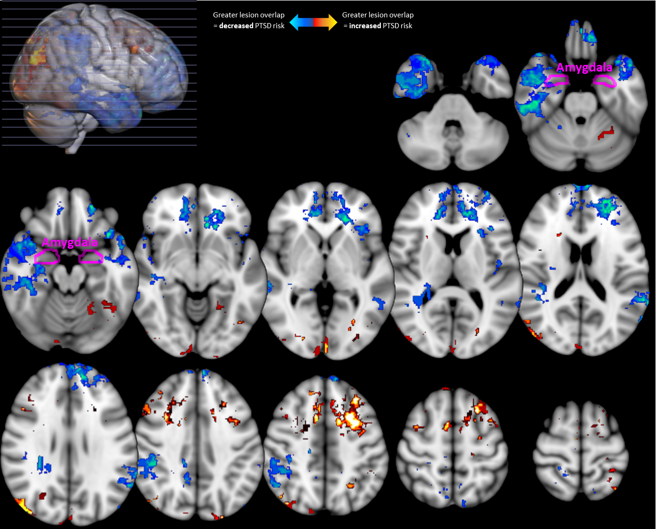
Figure S1: Whole-brain VLSM results (thresholded at uncorrected p<0.05). No voxels survived multiple comparisons correction.
As expected, the overall VLSM map showed positive concordance with the LNM map (r=0.37, p=0.001 on permutation testing). However, the peak locations were not identical. The peak VLSM location was not significant on LNM (r=0.12, p=0.08), and the peak negative VLSM location was only significant on LNM without multiple comparisons correction (r= -0.15, p=0.03). The peak positive LNM location showed no coverage with VLSM, and the peak negative LNM location was not significant on VLSM (r=0.14, p=0.06).

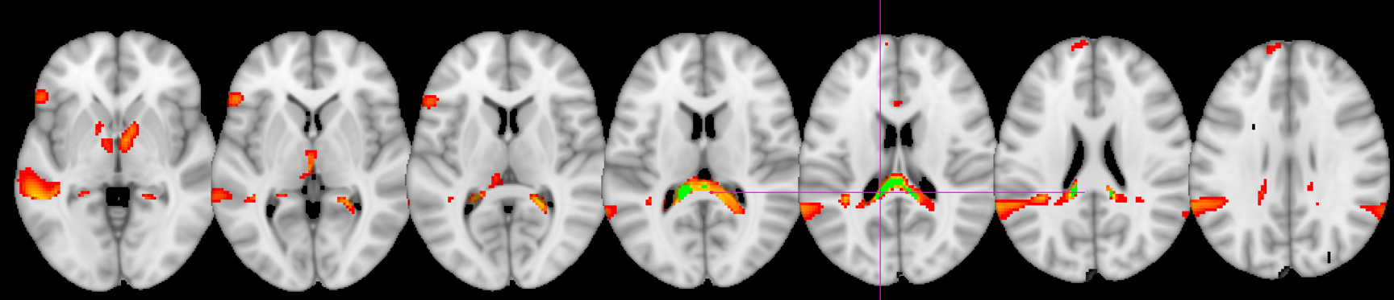
(a)

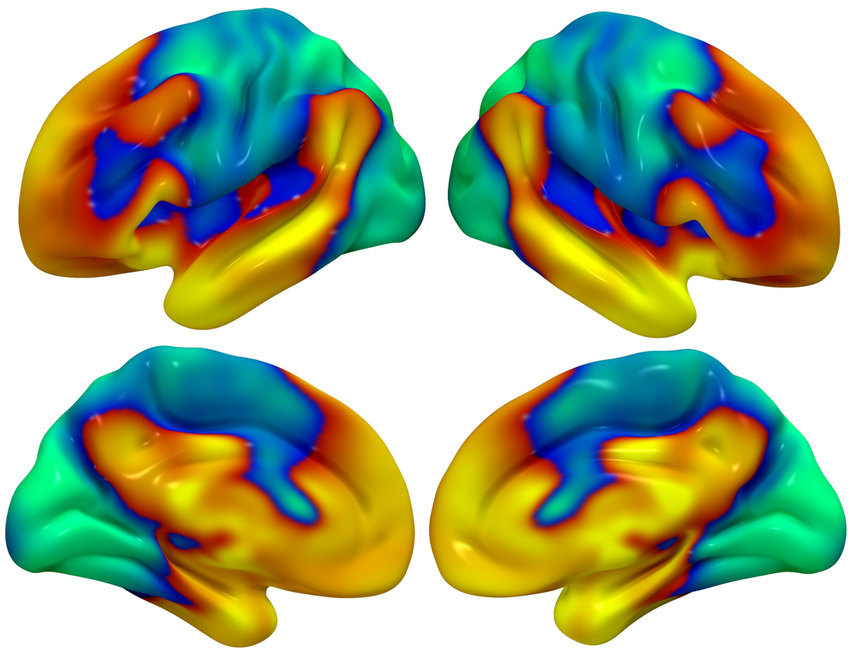
(b)

Figure S2: (a) The peak location in the PTSD circuit was the tapetum, which connects the two hippocampi to each other. Depicted here is the peak coordinate (-12, -38, 20) (p_{FWE}=0.035 with Westfall-Young correction) at the magenta crosshairs, a peak voxel cluster in green (p_{FWE}<0.05, detection p<0.001, cluster size=888 mm³), overlaid on a map with uncorrected p<0.05 which depicts the extent of the cluster into both medial temporal lobes. (b) We identified regions that were positively correlated (yellow) and negatively correlated (blue) to lesion locations that reduce probability of PTSD. To investigate whether the positive correlations (the “PTSD+ circuit”) or the negative correlations (the “PTSD- circuit”) were more relevant, we used both to predict PTSD diagnosis in a split-half analysis. PTSD risk was independently predicted by lesion overlap with the PTSD+ circuit (r=0.18, p=0.01), but not the PTSD- circuit (r=0.02, p=0.8). Permutation testing confirmed that the PTSD+ circuit was a significantly stronger predictor than the PTSD- circuit (mean difference r=0.14, p=0.02). Similar results were observed when excluding patients with subthreshold PTSD (r=0.21 vs r=0.03, p=0.01).
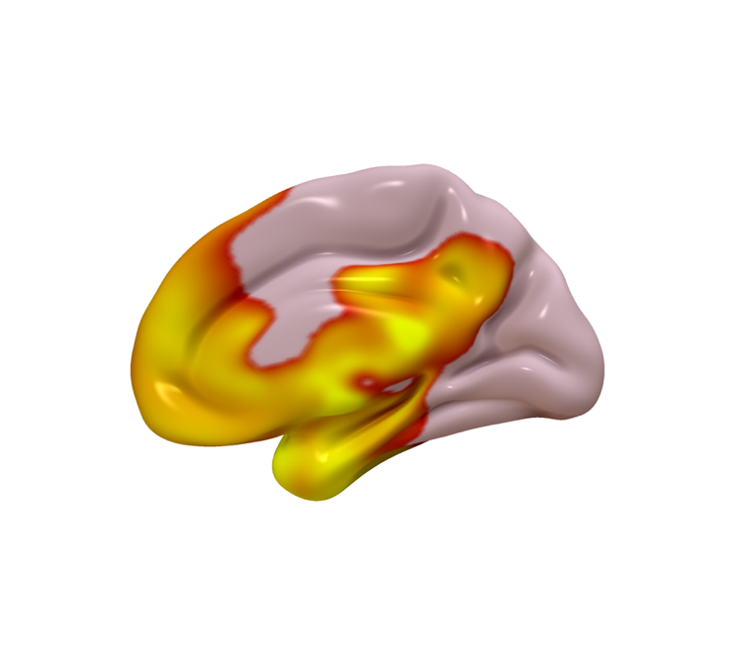
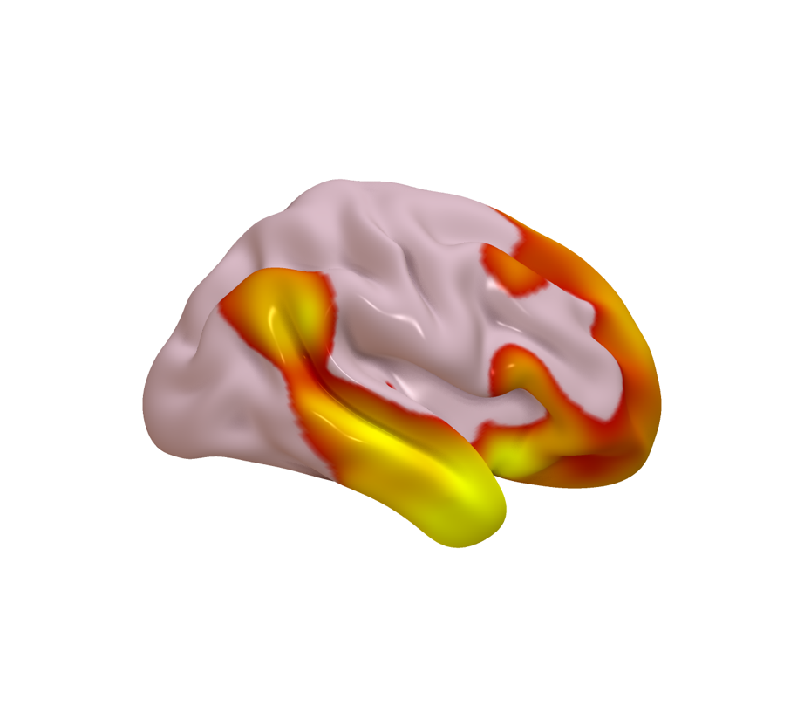
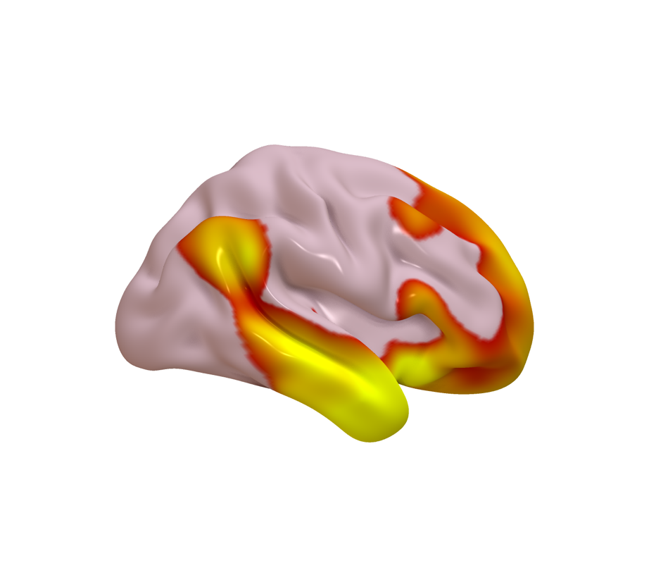
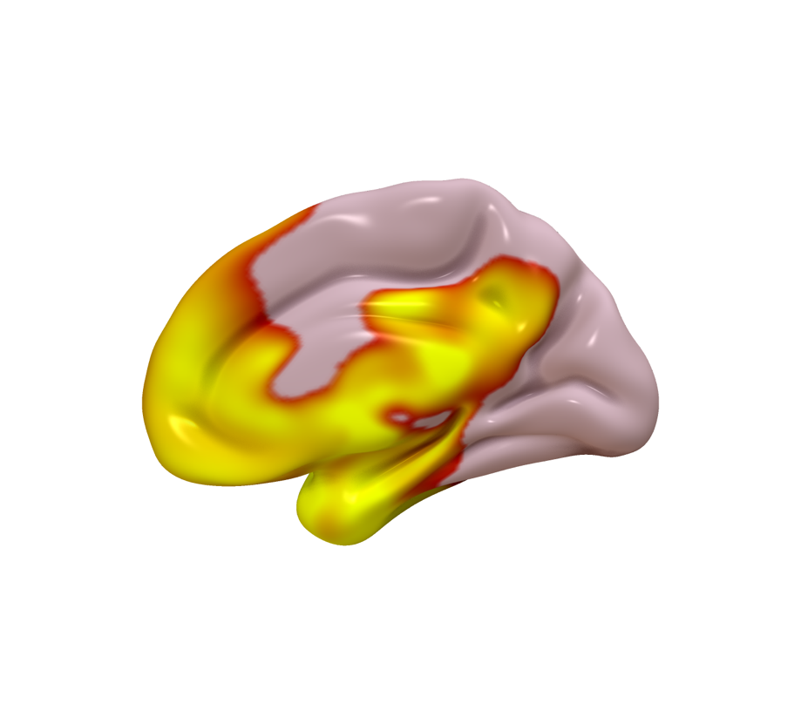
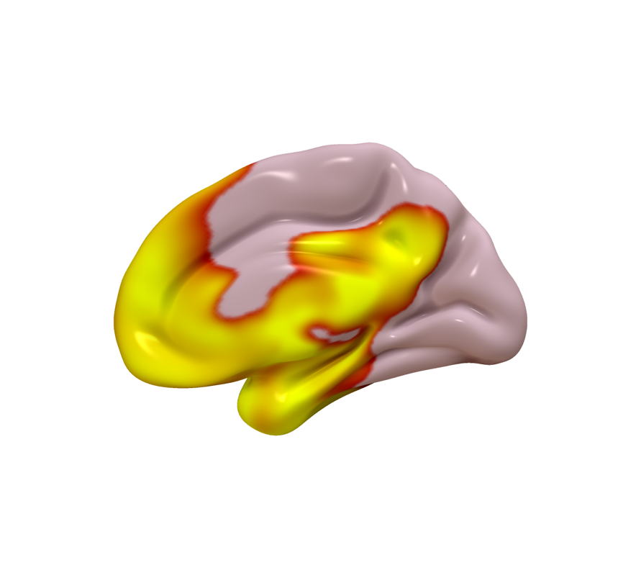
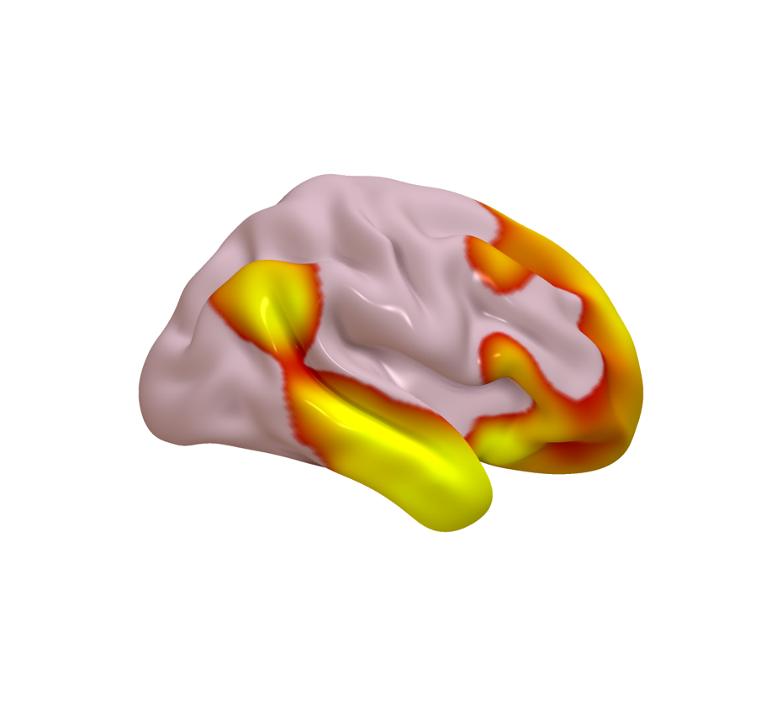
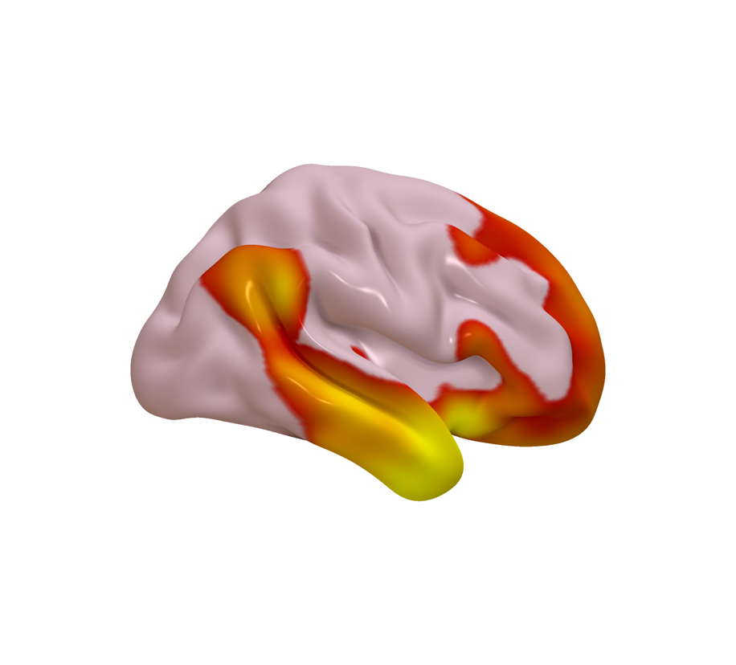
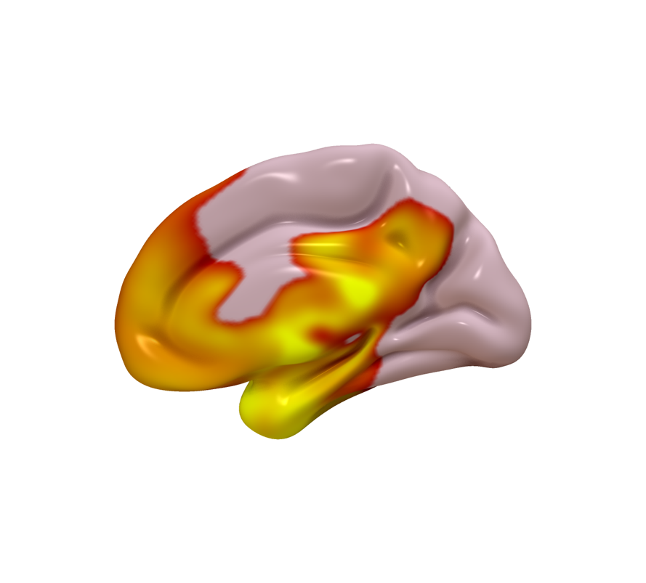
A) Excluding subthreshold PTSD
Spatial r = 0.999

B) Continuous PTSD severity
Spatial r = 0.96

C) Controlling for alcoholism risk
Spatial r = 0.98

D) Controlling for MMSE
Spatial r = 0.96

E) Not controlling for BDI
Spatial r = 0.96

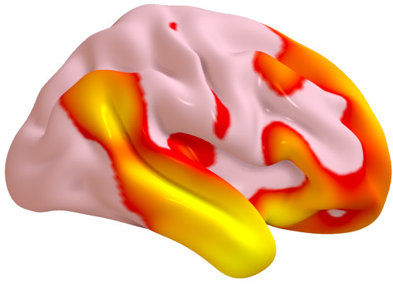
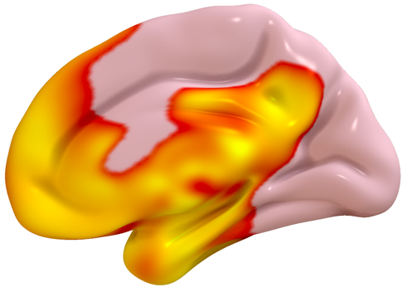

Figure S3: Nearly-identical circuits were generated when the primary analysis was repeated after (a) excluding subthreshold PTSD, (b) using a continuous measure of PTSD, (c) controlling for alcoholism risk, (d) controlling for MMSE, and (e) not controlling for BDI.

Figure S4: Similar circuits were generated when the primary analysis was repeated using individual symptom items on the Clinician Assessment for PTSD (green bars).
Some of the individual items on the Beck Depression Inventory also yielded similar circuits (orange bars).

Figure S5: (a) PTSD was negatively associated with resting-state functional connectivity within our PTSD circuit, after controlling for TBI and depression. (b) In the active arm of a clinical trial, treatment-induced change in connectivity was negatively correlated with treatment-induced change in PTSD symptoms. In the sham arm, there was no relationship between PTSD improvement and connectivity change. Note that data were rank-transformed in this dataset due to high influence of outliers in datasets with small sample sizes.
A B

Box S1: Clinical characteristics and treatment parameters in a case of TMS to our PTSD circuit
PTSD trigger: Severe childhood physical abuse at the hands of his father
Daily medications: Atorvastatin, omeprazole, losartan, chlorthalidone, tadalafil, and testosterone.
Prior treatment: Three prior failed courses of psychotherapy. A two-month course of amitriptyline was discontinued due to sexual side effects, after which he declined further pharmacotherapy.
Baseline PCL-5 subscores: 20/20 on re-experiencing, 8/8 on avoidance, 28/28 on negative cognition/mood, and 14/24 on hyper-arousal
Post-treatment PCL-5 subscores: 9/20 on re-experiencing, 6/8 on avoidance, 9/28 on negative cognition/mood, and 6/24 on hyper-arousal.
Imaging parameters: 22-minute acquisition, 3.4 x 3.4 x 4mm resolution, 2.15-sec TR
Target selection: The PTSD circuit was used as a weighted seed to compute resting-state functional connectivity to every voxel in the brain. The TMS target was chosen at the peak location in a cluster that was both the largest and the strongest voxel cluster on the surface of the prefrontal cortex.
TMS parameters: 10 sessions per day of 1800 pulses, spaced by 50 minutes, at 120% of motor threshold, with no fear-related task (i.e., a fear extinction condition).

