Colorimetric pH Sensitive Smart Film Based on Carrageenan Containing Quercetin or Eucalyptus Extract for Freshness Monitoring of Chicken Meat
Akbar Mirzaeiª, Yashar Bina Jorshariª, Shahrzad Javanshir^{a*}, Milad Nooriª, Mohammad Mahdavi^{b}
ª Pharmaceutical and Heterocyclic Compounds Research Laboratory, Chemistry Department, Iran University of Science and Technology, Tehran, Iran
^{b} Endocrinology and Metabolism Research Center, Endocrinology and Metabolism Clinical Sciences Institute, Tehran University of Medical Science, Tehran, Iran

Content | Page
FigureS1. QUE calibration curve. | S2
Figure S2. a) QUE solution at pH=1-12, b) Uv-vis spectra of QUE solution, c) ELE solution at pH=1-12, and d) UV-Vis spectra of ELE solution. | S3
Figure S3. Structure of quercetin. | S4
Figure S4. Optical transmittance curves of a) CG-QUE film, b) CG-ELE film. | S5
Figure S5. FESEM images of films. a,b) CG-QUE0.3, and c,d) CG-ELE0.3. | S6
Figure S6: FTIR spectrum. | S7
Figure S7. Color response of a) CG-QUE0.3, b) CG-ELE0.3 film at different pH values, sensing film applications for monitoring chicken freshness, c) 0 day, and d) after 3 days. | S8
Table S1. TVBN levels for chicken. | S9
Table S2. MIC values of developed QUE and ELE film against the tested bacteria strains. | S10
Table S3. Mechanical test results of films. | S11

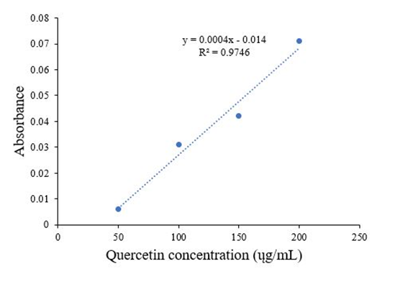

FigureS1. QUE calibration curve.

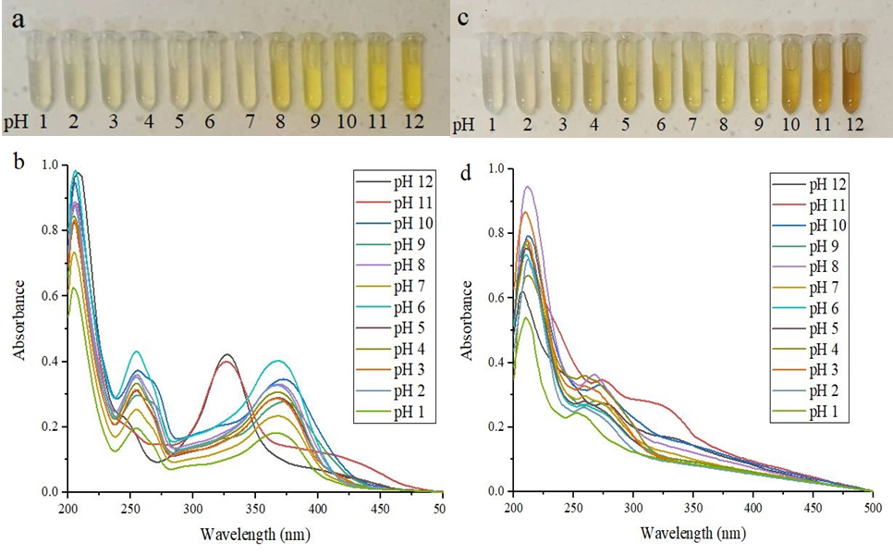

Figure S2. a) QUE solution at pH=1-12, b) Uv-vis spectra of QUE solution, c) ELE solution at pH=1-12, and d) UV-Vis spectra of ELE solution.

Figure S3. Structure of quercetin.

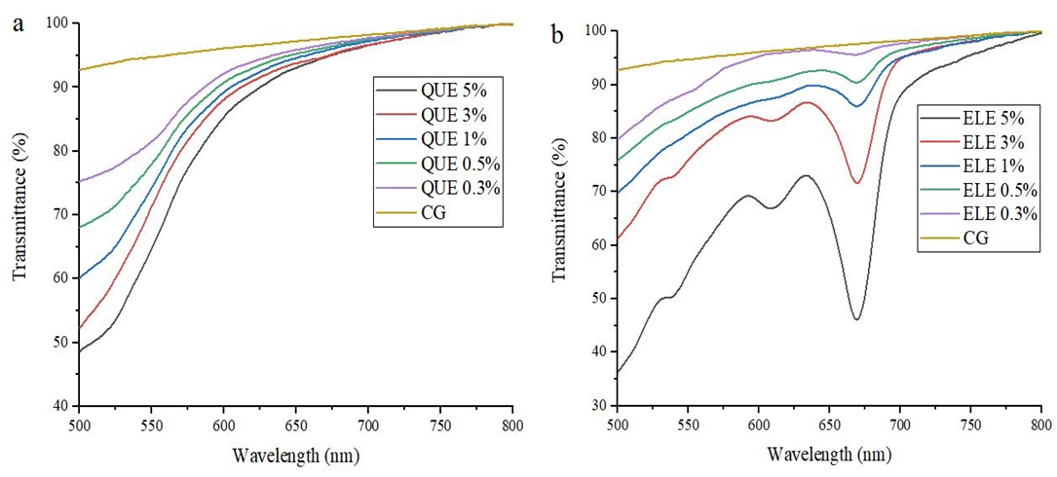

Figure S4. Optical transmittance curves of a) CG-QUE film, b) CG-ELE film.

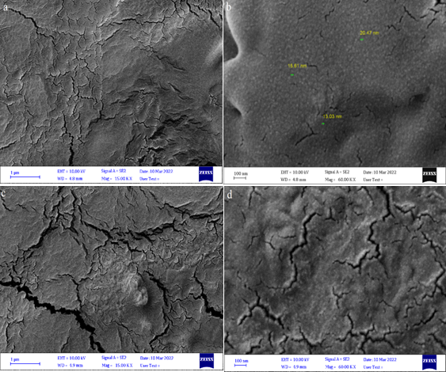
Figure S5. FESEM images of films. a,b) CG-QUE0.3, and c,d) CG-ELE0.3.

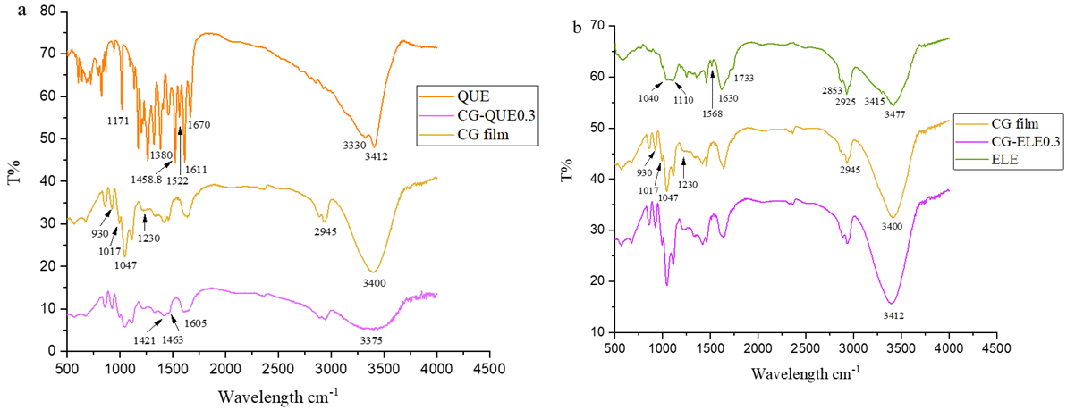
Figure S6: FTIR spectrum.

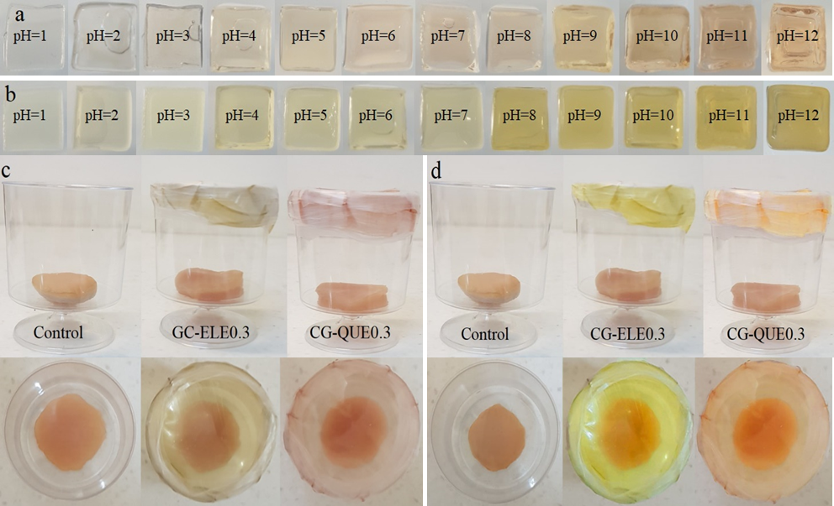
Figure S7. Color response of a) CG-QUE0.3, b) CG-ELE0.3 film at different pH values, sensing film applications for monitoring chicken freshness, c) 0 day, and d) after 3 days.

TVBN Test  Samples | TVBN (100/mg)
TVBN Test  Samples | 0 day | 3 days
Control | 21.7 | 41.22
CG-QUE0.3 | - | 29.75
CG-ELE0.3 | - | 26.5
Table S1. TVBN levels for chicken.

Microorganisms | Staphylococcus aureus ATCC 6538 | Staphylococcus epidermidis ATCC 12228 | Bacillus subtilis ATCC 6633 | Escherichia coli ATCC 8739 | Pseudomonas aeruginosa ATCC 9027 | Klebsiella pneumonia ATCC 10031
Compounds
Ciprofloxacin (µg/mL) | 0.195 | 0.195 | 0.195 | 0.012 | 0.195 | 0.006
CG-ELE0.3 | 22 | 16 | 82 | 17 | 14 | 4
CG-QUE0.3 | 45 | 27 | 90 | 37 | 26 | 8
Table S2. MIC values of developed QUE and ELE film against the tested bacteria strains.

Thin film | TS (MPa) | EB | Young’s modulus
CG-QUE0.3 | 6 ± 0.1% | 14 ± 0.6 | 0.43
CG-ELE0.3 | 5 ± 0.1% | 13.2 ± 0.6 | 0.38
Table S3. Mechanical test results of films.

