Supplementary material for “Cryptic carbon: The hidden carbon in forested wetland soils”

Anthony J Stewart*, Meghan Halabisky, Chad Babcock, David E. Butman, David V. D’Amore, L. Monika Moskal
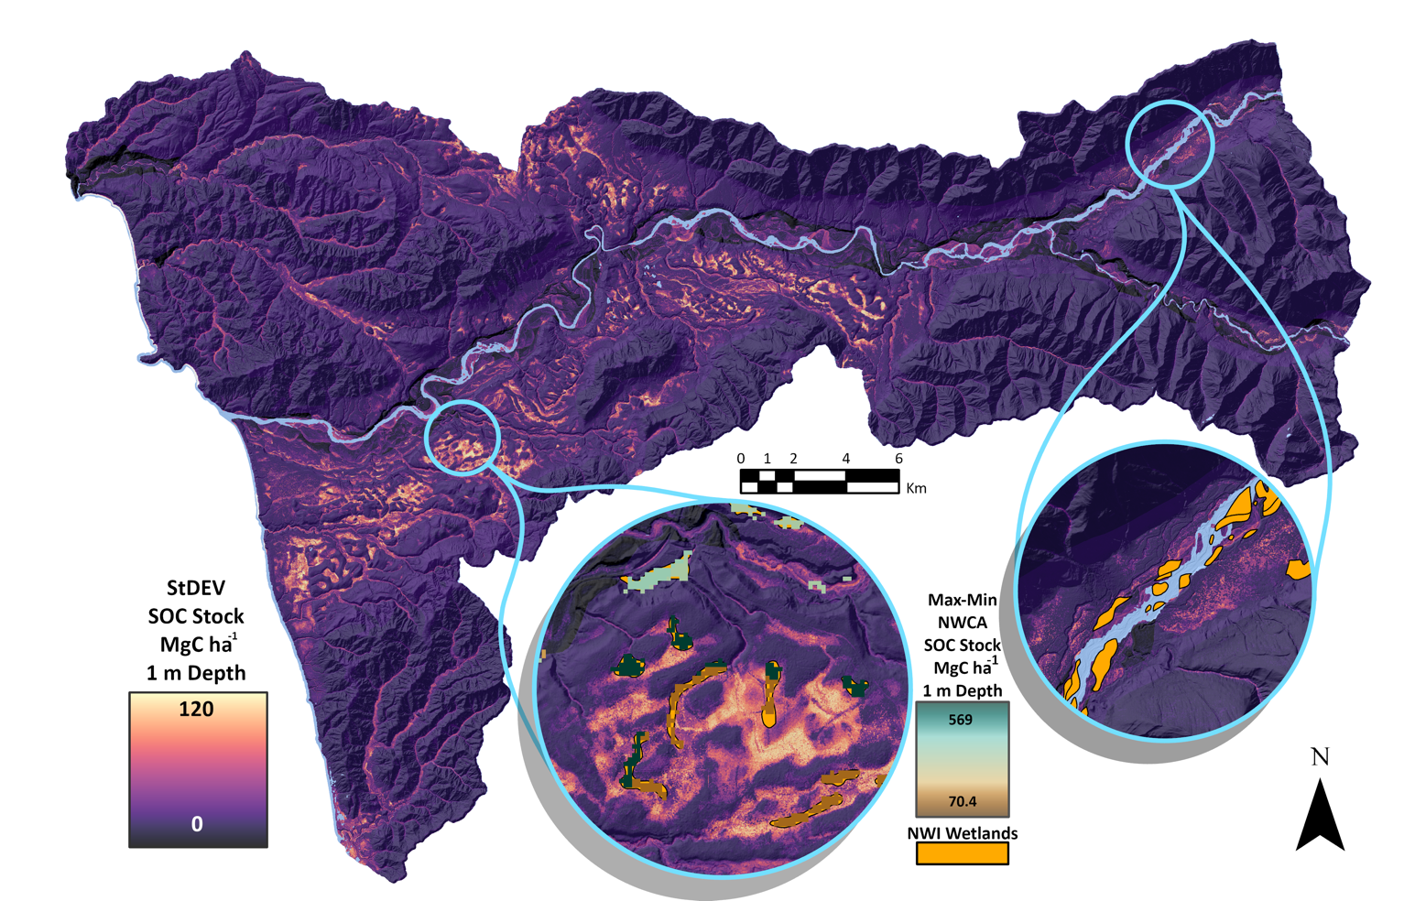
Supplemental Figure 1. Standard deviation of 1 m SOC stock modeling predictions from bootstrapping. Insets show both NWI and NWCA wetlands with NWCA SOC values reflecting the Min-Max difference from Uhran et al.

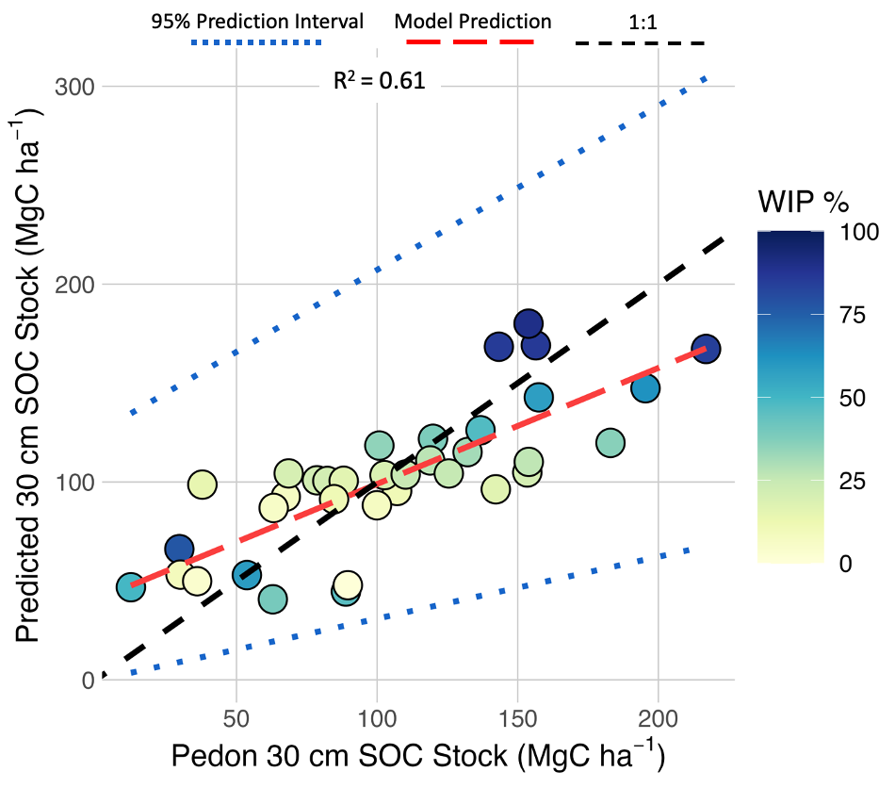
Supplementary Figure 2. Model predicted SOC stock compared to field sampled pedon SOC stock for the 30 cm depth. Modeled SOC stocks were back transformed from square root values in the original linear mixed effects model with the fixed effect of WIP probability and random effect of surficial geology. Prediction intervals are based on bootstrapped 95% confidence intervals.

Supplementary Table 1. Comparison of 30 cm SOC stocks for the entire HRW between the WIP model, SoilGrids 2.0⁶ and the UN FAO GSOC map ⁴⁶. ± indicates the standard deviation of the bootstrapped model predictions for the WIP derived estimates and published uncertainty ranges for SoilGrids and GSOC. The slight difference in surface area with GSOC is likely due to resampling from a coarse resolution (1 km).

 |  | 30cm Depth
Source | Surface Area | Mean SOC Stock | Total SOC Stock
 | (ha) | (MgC ha⁻¹) |  | (TgC)
WIP | 68,145 | 74 ± 16 |  | 5.1 ± 1.1
SoilGrids 2.0 | 68,145 | 115 ± 16 |  | 7.8 ± 1.1
FAO GSOC 1.5 | 68,300 | 57 ± 3 |  | 3.9 ± 0.2

Supplementary Table 2. Wetland surface area size class distribution using individual wetland surface area quantiles. The Size Classes group shows metrics for each individual percentile size class. The Cumulative Sum group shows the increasing sum over each quantile approaching 100% of all wetlands. SOC stock and Area under the Size Classes group were calculated as the sum within the wetland surface area size class for all wetlands above 0.0064 ha. Mean SOC stock was calculated as the mean SOC stock within each wetland and across all wetlands within the quantile size class.
 | Size Classes |  |  |  |  | Cumulative Sum
Quantiles Wetland Area (ha) | SOC Stock (Tg) | Mean SOC Stock (Mg ha⁻¹) | Count | Area (ha) |  | SOC Stock (Tg) | Area (ha) | Count
0-5% (0.006 ha) | 0.0101 | 254 | 6216 | 40 |  | 0.0101 | 39.8 | 6216
5-25% (0.006-0.008) | 0.00878 | 252 | 4375 | 35 |  | 0.0189 | 74.5 | 10591
25-50% (0.008-0.011) | 0.0142 | 254 | 5467 | 56 |  | 0.0331 | 130 | 16058
50-75% (0.011-0.026) | 0.0348 | 254 | 7973 | 137 |  | 0.0678 | 267 | 24031
75-96.4% (0.026-0.40) | 0.143 | 252 | 6808 | 560 |  | 0.211 | 827 | 30839
96.4-100% (0.40-401) | 1.42 | 264 | 1142 | 5010 |  | 1.63 | 5838 | 31981

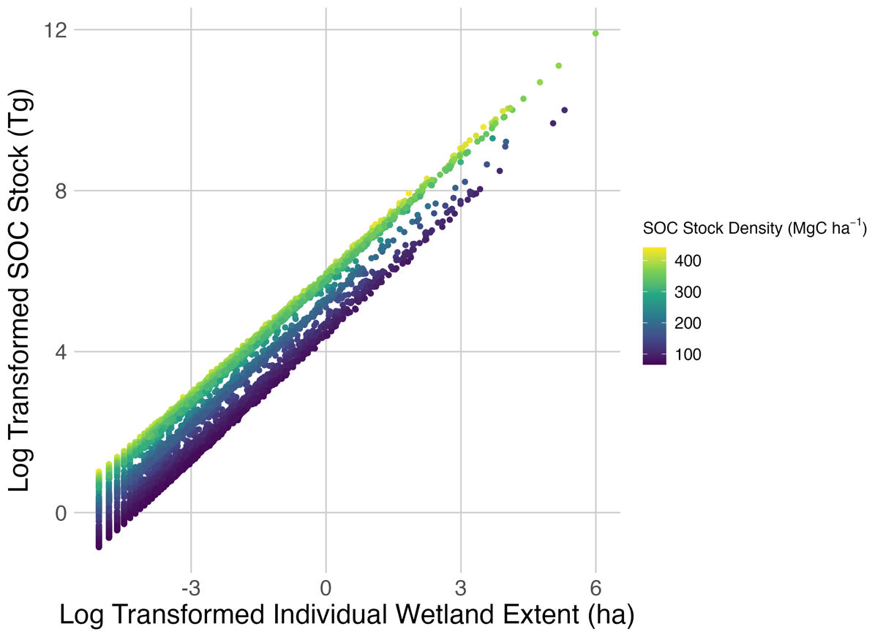
Supplemental Figure 3. Log transformed extent for individual wetlands in relation to log transform SOC stock for individual wetlands. Points are colored by mean SOC stock density in each wetland.

