Supporting Information For:
Plasticity and not adaptation is the primary driver of temperature-mediated variation in flowering phenology in North America
Authors: Tadeo H. Ramirez-Parada, Isaac W. Park, Sydne Record, Charles C. Davis, Aaron M. Ellison, Susan J. Mazer.
Corresponding Author: Tadeo H. Ramirez-Parada; tadeo@ucsb.edu; tadeoramirezp@gmail.com.

This PDF file includes:
- Supplemental References

- Fig. S1: S_{time} and S_{space} for five species exemplifying the patterns of sensitivity predicted under different relative contributions of plasticity and adaptation to phenological variation along temperature gradients (shown in Fig. 1 of the main text).
- Fig. S2: Spatial and temporal sensitivities to TMEAN among 201 long-lived species in the dataset.
- Fig. S3: Distribution and sampling intensity of herbarium specimens across the continental United States.
- Note S1: Hosting herbaria and databases used to access the data.
- Fig. S4: Distribution of correlations between TMEAN_{Normal} and TMEAN_{Anomaly} among species.
- Fig. S5: Distribution of TMEAN_{Normal} and TMEAN_{Anomaly} ranges among species.
- Fig. S6: Average Winter Temperature Normals and Average TMEAN normals for species with mean flowering dates occurring in different months throughout the year.
- Fig. S7: Variation in long-term climatic conditions across collection locations in the continental United States.
- Note S2: Stan code for varying-intercepts, varying-slopes Bayesian Model.
- Note S3: Model performance on simulated data: estimation accuracy and precision.
  - Fig. S8: Effects of sample size on the estimation accuracy of S_{space} and S_{time}
  - Fig. S9: Effects of sample size and effect size on estimation accuracy of apparent adaptation (S_{space} − S_{time}).
  - Fig. S10: Estimation accuracy of apparent adaptation (S_{space} − S_{time}) for species showing co- or counter-gradient apparent adaptation patterns.
  - Fig. S11: Estimation precision of apparent plasticity vs. apparent adaptation
- Note S4: Does our model account for temporal trends in temperature and phenology observed over recent decades? Demonstration through simulations and empirical analysis.
  - Fig. S12: Simulated (from the model in Note S2) vs. empirical trends in phenology as a function of temporal trends in TMEAN_{Anomaly} and a species’ responsiveness to TMEAN_{Anomaly} (S_{time}).
- Fig. S13: Trended vs. detrended estimates of S_{space}, S_{time}, and S_{space} − S_{time}.
- Note S5: Rationale for using TMEAN normals calculated between 1901 and 2020, and impacts of using normals for different reference periods instead.
  - Fig. S14: Relationship between 1901–2020 winter, spring, summer, and fall TMEAN_{Normal} and TMEAN_{Normal} obtained using other reference periods.
  - Fig. S15: Relationship between 1901–2020 winter, spring, summer, and fall TMEAN_{anomaly} obtained using 1901–2020 normals vs. TMEAN_{Anomaly} obtained using normals for other reference periods.
  - Fig. S16: Relationship between estimates of apparent plasticity (S_{time}) and apparent adaptation (S_{space} – S_{time}) obtained using 1901–2020 TMEAN_{Normal} vs. those estimated using TMEAN_{Normal} calculated over different reference periods.
- Note S6: Statistical design relative to Phillimore et al. (2010).
- Fig. S17: Intraspecific variation in sensitivity to TMEAN_{Anomaly} along various climatic gradients.
- Fig. S18: Estimates of sensitivity to TMEAN_{Normal} and TMEAN_{Anomaly} with and without accounting for the effects of precipitation in the models.
- Fig. S19: Spatial and temporal sensitivities to TMEAN among 157 species whose specimens were constrained to 1° latitudinal bands.
- Fig. S20: TMEAN_{Normal} and TMEAN_{Anomaly} sensitivity estimates with and without controlling for different in sample size among species.
- Fig. S21: TMEAN_{Normal} and TMEAN_{Anomaly} sensitivity estimates with and without controlling for spatial autocorrelation.
- Fig. S22: TMEAN_{Normal} and TMEAN_{Anomaly} sensitivity estimates with and without controlling for phylogenetic structure.
- Fig. S23: Model performance of linear vs. non-linear models of flowering time versus TMEAN_{Normal} and TMEAN_{Anomaly} .
- Fig. S24: Influence of latitudinal and longitudinal range size on estimates of apparent plasticity and apparent adaptation.
- Fig. S25: Species overlap among pairs of Level II Ecoregions
- Fig. S26: Variation in long-term climatic conditions among sites of specimen collection occurring in different Level II ecoregions of the contiguous United States.

Supplemental References
Bürkner, P. C. (2017). brms: An R package for Bayesian multilevel models using Stan. Journal of statistical software, 80, 1-28.
Calinger, K. M., Queenborough, S., & Curtis, P. S. (2013). Herbarium specimens reveal the footprint of climate change on flowering trends across north-central North America. Ecology Letters, 16(8), 1037–1044. https://doi.org/10.1111/ele.12135
Delgado, M. del M., Roslin, T., Tikhonov, G., Meyke, E., Lo, C., Gurarie, E., Abadonova, M., Abduraimov, O., Adrianova, O., Akimova, T., Akkiev, M., Ananin, A., Andreeva, E., Andriychuk, N., Antipin, M., Arzamascev, K., Babina, S., Babushkin, M., Bakin, O., … Ovaskainen, O. (2020). Differences in spatial versus temporal reaction norms for spring and autumn phenological events. Proceedings of the National Academy of Sciences, 117(49), 31249–31258. https://doi.org/10.1073/pnas.2002713117
Iler, A. M., Inouye, D. W., Schmidt, N. M., & Høye, T. T. (2017). Detrending phenological time series improves climate–phenology analyses and reveals evidence of plasticity. Ecology, 98(3), 647–655. https://doi.org/10.1002/ecy.1690
Jin, Y., & Qian, H. (2019). V.PhyloMaker: An R package that can generate very large phylogenies for vascular plants. Ecography, 42(8), 1353–1359. https://doi.org/10.1111/ecog.04434
Panchen, Z. A., Doubt, J., Kharouba, H. M., & Johnston, M. O. (2019). Patterns and biases in an Arctic herbarium specimen collection: Implications for phenological research. Applications in Plant Sciences, 7(3), e01229. https://doi.org/10.1002/aps3.1229
Paradis, E., Claude, J., & Strimmer, K. (2004). APE: analyses of phylogenetics and evolution in R language. Bioinformatics, 20(2), 289-290.
Phillimore, A. B., Hadfield, J. D., Jones, O. R., & Smithers, R. J. (2010). Differences in spawning date between populations of common frog reveal local adaptation. Proceedings of the National Academy of Sciences, 107(18), 8292–8297. https://doi.org/10.1073/pnas.0913792107
Pinheiro, J., Bates, D., DebRoy, S., Sarkar, D., Heisterkamp, S., Van Willigen, B., & Maintainer, R. (2017). Package ‘nlme’. Linear and nonlinear mixed effects models, version, 3(1).
Ramirez-Parada, T. H., Park, I. W., & Mazer, S. J. (2022). Herbarium specimens provide reliable estimates of phenological responses to climate at unparalleled taxonomic and spatiotemporal scales. Ecography, n/a(n/a), e06173. https://doi.org/10.1111/ecog.06173
Wolkovich, E. M., Cook, B. I., Allen, J. M., Crimmins, T. M., Betancourt, J. L., Travers, S. E., Pau, S., Regetz, J., Davies, T. J., Kraft, N. J. B., Ault, T. R., Bolmgren, K., Mazer, S. J., McCabe, G. J., McGill, B. J., Parmesan, C., Salamin, N., Schwartz, M. D., & Cleland, E. E. (2012). Warming experiments underpredict plant phenological responses to climate change. Nature, 485(7399), 494–497. https://doi.org/10.1038/nature11014

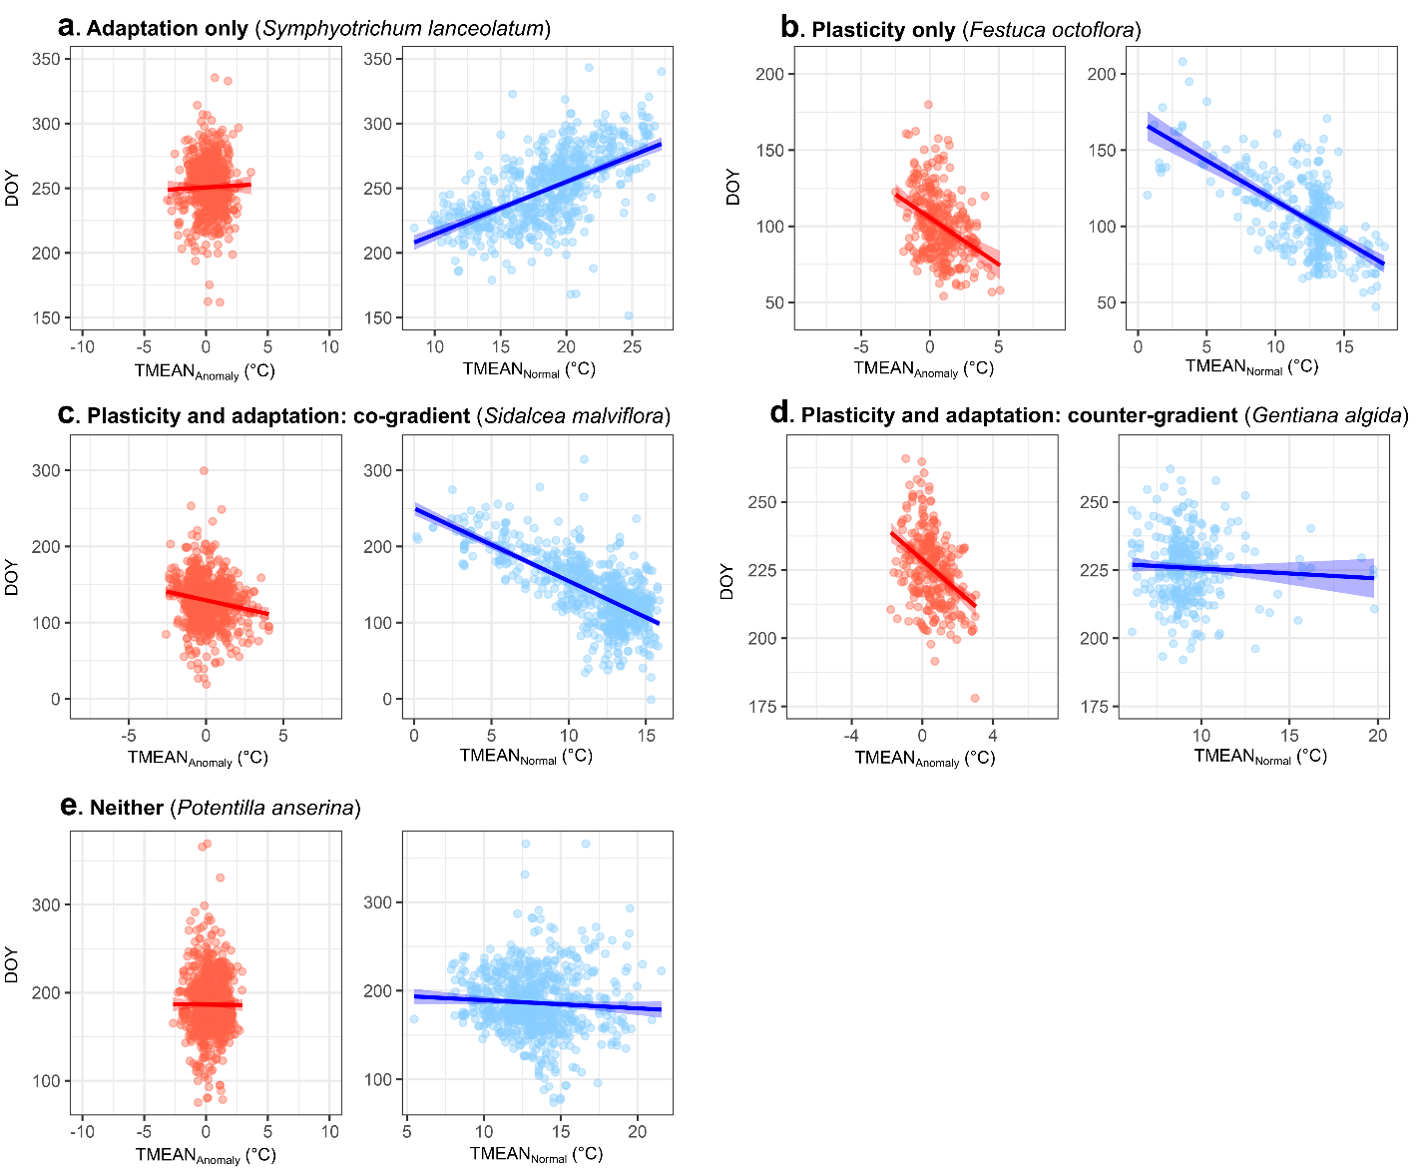
Figure S1—Phenological sensitivities to interannual temperature variation (S_{time}, corresponding to the slope of the red regression lines) and spatial temperature variation (S_{space}, corresponding to the slope of the blue regression lines) for five species (within the contiguous United States) predicted under various relative contributions of plasticity and adaptation. (a) Sensitivity patterns of the panicle aster (Symphyotrichum lanceolatum, Asteraceae), a widespread perennial herb primarily occupying moist habitats across the United States. Its lack of responsiveness to TMEAN_{Anomaly} (i.e., non-significant S_{time}) and significantly greater responsiveness to TMEAN_{Normal} (i.e., significant S_{space} – S_{time}) are consistent with a scenario in which adaptation is the sole driver of flowering time variation along the temperature gradient (see Fig. 1a,b in the main text). (b) Sensitivity patterns of the sixweeks fescue (Festuca octoflora, Poaceae), a widespread annual grass most abundant in arid prairies and deserts. F. octoflora exhibits significant S_{time} that does not substantially differ from S_{space} (i.e., non-significant S_{space} – S_{time}), a pattern consistent with plasticity as the sole cause of variation in flowering time along the temperature gradient (Fig. 1c,d in the main text). (c) Sensitivity patterns of the checker bloom (Sidalcea malviflora, Malvaceae)¸a perennial herb widespread in the West Coast of the United States. S. malviflora exhibits significant responsiveness to interannual temperature variation (i.e., significant S_{time}) and significantly greater sensitivity to spatial variation (i.e., S_{space} has greater magnitude and the same direction as S_{time}; S_{space} – S_{time} is significant), a scenario consistent with the joint effects of plasticity and adaptation in a co-gradient pattern (Fig. 1e,f in the main text). (d) Sensitivity patterns of the whitish gentian (Gentiana algida¸Gentianaceae), a herbaceous perennial occupying mid-to-high elevations in the southern, mid, and northern Rocky Mountains. Its significant responsiveness to interannual TMEAN variation (i.e., significant S_{time}) and significantly lesser responsiveness to geographic temperature variation (i.e., S_{space} has lesser magnitude or opposite direction than S_{time}; S_{space} – S_{time} is significant) is consistent with the joint effects of plasticity and local adaptation along the temperature gradient in a counter-gradient pattern (Fig. 1g,h in the main text). (e) Sensitivity patterns of silverweed (Potentilla anserina, Rosaceae), a widespread perennial herb occurring primarily in moist soils near bodies of water. Its apparent lack of sensitivity to interannual and geographic variation in temperature (and its non-significant S_{space} – S_{time}) make it inconsistent with the apparent roles of either plasticity or adaptation.
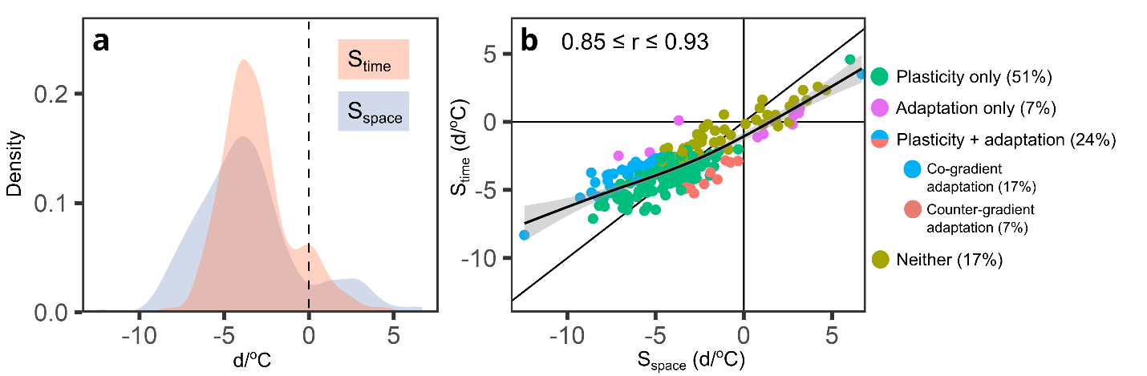
Figure S2—Distributions of flowering time sensitivity to TMEAN_{Normal} (S_{space}) and to TMEAN_{Anomaly} (S_{time}) (a) and their relationship (b) among 201 long-lived, woody species in the continental United States (analogous to Figure 3 of the main text). The solid black line in (b) indicates a 1:1 relationship corresponding to perfect agreement between sensitivity types. The solid curved line indicates the line of best fit obtained from a Generalized Additive Model (GAM) of S_{time} vs. S_{space}, with the shaded area around it denoting the standard error of the predicted mean value. Each point in (b) represents a species whose x, y coordinates are given by the maximum a posteriori (MAP) estimates for S_{space} and S_{time}, respectively. Point shapes and colors in (b) indicate whether sensitivity patterns were consistent with plasticity or adaptation as the sole drivers of flowering time variation along the temperature gradient, with both plasticity and adaptation having significant effects in a co- or counter-gradient adaptation pattern, or not showing statistically significant adaptation nor plasticity. The percent of species showing each pattern is shown in the legend in parenthesis. The 95% credible interval for the correlation between S_{space} and S_{time} is provided as a text inset in (b).
The subset of 201 species was selected based on growth form data from the United States Department of Agriculture Plant Database (USDA Plant Database, https://plants.usda.gov). We downloaded all records of growth habit information available through the search tool, and subset the resulting dataset to contain only species represented among the 1,605 species included in the analyses presented in the main text. We then retained only flowering specimens from species classified as “Tree”, “Shrub”, “Subshrub” or “Vine”, which yielded a dataset of 201 species. Using this subset dataset, we ran the same varying intercepts, varying slopes model, obtaining estimates of sensitivity to TMEAN_{Normal} and TMEAN_{Anomaly} and of their difference for each species, as well as an estimate of their correlation accounting for parameter uncertainty. The resulting patterns closely mirrored those of the larger dataset, with a high correlation and agreement in magnitude between S_{space} and S_{time}, and similar relative frequencies among species for each sensitivity pattern.

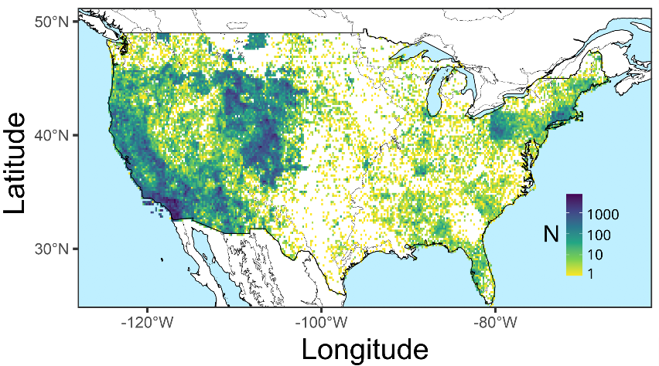
Figure S3—Map of collection availability across the continental United States, showing the total number of specimens collected per 20 × 20-km grid cell out of a total of 1,038,027 herbarium specimens from 1,605 species evaluated in this study.

Note S3—Hosting herbaria and databases used to access data
Herbaria hosting the specimen data used in this study (Darwin Core Institution Codes):
ACAD, AMES, BALT, BLMRD, BSCA, CalBG, SFV, UCR, SD, SDSU, SBBG, UCJEPS, IRVC, LOB, CDA, OBI, RSA, CSUSB, CSLA, GMDRC, FSC, LA, JOTR, POM, DAV, OBS, HSC, UCSC, UCSB, MACF, PUA, JROH, SCFS, SOC, UNLV, OSC, CHRB, CM, NY, University of Connecticut, Université de Montréal Biodiversity Centre, ANSP, Rutgers University, UConn, University of New Hampshire, NEBC, GH, A, YPM, Yale Peabody Museum of Natural History, Woods Hole Oceanographic Institution, ECON, Harvard University, University of Maine, Memorial University of Newfoundland, VT, ELH, Harvard, HUDC, Utah State University, ENLC, RENO, USU, BRY, SUU, RM, UT, NTS, EDOBLM, NDOA, BLM, SEINet, WSCO, NPS, SLCTNL, MARY, UNISON, HCIB, CIAD, BCMEX, IBUG, UJED, URUZA, UAEH, UADY, DEK, EIU, IND, MOR, MSC, WIS, MU, BUT, CINC, MICH, MWI, NC, F, LUC, CHIC, KE, MIN, ILL, PH, TAWES, PAC, APSC, USFWS, BHSC, USFS/BHSC, LCDI, MISU, CSCN, KSP, MSUB, FHKSC, MSUNH, PPWD, ASU, ARIZ, ASC, NAVA, DES, RHNM, USFS, UNM, SNM, MNA, SJNM, JEMEZ, KAIB, AWC, NHI, BTA, TAF, MUR, USCH, TROY, NCU, USF, MISSA, FLAS, DUKE, SWSL, SEL, WILLI, NCSM, BOON, MMNS, ANHC, AUA, LSU, CLEMS, NCSC, VDB, MISS, UNCC, USMS, TENN, PEMB, MUHW, GA, UARK, NLU, KNK, WVA, STAR, ODU, WWC, HBSH, NO, ENO, SC, ECUH, UAM, NCZP, CATU, HTTU, CAU, WEWO, WCUH, GMUF, URV, UOS, APCR, EKY, UCHT, MEM, SBAC, VPI, FARM, SFSU, dtnm, gtnp, WYAC, FBNM, USNH, YELLO, GRTE, dtnp, DTNM, RMBL, DBG, FLD, WSC, MESA, PUSC, COLO, ALAM, CIBO, SAT, SRSC, BRIT, TAC, PAUH, TTC, TLU, JWC, OKL.
Herbarium specimen data were accessed and downloaded from the following platforms:
SEINET, the Consortium of Pacific Herbaria, the Consortium of California Herbaria, the Consortium of Northeastern Herbaria, the Consortium of Pacific Northwest Herbaria, the consortium of MidAtlantic Herbaria, the Consortium of Canadian Herbaria, the Consortium of Midwest Herbaria, the North American Network of Small Herbaria, The Consortium of Northeastern Herbaria, the Red de Herbarios de Noroeste de México, the SouthEast Regional Network of Expertise and Collections (SERNEC), and the Texas Oklahoma Regional Consortium of Herbaria (TORCH).

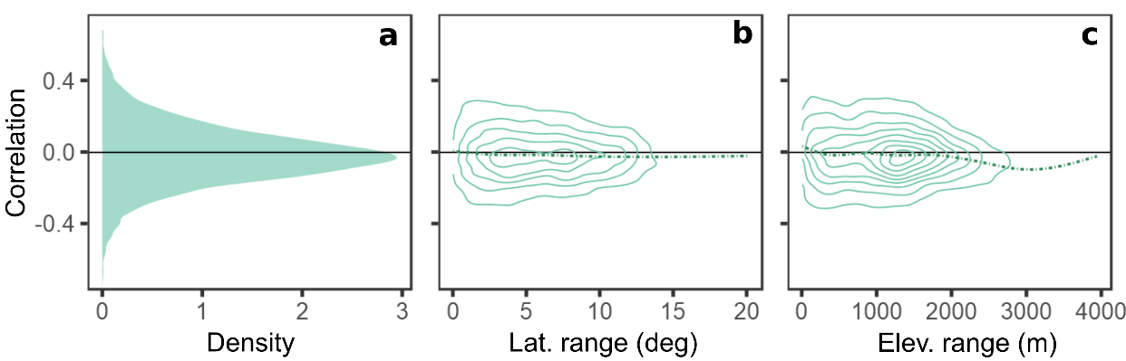
Figure S4—Distribution of the correlation between TMEAN_{Normal} and TMEAN_{Anomaly} across the ranges of 1,605 angiosperms in the continental United States (a), and its relationship with the latitudinal range (b) and elevational range (c) spanned by the central 90% of the specimens of each species. Contour lines in (b) and (c) correspond to bivariate density plots for each of the correlations between TMEAN_{Normal} and TMEAN_{Anomaly} and the predictor (latitudinal or elevational range).

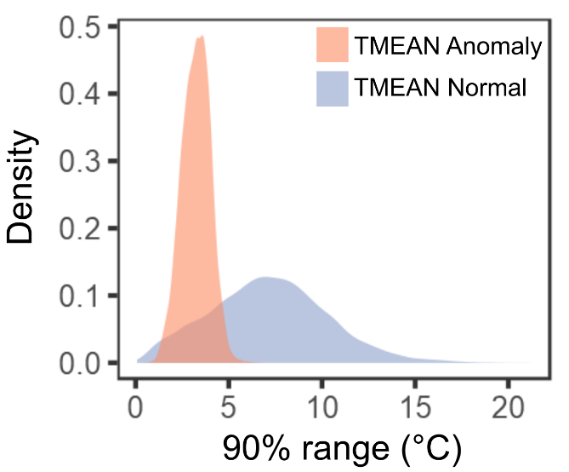

Figure S5—Temperature range spanned by the central 90% of specimens of each of 1,605 species across the continental United States for both TMEAN_{Normal} and TMEAN_{Anomaly}.

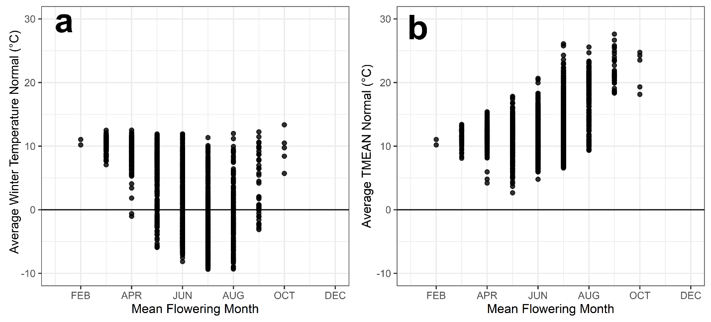
Figure S6—(a) Average winter temperatures and (b) average TMEAN_{Normal} (for the 3-month period leading up to mean flowering dates) experienced by 1,605 angiosperm species with varying mean months of flowering.

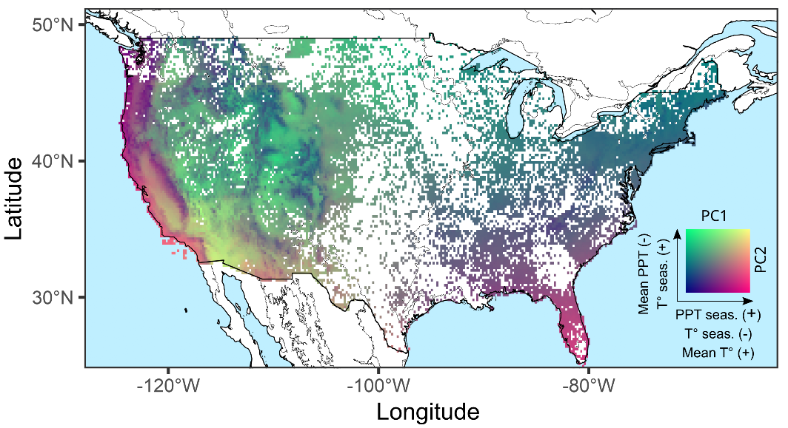
Figure S7—Maps of 20 × 20-km grid cells showing Mean PC1 values among specimen collection sites, corresponding to a gradient of increasing precipitation seasonality (PPT seas. in the legend), decreasing MAT seasonality (T° seas.), and increasing mean annual temperature (MAT) normal (Mean T°), and Mean PC2 values among specimen collection sites, corresponding to a gradient of decreasing mean annual precipitation (Mean PPT), and increasing MAT seasonality.

Note S2—Stan code for varying-intercept and varying-slopes Bayesian Model
"data{
int<lower=1> N; # number of observations
int<lower=1> N_species_i; # Number of species
real AzimuthDOY[N]; # Response variable: Day of Year of collection
real Norm_tmean_meanDOY_03m[N]; # TMEAN normal
real Dev_tmean_meanDOY_03m[N]; # TMEAN anomaly
int species_i[N]; # Numeric species ID
real DOY_SD; # Standard deviation of DOYs used to recover scale of sensitivities in d/°C
real NORM_SD; # Standard deviation of TMEAN normal used to recover scale as above
real ANOM_SD; } # Standard deviation of TMEAN anomaly used to recover scale as above
parameters{
matrix[3,N_species_i] z_N_species_i;
cholesky_factor_corr[3] L_rho;
vector<lower=0>[3] sigma_sp_i;
vector[N_species_i] sig_sp;}
transformed parameters{
vector<lower=0>[N] sigma = exp(sig_sp[species_i]);
matrix[N_species_i,3] v_N_species_i;
vector[N_species_i] a;
vector[N_species_i] b1;
vector[N_species_i] b2;

matrix[3,3] rho;
v_N_species_i = (diag_pre_multiply(sigma_sp_i,L_rho)*z_N_species_i)';
a = col(v_N_species_i,1);
b1 = col(v_N_species_i,2);
b2 = col(v_N_species_i,3);
rho = L_rho * L_rho';}
model{
vector[N] mu;
L_rho ~ lkj_corr_cholesky( 2 );
sig_sp[N_species_i] ~ normal(0,5);
sigma_sp_i ~ exponential( 1 );
to_vector(z_N_species_i) ~ normal( 0 , 1 );

for ( i in 1:N ) {
mu[i] = a[species_i[i]] +
b1[species_i[i]] * Norm_tmean_meanDOY_03m[i] +
b2[species_i[i]] * Dev_tmean_meanDOY_03m[i];
}
AzimuthDOY ~ normal( mu , sigma );
}
generated quantities{
vector[N_species_i] b3;
for(i in 1:N){
b3[species_i[i]] = (b1[species_i[i]]*DOY_SD)/NORM_SD - (b2[species_i[i]]*DOY_SD)/ANOM_SD;
}
}"

Note S3—Model performance on simulated data: estimation accuracy and precision

Our estimate of apparent adaptation is derived from the difference of two random variables (i.e., S_{space} − S_{time}). As such, apparent adaptation may show greater estimation uncertainty than apparent plasticity (S_{time}), which could result in lower probability of direction for apparent adaptation estimates compared to those of the same magnitude for apparent plasticity. If so, our criteria for classifying sensitivity patterns as consistent with plasticity or adaptation (see Table 1 of the main text) would be biased towards plasticity. Similarly, any directional biases in estimating S_{space} and S_{time} may be compounded when estimating their difference, making our estimates of apparent adaptation less reliable.
To assess whether our model (see Methods: Analyses in main text; and Note S2) could reliably recover estimates of apparent plasticity (S_{time}) and apparent adaptation (S_{space −} S_{time}), we simulated data and assessed how estimation accuracy and precision varied depending on 1) the average sample size among species, 2) the magnitude of the true value of S_{space} − S_{time}, and 3) whether S_{space} − S_{time} and S_{time} differed in a co- or counter-gradient manner.

Simulation Results
Overall, we found that our model produced accurate estimates of S_{space}, S_{time}, and S_{space} – S_{time} and that estimates of apparent plasticity and adaptation showed very similar degrees of precision. The distribution of estimation errors for S_{space} and S_{time} among simulated species was centered on or very close to 0 across all sample size categories, with decreasing variability in accuracy for increasing sample sizes (Fig. S8). S_{space} estimates tended to show less variability in error than S_{time} estimates, a result consistent with the greater signal-to-noise ratio (relative to DOY) observed for TMEAN_{Normal} vs. TMEAN_{Anomaly} (Fig. S5).
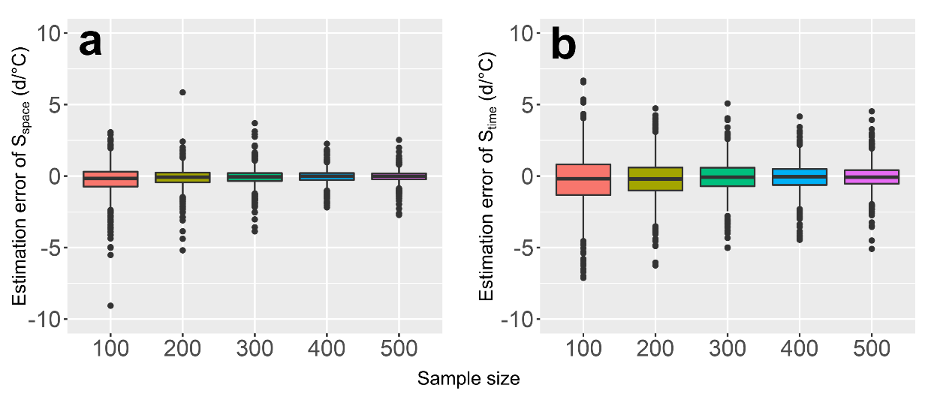
Figure S8—Estimation error of DOY sensitivity to: a) TMEAN_{Normal} (S_{space}) and to b) MEAN_{Anomaly} (S_{time}).

Accordingly, we found that the distribution of estimates of S_{space} – S_{time} was 0-centered among species for all combinations of effect size and sample size (Fig. S9), indicating that the models did not show systemic biases when estimating differences between S_{space} and S_{time}. The magnitude of the estimation error was consistent across true S_{space} – S_{time} values, but the variability in accuracy moderately increased with higher values of true S_{space} – S_{time}. The variability in estimation error decreased with sample size for all values of true S_{space} – S_{time}.
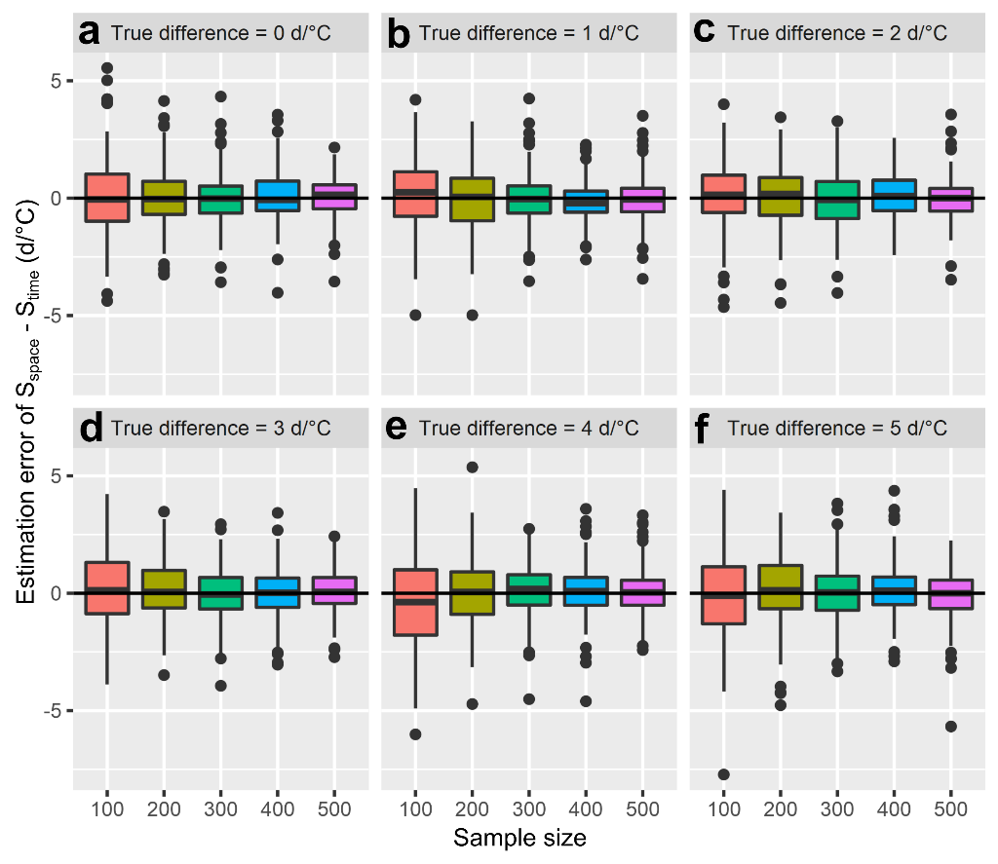
Figure S9—Error among simulated species for S_{space} – S_{time} estimates relative to true values of S_{space} – S_{time} for different sample and effect sizes.
Moreover, the absolute error of apparent adaptation estimates did not differ substantially among species showing apparent co- or counter-gradient adaptation patterns regardless of sample size or the true value of S_{space} – S_{time} (Fig. S10). The magnitude of estimation error decreased with sample size but did so only marginally for sample sizes >300 observations.
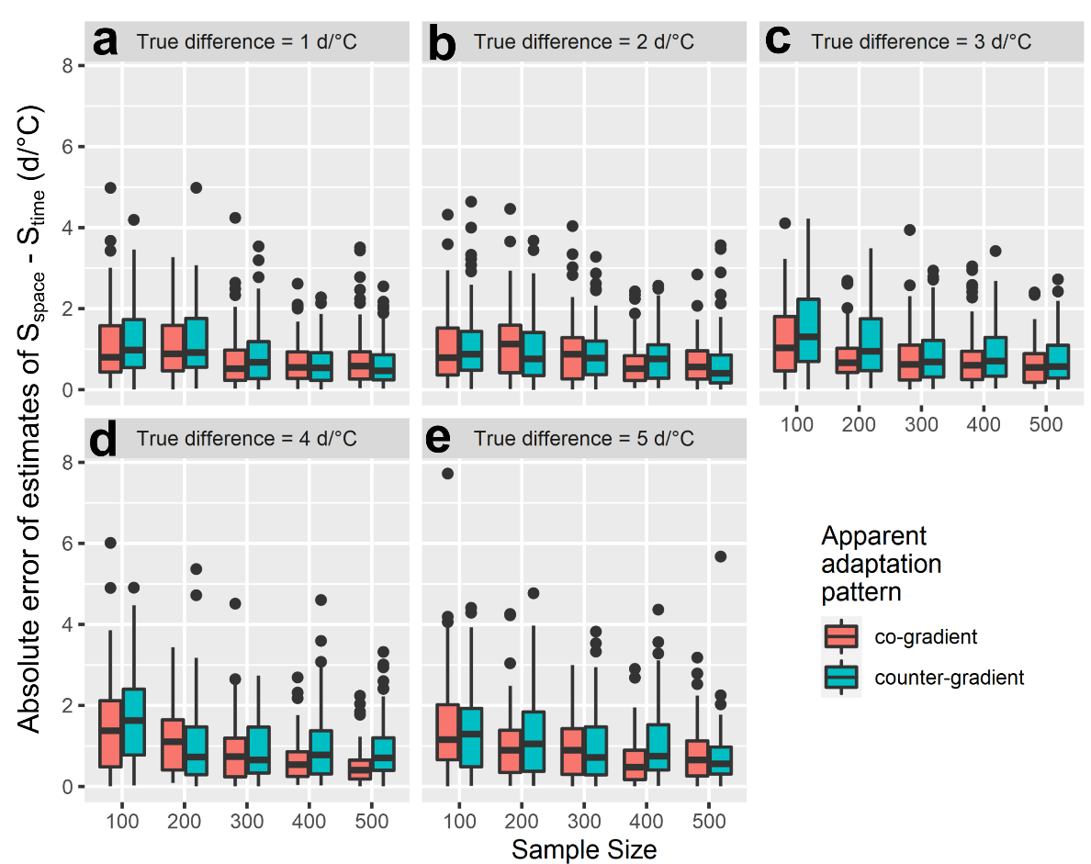
Figure S10—Variation in absolute error of S_{space} – S_{time} estimates for simulated species showing co- or counter-gradient patterns of apparent adaptation and differing in both sample size and the true magnitude of S_{space} ̶ S_{time}.

Apparent adaptation and plasticity showed similar degrees of estimation uncertainty for all sample size categories and true values of S_{space} – S_{time}, with only marginally greater uncertainty for S_{space} – S_{time} across groups (mean difference in posterior SD = 0.035 ± 0.013 d/°C; Fig. S11). Estimation uncertainty for both parameters decreased substantially with sample size for all values of true S_{space} – S_{time}.

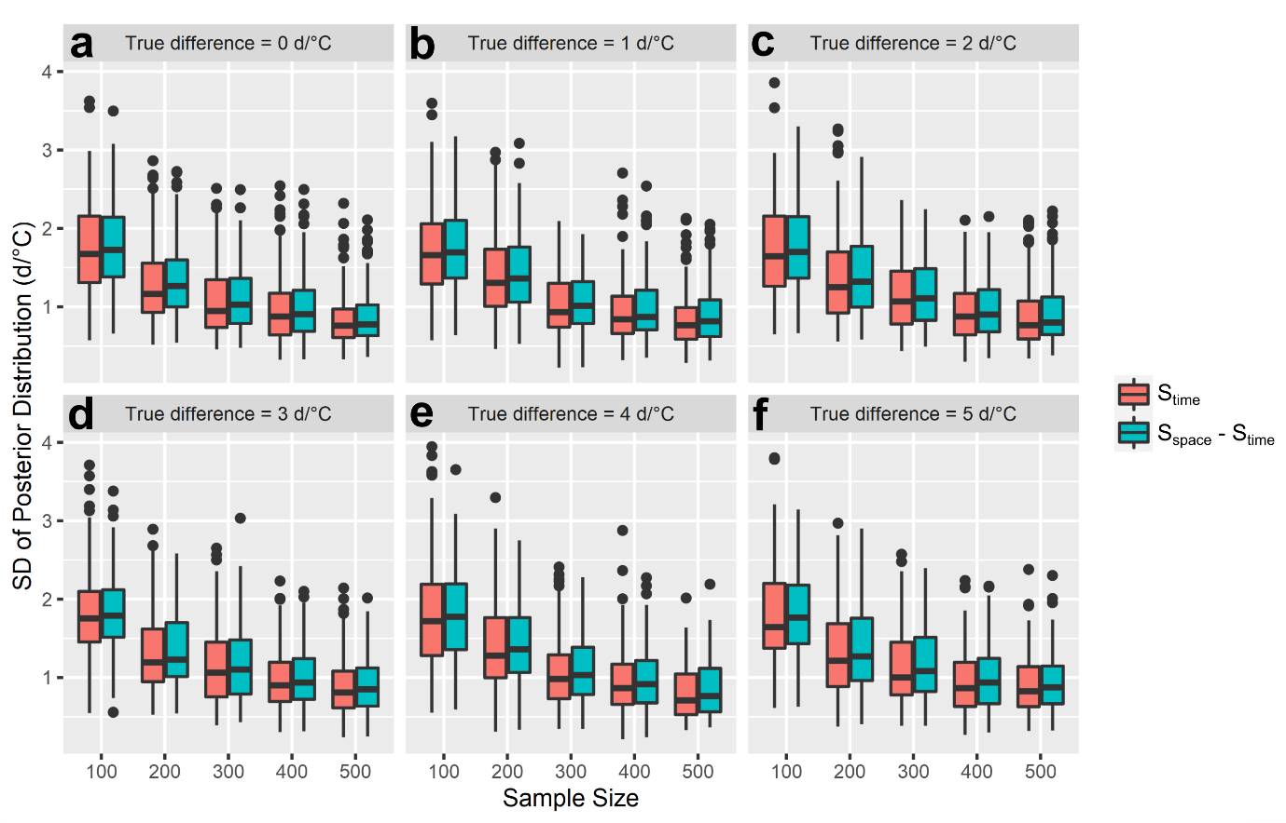
Figure S11—Estimation uncertainty of apparent plasticity (S_{time}) and apparent adaptation (S_{space} – S_{time}) derived from simulations of species differing in their true value of S_{space} – S_{time} and in the number of observations per species.

Conclusions
Together, our results demonstrate that the model presented in the main text does not exhibit systemic biases when estimating apparent plasticity and adaptation. Crucially, the estimation uncertainties of S_{time} and S_{space} – S_{time} were similar despite the fact that S_{space} – S_{time} is the difference between two random variables, suggesting that our classification method (Table 1 in the main text) should not result in a substantially larger likelihood of classifying a species’ sensitivity pattern as consistent with apparent plasticity (i.e., P(S_{time} ≠0) ≥ 0.95) than with apparent adaptation (i.e., P(S_{space} – S_{time} ≠0) ≥ 0.95). Finally, while the simulation showed increases in estimation precision with sample size, the magnitude of such increases declined as sample size increased. This observation—and the fact that the analyses presented in the main text included species represented by a median of 491 specimens (min = 300, max = 6,192)—suggests that estimation uncertainty would decrease marginally by using higher sample size cutoffs for inclusion of species in our models, which would come at the cost of substantial taxonomic breadth (e.g., requiring > 500 specimens would retain only 776 spp. while requiring > 300 specimens retained 1,605 species).
Although these results demonstrate that our model can recover the parameters of interest with sufficient accuracy and precision, our simulations assumed neither phylogenetic nor spatial structure in DOY, S_{space}, S_{time}, or S_{space} – S_{time} among species. However, the model presented in the main text was fitted under the same set of assumptions, and we confirmed that accounting for phylogeny or spatial autocorrelation did not substantially affect our estimates (Fig. S21, Fig. S22). Similarly, the model presented in the main text included many more species and larger sample sizes (specimens per species) than these simulations. The larger scale of the model in the main text, however, should improve model performance, as a larger number of groups should improve estimation of hyper-parameters—such as among-species means or standard deviations—thus improving partial pooling of species-specific effects.
Accordingly, we conclude that these simulations—in combination with other supplemental analyses verifying assumptions such as the lack of substantial effects of phylogeny or spatial autocorrelation on our estimates—demonstrate the statistical reliability of the model used to derive the results presented in the main text. We hope that these analyses and interpretations alleviate this reviewers’ concerns over our conclusions regarding the relative importance of plastic vs. adaptive responses to local climatic conditions.

Note S4—Does our model account for temporal trends in temperature and phenology observed over recent decades? Demonstration through simulations and empirical analysis.
Our model (see Methods: Analyses in main text; and Note S2) did not include an explicitly temporal term (i.e., year), and as such, it may appear to omit the potential influence of widespread warming and temporal shifts in phenology observed in recent decades. However, because TMEAN_{Anomaly} represents an interannually variable predictor, values for recent decades do indeed show temporal trends due to recent global warming. Therefore, to the extent that shifts in phenology are caused by TMEAN increases, our model should not only account for temporal trends in temperature, but also in phenology. Moreover, the magnitude of such phenological trends should depend on a species’ sensitivity to TMEAN_{Anomaly} (i.e., on S_{time}), as we would expect temperature increases to generate flowering shifts only among species that are responsive to interannual temperature variation.
To demonstrate this, we used simulations—much like those described in Note S3—to assess whether temporal trends in temperature generated concordant trends in phenology, and whether the magnitude of those phenological trends was mediated by S_{time}. Moreover, to evaluate the assumption that temporal trends in phenology are generated by increases in TMEAN_{Anomaly} in our data, we used the herbarium dataset to determine whether observed temporal trends in TMEAN_{Anomaly} and a species’ S_{time} explain observed trends in DOY. In doing so, we also highlight subsequent supplemental analyses (reported in the revised Supplementary Information) that demonstrate that omitting time (Year) as a term in our models does not bias our results (Fig. S13), as would be the case if phenology and temperature both showed temporal trends but were mechanistically unrelated (Iler et al. 2017).

Simulation outline
To assess whether our model would generate temporal trends in phenology, we simulated data for 1,605 species (as many as in our main analyses) following a similar procedure to the simulation described in our previous response: we generated DOYs by 1) randomly assigning sensitivities to TMEAN_{Normal} and TMEAN_{Anomaly} (i.e., S_{space} and S_{time}) to a simulated species, 2) randomly selecting temperature conditions from real observations within species in our dataset, 3) generating predicted DOYs based on S_{time}, S_{space}, and TMEAN_{Normal} and TMEAN_{Anomaly}, and 4) adding randomly distributed noise to the predicted DOYs.
In each iteration of our simulation, we generated data for a single species, first assigning it a random S_{time} parameter obtained from a normal distribution with a mean of -4 d/°C and standard deviation of 3 d/°C, and a randomly selected S_{space} – S_{time} parameter of 0, 1, 2, 3, 4, or 5 d/°C. We then generated an S_{space} parameter by randomly adding (or subtracting) S_{space} – S_{time} to (or from) S_{time}. Next, the focal species was randomly assigned an initial sample size of 100, 200, 300, 400, or 500 specimens, and for each sample, we obtained a pair of TMEAN_{Normal} and TMEAN_{Anomaly} values obtained from observations of species represented by at least 500 specimens in our data (776 species). As the onset of rapid warming began in the late 20th century, in each iteration, we retained only simulated specimens assigned TMEAN conditions from the year 1980 and onwards. If the resulting sample consisted of less than 30 observations, we skipped to the next iteration, discarding the current simulated species. In turn, if a simulated sample met this criterion, we generated predicted DOYs for each specimen of the focal species using the following linear equation:
Predicted DOY = S_{space} × TMEAN_{Normal} + S_{time} × TMEAN_{Anomaly}
As in Note S3, we were interested in modelling parameters measuring variation in DOY due to temperature (S_{space}, S_{time}, and S_{space} – S_{time}), so the numerical values of the response are immaterial in these analyses. Therefore, for simplicity, we assigned an intercept of 0 to all simulated species.
This approach generated simulations with sample sizes ranging from 30 to 479 observations (median = 167). To generate simulated DOYs, we then sampled values from a normal distribution with mean equal to the predicted DOY of each specimen. In turn, the standard deviation was drawn from an among-species distribution of standard deviations for the residual variation in DOY obtained after fitting a linear regression of DOY vs. TMEAN_{Normal} and TMEAN_{Anomaly} (as described in Note S3).
For each dataset simulated this way, we quantified temperature and phenological trends by fitting two simple regressions that included TMEAN_{Anomaly} or DOY as a response and year as a predictor. The coefficients from these regressions (indicating the rate of change of TMEAN_{Anomaly} or DOY per year) were stored in each iteration, as well as the S_{time} value used to simulate the data. Once the target threshold of 1,605 species was reached, we stopped the simulation and assessed whether temporal trends in sampled TMEAN_{Anomaly} and S_{time} explained simulated trends in DOY using the following linear regression:
Phenological Trend = β₁ × TMEAN_{Anomaly} Trend + β₂ × TMEAN_{Anomaly} Trend × S_{time}
Empirical assessment
We complemented these simulations by assessing whether—among species in our data—temporal trends in TMEAN_{Anomaly} and a species’ sensitivity to them (S_{time}) indeed mediated observed trends in phenology between 1980 and 2020. First, we subset the dataset to include only specimens collected from the year 1980 onwards. While all 1,605 species were retained after this step, subsetting resulted in sample sizes ranging from 34 to 4600 observations (mean = 410). As in the simulation, we calculated temporal trends in phenology and temperature by fitting two linear regressions, including TMEAN_{Anomaly} or DOY as a response and year as the only predictor. Then, we quantified the degree of responsiveness to interannual temperature variation by estimating S_{time} from a regression of DOY vs. TMEAN_{Normal} (as a control) and TMEAN_{Anomaly}. Finally, as in the simulated dataset, we assessed whether phenological trends were jointly explained by TMEAN_{Anomaly} trends and S_{time} by fitting the same regression model as for the simulation.
Results
Simulated species showed average trends in phenology of -1.4 days/decade, generated from sampled TMEAN_{Anomaly} conditions showing average trends of 0.24 °C/decade. As predicted, the magnitude of phenological trends was mediated by the magnitude of both a species’ sensitivity to TMEAN_{Anomaly} and of the temporal trend in TMEAN_{Anomaly} (Fig. S12a). Accordingly, species for which S_{time} was close to 0 tended to show no temporal trends in DOY regardless of the magnitude of the temporal trends in TMEAN anomaly; in turn, species responsive to TMEAN_{Anomaly} tended to show phenological trends proportional to the magnitude of the temperature trend. Accordingly, species that were more sensitive tended to show greater increases in the magnitude of phenological trends for equivalent increases in the magnitude of the temperature trends.
We detected the same patterns in the specimen dataset: phenological trends were mediated by the degree of warming and the sensitivity to temperature of a species (Fig. S12b). However, the magnitude of phenological trends tended to be moderately greater than that of the trends obtained from the simulated data. Specifically, species in the dataset showed average trends in phenology of -1.9 d/decade for average trends in TMEAN_{Anomaly} of the same magnitude as those in the simulate data (0.24 °C/decade).
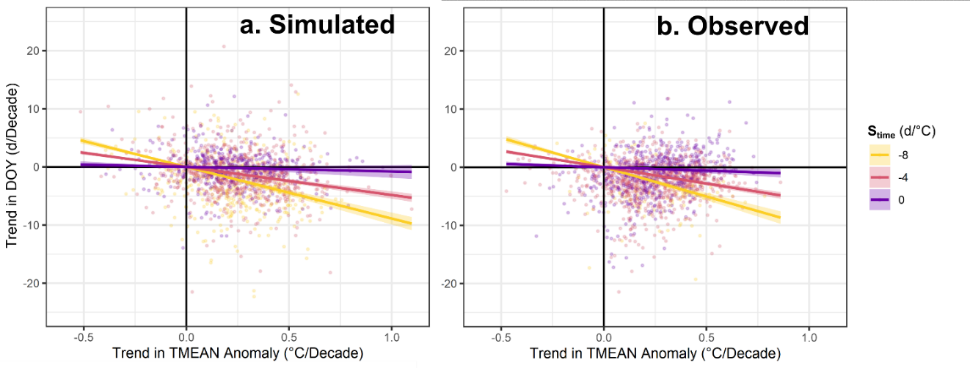
Figure S12—Relationship between temporal trends in flowering phenology (DOY) and the interaction between temporal trends in TMEAN anomaly and species sensitivity to TMEAN anomaly for (a) simulated data, and (b) 1,605 species represented by 658,778 specimens collected from 1980 onwards (i.e., after the approximate onset of rapid global atmospheric warming).

The results from our simulation demonstrate that—despite not including an explicitly temporal term—the model presented in the main text does account for trends through time in phenology due to trends in the TMEAN_{Anomaly} data caused by climate warming. However, this model assumes that temporal trends in phenology result exclusively from species responses to increasing TMEAN_{Anomaly}. If temporal trends in DOY and TMEAN_{Anomaly} were not causally related in our data, omitting their shared temporal trend in the model (e.g., by excluding time as a covariate) could lead to spurious results (Iler et al. 2017). Reassuringly, we recovered the same patterns using real data: the magnitude of a species’ phenological trends was mediated by its sensitivity to TMEAN_{Anomaly} and by the magnitude of temporal trends in TMEAN_{Anomaly}. These results suggest that observed phenological trends are indeed causally related to increases in TMEAN over time. Moreover, detrending DOY and TMEAN_{Anomaly} prior to fitting the model did not affect estimates of S_{time} (see Fig. S13), further indicating that DOY and TMEAN_{Anomaly} are mechanistically correlated, and that omitting temporal trends in the model is unlikely to bias our results.
Conclusions
The analyses outlined above demonstrate that 1) our results are robust to selection of different reference periods over which to calculate TMEANN_{ormal}, 2) that the model presented in the main text does account for temporal trends in temperature and phenology, and 3) that its assumptions (i.e., phenological shifts are caused by temperature shifts) are reasonable for our data.

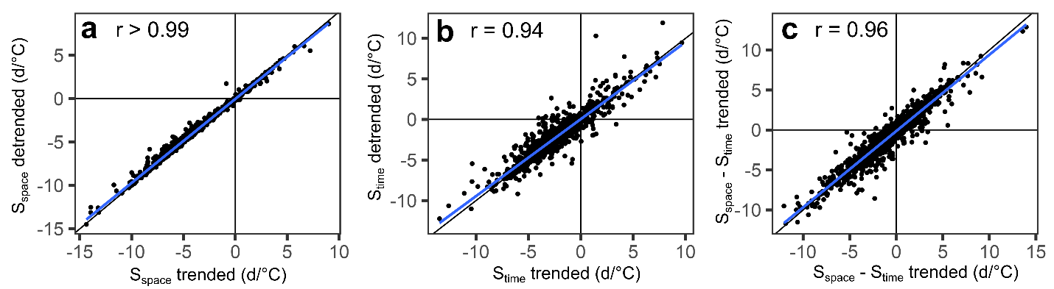
Figure S13—Relationship between estimates of sensitivity to S_{space}, S_{time}, and S_{space} − S_{time} with and without detrending both flowering DOY and TMEAN_{Anomaly} prior to fitting single-species models (x- and y-axis, respectively).
Iler et al. (2017) showed that shared temporal trends between DOY and temperature can generate spurious relationships between these variables that often disappear when the phenological and temperature time series are detrended prior to estimating their relationship. Alternatively, a non-spurious but trended relationship between DOY and temperature might reflect the effects of adaptation to directional changes in temperature, at least in short-lived species. Therefore, relationships between phenology and temperature that persist following detrending are more likely to reflect phenological plasticity. Accordingly, we assessed whether estimates of sensitivity to TMEAN_{Anomaly} (S_{time}) presented in the main text could be confounded by temporal trends in DOY and TMEAN_{Anomaly}. To do so, we first ran single-species linear regressions using DOY or TMEAN_{Anomaly} as responses, and year as a single predictor, storing the resulting residuals as detrended versions of both responses. Then, for each species, we ran two linear models of DOY against TMEAN_{Normal} and TMEAN_{Anomaly}: one with observed DOY and TMEAN_{Anomaly} and another with detrended DOY and TMEAN_{Anomaly}. As shown in Fig. S13, trended and detrended estimates of sensitivity to TMEAN_{Anomaly} were very highly correlated among species, suggesting that TMEAN sensitivity estimates presented in the main text do not reflect the confounding effect of shared temporal trends. Similarly, detrending DOY and TMEAN_{Anomaly} did not substantially alter estimates of S_{space} and S_{space} − S_{time}.

Note S5—Rationale for using TMEAN_{Normal} calculated between 1901 and 2020, and impacts of using TMEAN_{Normal} for different reference periods.
Because there is a long-term trend in temperature due to climate warming across most sites of specimen collection, it is possible that using a 120-year window for a long-term mean will be biased on both ends relative to the conditions that individuals or their source populations experienced preceding the collection of a specimen. The criticism is that the long-term temperatures (i.e., TMEAN_{Normal}) used in our models are much too warm for specimens collected in the early 1900s and much too cool for specimens collected in the 2000s. However, we used TMEAN_{Normal} with the objective of characterizing long-term temperature conditions of each site of specimen collection, whose variation therefore represents spatial temperature gradients for each species irrespective of the years in which the specimens were collected. In doing this, the main motivation is not to capture the conditions that a plant or its source population experienced prior to a specimen’s collection, but to differentiate locations within species’ ranges based on their chronic temperature conditions. Here, we aim to describe geographic temperature gradients (i.e., variation across locations), not the numerical temperature average that most closely matches conditions in the decades prior to the collection of a specimen. If alternative ways of measuring such geographic temperature gradients (i.e., TMEAN_{Normal} estimated over different time periods) do not substantially impact differences in long-term conditions observed among sites, then they should reveal the same associations between phenology and geographic temperature variation (i.e., they should result in equivalent estimates of S_{space}).
Nonetheless, in the previous version of the manuscript, we did not address these points or assess whether using different normals might affect our results. Accordingly, we evaluated the degree to which our choice of reference period for calculating TMEAN_{Normal} may have influenced our results. To do so, we measured the relationship between TMEAN_{Normal} for winter (Dec, Jan, Feb), spring (Mar, Apr, May), summer (Jun, Jul, Aug), and fall (Sep, Oct, Nov) calculated between 1901 and 2020 vs. those obtained using four 30-year reference periods (1901-1930, 1931-1960, 1961-1990, or 1991-2020) among all unique collection locations in our data. Before calculating TMEAN_{Normal} for all these periods, we downscaled the spatial resolution of the data to 111m (4 decimal points of a degree) to make the analyses computationally feasible, which yielded a total of 588,650 unique locations. We then calculated winter, spring, summer, and Fall TMEAN_{Anomaly} between 1901 and 2020 for each unique site of collection (approximately 72 million site-by-year combinations) relative to TMEAN_{Normal} calculated using each 30-year reference period, comparing their values to those obtained using TMEAN_{Normal} from 1901 to 2020. Finally, we evaluated how the choice of reference period for calculating normals and anomalies affected estimates of S_{space}, S_{time,} and S_{space} – S_{time}. To do this, we fitted single-species models (for each of 1,605 spp. included in the main analyses) of DOY vs. TMEAN_{Normal} and TMEAN_{Anomaly} relative to the 1901-1930, 1931-1960, 1961-1990, 1991-2020, or 1901-2020 periods. As in the main analyses, TMEAN_{Normal} and TMEAN_{Anomaly} were averaged over the 3-month period preceding the mean flowering date of each species. We then compared estimates of S_{space}, S_{time,} and S_{space} – S_{time} based on TMEAN_{Normal} estimated from 1901-2020 to those obtained using TMEAN variables for each alternative 30-year period.

Results
The values of TMEAN_{Normal} calculated between 1901 and 2020 (hereafter ‘1901-2020 normals’) were nearly identical to those obtained using alternative periods. For every season, 1901-2020 normals showed correlation coefficients greater than 0.99 and 1:1 in relationship to normals for other reference periods (Fig. S14). This is likely because the magnitude of temperature increases in recent decades—and the magnitude of variation in temperature trends among sites—is negligible compared to the range of geographic variation in long-term conditions typically spanned by a species. For example, locations in our data showed average increases of 0.23 °C/Decade in mean spring temperature between 1980 and 2020, whereas the average species spanned a 99% range of spring TMEAN_{Normal} conditions of 13.1 °C throughout its range.
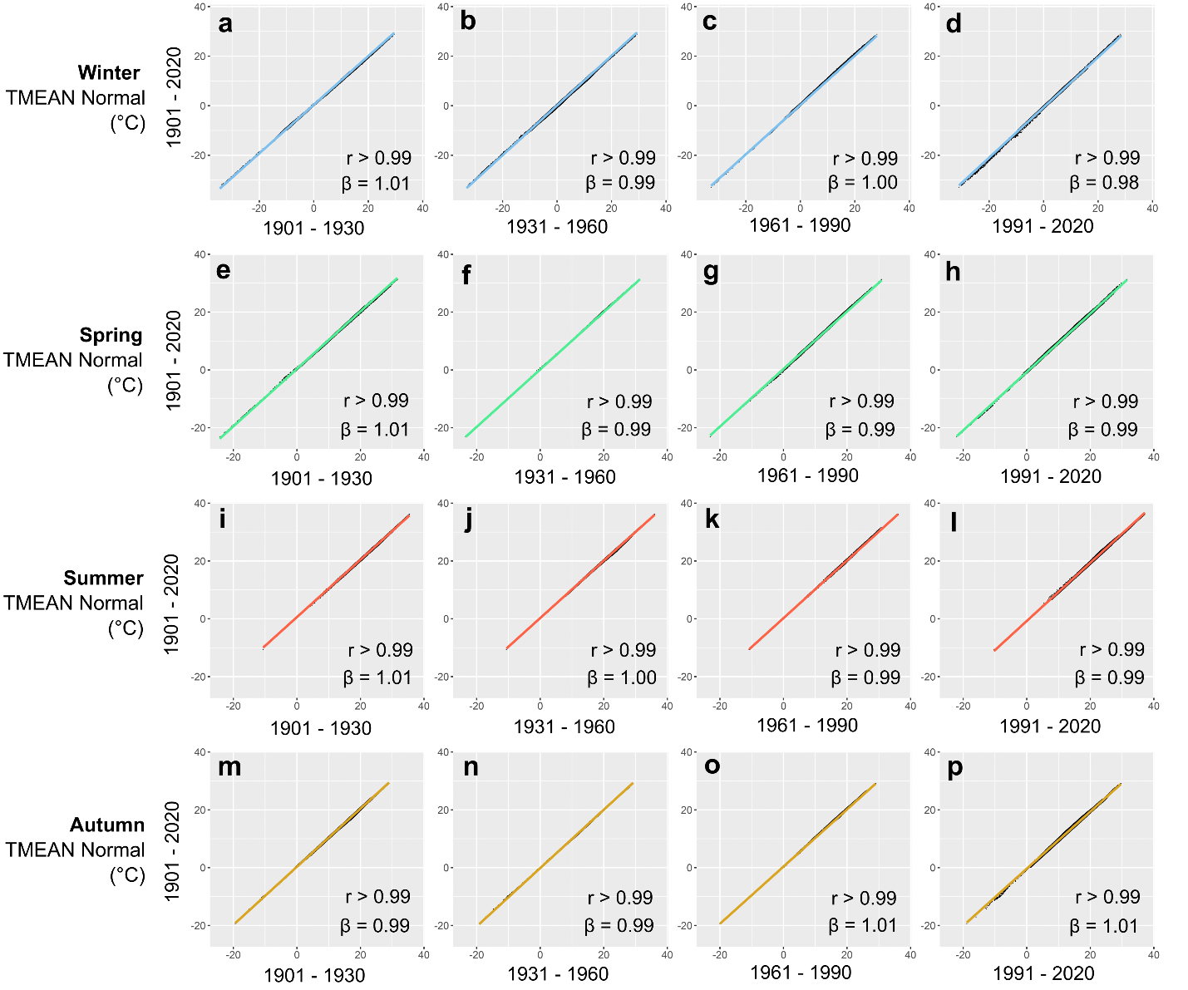
Figure S14—Relationship between winter, spring, summer, and autumn TMEAN_{Normal} calculated between 1901 and 2020 vs. those obtained using different reference periods.

Similarly, seasonal TMEAN_{Anomaly} calculated using 1901-2020 TMEAN_{Normal} (hereafter “1901-2020 anomalies”) were highly correlated with those obtained using normals for different reference periods (mean correlation = 0.97; Fig. S15). The relationship between 1901-2020 anomalies and those calculated relative to normals for other periods had a mean slope of 0.95, indicating that 1901-2020 anomalies tended to span, on average, a marginally narrower range of variation.
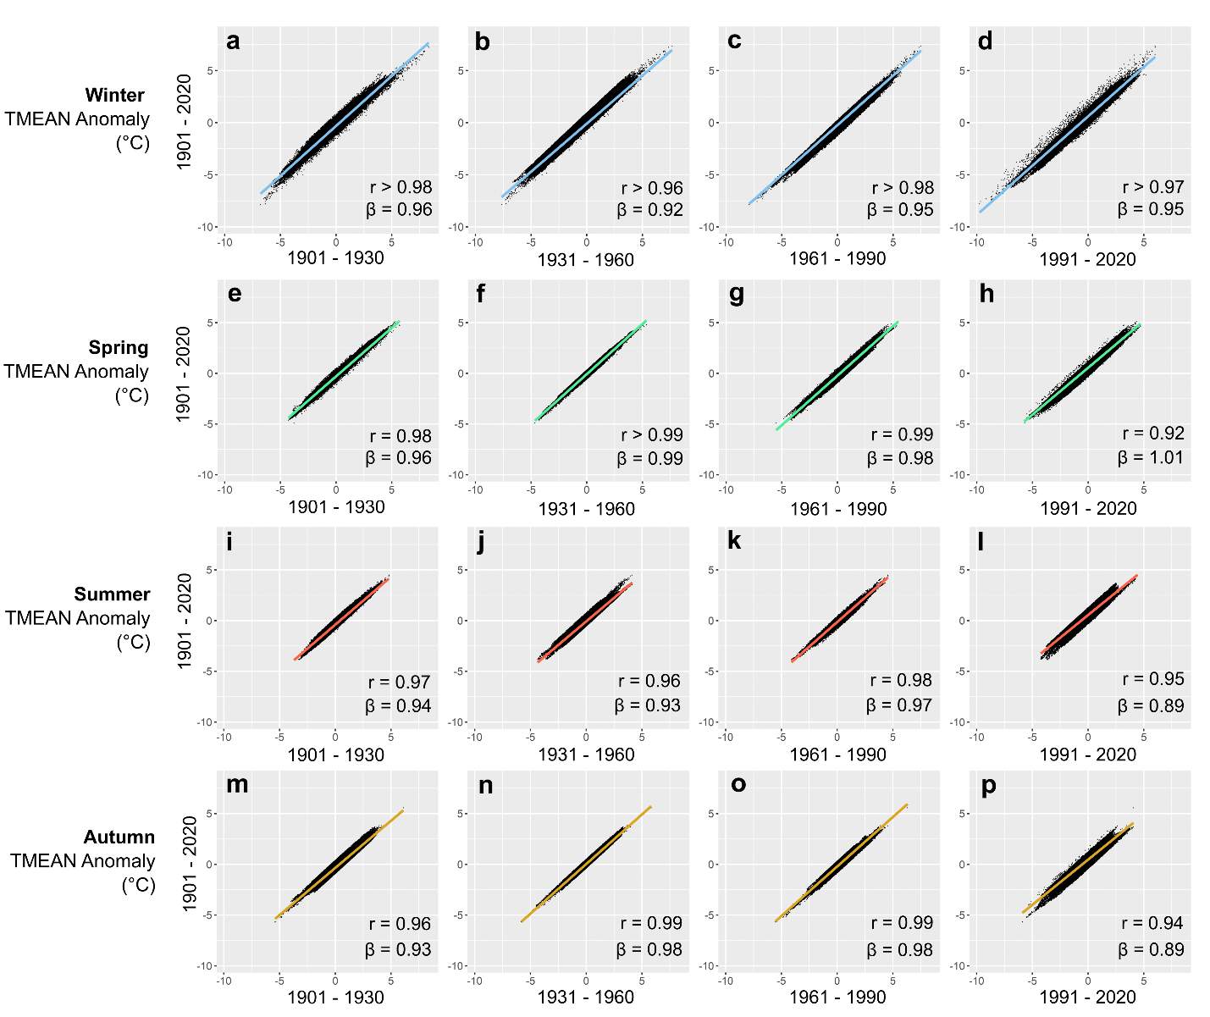
Figure S15—Relationship between TMEAN_{Anomaly} calculated using 1901—2020 TMEAN_{Normal} relative to those obtained using TMEAN_{Normal} for different periods.

Estimates of S_{space}, S_{time,} and S_{space} – S_{time} obtained using normals for 1901-2020 (hereafter ‘1901-2020 estimates’) were highly correlated to those obtained using other reference periods (Fig. S16). Estimates of S_{space} were least sensitive to period selection, with estimates for all periods showing nearly identical values and 1:1 relationships with those obtained using 1901-2020 normals and anomalies (r > 99; Fig. S16a—d). Similarly, 1901-2020 estimates of S_{time} and S_{space} – S_{time} were highly correlated to those obtained using different periods (r ≥ 0.89, mean r = 0.93; Figs. S16d—l). The relationships between 1901-2020 S_{time} or S_{space} – S_{time} and those obtained using alternative reference periods tended to deviate slightly from a 1:1 line, with estimates of slightly lesser magnitude than those obtained using different reference periods (i.e., slopes < 1 reflecting estimates closer to 0 in both the positive and the negative range). However, the magnitude of the deviation from the 1:1 relationship was nearly identical for S_{time} and S_{space} – S_{time} (mean S_{time} β= 0.84; mean S_{space} – S_{time} β= 0.84), indicating that selecting alternative periods for calculating TMEAN_{Normal} would have very similar effects on estimates of apparent plasticity and apparent adaptation of the same magnitude.

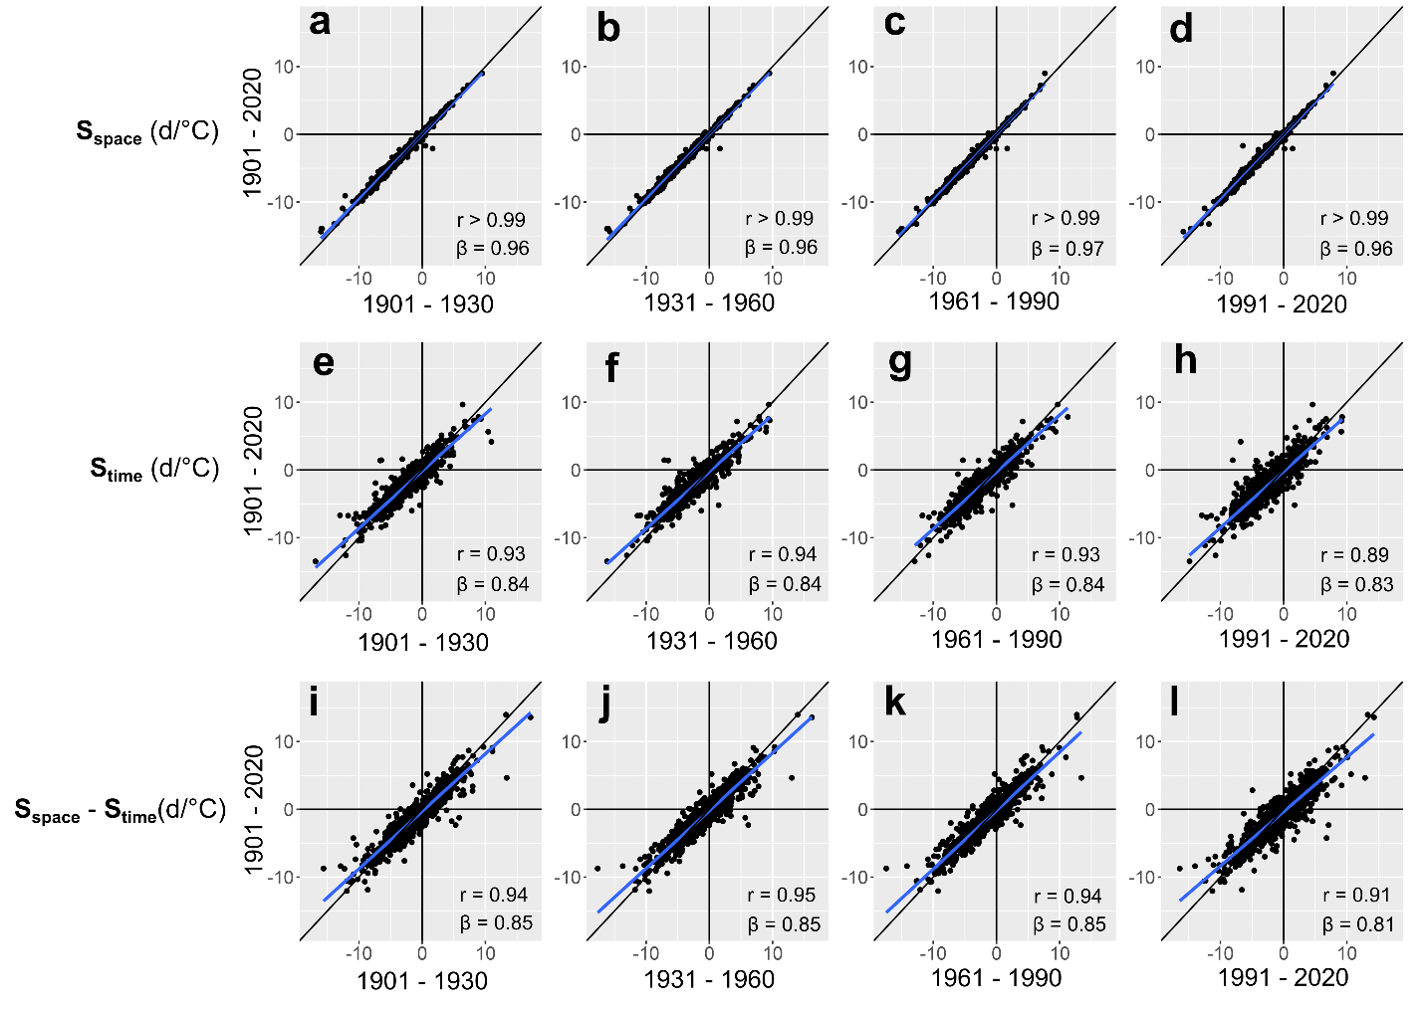
Figure S16—Relationship between estimates of S_{space}, S_{time}, and S_{space} - S_{time} obtained using TMEAN conditions calculated over different reference periods.

Together, these results demonstrate that the choice of period over which to calculate TMEAN_{Normal} does not substantially affect resulting patterns of geographic and interannual variation in temperature. Estimates of S_{space}, S_{time}, and S_{space} - S_{time} calculated using 1901-2020 normals and anomalies were largely equivalent to those obtained using alternative reference periods. While 1901-2020 estimates of apparent plasticity and adaptation (S_{time}, and S_{space} - S_{time}) tended to have slightly lower magnitude than those for other reference periods, the magnitude of these differences was nearly identical for estimates of apparent plasticity and of apparent adaptation (i.e., slopes in Fig. S16e-l). In other words, estimates of S_{time} and S_{space} – S_{time} of similar sign and magnitude would change by nearly the same amount when calculating TMEAN_{Normal} over a different period. Therefore, choice of TMEAN_{Normal} should not influence the likelihood that species are classified as showing sensitivity patterns consistent with apparent plasticity or apparent adaptation.

Note S6—Motivation for using a statistical design different from that in Phillimore et al. (2010)

Phillimore et al. (2010) generated spatial and temporal slopes by modeling the effects on frog spawning phenology of long-term, mean temperature among spatial grid cells (assumed to represent populations) and of the anomalies in the year of phenological observations from mean temperature conditions in each population. They used a generalized linear mixed-effects modelling approach (GLMM), treating phenology and temperature as a bivariate response and population and year as random effects, and estimated spatial and temporal slopes from population- and year-specific terms in the variance-covariance matrix of the model. Although statistically robust and largely derived from quantitative genetics theory, their method requires intensive sampling across space and time so that sufficient sampling within spatial units (at spatial scales fine enough that could be plausibly interpreted as populations) would be achieved across multiple years. Indeed, Phillimore et al. (2010) piloted this approach using a single-species dataset of 55,602 frog spawning dates from across Great Britain, a sample size unattainable for even the best sampled species in our extensive dataset.
Delgado et al. (2020) successfully applied this approach to a dataset consisting of occurrence dates for various phenological events across multiple taxa (including plants, saprotrophs, and primary and secondary consumers) using smaller sample sizes per species than those in Phillimore et al. (2010). However, phenological observations in Delgado et al.’s dataset were made regularly at individual sites over time, enabling extensive sampling within each location and relatively precise estimation of occurrence dates. In contrast, although they are abundant and spatiotemporally extensive, herbarium specimens of a given species rarely are collected repeatedly at the same location over many years. Because of this, even among the well-sampled species in the data set analyzed here, we found few areas with repeated observations across years and at spatial scales small enough to plausibly represent single populations. Additionally, specimens could have been collected at any time between the onset and termination of a phenophase (Panchen et al. 2019), which introduces noise to the phenological signal and increases the sample size required to estimate phenology-climate relationships (Ramirez-Parada et al. 2022).
Thus, we estimated spatial and temporal TMEAN sensitivities using different statistical methods from those in Phillimore et al. (2010) and Delgado et al. (2020), partitioning observed TMEAN conditions in sites and years of collection into climate normals and anomalies, and measuring sensitivities in a varying-slopes and varying intercepts Bayesian GLMM framework instead (see Methods: Analyses in the main text).

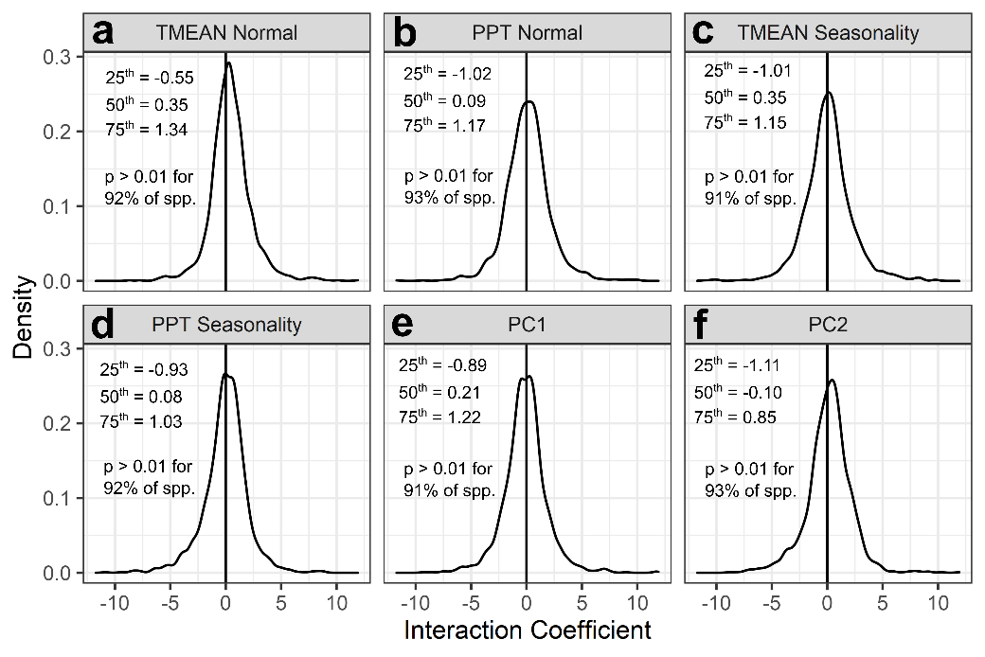
Figure S17—Variation in S_{time} across geographic climatic gradients for 1,605 across the coterminous United States. (a) Distribution of interaction terms between TMEAN_{Anomaly} and long-term climatic conditions within sites of specimen collection, including (a) TMEAN_{Normal}, (b) PPT Normal, (c) TMEAN Seasonality, (d) PPT Seasonality, (e) the gradient of increasing temperature and precipitation seasonality described by PC1, and (f) the gradient of decreasing precipitation and increasing temperature seasonality described by PC2. The values for the 25th, 50th and 75th percentiles of each distribution is indicated in each panel as a text inset, as well as the proportion of species for which the interaction coefficient had a p value greater than 0.01.
Phenological sensitivity to temperature can vary intraspecifically among portions of the range with different long-term climatic conditions. Therefore, differences between S_{space} and S_{time} presented in the main text may result from variation in the DOY–TMEAN_{Anomaly} slope across the geographic climatic gradients and not from the effects of adaptation across the gradient. Alterantively, it is possible that the interaction coefficients for all variables were obtained from single-species models including flowering DOY as a response, the focal long-term climatic variable and TMEAN_{Anomaly} as a predictor, and an interaction term between them. Long-term climatic variables were standardized (mean = 0, SD = 1) before fitting the models. Accordingly, the interaction terms quantify the change in the slope of TMEAN_{Anomaly} vs. DOY (S_{time}, in days/°C) for an increase of 1 SD in the long-term climatic variable.

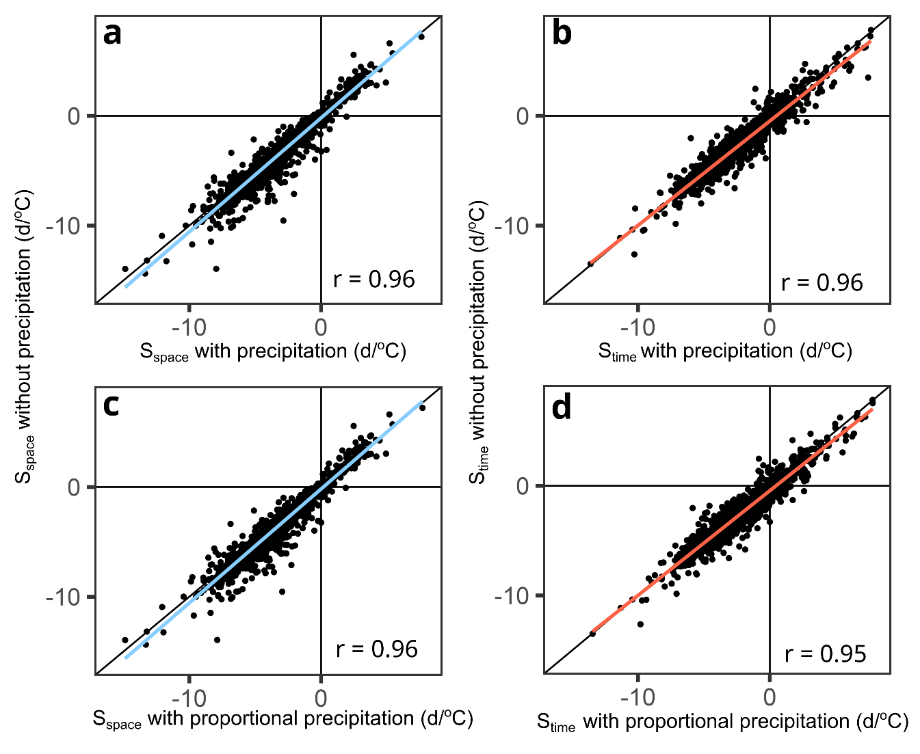
Figure S18—Relationship between estimates of flowering sensitivity to TMEAN_{Normal} (S_{space}) (a, c) and TMEAN_{Anomaly} (S_{time}) (b, d) with or without accounting for the effects of cumulative precipitation normal and anomaly (x-axis and y-axis, respectively) during the same 3-month periods used to calculate TMEAN_{Normal} and TMEAN_{Anomaly} for each species (see Methods in main text). Panels (a) and (b) show the relationships between estimates from temperature-only models with those obtained from models including PPT normal and net PPT anomaly for the focal 3-month period in the year of collection. In turn, panels (c) and (d) show the same relationship but with estimates from a model including PPT normal and PPT anomaly proportional to the long-term average for that period (i.e., divided by the PPT normal). Proportional anomalies were included to account for differences in the biological significance that the same amount of precipitation might have in chronically dry compared to chronically wet locations.
The method developed by Phillimore et al. (2010) assumed that the variables causing phenological variation along spatial temperature gradients were correctly identified and included in the model. Although temperature has been found to be a predominant environmental cue inducing flowering in temperate biomes, other variables such as precipitation, or those that emerge from the interaction between temperature and precipitation, such as snow cover or water stress, routinely have been implicated in phenological variation in many North American species. Therefore, it is possible that differences in spatial vs. temporal patterns of temperature-related phenological variation might stem from the confounding effects of phenologically important variables not included in our models. Estimates of phenologically important variables such as the timing of snowmelt or the onset of drought conditions in xeric environments are not available at the temporal and spatial scales spanned by our data. However, most of these variables are highly correlated with precipitation and temperature over space and time, and including both of these variables in phenoclimatic models might account for the effects of predictors other than temperature and precipitation. Accordingly, we assessed whether estimated S_{space} and S_{time} changed when accounting for the effects of long-term cumulative precipitation (PPT normal) and PPT anomalies in the year of collection, separately assessing the effects of both net PPT anomalies and of anomalies scaled proportionally to long-term means (PPT normal) for the focal 3-month period. Estimates of phenology-temperature relationships in space and time did not change substantially when including precipitation variables, resulting in a very high correlation between estimates from temperature-only models and those from models including precipitation (r = 0.95 or 0.96). Therefore, the estimates presented in the main text are unlikely to be biased by the omission of precipitation during the months leading up to flowering.

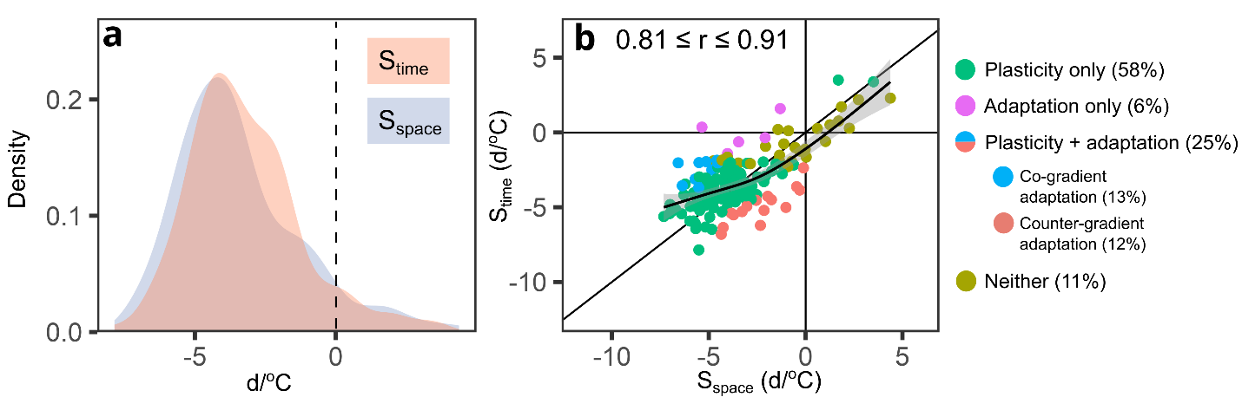
Figure S19—Distribution of flowering time sensitivity to TMEAN_{Normal} (S_{space}) and to TMEAN_{Anomaly} (S_{time}) (a) and their relationship (b) among 157 species with 200 or more specimens collected within a latitudinal band of 1° (~111km) in the continental United States (analogous to Figure 3 of the main text). The solid black line in (b) indicates a 1:1 relationship corresponding to perfect agreement between the two types of sensitivity. The solid curved line indicates the line of best fit obtained from a Generalized Additive Model (GAM) of S_{time} vs. S_{space}, with the shaded area around it denoting the standard error of the predicted mean value. Each point in (b) represents a species whose x, y coordinates are given by the maximum a posteriori (MAP) estimates for S_{space} and S_{time}, respectively. Point shapes and colors in (b) indicate whether sensitivity patterns were consistent with plasticity or adaptation as the sole drivers of flowering time variation along the temperature gradient, with both plasticity and adaptation having significant effects in a co- or counter-gradient adaptation pattern, or not showing statistically significant adaptation nor plasticity. The percent of species showing each pattern is shown in the legend in parenthesis. The 95% credible interval for the correlation between S_{space} and S_{time} is provided as a text inset in (b).
Both temperature and photoperiod are known to be the predominant environmental cues controlling both vegetative and reproductive phenology among plants in temperature regions. Therefore, across latitudinal ranges such as those spanned by most species in our data (median 90% latitudinal range = 5.7°), it is possible that differences in S_{time} and S_{space} (e.g., geographic temperature gradients) might reflect the confounding influence of latitudinal shifts in photoperiod on our estimates of sensitivity to TMEAN_{Normal}. To account for this possibility, we identified 157 species in our data that were well sampled (200 or more specimens) within narrow latitudinal bands (≤ 1°). Using this subset of species and including only specimens from such 1° bands, we ran the same varying intercepts, varying slopes model, obtaining estimates of S_{time} and S_{space} and their difference for each species, and an estimate of their correlation accounting for parameter uncertainty. The results did not qualitatively differ from those presented in the main text, with a high correlation between S_{space} and S_{time,} and similar relative frequencies of each sensitivity pattern among species..

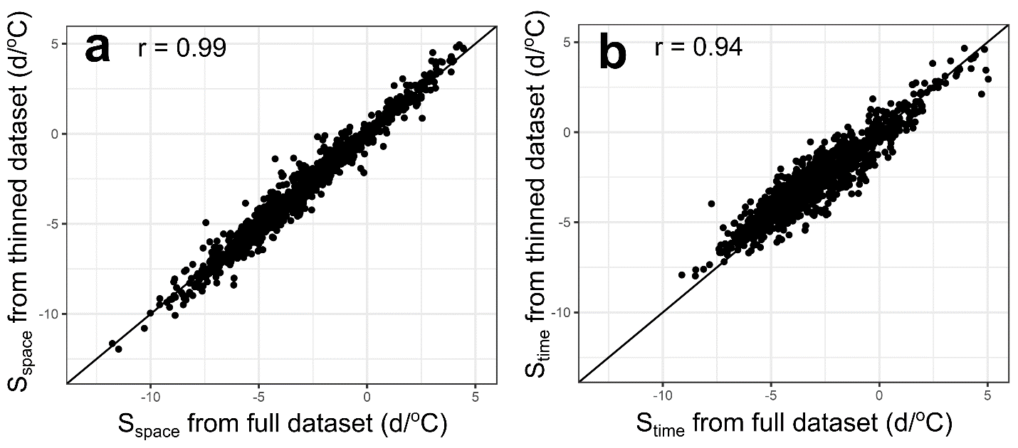
Figure S20—Estimates of flowering time sensitivity to TMEAN_{Normal} (S_{space}) and to TMEAN_{Anomaly} (S_{time}) obtained from the full dataset versus those obtained from a thinned dataset were sample size was homogenized to include 300 specimens for all species. (a) shows the relationship estimates of S_{space}, whereas (b) corresponds to the relationship between estimates of S_{time}. Estimates for the full dataset (x axis in a and b) are those presented in the main text. Estimates from the thinned dataset (y axis in a and b) were obtained using the same varying intercepts, varying slopes model presented in the main text. The solid black line in each panel represents a 1-to-1 line. Estimates from the thinned dataset closely agreed in direction and magnitude with those from the full dataset.

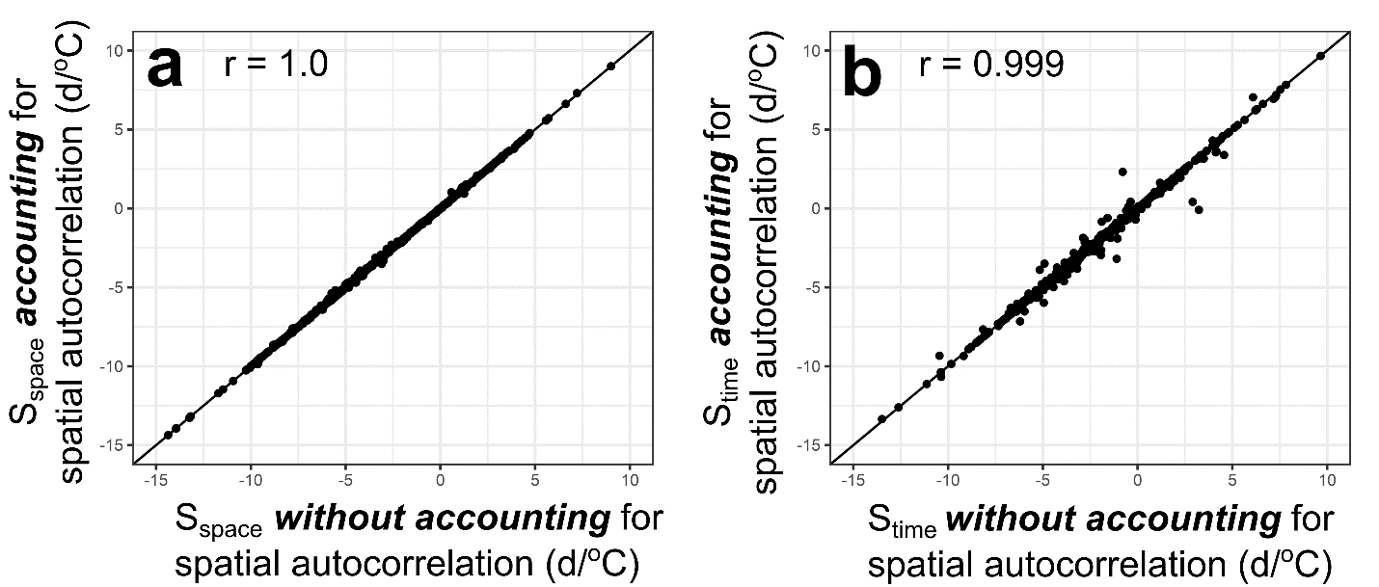
Figure S21—Comparison of estimates of flowering time sensitivity to TMEAN_{Normal} (S_{space}) and to TMEAN_{Anomaly} (S_{time}) obtained ignoring (x axes) or accounting for (y axes) spatial autocorrelation of the residuals. Panel (a) shows the relationship between S_{space} estimates accounting for and ignoring spatial autocorrelation, while panel (b) shows the same for S_{time} estimates. All S_{space} and S_{time} estimates were obtained using single-species models, but those accounting for spatial autocorrelation included a covariance structure for the residuals determined by the geographic distance between each pair of points. All models were fitted using the ’nlme’ package version 3.1 in R (Pinheiro et al. 2017). Estimates of S_{space} and S_{time} obtained accounting for or ignoring spatial autocorrelation were nearly indentical across species.

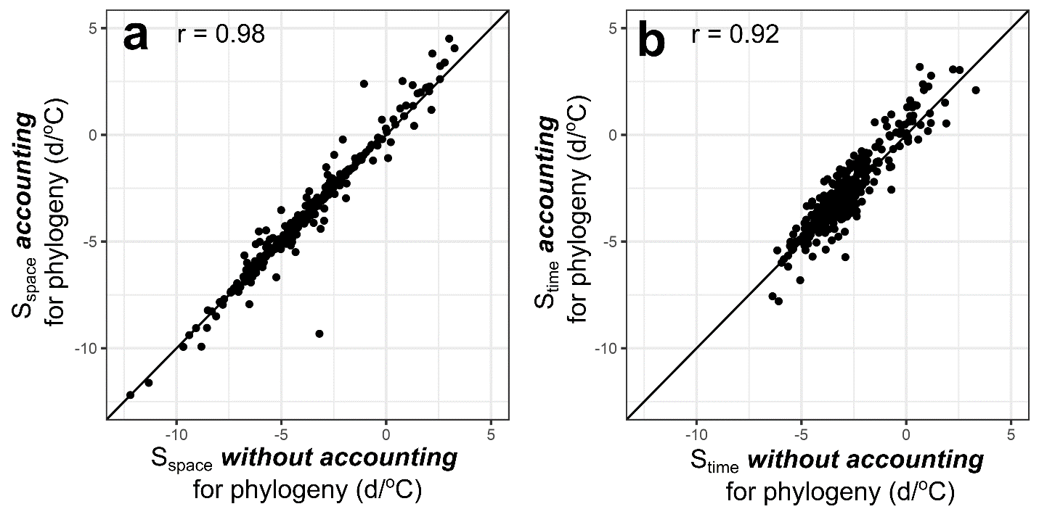
Figure S22—Comparison of estimates of flowering time sensitivity to TMEAN_{Normal} (S_{space}) and to TMEAN_{Anomaly} (S_{time}) obtained ignoring or accounting for shared evolutionary history (i.e., phylogeny) among 300 species randomly selected from among 1,605 species included in the analyses in the main text. The solid black lines corresponds to a 1-to-1 line, indicating perfect agreement between estimates in the x and y axes.
Prior to estimating S_{space} and S_{time}, we selected a random subset of 300 species from which to generte a phylogeny. Then, to control for potential differences in parameter estimates coming from differnces in sample size among species, we thinned this subset data to include only a random sample of 300 specimens for each species. S_{space} and S_{time} estimates that did not account for phylogeny were obtained using the same varying intercepts, varying slopes model described in the main text. In turn, the model accounting for phylogeny included a prior for the covariance structure of species-specific parameters consisting of the evolutionary distance between each pair of species as estimated from a phylogenetic hypothesis and a model of trait divergence amogn species. The phylogenetic tree (or hypothesis) was generated using the R package “v.PhyloMaker” version 0.1.0 (Jin and Qian 2019), and generated a phylogeny resovled to the genus level. Using this tree, we then calculated the variance-covariance phylogenetic matrix predicted by a Brownian model of trait evolution using the R package ‘ape’ version 5.6-2 (Paradis et al. 2004). Finally, both models were implemented using the ‘brms’ package version 2.18.0 (Bürkner et al. 2017).
Phylogenetically corrected and naïve estimates were highly correlated for both S_{space} and S_{time} (r ≥ 0.92).

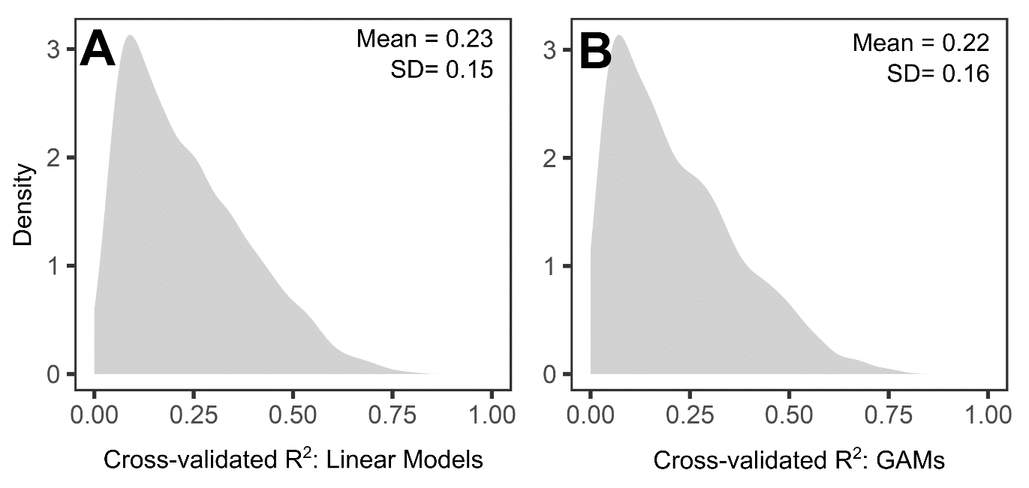

Figure S23—Comparison of R² values obtained using 10-fold cross-validation of models of flowering DOY versus TMEAN_{Normal} and TMEAN_{Anomaly} obtained from (A) linear regressions assuming linear relationships between phenology and temperature or (B) generalized additive models (GAMs) accounting for potential non-linear relationships. The shaded region in each panel represents the among-species kernel distribution of cross-validated R² values obtained using each model type (linear regression or GAM). The mean and SD of R² values each is presented as a text inset in each panel.
The model that generated the sensitivity estimates presented in the main text assumed linear relationships between flowering dates and TMEAN_{Normal} and TMEAN_{Anomaly}. To verify whether such an assumption was warranted for our data, we compared the predictive ability of single-species models assuming linear relationships between phenology and temperature (fitted using linear regression) and models accounting for possible non-linear relationships (fitted using Generalized Additive Models). We reasoned that if omitted non-linear relationships between flowering time and temperature were pervasive in our data and potentially biased our results, then models accounting for non-linear relationships would tend to perform better than linear regressions among species in our data. We used 10-fold cross-validation to compare the out-of-sample performance (quantified through R² values) of linear regressions and GAMs. For each model type (linear regression or GAM), this procedure randomly split the observations for each species into 10 groups, each of which was omitted from a model estimated from the remaining 9 groups. The performance of each of these models was then assessed against the observations omitted in fitting the model, generating 10 out-of-sample R² values for each model type (linear or GAM) per species. We then compared the distribution of mean cross-validated R² values obtained from linear models and GAMs to assess whether non-linear models explained additional variance.
GAMs did not perform better than linear models among species in our data; in fact, linear models exhibited marginally higher R² values among species than GAMs (0.23 vs. 0.22). Therefore, we conclude that the assumption of linearity is warranted in the analyses presented in the main text.

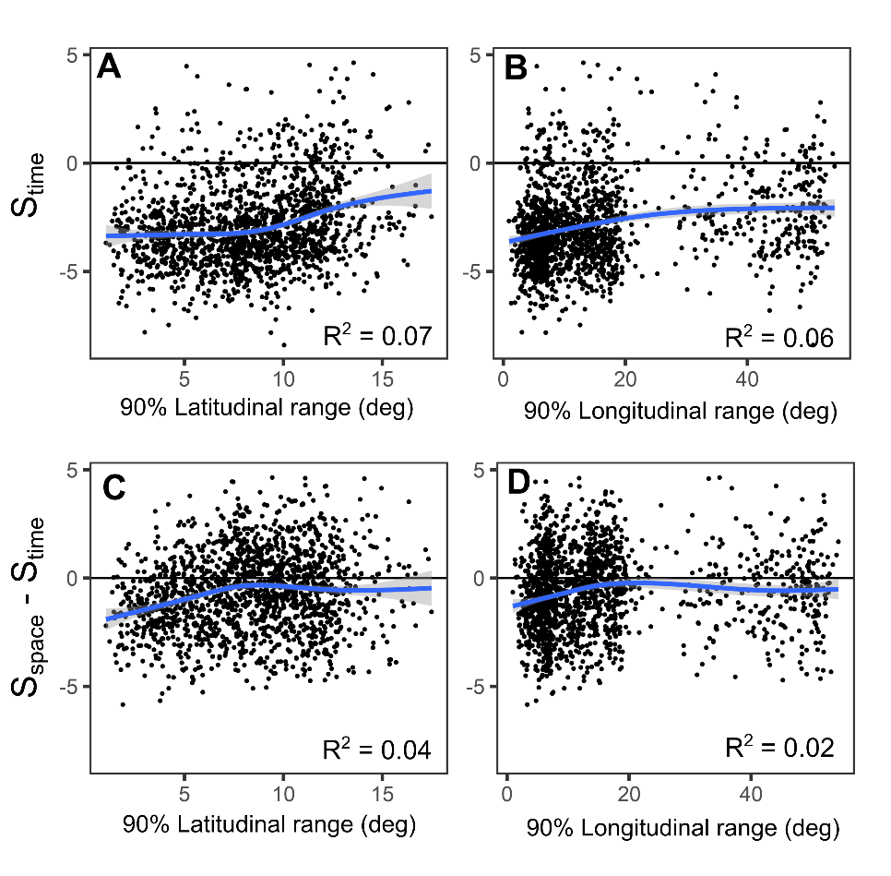
Figure S24—Relationships between the latitudinal and longitudinal range spanned by the central 90% of specimens of a species and estimates of apparent plasticity (S_{time}) and apparent adaptation (S_{space} – S_{time}). Blue lines in each panel correspond to best-fit lines obtained using generalized additive models (GAMs). R² are provided as text insets in each panel.
Although apparent plasticity and adaptation showed marginally greater magnitude among species with narrower latitudinal and longitudinal range, these relationships explained a very small proportion of the variance. Therefore, we conclude that it is unlikely that differences in latitudinal or longitudinal range size could confound the results presented in the main text. GAMs using apparent plasticity or apparent adaptation as a response and including both latitudinal and longitudinal range as predictors also explained a marginal proportion of the variance (R² = 0.08 and R² = 0.05, respectively).

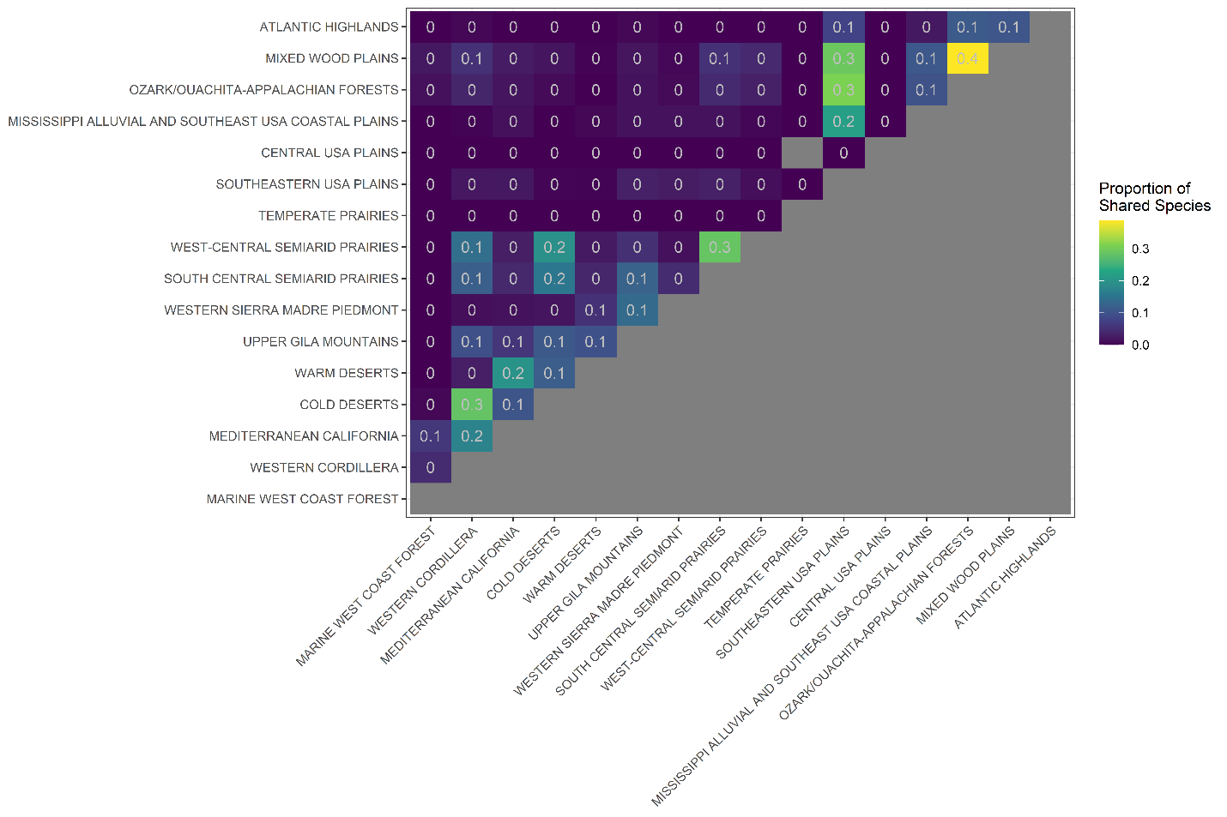
Figure S25—Proportion of species (n = 1,605) shared between pairs of Level II Ecoregions within the contiguous United States. The proportion of species overlap for each pair was calculated as the number of species occurring in both ecoregions (i.e., those for which at least 10% of the specimen were collected within that ecoregion) divided by the total number of unique species present in the two ecoregions combined.

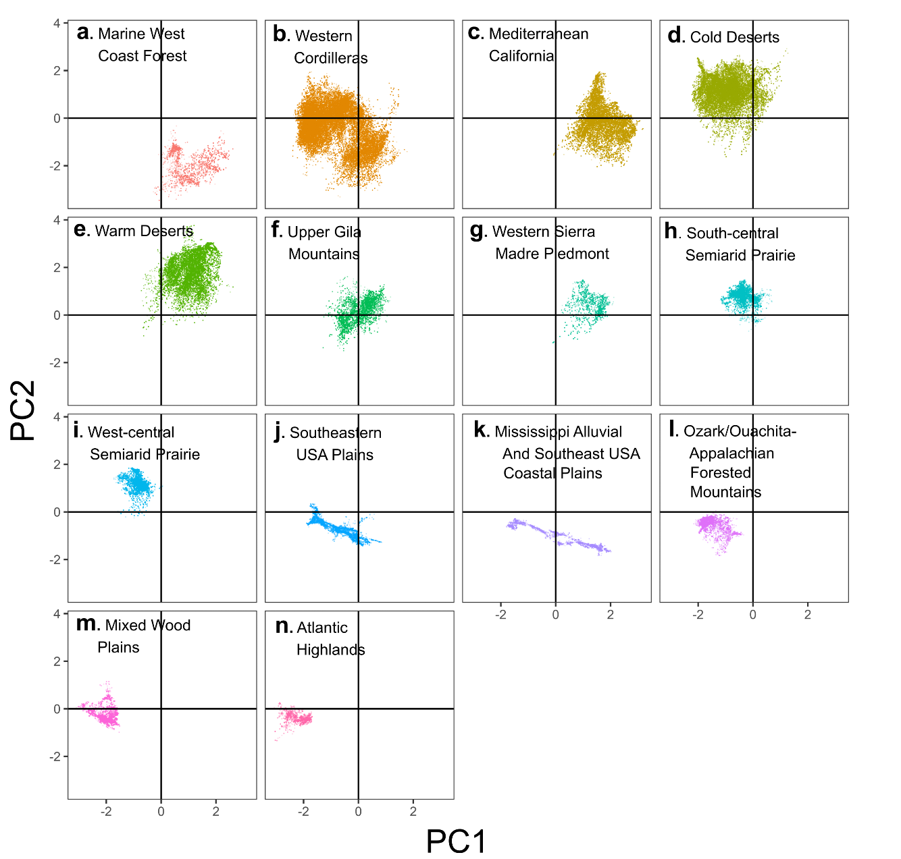
Figure S26—Variation in long-term climatic conditions among sites of specimen collection occurring within different Level II ecoregions throughout the contiguous United States. Variation in long-term conditions was calculated using principal components (PCs). PC1 represents a gradient of increasing precipitation seasonality (PPT seas. in the legend), decreasing MAT seasonality (T° seas.), and increasing mean annual temperature (MAT) normal (Mean T°). In turn, PC2 represents a gradient of decreasing mean annual precipitation (Mean PPT), and increasing MAT seasonality.

