Supplementary File
Title: Comparative analysis of Phenolic and antioxidant profiling of white variety guava fruit (cv Arka Mridula) across the ripening stages, a statistical multi-facet study
Yatheesharadhya Bylappaª, Anish Nagª*
ªDepartment of Life Sciences, Bangalore Central Campus, Hosur road, Bangalore-560029, India
*Corresponding author
Email: anish.nag@christuniversity.in
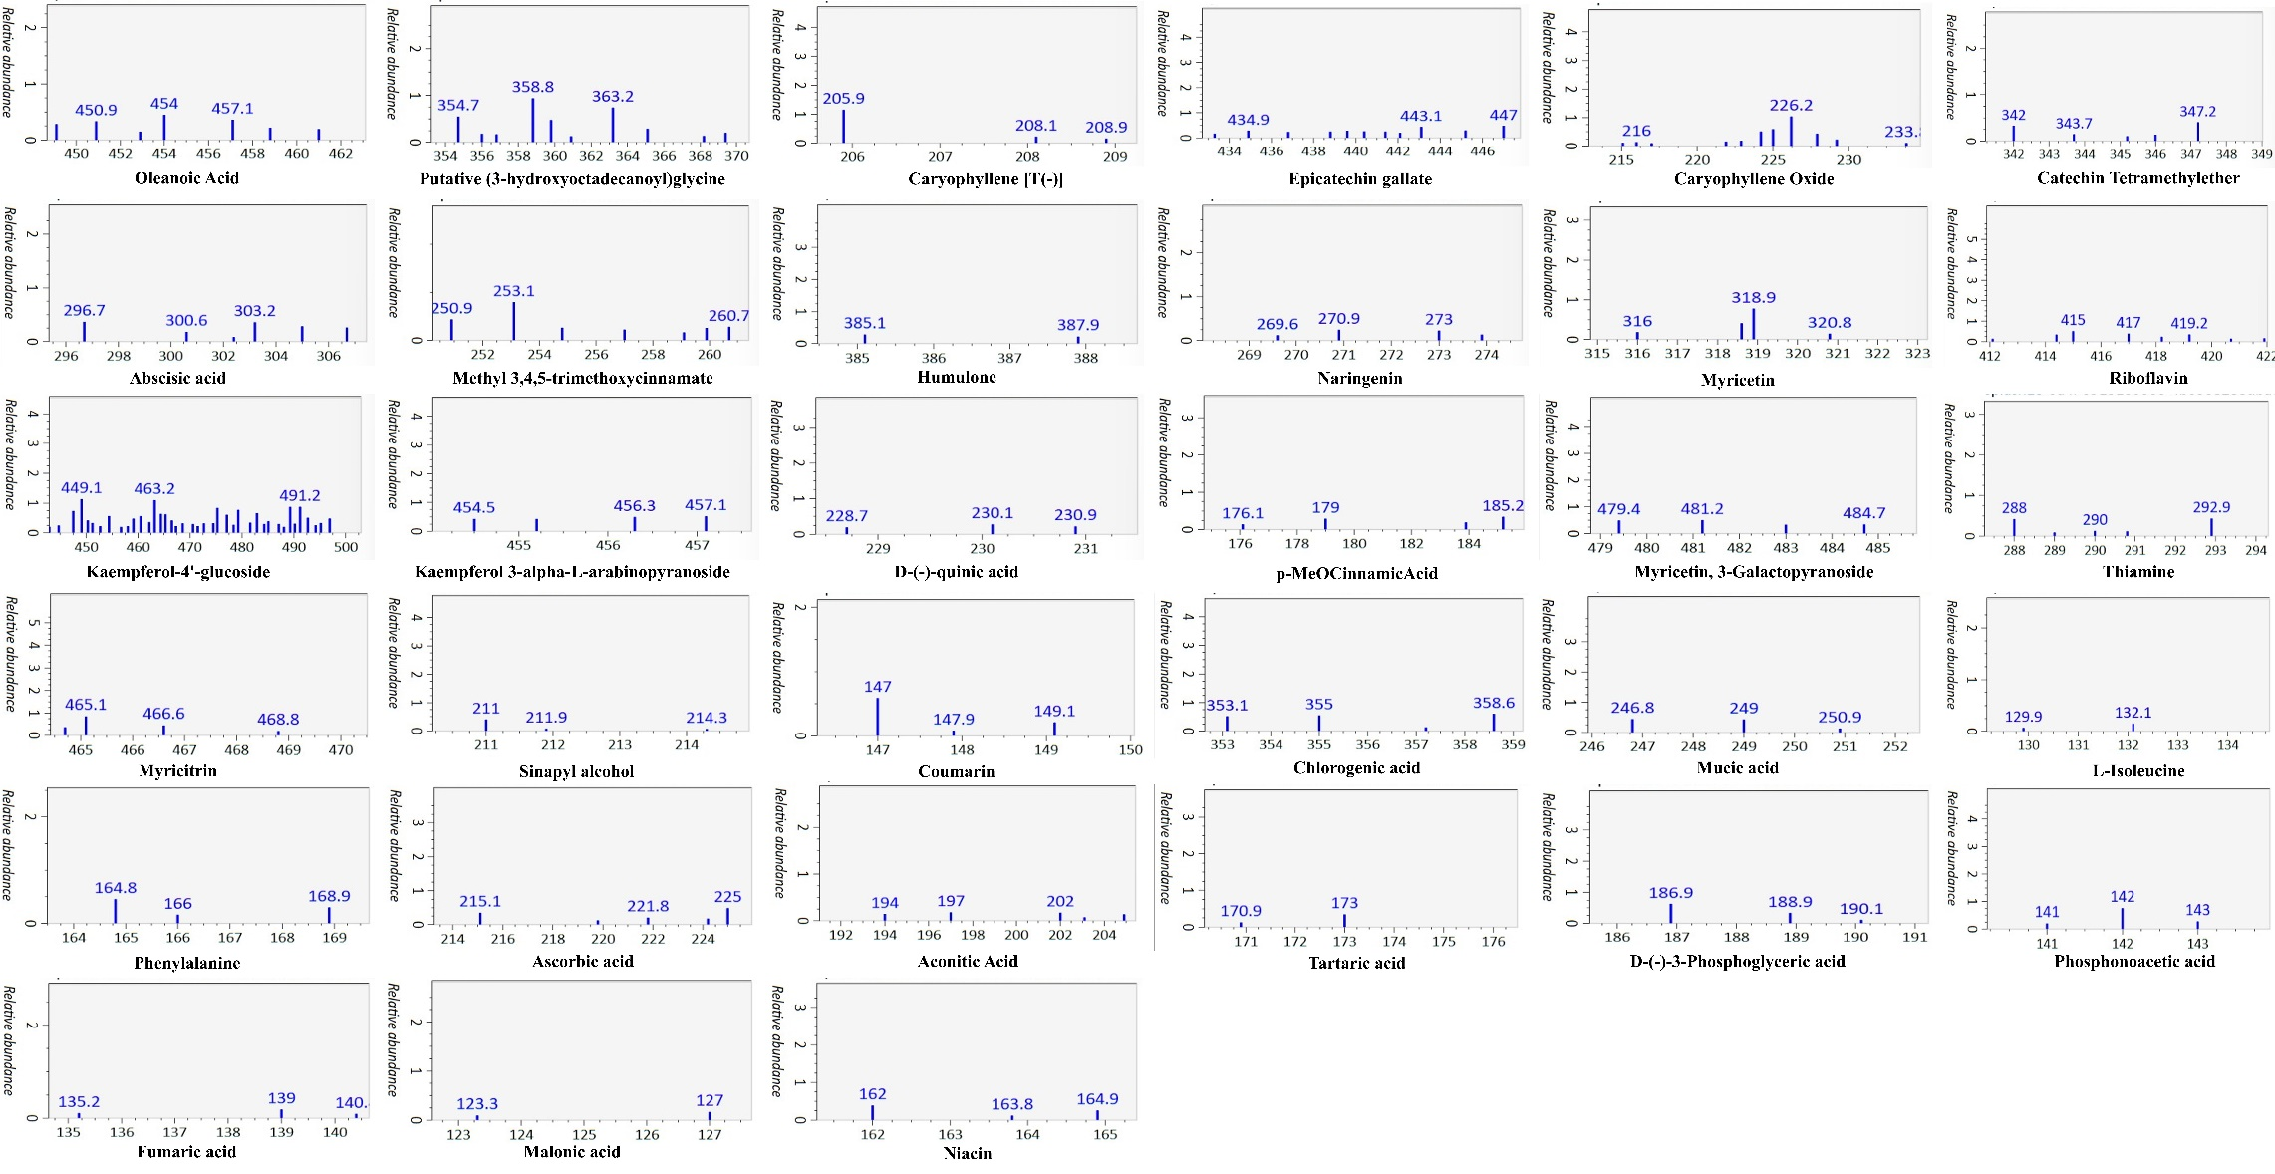
Figure S1: Mass Spectral profiles of compounds as identified by LC-MS

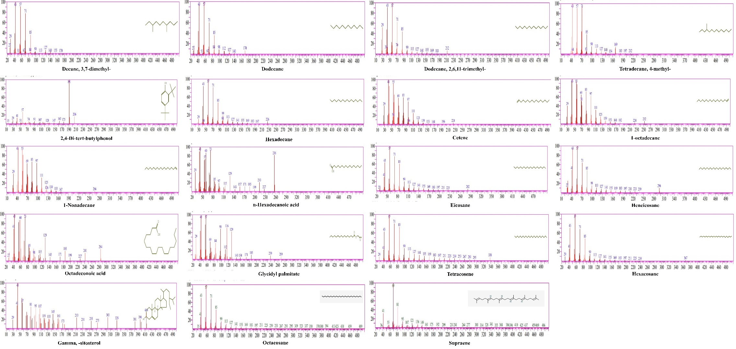
Figure S2: Mass Spectral profiles of compounds as identified by GC-MS

