Comparative Analysis of Phenolic and Antioxidant Profiling of White Variety Guava Fruit (Cv Arka Mridula) Across the Ripening Stages, a Statistical Multi-Facet Study
Yatheesharadhya Bylappaª, Anish Nagª*
ªDepartment of Life Sciences, Bangalore Central Campus, Hosur road, Bangalore-560029, India
*Corresponding author
Email: anish.nag@christuniversity.in
Materials and Methods
Plant materials, reagents and chemicals
The white cultivar of guava fruit, Arka mridula (P. guajava L.) was obtained from ICAR–IIHR (Indian Council of Agriculture Research-Indian Institute of Horticulture Research), Hessaraghatta, Bangalore, India in the month of March at the immature (pre-ripe) stage. Uniform sized (~180g) and healthy fruits were selected and immediately shifted to the laboratory for storage. Fruits with visible symptoms like defects, decay, diseases and pigmentation were discarded. 3 X5 fresh pre-ripe fruits (three replicates each containing 5 fruits) were immediately processed for the extraction (80% methanol, 2 days incaution) for further experimentations. Remaining fruits were stored at room temperature (28±2ºC) in two sets with the marking ripe and over-ripe for further maturation. Based on the peel color and fruit rigidity, 3 X5 fruits from each of the sets were processed after 4 (ripe) and 8 (over-ripe) consecutive days from the day of harvest respectively.
All chemicals used in this study was purchased from Himedia, SRL, Merck, Sigma etc. 2,2-Diphenyl-1-picrylhydrazyl (DPPH, extra pure 98%), and 2,2′-Azino-bis (3-ethylbenzothiazoline-6-sulfonic acid) diammonium salt (ABTS, extra pure 98%) were purchased from Sigma Aldrich Inc. USA, India). All solvents used for GC-MS and LC-MS were of HPLC and GC grades respectively and purchased from Thermo-Fisher Scientific (Qualigens, India).
Spectrophotometric analysis for secondary metabolite classes
The spectrophotometric analysis of the guava fruit peel was performed by using CI-710s SpectraVue leaf spectrometer (CID Bio-Science). The peel of the fresh fruit was carefully taken out and was analysed by using the instrument. The experiment was performed in triplicates as per the following formula:
Chlorophyll a (µg/cm²) = $(12.7*A663)-(2.59*A645)$
Chlorophyll b (µg/cm²) = $(22.9*A645)-(4.7*A663)$
Total chlorophyll Content (µg/cm²) = $8.2*A663+20.2*A645$
Plant Senescence Reflectance Index = $(R680-R500)/R750$ while A and R are the absorbance and reflectance at a particular wavelength.
Anatomical study of the guava pulp by Scanning Electron Microscopy (SEM)
The different stages of fruits (pre-ripe, ripe and over-ripe) were processed for Scanning Electron microscopy (SEM). Briefly, the pulp of the fruits was cut into 1 cm³ pieces and fixed in Karnovisky (pH 7.2) fluid for 24h. After that period, the samples were immersed in a cacodylate buffer and transferred to osmium tetroxide solution (1%) for 1 h. Afterwards, dehydration of the samples was done by alcohol gradient (30, 50, 70, 90 and 100%). Finally, the samples were sputter-covered with gold and observed under SEM (Hitachi-7000 and JEOL JSM-6490LV).
Total Phenolic Content (TPC)
The total phenolic content was evaluated using a modified spectrophotometric method previously described by [1] [1] and [2] [2]. Briefly, 0.5 mL of the extract was mixed with 5 mL of FC (Folin-Ciocalteu) reagent (1:9 ratio, diluted with distilled water) and neutralized with 4 ml Na₂CO₃ (1M, dissolved in distilled water). The reaction mixture was incubated at room temperature for 15 minutes in a dark condition. The absorbance of the reaction mixture was measured spectrophotometrically at 700 nm (Shimadzu, UV 1900), and a gallic acid standard curve (0-500 µg/mL) was prepared. The total phenol content was expressed as mg gallic acid equivalent per 100 g of dry weight (mg GAE/100 g DW) using the equation y = 0.0011x + 0.0065, R² = 0.9921. All experiments were carried out in triplicates.
Total Flavonoid Content
The aluminum chloride method was used to estimate the total flavonoid content as per Nag et al., (2013) [1] and Dos Santos et al., (2017) [3] with minor modifications. Briefly, 0.5 mL of the extract was added to 0.5 mL of 2% aluminum chloride solution. The reaction mixture was incubated at room temperature in the dark for 45 minutes. The absorbance was measured spectrophotometrically [Shimadzu, UV 1900] at 420 nm, and a quercetin standard curve (0-500 µg/mL) was prepared. The total flavonoid content was expressed as mg quercetin equivalent per 100 g of dry weight (mg QUE/100 g DW) using the equation y = 0.0017x - 0.0164, R² = 0.9974. All experiments were carried out in triplicates. The TFC assay was performed for the RSM-based experiments as well as for the validation experiments.
Antioxidant Assays
DPPH
The DPPH radical scavenging activity of the fruit sample was evaluated by using the modified method of Nag et al., (2021a) [4]. Briefly, 10 µL of the sample was added to 2 mL of 6×10⁻⁵ M DPPH solution in the methanol. The reaction mixture was vortexed and allowed to stand for 30 minutes in the dark at room temperature. The absorbance of the reacted solution was measured at 517 nm using a UV-VIS spectrophotometer (Shimadzu, UV-1900). The inhibition (I%) of the DPPH radicals by the antioxidant samples was calculated according to the formula:
$I\%=\frac{(ADPPH-ASample)}{ADPPH}X100$, ADPPH: absorbance of DPPH+solvent, ASample= absorbance of DPPH+antioxidant sample in the solvent and the ascorbic acid standard curve (0 to 500 µg/ml) was prepared. The DPPH antioxidant values of the samples were expressed as mg ascorbic acid equivalent per 100 g of dry weight (mg AAE/100 g DW) using the equation y = 0.07x + 7.8667; R² = 0.9924 [x= concentration of ascorbic acid (µg/ml); y= %inhibition]. All experiments were carried out in triplicates. The DPPH assay was performed for the RSM-based experiments as well as for the validation experiments.
ABTS
The ABTS antioxidant experiment was carried out using Nag et al., (2021a) [4] method with minor modifications for the RSM validated extraction condition (80% methanol, 3% solute to solvent, 2 days incubation at the hot temperature condition). Briefly, solutions of ABTS (7 mM) and potassium persulfate (2.45 mM) were mixed in a 1:1 ratio. The reaction mixture was incubated in the dark for 24 h at room temperature to obtain an ABTS⁺ cationic formation. The reaction mixture was diluted with the methanol to obtain an absorbance of 0.7 ± 0.02 at 734 nm spectrophotometrically (Shimadzu, UV-1900). 20 µL of the sample was added to the 200 µl of ABTS solution, and the absorbance was read at 734 nm. The inhibition (I%) of the ABTS radicals by the antioxidant samples was calculated according to the formula:
$I\%=\frac{(AABTS-ASample)}{AABTS}X100$, AABTS: absorbance of ABTS+solvent, ASample= absorbance of ABTS+antioxidant sample in the solvent and the ascorbic acid standard curve (0 – 40 µg/mL) was prepared. The ABTS antioxidant value of the samples was expressed as mg ascorbic acid equivalent per 100 g of dry weight (mg AAE/100g DW) using the equation y = y = 1.7402x - 0.8272; R² = 0.9958 [x= concentration of ascorbic acid (µg/ml); y= %inhibition]. All experiments were carried out in triplicates.
FRAP
The Ferric Reducing Antioxidant Potential (FRAP) assay was performed as per the method of Nag et al., (2021a) [4] with minor modifications for the RSM validated extraction condition. 100 µL of the sample was added to 3 mL of the FRAP reagent (10 mL of 300 mM Na acetate buffer, pH 3.6; 1 mL of 10 mM TPTZ in 40 mM HCl; and 1 mL of 20 mM FeCl₃). The absorbance of the reaction mixture was measured spectrophotometrically at 593 nm (Shimadzu, UV 1900), and an ascorbic acid standard curve (5–90 µg/mL) was prepared. The FRAP antioxidant value was expressed as mg ascorbic acid equivalent per 100 g of dry weight (mg AAE/100g DW) using the equation y = 0.0079x - 0.4039; R² = 0.9784 [x= concentration of ascorbic acid (µg/ml); y= absorbance @583 nm]. All experiments were carried out in triplicates.
Heat map generation
The TPC, TFC, and antioxidant assays (DPPH, FRAP and ABTS) were presented as the multi-colored heat map by the TBtools software. To discern the differences of values, all the values were converted into Log2.
Analytical characterization
LC-MS
The extraction was performed by using the validated condition. Fruit extracts from different stages (pre-ripe, ripe and over-ripe) were then injected (20 µL) into a Liquid Chromatography-Mass Spectrometry system (LC-MS, Shimadzu, LCMS8040, C18 column) to identify the secondary metabolites. LC chromatograms were recorded at 280 nm (1:1 ACN/H₂0, 1 ml min⁻¹ flow rate. Isocratic condition) and MS analysis was done in a positive mode triple QUAD system with a scan range from 100 to 1000 amu. The MS results were analysed by using CompMS MS Dial software, and compounds were identified by matching the mass spectra with the 'Riken All Public MS/MS database’ (positive mode) (http://prime.psc.riken.jp/compms/msdial/main.html). The result was expressed as %area.
GC-MS
Gas chromatography-Mass Spectrometry (GC-MS) analysis was performed to characterize volatile compounds at different ripening (pre-ripe, ripe and over-ripe) stages form the validated extracts, on the Shimadzu GC interfaced with a mass spectrometry using SH-RxiTM-5Sil (Shimadzu) column. The oven temperature was set from 60 to 280°C. A 27 min method was programmed as 3 min hold time at 60°C, 3 to 12 min ramping to 200°C, and 12 to 23 min ramping to 280°C, followed by 9 min hold at the same temperature. The injection port was set at 280°C. MS operating parameters include electron impact ionization at 70 eV with mass a range of 35-500 amu in a single QUAD system. 2 μL of samples of each stage was injected. Data was analysed by comparing with NIST mass spectral library 2017 (Version 1.0) and represented as %area.
The data were normalized to calculate the relative % area of GC-MS and LC-MS together, considering the sum% of all compounds as 100.
The relative % area of the formula was calculated as:
$$[\frac{\%area ofeach of the compounds}{\left\{\frac{ Σ \%area of compounds}{100}\right\}}]$$
Analytical data was converted to Log2 values and presented as a multi-colored heat map by TBtools software.
Principal Component Analysis (PCA) and Statistical Analysis
PCA is a multivariate statistical tool used to separate and group the data points based on their inherent variables as per our previous works [5, 6]. It helps to reduce the complexity of the multidimensional dataset and transforms them into orthogonal principal components (PCs), namely PC1, PC2 etc. While, in general, PC1 covers the maximum variability, subsequent PCs, which are unrelated to each other, explain the remaining variability [7]. Overall, a PCA plot provides a two-dimensional graphical presentation with four different clusters based on their loading onto the respective PCs (e.g. PC1 and PC2) [8, 9]. In this work, Minitab 18 statistical software was used for the PCA. The rotation of the data on the plot was performed by the Varimax tool. In two separate PCA graphs, phenolic-antioxidant parameters (TPC, TFC, FRAP, DPPH, and ABTS) and guava phyto-compounds as identified by GC-MS and LC-MS were clustered and presented, respectively.
One way ANOVA, by Minitab statistical software was used to statistically compare the data obtained from TPC, TFC, DPPH, FRAP and ABTS for all three maturation stages of guava.
References
1. Nag A, Bandyopadhyay M, Mukherjee A (2013) Antioxidant activities and cytotoxicity of Zingiber zerumbet (L.) Smith rhizome. J Pharmacogn Phytochem 2:102–108
2. Araújo HM, Rodrigues FF, Costa WD, et al (2015) Chemical profile and antioxidant capacity verification of Psidium guajava (Myrtaceae) fruits at different stages of maturation. Excli Journal 14:1020–1030. https://doi.org/10.17179%2Fexcli2015-522
3. Dos Santos WNL, da Silva Sauthier MC, dos Santos AMP, et al (2017) Simultaneous determination of 13 phenolic bioactive compounds in guava (Psidium guajava L.) by HPLC-PAD with evaluation using PCA and Neural Network Analysis (NNA). Microchemical Journal 133:583–592. https://doi.org/10.1016/j.microc.2017.04.029
4. Nag A, Banerjee R, Goswami P, et al (2021) Antioxidant and antigenotoxic properties of Alpinia galanga, Curcuma amada, and Curcuma caesia. Asian Pacific Journal of Tropical Biomedicine 11:363
5. Dey S, Kundu R, Gopal G, et al (2019) Enhancement of nitrogen assimilation and photosynthetic efficiency by novel iron pulsing technique in Oryza sativa L. var Pankaj. Plant Physiology and Biochemistry 144:207–221. https://doi.org/10.1016/j.plaphy.2019.09.037
6. Dey S, Paul S, Nag A, et al (2021) Iron-pulsing, a novel seed invigoration technique to enhance crop yield in rice: A journey from lab to field aiming towards sustainable agriculture. Science of The Total Environment 769:1–16. https://doi.org/10.1016/j.scitotenv.2020.144671
7. Kumari M, Singh R, Subbarao N (2021) Exploring the interaction mechanism between potential inhibitor and multi-target Mur enzymes of mycobacterium tuberculosis using molecular docking, molecular dynamics simulation, principal component analysis, free energy landscape, dynamic cross-correlation matrices, vector movements, and binding free energy calculation. Journal of Biomolecular Structure and Dynamics 40:1–30. https://doi.org/10.1080/07391102.2021.1989040
8. Jolliffe IT, Cadima J (2016) Principal component analysis: a review and recent developments. Philosophical transactions of the royal society A: Mathematical, Physical and Engineering Sciences 374:1–16. https://doi.org/10.1098/rsta.2015.0202
9. Lever J, Krzywinski M, Altman N (2017) Points of significance: Principal component analysis. Nature methods 14:641–643

SUPPLEMENTARY TABLES

Table S1 Spectrophotometric analysis of guava fruit peel at three different ripening stages (pre-ripe, ripe and over-ripe)
 | Pre-ripe  (x) | Ripe  (y) | % change  (ripe and Pre-ripe)  (y/x*100) | Over-ripe | %change  (Over-ripe and ripe)
Chlorophyll a (µg/cm²) | 5.29±0.41 | 1.90±0.28 | -35.92 | 0.05±0.01 | -2.63
Chlorophyll b (µg/cm²) | 5.66±0.88 | 1.38±0.10 | -24.38 | 0.04±0.01 | -2.89
Total chlorophyll Content (µg/cm²) | 11.02±1.24 | 3.29±0.39 | -29.85 | 0.07±0.01 | -2.13
Plant Senescence Reflectance Index | NA | 0.07±0.02 | NA | 0.36±0.02 | +80.56
'-' represents the reduction in value, and '+' represents an increase in the value, NA: Not Applicable-Negative value)
Table S2 Compounds identified in the PCA Cluster 1
S/N | Code as per PCA |  | Compounds | Compound Class | Identified by | RA (%)** in  Stages
 |  |  |  |  |  | Pre-Ripe | Ripe | Over-Ripe
1 |  | 1 | Oleanoic acid | Triterpenoid | LC/MS | 2.30 | 0.89 | 2.21
2 |  | 2 | 3 (hydroxyoctadecanoyl) Glycine | Amino acid | LC/MS | 1.21 | 0.40 | 4.61
3 |  | 3 | Caryophyllene [T(-)] | Sesquiterpene | LC/MS | 0.32 | 0.18 | 0.83
4 |  | 8 | Methyl 3,4,5-trimethoxycinnamate | Carboxylic acid ester | LC/MS | 1.12 | 0.34 | 1.67
5 |  | 10 | Naringenin | Flavanone | LC/MS | 1.15 | 0.66 | 1.53
6 |  | 11 | Myricetin | Hexahydroxyflavone | LC/MS | 2.58 | 0.96 | 3.25
7 |  | 12 | Riboflavin | Vitamin | LC/MS | 2.25 | 0.55 | 2.58
8 |  | 13 | Kaempferol-4'-glucoside | Flavonol glycoside | LC/MS | 3.17 | 1.07 | 3.70
9 |  | 17 | Myricetin, 3-Galactopyranoside | Hexahydroxyflavone glycoside | LC/MS | 1.80 | 1.01 | 3.30
10 |  | 22 | Chlorogenic acid | Polyphenol | LC/MS | 2.10 | 0.86 | 2.53
11 |  | 23 | Mucic Acid | Carboxylic acid | LC/MS | 1.03 | 0.49 | 1.77
12 |  | 28 | Tartaric acid | Carboxylic acid | LC/MS | 0.51 | 0.34 | 0.96
13 |  | 29 | D-(-)-3-Phosphoglyceric acid | Carboxylic acid | LC/MS | 1.64 | 0.73 | 2.88
14 |  | 48 | Octadeconoic acid | Fatty acid | GC-MS | 3.67 | 1.00 | 2.40
 |  |  | Group average |  |  | 1.78 | 0.68 | 3.11
Bold represents high content of the phytochemicals
Table S3 Compounds identified in the PCA Cluster 2
S/N | Code as per PCA | Compounds | Compound Class | Identified by | RA (%)** in  Stages
S/N |  | Compounds | Compound Class | Identified by | Pre-Ripe | Ripe | Over-Ripe
1 | 5 | Carylophyllene oxide | Terpenoid | LC-MS | 1.50 | 1.73 | 2.02
2 | 14 | Kaempferol 3-alpha-L-arabinopyranoside | Flavonol glycoside | LC-MS | 1.16 | 0.89 | 1.81
3 | 19 | Myricitrin | Flavonol | LC-MS | 4.50 | 3.36 | 4.46
4 | 33 | Niacin | Vitamin | LC-MS | 0.82 | 0.78 | 1.62
5 | 35 | Decane, 3,7-dimethyl- | Alkane hydrocarbon | GC-MS | 1.38 | 2.30 | 2.23
6 | 36 | Dodecane | Alkane hydrocarbon | GC-MS | 0.46 | 2.30 | 1.38
7 | 37 | Dodecane, 2,6,11-trimethyl- | Alkane hydrocarbon | GC-MS | 0.72 | 1.92 | 1.72
8 | 38 | Tetradecane, 4-methyl- | Alkane hydrocarbon | GC-MS | 1.53 | 0.51 | 2.39
9 | 39 | 2,4-Di-tert-butylphenol | Phenyl propane | GC-MS | 0.55 | 2.16 | 1.68
10 | 40 | Hexadecane | Alkane hydrocarbon | GC-MS | 1.27 | 2.38 | 2.01
11 | 43 | 1-octadecane | Alkane hydrocarbon | GC-MS | 0.42 | 1.71 | 1.15
12 | 44 | 1-Nonadecane | Alkane hydrocarbon | GC-MS | 0.37 | 1.71 | 1.15
13 | 45 | n-Hexadecanoic acid | Fatty acid | GC-MS | 9.44 | 3.71 | 6.86
14 | 51 | Hexacosane | Alkane hydrocarbon | GC-MS | 7.36 | 6.93 | 6.15
15 | 52 | Gamma, -Sitosterol | Phytosterols | GC-MS | 4.04 | 2.17 | 5.39
16 | 54 | Octacosane | Alkane hydrocarbon | GC-MS | 7.36 | 5.33 | 7.75
 |  | Group average |  |  | 2.86 | 2.80 | 3.11
Bold represents high content of the phytochemicals
Table S4 Compounds identified in the PCA Cluster 3
S/N |  | Compounds | Compound Class | Identified by | RA (%)** in  Stages
S/N | Code as per PCA | Compounds | Compound Class | Identified by | Pre-Ripe | Ripe | Over-Ripe
1 | 4 | (-)-Epicatechin gallate | Flavan-3-ol | LC-MS | 1.32 | 0.58 | 1.28
2 | 7 | Abscisic acid | Hormone | LC-MS | 0.87 | 0.44 | 1.10
3 | 9 | Humulone | Cyclic ketone | LC-MS | 1.07 | 0.31 | 0.92
4 | 15 | D-(-)-quinic acid | Cyclic polyol | LC-MS | 1.11 | 0.21 | 0.59
5 | 20 | Sinapyl alcohol | Alcohol | LC-MS | 1.03 | 0.44 | 1.16
6 | 21 | Coumarin | Polyphenol | LC-MS | 2.47 | 0.67 | 1.36
7 | 24 | L-Isoleucine | Amino acid | LC-MS | 0.15 | 0.07 | 0.26
8 | 25 | Phenylalanine | Amino acid | LC-MS | 0.20 | 0.09 | 0.40
9 | 26 | Ascorbic acid | Vitamin | LC-MS | 0.88 | 0.59 | 1.03
10 | 27 | Aconitic Acid | Carboxylic acid | LC-MS | 0.42 | 0.31 | 0.32
11 | 30 | Phosphonoacetic acid | Carboxylic acid | LC-MS | 0.37 | 0.19 | 0.47
12 | 31 | Fumaric acid | Carboxylic acid | LC-MS | 0.39 | 0.10 | 0.30
13 | 32 | Malonic acid | Carboxylic acid | LC-MS | 0.41 | 0.14 | 0.48
14 | 34 | Glutamine (L) | Amino acid | LC-MS | 0.67 | 0.33 | 0.93
15 | 41 | Tetradecane, 4-methyl | Alkane hydrocarbon | GC-MS | 1.53 | 0.51 | 0.45
16 | 47 | Heneicosane | Alkane hydrocarbon | GC-MS | 0.37 | 0.37 | 0.38
17 | 49 | Glycidyl Palmitate | Fatty acid | GC-MS | 2.59 | 0.87 | 1.16
18 | 50 | Tetracosene | Alkane hydrocarbon | GC-MS | 0.87 | 0.32 | 0.37
 |  | Group average |  |  | 0.93 | 0.36 | 0.72
Bold represents high content of the phytochemicals
Table S5 Compounds identified in the PCA Cluster 4
S/N |  | Compounds | Compound Class | Identified by | RA (%)** in  Stages
S/N | Code as per PCA | Compounds | Compound Class | Identified by | Pre-Ripe | Ripe | Over-Ripe
1 | 6 | Catechin | Flavan-3-ol | LC-MS | 10.73 | 26.52 | 1.43
2 | 16 | Cinnamic Acid | Carboxylic acid | LC-MS | 0.43 | 0.23 | 0.37
3 | 18 | Thiamine | Vitamin | LC-MS | 1.16 | 7.58 | 1.40
4 | 42 | 1-Hexadecene | Alkane hydrocarbon | GC-MS | 0.56 | 1.46 | 0.91
5 | 46 | Eicosane | Alkane hydrocarbon | GC-MS | 0.78 | 0.96 | 1.02
6 | 53 | Octadeconoic acid, 2,3-dihydroxypropyl ester | Carboxylic acid ester | GC-MS | 0.83 | 7.45 | 0.60
7 | 55 | Squalene | Alkane hydrocarbon | GC-MS | 1.38 | 0.95 | 1.08
 |  | Group Average |  |  | 2.27 | 6.54 | 0.97

Bold represents high content of the phytochemicals

SUPPLEMENTARY FIGURES

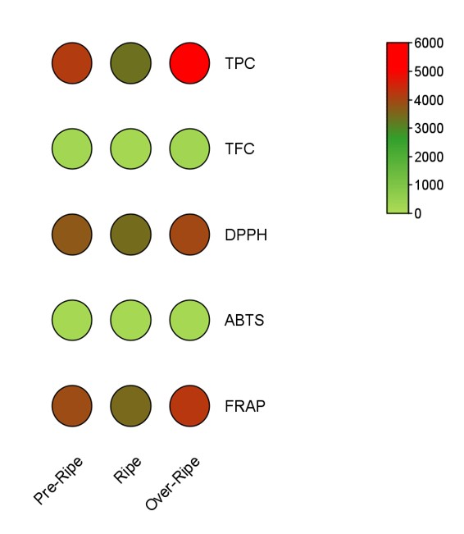
Fig. S1 Comparative heat map representation of different phytochemical (Total Phenolic Content [TPC] and Total Flavanoid Content [TFC] and antioxidant parameters (DPPH, ABTS and FRAP)

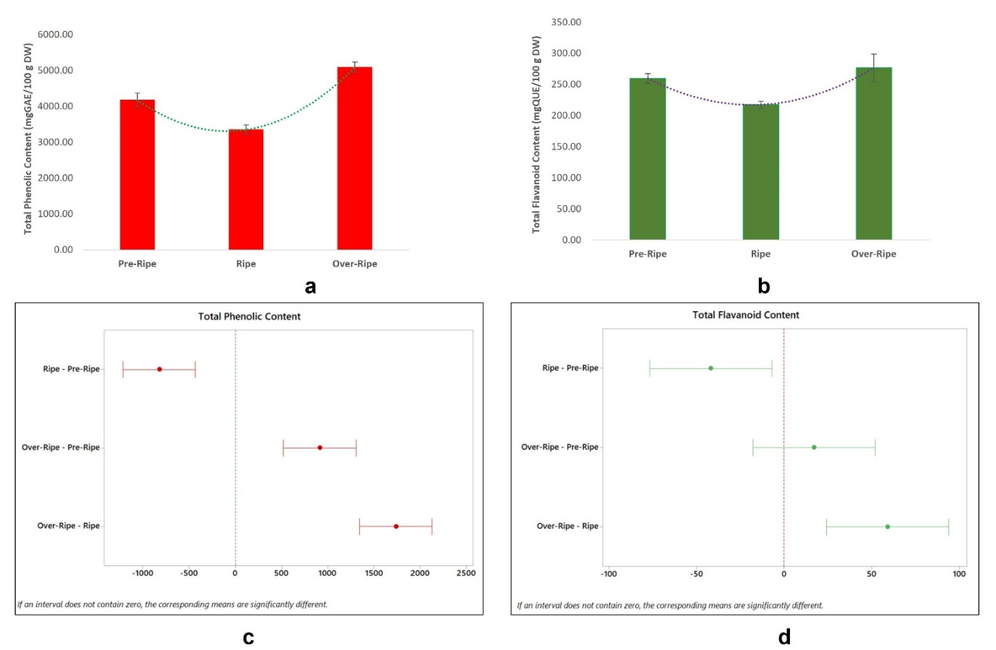
Fig. S2 (a-b) Graphical representation of Total phenolic content (mgGAE/100 g DW) and Total Flavanoid Content (mgQUE/100 g DW); (c-d) Graphical representation of statistical comparison (One way ANOVA, TUKEY) among different stages; the internal which does not contain 0 shows statistical significance (p≤0.05)
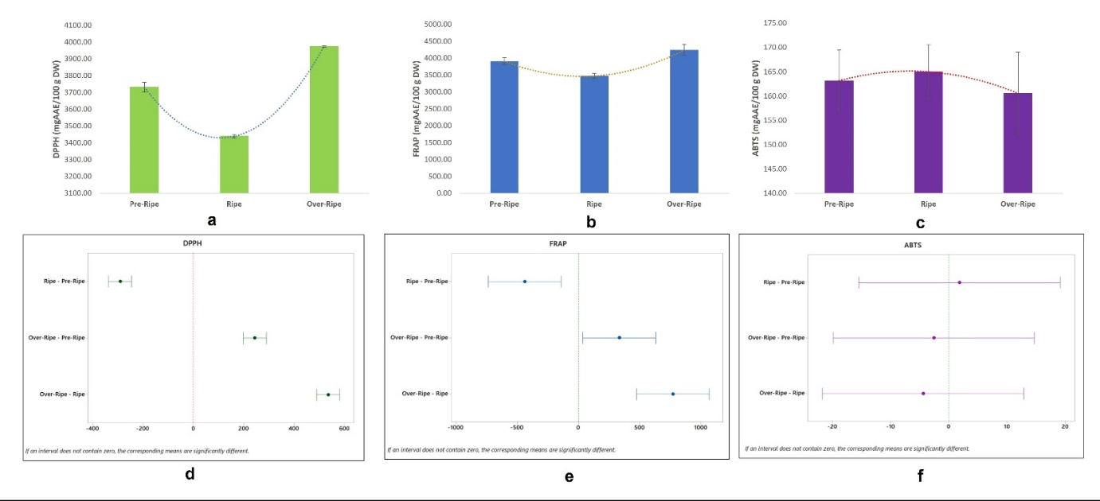
Fig. S3 (a-c) Graphical representation of DPPH (mgAAE/100 g DW) and FRAP (mgAAE/100 g DW) and ABTS (mgAAE/100 g DW); (c-d) Graphical representation of statistical comparison (One way ANOVA, TUKEY post-hoc analysis) among different stages; the internal which does not contain 0 shows statistical significance (p≤0.05)
The results of TFC and TPC often showed a high correlation with the antioxidant assays in the

