Supporting Information of
Taking SCFAs produced by Lactobacillus reuteri orally reshapes gut microbiota and elicits antitumor responses
Nannan Li^{1,2#}, Yao Liu^{2,3#}, LiLi Niu^{1,2}, Yang Wang^{1,2}, Xiaomin Su^{1,2}, Ce Xu^{1,2}, Zanya Sun^{1,2}, Huishu Guo¹*, Huiping Lu²*, and Shun Shen²* 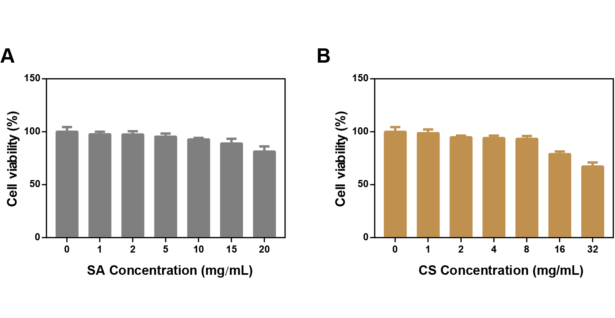
Figure S1. CCK-8 detected the effect of substances SA and CS on CT26 cells (n=5).

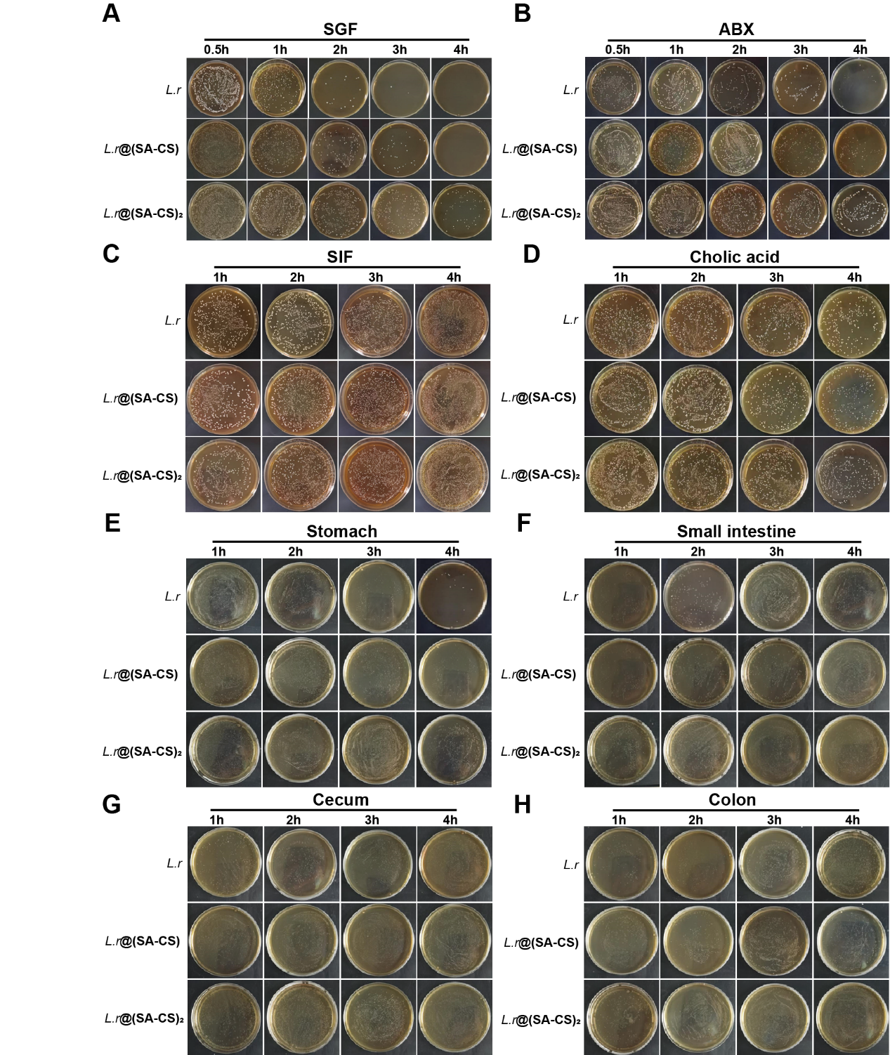
Figure S2. Representative photographs of solid MRS agar plates of L.r. (A to D) L.r, L.r@(SA-CS), and L.r@(SA-CS)₂ after treatment with (A) SGF, (B) ABX, (C) SIF, or (D) Cholic acid in vitro (n = 3). (E to H) L.r in the (E) stomach, (F) small intestine, (G) cecum, and (H) colon.at the indicated time points after gavage of 4.0 × 10⁸ CFUs of L.r, L.r@(SA-CS) and L.r@(SA-CS)₂ in vivo (n = 3).

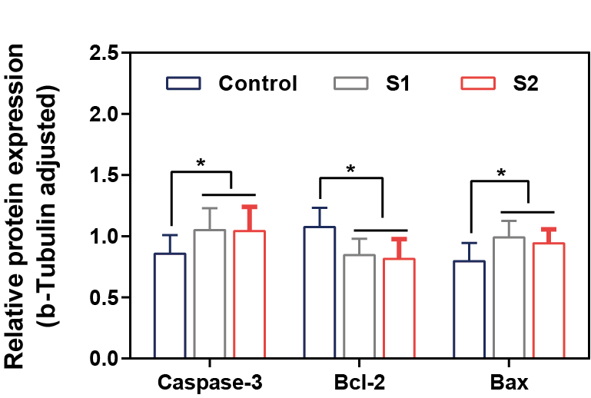
Figure S3. Semi-quantitative analysis of apoptosis-related proteins in Figure 3E. S1: Supernatant collected after L.r was shaken at 37°C for 12 hours, S2: Supernatant collected after L.r@(SA-CS)₂ was shaken at 37°C for 12 hours (n=3). *p < 0.05.

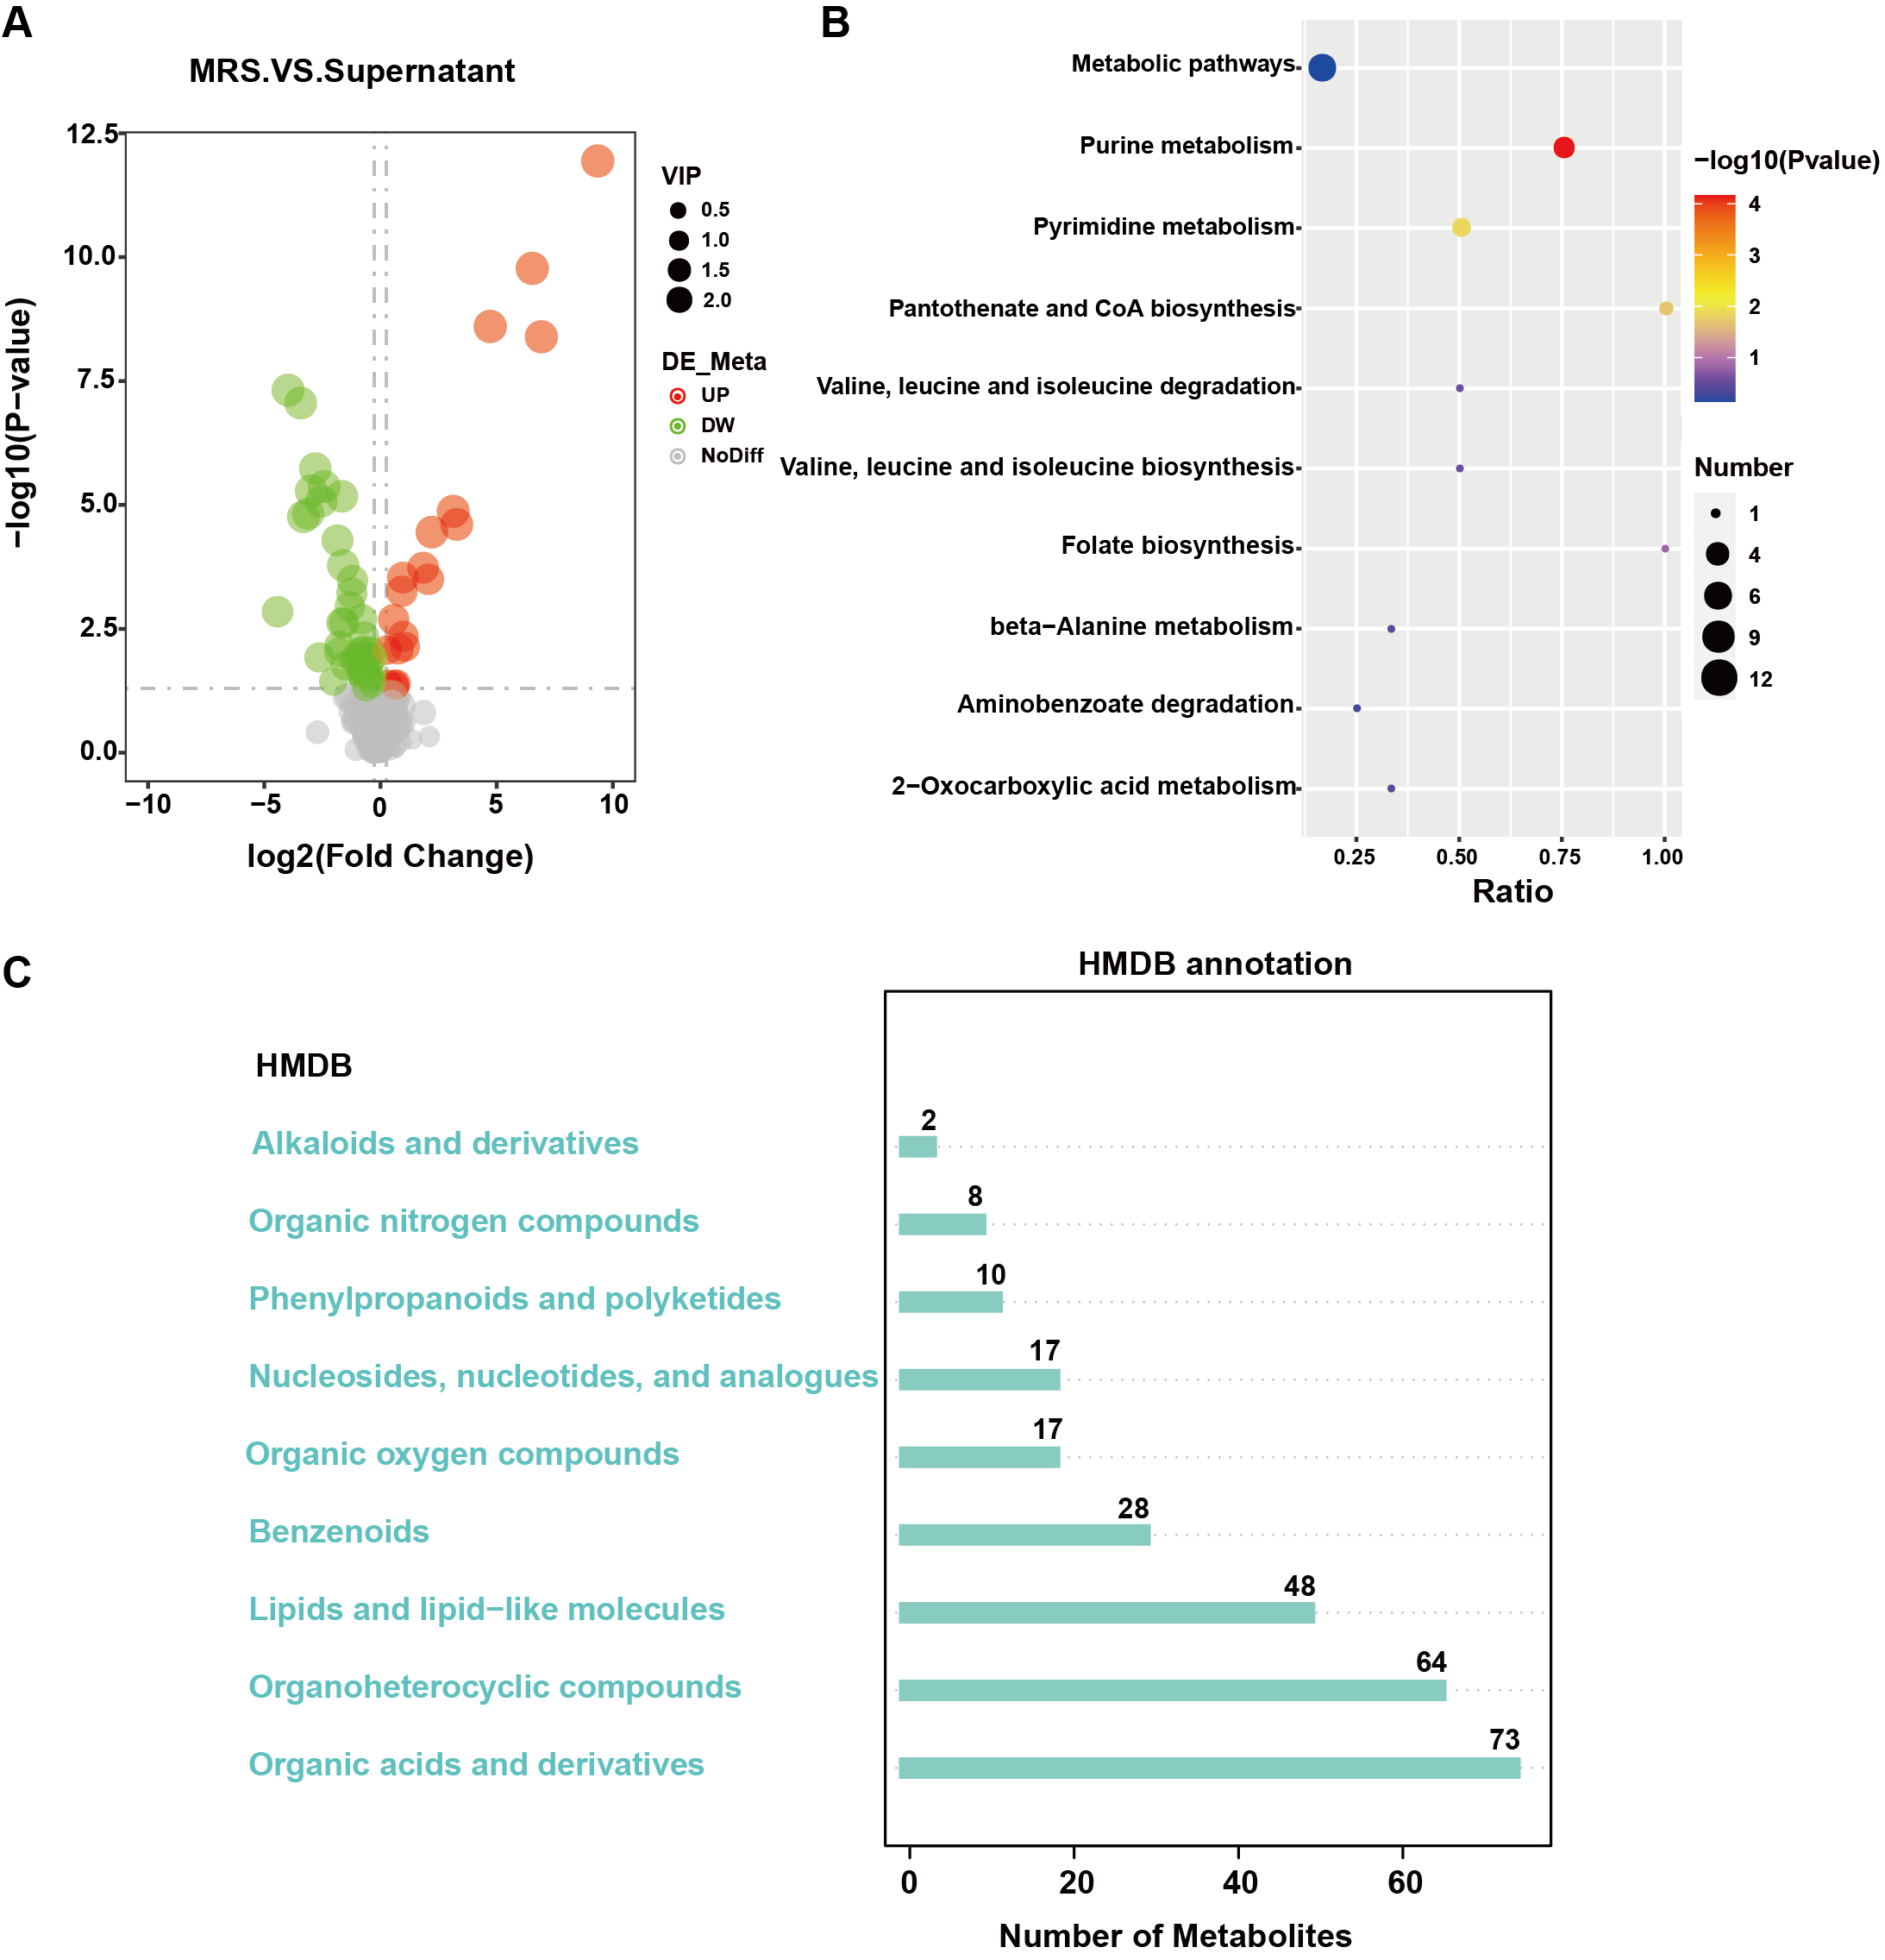
Figure S4. LC-MC analysis of MRS liquid medium and L.r supernatant. (A) Valcano plot of representing the distribution of differentially expressed metabolites between MRS and supernatant. (B) A bubble chart displaying the results of KEGG enrichment analysis. (C) MRS and Supernatant metabolites annotated classification map in HMDB (n=6).
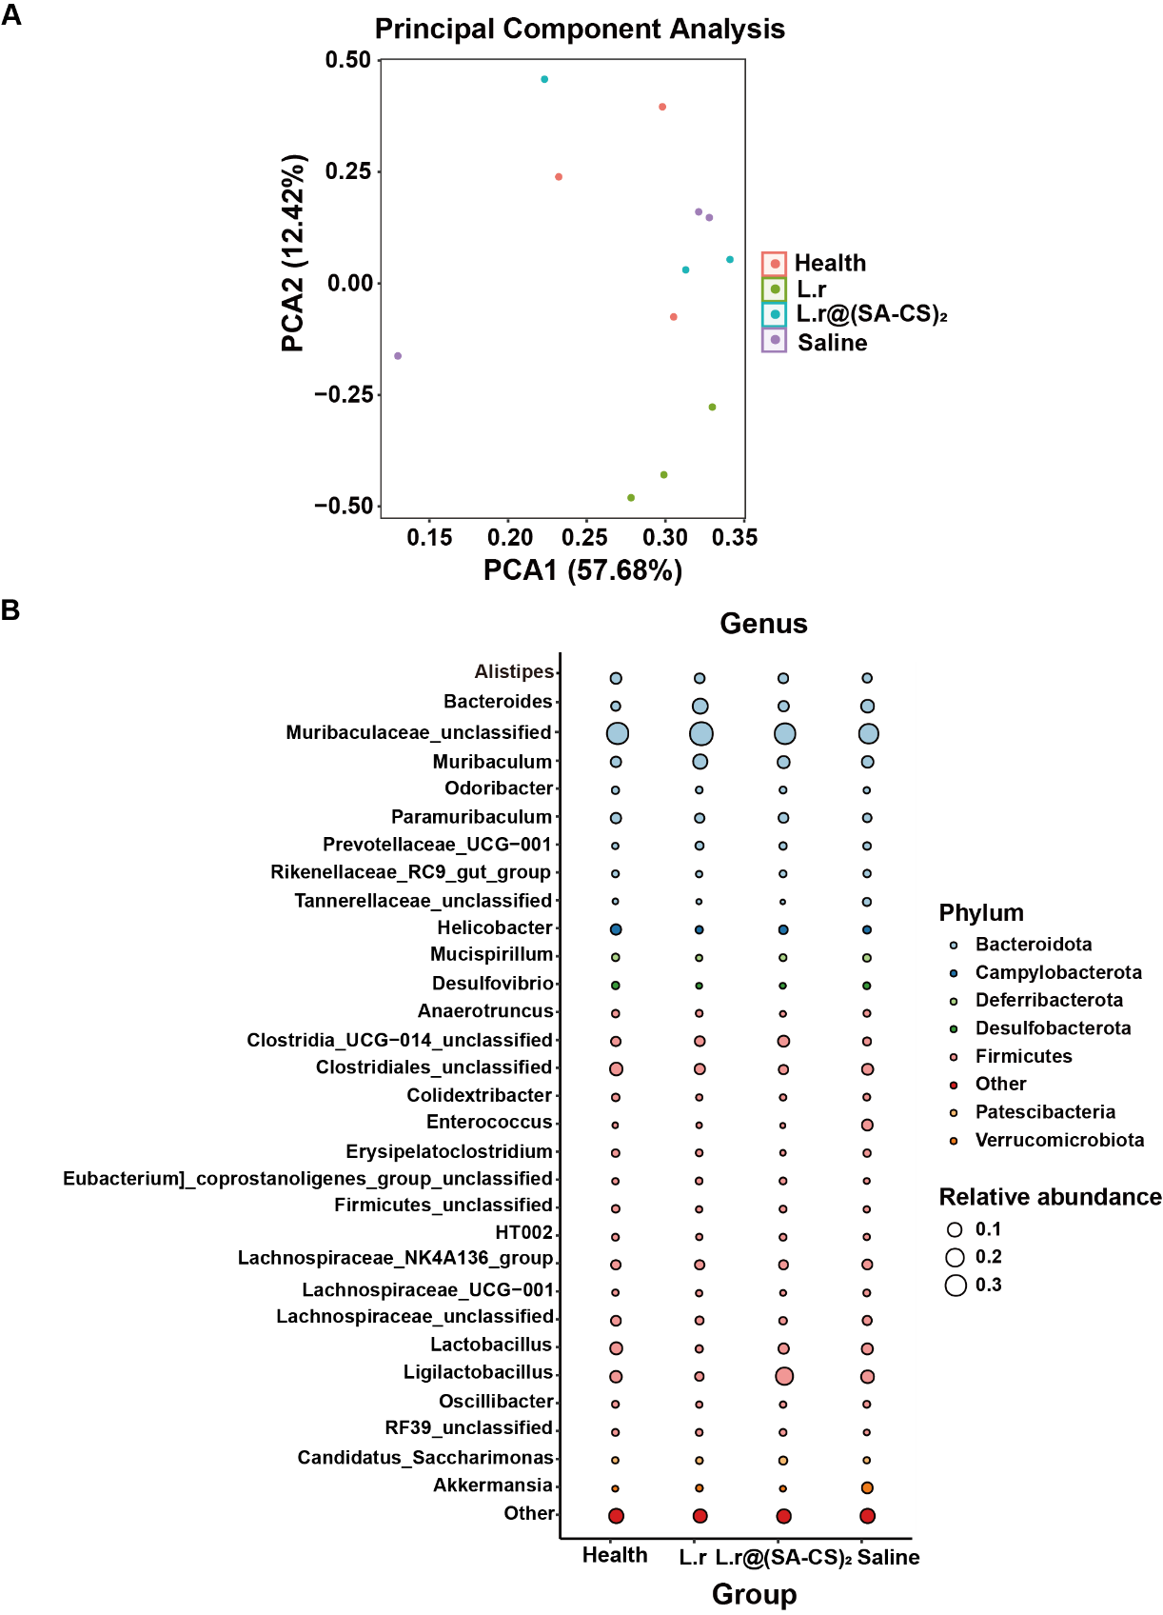
Figure S5. 16S rDNA Sequencing detection feces flora changes in Health mice, and Saline, L.r, L.r@(SA-CS)₂ in CT26 tumor-bearing mice on 7 d after gavage. (A) PCA analysis of the similarity and difference between the groups in Health, Saline, L.r and L.r@(SA-CS)_{2.} (B) Bubble plots show species annotation information at genus level and relative abundance (circle size) in different sample groups, as well as species annotation information at phylum level (circle color) (n=3).
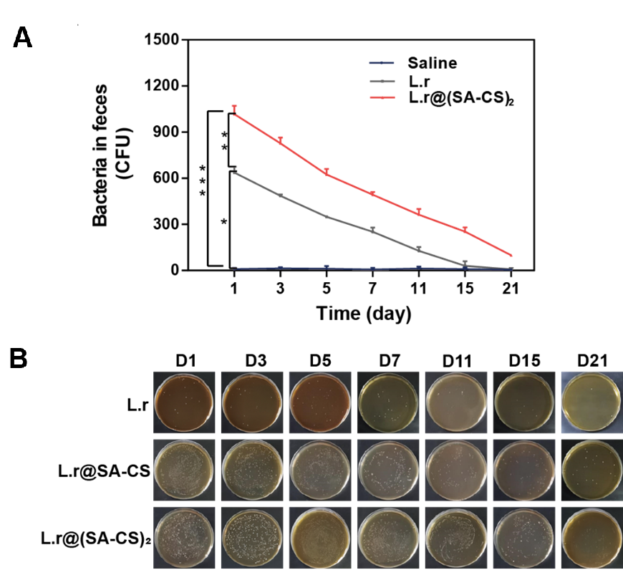
Figure S6. (A) An analysis of live L.r. in mouse feces at different stages of development. *p < 0.05, **p < 0.01, ***p < 0.001. (B) Representative photographs of solid MRS agar plates of L.r, gavaged with saline, L.r, and L.r@(SA-CS)₂ (n = 3).

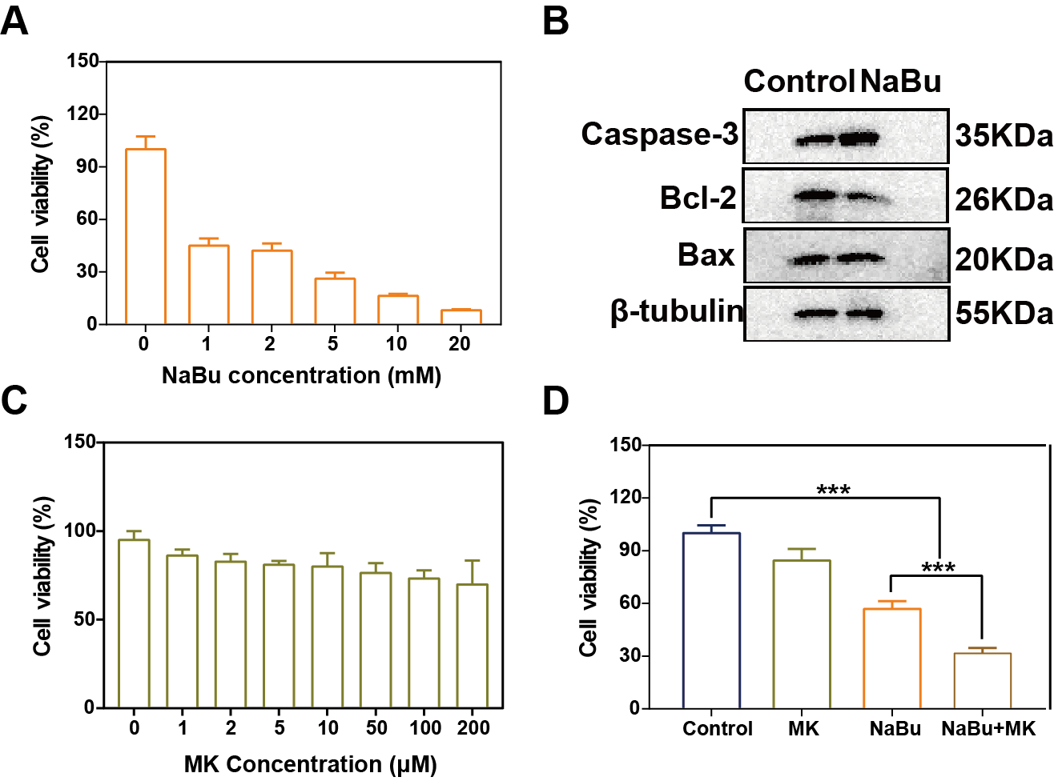
Figure S7. Effects of sodium butyrate and MK on CT26 cells. (A) A CCK8-based assay detected the killing effect of NaBu on CT26 cells. (B) NaBu induced the expression of apoptosis-related proteins in tumor cells by western blotting (n=3). (C) A cytotoxicity test was performed on MK using CCK8. (D) NaBu combined with MK killed cells when detected by CCK8 (n=5).

