Figure S1. Sensitivity (panel A) and specificity (panel B) of urinary intestinal fatty acid-binding protein (I-FABP) predicting AMI

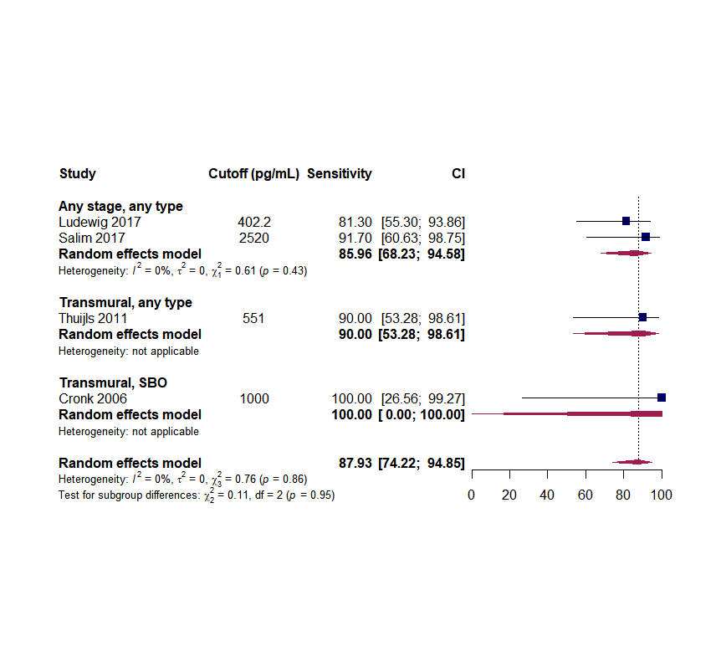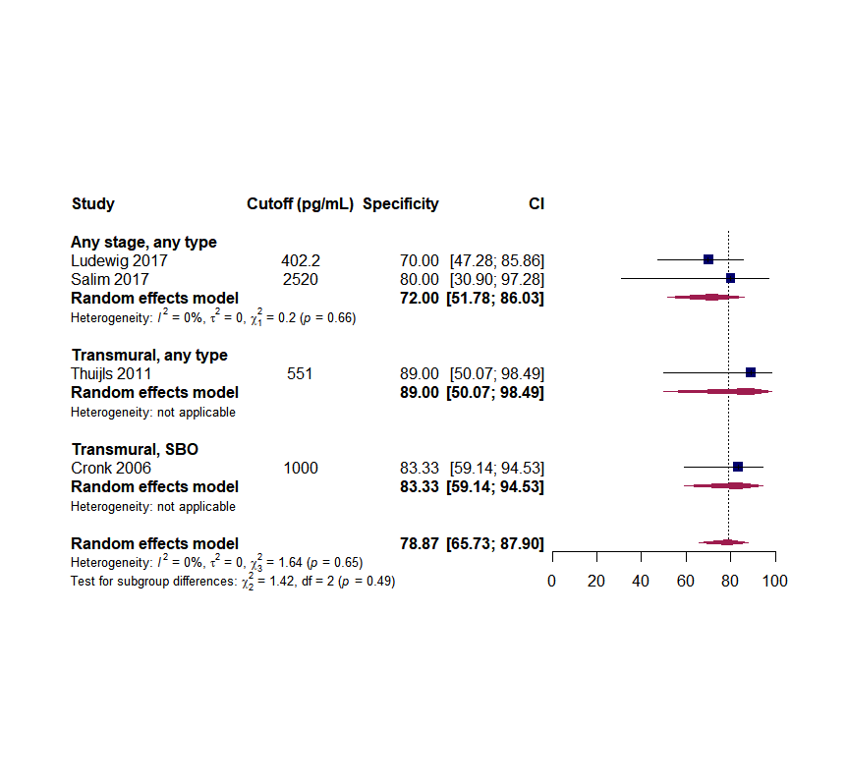

Figure S2. Sensitivity (panel A) and specificity (panel B) of serum C-reactive protein predicting AMI

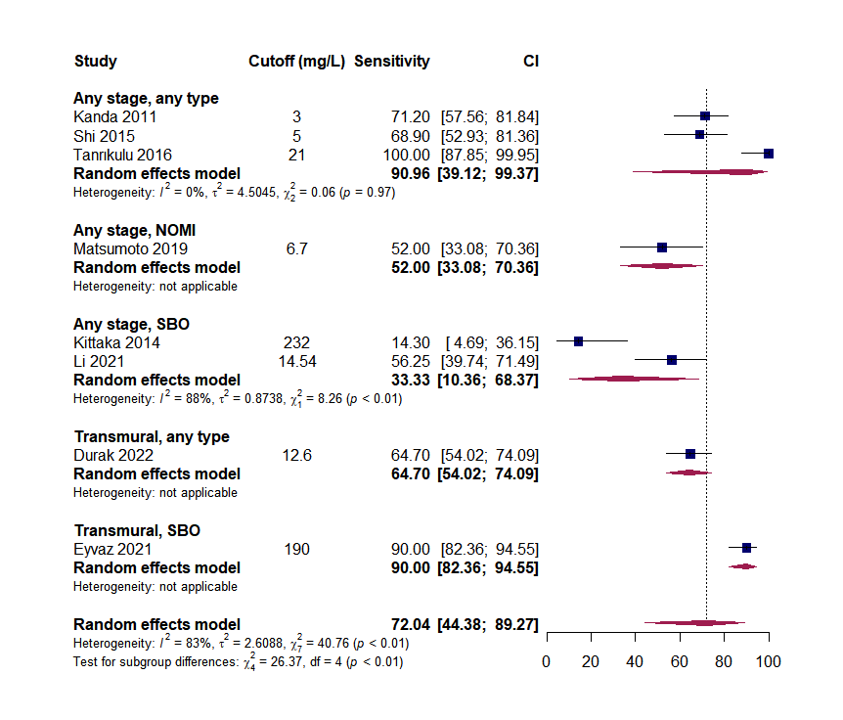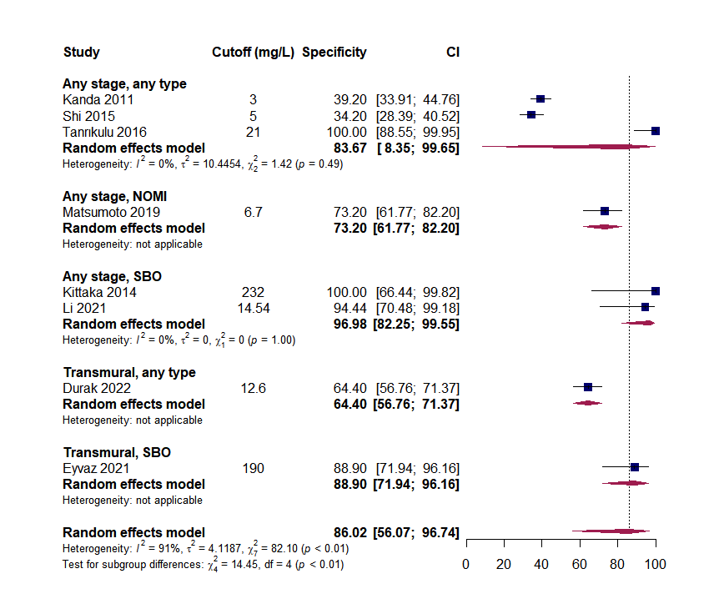

Figure S3. Sensitivity (panel A) and specificity (panel B) of serum procalcitonin predicting AMI

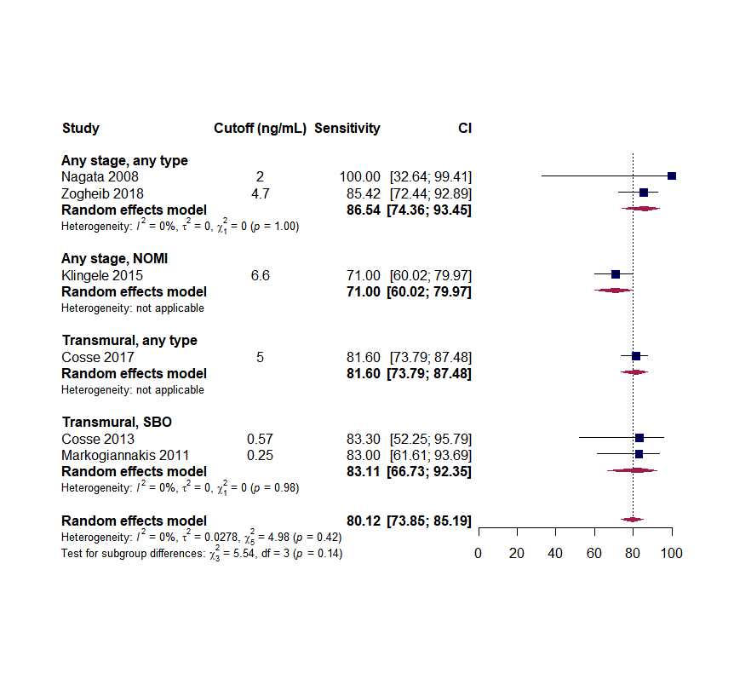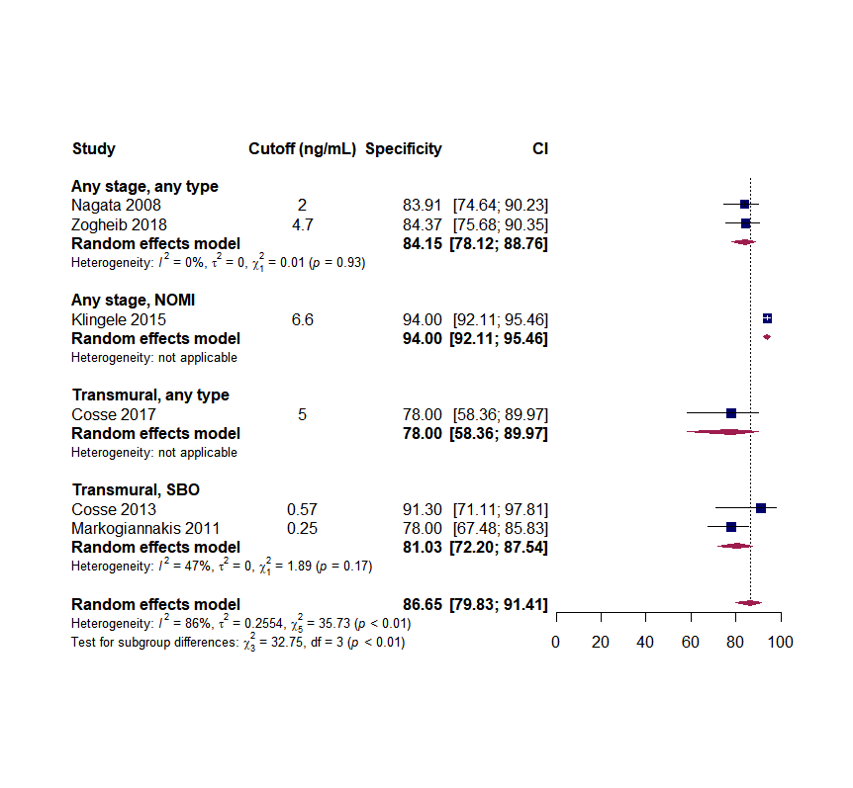

Figure S4. Sensitivity (panel A) and specificity (panel B) of serum interleukin-6 predicting AMI

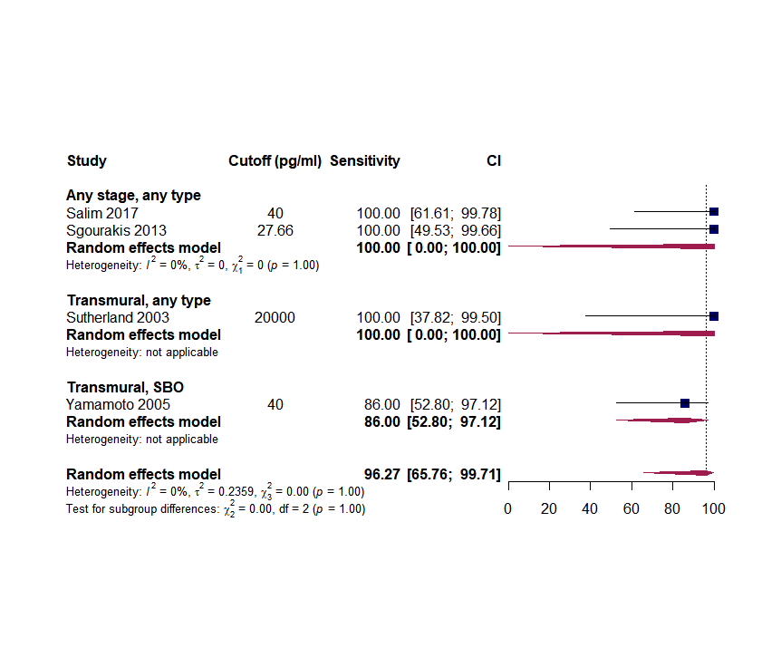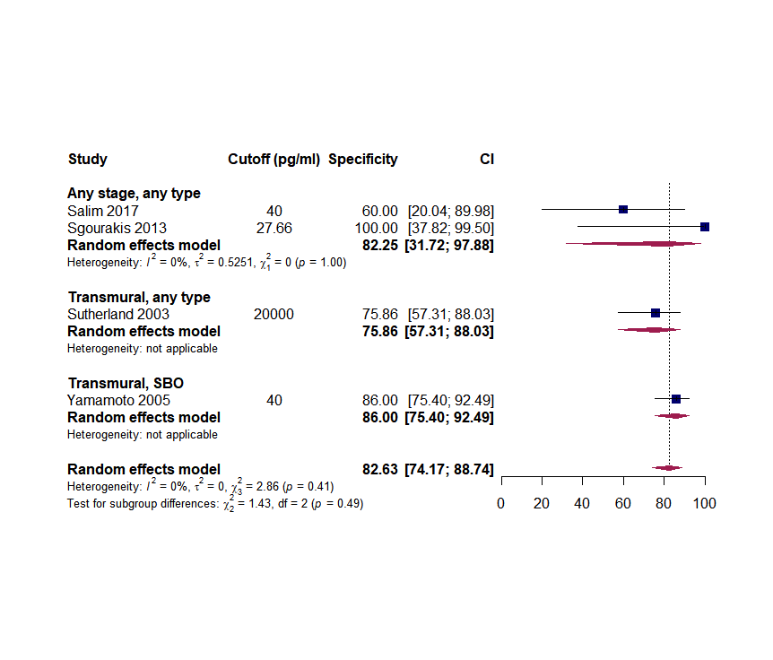

Figure S5. Sensitivity (panel A) and specificity (panel B) of serum alpha glutathione S transferase (alpha-GST) predicting AMI
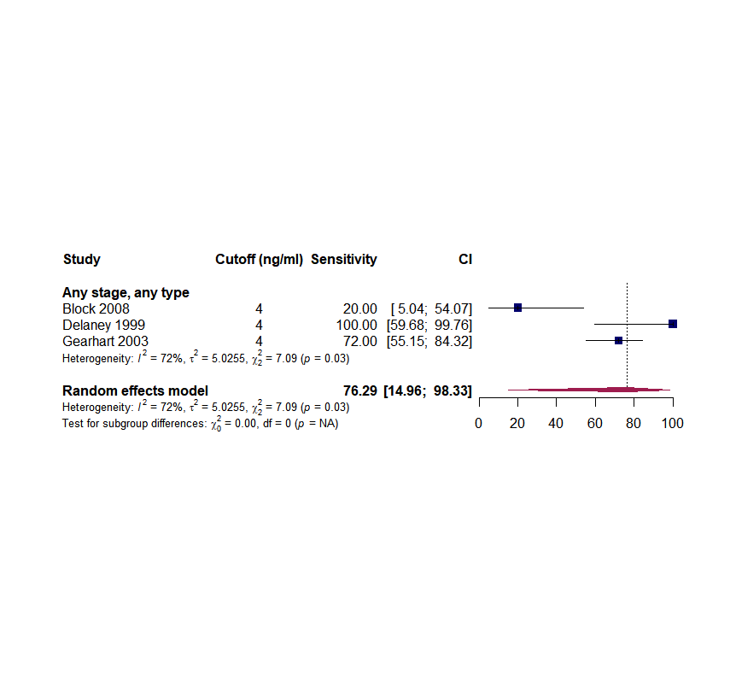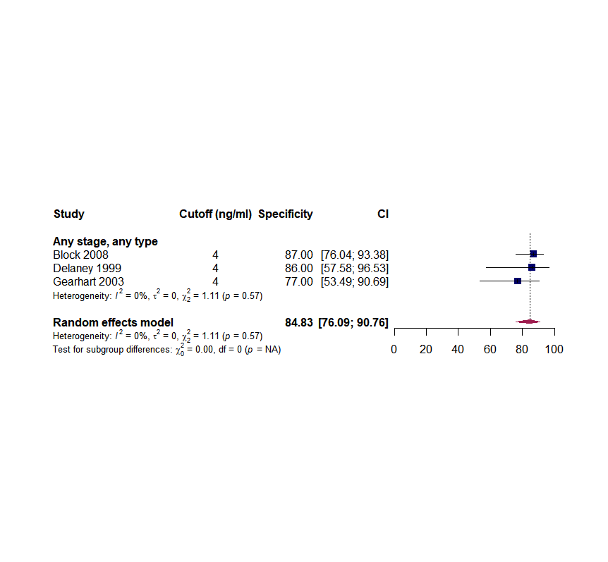

Figure S6. Sensitivity (panel A) and specificity (panel B) of serum citrulline predicting AMI

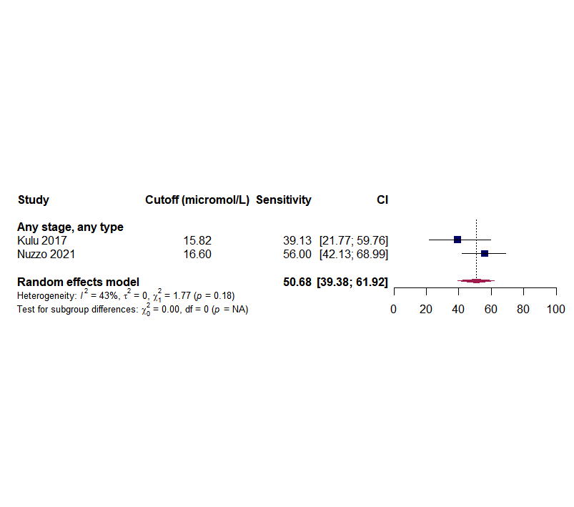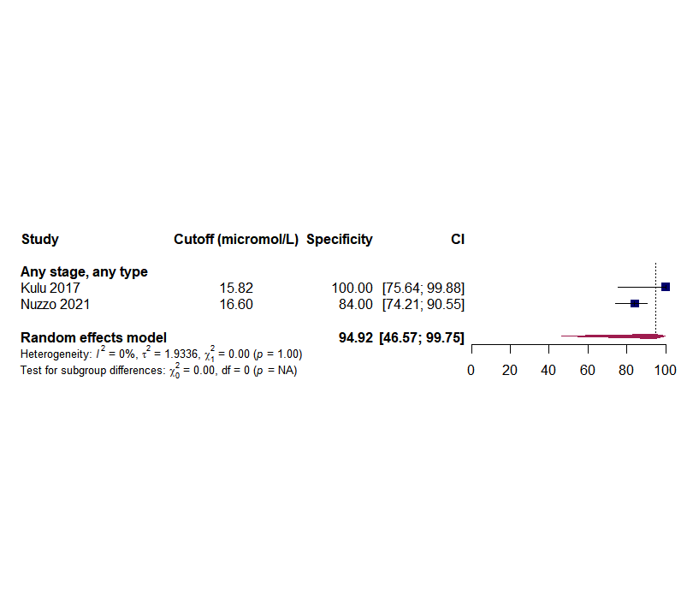

Figure S7. Sensitivity (panel A) and specificity (panel B) of serum ischaemia modified albumin (IMA) predicting AMI
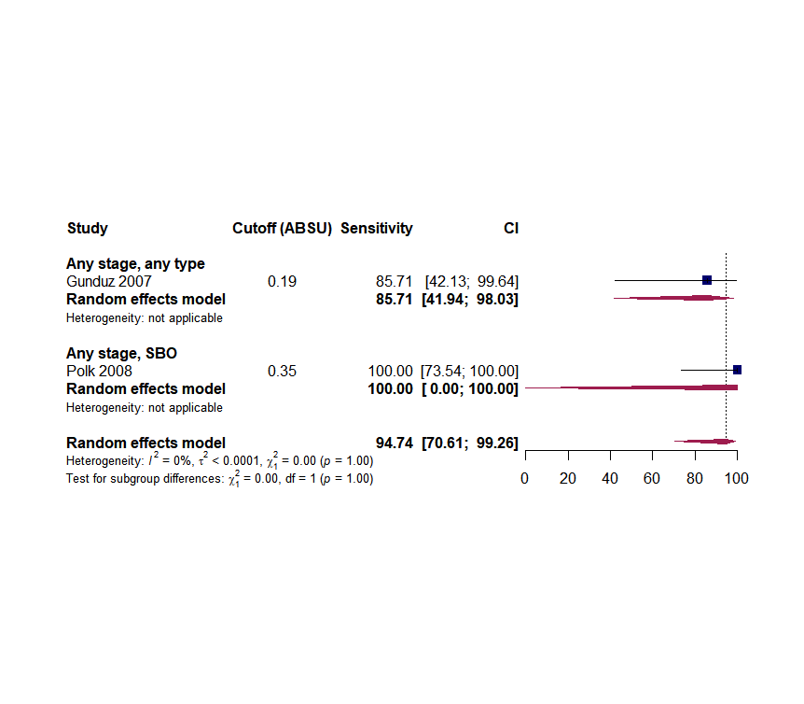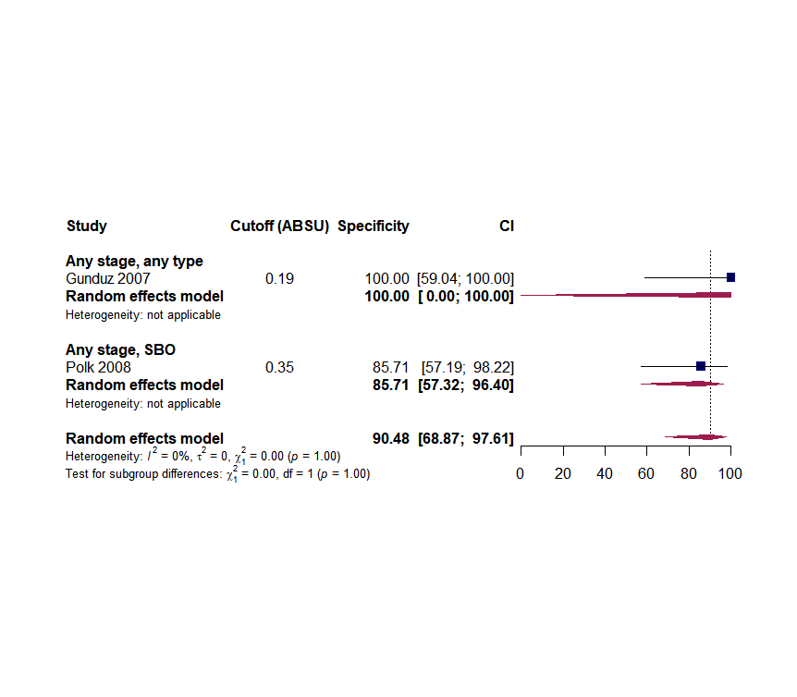
Legend: Gunduz 2007 included healthy volunteers as controls.

Figure S8. Sensitivity (panel A) and specificity (panel B) of mean platelet volume (MPV) predicting AMI

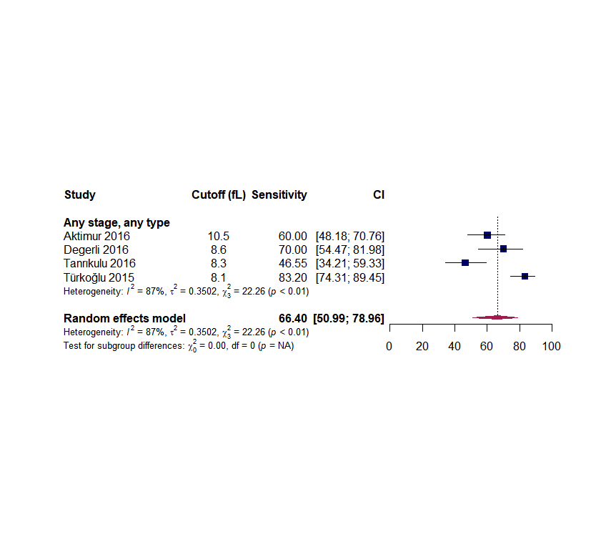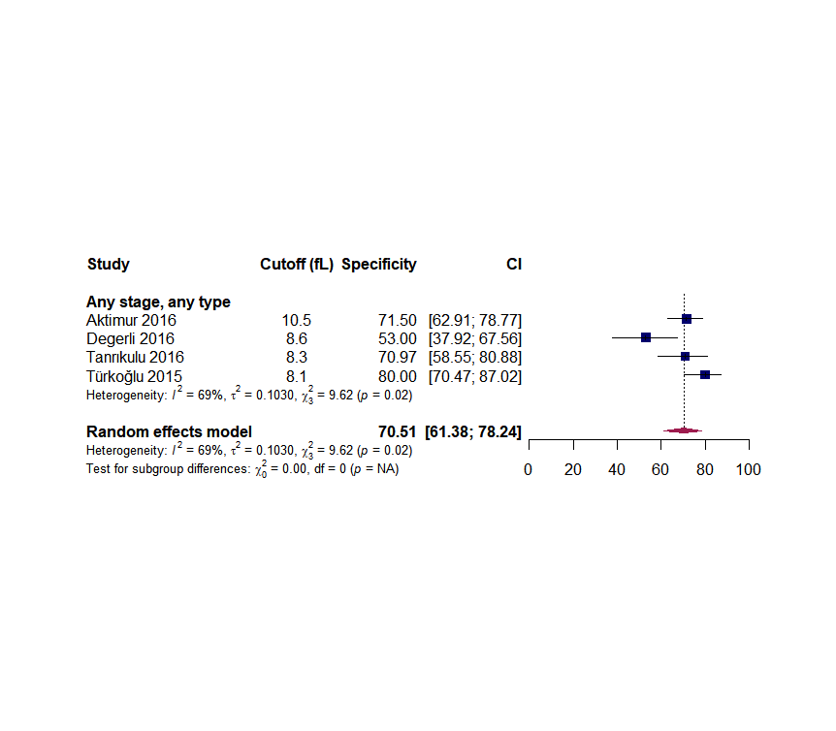

Legend: Degerli 2016 and Türkoglu 2015 included healthy volunteers as controls.

Figure S9. Sensitivity (panel A) and specificity (panel B) of red cell distribution width (RDW) predicting AMI

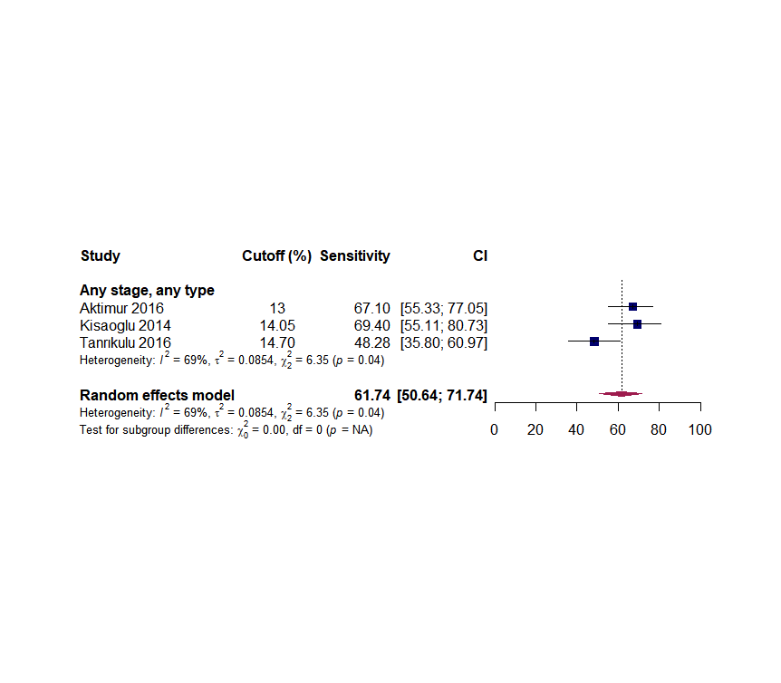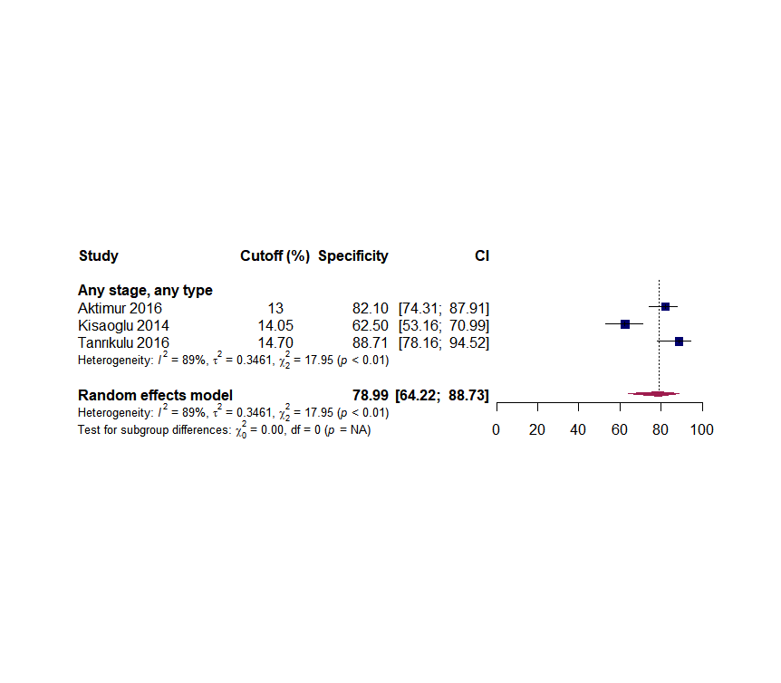

Figure S10. Sensitivity (panel A) and specificity (panel B) of neutrophil-lymphocyte ratio (NLR) predicting AMI

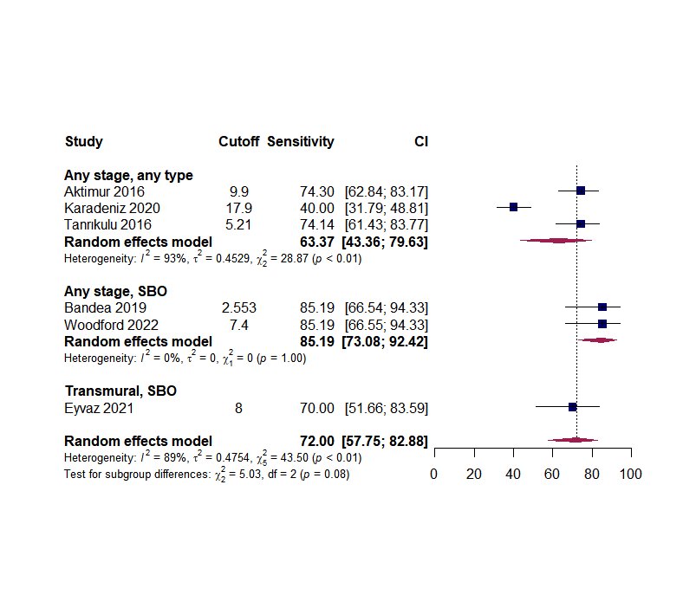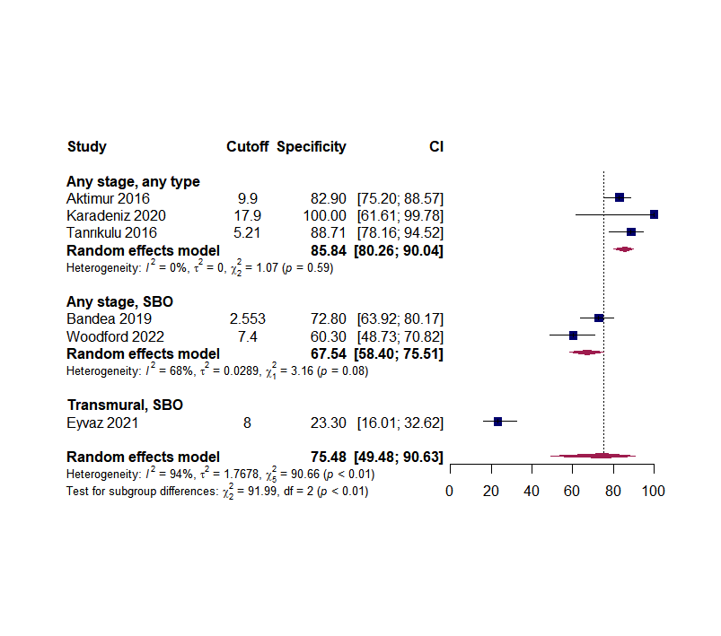
Figure S11. Sensitivity (panel A) and specificity (panel B) of platelet-lymphocyte ratio (PLR) predicting AMI

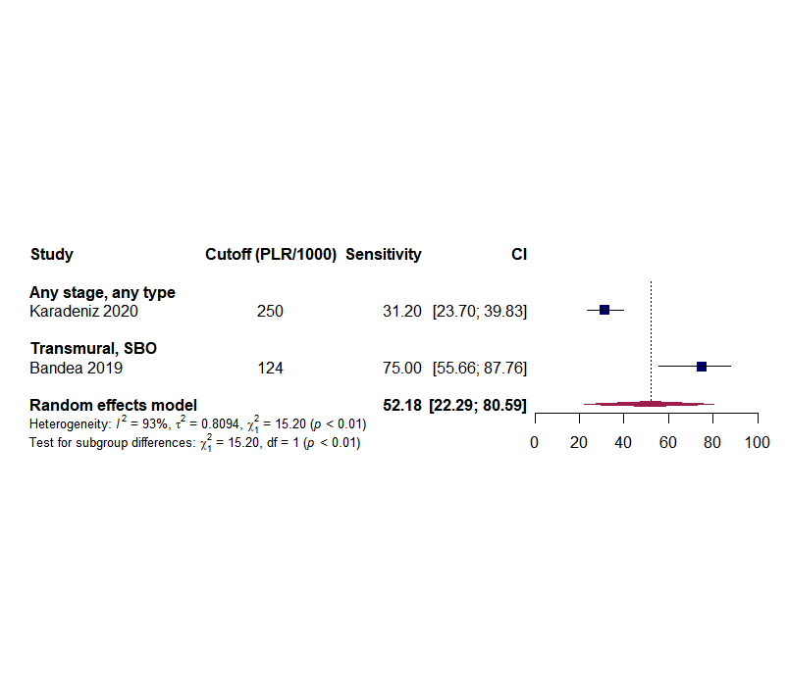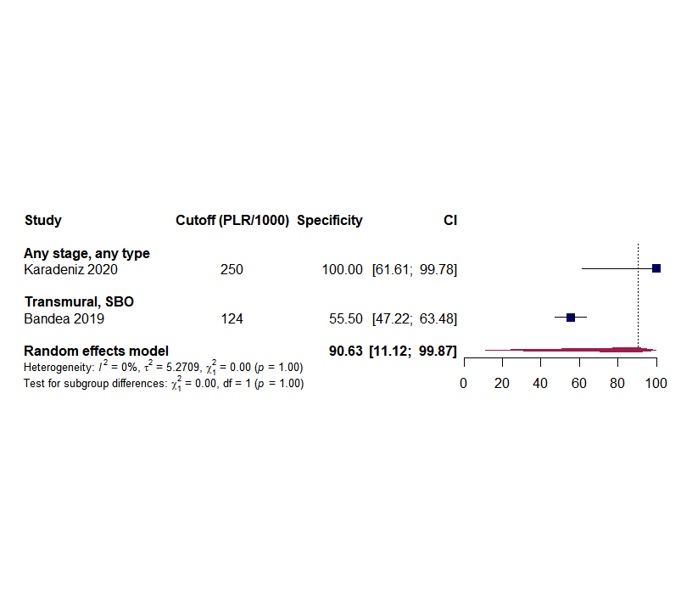

Figure S12. Sensitivity (panel A) and specificity (panel B) of serum lactate dehydrogenase (LDH) predicting AMI

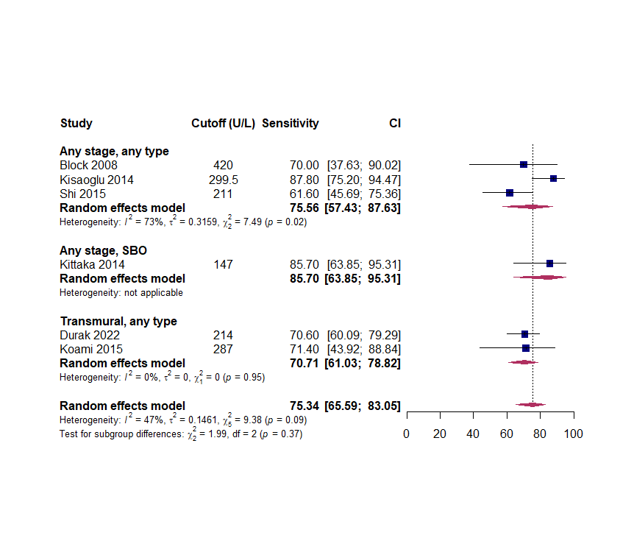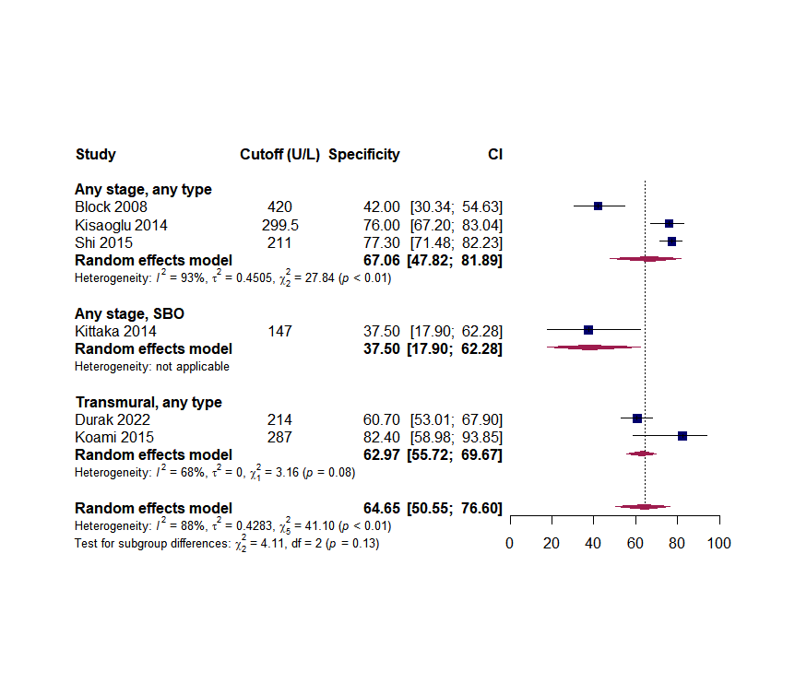

Figure S13. Sensitivity (panel A) and specificity (panel B) of serum D-lactate predicting AMI
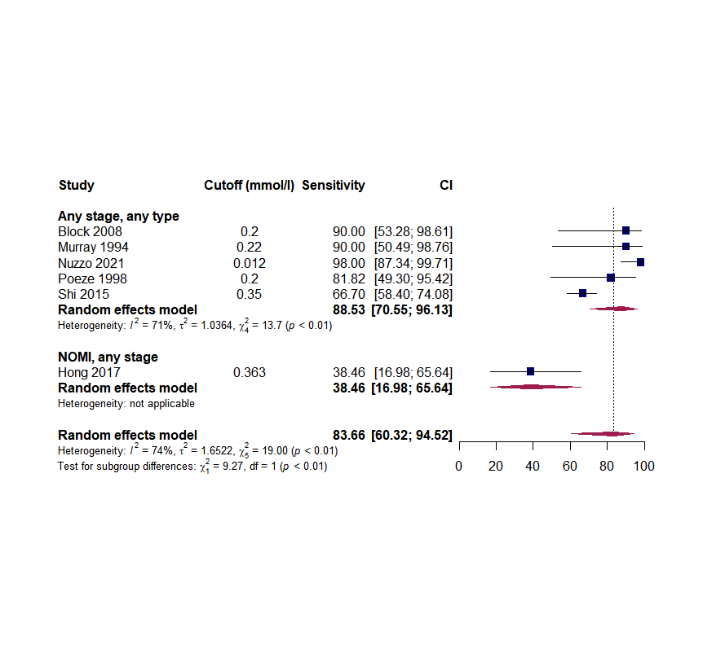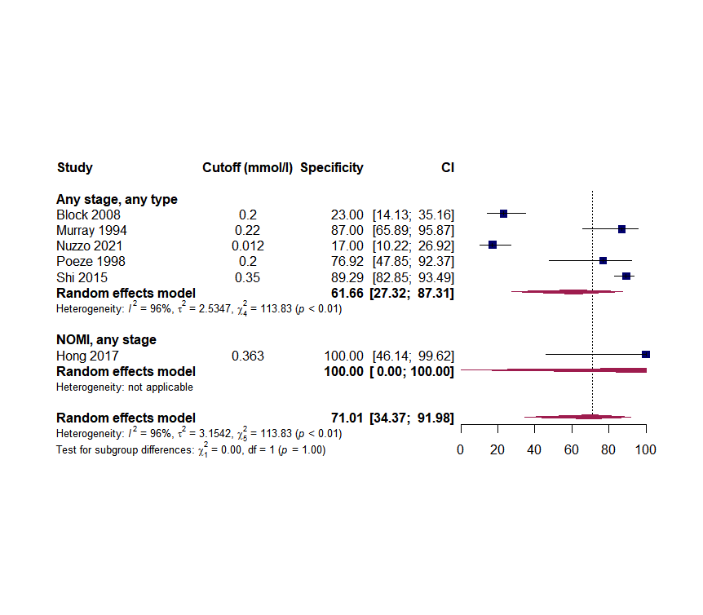

Figure S14. Sensitivity (panel A) and specificity (panel B) of serum pH predicting AMI

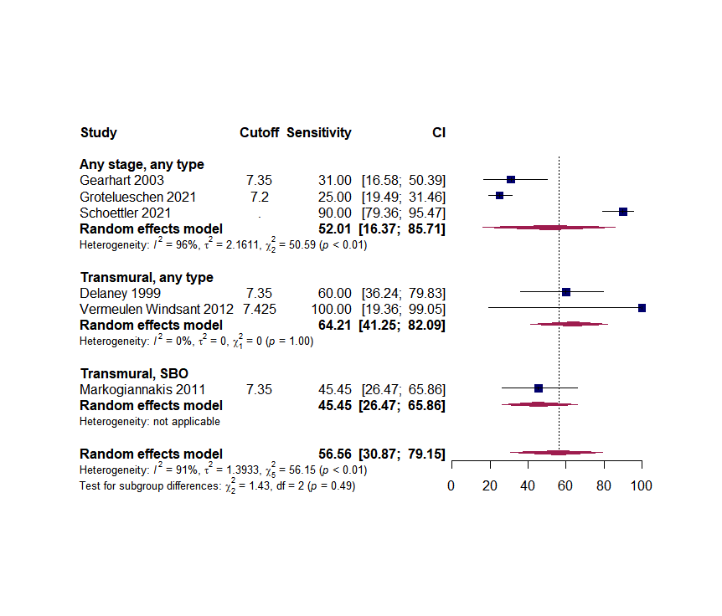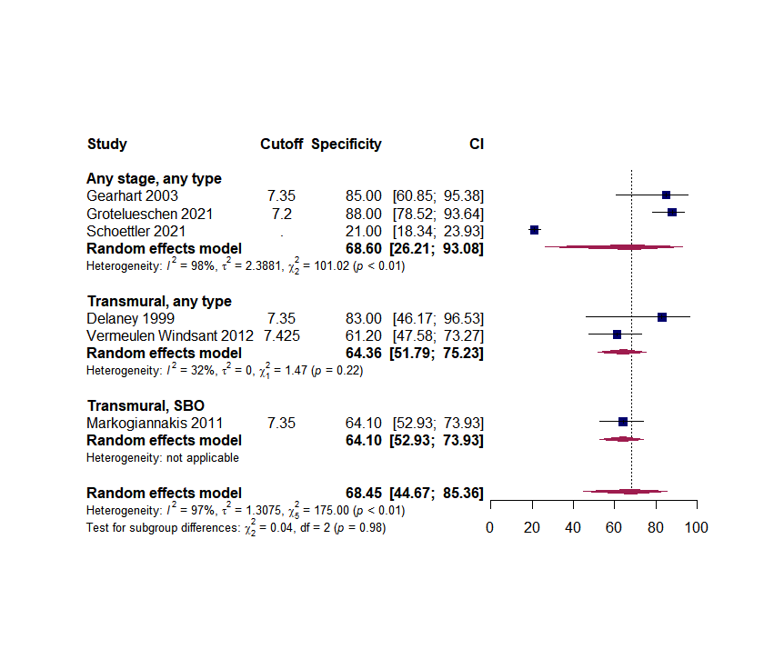
Legend:
Grotelueschen 2008: TP/FP/TN/FN numbers were used, reaching different sensitivity and specificity as reported in the original publication.

Figure S15. Sensitivity (panel A) and specificity (panel B) of serum bicarbonate predicting AMI

