Supplement

Table S1. Intercorrelations between dimensions of the LAP-R scale
 | PU | CO | CR | DA | EV | GS | TMPI | ET
PU | 1.000
CO | 0.934** | 1.000
CR | 0.917** | 0.873** | 1.000
DA | 0.321** | 0.320** | 0.288** | 1.000
EV | -0.969** | -0.923** | -0.908** | -0.353** | 1.000
GS | 0.856** | 0.873** | 0.840** | 0.245* | -0.846** | 1.000
TPMI | 0.987** | 0.980** | 0.912** | 0.326** | -0.964** | 0.878** | 1.000
ET | 0.974** | 0.935** | 0.941** | 0.413** | -0.975** | 0.798** | 0.972** | 1.000
*p<0.05 (two-sided)
**p<0.001 (two-sided)

Table S2. Differences in medians (Q1-Q3) between the 4 analyzed groups in the study
Median
(Q1-Q3)
 |  | Asperger Syndrome + Depression  (N=43) | Asperger Syndrome  (N=41) | Depression (N=40) | Healthy (N=46)
DJGLS |  | 49.00  (41.00 – 54.00) | 31.00  (26.00 – 36.00) | 37.50  (31.50 – 48.00) | 12.00  (11.00 – 12.00)
LAP-R | PU | 15.00  (9.00 – 23.00) | 27.00  (25.00 - 30.00) | 25.00  (19.50 - 28.00) | 36.00  (34.00 - 37.00)
LAP-R | CO | 22.00  (19.00 – 25.00) | 29.00  (28.00 – 32.00) | 29.00  (23.00 – 30.00) | 36.50  (35.00 – 38.00)
LAP-R | CR | 28.00  (11.00 – 29.00) | 34.00  (33.00 – 36.00) | 30.50  (28.00 – 34.50) | 41.00  (40.00 – 42.00)
LAP-R | DA | 31.00  (29.00 – 33.00) | 31.00  (30.00 – 33.00) | 30.50  (29.00 – 32.00) | 33.00  (32.00 – 34.00)
LAP-R | EV | 54.00  (42.00 – 56.00) | 38.00  (35.00 – 39.00) | 38.50  (37.00 – 45.00) | 27.00  (25.00 – 29.00)
LAP-R | GS | 26.00  (22.00 – 28.00) | 34.00  (32.00 – 36.00) | 32.00  (26.00 – 33.00) | 41.00  (39.00 – 43.00)
LAP-R | TPMI | 37.00  (29.00 – 48.00) | 57.00  (53.00 – 61.00) | 55.00  (42.00 – 58.00) | 72.00  (70.00 – 75.00)
LAP-R | ET | 17.00  (-4.00 – 37.00) | 48.00  (44.00 – 58.00) | 44.00  (25.50 – 54.00) | 76.50  (71.00 – 87.00)

Table S3. Results of post-hoc statistical significance of Dunn's test analysis for comparison of the Loneliness Scale (DJGLS) and LAP-R scale dimensions in the compared 4 groups
DJGLS vs 4 groups
 | Asperger Syndrome + Depression | Asperger Syndrome | Depression
Asperger Syndrome | <0.001 | - | -
Depression | 0.011 | 0.043 | -
Healthy | <0.001 | <0.001 | <0.001
LAP-R: Purpose
 | Asperger Syndrome + Depression | Asperger Syndrome | Depression
Asperger Syndrome | <0.001 | - | -
Depression | 0.008 | 0.114 | -
Healthy | <0.001 | <0.001 | <0.001
LAP-R: Coherence
 | Asperger Syndrome + Depression | Asperger Syndrome | Depression
Asperger Syndrome | <0.001 | - | -
Depression | 0.003 | 0.460 | -
Healthy | <0.001 | <0.001 | <0.001
LAP-R: Choice/Responsibleness
 | Asperger Syndrome + Depression | Asperger Syndrome | Depression
Asperger Syndrome | <0.001 | - | -
Depression | 0.015 | 0.089 | -
Healthy | <0.001 | <0.001 | <0.001
LAP-R: Death Acceptance
 | Asperger Syndrome + Depression | Asperger Syndrome | Depression
Asperger Syndrome | >0.999 | - | -
Depression | >0.999 | >0.999 | -
Healthy | 0.001 | 0.011 | <0.001
LAP-R: Existential vacuum
 | Asperger Syndrome + Depression | Asperger Syndrome | Depression
Asperger Syndrome | <0.001 | - | -
Depression | 0.003 | 0.315 | -
Healthy | <0.001 | <0.001 | <0.001
LAP-R: Goal Seeking
 | Asperger Syndrome + Depression | Asperger Syndrome | Depression
Asperger Syndrome | <0.001 | - | -
Depression | 0.019 | 0.054 | -
Healthy | <0.001 | <0.001 | <0.001
LAP-R: The Personal Meaning Index
 | Asperger Syndrome + Depression | Asperger Syndrome | Depression
Asperger Syndrome | <0.001 | - | -
Depression | 0.004 | 0.218 | -
Healthy | <0.001 | <0.001 | <0.001
LAP-R: Existential Transcendence
 | Asperger Syndrome + Depression | Asperger Syndrome | Depression
Asperger Syndrome | <0.001 | - | -
Depression | 0.008 | 0.254 | -
Healthy | <0.001 | <0.001 | <0.001

Table S4. Correlation of the severity of depression in the Beck Scale (BDI-II) and the Loneliness Scale (DJGLS) and dimensions in the LAP-R scale for all patients without grouping (N=170)
 |  | LAP-R
 | DJGLS | PU | CO | CR | DA | EV | GS | TMPI | ET
BDI-II | 0.954* | -0.932* | -0.912* | -0.920* | -0.395* | 0.923* | -0.868* | -0.930* | -0.923*
*p<0.001 (two-sided)

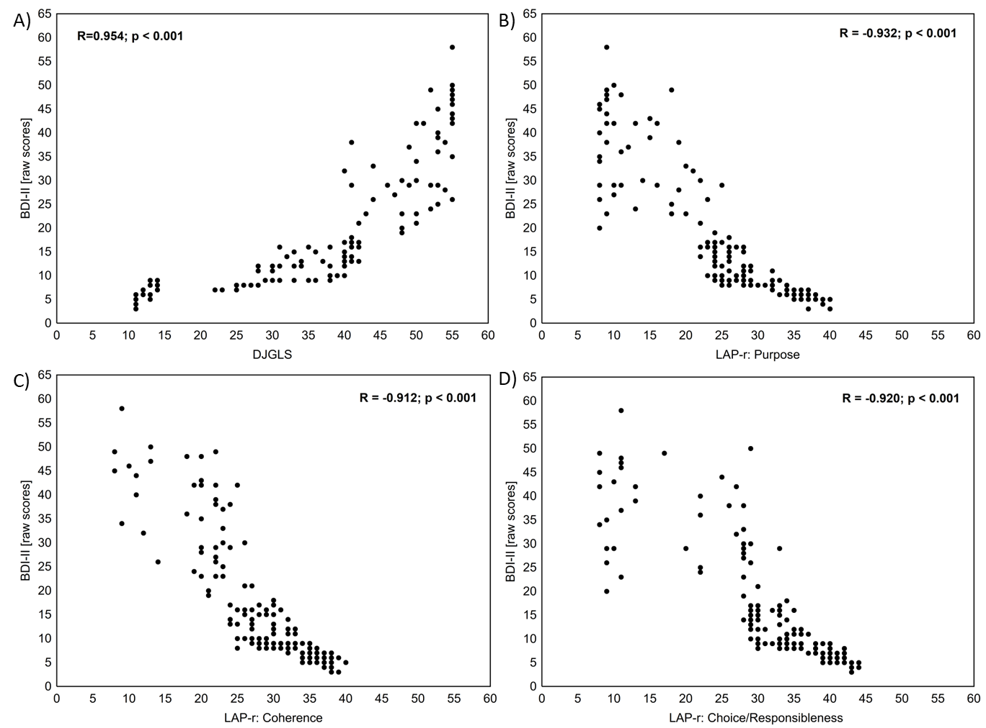
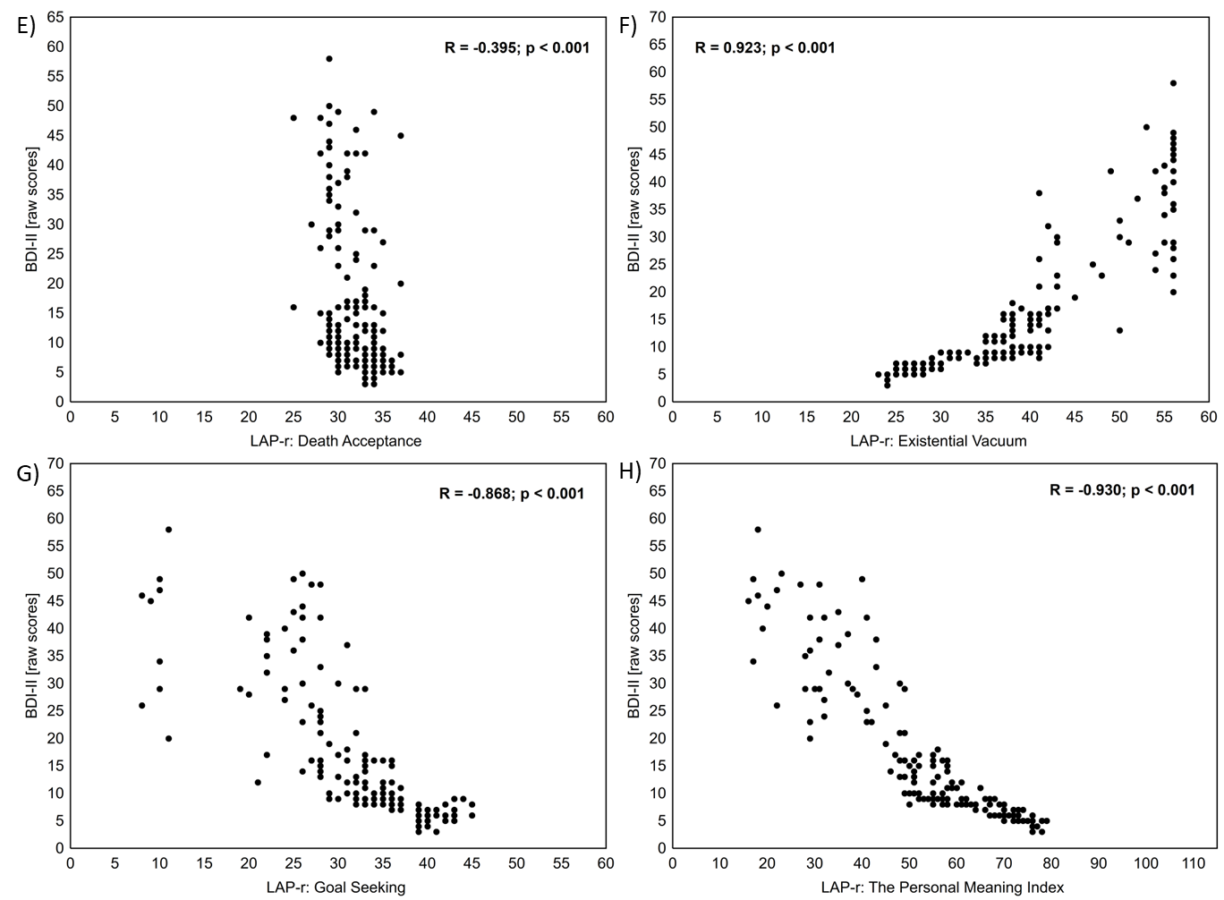

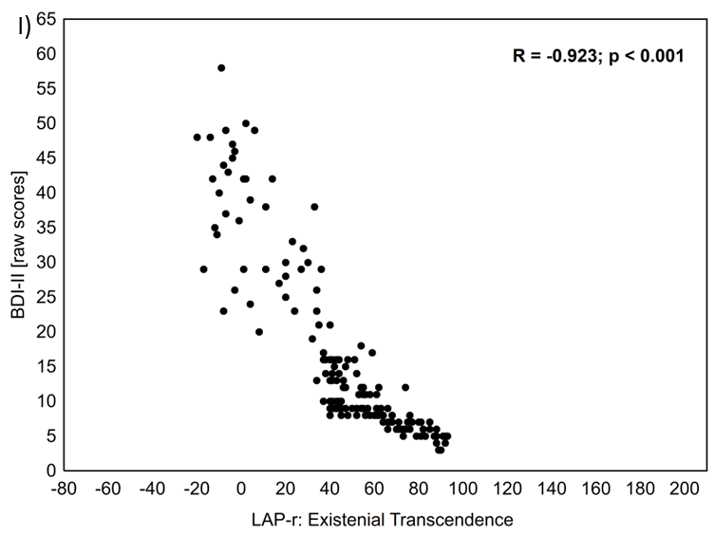
Figure S1. Scatterplots of correlation between the severity of depression in the Beck scale (BDI-II) and the feeling of loneliness in the DJGLS scale and dimensions in the LAP-R scale for all patients without division into groups

Table S5. Correlation of age with the DJGLS scale and LAP-R scale dimensions divided into 4 study groups
 |  | Age [Years]
 |  | Asperger syndrome and depression (N=43) |  | Asperger syndrome (N=41) |  | Depression (N=40) |  | Healthy (N=46)
 |  | R* | p | R* | p | R* | p | R* | p
DJGLS |  | -0.252 | 0.103 | -0.163 | 0.308 | -0.238 | 0.139 | -0.211 | 0.159
LAP-R | PU | 0.200 | 0.199 | 0.313 | 0.047 | 0.308 | 0.053 | 0.484 | <0.001
LAP-R | CO | 0.259 | 0.093 | 0.467 | 0.002 | 0.349 | 0.027 | 0.539 | <0.001
LAP-R | CR | 0.381 | 0.012 | 0.145 | 0.367 | 0.280 | 0.080 | 0.120 | 0.428
LAP-R | DA | -0.001 | 0.993 | -0.040 | 0.804 | -0.326 | 0.040 | -0.035 | 0.817
LAP-R | EV | -0.334 | 0.029 | -0.465 | 0.002 | -0.300 | 0.060 | -0.298 | 0.045
LAP-R | GS | -0.032 | 0.837 | -0.114 | 0.477 | 0.062 | 0.702 | -0.590 | <0.001
LAP-R | TPMI | 0.219 | 0.159 | 0.406 | 0.008 | 0.364 | 0.021 | 0.561 | <0.001
LAP-R | ET | 0.350 | 0.021 | 0.425 | 0.006 | 0.287 | 0.072 | 0.433 | 0.003

