Supplementary materials for

Growing climate change concern but rising regional disparities in China
Table S1 Demographic characteristics of respondents 3

Fig. A1 Correlation between Perceived Priority and Perceived Impact of Climate Change. 4
Fig. A2 Influencing Factors of Climate Change Perception in China. 5
Fig. A3 Provincial and City-level Analysis of Perceived Impact and Exposure to Extreme Events. 6
Fig. A4 Mean Absolute Error (MAE) comparison between Multilevel Regression and Poststratification (MRP) and Disaggregation methods over repeated simulations. 7

Table S1 Demographic characteristics of respondents. Comparison of the demographic characteristics between the participants of our survey conducted in 2022 and those from the China General Social Survey (CGSS) conducted in 2010. Percentages may not sum to 100% due to rounding. Respondents are categorised into groups based on gender, age, education, family income (USD per month), residence, and occupation. Occupation groupings for the CGSS survey are not reported.

Factors | Groups | Our survey (2022) |  | CGSS (2010)
Factors | Groups | Sample size | Percentage (%) | Sample size | Percentage (%)
Gender | Male | 1,387 | 34.2 | 5677 | 48.2
Gender | Female | 2,663 | 65.8 | 6106 | 51.8
Age | <25 | 1,438 | 35.5 | 906 | 7.69
Age | 26~35 | 1,156 | 28.5 | 2210 | 18.8
Age | 35~45 | 796 | 19.7 | 2514 | 21.3
Age | >46 | 660 | 15.6 | 6150 | 52.2
Education | High school or lower | 3,139 | 77.5 | 9350 | 91.4
Education | College or higher | 911 | 22.5 | 880 | 8.60
Family income  (USD/month) | <800 | 654 | 16.1 | 964 | 9.33
Family income  (USD/month) | 800~1,500 | 1,356 | 33.5 | 1213 | 11.7
Family income  (USD/month) | 1,500~3,000 | 1,313 | 32.4 | 2383 | 23.1
Family income  (USD/month) | >3,000 | 727 | 18.0 | 5774 | 55.9
Residence | Urban | 3,113 | 76.9 | 7222 | 61.3
Residence | Rural | 937 | 23.1 | 4561 | 38.7
Occupation | Student | 1,052 | 26.0
Occupation | Civil servant | 365 | 9.0
Occupation | Resource or energy-related | 476 | 11.8
Occupation | Agriculture-related | 234 | 5.8
Occupation | Outdoor workers | 218 | 5.4
Occupation | Others | 1,705 | 42.0

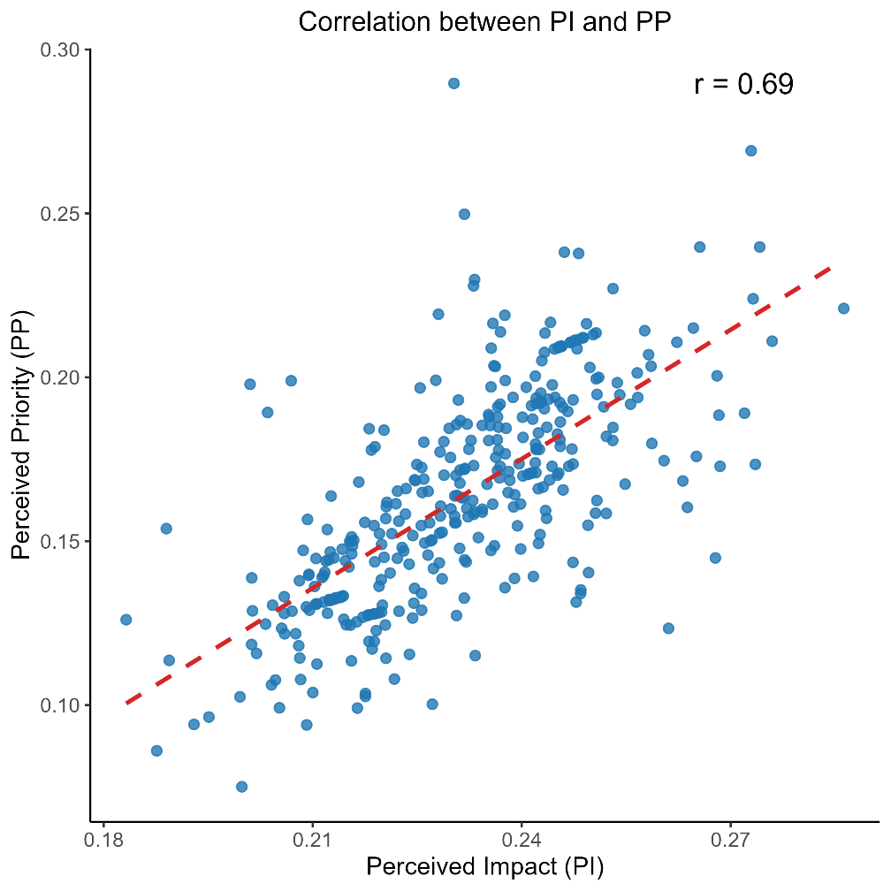
Fig. A1 Correlation between Perceived Priority and Perceived Impact of Climate Change. The scatter plot depicts the strong positive relationship between Perceived Priority and Perceived Impact across MRP estimation, demonstrating a correlation coefficient of 0.69. Each point represents an individual city, with their Perceived Priority and Perceived Impact scores plotted on the x and y axes, respectively.

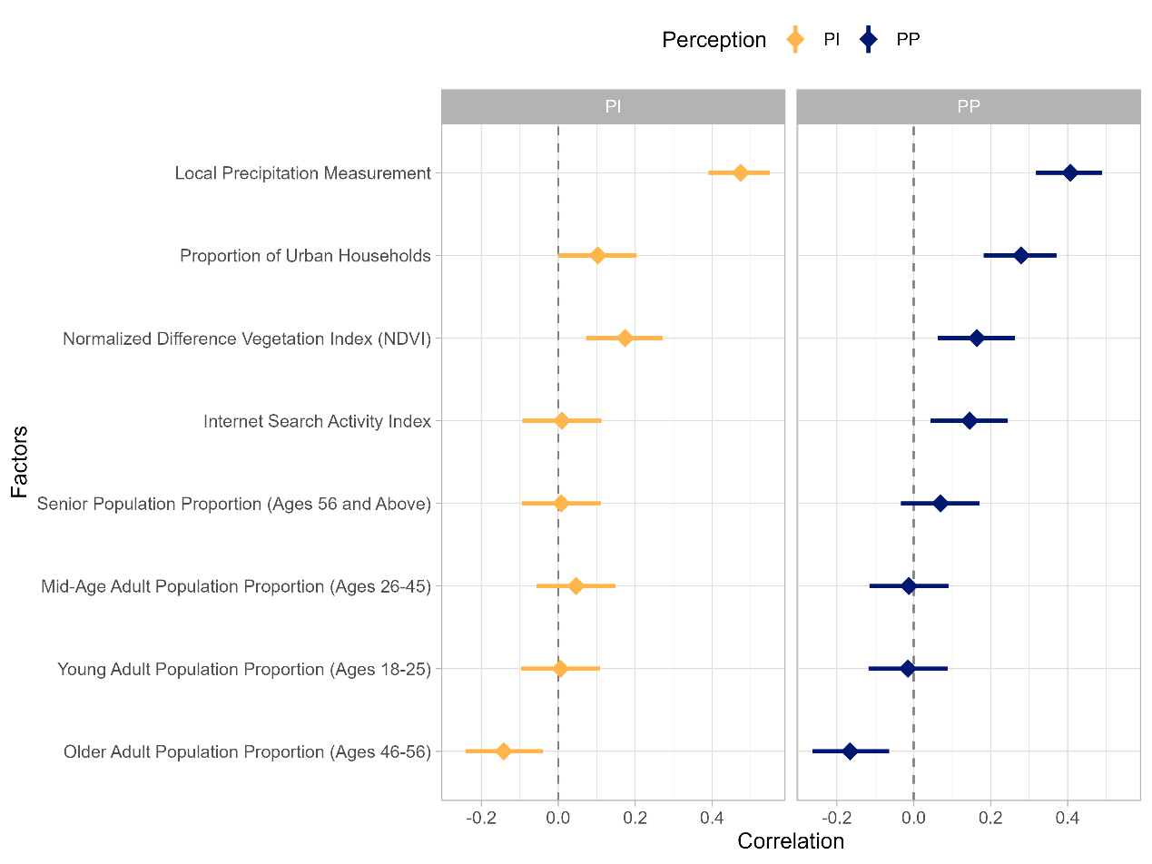
Fig. A2 Influencing Factors of Climate Change Perception in China. The forest plot displays the city-level scale-down estimates of Multilevel Regression with Poststratification (MRP) against a range of demographic, environmental, and societal factors impacting climate change perception across China. Each influencing factor is represented by a diamond marker indicating the estimate, with horizontal lines illustrating the confidence interval.
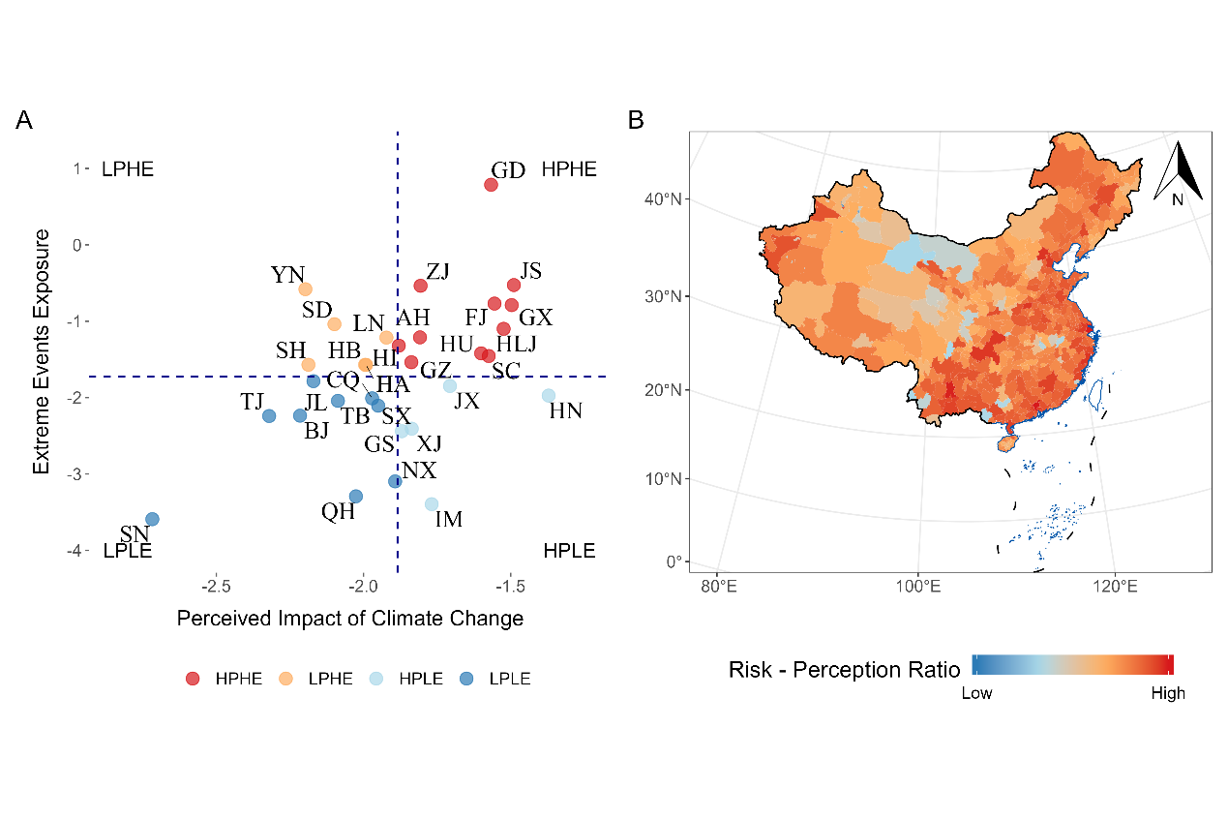
Fig. A3 Provincial and City-level Analysis of Perceived Impact and Exposure to Extreme Events. (A) The provincial map visualizes the relationship between perceived impact of climate change and exposure to extreme weather events, illustrating the spatial distribution of climate risk across China. The extreme weather events are defined based on the 98th percentile of historical daily mean temperatures for each province from 1980-2020. (B) The city-level map represents a finer scale down of the risk-perception ratio, highlighting the discrepancies between perceived risk and actual exposure to extreme weather events. The risk-perception ratio is computed by dividing the perceived impact of climate change on families by the exposure to extreme events.

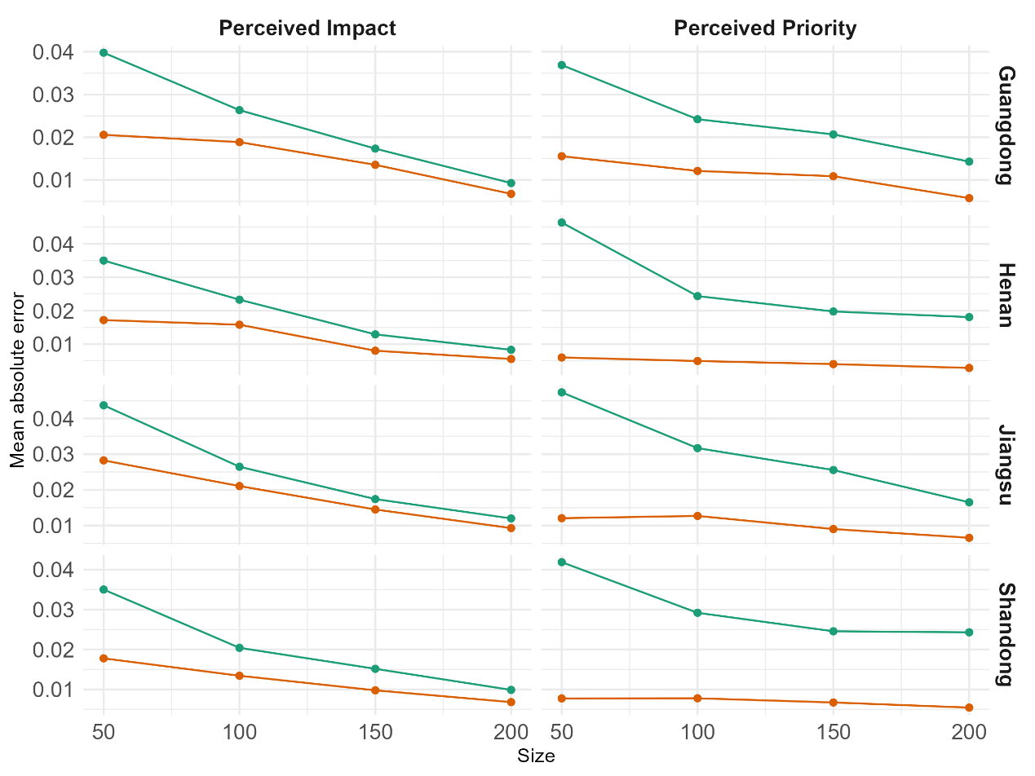
Fig. A4 Mean Absolute Error (MAE) comparison between Multilevel Regression and Poststratification (MRP) and Disaggregation methods over repeated simulations. The figure illustrates the MAE for Perceived Priority (PP) and Perceived Impact (PI) of climate change, derived from two methods - MRP and Disaggregation - across different sample sizes and provinces. The sample sizes are determined based on 99 random samplings of 50, 100, 150, and 200 responses from the survey data. The different panels correspond to different provinces (shown on the vertical axis). This comparison validates the robustness of MRP estimates across varying sample sizes, demonstrating its effectiveness in estimating climate change perceptions, even with small sample sizes.

