Table 2. Comparison of specifically adhered exercises between study groups.
 | Flexion |  | Extension |  | Lateral flexion and rotation
A. | Waiters bow  1. 98%  2. 78% | 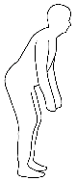 | Pelvic tilt  1. 54%  2. 44% | 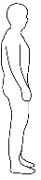 | One leg stance with weight shift  1. 100%  2. 89% | 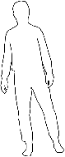
B. | One leg raise on standing  1. 38%  2. 44% | 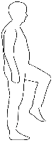 | Lunge  1. 31%  2. 44% | 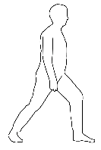 | Transverse lunge  1. 100%  2. 89% | 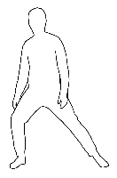
C. | Squat  1. 87%  2. 67% | 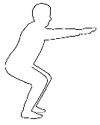 | All fours forwards  1. 92%  2. 100% | 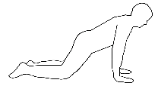 | All fours rotation  1. 92%  2. 67% | 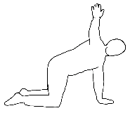
D. | Leg extension on sitting  1. 0%  2. 11% | 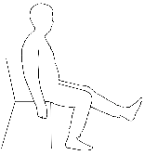 | All fours forward arm raise  1. 31%  2. 44% | 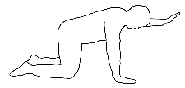 | All fours knee sideway raise  1. 15%  2. 22% | 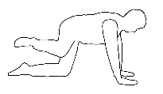
E. | All fours backwards  1. 100%  2. 78% | 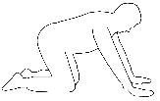 | All fours leg raise backwards  1. 23%  2. 56% | 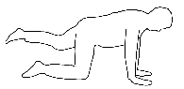 | Prone knee hip internal rotation  1. 0%  2. 0% | 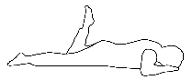
F. | All fours hip flexion  1. 38%  2. 44% | 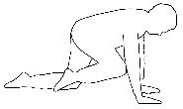 | All fours alternative leg and arm raise  1. 23%  2. 33% | 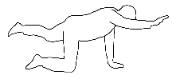
G. | Camel exercise  1. 62%  2. 56% | 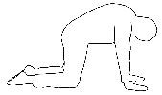 | Cat exercise  1. 23%  2. 33% | 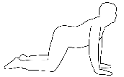
8. | Dead bug exercise  1. 69%  2. 33% | 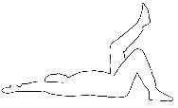 | Prone knee flexion  1. 31%  2. 22% | 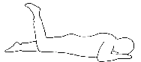
9. | Kneeling forward bending  1. 46%  2. 22% | 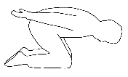 | Bridge  1. 38%  2. 56% | 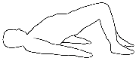
1. Control group without specific breathing and 2. Experimental group with specific breathing technique adherence to this exercise in a total number of subjects in the group.

