Appendix I: Showing bivariate relationship between MDAS score and each of the explanatory variable.
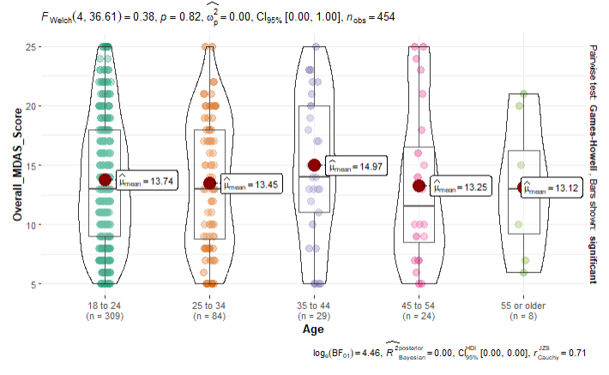
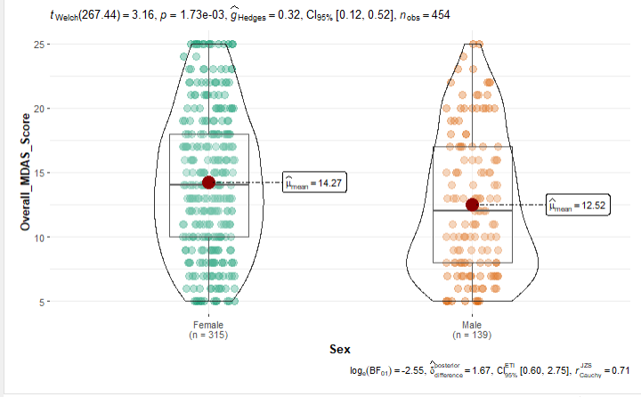

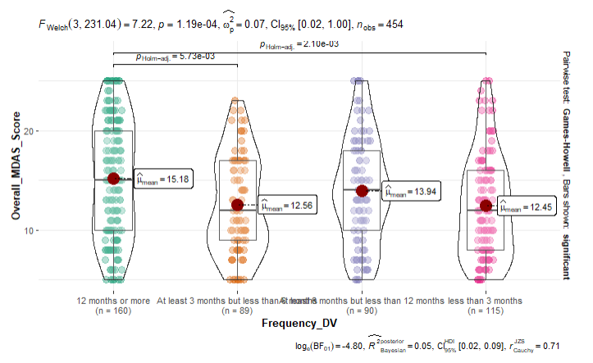
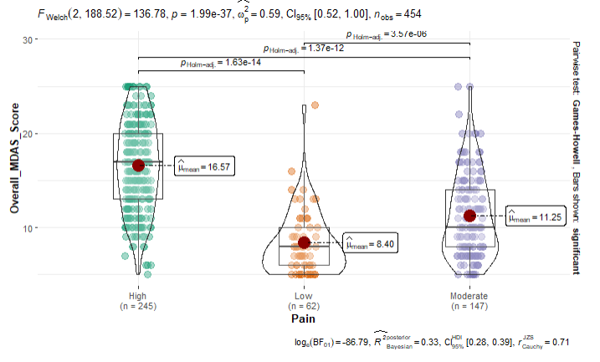

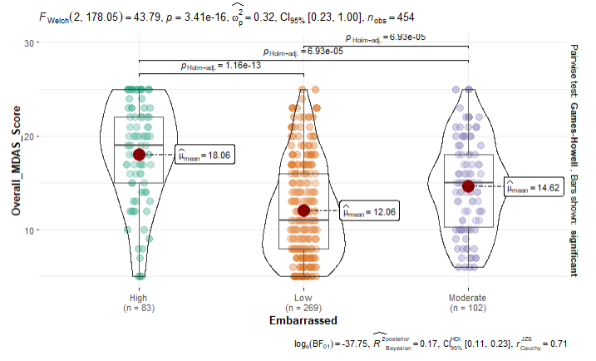
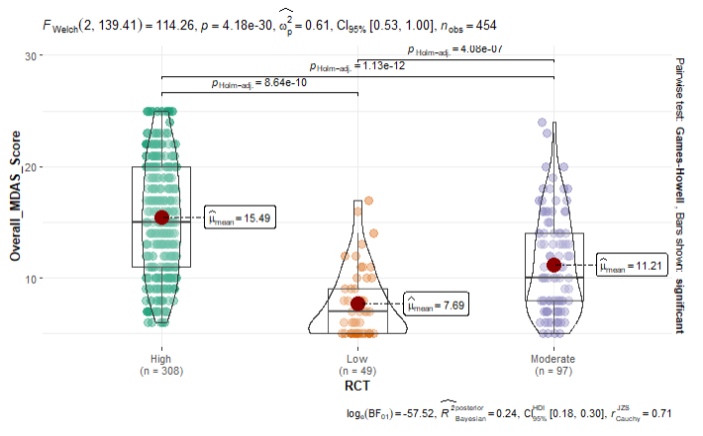

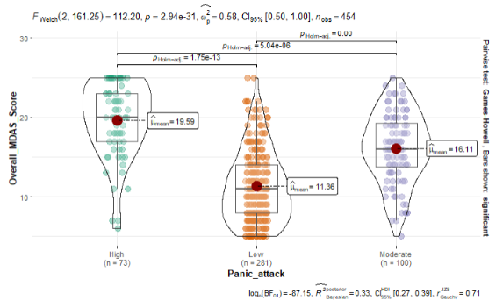
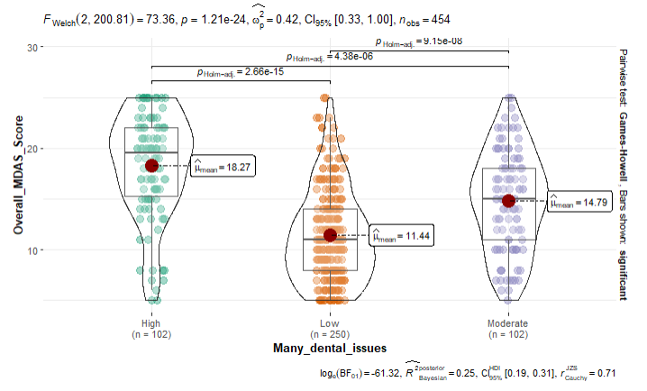

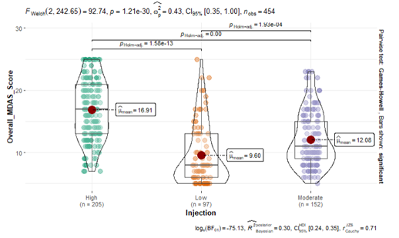
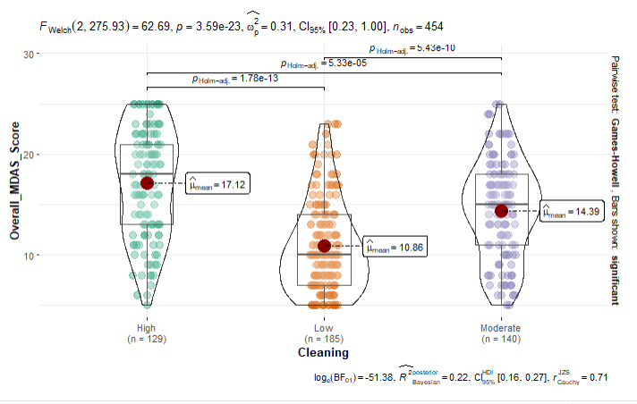

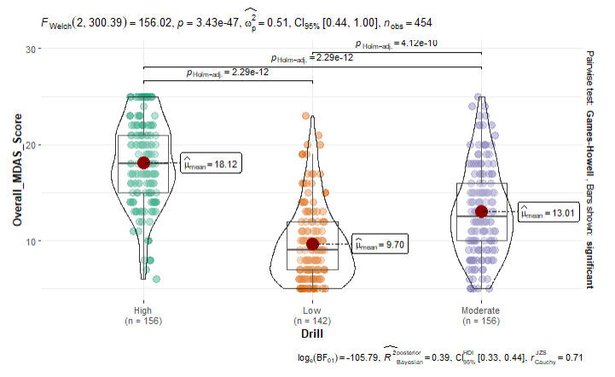

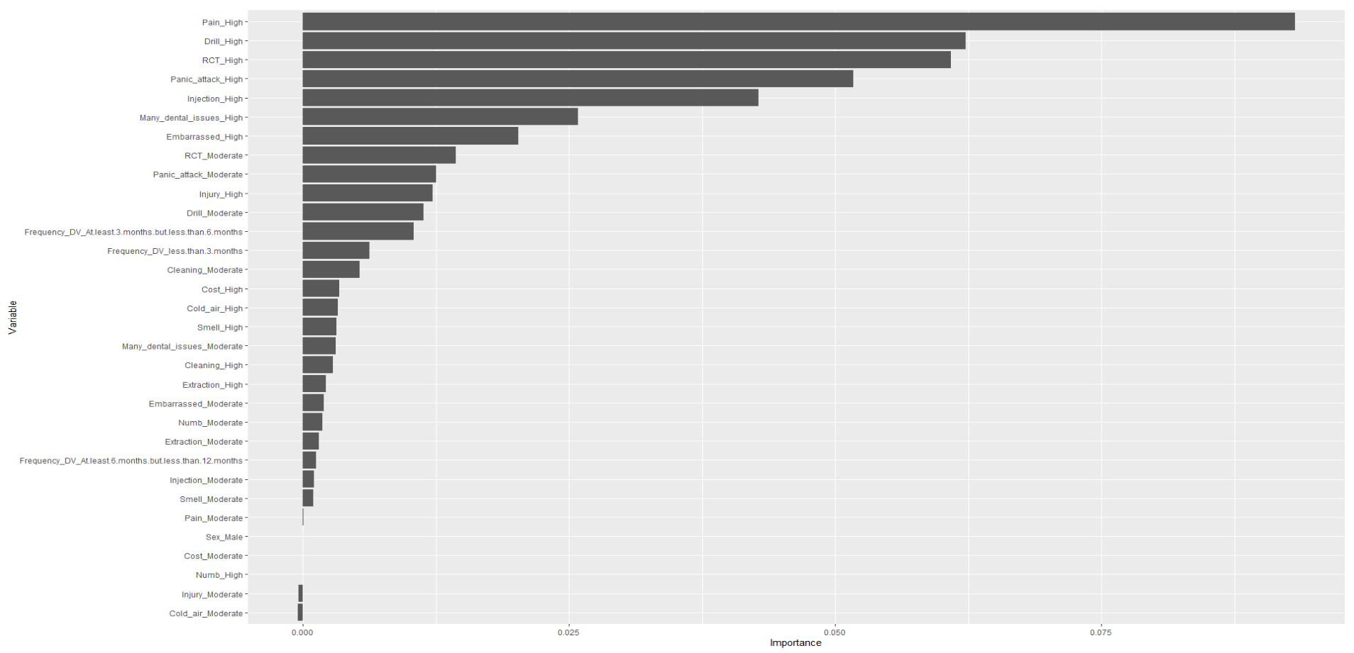
Appendix II. Chart showing variable importance of the variables in the Lasso model.

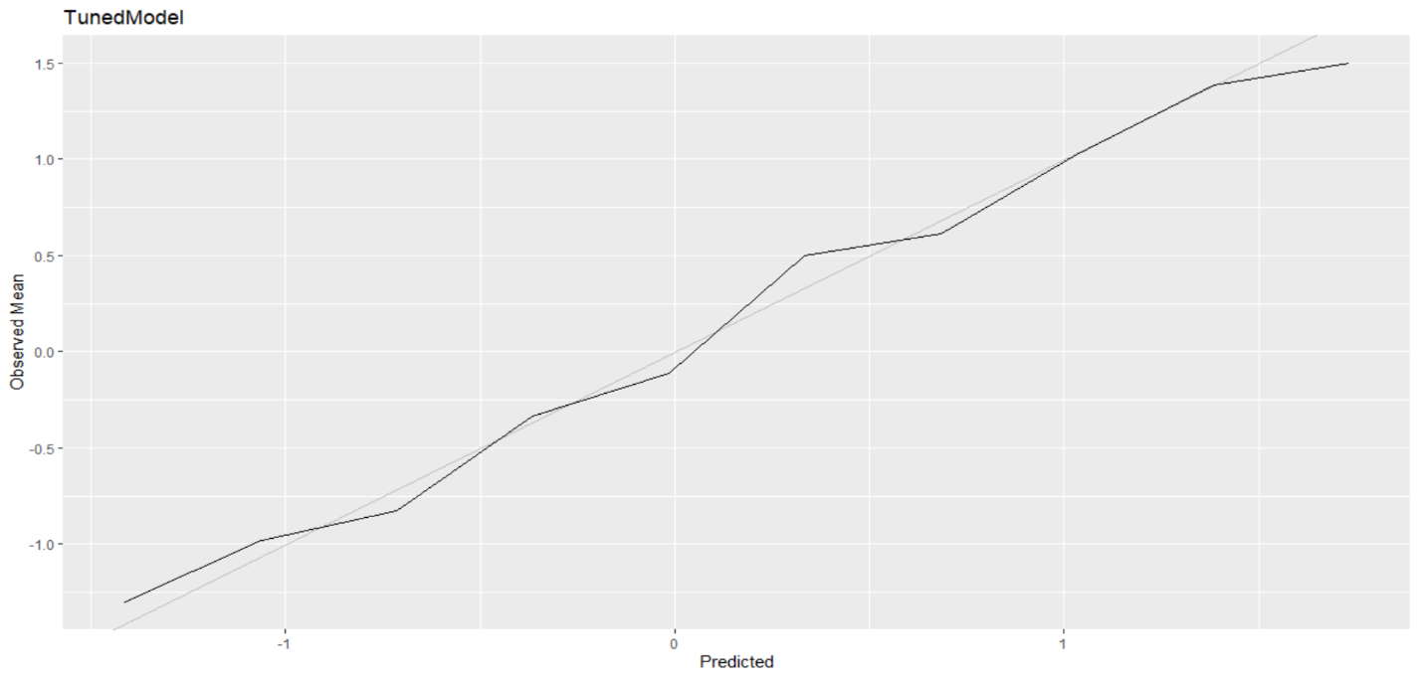
Appendix III. Calibration plot showing the relationship between the observed means and predicted means.

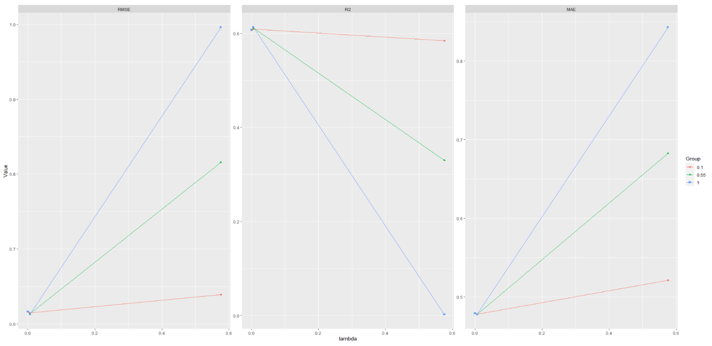
Appendix IV. Partial dependence plot showing the relationship between penalty function (Lambda) and the performance parameters (Lasso model)

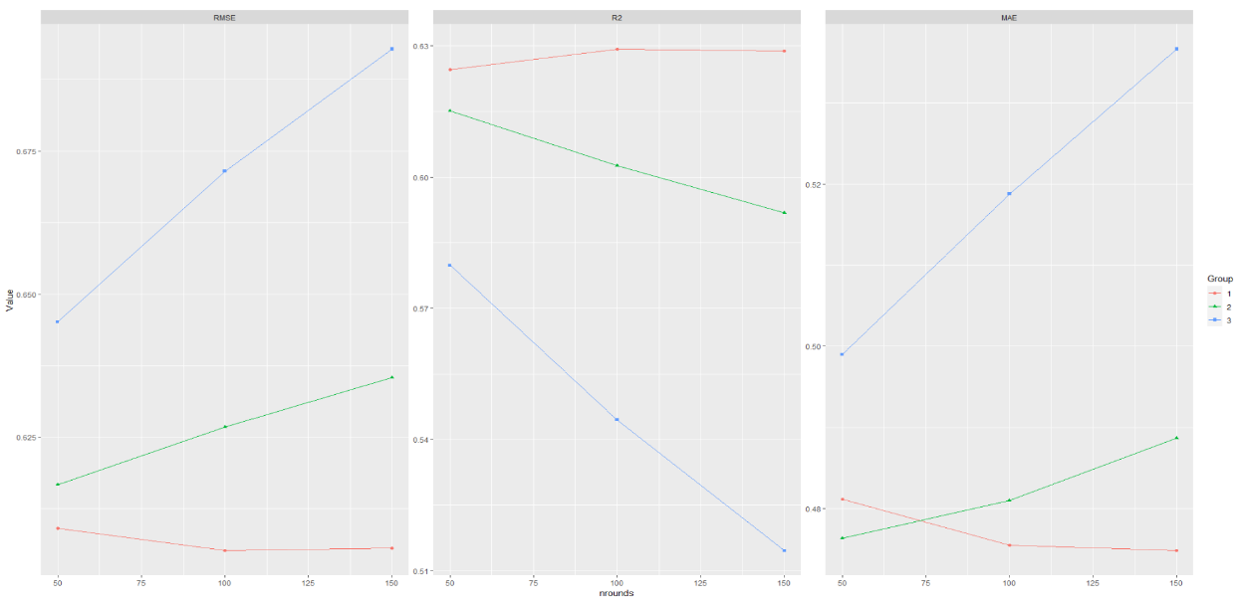
Appendix V. Partial dependence plot showing the relationship between penalty function (Lambda) and the performance perimeter. (XG-BOOST)

Appendix VI. Chart showing variable importance (XG-BOOST)
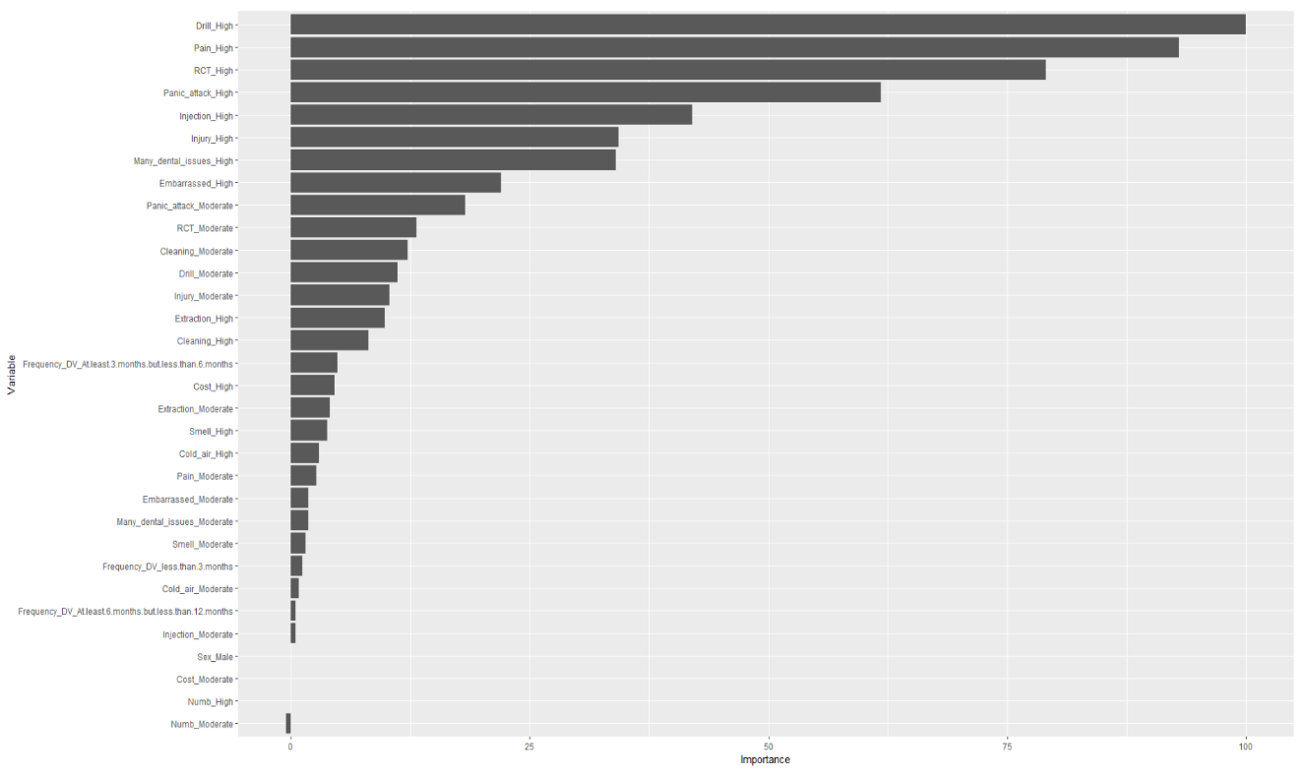

Appendix VII. Showing the performance of the XG-BOOST regression model.

Metrics | Mean | Median | SD | Min | Max
RMSE | 0.618 | 0.622 | 0.035 | 0.585 | 0.667
R² | 0.615 | 0.630 | 0.048 | 0.532 | 0.654
MAE | 0.483 | 0.476 | 0.022 | 0.455 | 0.507
RMSE = Root mean square error; R² = Coefficient of determination; MAE = Mean absolute error

Appendix VIII. Calibration plot showing the relationship between the observed mean and predicted mean (XG_BOOST).

