Supplemental Table 1. Associations between self-reported household exposures and COVID-19 outcomes in the second wave (2021) of the Tufts Equity in Health, Wealth, and Civic Engagement Study
Exposure | Probable or actual COVID-19 diagnosis  Unadjusted OR (95% CI; p)¹  Adjusted 1 OR (95% CI; p)²  Adjusted 2 OR (95% CI; p)³ | COVID-19 diagnosis  Unadjusted OR (95% CI; p)  Adjusted 1 OR (95% CI; p)  Adjusted 2 OR (95% CI; p) | Vaccinated/definitely willing to vaccinate for COVID-19 Unadjusted OR (95% CI; p)  Adjusted 1 OR (95% CI; p)  Adjusted 2 OR (95% CI; p)
Visible water damage or mold, or musty or moldy smell | 1.36 (0.97, 1.90)  1.35 (0.95, 1.91)  1.34 (0.95, 1.89) | 1.09 (0.71, 1.66)  1.12 (0.72, 1.74)  1.14 (0.74, 1.75) | 0.64 (0.47, 0.87)*  0.73 (0.53, 1.02)  0.74 (0.53, 1.03)
Smoking inside the home | 0.57 (0.30, 1.09)  0.63 (0.32, 1.22)  0.61 (0.31, 1.19) | 0.50 (0.18, 1.40)  0.58 (0.23, 1.50)  0.62 (0.22, 1.73) | 0.32 (0.21, 0.49)*  0.49 (0.31, 0.78)*  0.40 (0.25, 0.63)*
Negative impact: Poor outdoor air quality | 1.14 (0.71, 1.84)  1.19 (0.72, 1.96)  1.14 (0.70, 1.88) | 0.86 (0.45, 1.64)  0.79 (0.40, 1.56)  0.78 (0.40, 1.53) | 0.99 (0.64, 1.54)  0.79 (0.49, 1.28)  0.83 (0.51, 1.35)
Negative impact: Poor indoor air quality | 1.33 (0.81, 2.18)  1.51 (0.92, 2.49)  1.47 (0.90, 2.40) | 0.95 (0.52, 1.71)  1.09 (0.58, 2.05)  1.09 (0.59, 1.99) | 0.71 (0.45, 1.12)  0.73 (0.45, 1.20)  0.78 (0.47, 1.30)
Negative impact: Poor indoor temperature | 1.26 (0.71, 2.25)  1.18 (0.65, 2.13)  1.22 (0.68, 2.16) | 1.48 (0.73, 2.98)  1.52 (0.74, 3.10)  1.52 (0.76, 3.04) | 0.87 (0.48, 1.55)  1.08 (0.58, 2.04)  1.13 (0.61, 2.12)
Negative impact: Poor water quality | 1.26 (0.70, 2.27)  1.35 (0.75, 2.43)  1.36 (0.76, 2.43) | 0.67 (0.27, 1.66)  0.72 (0.29, 1.82)  0.70 (0.28, 1.76) | 0.45 (0.26, 0.78)*  0.37 (0.20, 0.68)*  0.42 (0.21, 0.85)*
Negative impact: Poor physical condition | 1.69 (0.99, 2.90)  1.78 (0.99, 3.17)  1.75 (0.99, 3.10) | 1.95 (1.02, 3.72)*  2.42 (1.22, 4.79)*  2.32 (1.17, 4.59)* | 0.52 (0.31, 0.87)*  0.76 (0.40, 1.43)  0.71 (0.37, 1.34)
Negative impact: Presence of pests | 1.40 (0.83, 2.35)  1.44 (0.86, 2.40)  1.42 (0.86, 2.35) | 0.94 (0.51, 1.73)  1.01 (0.54, 1.87)  0.99 (0.54, 1.81) | 0.70 (0.44, 1.11)  0.83 (0.52, 1.32)  0.93 (0.56, 1.52)
Negative impact: Nighttime noise from road traffic | 0.89 (0.50, 1.58)  0.92 (0.49, 1.72)  0.93 (0.50, 1.71) | 0.73 (0.34, 1.58)  0.88 (0.41, 1.89)  0.86 (0.40, 1.84) | 0.73 (0.42, 1.28)  1.02 (0.56, 1.84)  1.18 (0.64, 2.19)
Negative impact: Nighttime noise from aircraft or railways | 1.15 (0.56, 2.34)  1.26 (0.59, 2.69)  1.23 (0.59, 2.58) | 0.53 (0.16, 1.70)  0.57 (0.17, 1.90)  0.56 (0.17, 1.82) | 0.65 (0.33, 1.25)  0.51 (0.22, 1.15)  0.59 (0.28, 1.25)
Negative impact: Neighborhood crime or drug activity | 1.27 (0.68, 2.35)  1.21 (0.68, 2.16)  1.19 (0.66, 2.13) | 1.27 (0.63, 2.55)  1.24 (0.64, 2.41)  1.25 (0.65, 2.38) | 0.74 (0.42, 1.29)  0.95 (0.49, 1.83)  1.01 (0.51, 2.00)
Negative impact: Lack of privacy | 1.50 (0.76, 2.98)  1.43 (0.69, 2.96)  1.47 (0.73, 2.96) | 0.65 (0.19, 2.16)  0.67 (0.20, 2.30)  0.69 (0.21, 2.27) | 0.35 (0.19, 0.67)*  0.49 (0.23, 1.08)  0.51 (0.24, 1.11)
Negative impact: Household member exposed to COVID-19 | 1.50 (0.71, 3.18)  1.57 (0.69, 3.57)  1.63 (0.74, 3.60) | 2.08 (0.88, 4.91)  2.25 (0.96, 5.26)  2.22 (0.94, 5.29) | 1.43 (0.67, 3.07)  1.55 (0.61, 3.91)  1.56 (0.53, 4.62)
*: p < 0.05
¹OR: odds ratio; CI = confidence interval; p = value
²Adjusted for age, gender, race/ethnicity, educational attainment, annual household income, ZIP-code level median household income, county-level population density, county-level annual air pollution, and county-level greenness
³Primary models adjusted for age, race/ethnicity, annual household income, county-level population density, county-level annual air pollution, and county-level greenness. These values are also shown in Table 2 but are reproduced here for ease of comparison.

Supplemental Table 2. Correlations between heating and cooling source for participants in the second wave (2021) of the Tufts Equity in Health, Wealth, and Civic Engagement Study¹
 |  | Heating source
 |  | Central gas, or gas/oil furnace or boiler | Heat pump | Space heater (combustion or electric) | Wood stove or gas/wood fireplace | None of the above | Don't know
Cooling source | Central air conditioning | <0.001* (641) | <0.001* (126) | <0.001* (47) | 0.273 (104) | 0.025* (78) | <0.001* (20)
Cooling source | Window/wall air conditioning | 0.030* (145) | <0.001* (8) | <0.001* (43) | 0.295 (37) | 0.575 (22) | 0.874 (11)
Cooling source | Fans | 0.831 (300) | 0.008* (32) | 0.008* (58) | 0.019* (73) | 0.223 (53) | 0.011* (10)
Cooling source | Open windows | 0.339 (273) | 0.045* (30) | 0.015* (51) | <0.001* (74) | 0.225 (34) | 0.053 (10)
Cooling source | Evaporative cooling, humidifier, or HEPA or electrostatic filter | 0.178 (32) | 0.391 (3) | <0.001* (28) | 0.008* (13) | 0.744 (5) | 0.268 (0)
Cooling source | None of the above | <0.001* (1) | 0.303 (2) | 0.411 (0) | 0.151 (2) | 0.014* (3) | 0.594 (0)
Cooling source | Don't know | <0.001* (1) | 0.254 (0) | 0.29 (0) | 0.149 (1) | 0.263 (0) | <0.001* (23)

*p < 0.05
¹Cells show the weighted Pearson’s chi-squared p-value for the association between use of the given heating and cooling sources, along with the weighted sample size of participants who use the stated combination of heating and cooling sources.

Supplemental Table 3. Associations between self-reported heating and cooling sources and COVID-19 outcomes in the second wave (2021) of the Tufts Equity in Health, Wealth, and Civic Engagement Study
Exposure | Probable or actual COVID-19 diagnosis  Unadjusted OR (95% CI; p)¹  Adjusted 1 OR (95% CI; p)²  Adjusted 2 OR (95% CI; p)³ | COVID-19 diagnosis  Unadjusted OR (95% CI; p)  Adjusted 1 OR (95% CI; p)  Adjusted 2 OR (95% CI; p) | Vaccinated/definitely willing to vaccinate for COVID-19 Unadjusted OR (95% CI; p)  Adjusted 1 OR (95% CI; p)  Adjusted 2 OR (95% CI; p)
Heating source: Central gas, or gas/oil furnace or boiler | 1.09 (0.79, 1.50)  1.14 (0.81, 1.59)  1.15 (0.82, 1.60) | 1.19 (0.78, 1.82)  1.21 (0.77, 1.89)  1.20 (0.77, 1.89) | 1.53 (1.15, 2.03)*  1.20 (0.88, 1.64)  1.21 (0.89, 1.64)
Heating source: Heat pump | 0.88 (0.51, 1.53)  0.95 (0.53, 1.70)  0.93 (0.53, 1.66) | 0.83 (0.36, 1.87)  0.90 (0.40, 2.07)  0.86 (0.38, 1.98) | 1.61 (0.94, 2.76)  1.60 (0.94, 2.75)  1.56 (0.89, 2.73)
Heating source: Space heater (combustion or electric) | 1.01 (0.58, 1.77)  0.91 (0.51, 1.61)  0.91 (0.51, 1.60) | 1.51 (0.78, 2.93)  1.42 (0.72, 2.81)  1.43 (0.72, 2.82) | 0.71 (0.44, 1.13)  0.75 (0.44, 1.30)  0.77 (0.44, 1.36)
Heating source: Wood stove or gas/wood fireplace | 1.43 (0.89, 2.29)  1.43 (0.88, 2.32)  1.45 (0.89, 2.35) | 0.83 (0.43, 1.61)  0.81 (0.40, 1.65)  0.81 (0.40, 1.63) | 0.77 (0.49, 1.19)  0.70 (0.44, 1.12)  0.70 (0.44, 1.13)
Heating source: None | 0.91 (0.58, 1.45)  0.92 (0.57, 1.47)  0.92 (0.58, 1.47) | 1.05 (0.58, 1.89)  1.00 (0.55, 1.82)  0.99 (0.55, 1.79) | 0.87 (0.56, 1.34)  0.95 (0.57, 1.57)  0.93 (0.59, 1.47)
Cooling source: Central air conditioning | 0.81 (0.58, 1.13)  0.84 (0.59, 1.21)  0.84 (0.59, 1.20) | 0.79 (0.52, 1.21)  0.81 (0.52, 1.26)  0.81 (0.52, 1.24) | 1.51 (1.12, 2.03)*  1.15 (0.82, 1.61)  1.31 (0.95, 1.83)
Cooling source: Window/wall air conditioning | 1.58 (1.09, 2.29)*  1.59 (1.07, 2.36)*  1.57 (1.06, 2.32)* | 1.46 (0.92, 2.32)  1.50 (0.92, 2.43)  1.53 (0.94, 2.48) | 0.56 (0.40, 0.79)*  0.87 (0.61, 1.26)  0.72 (0.50, 1.03)
Cooling source: Fans | 0.87 (0.63, 1.19)  0.91 (0.65, 1.27)  0.90 (0.65, 1.26) | 0.71 (0.46, 1.08)  0.77 (0.50, 1.19)  0.75 (0.48, 1.16) | 0.92 (0.69, 1.24)  0.95 (0.69, 1.30)  1.00 (0.73, 1.37)
Cooling source: Open windows | 0.84 (0.60, 1.18)  0.87 (0.61, 1.23)  0.87 (0.61, 1.23) | 0.67 (0.42, 1.05)  0.75 (0.47, 1.19)  0.71 (0.45, 1.13) | 1.15 (0.84, 1.56)  1.10 (0.80, 1.53)  1.25 (0.90, 1.73)
Cooling source: Evaporative cooling, humidifier, or HEPA or electrostatic filter | 0.94 (0.43, 2.07)  1.09 (0.49, 2.45)  0.99 (0.45, 2.20) | 1.27 (0.48, 3.39)  1.48 (0.53, 4.15)  1.34 (0.49, 3.67) | 0.84 (0.38, 1.84)  0.66 (0.28, 1.56)  0.78 (0.31, 1.97)
Cooling source: None | 0.46 (0.05, 3.86)  0.50 (0.05, 4.89)  0.48 (0.05, 4.83) | ⁴ | 0.78 (0.18, 3.35)  0.68 (0.16, 2.82)  0.52 (0.14, 1.97)
Heating/cooling combination: Central gas, or gas/oil furnace or boiler with central air conditioning | 0.86 (0.63, 1.17)  0.87 (0.62, 1.21)  0.87 (0.63, 1.21) | 0.86 (0.58, 1.28)  0.83 (0.54, 1.28)  0.84 (0.54, 1.28) | 1.58 (1.18, 2.11)*  1.16 (0.85, 1.59)  1.25 (0.92, 1.69)
Heating/cooling combination: Central gas, or gas/oil furnace or boiler with window/wall air conditioning | 2.01 (1.24, 3.26)*  2.15 (1.30, 3.56)*  2.13 (1.29, 3.50)* | 1.54 (0.85, 2.78)  1.63 (0.90, 2.94)  1.64 (0.91, 2.94) | 0.69 (0.43, 1.09)  0.87 (0.52, 1.45)  0.73 (0.43, 1.22)
Heating/cooling combination: Heat pump with central air conditioning | 0.94 (0.53, 1.67)  1.02 (0.56, 1.87)  0.99 (0.54, 1.80) | 0.89 (0.38, 2.05)  1.00 (0.43, 2.33)  0.92 (0.39, 2.16) | 1.56 (0.89, 2.71)  1.55 (0.89, 2.70)  1.56 (0.87, 2.79)
Heating/cooling combination: Heat pump with fans | 0.84 (0.29, 2.47)  0.88 (0.28, 2.79)  0.86 (0.27, 2.74) | ⁴ | 1.99 (0.73, 5.46)  1.58 (0.56, 4.48)  1.71 (0.58, 5.05)
Heating/cooling combination: Heat pump with open windows | 0.35 (0.09, 1.32)  0.35 (0.08, 1.44)  0.34 (0.09, 1.38) | 0.09 (0.01, 0.71)*  0.09 (0.01, 0.69)*  0.09 (0.01, 0.67)* | 1.72 (0.41, 7.26)  1.58 (0.45, 5.59)  1.47 (0.34, 6.27)
Heating/cooling combination: Space heater (combustion or electric) with central air conditioning | 0.93 (0.38, 2.24)  0.85 (0.35, 2.08)  0.88 (0.36, 2.14) | 1.76 (0.69, 4.52)  1.74 (0.68, 4.45)  1.86 (0.71, 4.88) | 0.82 (0.37, 1.82)  0.99 (0.38, 2.61)  0.95 (0.34, 2.68)
Heating/cooling combination: Space heater (combustion or electric) with window/wall air conditioning | 0.86 (0.34, 2.18)  0.73 (0.28, 1.89)  0.73 (0.28, 1.91) | 1.27 (0.41, 3.90)  1.16 (0.36, 3.68)  1.12 (0.35, 3.57) | 0.57 (0.29, 1.12)  0.67 (0.35, 1.25)  0.73 (0.38, 1.40)
Heating/cooling combination: Space heater (combustion or electric) with fans | 1.01 (0.45, 2.24)  0.94 (0.41, 2.12)  0.96 (0.43, 2.17) | 0.87 (0.28, 2.76)  0.87 (0.27, 2.80)  0.88 (0.27, 2.87) | 0.62 (0.31, 1.21)  0.75 (0.35, 1.63)  0.79 (0.34, 1.84)
Heating/cooling combination: Space heater (combustion or electric) with open windows | 0.38 (0.14, 1.08)  0.36 (0.12, 1.04)  0.35 (0.12, 1.01) | 0.17 (0.04, 0.74)*  0.16 (0.04, 0.75)*  0.15 (0.03, 0.69)* | 0.96 (0.45, 2.07)  0.94 (0.34, 2.61)  1.09 (0.39, 3.03)
Heating/cooling combination: Space heater (combustion or electric) with evaporative cooling, humidifier, or HEPA or electrostatic filter | 1.19 (0.44, 3.23)  1.20 (0.43, 3.34)  1.16 (0.42, 3.19) | 1.81 (0.59, 5.63)  1.84 (0.55, 6.19)  1.76 (0.53, 5.86) | 0.64 (0.24, 1.75)  0.55 (0.17, 1.77)  0.56 (0.16, 1.93)
Heating/cooling combination: Wood stove or gas/wood fireplace with fans | 0.78 (0.42, 1.48)  0.76 (0.40, 1.43)  0.77 (0.41, 1.46) | 0.37 (0.14, 1.00)*  0.36 (0.13, 0.98)*  0.35 (0.13, 0.94)* | 0.78 (0.42, 1.47)  0.61 (0.31, 1.19)  0.63 (0.33, 1.23)
Heating/cooling combination: Wood stove or gas/wood fireplace with open windows | 0.97 (0.51, 1.84)  0.96 (0.50, 1.84)  0.99 (0.51, 1.89) | 0.60 (0.22, 1.61)  0.61 (0.22, 1.67)  0.60 (0.22, 1.63) | 0.89 (0.46, 1.71)  0.68 (0.34, 1.35)  0.76 (0.38, 1.52)
Heating/cooling combination: No heating with central air conditioning | 0.95 (0.55, 1.64)  0.95 (0.55, 1.64)  0.97 (0.56, 1.67) | 1.05 (0.53, 2.07)  0.95 (0.49, 1.86)  0.99 (0.51, 1.92) | 0.88 (0.54, 1.44)  0.78 (0.43, 1.43)  0.86 (0.50, 1.47)
*: p < 0.05
¹OR: odds ratio; CI = confidence interval; p = value
²Adjusted for age, gender, race/ethnicity, educational attainment, annual household income, ZIP-code level median household income, county-level population density, county-level annual air pollution, and county-level greenness
³Primary models adjusted for race/ethnicity, annual household income, county-level population density, county-level annual air pollution, and county-level greenness. These values are also shown in Table 3 but are reproduced here for ease of comparison.
⁴Not applicable. No people with exposure and outcome.

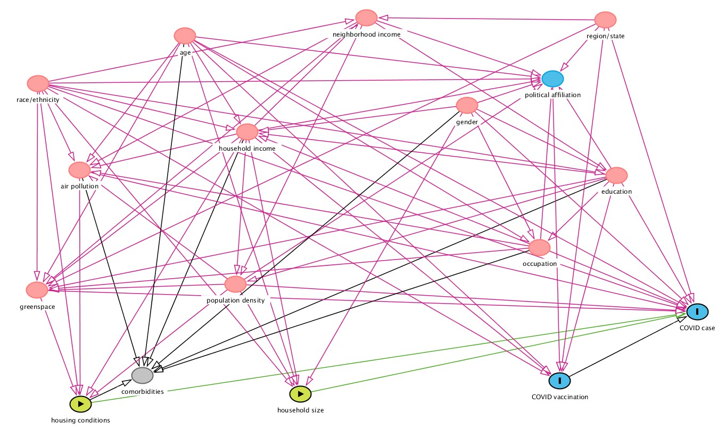

Supplemental Figure 1. Directed acyclic graph showing the conceptual model.
“Housing conditions” and “household size” are the exposure variables (green box) and have causal paths (green arrows) to “COVID case” and “COVID vaccination” outcomes (blue box with a vertical rectangle). The pink arrows indicate biasing paths. The variables in pink circles are ancestors of both the exposure and outcome. To identify the minimal sufficient adjustment set, we used either exposure variable and allowed the other to remain as another node in the model.
- 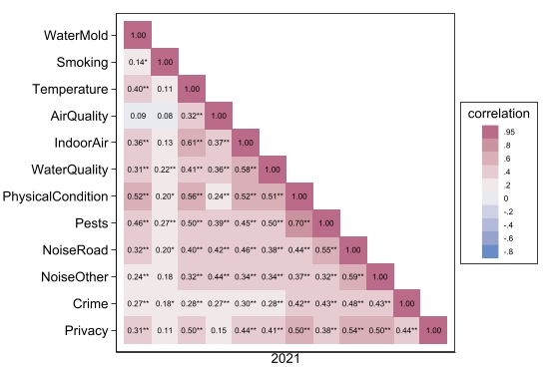
- 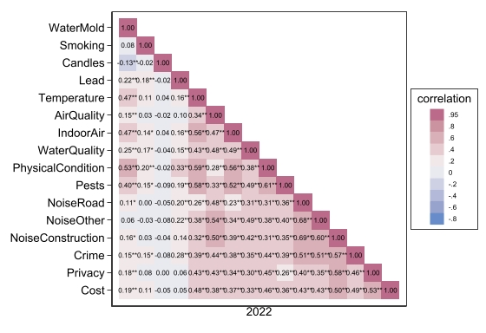
Supplemental Figure 2. Unweighted tetrachoric correlations among select self-reported household exposures in the Tufts Equity in Health, Wealth, and Civic Engagement Study for 2021 (a) and 2022 (b). ** p < 0.01; * p < 0.05

Supplementary Text

We identified 13 target variables (age, gender, race/ethnicity, educational attainment, individual income, community-level median household income, population density, particulate matter (PM_{2.5}), greenness, region/state, having COVID-19 comorbidities, occupation, and political affiliation) that possibly confound the relationship between exposures (household size or housing conditions) and outcomes (COVID-19 diagnosis or vaccination). We searched the literature for associations between the target variables and the exposure or outcome variables. This was done using a Google Scholar search with the following terms: “Effect of/association between/relationship between” [Variable A] and [Variable B]; or “how does [Variable A] affect [Variable B]”. Additional literature was also found in the references of identified articles.

Literature supporting our conceptual model

- Age is associated with…
  - Income [46]
  - PM_{2.5} exposure [47]
  - COVID-19 comorbidities [48]
  - Occupation [49]
  - Political affiliation [50]
  - Household size [51]
  - COVID-19 cases [52]
  - COVID-19 vaccination [53]
- Gender is associated with…
  - Education [54]
  - Income [55]
  - COVID-19 comorbidities [56]
  - Occupation [57]
  - Political affiliation [58]
  - Household size [59]
  - COVID-19 vaccination [42]
- Race is associated with…
  - Education [60]
  - Household size [61]
  - Housing quality [62,63]
  - Income [64]
  - PM_{2.5} exposure [65]
  - Greenness [2]
  - Political affiliation [66]
  - COVID-19 cases [67–70]
  - COVID-19 vaccination [53]
- Education is associated with…
  - Income [46]
  - Population density [71]
  - COVID-19 comorbidities [72]
  - Occupation [73]
  - Political affiliation [74]
  - COVID-19 cases [75]
  - COVID-19 vaccination [76]
- Individual income is associated with…
  - Median household income
  - COVID-19 comorbidities [77]
  - Political affiliation [78]
  - Household size [79]
  - Housing quality [80]
  - COVID-19 vaccination [53]
- Median household income is associated with…
  - Education [81]
  - PM_{2.5} exposure [82]
  - Greenness [83]
  - Population density [84]
  - Political affiliation [85]
  - Household size [86]
- Household size is associated with…
  - Population density
  - COVID-19 cases [87]
  - COVID-19 vaccination [88]
- Population density is associated with…
  - PM_{2.5} exposure [89]
  - Greenness [90]
  - Political affiliation [91]
  - Housing quality [92]
  - COVID-19 cases [67,93]
- PM_{2.5} exposure is associated with…
  - COVID-19 comorbidities [94]
  - Housing quality [95]
  - COVID-19 cases [94]
- Greenness is associated with…
  - COVID-19 comorbidities [96]
  - Housing quality [97]
  - COVID-19 cases [98]
- Region is associated with…
  - Median household income [99]
  - Greenness
  - Political affiliation [91]
  - COVID-19 vaccination [100]
- COVID-19 comorbidities are associated with…
  - COVID-19 cases [101]
- Occupation is associated with…
  - Income
  - PM_{2.5} exposure [102]
  - Greenness [103]
  - COVID-19 comorbidities [104]
  - COVID-19 cases [105]
- Political affiliation is associated with…
  - COVID-19 cases [106]
  - COVID-19 vaccination [107]
- Housing quality is associated with…
  - COVID-19 comorbidities [8]
  - COVID-19 cases [108]
- COVID-19 vaccination is associated with…
  - COVID-19 cases [109]
Conceptual model code

dag {
"COVID case" [outcome,pos="0.512,0.948"]
"COVID vaccination" [outcome,pos="0.035,1.713"]
"air pollution" [pos="-1.631,-0.621"]
"household income" [pos="-1.050,-1.041"]
"household size" [exposure,pos="-0.865,1.860"]
"housing conditions" [exposure,pos="-1.628,1.970"]
"neighborhood income" [pos="-0.636,-2.306"]
"political affiliation" [pos="0.010,-1.633"]
"population density" [pos="-1.090,0.643"]
"race/ethnicity" [pos="-1.776,-1.580"]
"region/state" [pos="0.193,-2.285"]
age [pos="-1.265,-2.106"]
comorbidities [pos="-1.413,1.656"]
education [pos="0.231,-0.561"]
gender [pos="-0.286,-1.335"]
greenness [pos="-1.778,0.711"]
occupation [pos="-0.035,0.237"]
"COVID vaccination" -> "COVID case"
age -> "household income"
age -> "air pollution"
age -> greenness
age -> comorbidities
age -> occupation
age -> "political affiliation"
age -> "household size"
age -> "COVID case"
age -> "COVID vaccination"
gender -> education
gender -> "household income"
gender -> comorbidities
gender -> occupation
gender -> "political affiliation"
gender -> "household size"
gender -> "COVID case"
"race/ethnicity" -> education
"race/ethnicity" -> "household income"
"race/ethnicity" -> "neighborhood income"
"race/ethnicity" -> "air pollution"
"race/ethnicity" -> greenness
"race/ethnicity" -> "political affiliation"
"race/ethnicity" -> "housing conditions"
"race/ethnicity" -> "household size"
"race/ethnicity" -> "COVID case"
"race/ethnicity" -> "COVID vaccination"
education -> "household income"
education -> "population density"
education -> greenness
education -> comorbidities
education -> occupation
education -> "political affiliation"
education -> "COVID case"
education -> "COVID vaccination"
"household income" -> "neighborhood income"
"household income" -> "air pollution"
"household income" -> greenness
"household income" -> "population density"
"household income" -> comorbidities
"household income" -> "political affiliation"
"household income" -> "housing conditions"
"household income" -> "household size"
"household income" -> "COVID vaccination"
"neighborhood income" -> education
"neighborhood income" -> "population density"
"neighborhood income" -> "air pollution"
"neighborhood income" -> greenness
"neighborhood income" -> "political affiliation"
"population density" -> "air pollution"
"population density" -> greenness
"population density" -> "political affiliation"
"population density" -> "housing conditions"
"population density" -> "household size"
"political affiliation" -> "COVID vaccination"
"population density" -> "COVID case"
"air pollution" -> comorbidities
"air pollution" -> "housing conditions"
"air pollution" -> "COVID case"
greenness -> "housing conditions"
greenness -> "COVID case"
"region/state" -> "neighborhood income"
"region/state" -> greenness
"region/state" -> "political affiliation"
"region/state" -> "COVID case"
"region/state" -> "COVID vaccination"
occupation -> "household income"
occupation -> "air pollution"
occupation -> greenness
occupation -> comorbidities
occupation -> "political affiliation"
occupation -> "COVID case"
"household size" -> "COVID case"
"housing conditions" -> comorbidities
"housing conditions" -> "COVID case"
}

