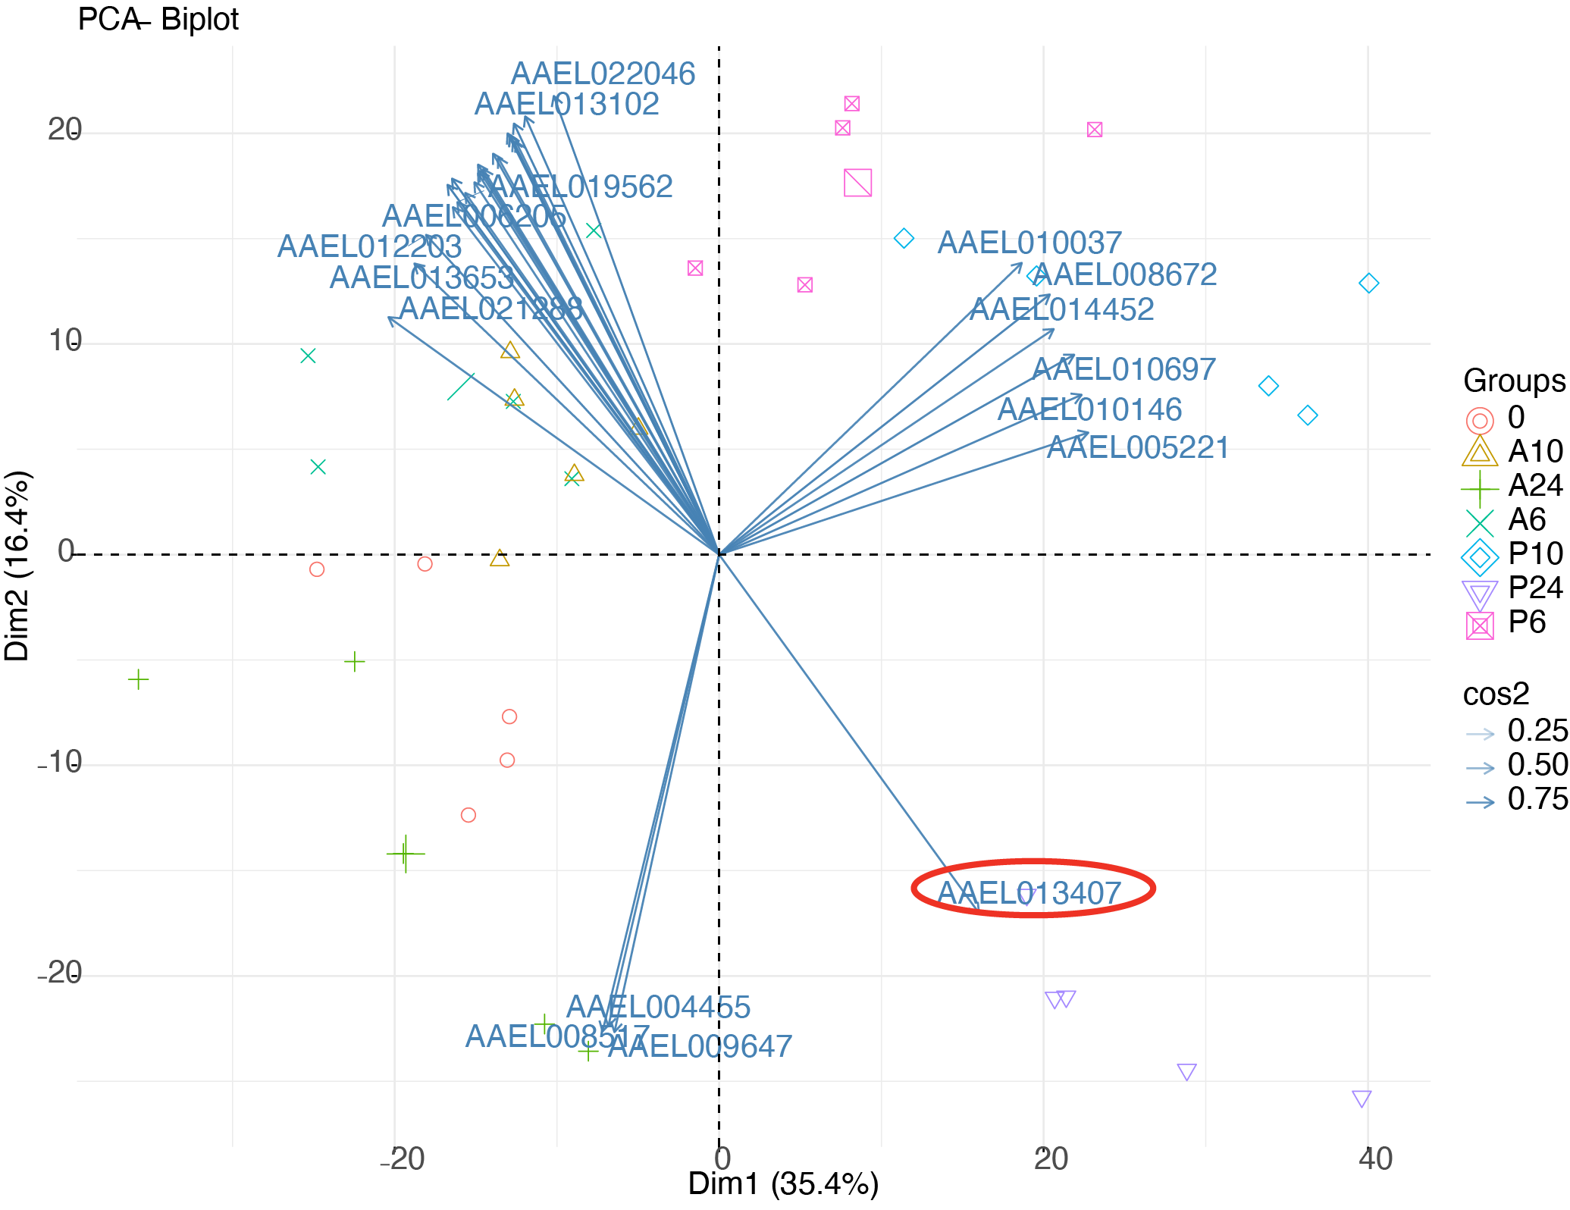

Supplementary Figure 1. Biplot of PCA in Fig. 1.

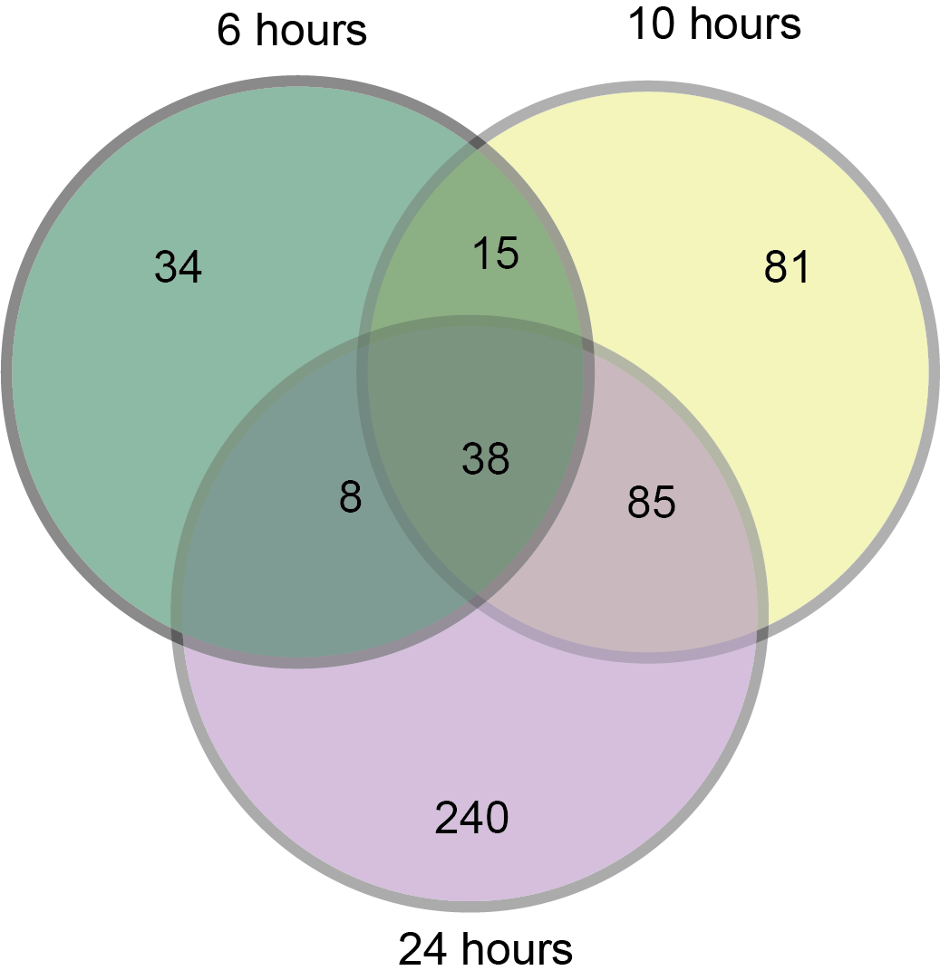
Supplementary Figure 2. Summary of pairwise gene expression overlap of upregulated genes, FDR < 0.05.

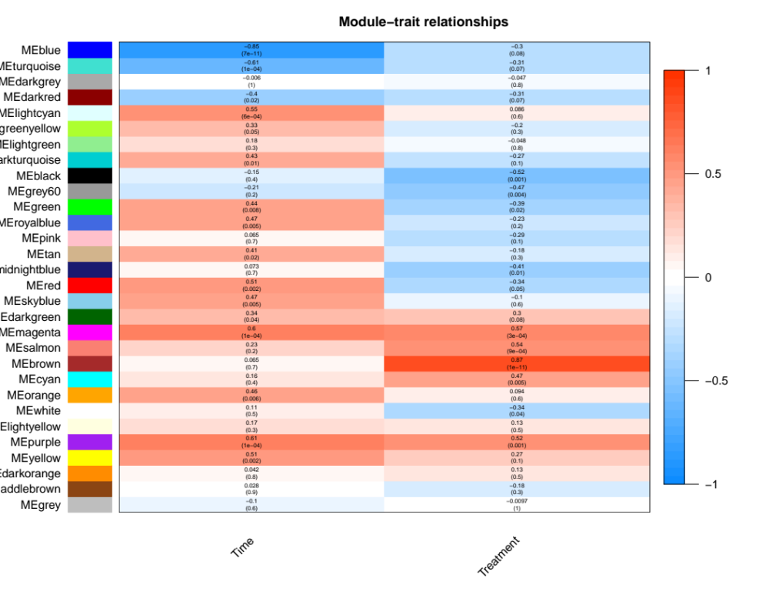
Supplementary Figure 3. Heat map from WGCNA analysis showing correlation with time and treatment.

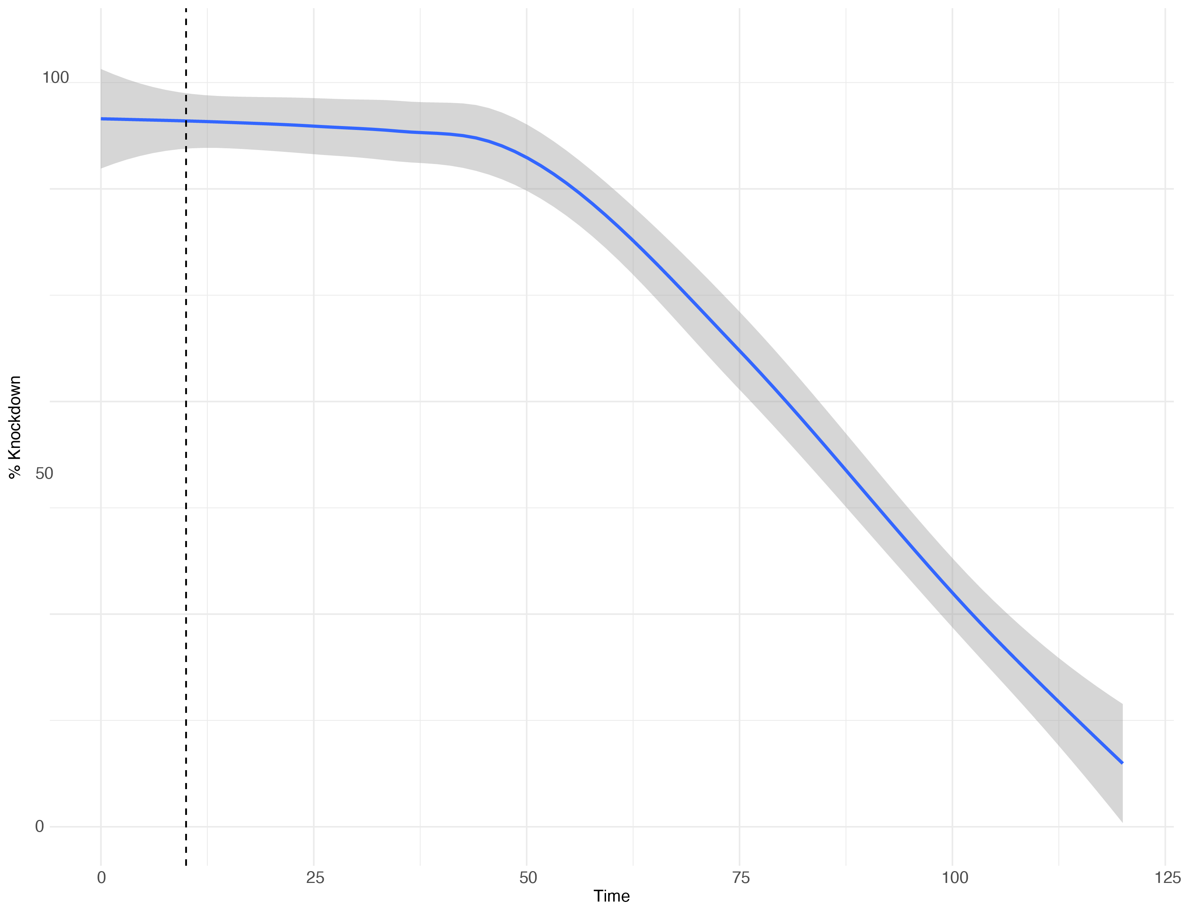

Supplementary Figure 4. Knockdown curve from CDC bottle bioassay. Dashed line indicated diagnostic time

