EEG-based Emotional Valence and Emotion Regulation Classification: A Data-centric and Explainable Approach
Linda Fiorini^{1,+}, Francesco Bossi^{1,+}, and Francesco Di Gruttola^{1,*}

1 Molecular Mind Laboratory (MoMiLab), IMT School for Advanced Studies Lucca, Lucca, Italy

+ These authors contributed equally to this work
* Corresponding author: Mail: francesco.digruttola@gmail.com

Figure 1,2,3 and 4 show example of matrix of the Integrated Gradient (IG) attribution score for each EEG feature (channels x time) in every deep learning model considered.
In the matrix, each element represents the importance of a feature in the model’s prediction. The colors in the matrix indicate the magnitude and direction of the feature’s importance. Blue represents high positive importance, while yellow represents high negative importance. The intensity of the color reflects the magnitude of the importance, with more intense colors indicating higher importance. It can be observed that each model has a unique pattern of feature importance, which remains consistent for different stimuli and conditions within the same model.

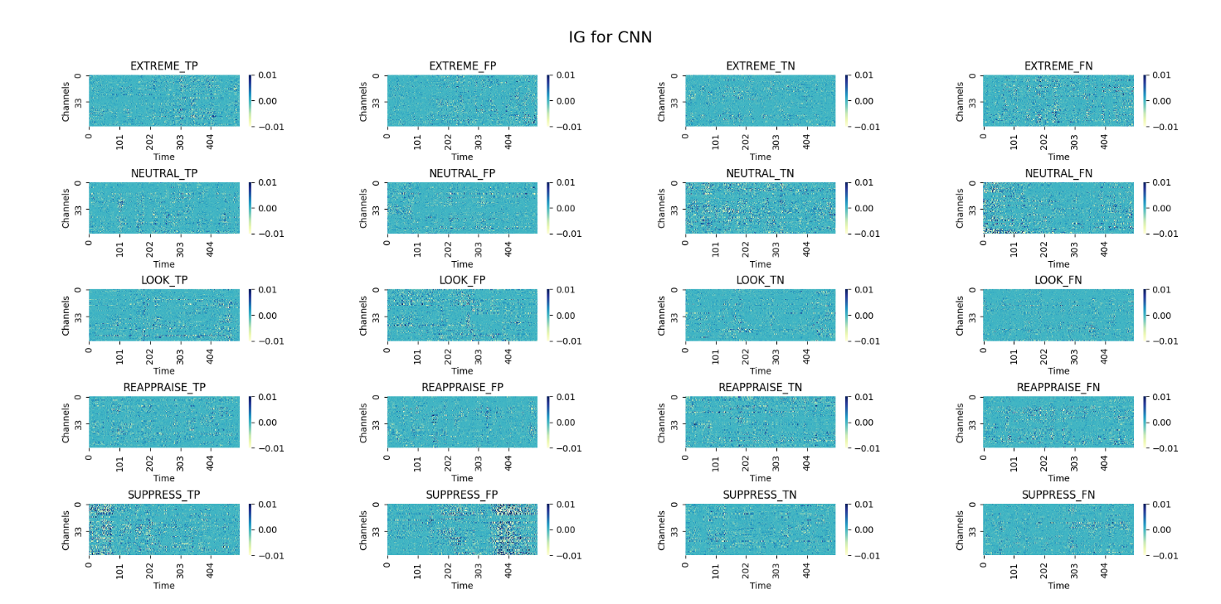
Figure 1. Graphical representation of the gradient attributions for each class for the CNN model.
TP=True positive, FP=False positive, TN=True negative, FN= False negative.

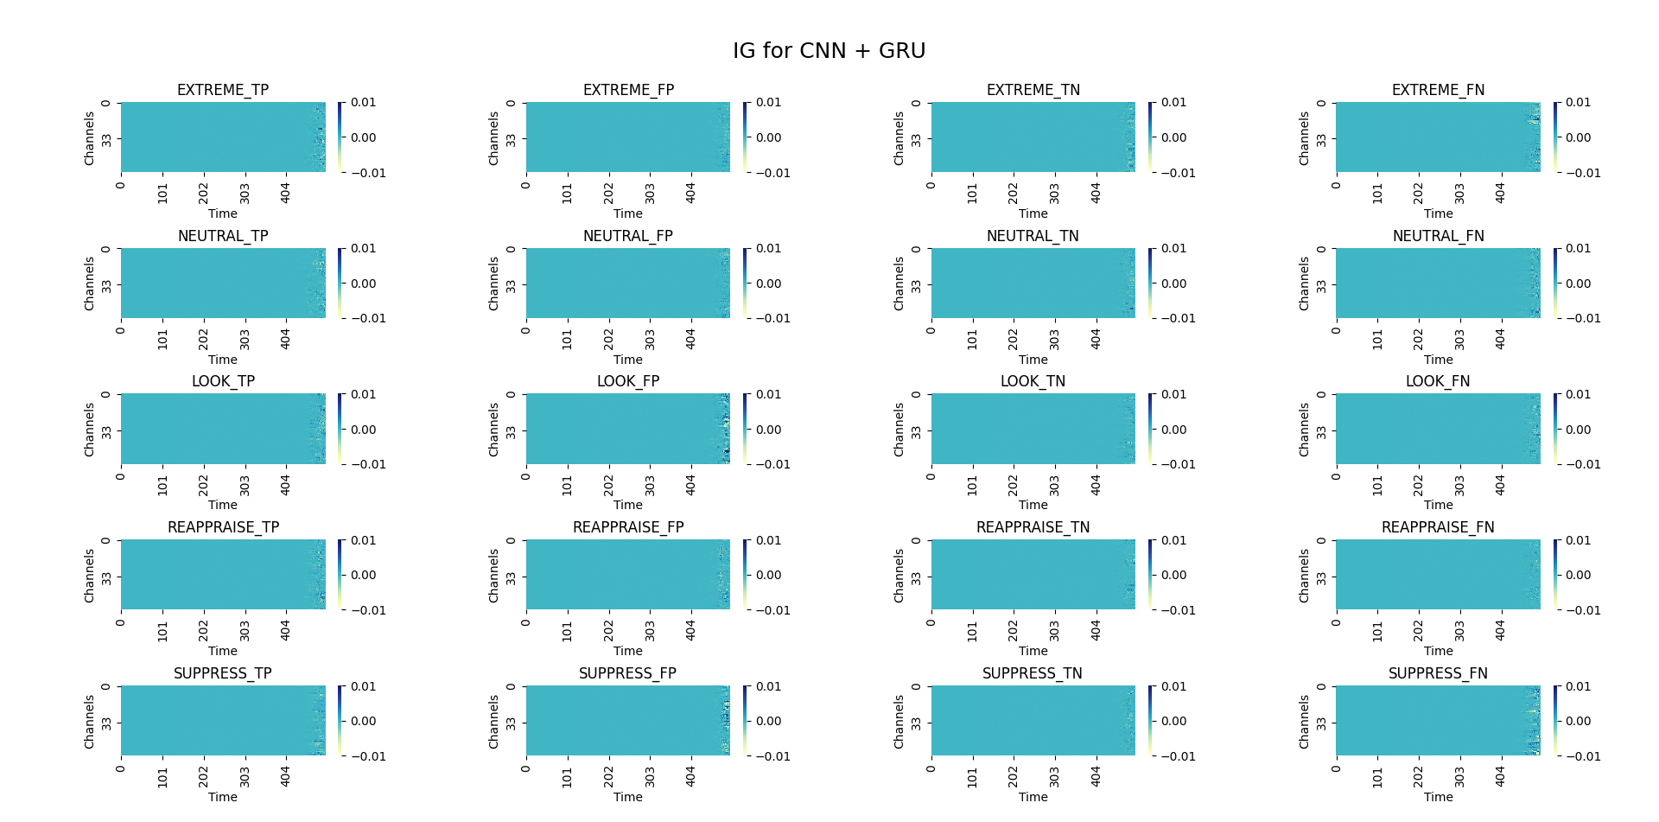
Figure 2. Graphical representation of the gradient attributions for each class for the CNN+GRU model.
TP=True positive, FP=False positive, TN=True negative, FN= False negative.

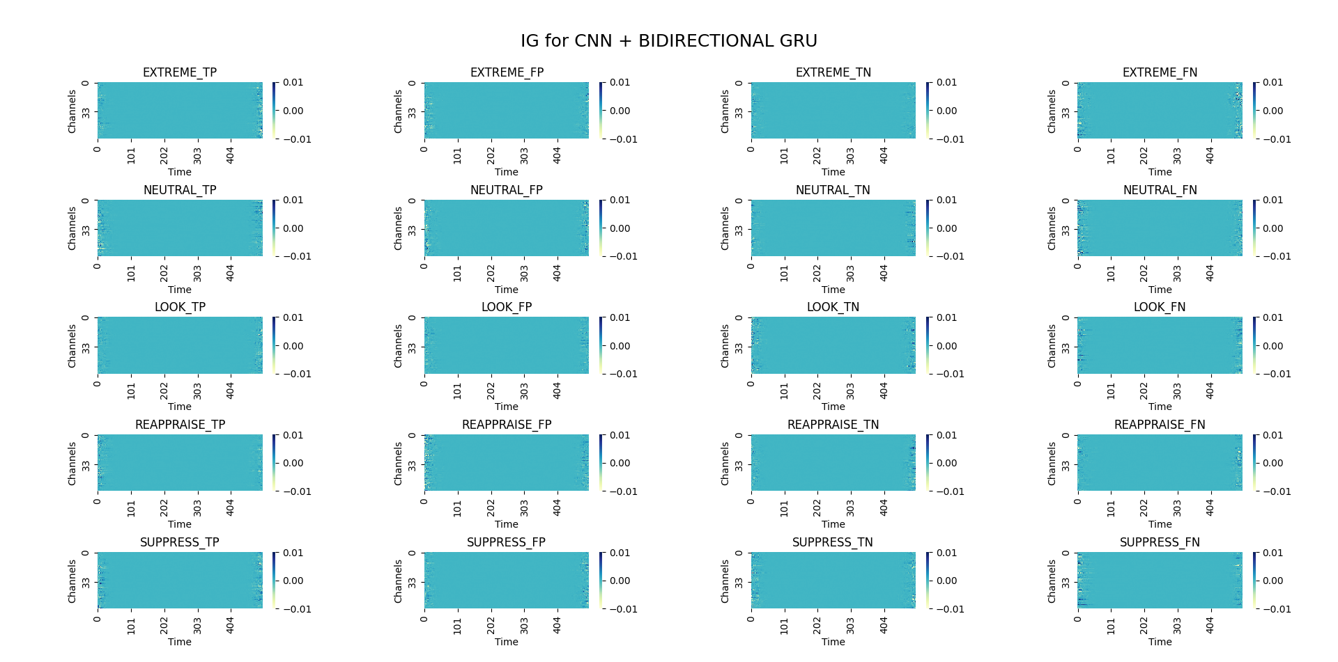
Figure 3. Graphical representation of the gradient attributions for each class for CNN+ bidirectional GRU model.
TP=True positive, FP=False positive, TN=True negative, FN= False negative.

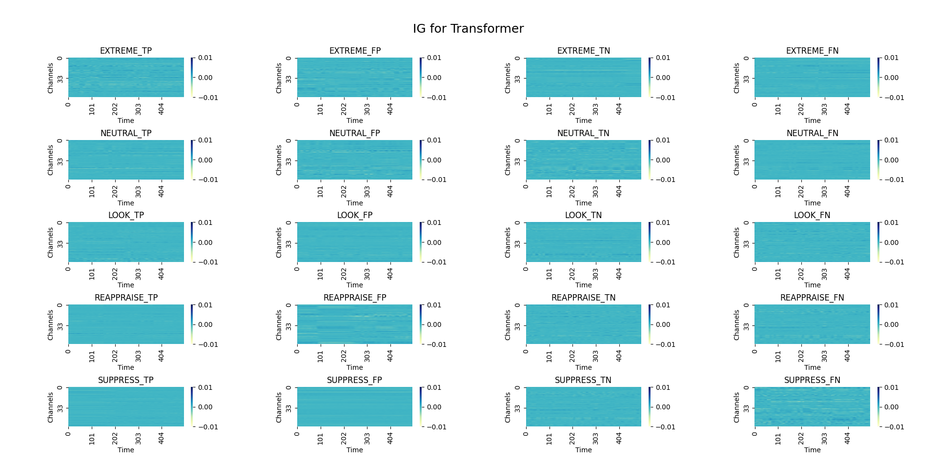
Figure 4. Graphical representation of the gradient attributions for each class for the transformer model.
TP=True positive, FP=False positive, TN=True negative, FN= False negative.

