SUPPLEMENTARY INFORMATION

Drought can delay or speed-up riverine flooding
Alessia Matanó¹, Wouter Berghuijs², Maurizio Mazzoleni¹, Marleen C. de Ruiter¹, Philip J. Ward^{1,3}, and Anne F. Van Loon¹
¹Institute for Environmental Studies (IVM), Vrije Universiteit Amsterdam, the Netherlands
²Department of Earth Sciences, Vrije Universiteit Amsterdam, the Netherlands
³Department of Climate Adaptation and Disaster Risk Management, Deltares, Delft, the Netherlands

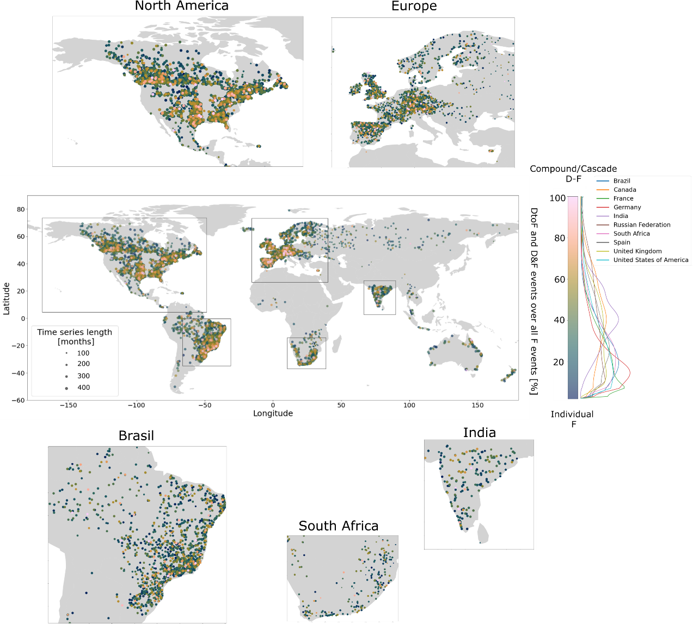

SFig. 1 - Occurrence of compound and consecutive drought-flood events per catchment. Percentage of DtoF and D&F events on total flood events by catchment, with close-up maps for North America, Europe, Brazil, South Africa and India and density chart by country (only countries with a minimum of 160 analysed catchments were selected, smoothing applied with a bandwidth of 1).
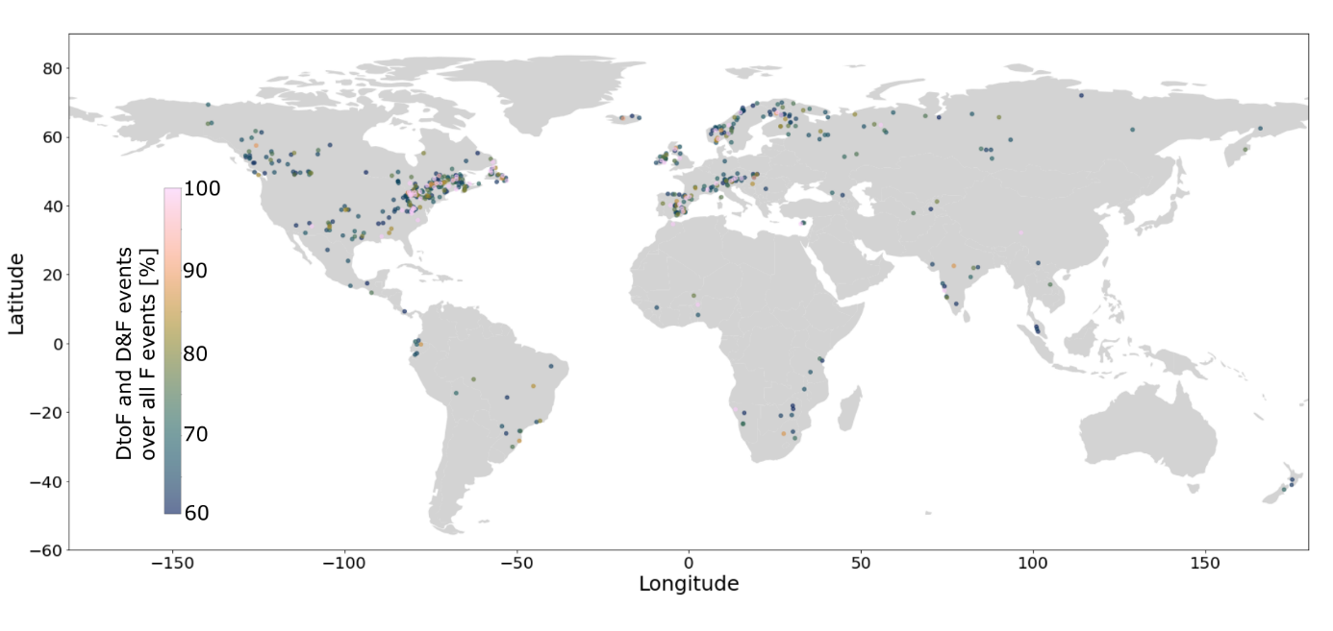
SFig. 2 - Occurrence of compound and consecutive drought-flood events per catchment above 60%. Stations with at least 60% of the flood events occurring during (compound, D&F) or soon after (consecutive, DtoF) drought periods.

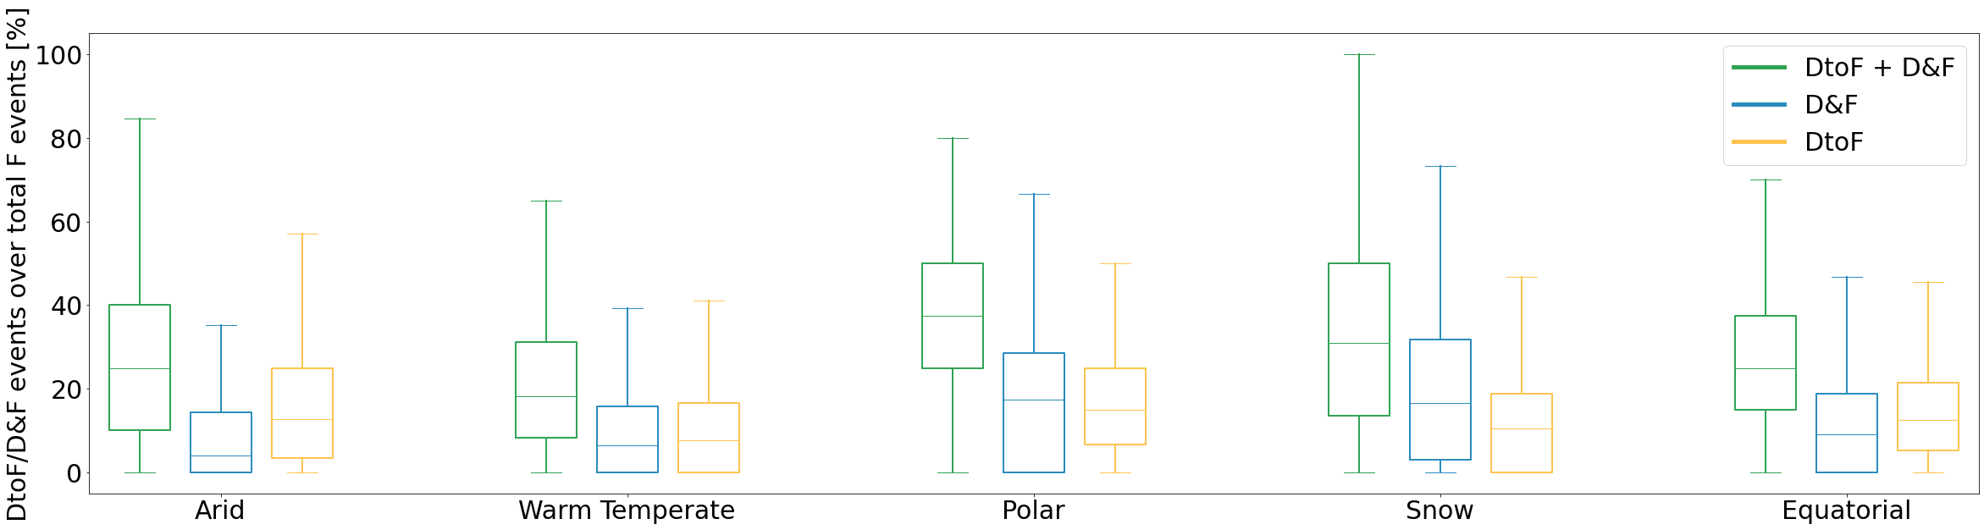
SFig. 3 – Box plots of drought-flood event occurrence clustered per climate region. Percentage of the occurrence of drought-flood, consecutive (DtoF) and compound (D&F) events respect to the total flood events per catchments aggregated according to the five major Köppen-Geiger climate classes: Arid, Warm Temperate, Polar, Snow and Equatorial. D&F events are most common in snow regions, followed by polar and equatorial regions (Supplementary Fig. 3). Conversely, DtoF events are most common in polar regions, closely followed by arid and equatorial regions.

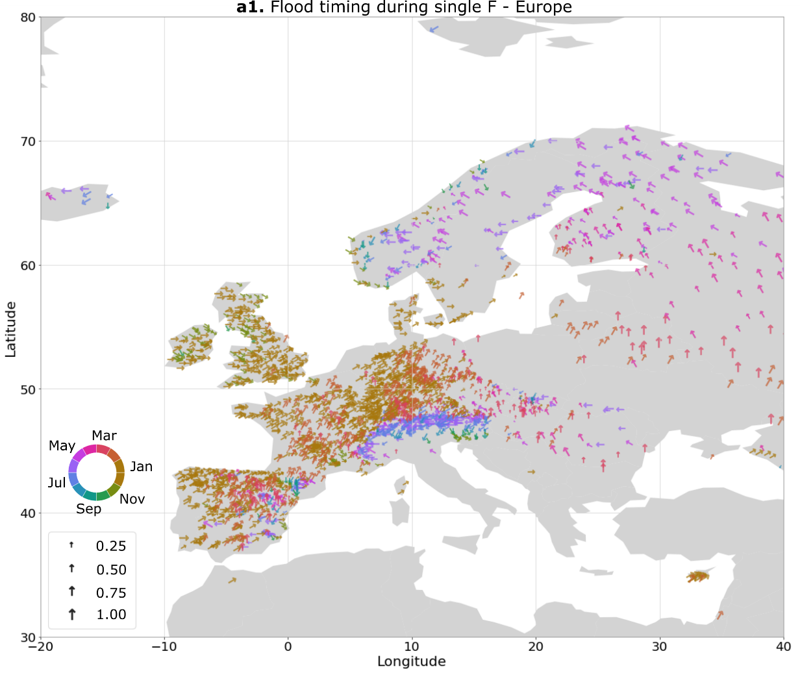
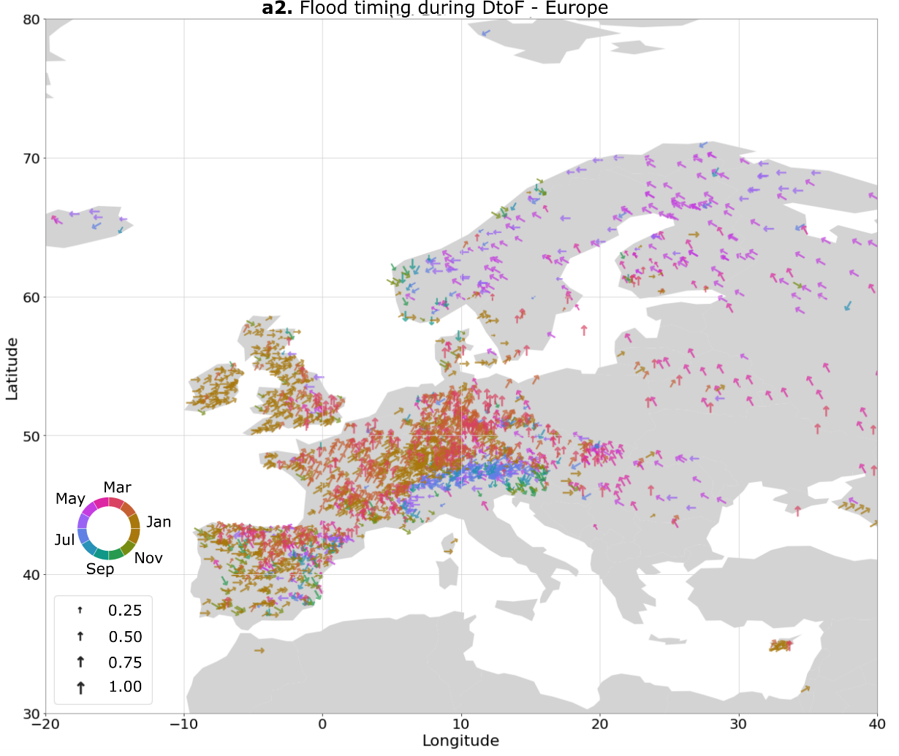
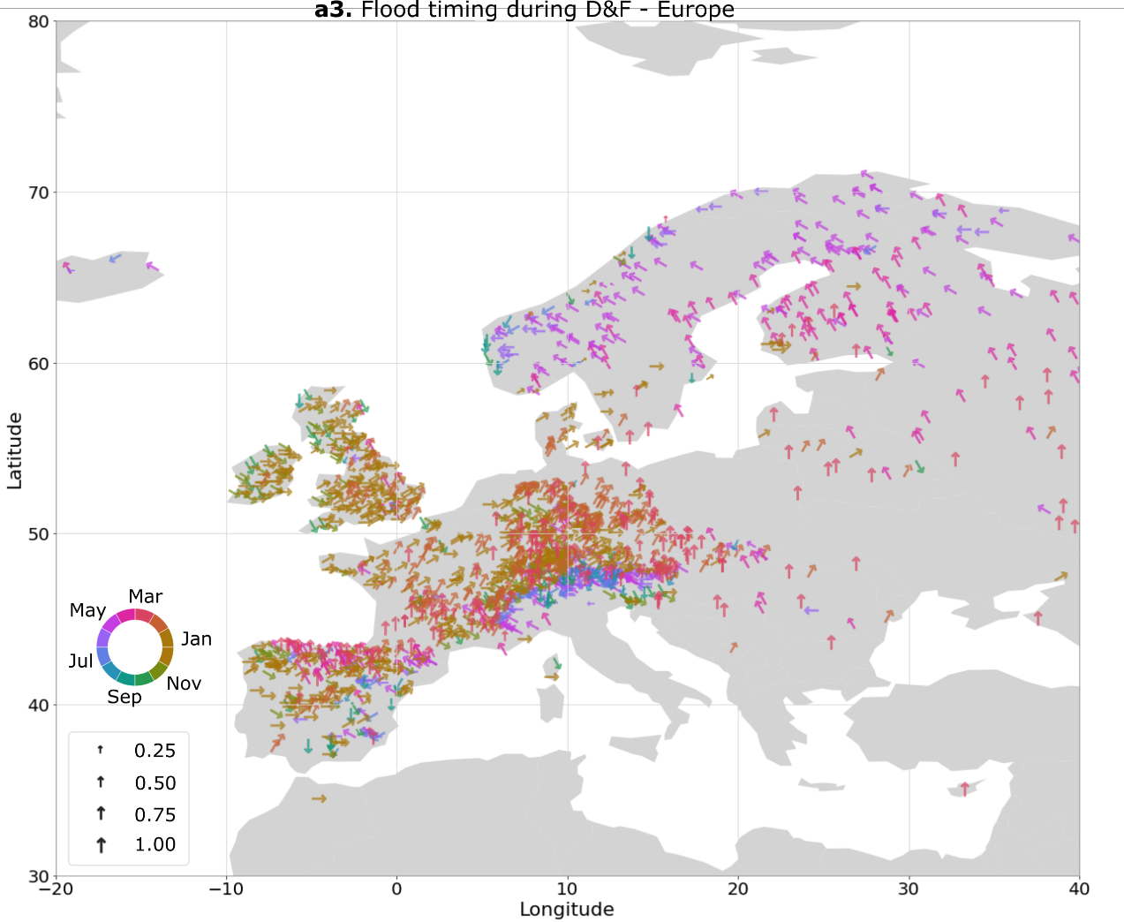

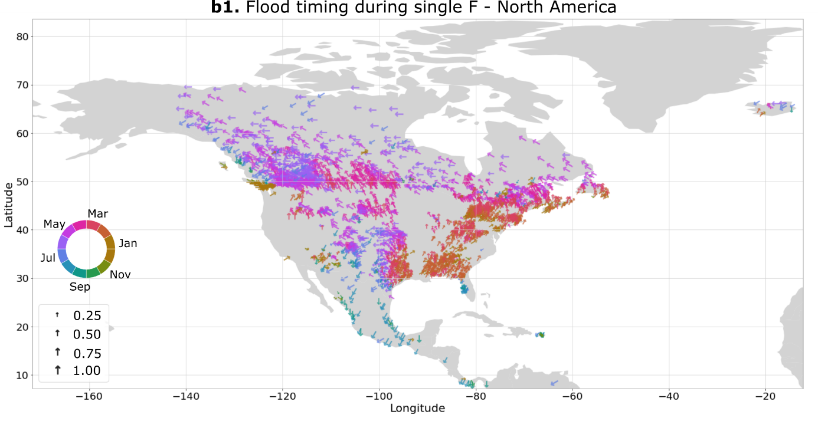

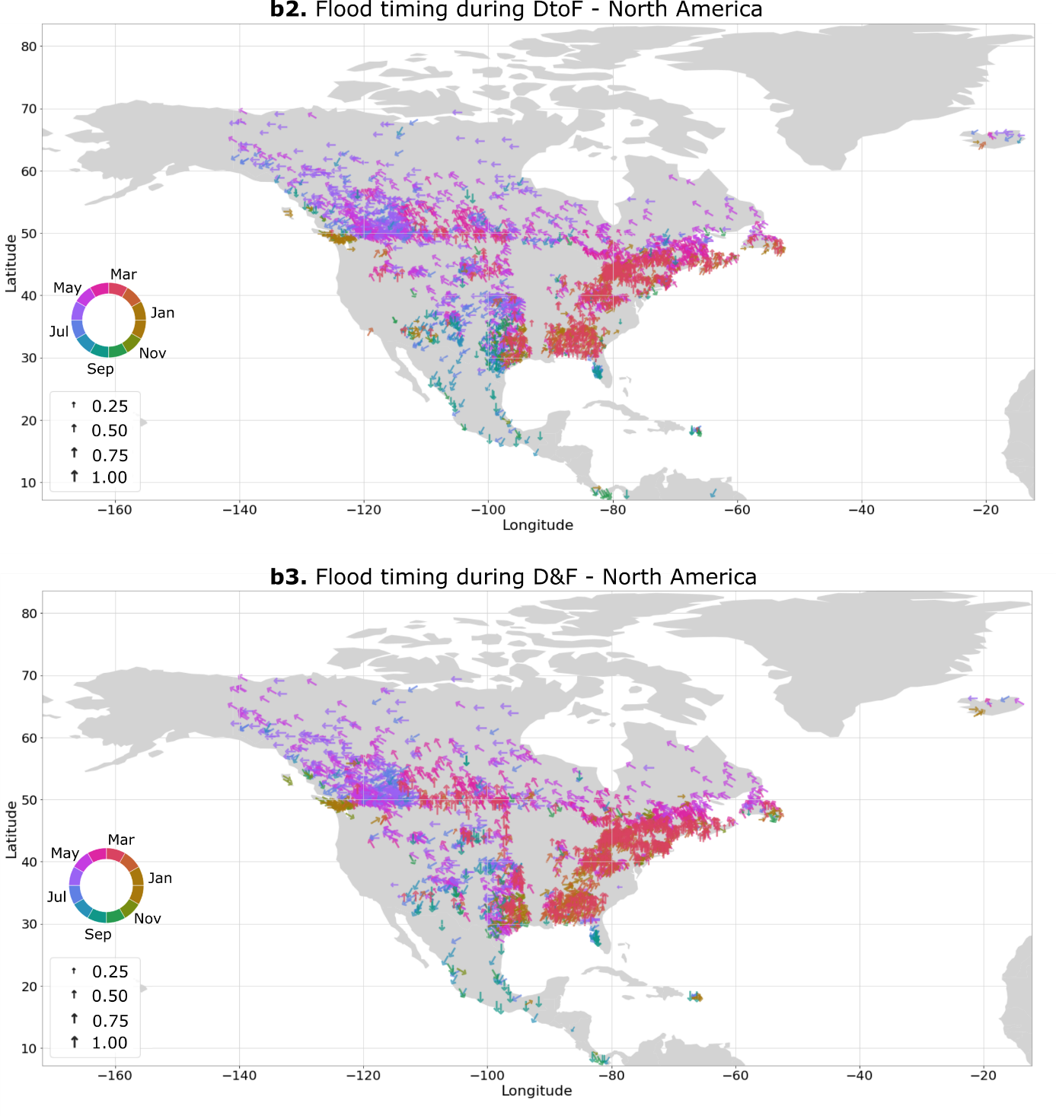

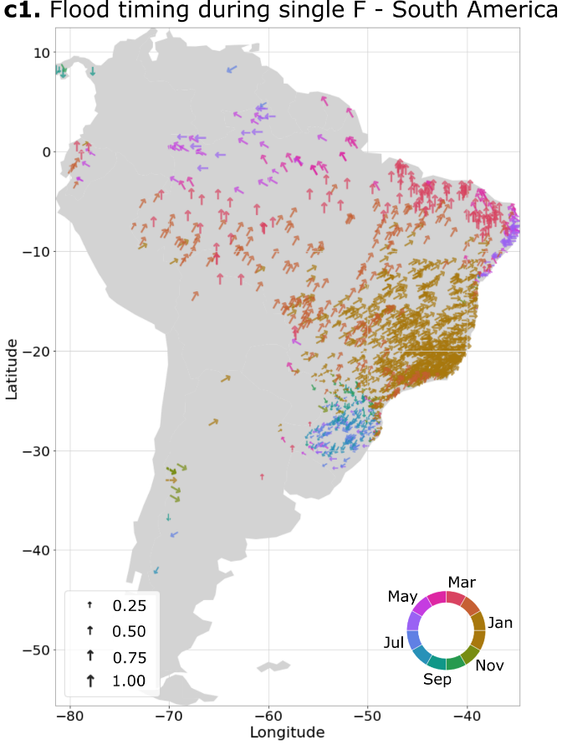
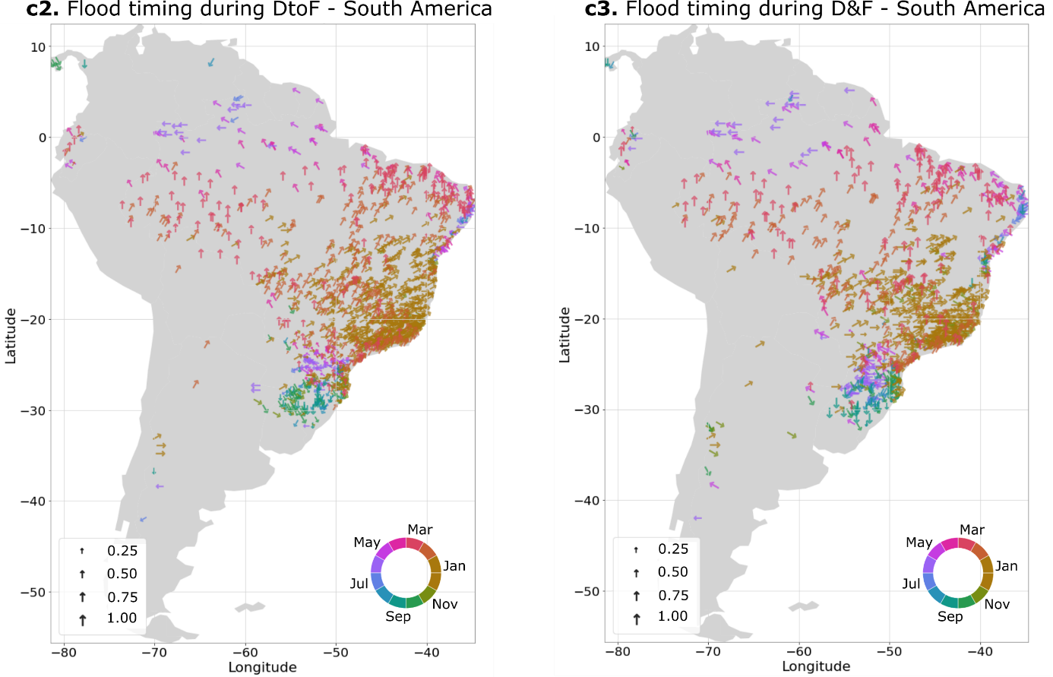

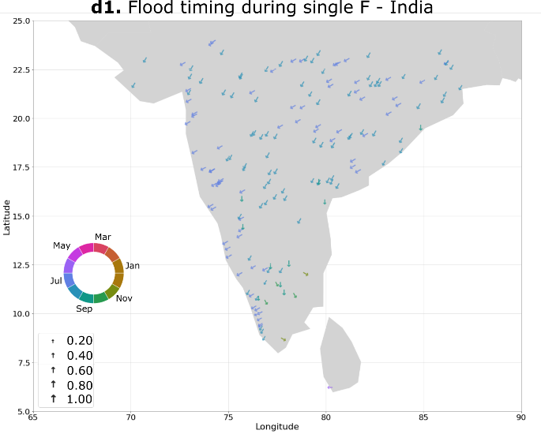
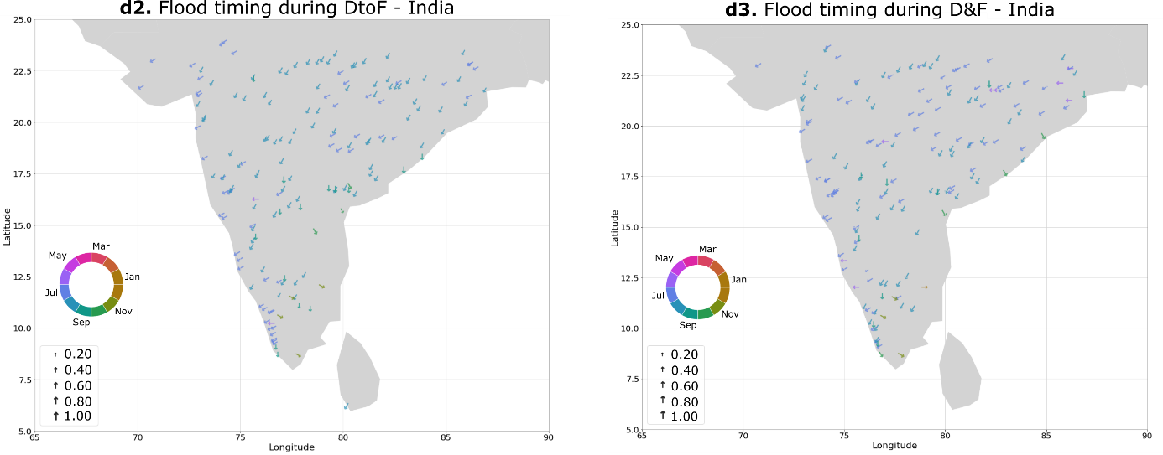
SFig. 4 - Flood timing during single flood, consecutive (DtoF) and compound (D&F) zoomed per continents, regions and countries. Each arrow represents a hydrometric station, where the colour and the arrow orientation indicate the season and month in which the onset timing of streamflow peak usually occurs when preceded by drought conditions. Lengths of the arrows indicate the concentration of single floods within the analysed period (0, evenly distributed; 1, all floods occur on the same date). Average timing of single flood, DtoF and D&F events per station has been computed according to circular statistics (Methods).
Broadly speaking, flood events after drought (DtoF) mainly occur from February through April (e.g., in western Europe and eastern United States), or between May and July (e.g., western Canada, north-eastern Europe; Fig. 4a1, 4b1). In Brazil, flood events after drought tend to occur between September and April (with a south-to-north gradient in timing), while in India, DtoF events occur mainly between June and August (Fig. 4c1, 4d1). Flood events during drought (D&F) occur predominantly between October and December (e.g., western Europe, eastern United States) or March through May (e.g., western Canada, north-eastern Europe; Fig. 4a2, 4b2, 4c2). In India, flood events during drought occur between May and July (Fig. 4d2).

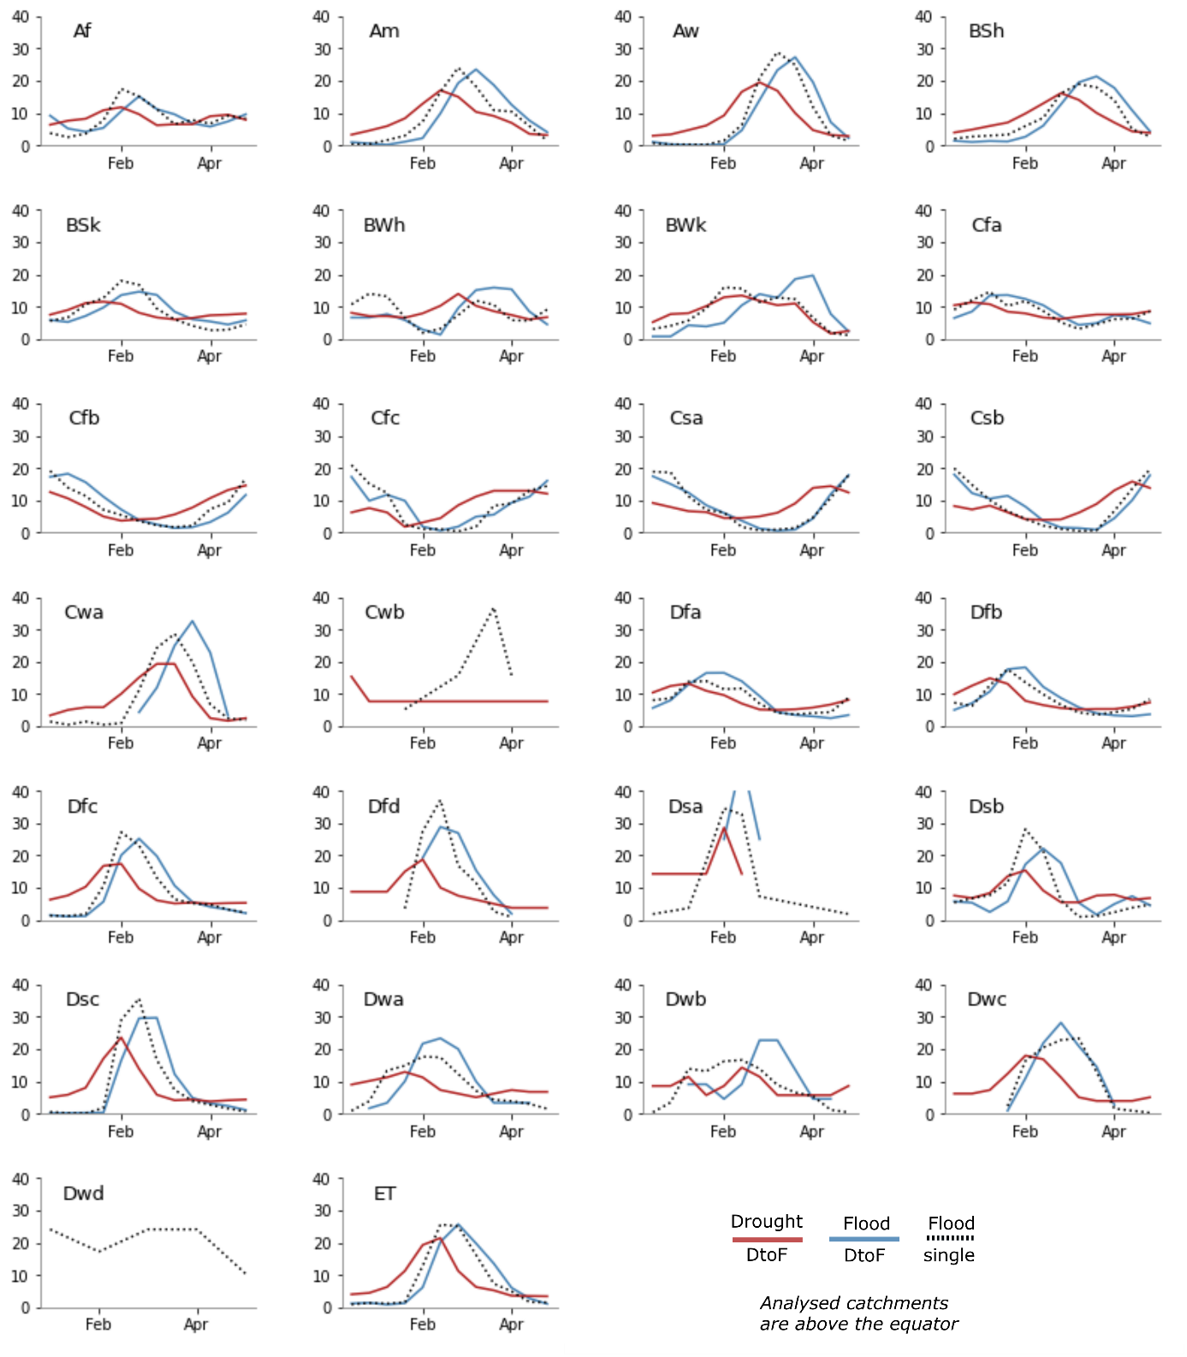
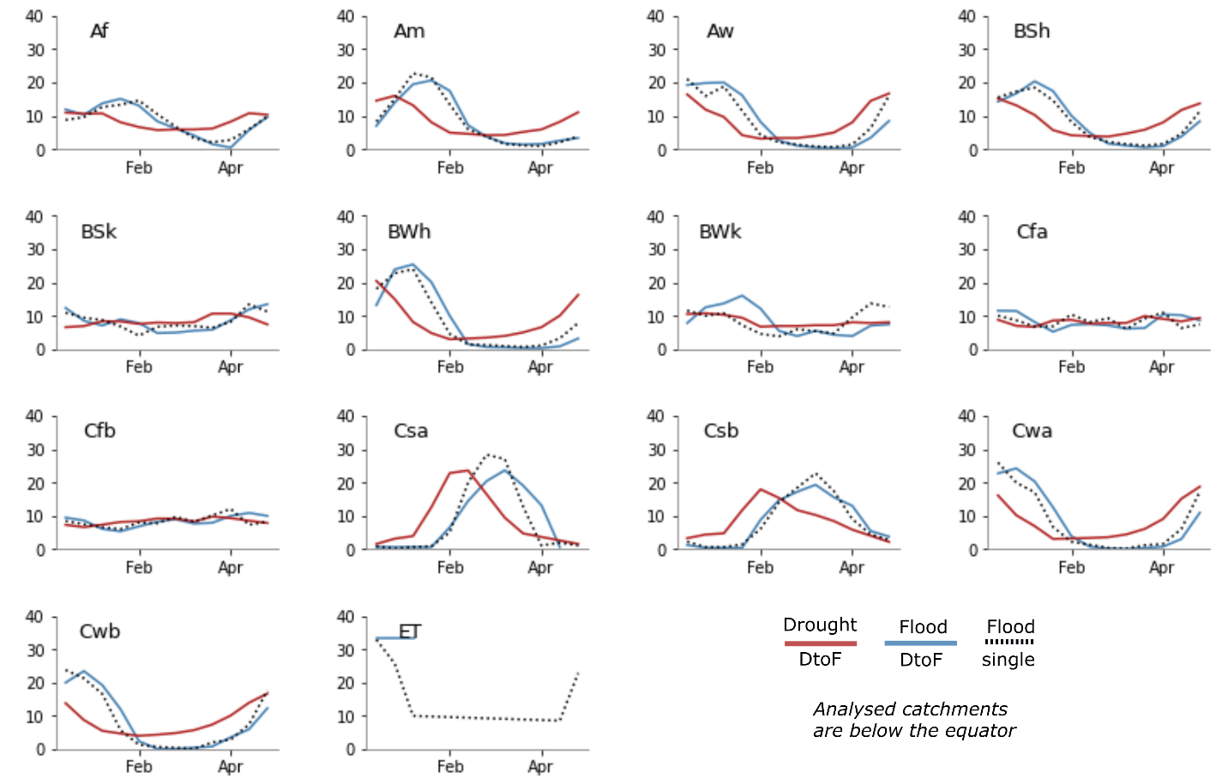
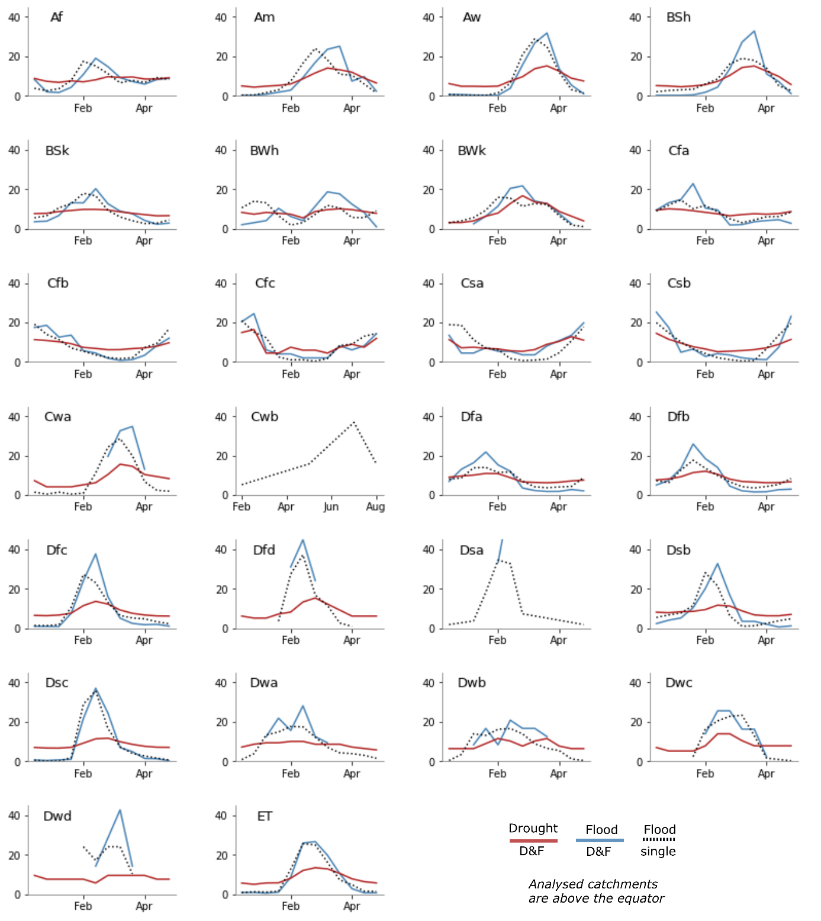
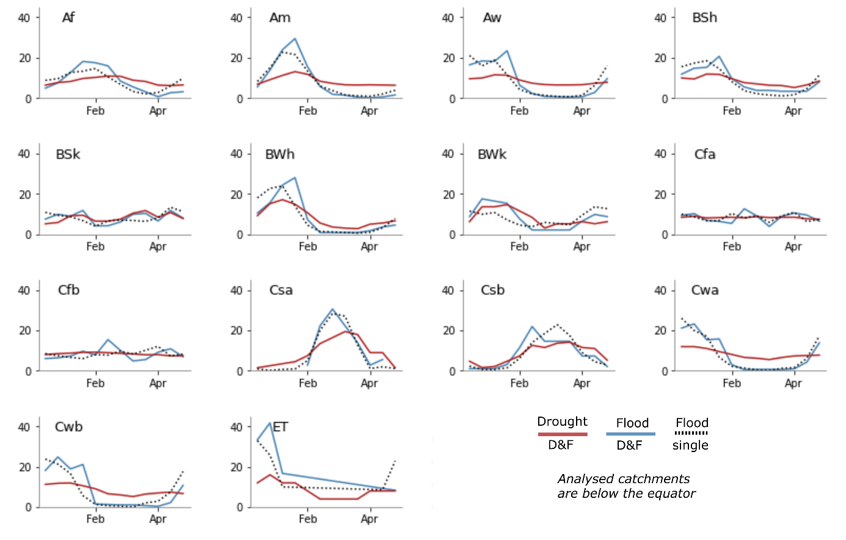
SFig. 5 - Drought and flood month occurrence over the year, during consecutive (DtoF), compound (D&F) drought-flood events and during single floods. Catchments are clustered according to Köppen-Geiger climate classification and their location relative to the equator. Köppen-Geiger acronyms: Tropical rainforest (Af), Tropical monsoon (Am), Tropical savannah (Aw), Arid desert hot (BWh), Arid desert cold (BWk), Arid steppe hot (BSh), Arid steppe cold (BSk), Temperate dry and hot summer (Csa), Temperate dry and warm summer (Csb), Temperate dry and cold summer (Csc), Temperate, dry and hot summer (Cwa), Temperate dry winter and warm summer (Cwb), Temperate dry winter and cold summer (Cwc), Temperate no dry season and hot summer (Cfa), Temperate no dry season and warm summer (Cfb), Temperate no dry season and cold summer (Cfc), Cold dry and hot summer (Dsa), Cold dry and warm summer (Dsb), Cold dry and cold summer (Dsc), Cold, dry summer, very cold winter (Dsd), Cold, dry winter, hot summer (Dwa), Cold, dry winter, warm summer (Dwb), Cold, dry winter, cold summer (Dwc), Cold, dry winter, very cold winter (Dwd), Cold, no dry season, hot summer (Dfa), Cold, no dry season, warm summer (Dfb), Cold, no dry season, cold summer (Dfc), Cold, no dry season, very cold winter (Dfd), Polar, tundra (ET).

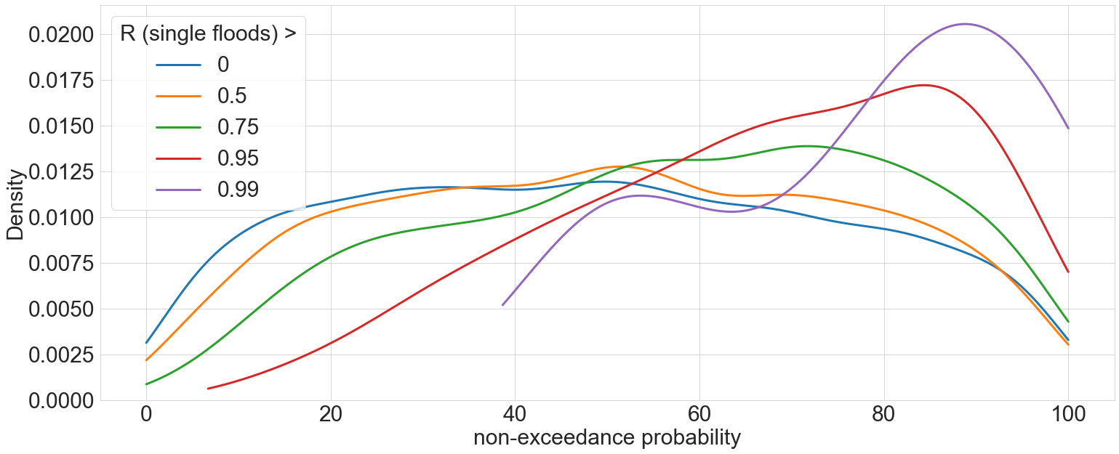
SFig. 6 - Kernel density estimates of the non-exceedance probability of flood timing shift in drought-flood events. The curve with a single flood timing concentration (R) above 0 represents the probability density function for all catchments. The other probability density functions refer to catchments with concentration R above 0.5, 0.75, 0.95 and 0.99. Catchments with a concentration R above 0.75 can be considered characterized by strong flood seasonality (Ye et al., 2017). Smoothing applied with a bandwidth of 1.

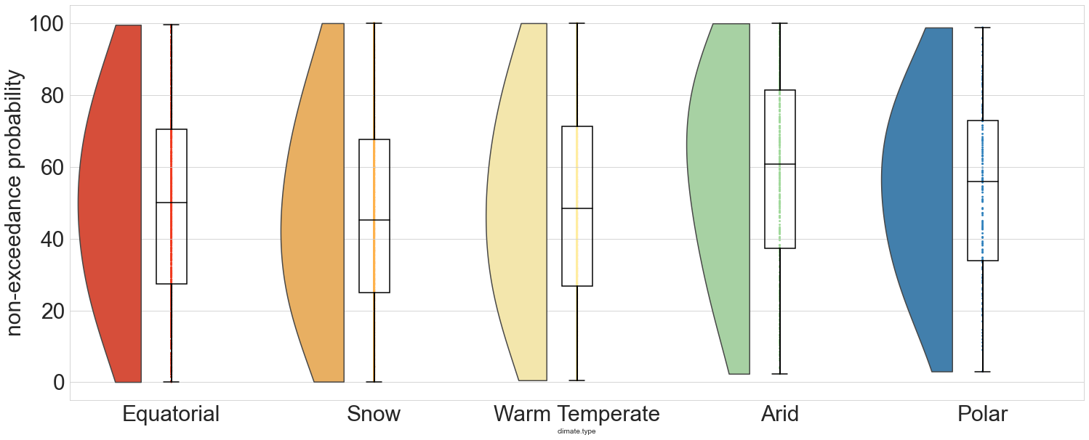
SFig.7 - Box plots and kernel density estimates of the non-exceedance probability of flood timing shift in drought-flood events respect to climate type. Catchments are clustered according to the five major Köppen-Geiger climate classes: Arid, Warm Temperate, Polar, Snow and Equatorial. Smoothing applied with a bandwidth of 1.

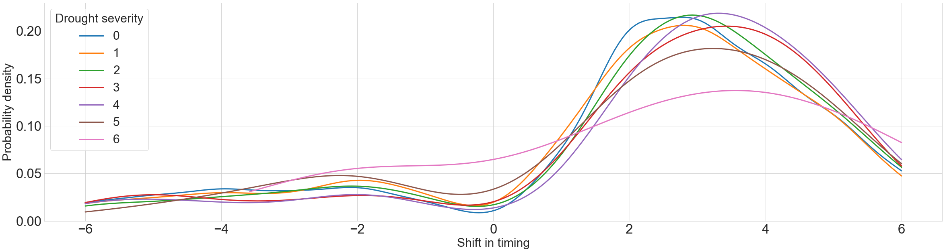
SFig. 8 - Kernel density estimates of flood timing shifts for consecutive (DtoF) events accounting for different degrees of drought severity conditions. Probability density functions smoothed using a kernel with a bandwidth of 1. A drought severity degree of 0 means that drought conditions are moderate (below the 15th percentile), a drought severity degree greater than 1 means that at least one hydrometeorological variable has severe drought conditions (below the 5th percentile). The number of drought severity degrees corresponds to the number of hydrometeorological variables under severe conditions. The events under analysis are those occurring in catchments presenting a non-exceedance probability of the drought-flood timing above 70% and exhibiting a timing shift above a 70% non-exceedance probability.

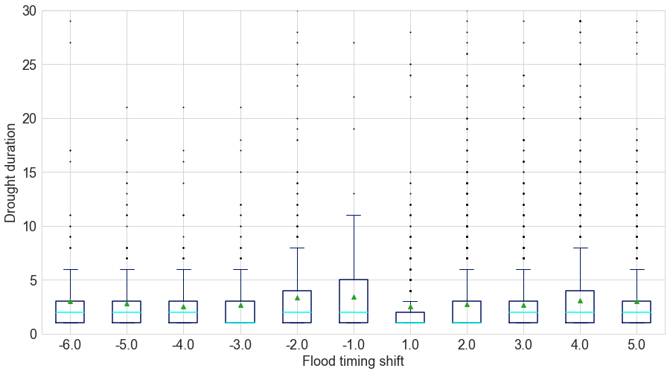
SFig. 9 - Box plots of the flood timing shift for consecutive (DtoF) events respect to drought duration (months).

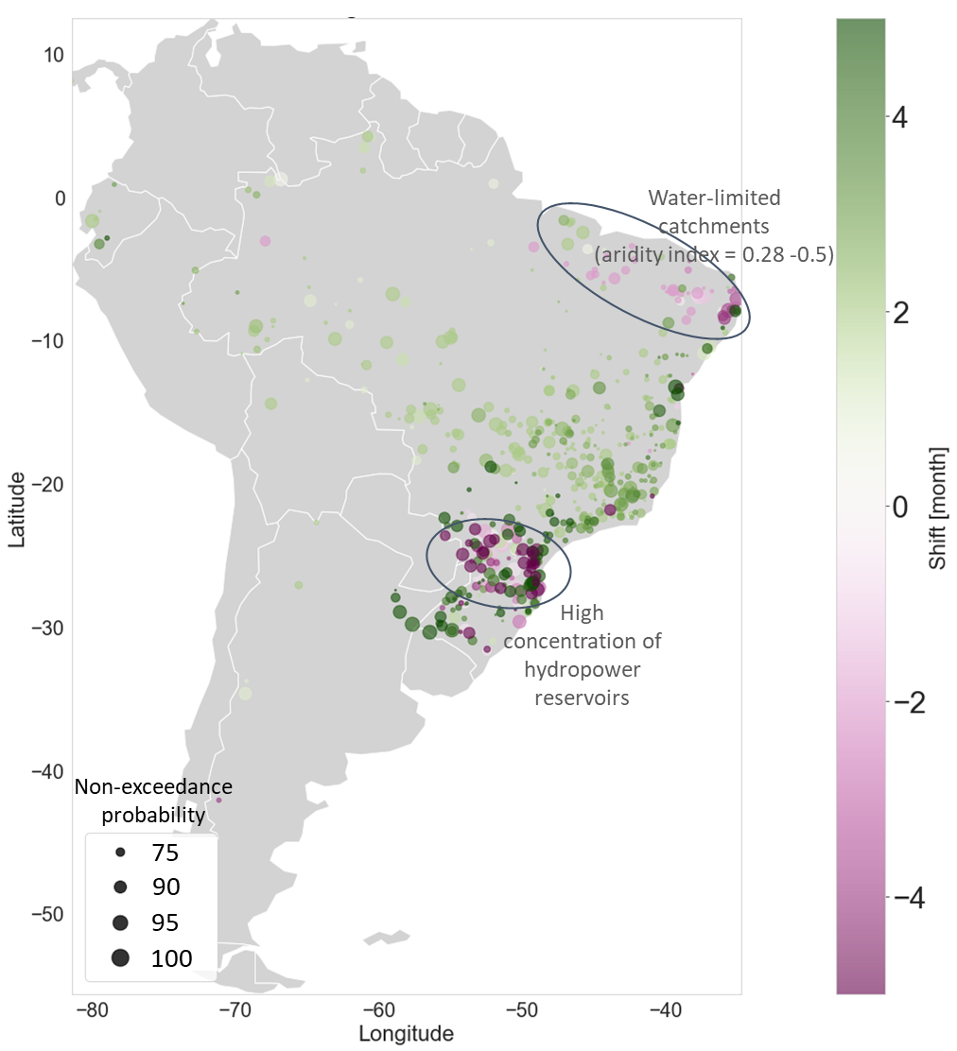
SFig. 10 - Close-up map for South America of later and earlier floods during consecutive drought-flood events. Dot size represents the non-exceedance probability of flood timing shift in drought-flood events. Black circle highlights areas in which we have a predominant concentration of catchments experiencing earlier floods during DtoF events. Aridity values extracted from https://cgiarcsi.community/data/global-aridity-and-pet-database/. Reservoir concentration and location of hydropower plants verified from GRanD (https://sedac.ciesin.columbia.edu/data/collection/grand-v1) and from https://www.sciencedirect.com/science/article/pii/S0360544221021757

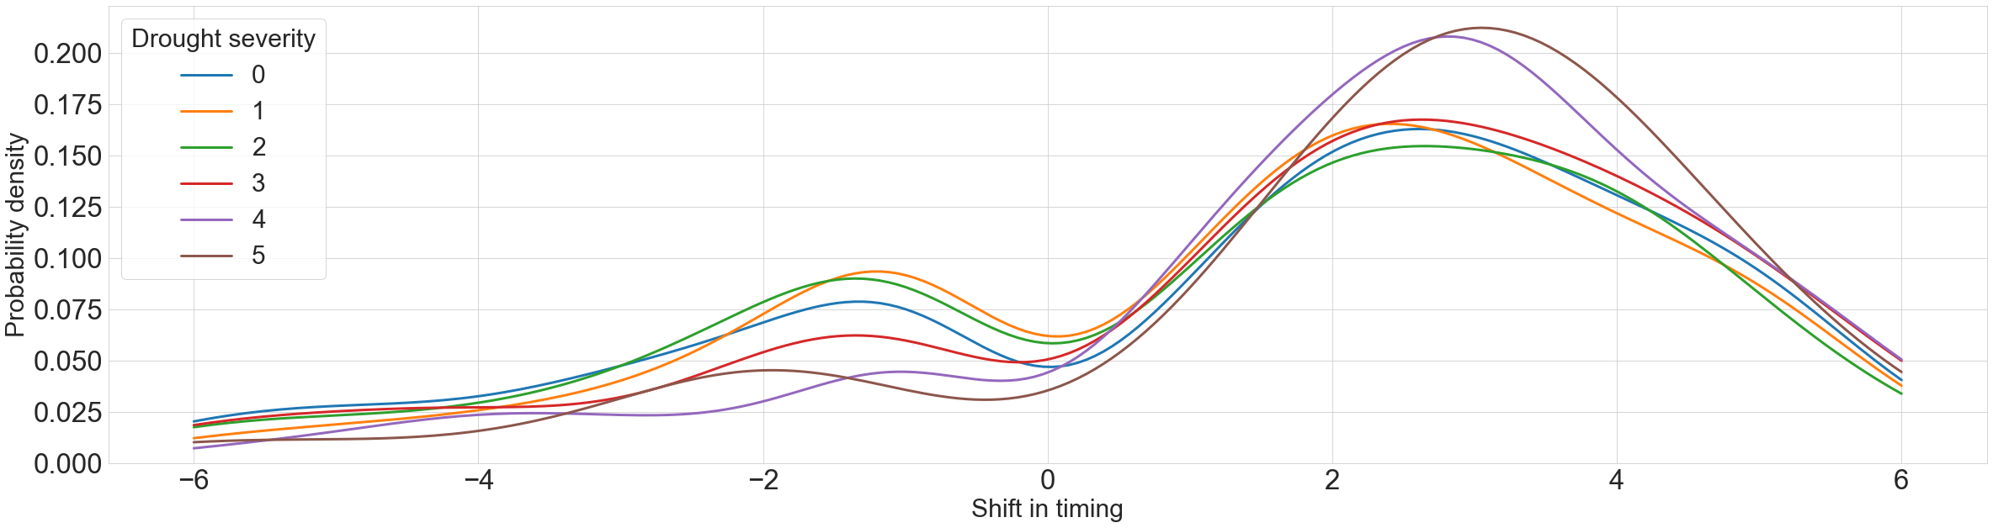
SFig. 11 – Kernel density estimates of flood timing shifts for compound (D&F) events accounting for different degrees of drought severity conditions. Probability density functions smoothed using a kernel with a bandwidth of 1. A drought severity degree of 0 means that drought conditions are moderate (below the 15th percentile), a drought severity degree greater than 1 means that at least one hydrometeorological variable has severe drought conditions (below the 5th percentile). The number of drought severity degrees corresponds to the number of hydrometeorological variables under severe conditions. The events under analysis are those occurring in catchments presenting a non-exceedance probability of the drought-flood timing above 70% and exhibiting a timing shift above a 70% non-exceedance probability.

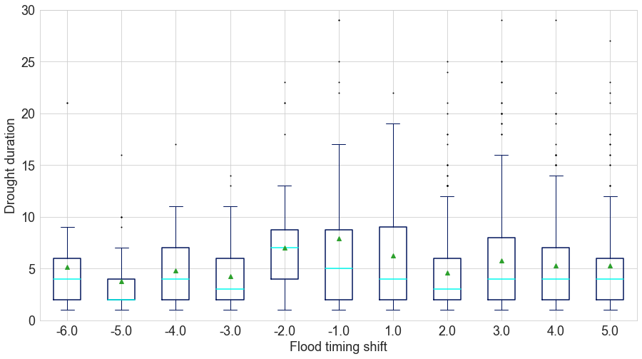
SFig. 12 - Box plots of the flood timing shift for compound (D&F) events respect to drought duration (months).

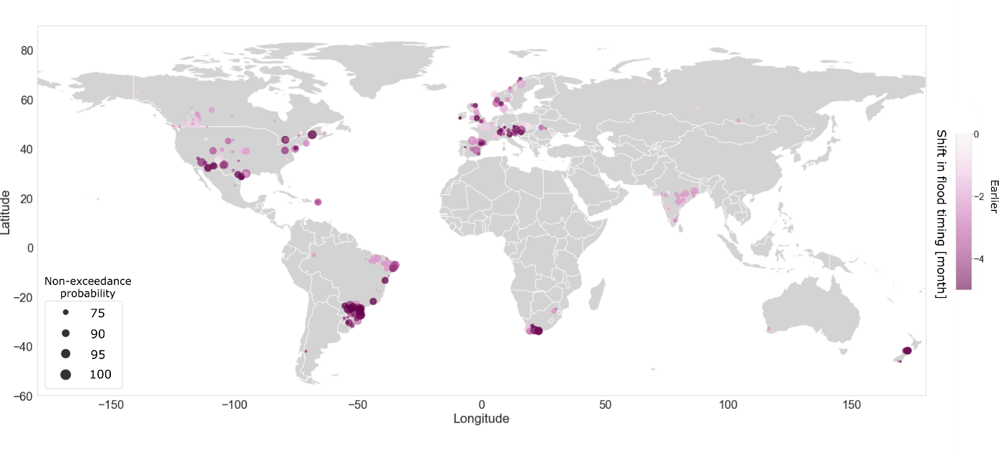
SFig. 13 – Earlier flood timing shift distribution for drought-flood events. Earlier floods (in months) during drought-flood events, calculated compared to the mean date of occurrence of single floods (not preceded or compounded with drought conditions).

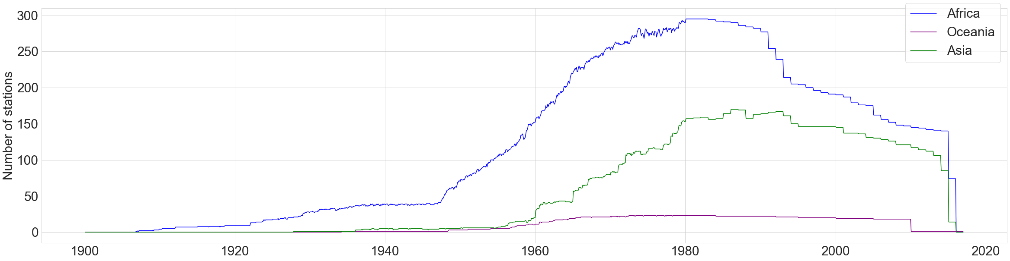
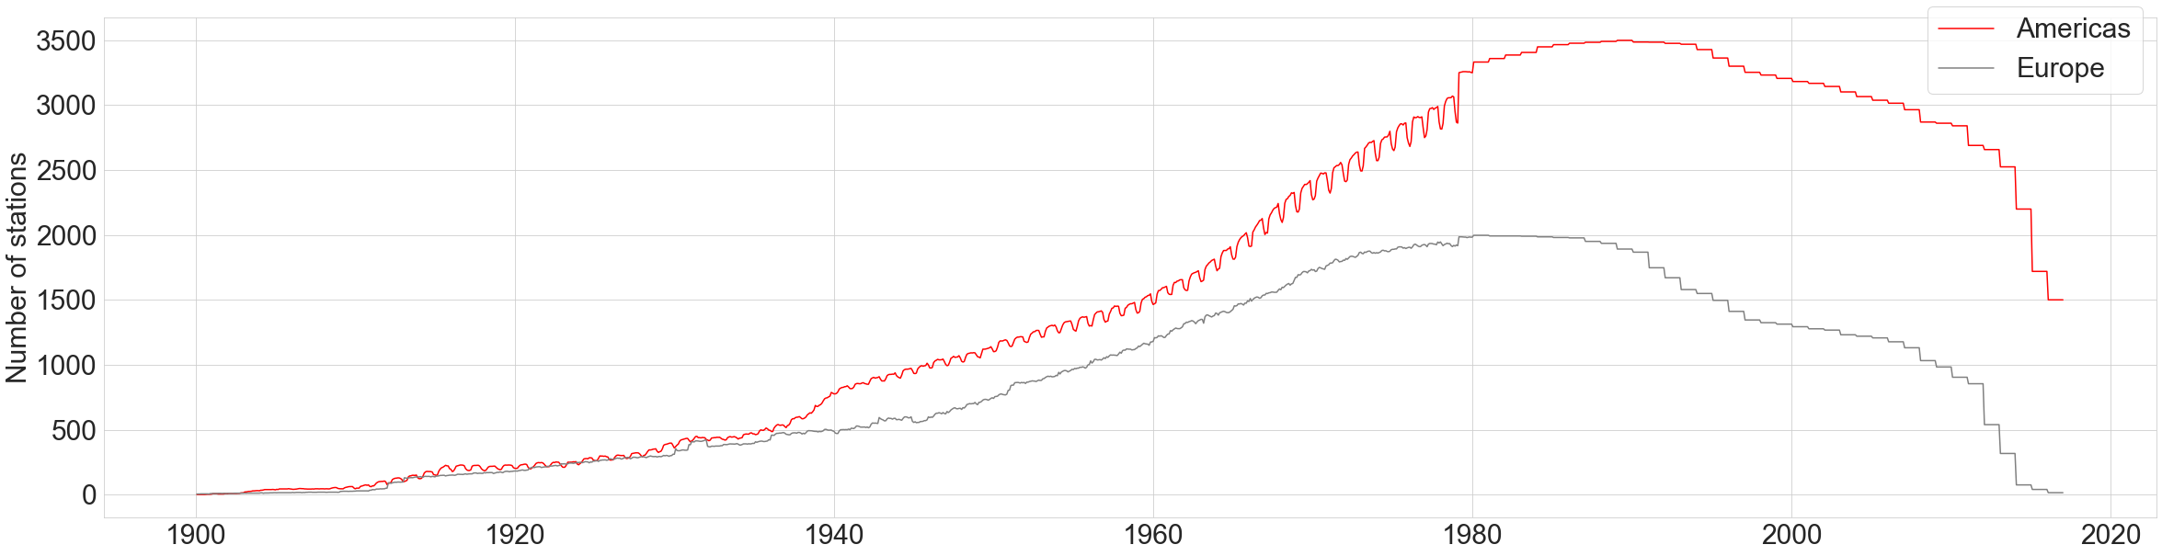

SFig. 14 Number of hydrometric stations available per month and per continent in the GSIM dataset.

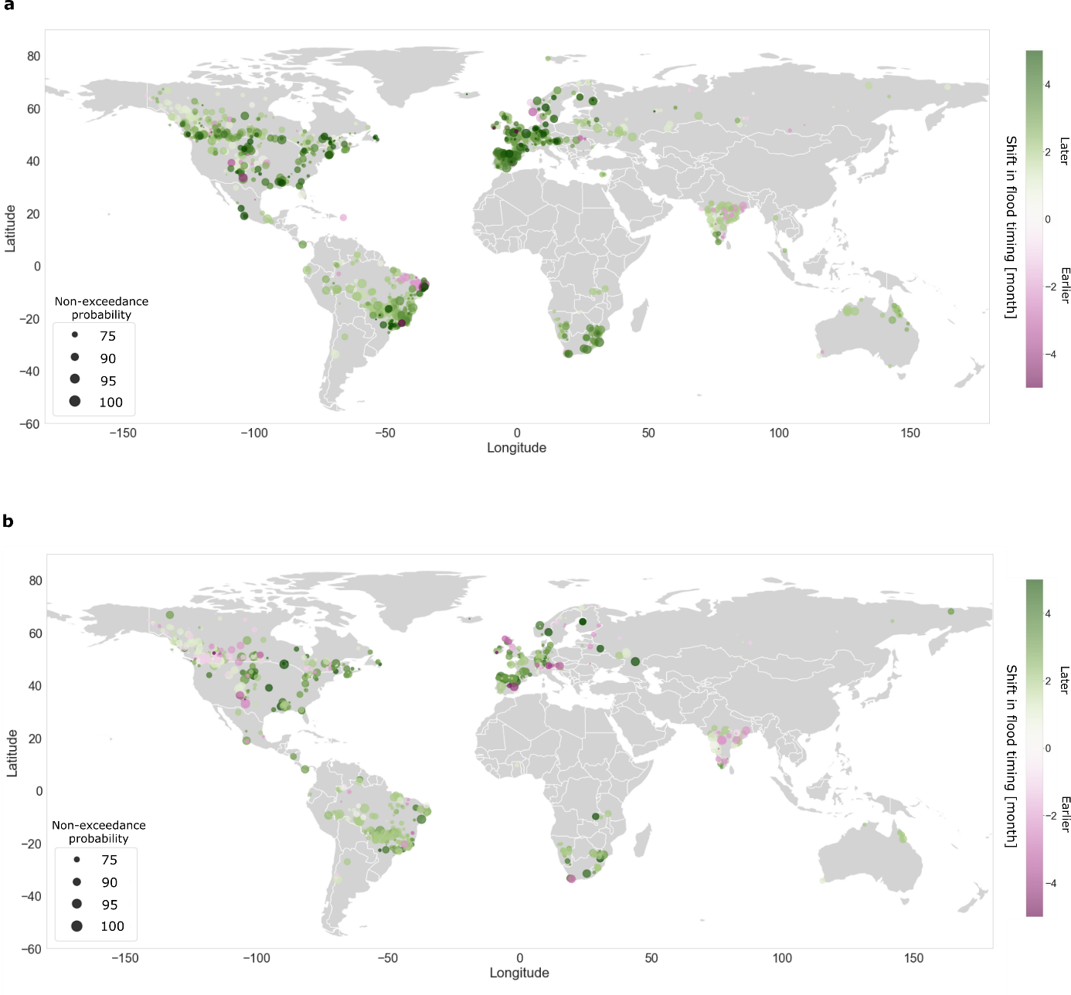
SFig. 15 Flood timing shift distribution for consecutive and compound drought-flood events in catchments with single flood timing concentration above 0.5. Flood timing shift for Dtof and D&F obtained selecting only catchments with concentration of single flood timing greater than 0.5, in order to account only for single-peaked rivers.

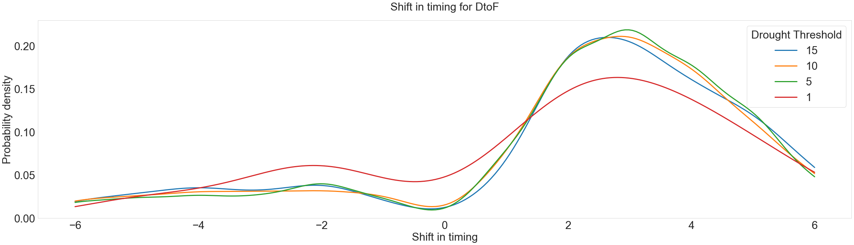
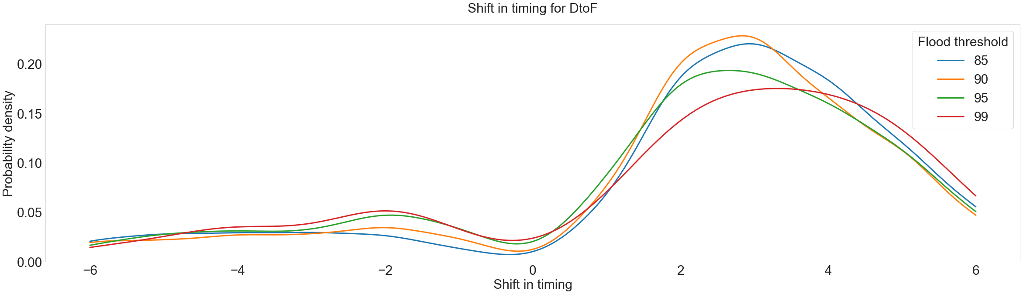

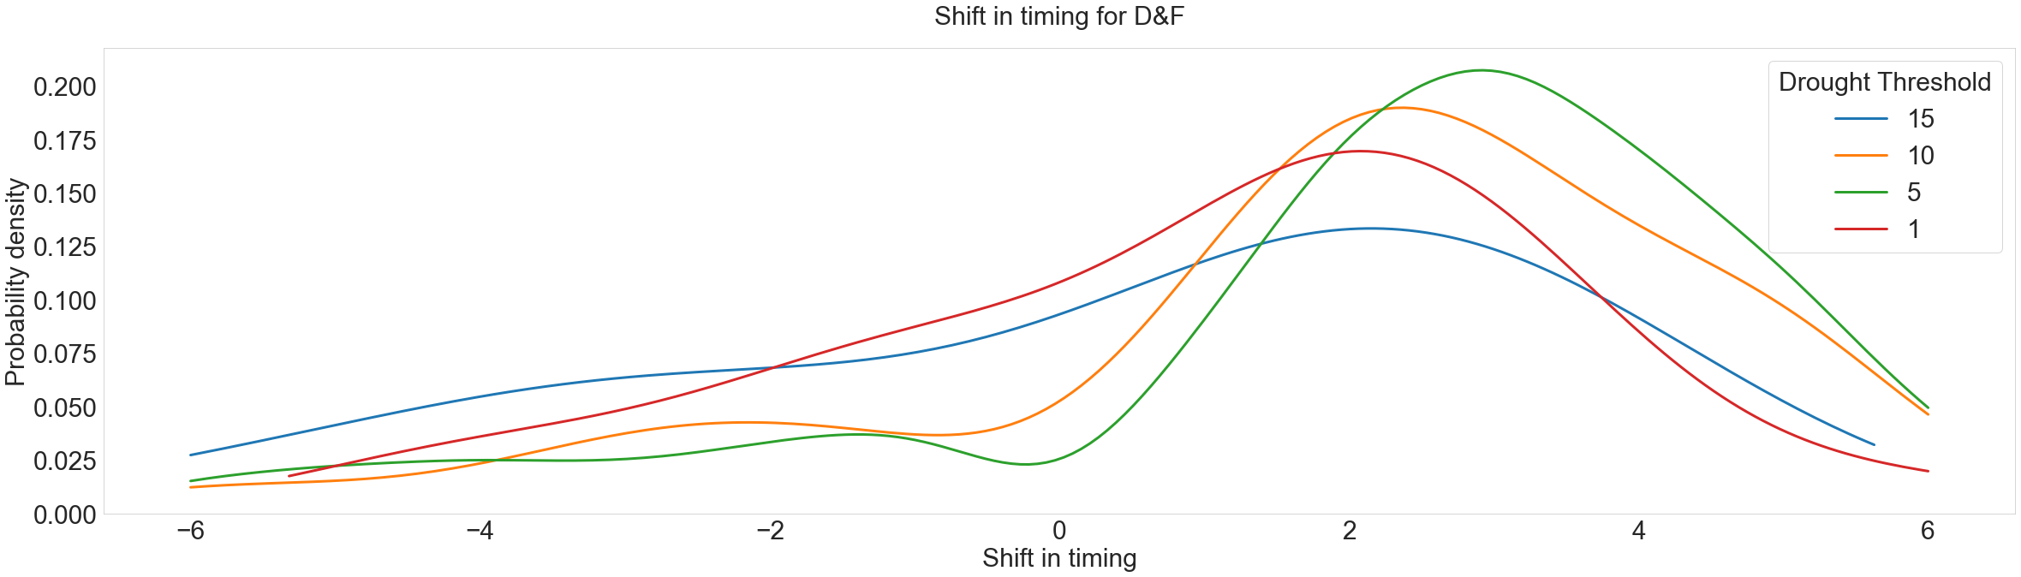
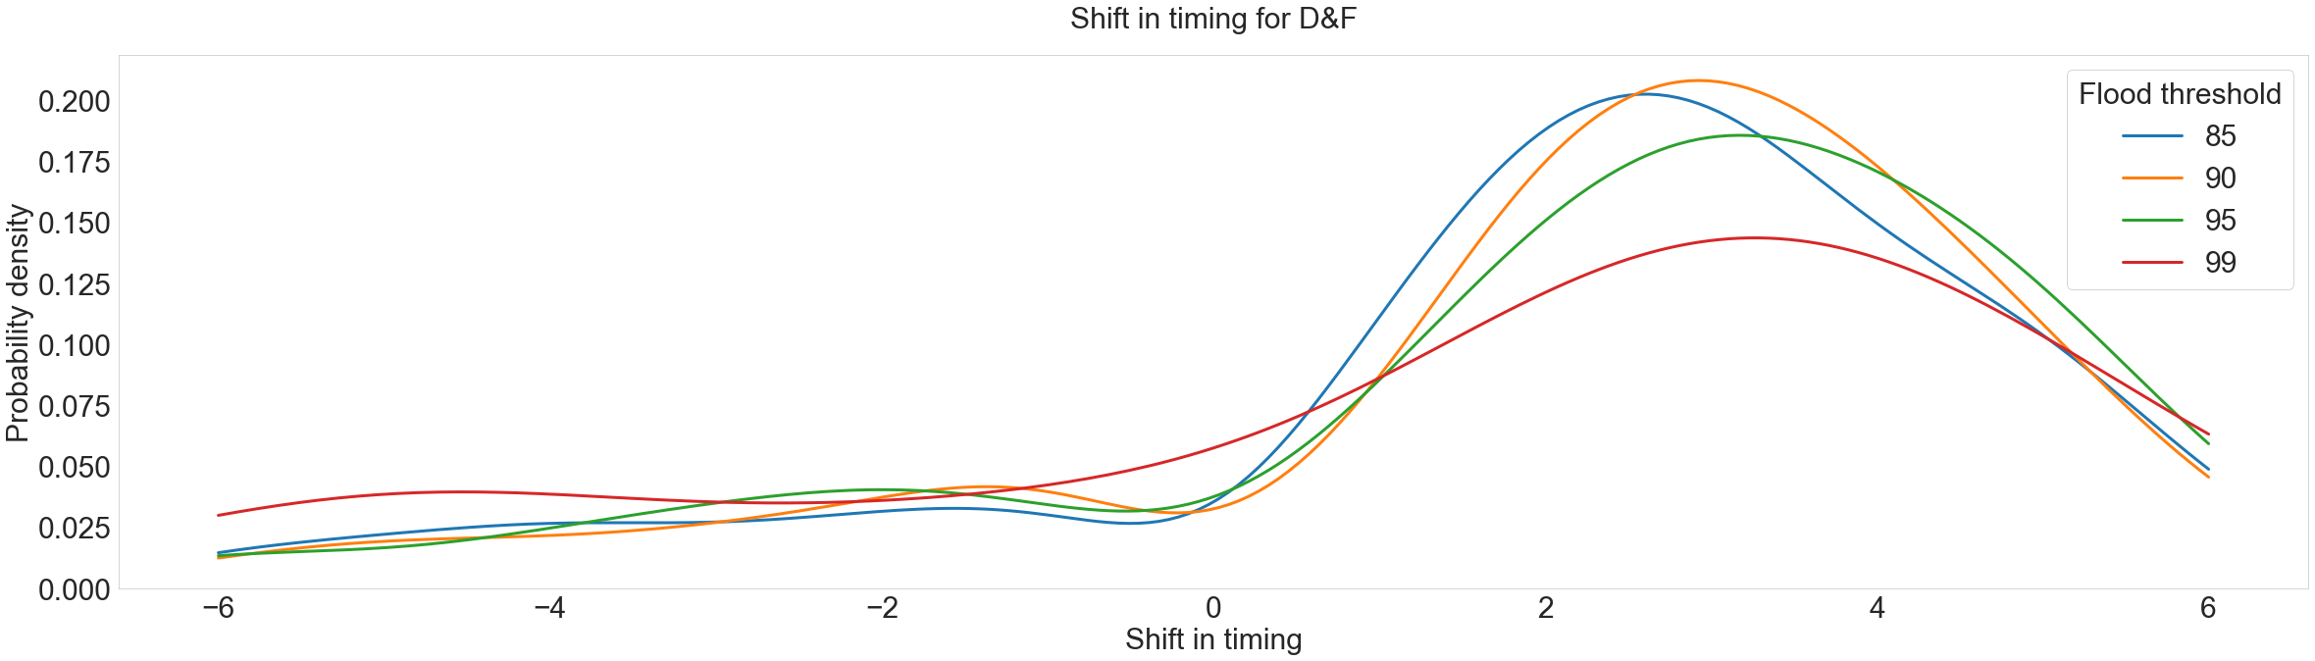

SFig. 16 Effect of threshold choice on flood timing shift in consecutive (DtoF) and compound (D&F) events. Effect of threshold choice used to define drought (0.15, 0.10, 0.5, 0.1) and flood (0.85, 0.90, 0.95, 0.99) in DtoF and D&F events. Smoothing applied with a bandwidth of 1.

