Development and Validation of the Chemotherapy-induced Peripheral Neuropathy Integrated Assessment–Oxaliplatin Subscale
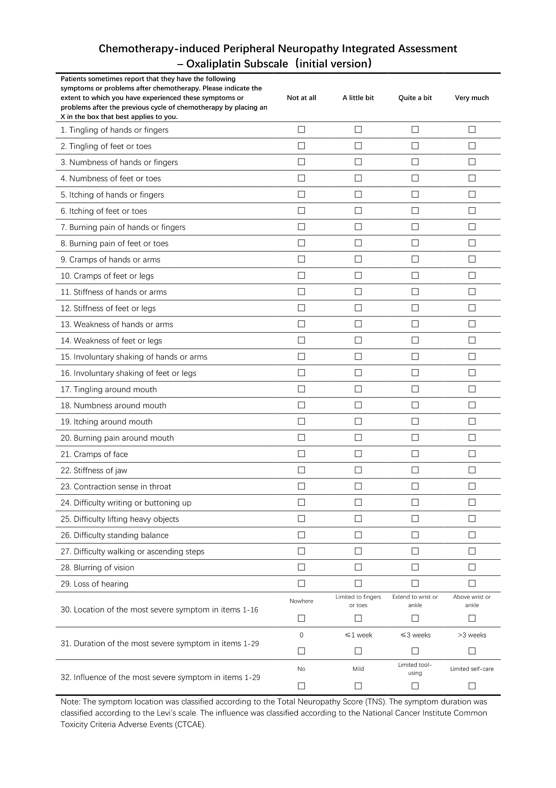
SUPPLEMENTARY FIGURE S1. Chemotherapy-induced Peripheral Neuropathy Integrated Assessment – Oxaliplatin Subscale (initial version).
Scoring standard: "Not at all"=0, "A little bit"=1, "Quite a bit"=2, "Very much"=3. The symptom location was classified according to the Total Neuropathy Score (TNS). The symptom duration was classified according to the Levi’s scale. The influence was classified according to the National Cancer Institute Common Toxicity Criteria Adverse Events (NCI-CTCAE).
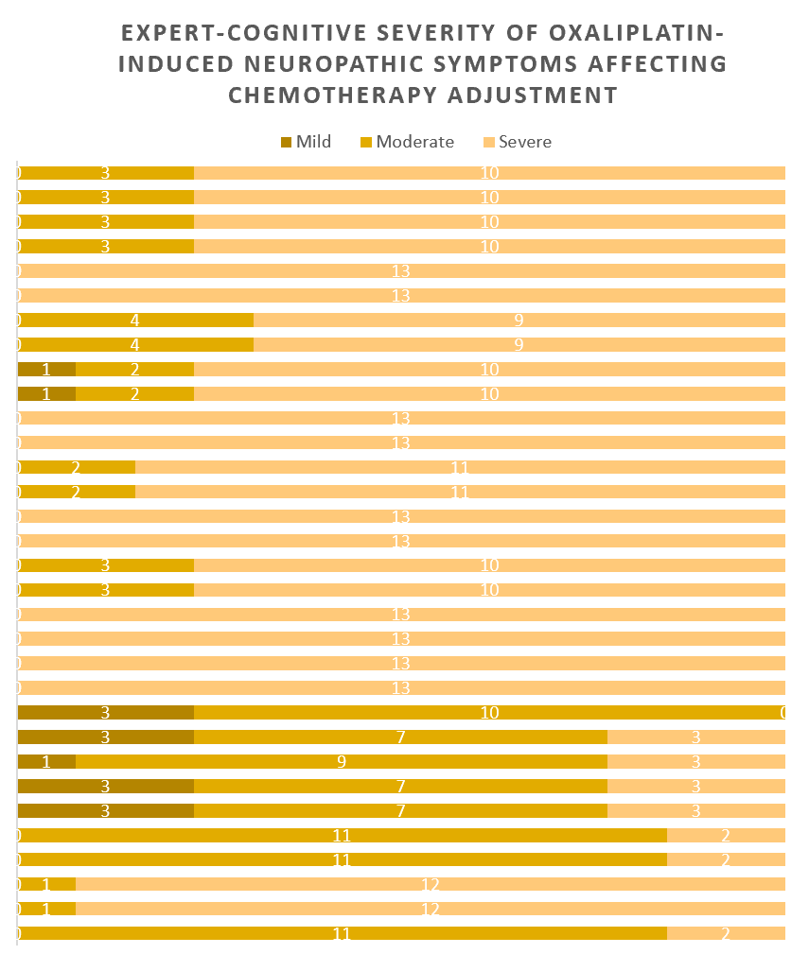
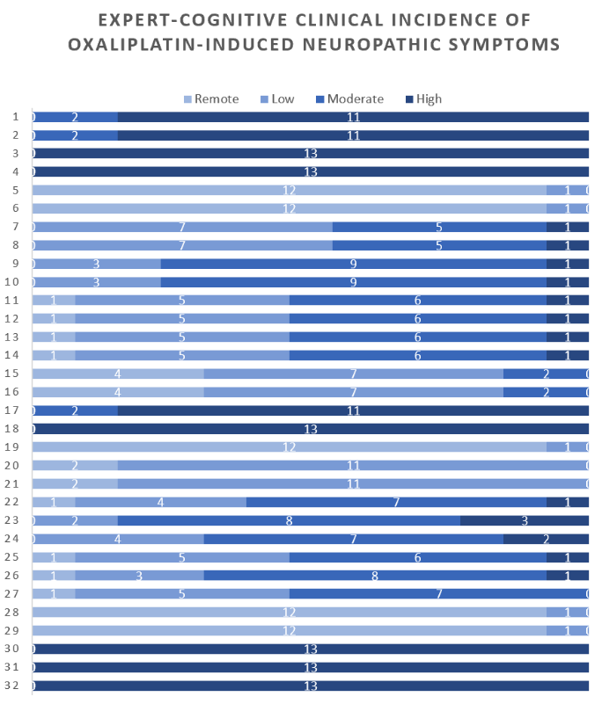
SUPPLEMENTARY FIGURE S2 | Distributions of expert-cognitive clinical incidence and severity of symptoms affecting chemotherapy adjustment. The numbers in the column represent the number of experts who gave the evaluation corresponding to the color. (a) Expert-cognitive clinical incidence of oxaliplatin-induced neuropathic symptoms (scoring standard: Remote=0.25, Low=0.5, Moderate=0.75, High=1). (b) Expert-cognitive severity of oxaliplatin-induced neuropathic symptoms affecting chemotherapy adjustment (scoring standard: Mild=1, Moderate=0.66, Severe=0.33).
a
b

SUPPLEMENTARY FIGURE S3 | Pre-testing item-level positive response rate (I-PRR) of the original version
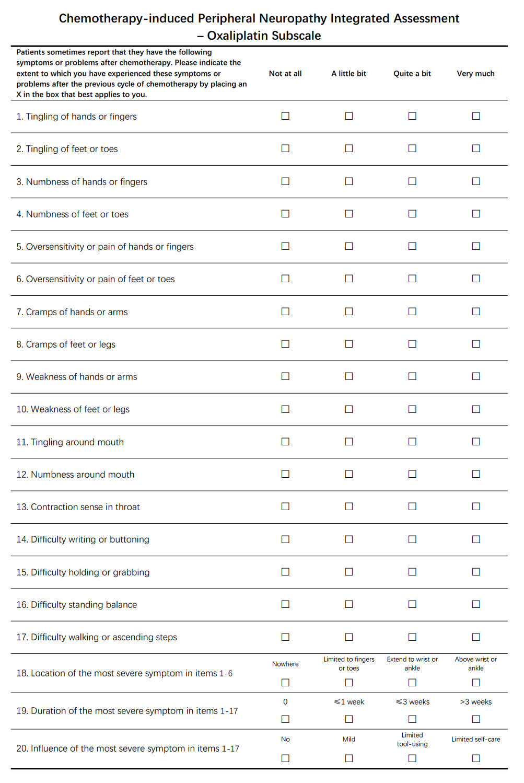SUPPLEMENTARY FIGURE S4 | Chemotherapy-induced Peripheral Neuropathy Integrated Assessment –Oxaliplatin Subscale (modified version)
Scoring standard: "Not at all"=0, "A little bit"=1, "Quite a bit"=2, "Very much"=3. The symptom location was classified according to the Total Neuropathy Score (TNS). The symptom duration was classified according to the Levi’s scale. The influence was classified according to the National Cancer Institute Common Toxicity Criteria Adverse Events (NCI-CTCAE).

