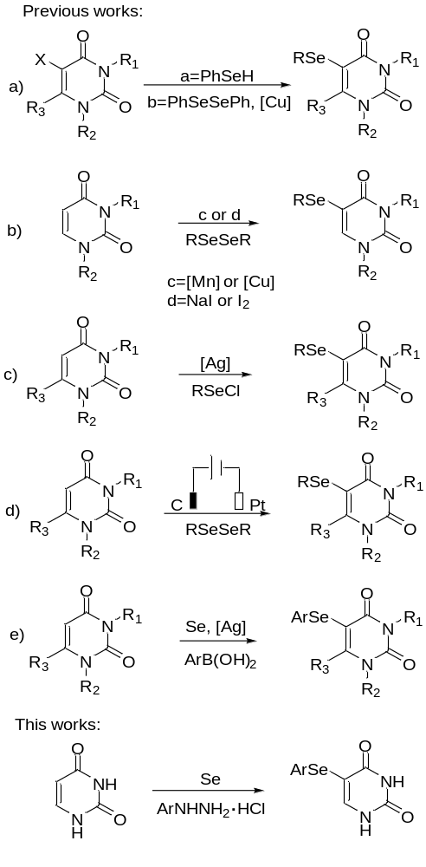
Scheme 1. Different methods for the synthesis of 5-selenouracils

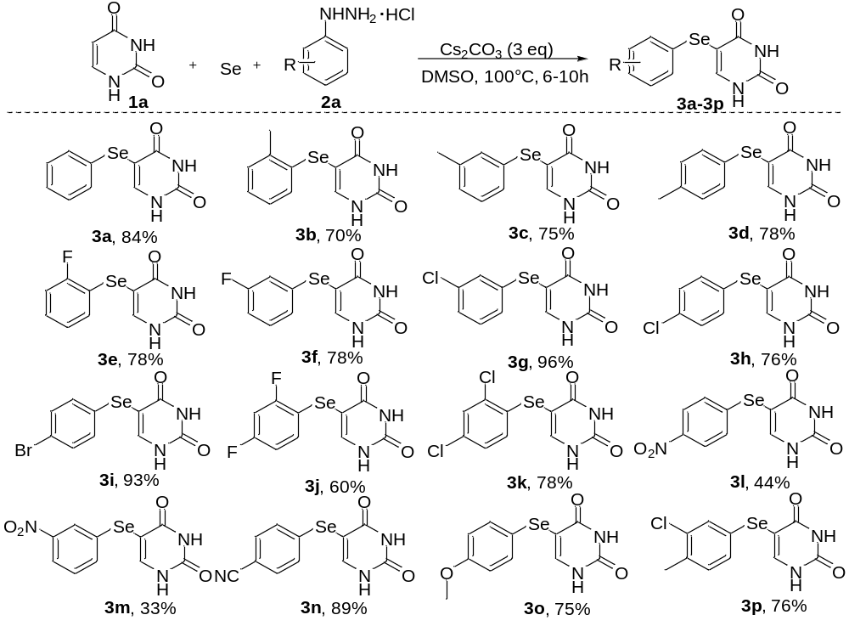

Scheme 2. Reaction scope of arylhydrazine salt
Reaction conditions: 1a (0.53 mmol, 1 eq), 2a (1.6 mmol, 3 eq), Se (1.325 mmol, 2.5 eq), Cs₂CO₃ (1.6 mmol, 3 eq), solvent (1.5 mL) at 100 °C. ^{b} Isolated yield based on 1a.

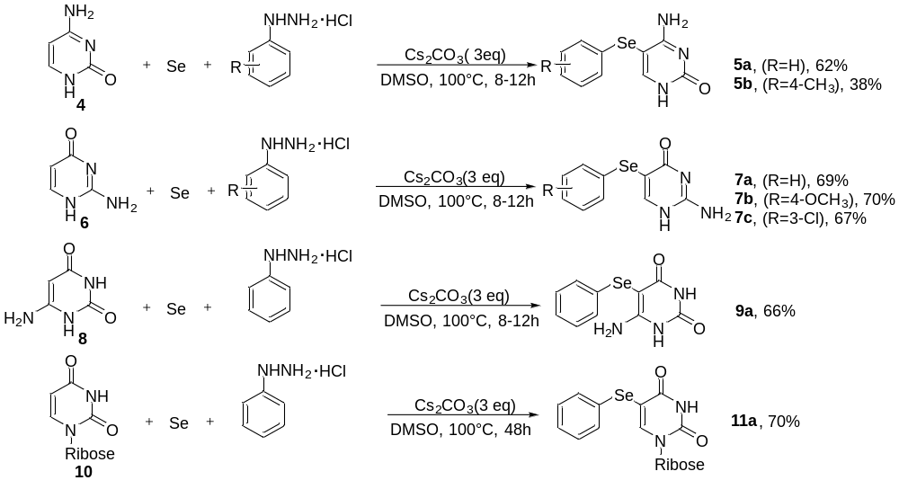
Scheme 3. Reaction scope of uracil derivatives
Reaction conditions: Substituted pyrimidine (0.53 mmol), 2a (1.6 mmol, 3 eq), Se (1.325 mmol, 2.5 eq), Cs₂CO₃ (1.6 mmol, 3 eq), solvent (1.5 mL) at 100 °C. Isolated yield based on substituted pyrimidine.

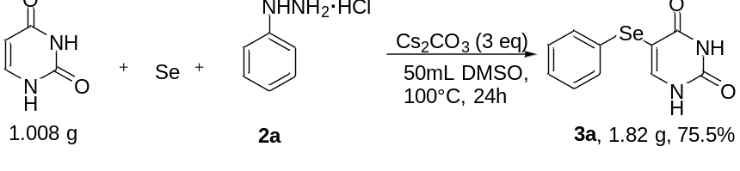

Scheme 4. Gram-scale synthesis and application

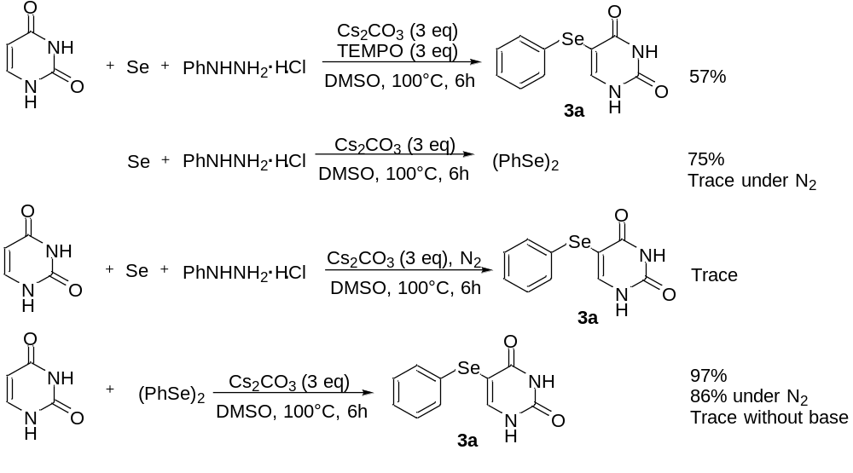

Scheme 5. Investigation of the reaction mechanism.

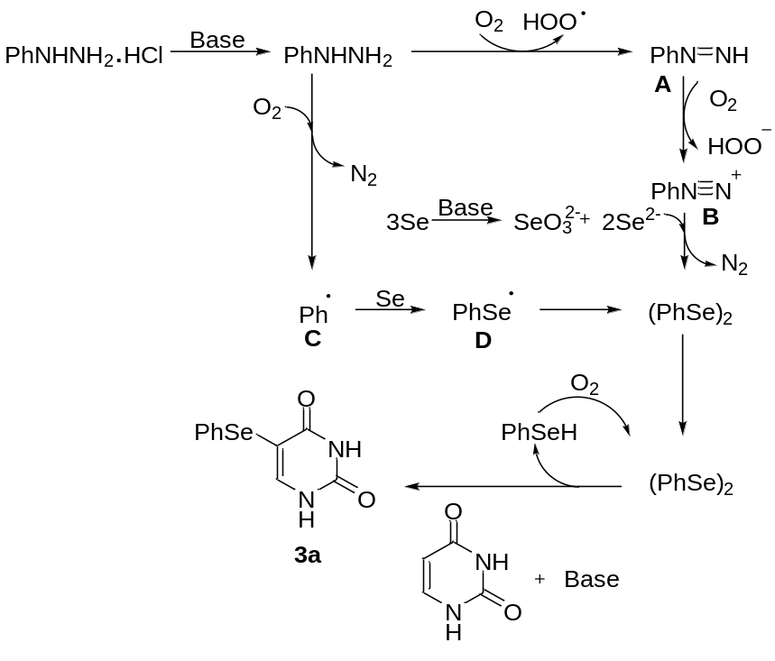
Scheme 6. Proposed mechanism for the reaction.

