Supporting Information
Arylhydrazine salt-selenium: a novel and efficient reagent system for arylselenenylation of unprotected uracil and its derivatives

Cong Wang ^{a,} ∗, §, Yi Wu ^{a, §}, Qi-Yun Peng ª, Yan-Ling He ^{b}, Xiao-He Zheng ^{b}, Yan-Qin Chen ª, Hai-Bo Wang ^{c}, Bing Wang ^{d}, Jun Xie ^{a ∗}, Lei Tang ^{e, ∗}

ªSchool of Pharmacy, Guizhou Provincial Engineering Technology Research Center for Chemical Drug R&D, Guizhou Medical University, Guiyang, China
^{b}Zhejiang Hisun pharmaceutical Co., Ltd., Taizhou 318000 Zhejiang, China
^{c}Zhejiang Hongyuan pharmaceutical Co., Ltd., Linhai, Zhejiang 317016, P. R. China.
^{d}School of Biology & Engineering, Guizhou Medical University, Guiyang 550025, Guizhou, P. R. China.
^{e}State Key Laboratory of Functions and Applications of Medicinal Plants, Guizhou Medcial University, Guiyang, China

Table of Contents
Supporting Information S1
Characterization of compounds S3

Characterization of compounds
5-(phenylselanyl) pyrimidine-2,4(1H,3H)-dione (3a)
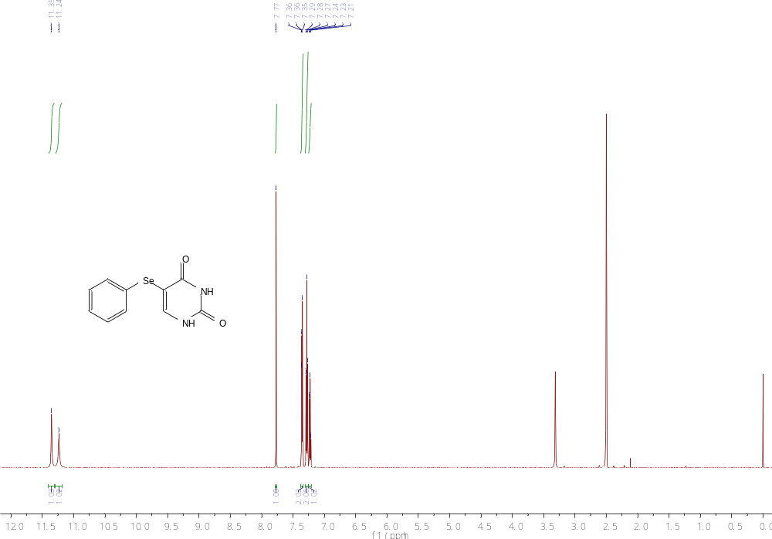

5-(o-tolylselanyl) pyrimidine-2,4(1H,3H)-dione(3b)
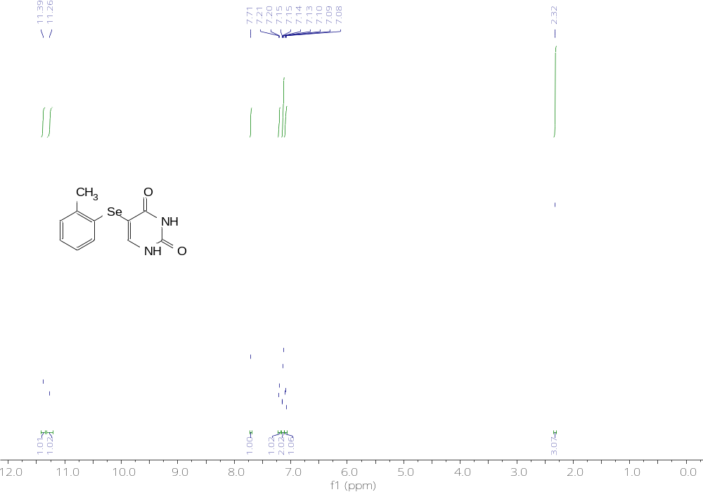

5-(m-tolylselanyl) pyrimidine-2,4(1H,3H)-dione(3c)
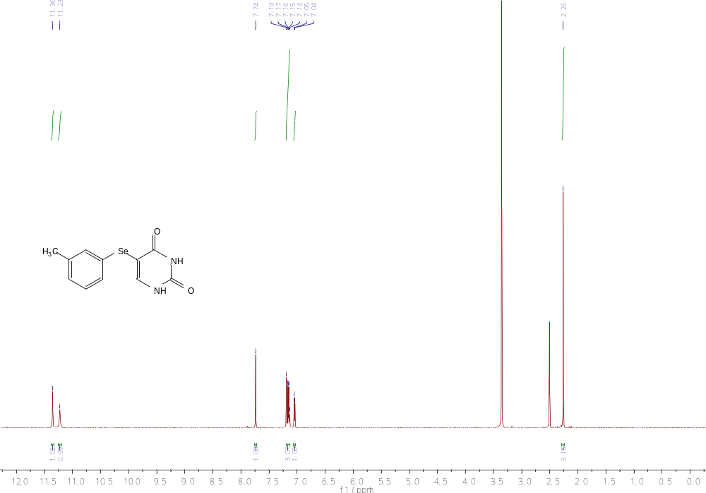
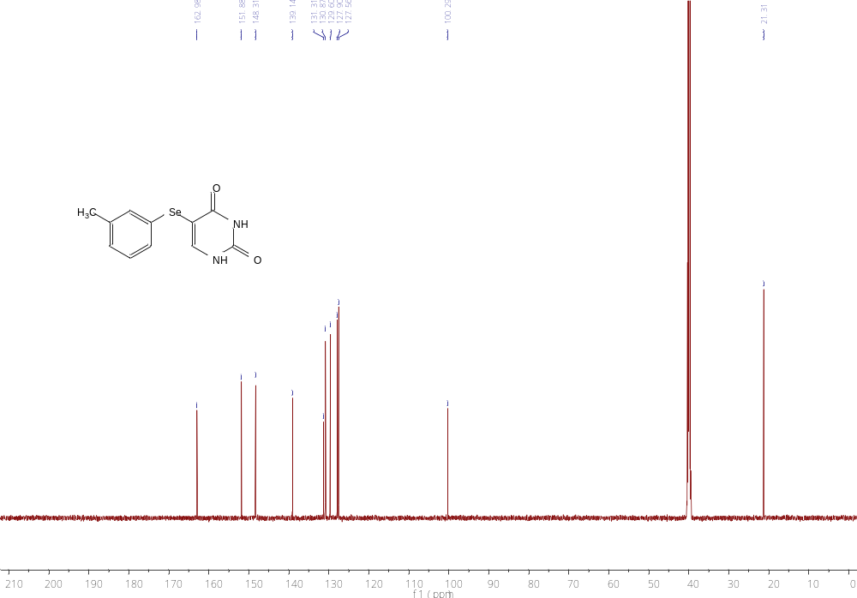

5-(p-tolylselanyl) pyrimidine-2,4(1H,3H)-dione(3d)
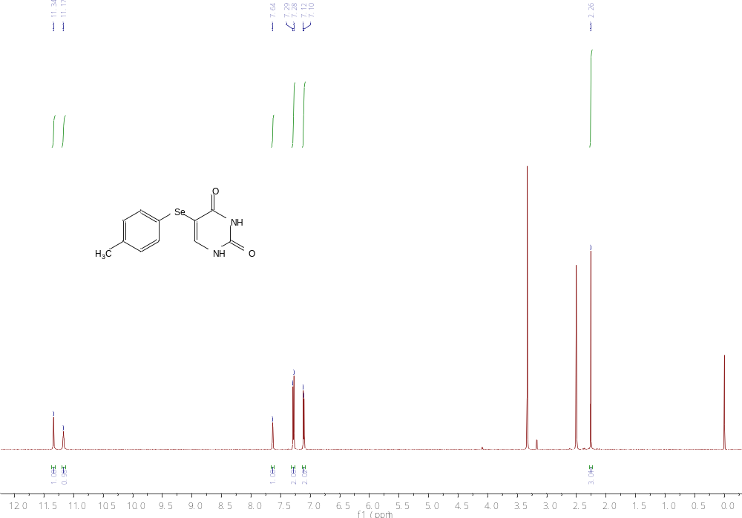
5-((2-fluorophenyl) selanyl) pyrimidine-2,4(1H,3H)-dione（3e）
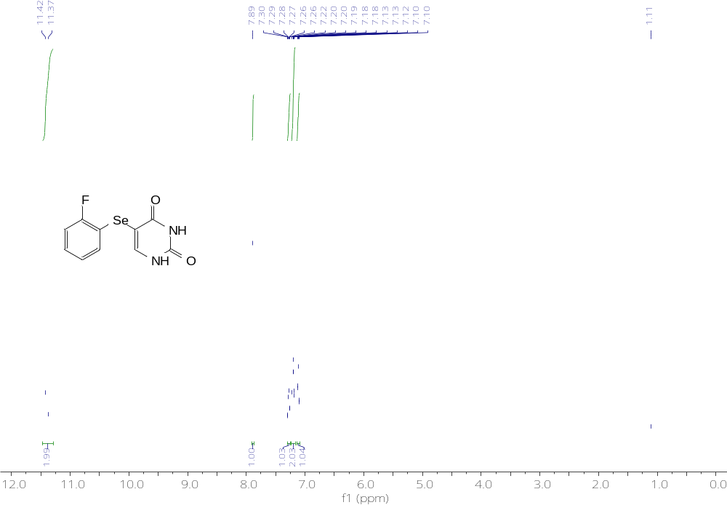
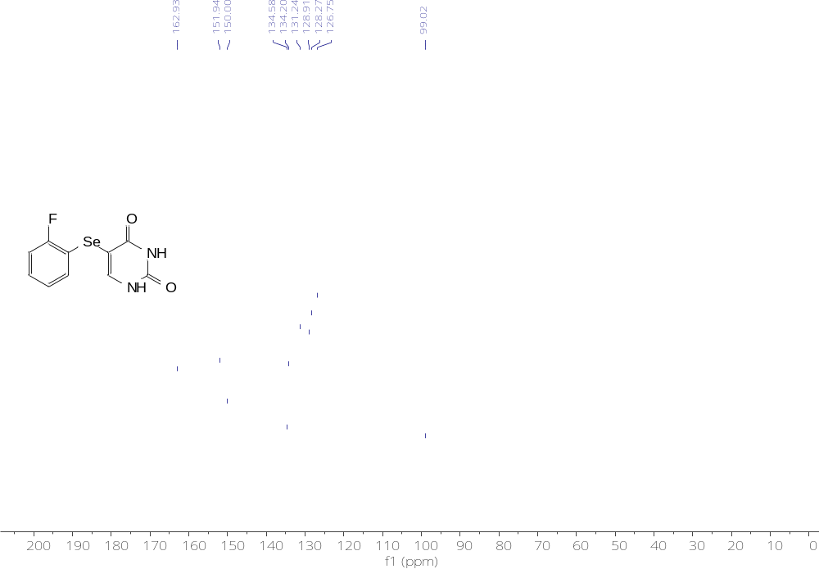
5-((3-fluorophenyl) selanyl) pyrimidine-2,4(1H,3H)-dione(3f)
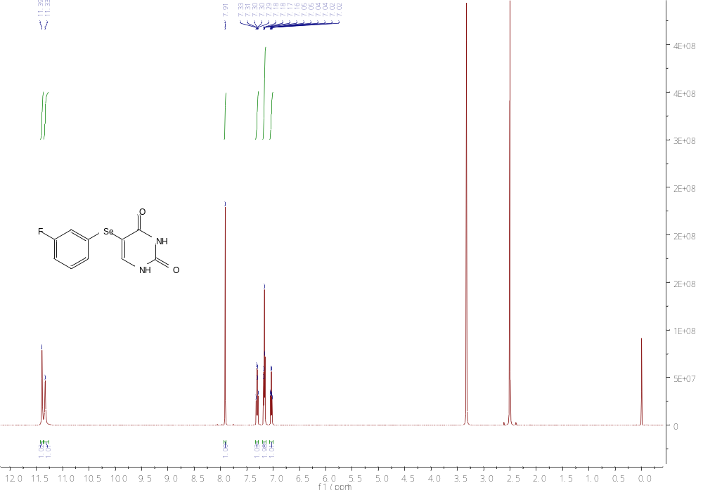

5-((3-chlorophenyl) selanyl) pyrimidine-2,4(1H,3H)-dione(3g)
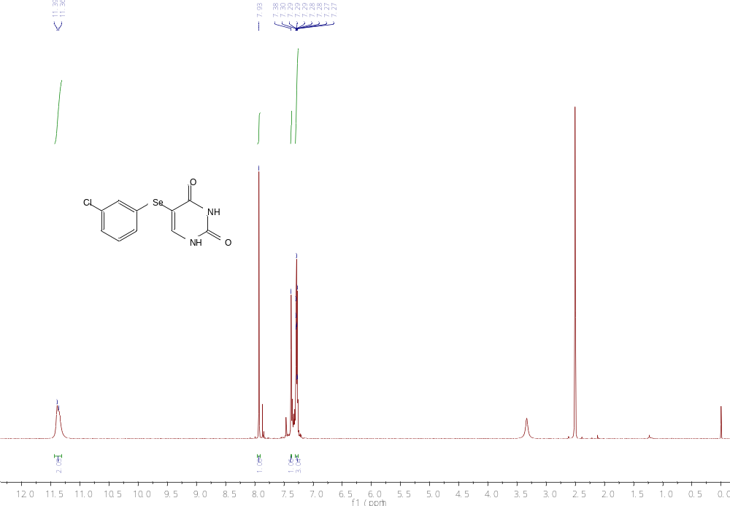
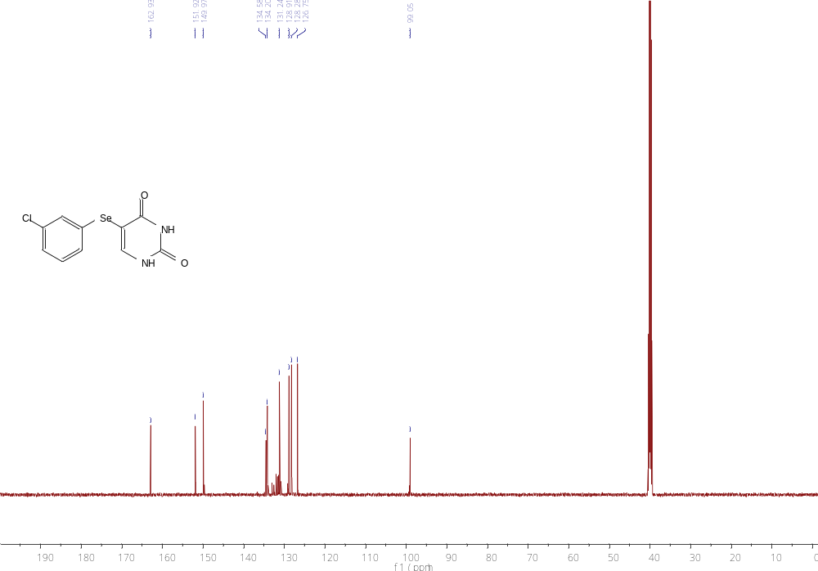

5-((4-chlorophenyl) selanyl) pyrimidine-2,4(1H,3H)-dione(3h)
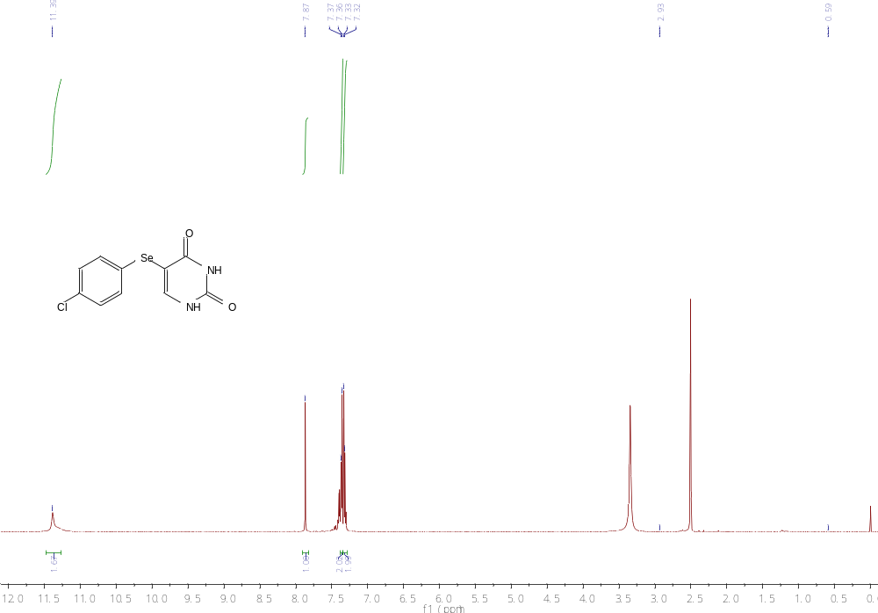

5-((4-bromophenyl) selanyl) pyrimidine-2,4(1H,3H)-dione(3i)
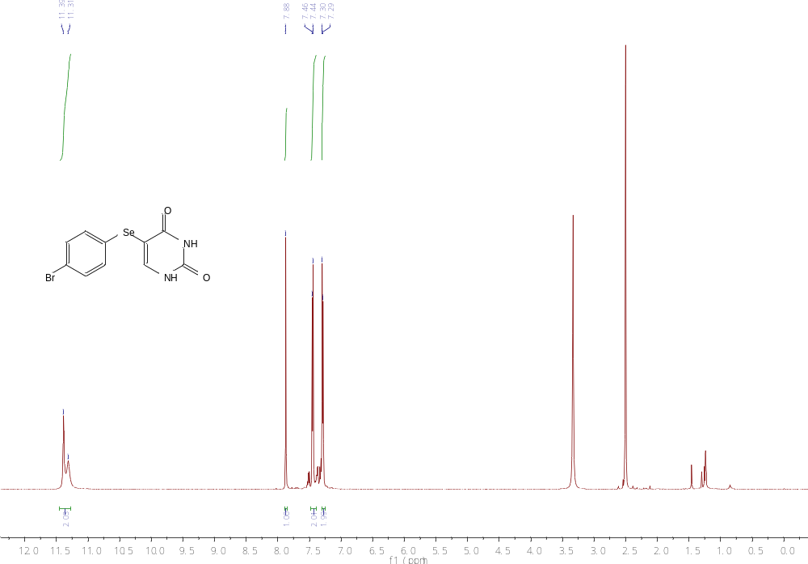

5-((2,4-difluorophenyl) selanyl) pyrimidine-2,4(1H,3H)-dione(3j)
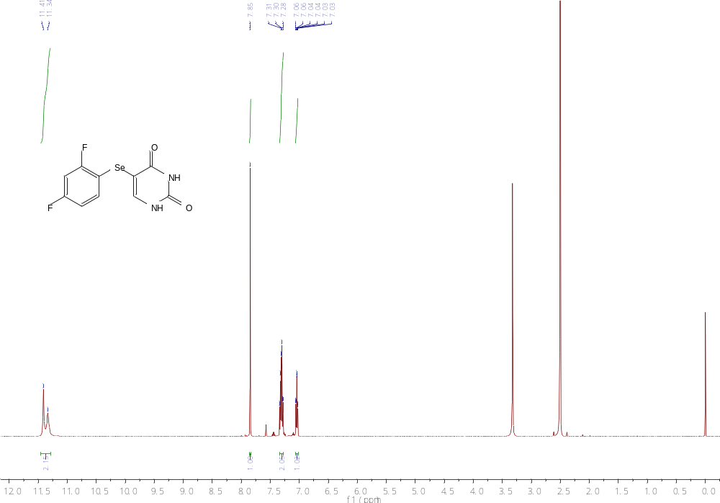
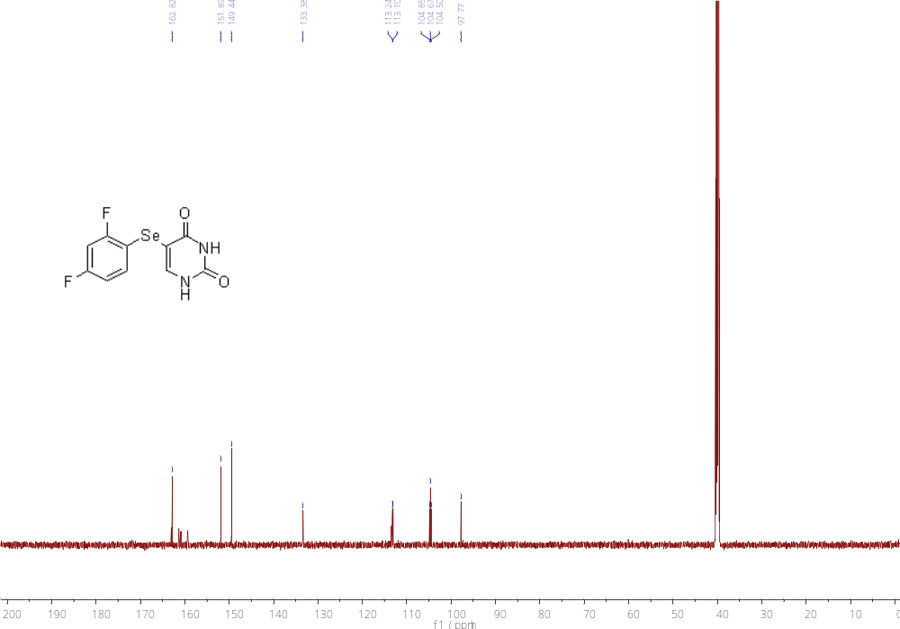

5-((2,4-dichlorophenyl) selanyl) pyrimidine-2,4(1H,3H)-dione(3k)
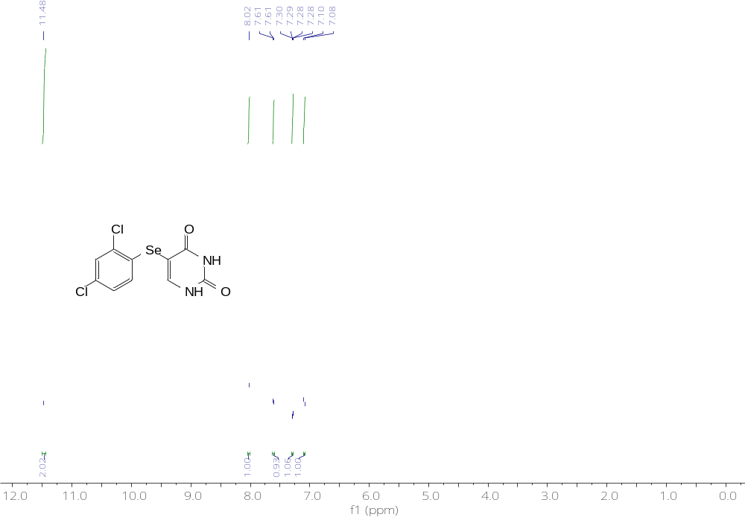
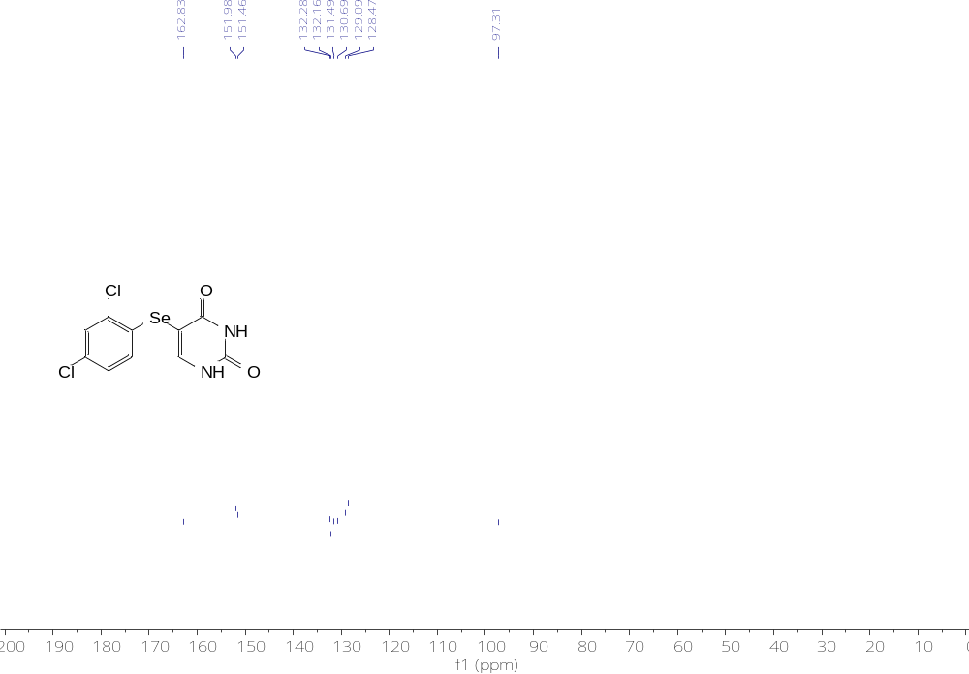

5-((4-nitrophenyl) selanyl) pyrimidine-2,4(1H,3H)-dione(3l)
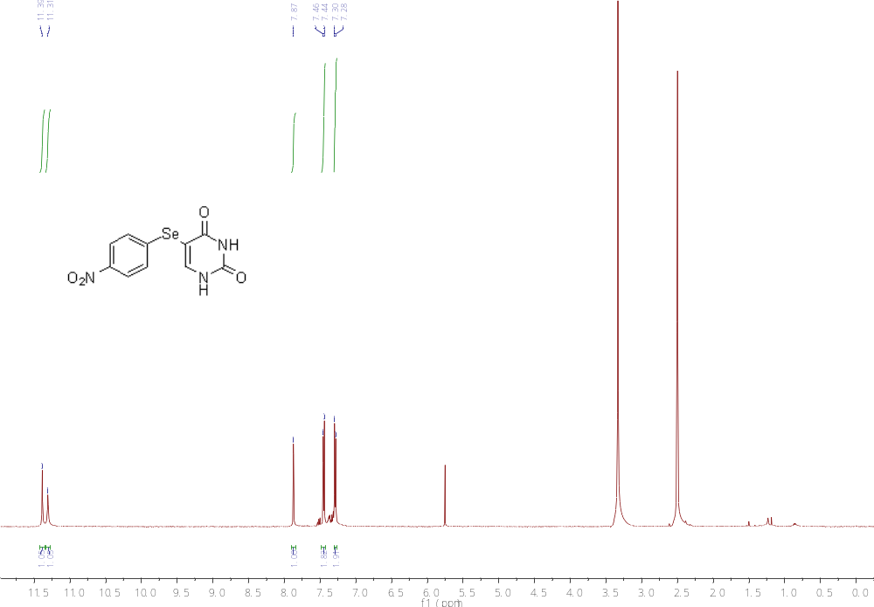
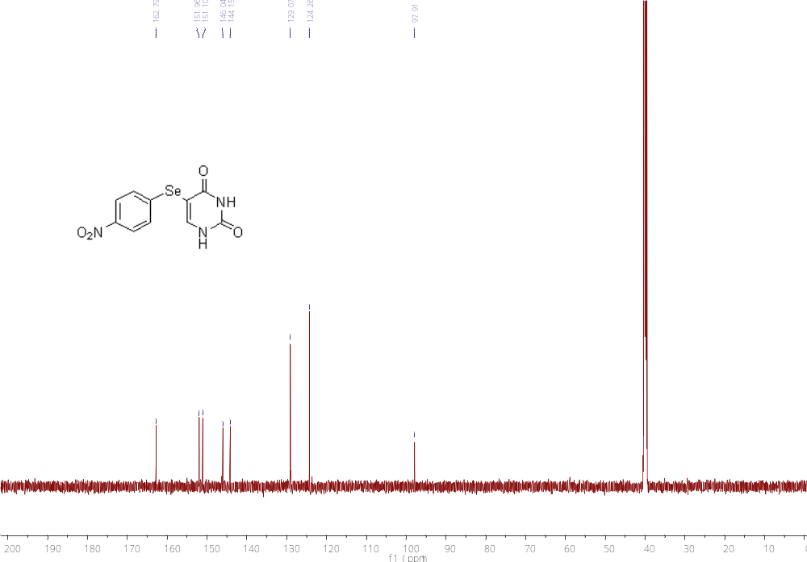
5-((3-nitrophenyl) selanyl) pyrimidine-2,4(1H,3H)-dione(3m)
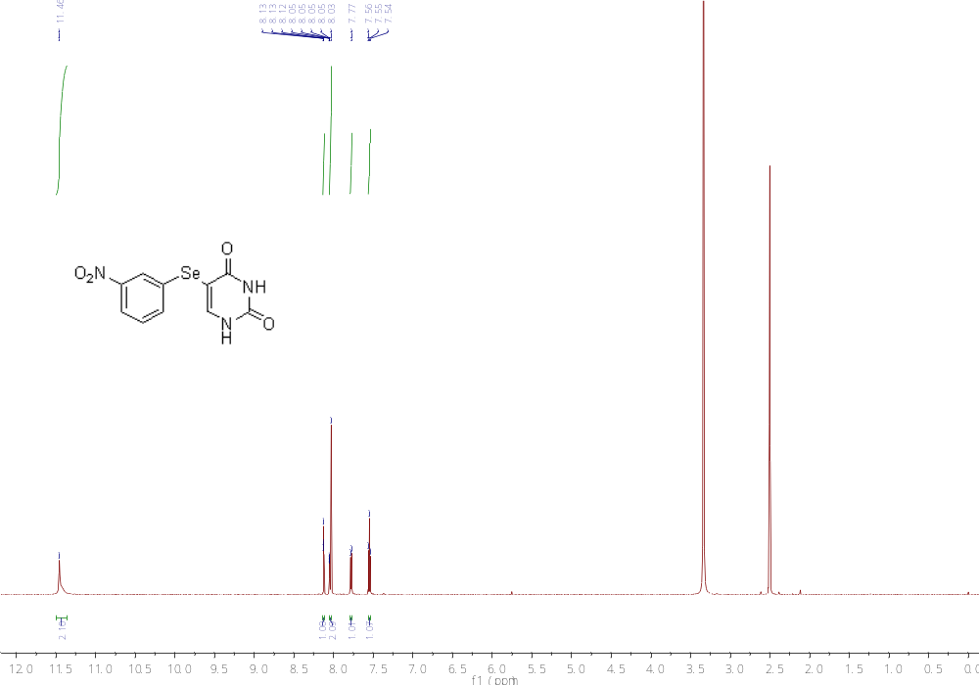
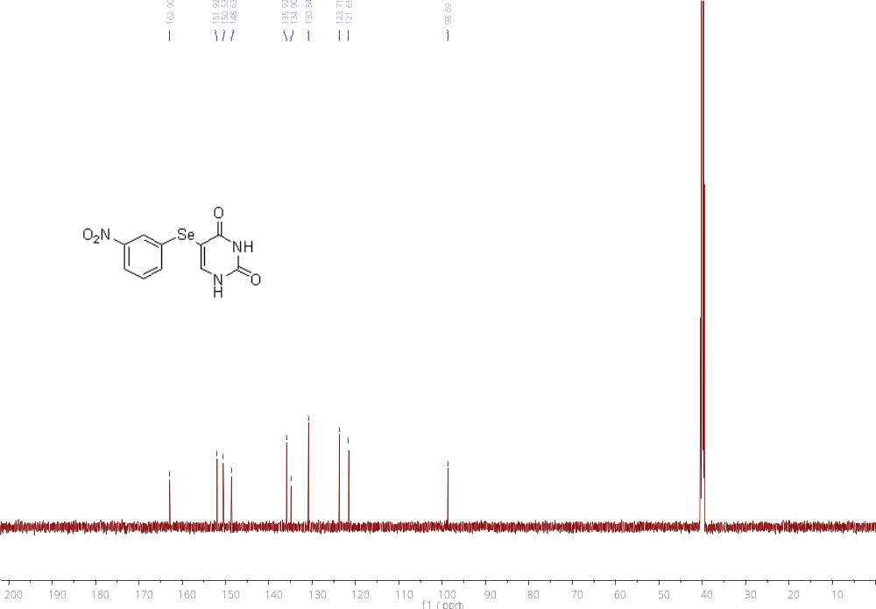

4-((2,4-dioxo-1,2,3,4-tetrahydropyrimidin-5-yl) selanyl) benzonitrile(3n)
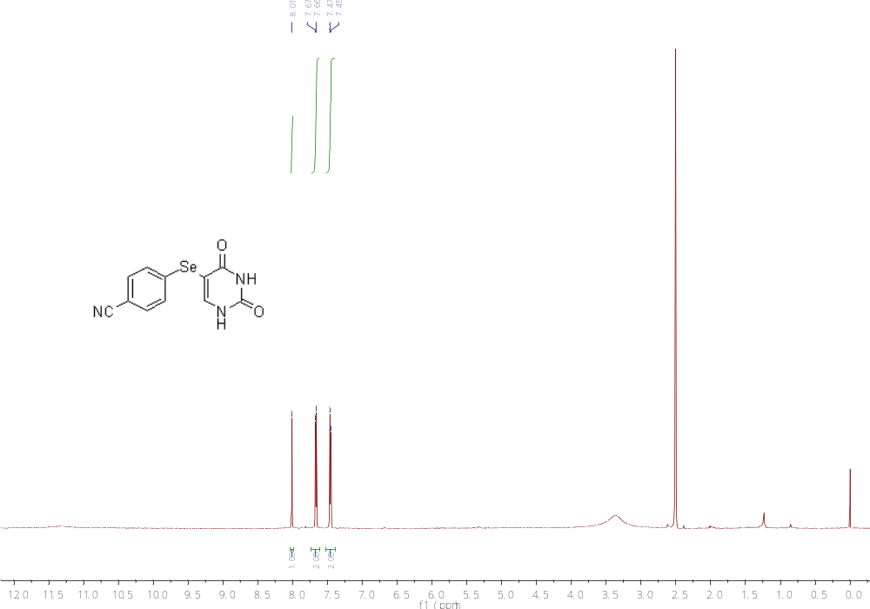

5-((4-methoxyphenyl) selanyl) pyrimidine-2,4(1H,3H)-dione(3o)
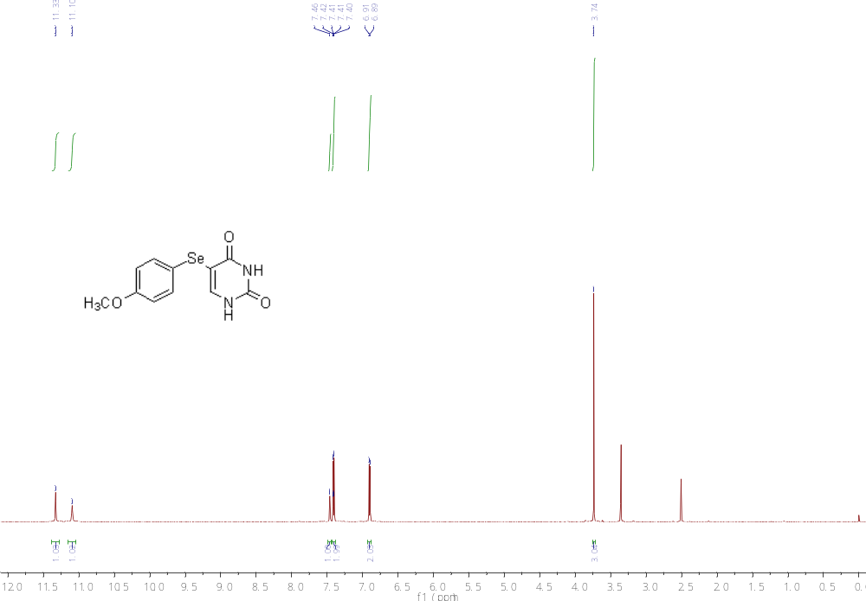
5-((3-chloro-4-methylphenyl) selanyl) pyrimidine-2,4(1H,3H)-dione(3p)
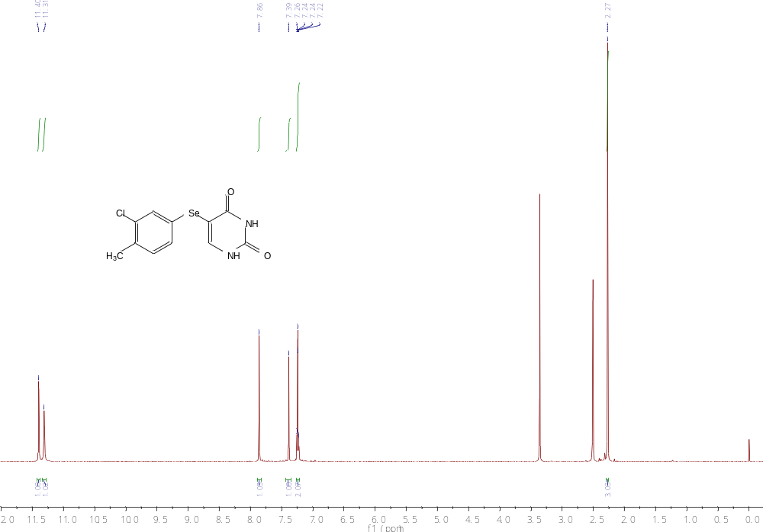
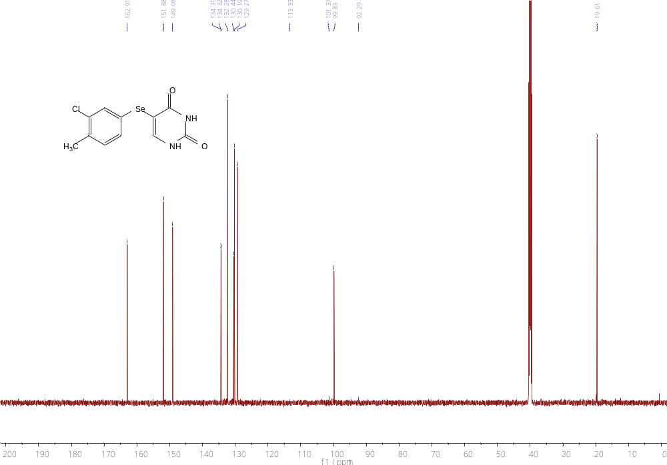

4-amino-5-(phenylselanyl) pyrimidin-2(1H)-one（5a）
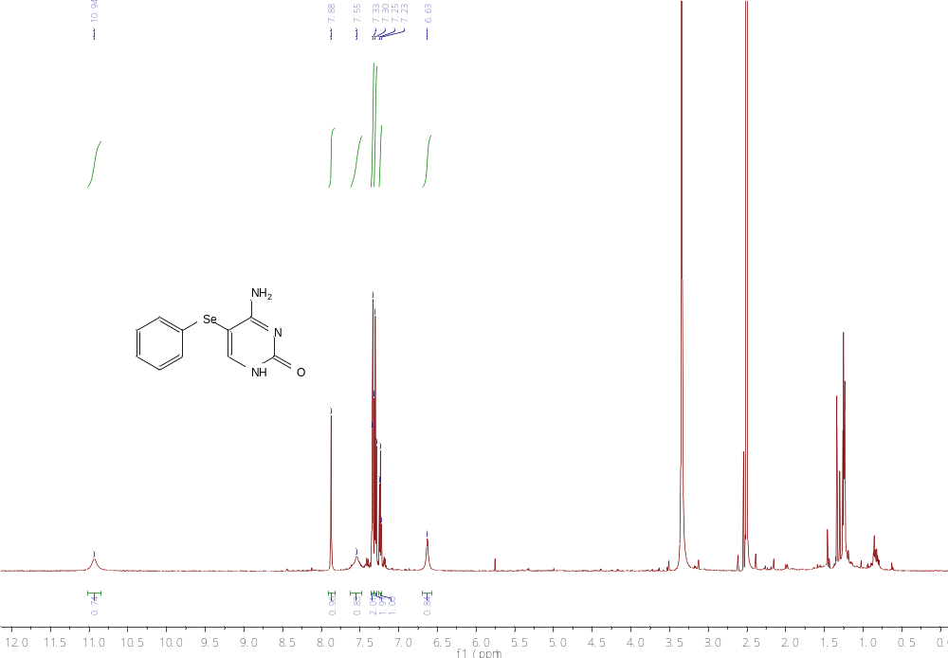
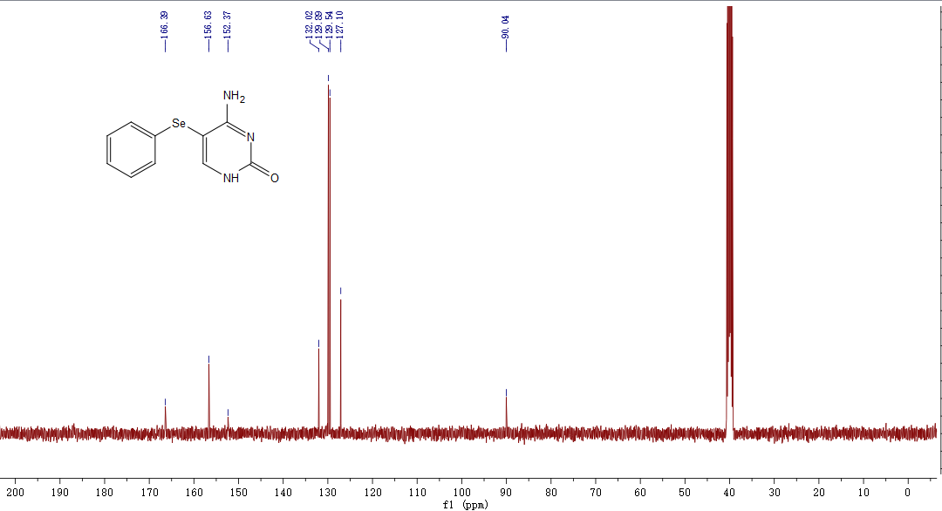

4-amino-5-(p-tolylselanyl) pyrimidin-2(1H)-one(5b)
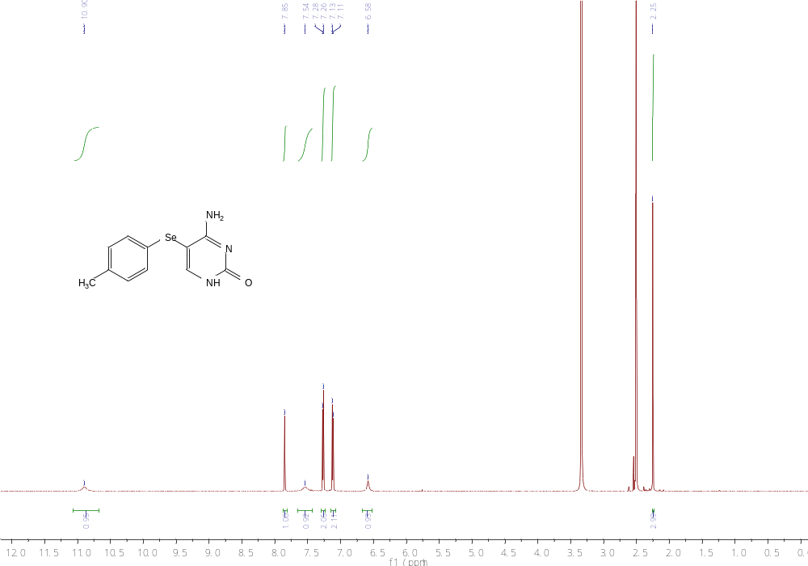
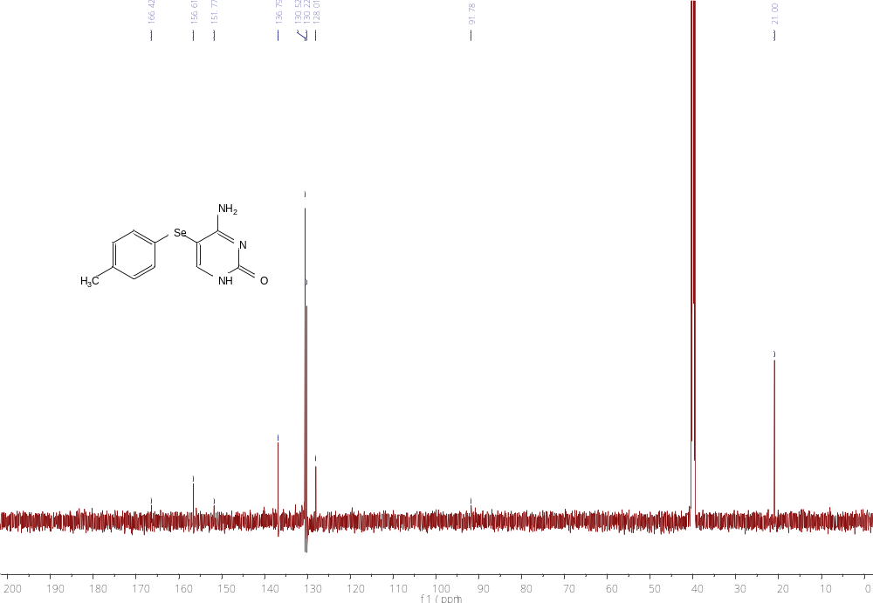

2-amino-5-(phenylselanyl) pyrimidin-4(1H)-one(7a)
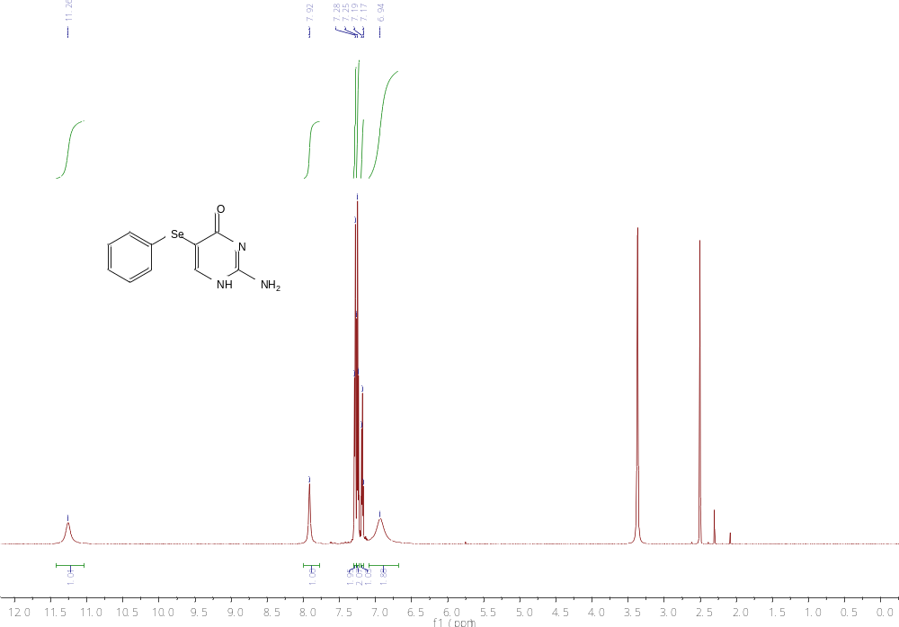
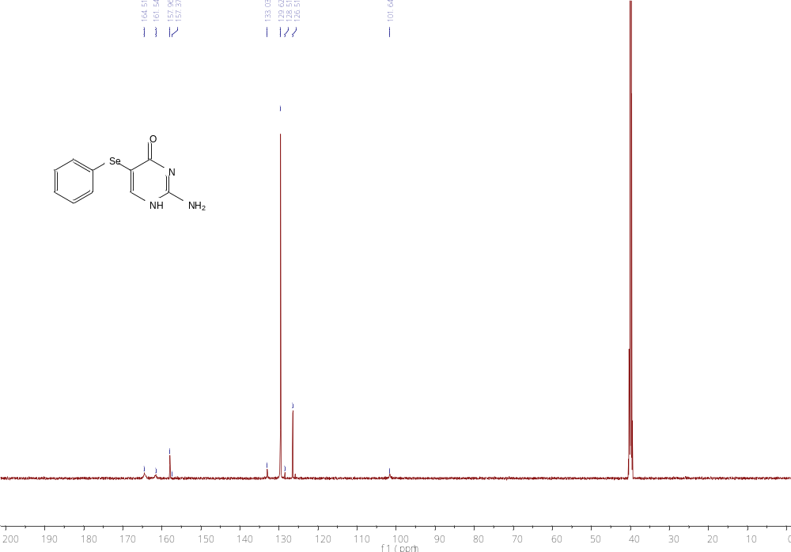

2-amino-5-((4-methoxyphenyl) selanyl) pyrimidin-4(1H)-one(7b)
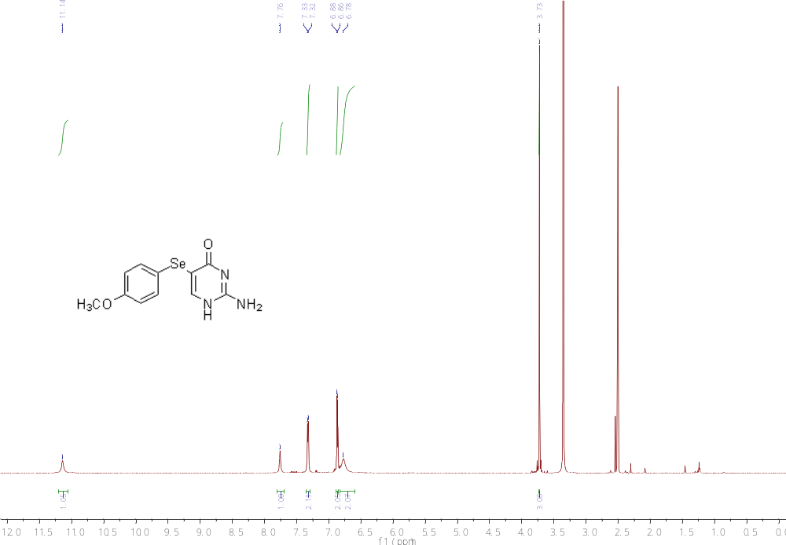
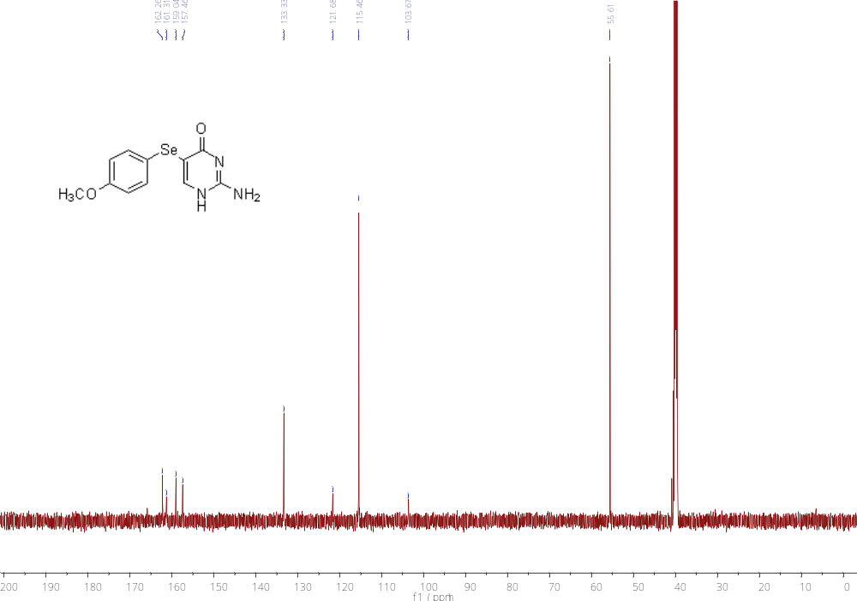
2-amino-5-((3-chlorophenyl) selanyl) pyrimidin-4(1H)-one(7c)
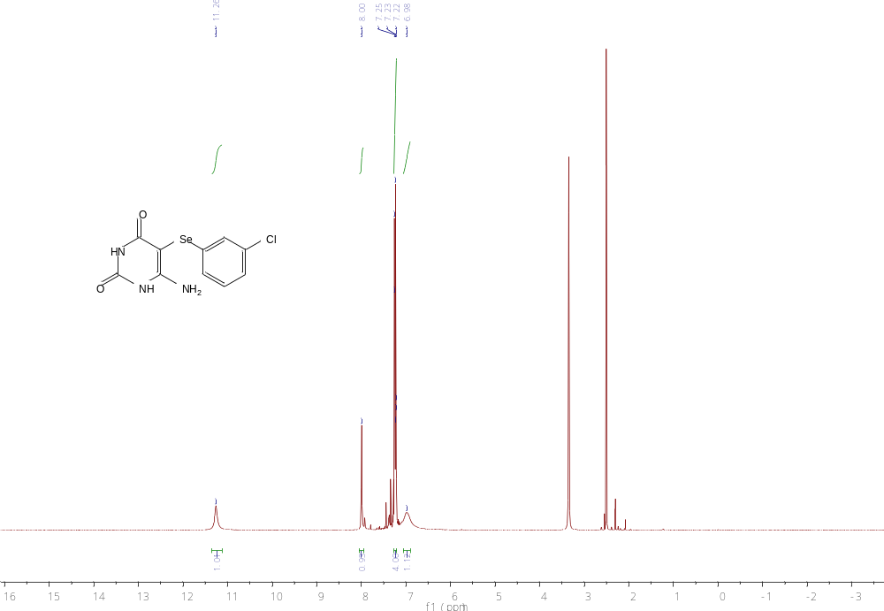
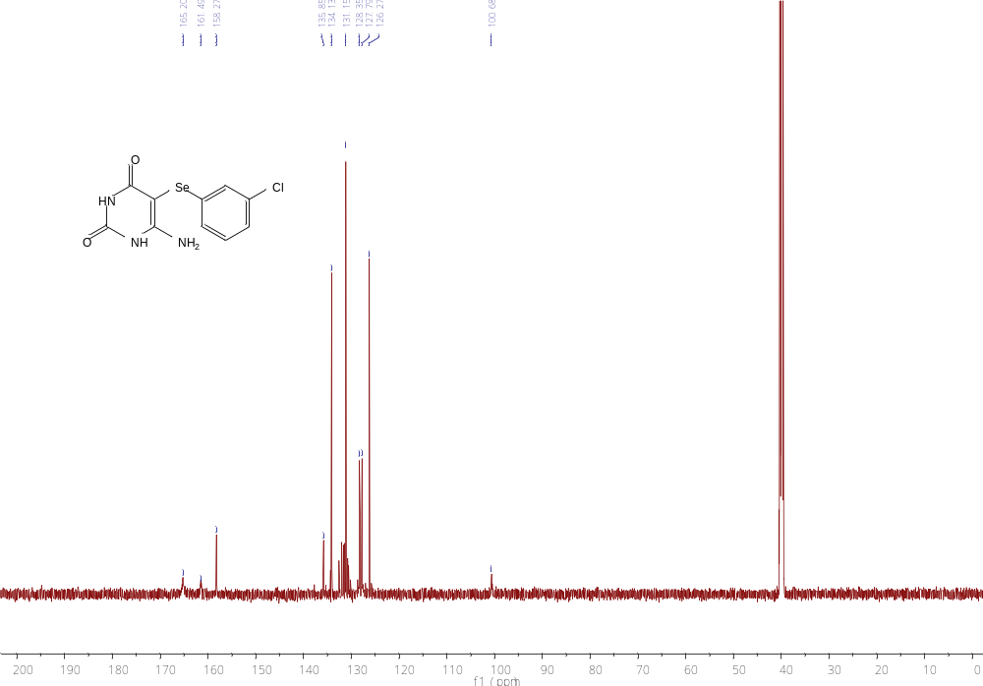

6-amino-5-(phenylselanyl) pyrimidine-2,4(1H,3H)-dione(9a)
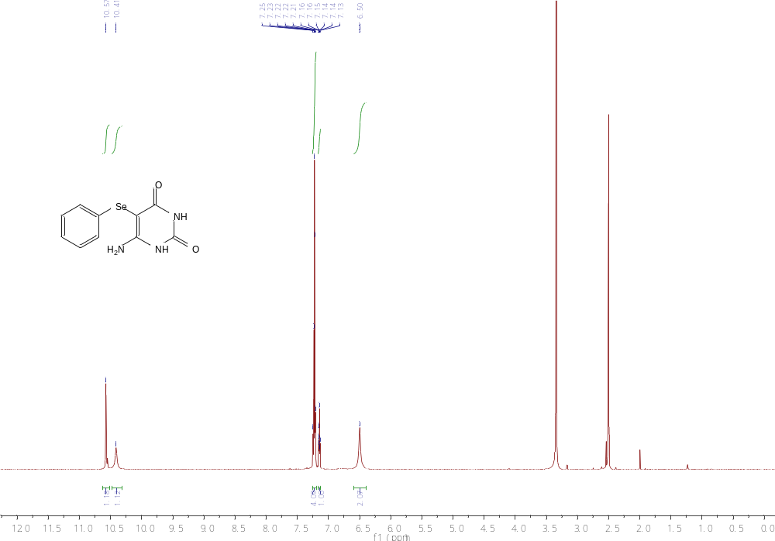

1-((2R,3R,4S,5R)-3,4-dihydroxy-5-(hydroxymethyl) tetrahydrofuran-2-yl)-5-(phenylselanyl) pyrimidine-2,4(1H,3H)-dione(11a)
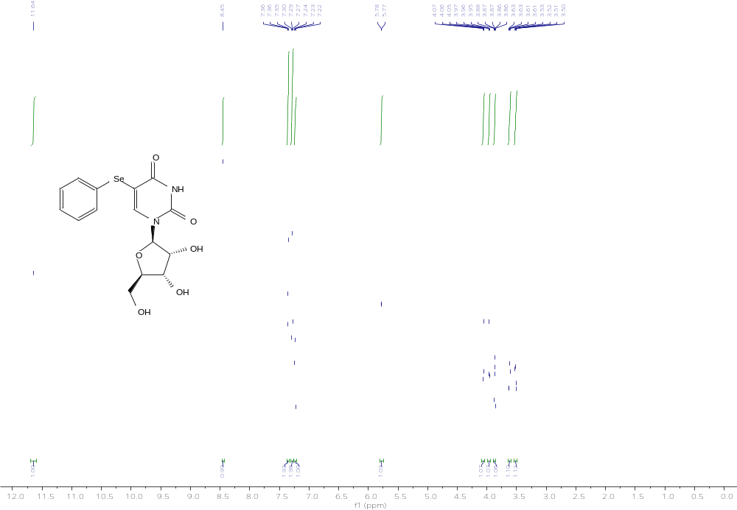

§ These authors contributed equally to this work. ∗ Corresponding author. E-mail address: kingland1@163.com, tlei1974@163.com.

