Supplementary Information
Retain strength, gain ductility: tough and transparent nanopapers by mercerisation
Florian Mayer ^{* a}, Alexander Prado-Roller ^{b}, Andreas Mautner ^{a, c},
and Alexander Bismarck ^{a,d,e}

ª Institute of Materials Chemistry and Research, Polymer and Composite Engineering (PaCE) Group, Faculty of Chemistry, University of Vienna, Währinger Straße 42, 1090 Vienna, Austria
^{b} Institute of Inorganic Chemistry – Functional Materials, Faculty of Chemistry, University of Vienna, Währinger Straße 42 , 1090 Vienna, Austria
^{c} Institute of Environmental Biotechnology, IFA-Tulln, University of Natural Resources and Life Sciences, Vienna, Konrad-Lorenz-Straße 20, 3430 Tulln an der Donau
^{d} Department of Chemical Engineering, Imperial College London, South Kensington Campus, SW7 2AZ London, United Kingdom
^{e} Division of Materials Science, Department of Engineering Sciences and Mathematics, Luleå University of Technology, SE-971 87, Luleå, Sweden

SI Section 1: Workflow used for Riedveld refinement of wide angle PXRD diffractograms of un/mercerised nanopapers
Conditions and workflow
The Rietveld fitting was performed stepwise. Starting with scale and background fits, followed by specimen displacement. Afterwards, a rough estimation of FWHM was inserted manually. The amorphous phase FWHM was fixed to a resulting value for the crystallite size to be smaller than 25 Å. As next step cell refinement by updating FWHM was performed. At this point the preferred orientation was included in the refinement. Finally, all parameters were fitted together if possible.
Problems in the fit of 2θ regions above 30º made a correction in the background setup necessary. Sharp peaks in the 2θ range are not part of the Rietveld refinement and were inserted and refined manually to exclude intensities from the Rietveld refinement.
Remarks:
The refined cellulose cells deviate from the initial starting point. We cannot guarantee that the resulting cells are a correct representation of our cellulose. We found three phase models (cellulose Iβ, cellulose II and amorphous cellulose) based on input parameters that fit the diffractograms. The changing cellulose Iβ to cellulose II ratio ended in a realistic scenario.
Cellulose Iβ ends in two cell scenarios depending on concentration of the NaOH solution used and mercerization time. The Rietveld fitting of the diffractograms of the original, unmercerised cellulose, the cellulose mercerised for 2 min in 40 wt.% NaOH solution, and for 10 min in 40 wt.% NaOH solution resulted in a smaller cell size than that of all samples mercerised in 20 wt.% NaOH and the sample mercerised in 40 wt.% NaOH for 60 min.
Cellulose II seemed to be more stable.
Amorphous Cellulose was refined almost without any restrictions other than the one on crystallite size mentioned above.
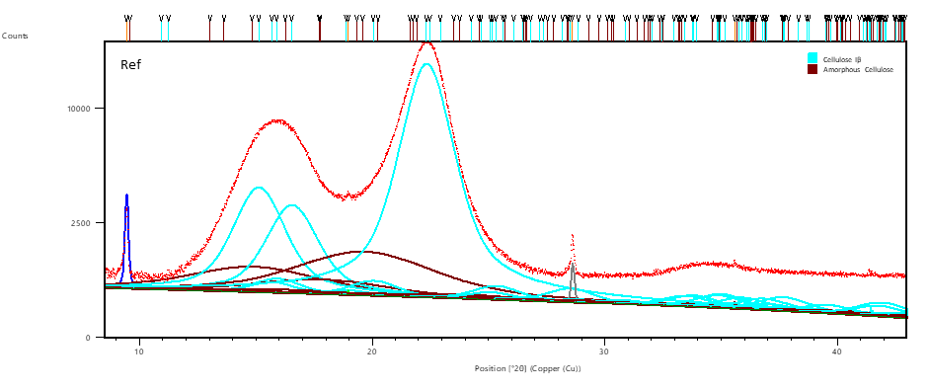
Figure SI 1-1 Wide Angle PXRD Diffractogram of an unmercerised reference nanopaper
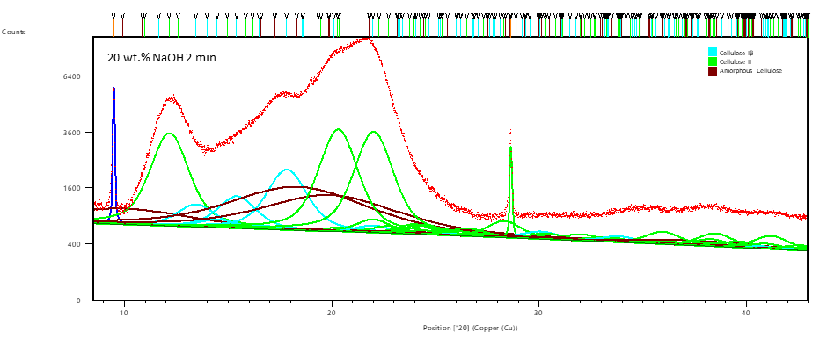
Figure SI 1-2 Wide Angle PXRD Diffractogram of a nanopaper mercerised for 2 min in 20 wt.% NaOH solution

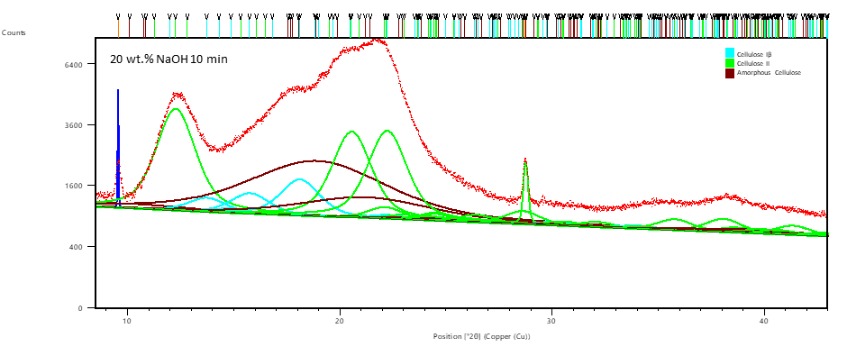
Figure SI 1-3 Wide Angle PXRD Diffractogram of a nanopaper mercerised for 10 min in 20 wt.% NaOH solution

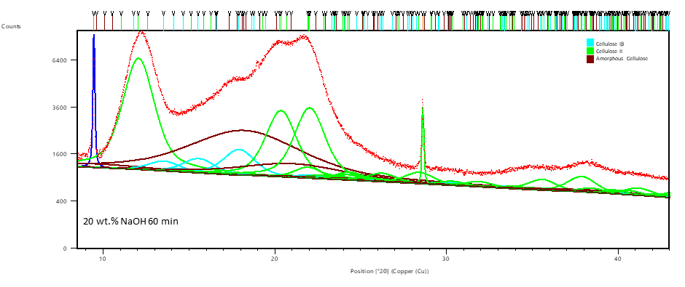
Figure SI 1-4 Wide Angle PXRD Diffractogram of a nanopaper mercerised for 60 min in 20 wt.% NaOH solution

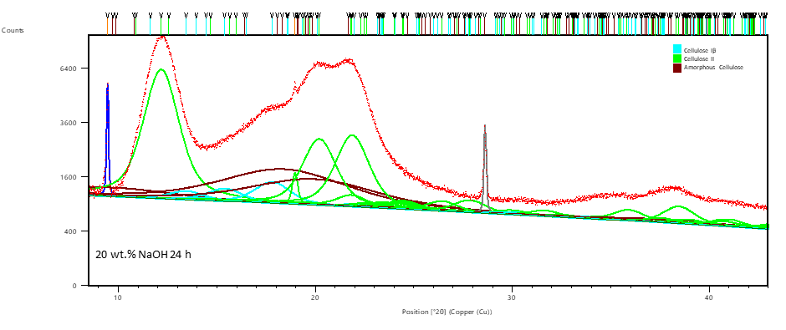
Figure SI 1-5 Wide Angle PXRD Diffractogram of a nanopaper mercerised for 1440 min in 20 wt.% NaOH solution

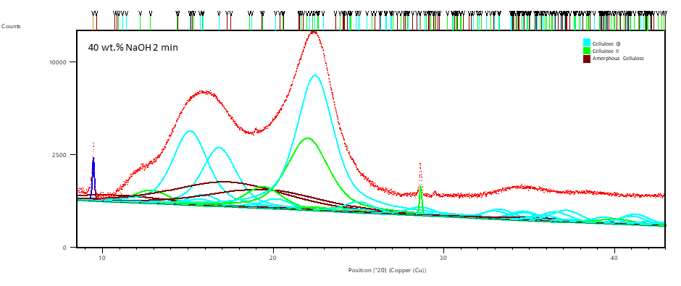
Figure SI 1-6 Wide Angle PXRD Diffractogram of a nanopaper mercerised for 2 min in 40 wt.% NaOH solution
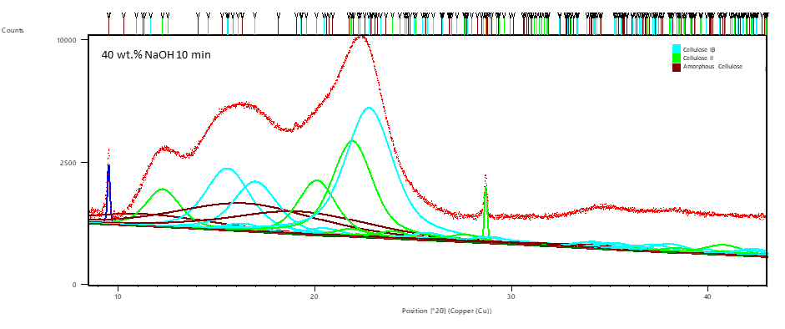
Figure SI 1-7 Wide Angle PXRD Diffractogram of a nanopaper mercerised for 10 min in 40 wt.% NaOH solution

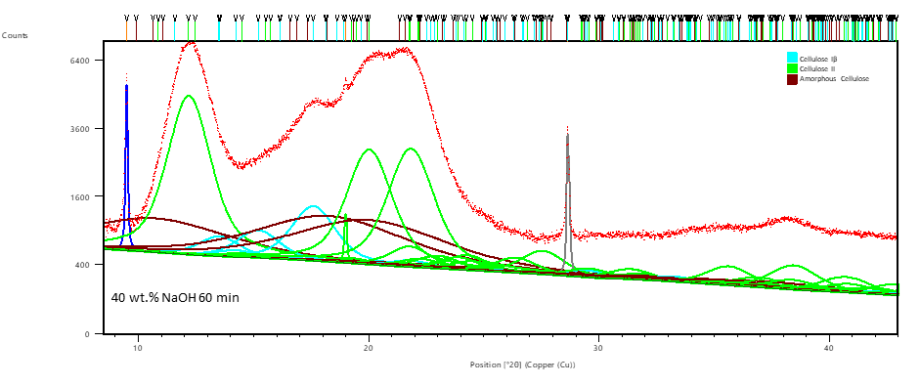
Figure SI 1-8 Wide Angle PXRD Diffractogram of a nanopaper mercerised for 60 min in 40 wt.% NaOH solution

SI Section 2. Morphological differences of nanopapers before and after mercerisation
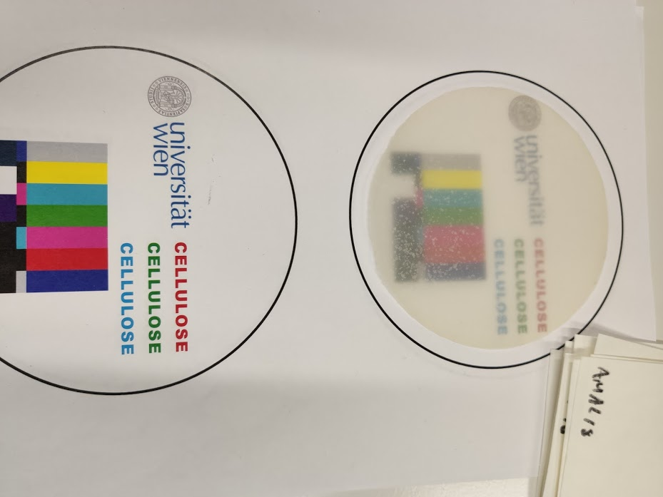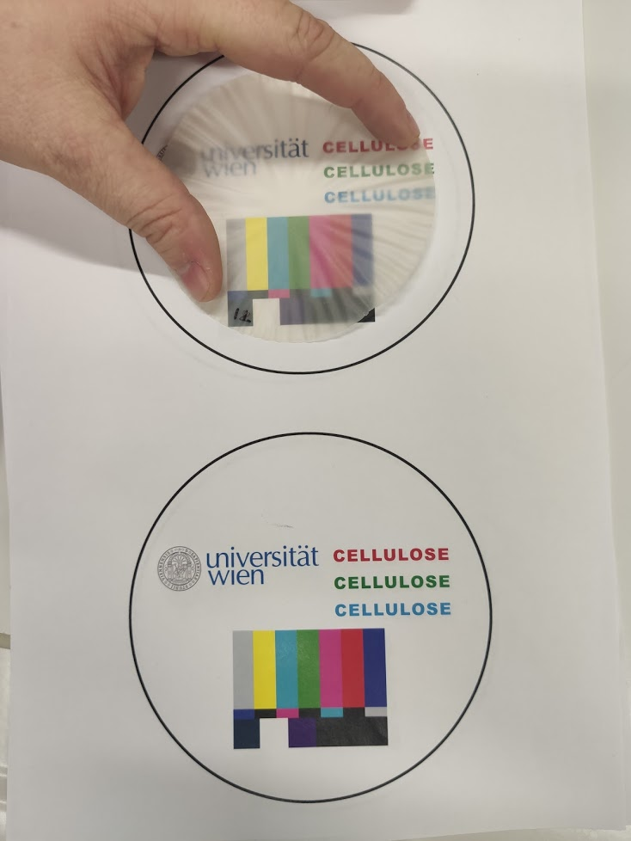
Figure SI 2-1: comparison of a nanopaper before (left) and after (right) mercerisation in 40 wt.% NaOH solution without clamping for 1h exhibiting shrinkage and cockling.

Table SI 2-1. Thickness, Density and porosity of nanopapers before and after mercerisation
 |  | Thickness
Sample Name |  | before mercerisation  [µm] |  |  |  |  |  | after mercerisation  [µm] |  |  |  |  |  |  | Δ
Sample Name |  |  |  |  |  |  |  |  |  |  |  |  |  |  | abs.  [µm] |  |  |  | rel.  [%]
20% 2min 1 |  | 52.0 | ± |  | 2.4 |  |  | 55.8 |  | ± | 2.4 |  |  |  | 3.8 |  |  |  | 7.3
20% 2min 2 |  | 59.2 | ± |  | 2.6 |  |  | 56.9 |  | ± | 3.1 |  |  |  | -2.3 |  |  |  | -3.9
20% 10min 1 |  | 59.3 | ± |  | 2.7 |  |  | 59.5 |  | ± | 4.0 |  |  |  | 0.2 |  |  |  | 0.3
20% 10min 2 |  | 52.6 | ± |  | 2.3 |  |  | 54.5 |  | ± | 2.8 |  |  |  | 1.9 |  |  |  | 3.6
20% 60min 1 |  | 53.9 | ± |  | 1.8 |  |  | 51.9 |  | ± | 1.5 |  |  |  | -2.0 |  |  |  | -3.7
20% 60min 2 |  | 54.9 | ± |  | 2.5 |  |  | 56.0 |  | ± | 2.6 |  |  |  | 1.1 |  |  |  | 2.0
20% 24h 1 |  | 53.0 | ± |  | 2.1 |  |  | 47.9 |  | ± | 1.6 |  |  |  | -5.1 |  |  |  | -9.5
20% 24h 2 |  | 53.6 | ± |  | 2.0 |  |  | 49.0 |  | ± | 2.0 |  |  |  | -4.6 |  |  |  | -8.6
40% 2min 1 |  | 52.6 | ± |  | 1.2 |  |  | 53.8 |  | ± | 4.1 |  |  |  | 1.2 |  |  |  | 2.3
40% 2min 2 |  | 53.9 | ± |  | 1.9 |  |  | 51.5 |  | ± | 2.1 |  |  |  | -2.4 |  |  |  | -4.4
40% 10min 1 |  | 55.3 | ± |  | 3.3 |  |  | 54.6 |  | ± | 5.1 |  |  |  | -0.7 |  |  |  | -1.3
40% 10min 2 |  | 53.5 | ± |  | 1.8 |  |  | 52.3 |  | ± | 2.0 |  |  |  | -1.2 |  |  |  | -2.2
40% 60min 1 |  | 53.7 | ± |  | 1.3 |  |  | 53.3 |  | ± | 1.6 |  |  |  | -0.4 |  |  |  | -0.7
40% 60min 2 |  | 57.9 | ± |  | 3.8 |  |  | 57.6 |  | ± | 3.0 |  |  |  | -0.3 |  |  |  | -0.5
20% 10min unrestrained |  | 54.3 | ± |  | 2.6 |  |  | 65.5 |  | ± | 2.5 |  |  |  | 11.2 |  |  |  | 20.6
Ref |  | 51.3 | ± |  | 2.3
 |  | Density
Sample Name |  | before mercerisation  [kg/m³] |  |  |  |  |  |  | after mercerisation  [kg/m³] |  |  |  |  |  |  |  | Δ density
 |  |  |  |  |  |  |  |  |  |  |  |  |  |  |  |  | abs.  [kg/m³] |  |  |  | rel.  [%]
20% 2min 1 |  | 998 |  | ± |  | 45 |  |  | 1083 |  |  | ± | 33 |  |  |  | 85 |  |  |  | 9
20% 2min 2 |  | 959 |  | ± |  | 43 |  |  | 1073 |  |  | ± | 35 |  |  |  | 114 |  |  |  | 12
20% 10min 1 |  | 1018 |  | ± |  | 47 |  |  | 1110 |  |  | ± | 32 |  |  |  | 92 |  |  |  | 9
20% 10min 2 |  | 1010 |  | ± |  | 43 |  |  | 1091 |  |  | ± | 17 |  |  |  | 81 |  |  |  | 8
20% 60min 1 |  | 975 |  | ± |  | 32 |  |  | 1076 |  |  | ± | 27 |  |  |  | 101 |  |  |  | 10
20% 60min 2 |  | 974 |  | ± |  | 44 |  |  | 1101 |  |  | ± | 25 |  |  |  | 127 |  |  |  | 13
20% 24h 1 |  | 986 |  | ± |  | 40 |  |  | 1060 |  |  | ± | 22 |  |  |  | 73 |  |  |  | 7
20% 24h 2 |  | 1005 |  | ± |  | 38 |  |  | 1097 |  |  | ± | 19 |  |  |  | 91 |  |  |  | 9
40% 2min 1 |  | 1052 |  | ± |  | 24 |  |  | 1067 |  |  | ± | 36 |  |  |  | 14 |  |  |  | 1
40% 2min 2 |  | 1027 |  | ± |  | 37 |  |  | 1097 |  |  | ± | 20 |  |  |  | 69 |  |  |  | 7
40% 10min 1 |  | 998 |  | ± |  | 60 |  |  | 1062 |  |  | ± | 51 |  |  |  | 65 |  |  |  | 7
40% 10min 2 |  | 1065 |  | ± |  | 36 |  |  | 1120 |  |  | ± | 25 |  |  |  | 55 |  |  |  | 5
40% 60min 1 |  | 1053 |  | ± |  | 27 |  |  | 1105 |  |  | ± | 28 |  |  |  | 52 |  |  |  | 5
40% 60min 2 |  | 1010 |  | ± |  | 66 |  |  | 1127 |  |  | ± | 20 |  |  |  | 117 |  |  |  | 12
20% 10min unrestrained |  | 1034 |  | ± |  | 50 |  |  | 1135 |  |  | ± | 28 |  |  |  | 101 |  |  |  | 10
Ref |  | 998 |  | ± |  | 49.0

 |  | Porosity
Sample Name |  | before mercerisation  [%] |  |  |  | after mercerisation  [%] |  |  |  | Δ
Sample Name |  |  |  |  |  |  |  |  |  | abs.  [%] |  | rel.  [%]
20% 2min 1 |  | 37.9 | ± | 1.7 |  | 32.6 | ± | 1.0 |  | -5.3 | ± | -14.0
20% 2min 2 |  | 40.3 | ± | 1.8 |  | 33.2 | ± | 1.1 |  | -7.1 | ± | -17.6
20% 10min 1 |  | 36.6 | ± | 1.7 |  | 30.9 | ± | 0.9 |  | -5.7 | ± | -15.6
20% 10min 2 |  | 37.1 | ± | 1.6 |  | 32.1 | ± | 0.5 |  | -5.0 | ± | -13.5
20% 60min 1 |  | 39.3 | ± | 1.3 |  | 33.0 | ± | 0.8 |  | -6.3 | ± | -16.0
20% 60min 2 |  | 39.3 | ± | 1.8 |  | 31.4 | ± | 0.7 |  | -7.9 | ± | -20.1
20% 24h 1 |  | 38.6 | ± | 1.6 |  | 34.0 | ± | 0.7 |  | -4.6 | ± | -11.8
20% 24h 2 |  | 37.4 | ± | 1.4 |  | 31.7 | ± | 0.6 |  | -5.7 | ± | -15.2
40% 2min 1 |  | 34.5 | ± | 0.8 |  | 33.6 | ± | 1.1 |  | -0.9 | ± | -2.6
40% 2min 2 |  | 36.0 | ± | 1.3 |  | 31.7 | ± | 0.6 |  | -4.3 | ± | -12.0
40% 10min 1 |  | 38.0 | ± | 2.3 |  | 33.9 | ± | 1.6 |  | -4.1 | ± | -10.7
40% 10min 2 |  | 33.7 | ± | 1.1 |  | 30.2 | ± | 0.7 |  | -3.4 | ± | -10.2
40% 60min 1 |  | 34.4 | ± | 0.9 |  | 31.2 | ± | 0.8 |  | -3.2 | ± | -9.4
40% 60min 2 |  | 37.1 | ± | 2.4 |  | 29.8 | ± | 0.5 |  | -7.3 | ± | -19.7
20% 10min unrestrained |  | 35.6 | ± | 1.7 |  | 29.3 | ± | 0.7 |  | -6.3 | ± | -17.7
Ref |  | 36.5 | ± | 1.3

Figure SI 2-2: Fracture surfaces of un/mercerized cellulose nanopapers.

SI Section 3. XPS analysis and elemental composition of nanopapers before and after mercerisation.
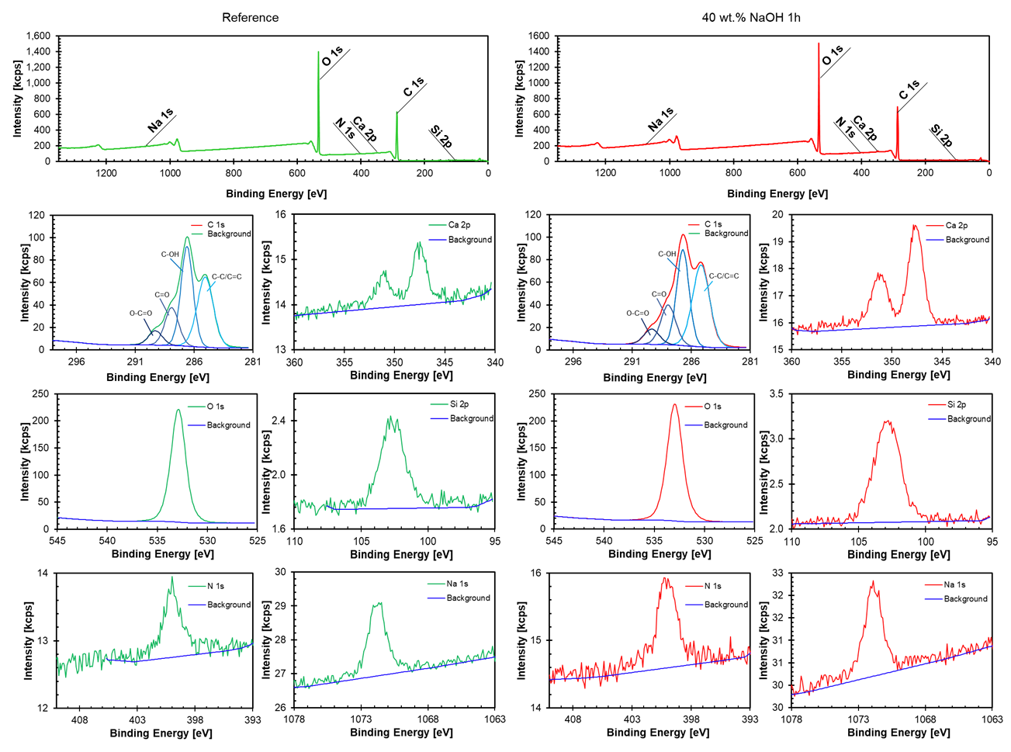
Figure SI 3-1: XP survey Top) and element specific high-resolution XP spectra (below the respective Survey) after 1 min ablation with 1k atom Ar clusters with an energy of 6 keV to remove adventitious carbon. The elemental composition of original and nanopapers mercerised in 40 wt.% NaOH for 1 h shown in Figure SI 3-2 were determined from the peak areas of the high-resolution spectra.

To exclude the possibility of the bulbs formed on the surface of the nanopapers after mercerisation being caused by the precipitation of inorganic salts stemming from (tap) water during the rinsing step. XPS spectra were recorded and the elemental compositions of all samples determined for the original surface as well as after 1 min and 6 min of etching, respectively (Figure SI 3-2). Small amounts of Si were found on all samples, which can be attributed to residues of the grindstones used for nanocellulose preparation. Also, minor amounts of Ca and Na were found, but too little for the rather high number of bulbs being present. After etching, which removes adventitious carbon species from the surface of the samples, also the Si content had decreased indicating that Si was only present on the surface of the papers, but the elemental composition of samples before and after mercerisation was in essence identical. 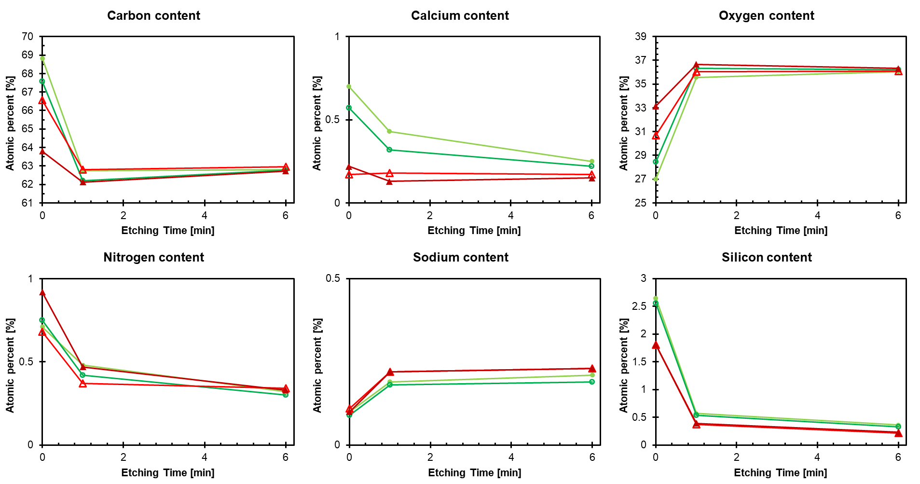
Figure SI 3-2: Elemental composition of original and mercerised (40 wt.% NaOH for 1h) nanopapers. Two different spots with a diameter of 400 µm were analysed on original (red triangles) and mercerized samples (green circles), respectively.

