Low-Pressure Plasma as a Seed Coat to Enhance the Growth of Wheat Seedlings for Obtaining Future Outcomes Under Salinity Conditions
Abdelfattah T. Elgendy^{1,*}, Hesham Elsaid1, Sameh A. Rizk², Hani S. Saudy³, Nimer Wehbe⁴, Mohamed Ben Hassine⁵, Ruba Al-Nemi⁶, Mariusz Jaremko ^{7,*}, and Abdul-Hamid Emwas ^{8,*}
1 Physics Department, Faculty of Science, Ain Shams University Cairo, Egypt; e- abdelfattah.elgendy@sci.asu.edu.eg
2 Chemistry Department, Faculty of Science, Ain Shams University Cairo, Egypt; e- samehrizk@sci.asu.edu.eg
3 Agronomy Department, Faculty of Agriculture, Ain Shams University Cairo, Egypt; e-hani_saudy@agr.asu.edu.eg; ORCID: http://orcid.org/0000–0002–6341–6156
4 Core Labs, King Abdullah University of Science and Technology (KAUST), Thuwal, Kingdom of Saudi Arabia; e-nimer.wehbe@kaust.edu.sa
5 Core Labs, King Abdullah University of Science and Technology (KAUST), Thuwal, Kingdom of Saudi Arabia; e- mohamed.benhassine@kaust.edu.sa
6 Bioscience program, Biological and Environmental Science and Engineering (BESE) Division, King Abdullah University of Science and Technology (KAUST), Thuwal 23955-6900, Kingdom of Saudi Arabia; e- ruba.nami@kaust.edu.sa
7 Smart-Health Initiative (SHI) and Red Sea Research Center (RSRC), Division of Biological and Environmental Sciences and Engineering (BESE), King Abdullah University of Science and Technology (KAUST), Thuwal, Jeddah, Saudi Arabia; e- mariusz.jaremko@kaust.edu.sa
8 Core Labs, King Abdullah University of Science and Technology (KAUST), Thuwal, 23955-6900, Kingdom of Saudi Arabia; e- abdelhamid.emwas@kaust.edu.sa

*Corresponding authors: Mariusz Jaremko (mariusz.jaremko@kaust.edu.sa), Abdul-Hamid Emwas (abdelhamid.emwas@kaust.edu.sa)

Supplementary Materials
Appendix A: Summary of results for plasma-treated Gemmeza-11 wheat
12/12/2021 15/2/2022
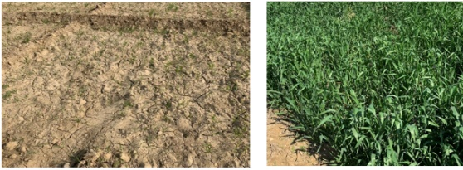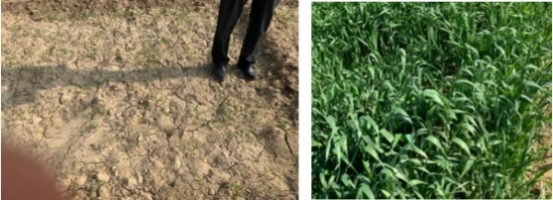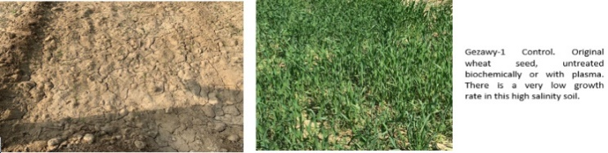
Gemmeza-11 Control. Original wheat seed, untreated hard growth rate.
Gemmeza-11 D(00). Wheat seed treated biowaste material. An active growth rate.
Gemmeza-11 D(22). Wheat seed treated plasma. Very active growth rate.
Figure S1. Our results on 12 Dec-2021 and 15 Feb 2022: The figure shows very good growth rate with optimized treatment of the wheat seed Gemmeza-11. Selected doses are shown (control, 00, 22). Although Gemmeza-11 is a sensitive wheat seed it has very good growth rate at a plasma dose of 2 min D(22).

Results for plasma-treated Misr-1 wheat

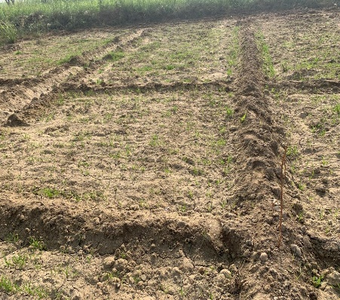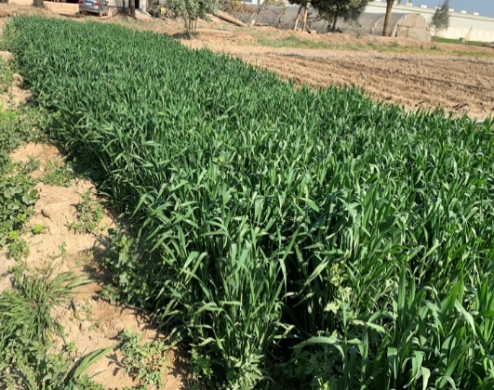
Misr-1 (control) wheat seed No treated land.
Misr-1 Dose (00) plasma treat with lignin Active growing rate
Misr-1 Dose (22) plasma treat with lignin Active growing rate
Figure S2. Results from 16 November 2021 show a very good growth rate of wheat Misr-1 at different doses. Mosr-1 is a very sensitive wheat seed and struggles to grow in semi-soil land.

Bio-coating material analysis

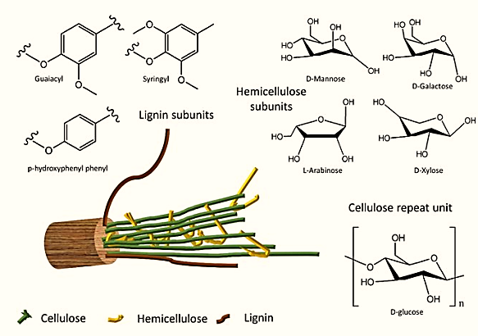

Figure S3. Outline of the chemical structure of cellulose, lignin, and hemicellulose in biopolymers.

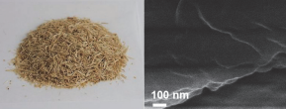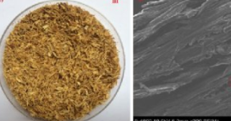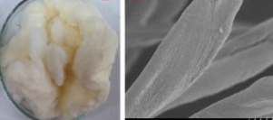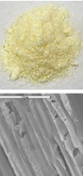
(A)
(B)
(C)
(D)
Figure S4. SEM images of flavone lignocellulose (FLC) (A), modified FLC acetic acid (B), FLC thiadiazole (C), and methylene diacrylamide (D).

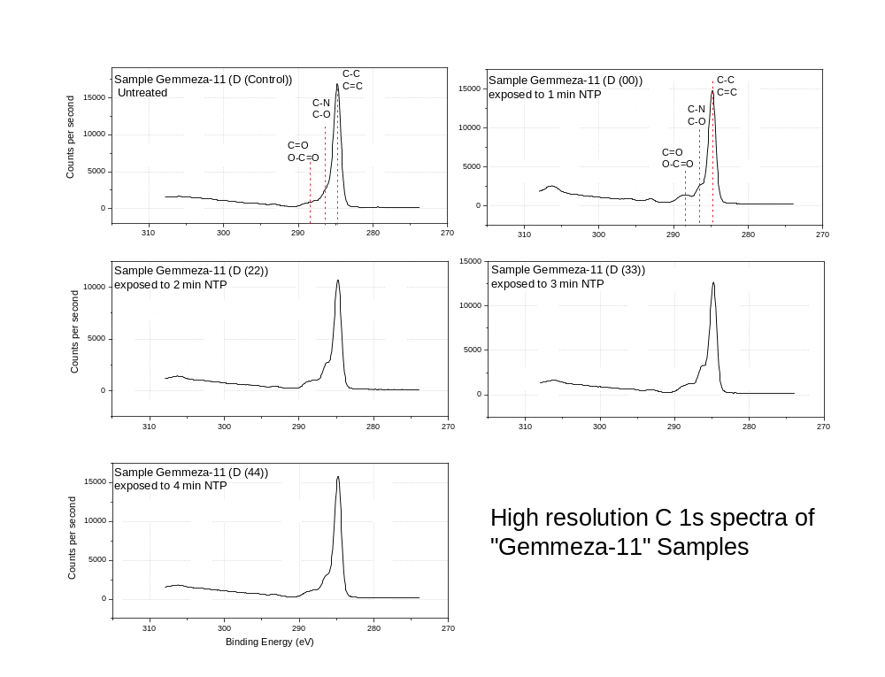
Figure S5. High resolution XPS C 1s spectra of Gemmeza-11.
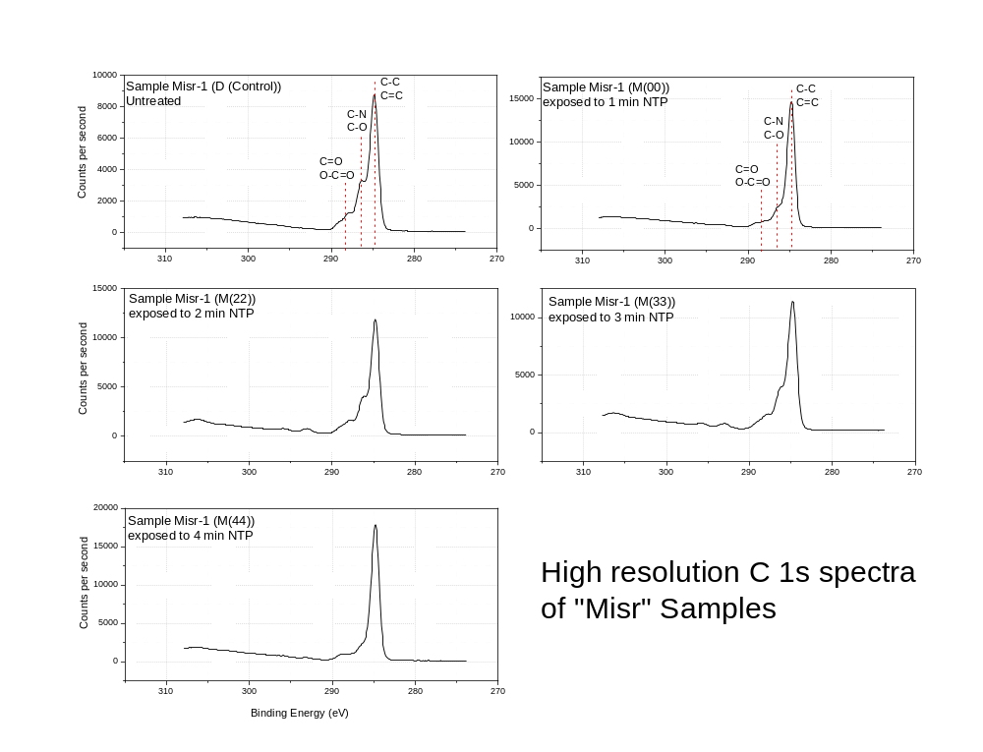
Figure S6. High resolution XPS C 1s spectra of Misr samples.

