Supplementary materials
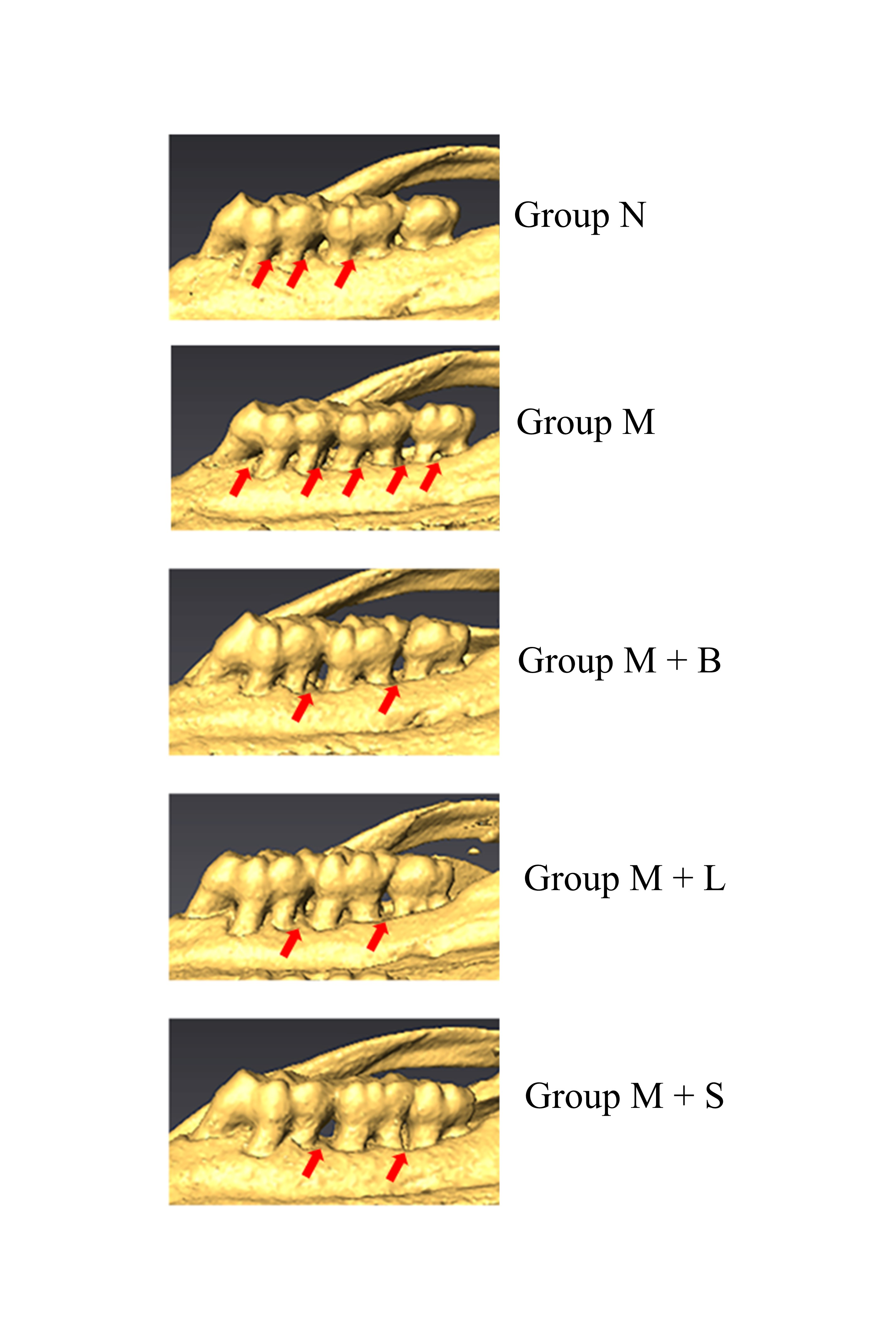
Figure S1 | 3D scan of alveolar bone resorption in rats. After the probiotic intervention, alveolar bone destruction in group M+B, M+L and M+S showed a tendency to be suppressed.
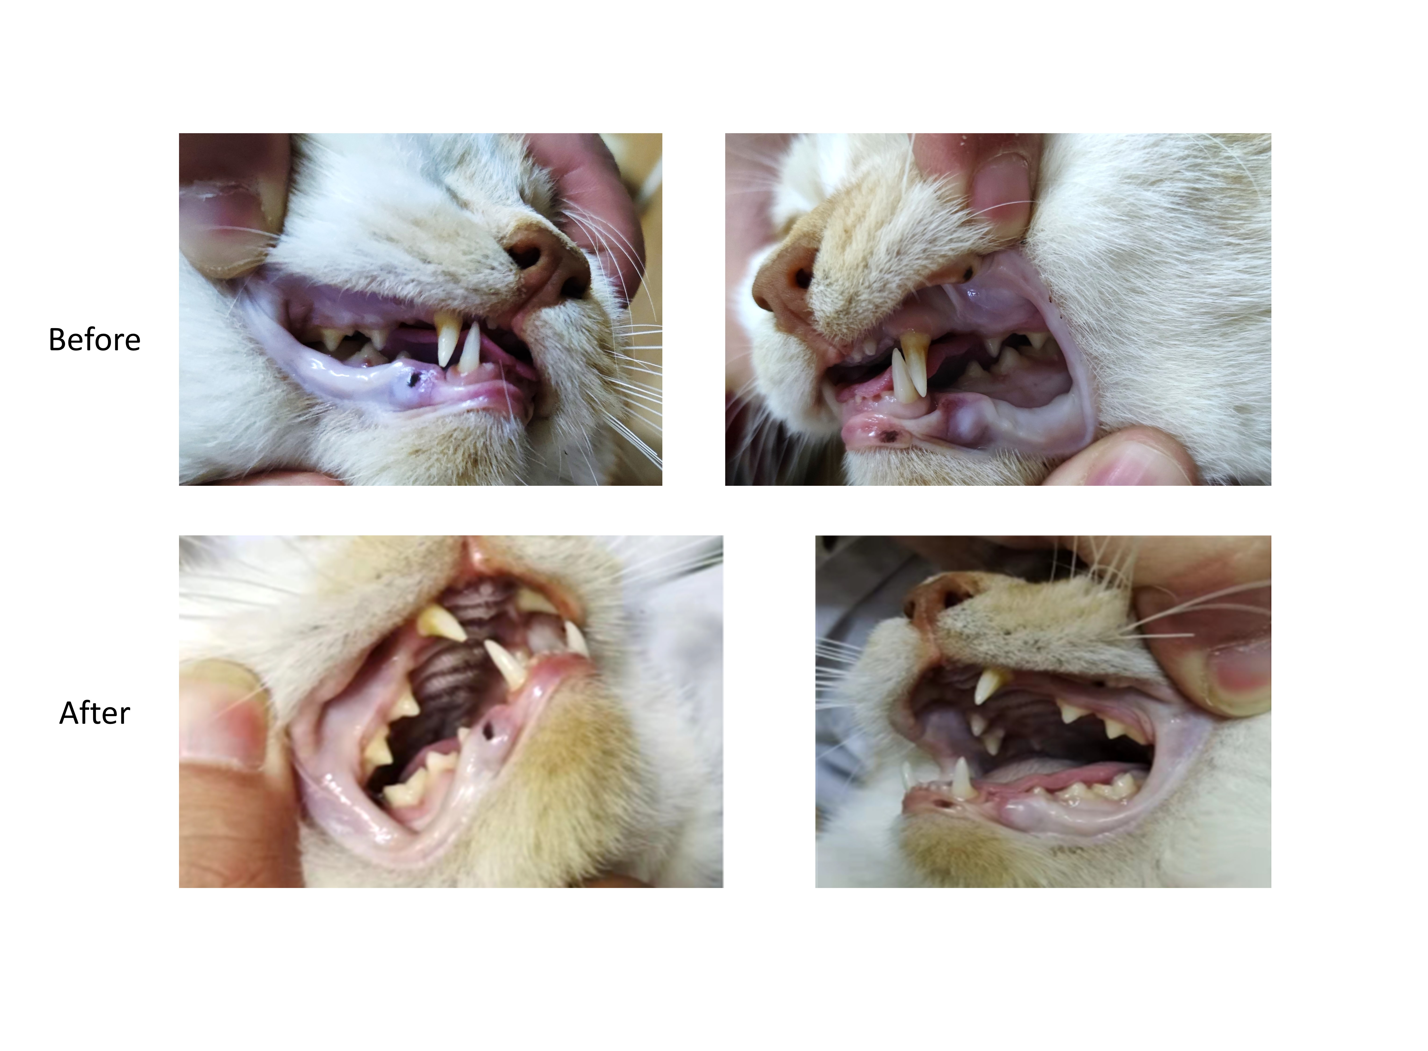
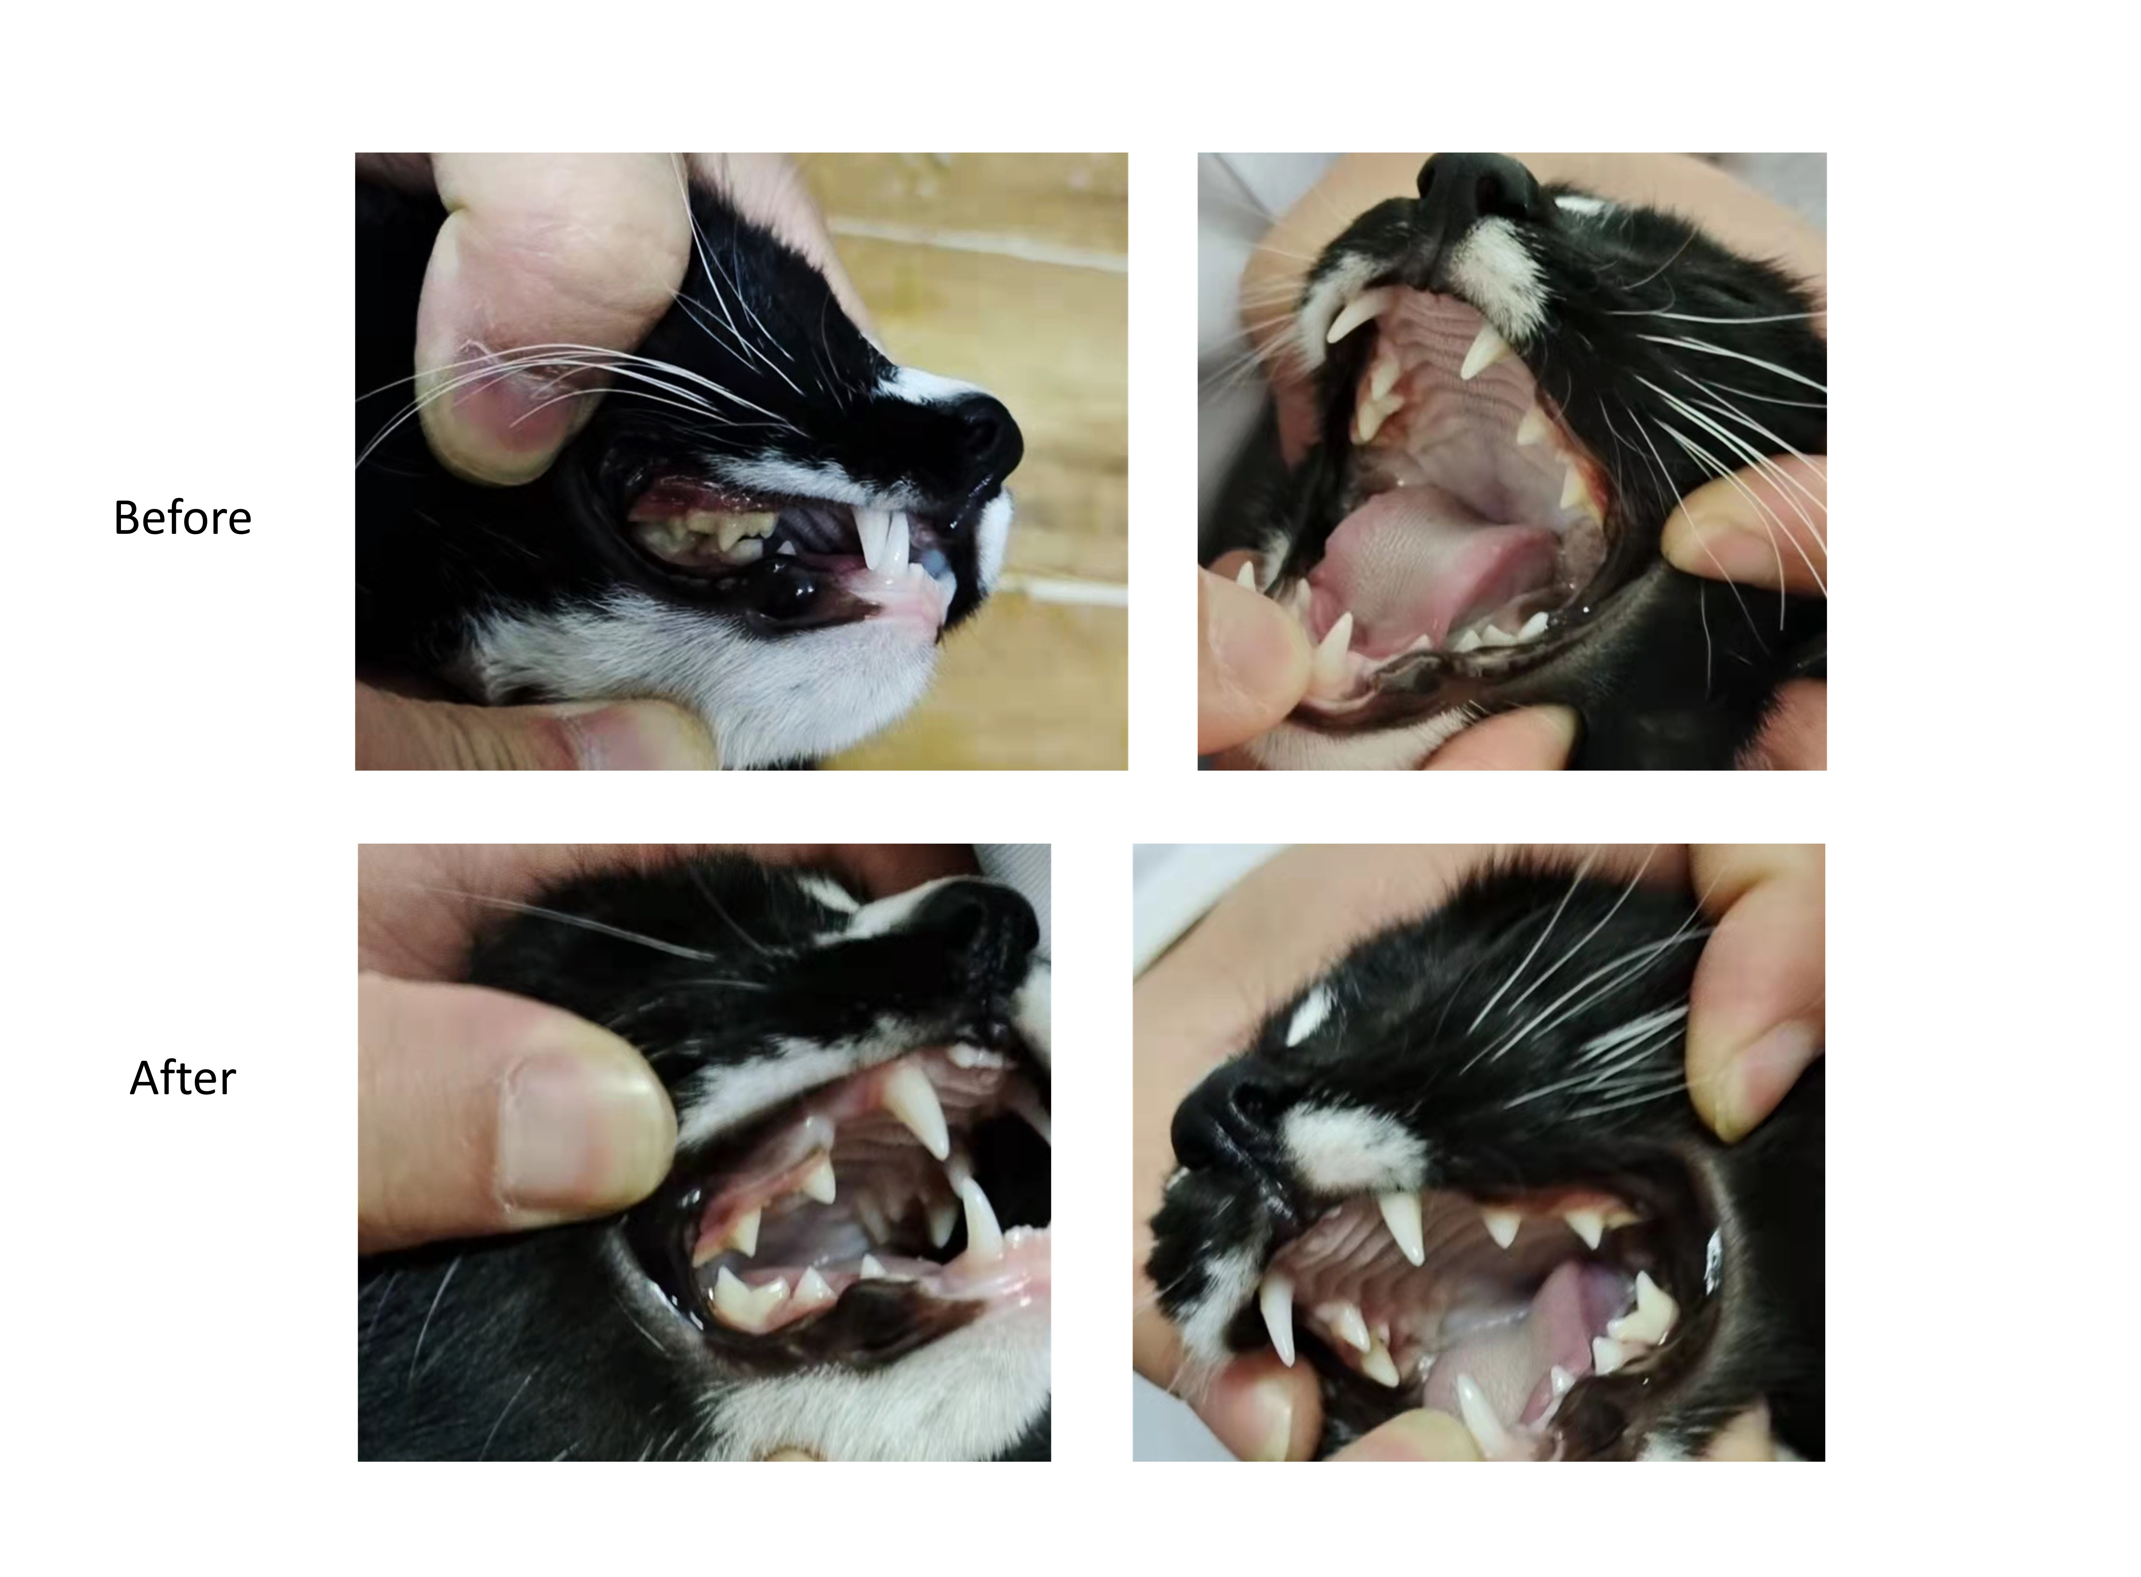
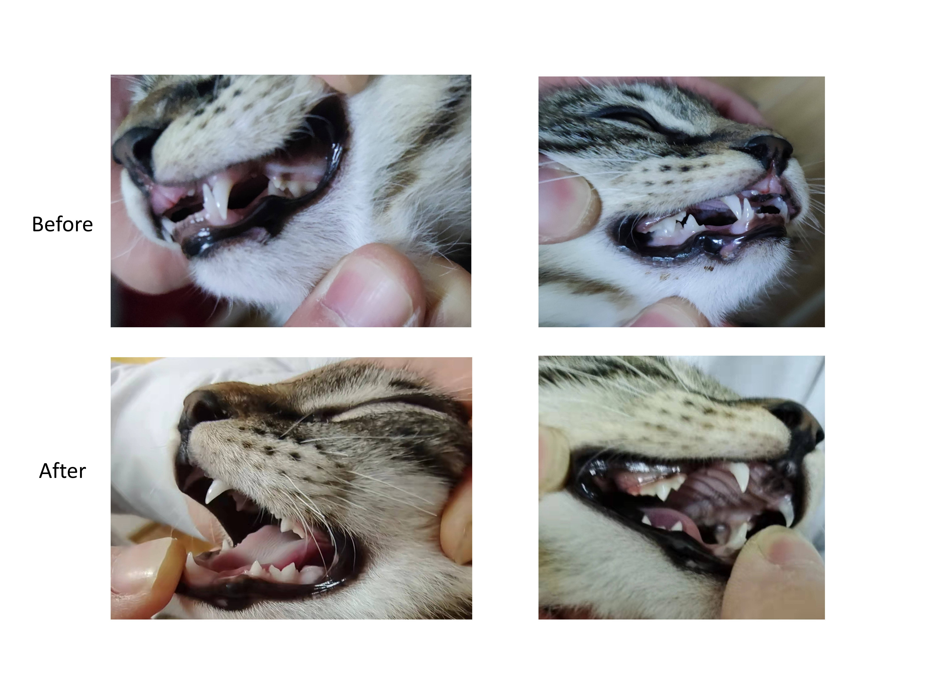
Figure S2 | Changes in tooth color after the probiotic intervention in cats

