Supplementary material 1: HPAIV outbreak triggers enhanced colony connectivity in a seabird metapopulation

Jana W.E. Jeglinski, Jude Lane, Steven C. Votier, Bob Furness, Keith C. Hamer, Dominic McCafferty, Ruedi Nager, Maggie Sheddan, Sarah Wanless and Jason Matthiopoulos

Reference data for Northern gannets GPS tagged during the HPAI outbreak in June 2022
Table S 1: Auxiliary data for the 10 GPS tagged gannets captured in April 2022.
ID | Pair ID | Transmission duration following HPAI outbreak (days ) | Status
18232 | 1 | 2 | unknown
18220 | 1 | 47 | resighted on the Bass Rock without tag 23.09.2022, right eye black, left eye normal
18226 | 2 | 18 | unknown
18209 | 2 | 6 | unknown
18242 | 3 | 28 | resighted on the Bass Rock without GPS tag 28.04.2023
18233 | 3 | 16 | Resighted on the Bass Rock without GPS tag 01.08.2022
18239 | 4 | -1 | resighted on the Bass Rock without GPS tag 28.04.2023
18247 | 4 | 101 | resighted on the Bass Rock without GPS tag 24.09.2022
18215 | 5 | 5 | resighted on the Bass Rock without GPS tag 28.04.2023
18244 | 6 | 5 | found decomposed on Stora Varholmen, province Vestra Goetaland 21.07.2022

Detailed description of long-distance moving birds during HPAIV outbreak
Two birds prospected alternative gannet breeding colonies shortly after the HPAIV outbreak on the Bass Rock. Both prospecting birds were females.
Tag ID 18220
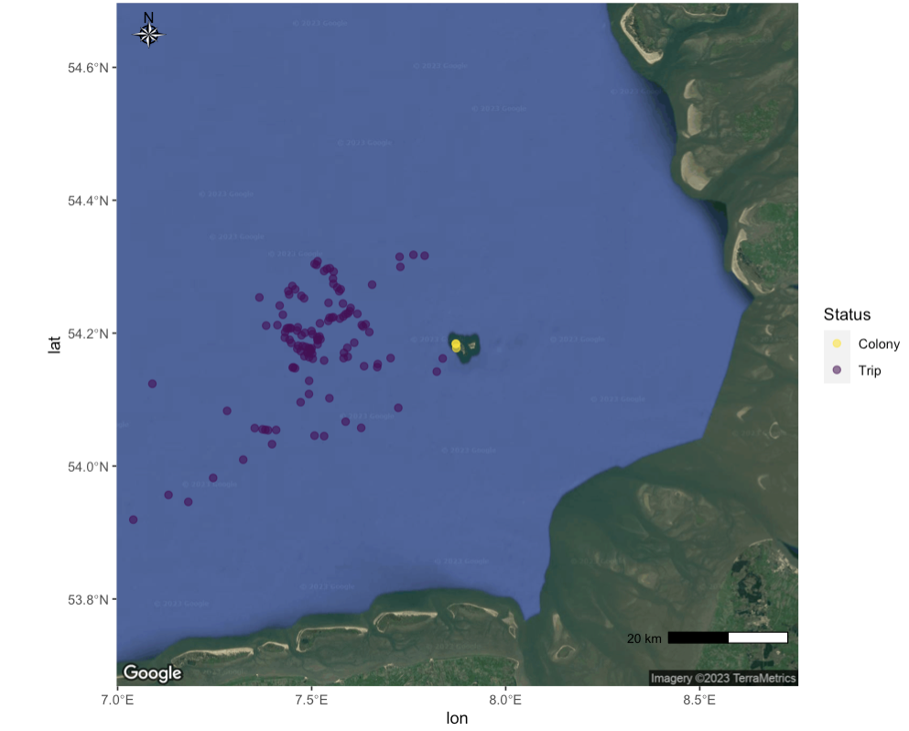
Tag ID 18220 moved to the coast of Norway on the 19th of June, returned to the Bass Rock, and then moved south and visited the colony of Helgoland on the 15th of July 2022 between 07:43 AM and 09:05 AM for a duration of 81 minutes, with the closest distance to the colony centroid recorded as 344 m (Figure S1). Figure S1 illustrates that the bird spent considerable time in the vicinity to Heligoland at sea, within the foraging range of Heligoland gannets ¹

Figure S1: GPS tracking data for Tag ID 18220 illustrating the prospecting visit at the gannet breeding colony Heligoland, Germany.
Tag ID 18247
Tag ID 18247 visited three different breeding colonies. On the 28th of June 2022, 18247 visited the Troup Head colony, the nearest neighbouring colony to the Bass Rock, between 4:38 AM and 5:23 AM for a duration of 45 minutes, with the nearest distance to the colony centroid recorded as 1103 m (Figure S2).
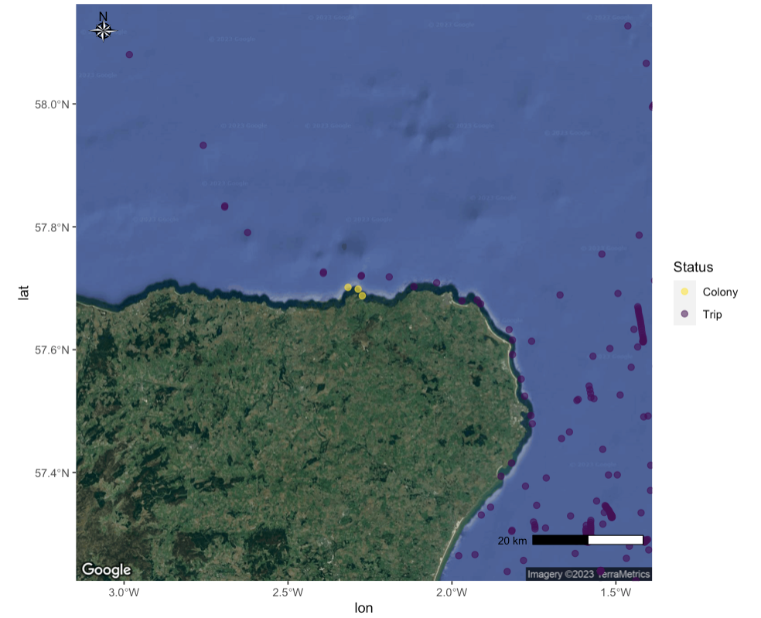
Figure S2: GPS tracking data for Tag ID 18247 illustrating the prospecting visit at the gannet breeding colony Troup Head, Scotland.

Tag ID 18247 then flew past the colony St. Kilda on the 30th of June with one GPS location in a distance of 1122 m which did not qualify as colony visit according to or criteria (see materials and methods). Tag 18247 returned to St. Kilda on the 2 July 2023 and stayed within 2 km of the colony for 75 minutes, with the closest distance to the colony centroid of 1040 m (Figure S3).

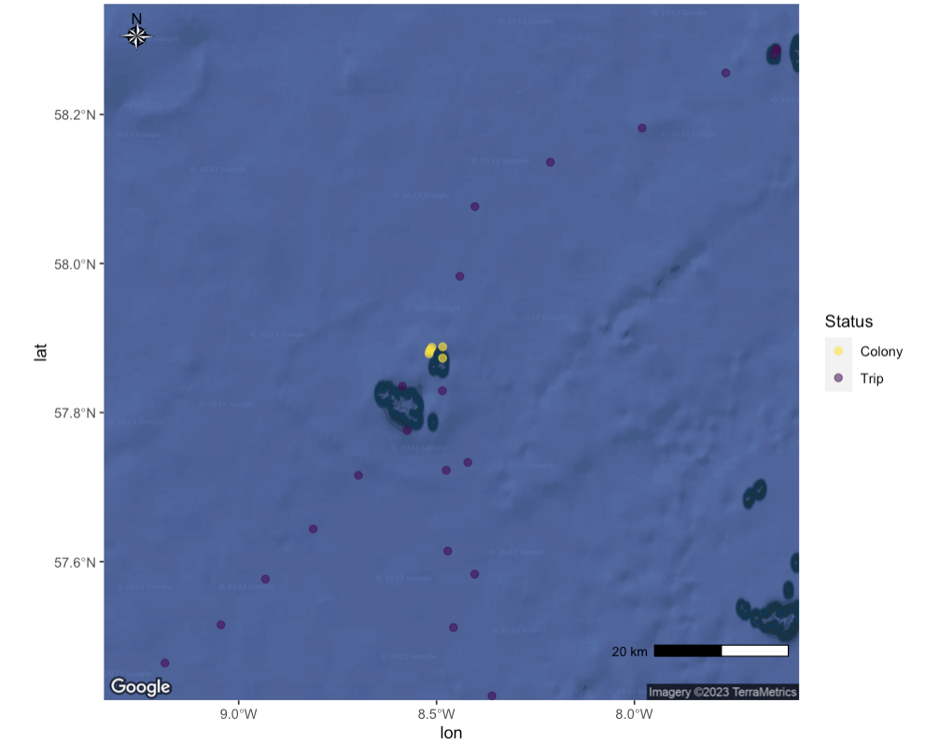
Figure S3: GPS tracking data for Tag ID 18247 illustrating the prospecting visit at the gannet breeding colony St. Kilda, Scotland.

On the 3rd July 2022, 18247 visited the colony Ailsa Craig for a duration of 60 minutes, with the closest distance to the colony centroid measuring 463 m (Figure S4).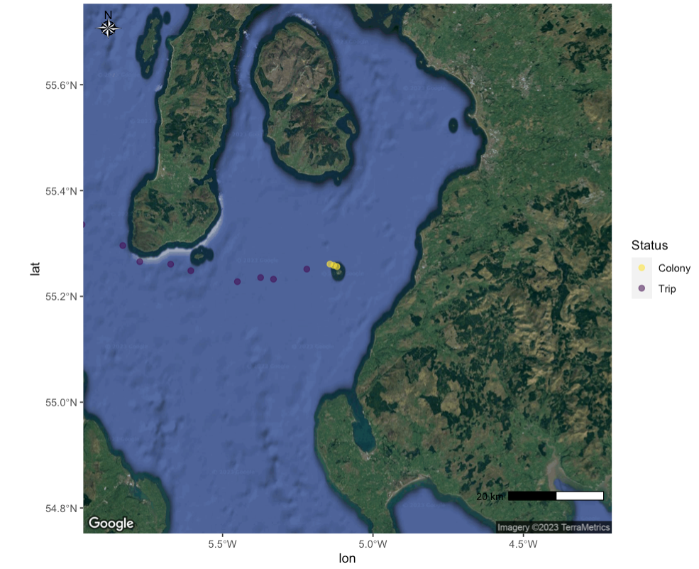
Figure S4: GPS tracking data for Tag ID 18247 illustrating the prospecting visit at the gannet breeding colony Ailsa Craig, Scotland.

18247 also logged one GPS location in a distance of 649 m to the breeding colony Sule Stack (Figure S5) but this did not qualify as colony visit according to our criteria (see materials and methods).
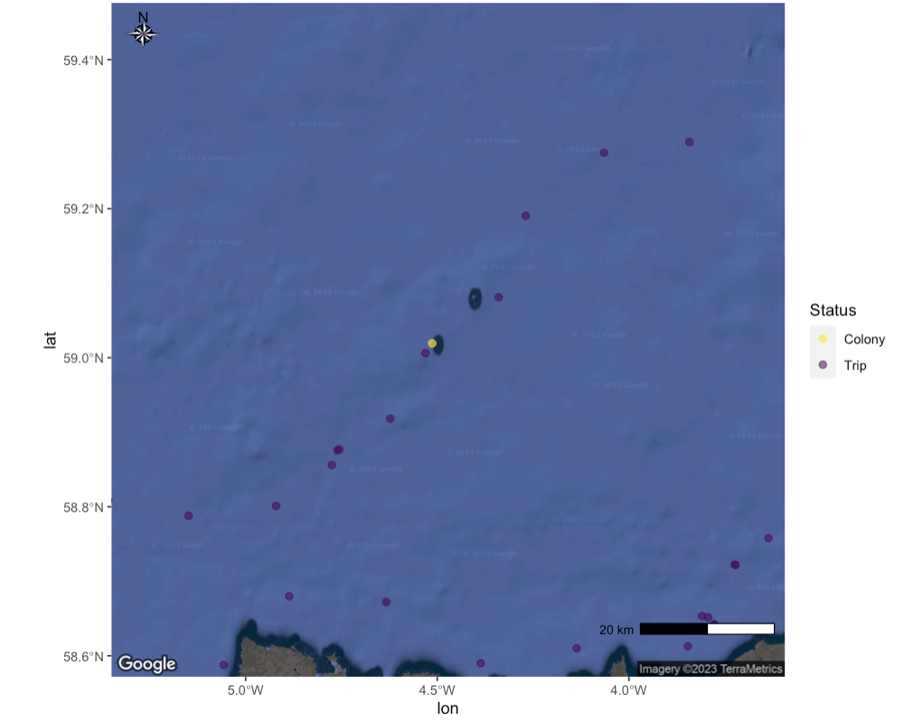
Figure S5: GPS tracking data for Tag ID 18247 illustrating a fly-by at the gannet breeding colony Sule Stack and neighbouring Sula Sgeir, Scotland.

Tag ID 18226
Tag ID 18226, a male gannet, departed from the Bass Rock and flew north towards Wick and the southern Orkney Islands. From there, it flew in a straight path across the North Sea east to the Norwegian coast close to Egersund (Figure S6). The bird first flew approximately 50 km inland, along the lake Ørsdalsvatnet and onwards to come to stay at several smaller waterbodies between Storvatnet and Stakken (Figure S7), before returning to the coast between Egersund and Sogndalstrand. The signal ceased on the 22 June 2022 at around noon. To our knowledge, this is the first evidence of a GPS tracked gannet moving inland and spending time at an inland waterbody.
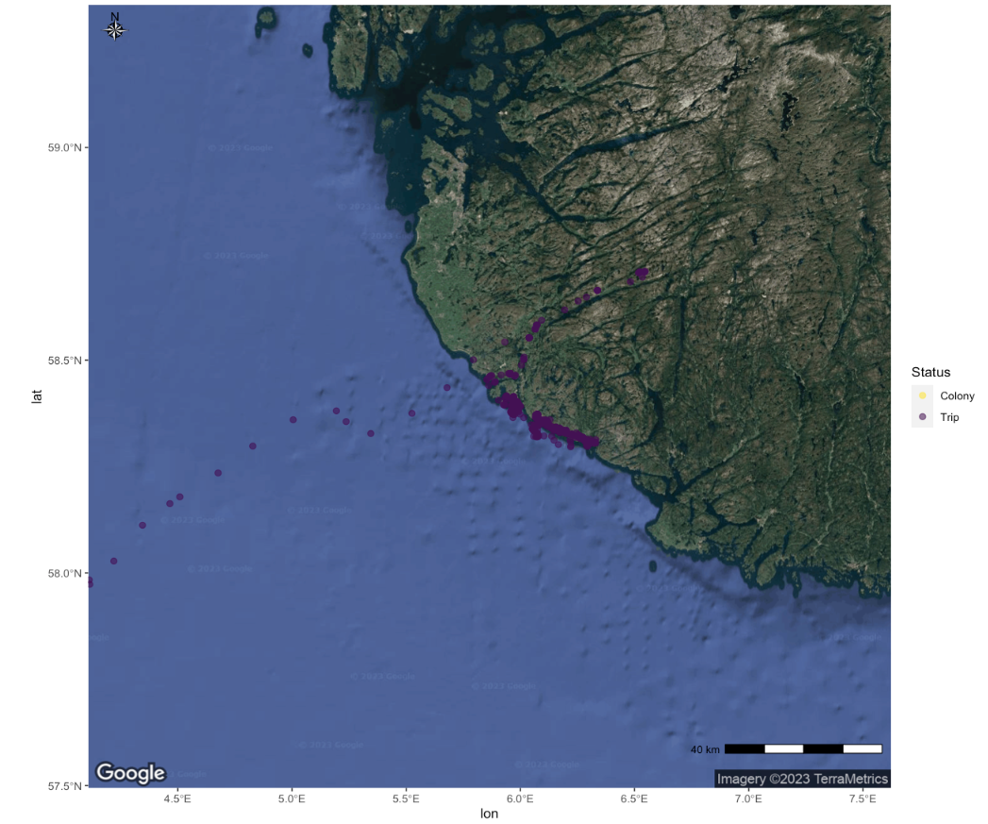
Figure S6: GPS tracking data illustrating inland movements of Tag ID 18226.

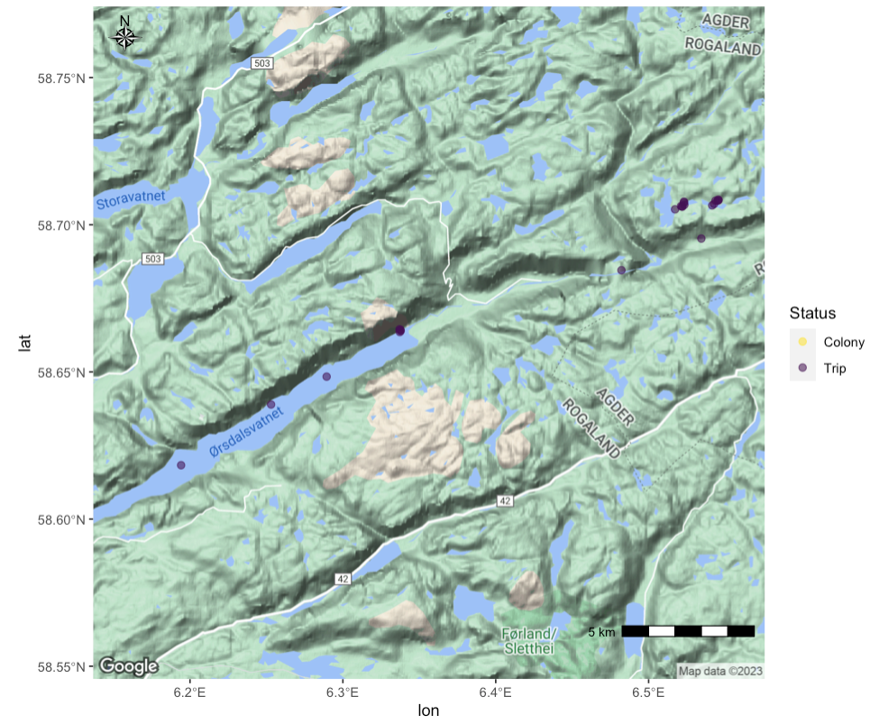
Figure S7: GPS tracking data illustrating the use of inland waterbodies by Tag ID 18226.

References

1. Peschko, V., Mendel, B., Mercker, M., Dierschke, J. & Garthe, S. Northern gannets (Morus bassanus) are strongly affected by operating offshore wind farms during the breeding season. J Environ Manage 279, 111509 (2021).

