Supplementary Information

Impact of Charge Extraction on Current-Voltage Characteristics of Perovskite Solar Cells

Deli Li,^{1*} Xiao Zhang,¹ Qianqian Liang,¹ Jian Sun,¹ Ximan Chen,¹ Yang Liu,¹ Qing Song,¹ Yue Wang,^{1*} Yonghua Chen,^{2*} Wei Huang^{2,3,4*}

¹Fujian Cross Strait Institute of Flexible Electronics (Future Technologies), Fujian Normal University, Fuzhou 350117, China;
²Key Laboratory of Flexible Electronics (KLOFE) and Institute of Advanced Materials (IAM), Nanjing Tech University (NanjingTech), Nanjing 211816 Jiangsu, China;
³Frontiers Science Center for Flexible Electronics, Xi'an Institute of Flexible Electronics (IFE) and Xi'an Institute of Biomedical Materials and Engineering, Northwestern Polytechnical University, Xi'an 710072, China;
⁴Key Laboratory for Organic Electronics & Information Displays (KLOEID), and Institute of Advanced Materials (IAM), Nanjing University of Posts and Telecommunications, Nanjing 210023, Jiangsu, China;
*Email: ifedlli@fjnu.edu.cn, ifeywang@fjnu.edu.cn, iamyhchen@njtech.edu.cn, and vc@nwpu.edu.cn

Supplementary Note 1
The extraction voltage V_{EX4} across the ETL is formulated with Ohm’s law. A transport resistance R_{ETL} is defined by the thickness, doping density, and charge carrier mobility. As a result, the extraction voltage V_{Ex4} can be written as:
$V_{Ex4}=−JR_{ETL}=−J\frac{L_{ETL}}{qμ_{eE}N_{DE}}$ (S1)
where $L_{ETL}$ is the thickness of the ETL, N_{DE} the doping density (Donor), μ_{eE} the mobility of electrons, and J the current density.

Supplementary Note 2
The formula of the extraction voltage V_{Ex5} at ETL/Cathode is written in the classical diode form as:
$J=−J_{0C}\left[exp(\frac{qV_{Ex4}}{k_{B}T})−1\right]$ (S2)
where J_{0C} is the dark-saturation current density, which is given by
$J_{0C}=A^{∗}T^{2}exp(\frac{−qϕ_{C}}{k_{B}T})exp(\frac{qΔϕ_{C}}{k_{B}T})$ (S3)
where $A^{∗}$ is the effective Richardson constant for thermionic emission, ϕ_{C} is the ETL/Cathode contact barrier, and Δϕ_{C} is the effective change in barrier height, which is assumed as:
$exp(\frac{qΔϕ_{C}}{k_{B}T})=γ_{H}μ_{eE}N_{CE}\sqrt{N_{DE}}$ (S4)
where γ_{H} is determined by fitting one current density voltage (J–V ) curve and is applied for the rest cases, N_{CE} is the effective density of states in the conduction band, N_{DE} is the doping density (Donor), and μ_{eE} is the mobility of electrons.
Based on Equations (S2)~(S4), the extraction voltage V_{Ex5} is written as:
$V_{Ex5}=\frac{k_{B}T}{q}ln(1−\frac{J}{J_{0C}})$ (S5)

Supplementary Note 3
The extraction voltage V_{Ex6} for the HTL/Perovskite contact has a similar form to V_{Ex3} :
$V_{Ex6}=\frac{k_{B}T}{q}ln(1−\frac{J}{J_{HP}})$ (S6)
where J_{HP} is the dark-saturation current density of a diode at the HTL/Perovskite contact. Like J_{EP} in Equation (14) in the main text, J_{HP} is varied due to the band bending when quasi-Fermi levels splitting is larger than the built-in voltage. We assumed that:
$\left\{\begin{aligned}J_{HP}=−A^{∗}T^{2}exp(\frac{−qϕ_{HP}}{k_{B}T})exp(\frac{qΔϕ_{HP}}{k_{B}T}), V+V_{Ex1}+V_{Ex2}{ + V}_{Ex3}+V_{Ex4}<V_{Bi} \\ J_{HP}=−A^{∗}T^{2}exp(\frac{−qϕ_{HP2}}{k_{B}T})exp(\frac{qΔϕ_{HP}}{k_{B}T}), V+V_{Ex1}+V_{Ex2}{ + V}_{Ex3}+V_{Ex4}≥V_{Bi}\end{aligned}\right.$ (S7)
where ϕ_{HP} is the energy band offset at the HTL/Perovskite contact, the built-in voltage V_{Bi} is defined as (E_{g}–ϕ_{HP}–Δ) with Δ the effective reduced factor of the built-in potential due to band bending, ϕ_{HP2} is the reduced effective energy band offset [ϕ_{HP} –(V+V_{Ex1}+V_{Ex2}+V_{Ex3}+V_{Ex4}–V_{Bi})/2 ] caused by the enhanced Fermi levels [(V+V_{Ex1}+V_{Ex2}+V_{Ex3}+V_{Ex4}–V_{Bi})/2 ] of holes, and Δϕ_{HP} is the effective change in barrier height, which is assumed as:
$exp(\frac{qΔϕ_{HP}}{k_{B}T})=γ_{EP}μ_{hP}N_{VP}\sqrt{N_{DH}N_{VH}}$ (S8)
where γ_{EP} is fixed for the ETL/Perovskite and HTL/Perovskite contact and is the only undefined parameter.

Supplementary Note 4
The solving of the extended Shockley equation is performed by the mature least-squares method in Matlab using the nonlinear least-squares function“Lsqnonlin”, which starts at the point J0 and finds a minimum of the sum of squares of the function described in Myfun(J,b,V).

[J, fval] =lsqnonlin(@Myfun,J0,lb,ub,options,b,V);

Options is the settings of the parameters of lsnonlin function. V is the applied voltage. b is a set of material parameters, b(1)=J_{SC}, b(2)=L_{P}, b(3)=μ_{eP/}μ_{hP}, b(4)=N_{CP}, b(5)=N_{VP}, b(6)=ϕ_{C}, b(7)=ϕ_{A}, b(8)=n_{id}, b(9)=J_{R,2}, b(10)=$J_{0A}$, b(11)=$J_{0A}$, b(12)=ϕ_{HP}, b(13)=ϕ_{EP}, b(14)=J_{HP}, b(15)=J_{EP}, b(16)=μ_{eE}, b(17)=N_{DE}, b(18)=L_{ETL}, b(19)=N_{CE}, b(20)=μ_{hH}, b(21)=N_{DH}, b(22)=L_{HTL}, b(23)=N_{VH}, b(24)=E_{g}, and b(25)=V_{OC}. The lb and ub defines a set of lower and upper bounds on the design variables in J. fval returns the value of the squared 2-norm of the residual.

function dJ=Myfun(J,b,Va)
Rn=Ln/(q*μ_{eE}*N_{DE});
Rp=Lp/(q*μ_{hH}*N_{DH});
V_{Ex1}=-J*Rn;
V_{Ex4}=-J*Rp;
V_{Ex2}=log(1-J/J_{0A})*kT;
V_{Ex5}=log(1-J/J_{0C})*kT;
V_{Ex3}=log(1-J./J_{EP})*kT;
V_{Ex6}=log(1-J/J_{HP})*kT;
dJ=J_{R,2}*(exp((V+V_{Ex1}+V_{Ex2}+V_{Ex3}+V_{Ex4}+V_{Ex5}+V_{Ex6})/kT/nid)-1)-J_{SC}-J;

T, k, and q are the temperature, the Boltzmann constant, and the electron charge, we define kT=k∙T/q. The symbols of the parameters are defined in the main text and Supplementary Notes.

Supplementary Figure 1. The models (a) and basic configurations (b) of the perovskite solar cell in the SCAPS program. During the simulation, the spectrum file is AM1_5G 1 sun.spe and the illumination power is 1000 W m⁻².

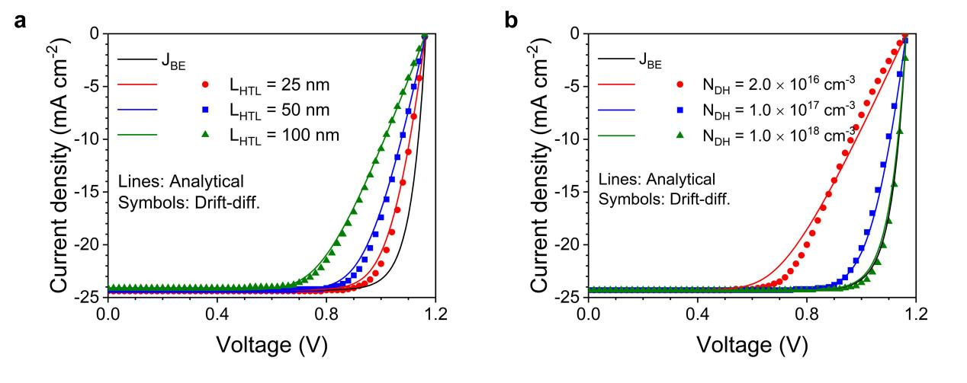
Supplementary Figure 2. The impact of the voltage drops across the transport layer (V_{Ex1}) on the current density voltage (J–V) curve with varied thickness (L_{HTL}) (a) and doping density (N_{DH}) (b) of the hole transport layer (HTL), showing resistance shape J–V curves (R-curve) with nearly gradual decays as the applied voltage approaches the V_{OC}. The lines show more penalty of the J-V curves for thicker L_{HTL} and smaller N_{DH}.

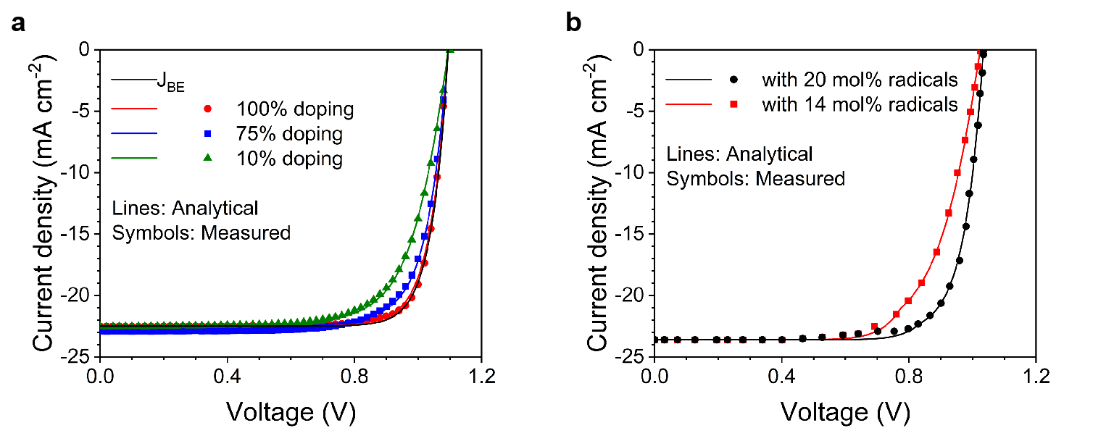
Supplementary Figure 3. (a) Resistance J–V curves (R-curve) in device performance by reducing doping concentration for spiro-OMeTAD with hygroscopic lithium salts (LiTFSI) and volatile 4-tert-butylpyridine (tBP) as the dopant. The analytical lines are calculated with doping densities of 5.0×10¹⁷ cm⁻³, 2.5×10¹⁷ cm⁻³, and 5.0×10¹⁶ cm⁻³ for 100%, 75%, and 10% doping, respectively. (b) R-curves in device performance by reducing the doping radical ratio. The measured data series are taken from the literature.¹ The configuration of the PSCs is indium tin oxide (ITO)/SnO₂/Perovskite/spiro-OMeTAD/Molybdenum oxide (MoO_{x})/Ag. In the analysis, the mobility is 2.0 ×10⁻⁴ cm² V⁻¹ s⁻¹ and the thickness of the HTL is 20 nm.

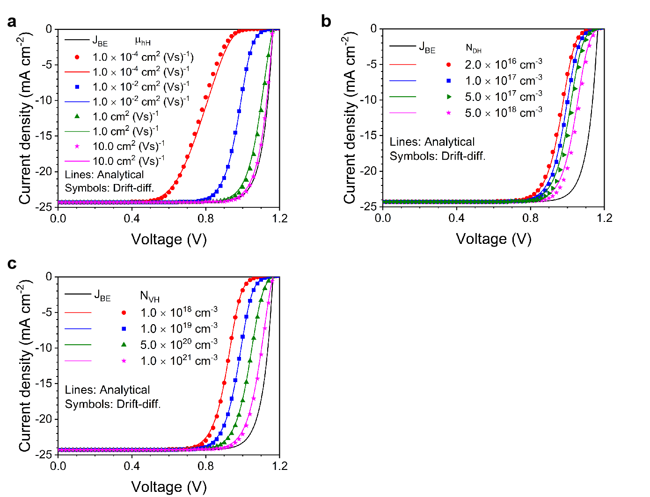
Supplementary Figure 4. The impact of the voltage drops at the HTL/Perovskite contact (V_{Ex2}) on the J–V curves with (a) varied mobility of holes (μ_{hH}), (b) the doping densities (N_{DH}), and (c) effective density of states in valance band (N_{VH}). During the calculation, the energy barrier ϕ_{A} at the HTL/Anode contact is set as 0.45 eV. It is shown that the analytical results agree well with the drift-diffusion symbols within a large range of parameters (orders of magnitude cover the material parameters of the popular TLs).

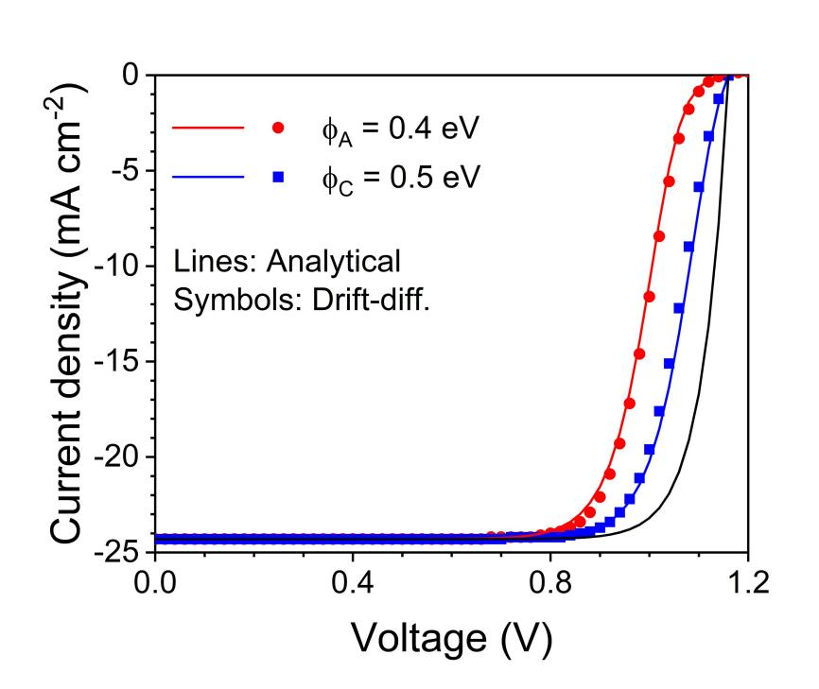
Supplementary Figure 5. The analytical and drift-diffusion S-curves due to the HTL/Anode contact with an energy barrier ϕ_{A} of 0.4 eV and ETL/Cathode contact with an energy barrier ϕ_{C} of 0.5 eV. During the analysis, we replace the HTL material parameters with ETL’s material parameter in Equations (9) ~ (12) in the main text, as shown in Supplementary Note 2. We note that γ_{H} is unchanged.

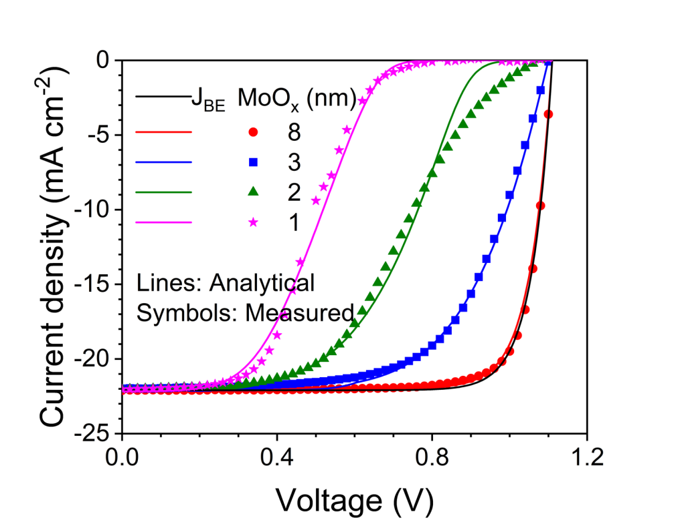
Supplementary Figure 6. Measured and analytical S-shaped J-V curves (S-curve) with varied thicknesses of the Molybdenum oxide (MoO_{x}) layer in PSCs with the configuration of ITO/SnO₂/Perovskite/spiro-OMeTAD/MoO_{x}/Ag. The thickness of the MoO_{x} layer is varied to adjust the anode work function. During the analytical process, the values of ϕ_{A} are 0.64 eV, 0.45 eV, 0.3 eV, and 0.0 for thicknesses of the MoO_{x} layer of about 1 nm, 2 nm, 3 nm, and 8 nm, respectively. The mobility of holes of spiro-OMeTAD is 2×10⁻⁴ cm² V⁻¹ s⁻¹, the doping density is 2.0×10¹⁶ cm⁻³, and the effective density of states in the valance band is 1.0×10¹⁹ cm⁻³.

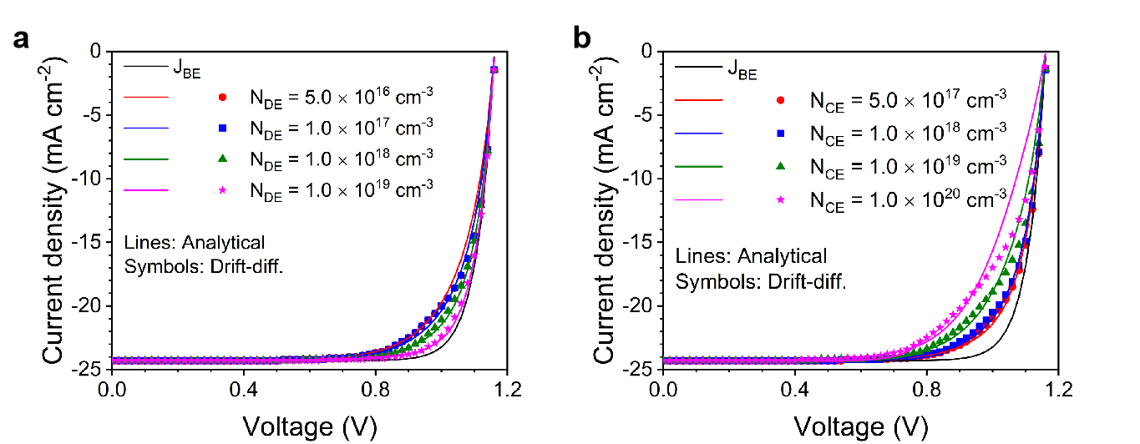
Supplementary Figure 7. The analytical and drift-diffusion M-curves (MMP shift J–V curves) with varied (a) N_{DE}, and (b) N_{CE} of the ETL. The energy band offset at the ETL/Perovsktie is set as 0.3 eV, the other parameters are shown in Supplementary Table 1.

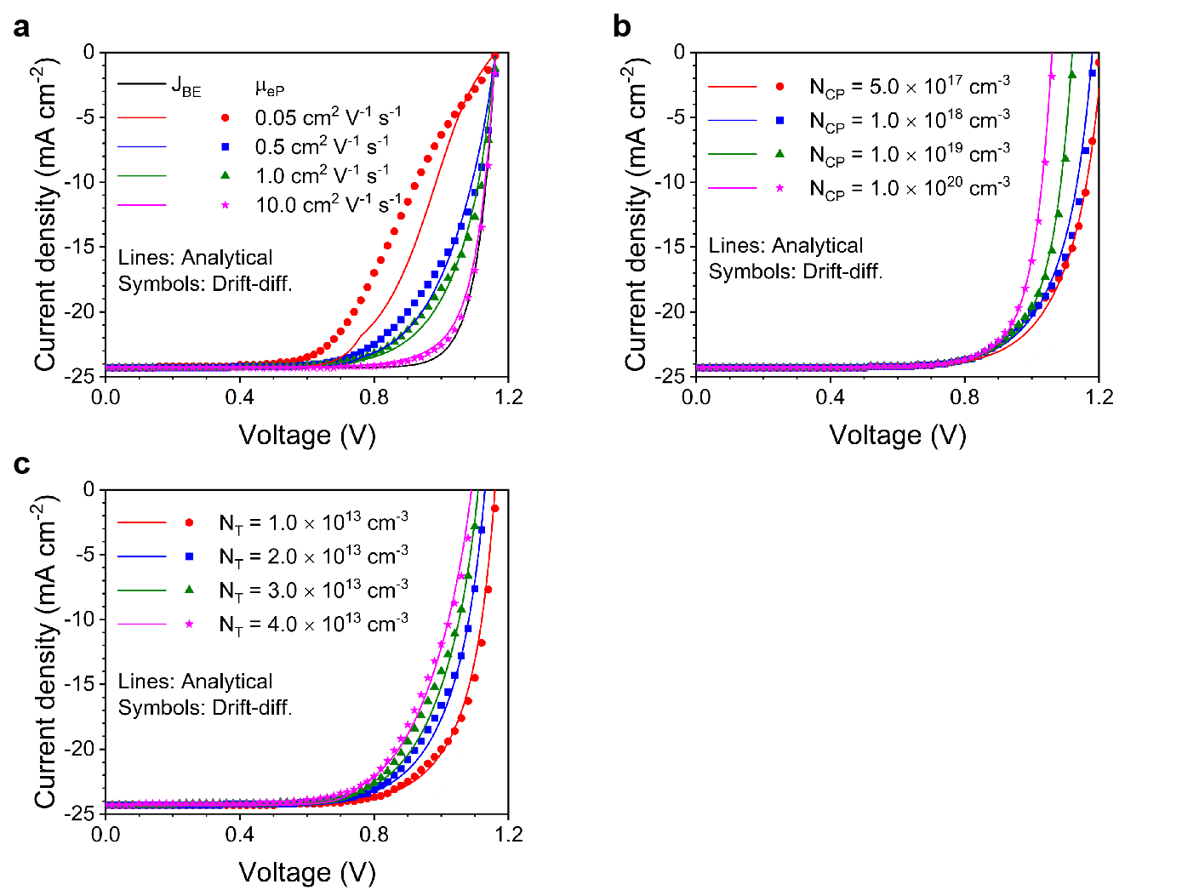
Supplementary Figure 8. The analytical and drift-diffusion M-curves with varied (a) μ_{eP}, (b) N_{CP}, and (c) N_{T} of the perovskite material. The energy band offset at the ETL/Perovsktie is set as 0.3 eV, the other parameters are shown in Supplementary Table 1.

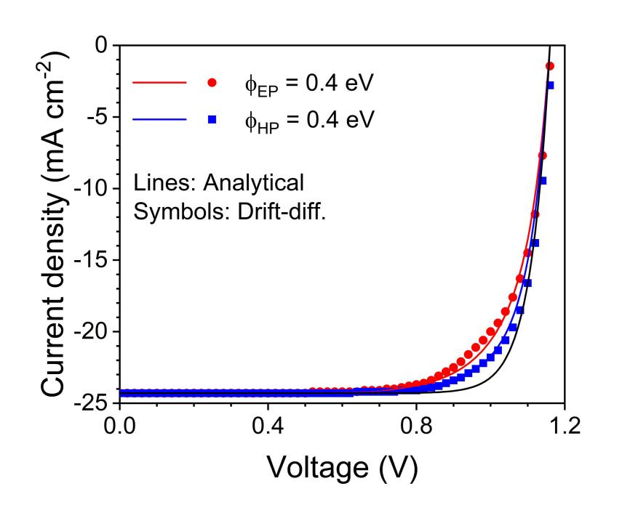
Supplementary Figure 9. The analytical and drift-diffusion M-curves due to the ETL/Perovksite contact with an energy barrier ϕ_{A} of 0.4 eV and HTL/Perovksite contact with an energy barrier ϕ_{C} of 0.4 eV. During the analysis, we replace the ETL material parameters with HTL’s material parameters and change μ_{eP}, N_{CP} with μ_{hP}, N_{VP} in Equations (13) ~ (15) in the main text, as shown in Supplementary Note 3. We note that γ_{EP} is unchanged in this process, indicating that Equation (13) in the main text bears universal applicability.

Supplementary Figure 10. The measured and analytical M-curves realized in device with the configuration of ITO/NiO_{x}/Perovskite/PC₆₁BM/bathocuproine(BCP)/Ag. Excellent agreement are shown between the measured data and the analytical M-curve by the ESE with an energy band offset of 0.3 eV, close to the values of the difference between the valance bands of NiO_{x} and MAPbI₃ of 0.2 eV ~ 0.4 eV.

Supplementary Figure 11. (a) The PCE for the S-curves as a function of mobility of holes (μ_{hH}) for five different HTL/Anode contact barriers (ϕ_{A}) to illustrate the S-loss. The effective density of states in the valance band (N_{VH}) and doping density (N_{DH}) of the HTL are 1.0×10¹⁹ cm⁻³ and 5.0×10¹⁶ cm⁻³, respectively. (b), (c) The PCE the S-curve as a function of doping density (N_{DH}) (c) and density of states (DOS) in the valance band (N_{VH}) (d) for five different HTL/Anode contact barriers (ϕ_{A}) to illustrate the S-loss. The mobility of holes μ_{hH} is 2.0 cm² V⁻¹s⁻¹. PCE_{BE} is the power conversion efficiency for devices with boundless extraction.

Supplementary Figure 12. The M-curve fittings of the J–V data series for the PSCs of (a) Cell 1, (b) Cell 2, (c) Cell 3, and (d) Cell 5, showing excellent fitting degrees between the analytical M-curve and the J–V data series. The material parameters used are listed in Supplementary Table 3.

Supplementary Table 1. Material parameters for the analytical lines and drift-diffusion symbols.

Parameters | Meaning | Value
T | Temperature | 300 K
Perovskite layer
L_{P} | Thickness | 450 nm
E_{cP} | Electron affinity | 4.0 eV
E_{g} | Band gap | 1.55 eV
N_{cP} | CB effective density of states | 2.2×10¹⁸ cm⁻³ or varied (see text)
N_{vP} | VB effective density of states | 1.9×10¹⁹ cm⁻³
μ_{eP/}μ_{hP} | Mobility of electrons/holes | 2.0 cm² V⁻¹ s⁻¹ or varied (see text)
N_{DP} | Donor/Acceptor density | 0.0
N_{T} | Defect density | 1.0×10¹⁵ cm⁻³ or varied (see text)
γ | Radiative recombination coefficient | 1.0×10⁻¹² cm² s⁻¹
C_{e/h} | Capture cross section | 2.0×10⁻¹⁶ cm²
Electrodes
ϕ_{A} | HTL/Anode contact or barrier | Ohmic or varied (0.0 ~ 5.5 eV)
ϕ_{C} | ETL/Cathode contact or barrier | Ohmic
HTL (Hole transport layer)
L_{HTL} | Thickness | 50 nm or varied (see text)
E_{CH} | Electron affinity | 2.55 eV
E_{gE} | Band gap | 3.0 eV or varied (see text)
N_{DH} | Doping density (Acceptor) | 5.0×10¹⁶ cm⁻³ or varied (see text)
μ_{hH} | Mobility of holes | 0.02 cm² V⁻¹ s⁻¹ or varied (see text)
N_{VH} | Effective density of states in valance band | 1.0×10¹⁹ cm⁻³ varied (see text)
N_{CH} | Effective density of states in conduction band | 1.0×10¹⁹ cm⁻³
ETL (Electron transport layer)
L_{ETL} | Thickness | 50 nm
E_{CE} | Electron affinity | 4.0 eV
E_{gE} | Band gap | 3.5 eV
N_{DE} | Doping density (Donor) | 1.0×10¹⁷ cm⁻³
μ_{eE} | Mobility of electrons | 10 cm² V⁻¹ s⁻¹ or varied (see text)
N_{CE} | Effective density of states in conduction band | 2.2×10¹⁸ cm⁻³
N_{VE} | Effective density of states in valence band | 1.9×10¹⁹ cm⁻³

Supplementary Table 2. Configurations and electrical parameters of several recent record PSCs based on NiO_{x} HTL used in the main text.

PSCs | Configurations | V_{OC} (V) | J_{SC} (mA cm⁻²) | FF (%) | PCE(%) | Ref.
Fig.4a (control) | ITO/SnO₂/KCl/Cs_{0.05}FA_{x}MA_{1-x}PbI₃/spiro-OMeTAD/Au | 1.171 | 25.8 | 75.2% | 22.7 | 2
Fig.4a (Modified) | ITO/SnO₂/KCl/Cs_{0.05}FA_{x}MA_{1-x}PbI₃/spiro-OMeTAD( DDT-treated)/Au | 1.198 | 25.9 | 79.2% | 24.6 | 2
Fig.4b (control) | ITO/TiO₂/FAPbI₃/spiro-OMeTAD/Au | 1.169 | 25.66 | 82.49 | 24.75 | 1
Fig.4b (Modified) | ITO/TiO₂/FAPbI₃/spiro-OMeTAD(Ion-modulated radical)/Au | 1.175 | 25.52 | 83.88 | 25.15 | 1
Fig.4c (control)/Cell4 | ITO/NiO/perovskite/C₆₀/BCP/Ag | 1.09 | 21.71 | 76.1 | 17.96 | 3
Fig.4c (Modified)/Cell4 | ITO/Cu:NiO/perovskite/C₆₀/BCP/Ag | 1.12 | 22.23 | 80.9 | 20.24 | 3
Cell1 (control) | FTO/NiO_{x}/Me-4PACz/FA_{0.95}Cs_{0.05}PbI₃/PEAI/C₆₀/SnO₂/Ag | 1.11 | 25.42 | 79 | 22.51 | 4
Cell1 (Modified) | FTO/NiO_{x}/Me-4PACz/DPPP/FA_{0.95}Cs_{0.05}PbI₃/PEAI/C₆₀/SnO₂/Ag | 1.16 | 25.61 | 82 | 24.47 | 4
Cell2 (control) | ITO/NiO_{x}/perovskite/PC₆₁BM/BCP/Ag | 1.13 | 24.5 | 80.2 | 21.72 | 5
Cell2 (Modified) | ITO/NiO_{x}+6FPPY  /perovskite/PC₆₁BM/BCP/Ag | 1.18 | 24.9 | 81.3 | 23.94 | 5
Cell3 (control) | ITO/Com-NiO_{x}/perovskite/C₆₀/BCP/Ag | 1.101 | 21.45 | 74 | 16.84 | 6
Cell3 (Modified) | ITO/Por-NiO_{x}/perovskite/C₆₀/BCP/Ag | 1.176 | 22.58 | 81 | 20.65 | 6
Cell5 (control) | ITO/NiO_{x}/MA_{1-x}FA_{x}PbI_{3-y}Cl_{y}/PC₆₁BMr/BCP/Ag | 1.07 | 22.7 | 73.7 | 17.44 | 7
Cell5 (Modified) | ITO/NiO_{x}/CsBr/MA_{1-x}FA_{x}PbI_{3-y}Cl_{y}/PC₆₁BMr/BCP/Ag | 1.10 | 23.7 | 76 | 19.04 | 7

Supplementary Table 3. The material parameters of the HTL used in fiting the J-V data series for the PSCs based on the NiO_{x} HTL in Figure 4d of the main manuscript.

PSCs | Configurations | ϕ_{A} (eV) | L_{HTL} (nm) | N_{DH} (cm⁻³) | PCE_{BE} (%) | M-loss (%)
Fig.4c (control)/Cell4 | ITO/NiO/perovskite/C₆₀/BCP/Ag | 0.30 | 50 | 1.0×10¹⁶ | 19.03 | 1.1
Fig.4c (Modified)/Cell4 | ITO/Cu:NiO/perovskite/C₆₀/BCP/Ag | 0.20 | 50 | 1.0×10¹⁶ | 20.46 | 0.24
Cell1 (control) | FTO/NiO_{x}/Me-4PACz/FA_{0.95}Cs_{0.05}PbI₃/PEAI/C₆₀/SnO₂/Ag | 0.25 | 50 | 1.0×10¹⁶ | 23.26 | 0.76
Cell1 (Modified) | FTO/NiO_{x}/Me-4PACz/DPPP/FA_{0.95}Cs_{0.05}PbI₃/PEAI/C₆₀/SnO₂/Ag | 0.20 | 50 | 1.0×10¹⁶ | 24.61 | 0.14
Cell2 (control) | ITO/NiO_{x}/perovskite/PC₆₁BM/BCP/Ag | 0.35 | 50 | 1.0×10¹⁶ | 21.76 | 1.01
Cell2 (Modified) | ITO/NiO_{x}+6FPPY  /perovskite/PC₆₁BM/BCP/Ag | 0.31 | 50 | 1.0×10¹⁶ | 24.46 | 0.48
Cell3 (control) | ITO/Com-NiO_{x}/perovskite/C₆₀/BCP/Ag | 0.30 | 50 | 1.0×10¹⁶ | 19.26 | 2.40
Cell3 (Modified) | ITO/Por-NiO_{x}/perovskite/C₆₀/BCP/Ag | 0.20 | 50 | 1.0×10¹⁶ | 21.77 | 1.07
Cell5 (control) | ITO/NiO_{x}/MA_{1-x}FA_{x}PbI_{3-y}Cl_{y}/PC₆₁BMr/BCP/Ag | 0.35 | 50 | 1.0×10¹⁶ | 19.86 | 2.42
Cell5 (Modified) | ITO/NiO_{x}/CsBr/MA_{1-x}FA_{x}PbI_{3-y}Cl_{y}/PC₆₁BMr/BCP/Ag | 0.29 | 50 | 1.0×10¹⁶ | 20.81 | 1.80

Supplementary Table 4. The power conversion efficiency (PCE) analysis on several recent record PSCs based on the NiO_{x} HTL.
PSCs | PCE (Control) (%) | PCE (Modified) (%) | Improved PCE (%) | Reduced M-loss (%) | Reduced Recombination loss (%) | PCE_{BE} (Modified) (%) | Residual M-loss (%)
Cell1 | 22.51 | 24.47 | 1.96 | 0.61 | 1.35 | 24.61 | 0.14
Cell2 | 21.72 | 23.94 | 2.22 | 0.52 | 1.70 | 24.46 | 0.52
Cell3 | 16.84 | 20.65 | 3.81 | 1.31 | 2.50 | 21.76 | 1.11
Cell4 | 17.96 | 20.24 | 2.28 | 0.84 | 1.44 | 20.46 | 0.22
Cell5 | 17.44 | 19.04 | 1.60 | 0.64 | 0.96 | 20.82 | 1.78

References
- Zhang, T. et al. Ion-modulated radical doping of spiroOMeTAD for more efficient and stable perovskite solar cells. Science 377, 495–501(2022).
- Liu, X. et al. Perovskite solar cells based on spiro-OMeTAD stabilized with an alkylthiol additive. Nat. Photon. 17, 96–105 (2023).
- Chen, W. et al. Understanding the doping effect on NiO: toward high performance inverted perovskite solar cells. Adv. Energy Mater. 8, 1703519 (2018).
- Li, C. et al. Rational design of Lewis base molecules for stable and efficient inverted perovskite solar cells. Science 379, 690–694 (2023).
- Wang, H. et al. Modulating buried interface with multi-fluorine containing organic molecule toward efficient NiO_{x}-based inverted perovskite solar cell. Nano Energy 111, 108363(2023).
- Shen, G. et al. High-performance and large-area inverted perovskite solar cells based on NiOx films enabled with a novel microstructure-control technology. Energy Environ. Mater. 0, e12504(2023).
- Zhang, B. et al. NiO/Perovskite heterojunction contact engineering for highly efficient and stable perovskite solar cells. Adv. Sci. 7, 1903044(2020).

