Supplementary material
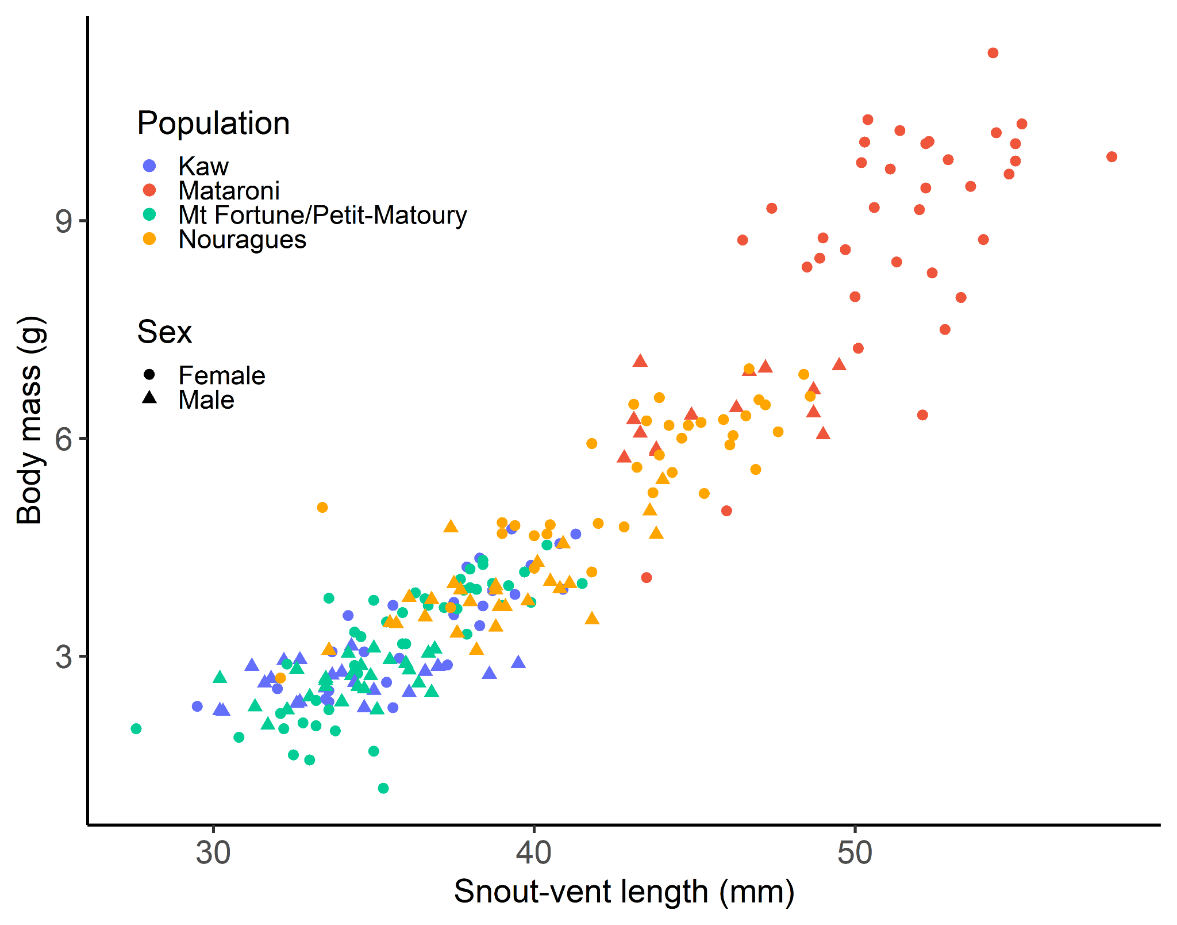
Fig. S1: The plotted relationship between snout-vent length and body mass for all observed dyeing poison frogs (Dendrobates tinctorius), shown separately for females (circles) and males (triangles) and for the different populations.

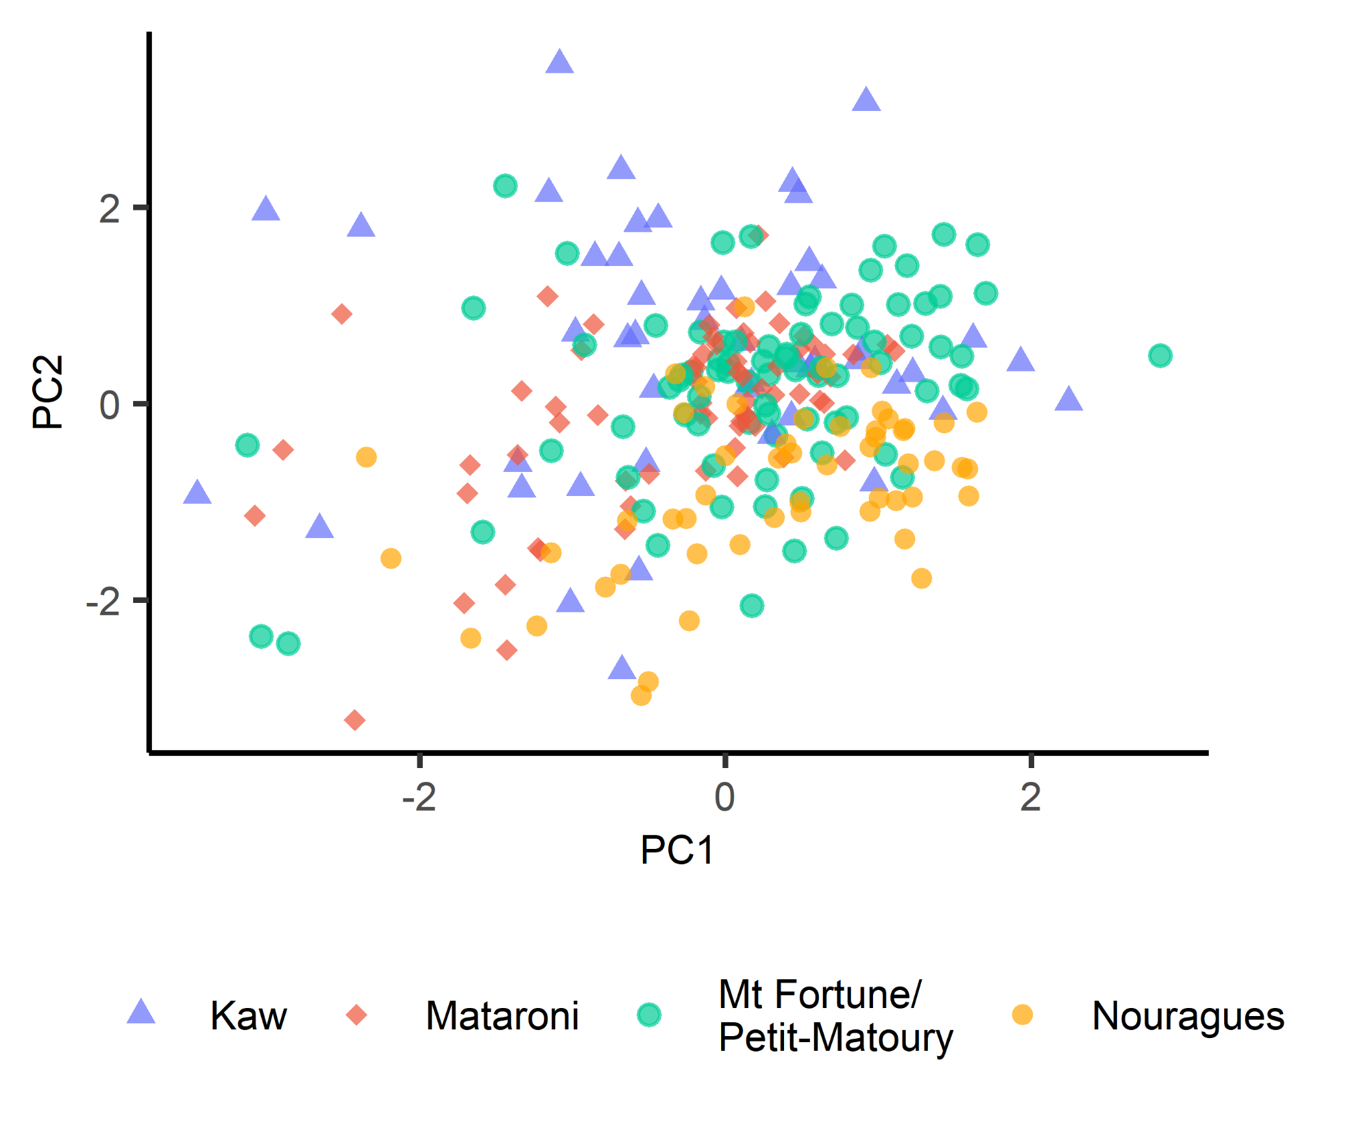
Fig. S2: Showing the principal component scores of the two first axes (explaining 27% and 16% of the variation in the microhabitat data) obtained by a principal component analysis separately for each population. Note that large overlap in principal component scores among populations.

Table S1: Overview of the climate and microhabitat structure for each population.
Population | Annual precipitation (mm) | Mean annual temperature (m) | Number of habitat plots | Elevation (m) | Ground vegetation cover (%) | Leaf litter cover (%) | Number of large trees | Woody structures (%)
Kaw NR | 2560 | 26.2 | 49 | 65 ± 51 | 29 ± 21 | 78 ± 23 | 0.31 ± 0.51 | 8 ± 13
Mataroni | 2338 | 25.4 | 68 | 75 ± 15 | 29 ± 24 | 86 ± 16 | 0.25 ± 0.53 | 9 ± 14
Nouragues | 2990 | 26.3 | 53 | 136 ± 36 | 27 ± 18 | 87 ± 15 | 0.4 ± 0.53 | 8 ± 12
Petit-Matoury/Mt Fortune | 2446 | 25.9 | 83 | 85 ± 23 | 19 ± 20 | 82 ± 22 | 0.19 ± 0.45 | 8 ± 11

Table S2: Overview of the model selection for the analysis of (1) number of clutches per pair, (2) days between clutch deposition, (3) clutch size, (4) number of tadpoles hatched per clutch, (5) time to hatching, (6) tadpole size at hatching, (7) time to metamorphosis, and (8) survival (from egg deposition to metamorphosis). All models within delta AIC <2, including the full and intercept only model, are shown. Models are ranked according to AIC. The marginal R² is the variation explained by the fixed effects and the conditional R² the variation explained by fixed and random effects combined. Maternal ID was included as random intercept in all analyses (except for the number of clutches per pair).
Analysis/Predictor variables | df | logLik | AICc | delta AIC | AIC weight | marginal R² | conditional R²
1. Number of clutches per pair (n = 45 pairs)
Population + female SVL | 6 | -200 | 415 | 0.0 | 1.00 | 0.647
Intercept only | 1 | -240 | 482 | 67.6 | 0.00
2. Days between clutch deposition (n = 242 clutches)
Population | 6 | -4143 | 8298 | 0.0 | 0.52 | 0.288 | 0.935
Population + female SVL | 7 | -4142 | 8299 | 1.0 | 0.32 | 0.347 | 0.938
Intercept only | 2 | -4148 | 8301 | 2.7 | 0.14 |  | 0.942
Population + female SVL + Population × female SVL | 11 | -4141 | 8305 | 6.6 | 0.02 | 0.343 | 0.93
3. Clutch size (n = 290 clutches)
Population + female SVL | 7 | -548 | 1111 | 0.0 | 0.47 | 0.137 | 0.163
Population | 6 | -550 | 1111 | 0.1 | 0.44 | 0.118 | 0.166
Population + female SVL + Population × female SVL | 11 | -546 | 1115 | 3.4 | 0.09 | 0.16 | 0.174
Intercept only | 2 | -559 | 1122 | 10.3 | 0.00 |  | 0.207
4. Number of tadpoles per clutch (n = 299 clutches)
Intercept only | 2 | -588 | 1181 | 0.0 | 0.72 |  | 0.113
Population + female SVL + Population × female SVL | 11 | -580 | 1183 | 1.9 | 0.28 | 0.08 | 0.08
5. Time to hatching (n = 217 clutches)
Population + average tadpole size | 7 | -600 | 1214 | 0.0 | 0.53 | 0.221 | 0.221
Population + average tadpole size + female SVL | 8 | -599 | 1216 | 1.8 | 0.22 | 0.222 | 0.222
Population + average tadpole size + clutch size | 8 | -599 | 1216 | 1.8 | 0.22 | 0.221 | 0.221
Population + female SVL + clutch size + average tadpole size + Population × female SVL | 13 | -596 | 1219 | 5.4 | 0.04 | 0.245 | 0.245
Intercept only | 2 | -626 | 1256 | 42.3 | 0.00 |  | 0.084
6. Tadpole size (n = 738 tadpoles)
Population | 7 | -1240 | 2494 | 0.0 | 0.61 | 0.076 | 0.35
Intercept only | 3 | -1244 | 2495 | 0.9 | 0.39 |  | 0.334
Population + female SVL + clutch size + Population × female SVL | 13 | -1245 | 2516 | 22.1 | 0.00 | 0.091 | 0.408
7. Time to metamorphosis (n = 485 froglets)
Clutch size | 3 | -2027 | 4060 | 0.0 | 0.72 | 0.041 | 0.614
Clutch size + female SVL | 4 | -2027 | 4062 | 1.9 | 0.28 | 0.05 | 0.617
Population + female SVL + clutch size + Population × female SVL | 12 | -2023 | 4070 | 10.2 | 0.00 | 0.143 | 0.575
Intercept only | 2 | -2038 | 4080 | 20.0 | 0.00 |  | 0.587
8. Survival (n = 174 clutches)
Clutch size | 3 | -394 | 795 | 0.0 | 0.52 | 0.019 | 0.188
Intercept only | 2 | -396 | 796 | 1.6 | 0.24 |  | 0.198
Clutch size + female SVL | 4 | -394 | 796 | 1.8 | 0.21 | 0.024 | 0.188
Population + female SVL + clutch size + Population × female SVL | 12 | -388 | 800 | 5.6 | 0.03 | 0.127 | 0.181

Table S3: Post-hoc pairwise comparison of regression coefficients (estimate ± standard error (SE)), based on a linear regression of body condition and population, shown separately for all frogs, females, and males. There are no differences between populations or sexes.
 | Body condition (all frogs) |  | Female body condition |  | Male body condition
Population | Estimate ± SE | P-value | Estimate ± SE | P-value | Estimate ± SE | P-value
Kaw - Mataroni | 0.00 ± 0.02 | 1.00 | 0.01 ± 0.03 | 0.99 | 0.00 ± 0.03 | 1.00
Kaw - (Mt Fortune/Petit-Matoury) | 0.02 ± 0.02 | 0.85 | 0.01 ± 0.03 | 0.97 | 0.02 ± 0.03 | 0.82
Kaw - Nouragues | 0.00 ± 0.02 | 1.00 | -0.01 ± 0.03 | 0.95 | 0.01 ± 0.03 | 0.96
Mataroni - (Mt Fortune/Petit-Matoury) | 0.01 ± 0.02 | 0.92 | 0.00 ± 0.02 | 1.00 | 0.03 ± 0.03 | 0.79
Mataroni - Nouragues | -0.01 ± 0.02 | 0.99 | -0.02 ± 0.02 | 0.82 | 0.02 ± 0.03 | 0.94
(Mt Fortune/Petit-Matoury) - Nouragues | -0.02 ± 0.02 | 0.71 | -0.03 ± 0.02 | 0.69 | -0.01 ± 0.03 | 0.97

Table S4: Post-hoc pairwise comparison of regression coefficients (estimate ± standard error (SE)), based on linear regressions of (1) number of clutches per pair and (2) number of days between clutch laying between five dyeing poison frog populations. Statistically significant differences (p < 0.05) are in bold.
Population comparison | 1. Number of clutches |  | 2. Days between clutch laying
 | Estimate ± SE | P-value | Estimate ± SE | P-value
Bruyere - Kaw | -0.56 ± 0.28 | 0.27 | -0.35 ± 0.52 | 0.96
Bruyere - Mataroni | 1.4 ± 0.41 | 0.01 | -1.06 ± 0.55 | 0.29
Bruyere - Ouanary | 0.53 ± 0.31 | 0.41 | -1.41 ± 0.54 | 0.07
Bruyere - Petit-Matoury | 0.34 ± 0.41 | 0.92 | -0.18 ± 0.6 | 1.00
Kaw - Mataroni | 1.96 ± 0.34 | <0.01 | -0.71 ± 0.37 | 0.31
Kaw - Ouanary | 1.08 ± 0.17 | <0.01 | -1.06 ± 0.37 | 0.03
Kaw - Petit-Matoury | 0.9 ± 0.32 | 0.04 | 0.17 ± 0.45 | 1.00
Mataroni - Ouanary | -0.87 ± 0.34 | 0.08 | -0.35 ± 0.41 | 0.91
Mataroni - Petit-Matoury | -1.06 ± 0.49 | 0.20 | 0.88 ± 0.48 | 0.35
Ouanary - Petit-Matoury | -0.19 ± 0.35 | 0.98 | 1.23 ± 0.48 | 0.08

Table S5: Post-hoc pairwise comparison of regression coefficients (estimate ± standard error (SE)), based on linear regressions of (1) clutch size and (2) time to hatching of tadpoles between five dyeing poison frog populations. Statistically significant differences (p < 0.05) are in bold.
 | 1. Clutch size |  | 2. Time to hatching (days) |  | 3. Tadpole size (mm)
Population | Estimate ± SE | P-value | Estimate ± SE | P-value | Estimate ± SE | P-value
Bruyere - Kaw | -0.09 ± 0.15 | 0.98 | 0.07 ± 0.07 | 0.84 | 1.02 ± 0.68 | 0.58
Bruyere - Mataroni | -0.7 ± 0.16 | <0.01 | 0.1 ± 0.08 | 0.76 | 0.77 ± 0.71 | 0.82
Bruyere - Ouanary | 0.05 ± 0.18 | 1.00 | 0.23 ± 0.08 | 0.04 | -0.07 ± 0.7 | 1.00
Bruyere - Petit-Matoury | 0.32 ± 0.23 | 0.63 | 0.56 ± 0.12 | <0.01 | 0.19 ± 0.82 | 1.00
Kaw - Mataroni | -0.61 ± 0.09 | <0.01 | 0.02 ± 0.05 | 0.99 | -0.25 ± 0.48 | 0.98
Kaw - Ouanary | 0.14 ± 0.13 | 0.82 | 0.15 ± 0.05 | 0.04 | -1.09 ± 0.46 | 0.17
Kaw - Petit-Matoury | 0.41 ± 0.19 | 0.20 | 0.49 ± 0.11 | <0.01 | -0.83 ± 0.62 | 0.68
Mataroni - Ouanary | 0.75 ± 0.14 | <0.01 | 0.13 ± 0.07 | 0.32 | -0.84 ± 0.51 | 0.48
Mataroni - Petit-Matoury | 1.02 ± 0.2 | <0.01 | 0.46 ± 0.11 | 0.00 | -0.58 ± 0.66 | 0.90
Ouanary - Petit-Matoury | 0.28 ± 0.22 | 0.72 | 0.33 ± 0.11 | 0.03 | 0.26 ± 0.65 | 0.99

