Antcin-B, a phytosterol-like compound from Taiwanofungus camphoratus inhibits SARS-CoV-2 3-chymotrypsin-like protease (3CLPro) activity in-silico and in vitro
Gyaltsen Dakpa^{1,2}, K. J. Senthil Kumar³, Jochem Nelen⁴, Horacio Pérez-Sánchez⁴ & Sheng-Yang Wang^{1,5,6,7,*}

¹Molecular and Biological Agricultural Sciences Program, Taiwan International Graduate Program, Academia Sinica, Taipei-108, Taiwan. ²Graduate Institute of Biotechnology, National Chung Hsing University, Taichung-402, Taiwan. ³Bachelor Program of Biotechnology, National Chung Hsing University, Taichung-402, Taiwan. ⁴Structural Bioinformatics and High-Performance Computing Research Group (BIO-HPC), HiTech Innovation Hub, Universidad Católica de Murcia (UCAM), 30107 Murcia, Spain. ⁵Department of Forestry, National Chung Hsing University, Taichung-402, Taiwan. ⁶Special Crop and Metabolome Discipline Cluster, Academy of Circle Economy, National Chung Hsing University, Taichung-402, Taiwan. ⁷Agricultural Biotechnology Research Center, Academia Sinica, Taipei-108, Taiwan. Email: taiwanfir@drgon.nchu.edu.tw

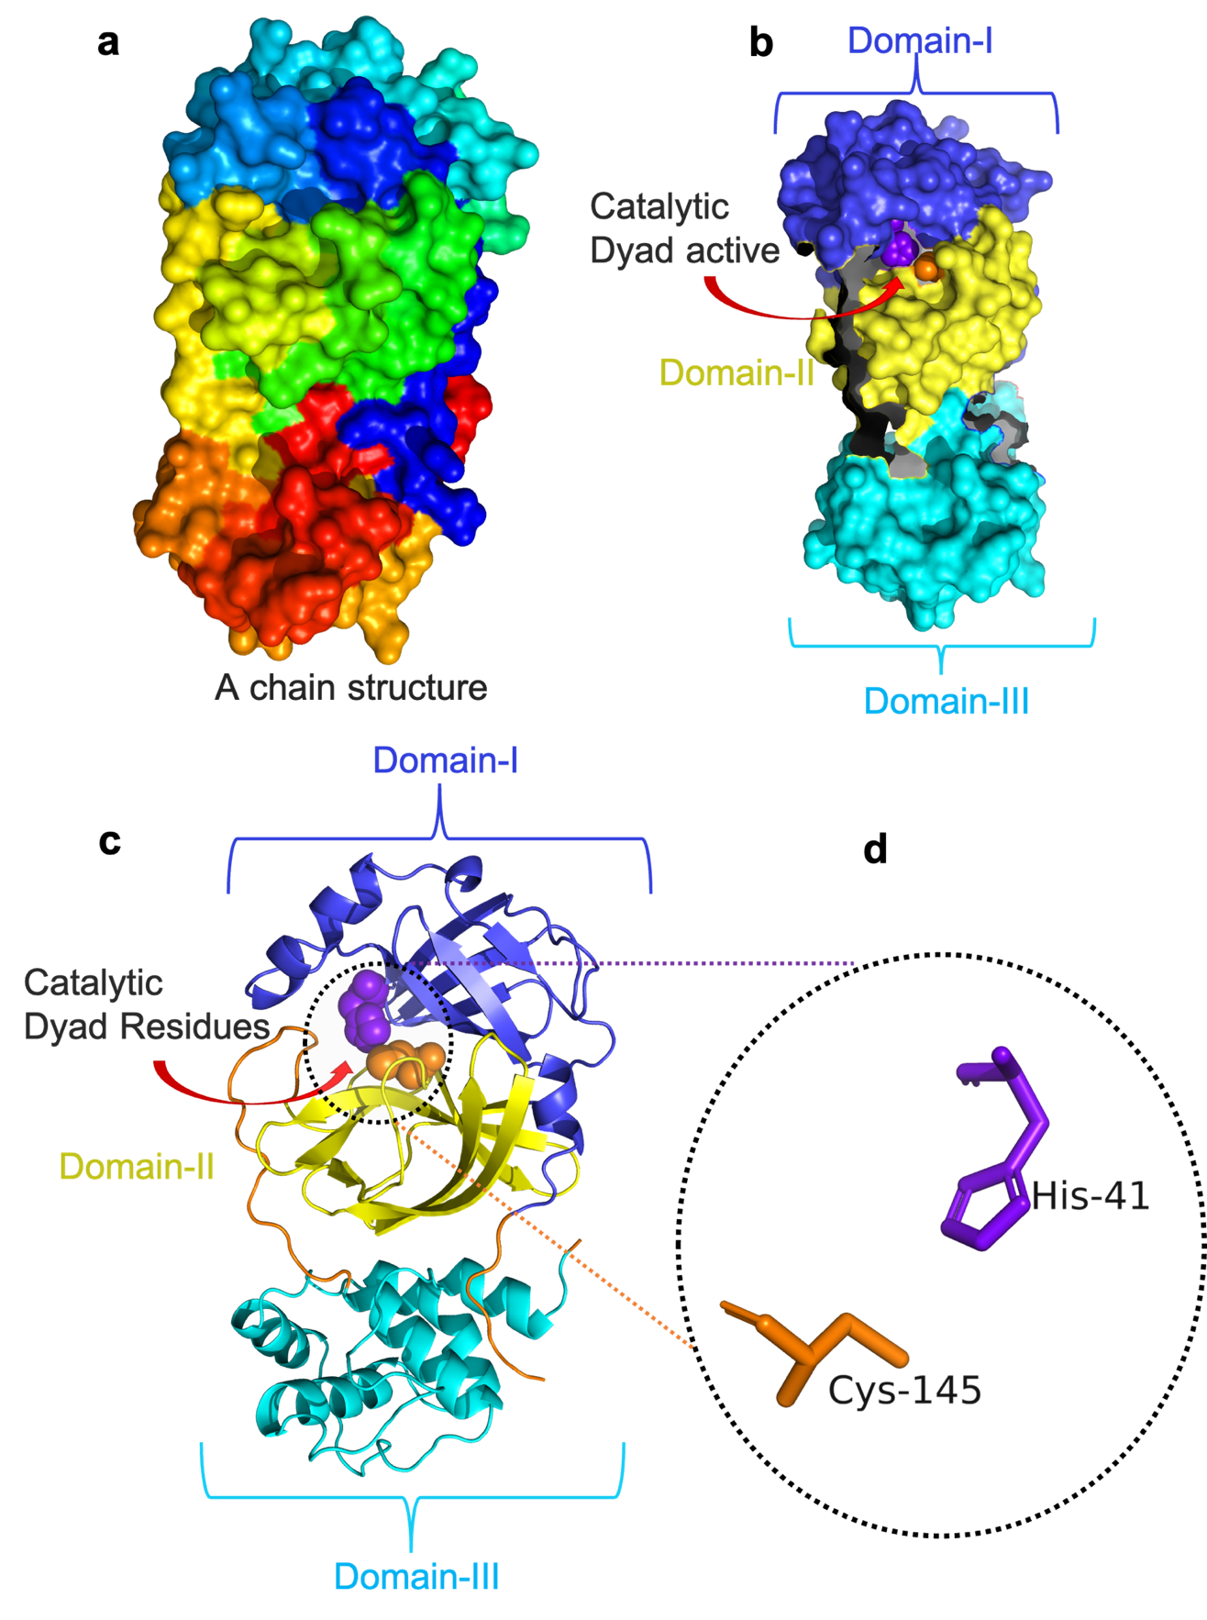
Figure S1. Three-dimensional structure of SARS-CoV-2 3CLpro. (a) 3D structure of SAR-Cov-2-3CLpro represented in a surface model with a rainbow color which was obtained from the RCSB Protein Data Bank (PDB) with (PDB ID; 7LME)¹ and visualized and only-A was retained using the PyMoL Molecular Graphic System GL_VERSION: 2.5.4, which contains the 304 amino acid residues. (b) 3D surface model containing three domains of 3CLPro domain-I indicated in deep blue color; domain-ii, shown in yellow color; and domain-III, represented in cyan color. The central catalytic dyed residues (His41 and Cys145) are presented in a sphere model with purple and orange colors, respectively. (c) three domains of 3CLPro are shown in the cartoon model with three colors which are the same as in B. (d) then catalytic dyed residues are present in the sticks model with specific positive residues in the 3CLpro chain, that is, His41 and Cys145.

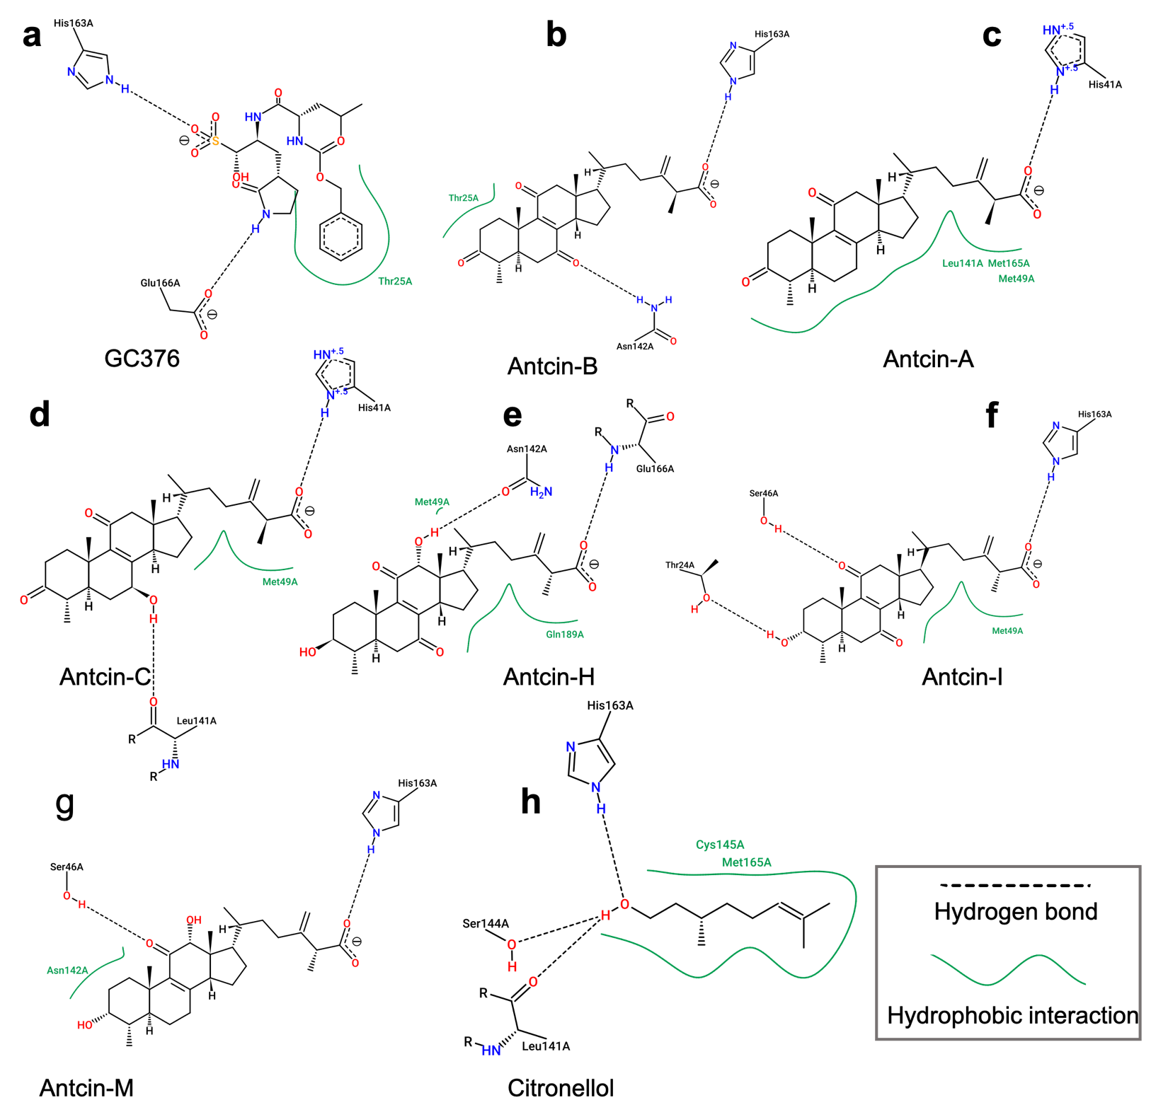

Figure S2. 2D protein-ligand interaction diagrams obtained by ProteinPlus. Further validating docking results and interactions, we have performed the ProteinPlus, which provides the details of chemical 2D protein–ligand interaction diagrams. These pre-processing tasks like structure quality assessment (EDIA), hydrogen placement (Protoss), and the search for alternative conformations (SIENA). Beyond that, it also addresses frequent problems such as generating 2D-interaction diagrams (PoseView), http://proteins.plus. The complex interaction between antcins, non-antcins, and GC376 and SARS-CoV2-3CLPro inhibits the activity that can be a potential leading drug candidate to protect from COVID-19. (a) GC376, (b) antcin-A, (c) antcin-B, (d) antcin- C, (e) antcin-H, (f) antcin-I, (g) antcin-M, (h) citronellol, are interaction with residues of SARS-CoV2-3CLPro are represented in the 2D visualization. Interaction between residues and drugs depicts all structure diagrams following the IUPAC drawing conventions. The black dishes line indicated the hydrogen bonds, and the green lines represented hydrophobic interaction. The formation of hydrogen bonds is detailed depicted in. It was observed that the drugs interacted with neighboring amino acid residues. Based on the ProteinPlus, there is no interaction of Limonene with 3CLPro due to a lack of hydron bonds and to further of limonene from 3CLPro to be hydrophobic.

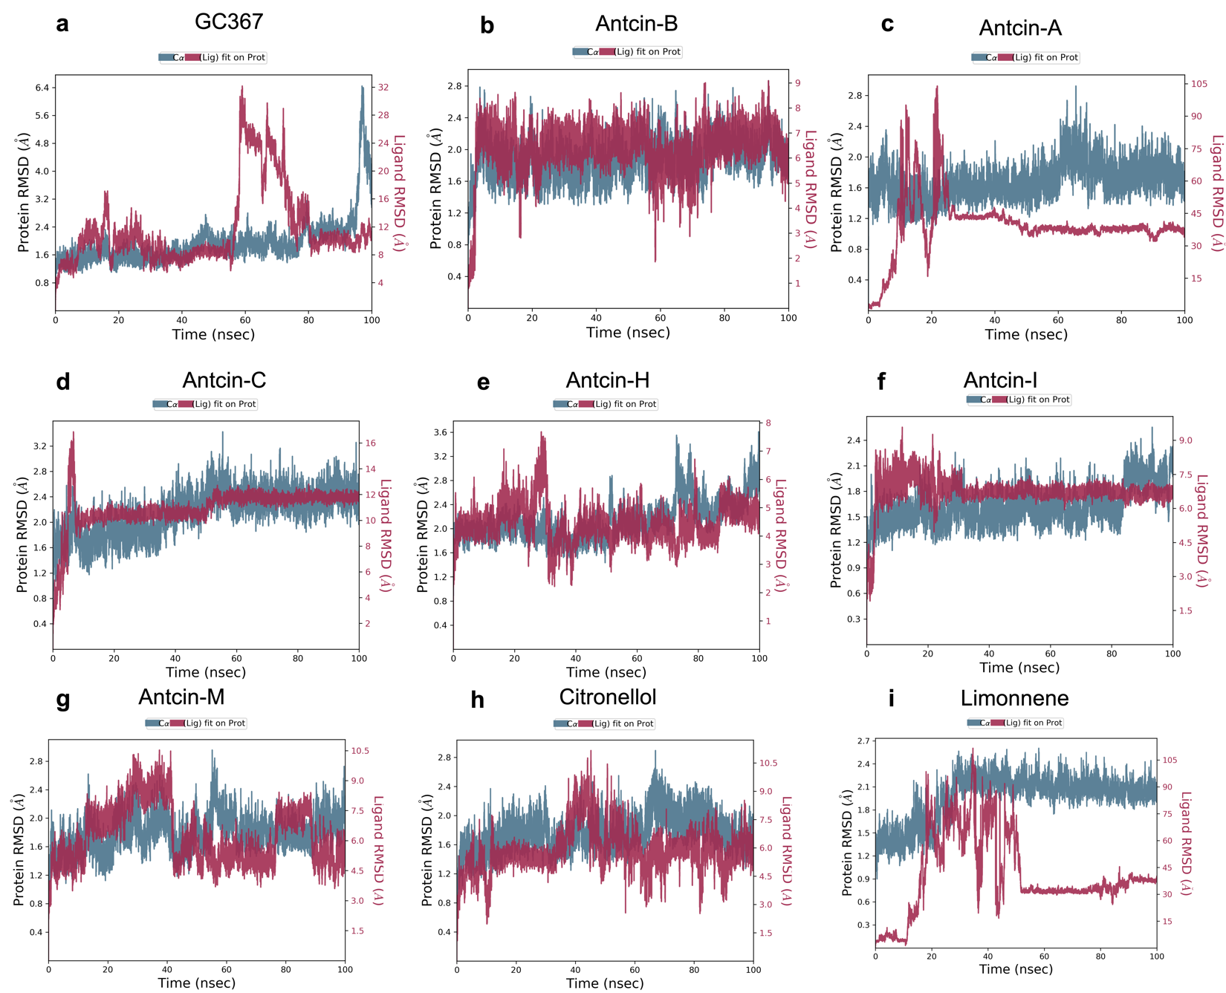

Figure S3. RMSD protein-ligand complex. Protein-ligand interaction root-mean-square-deviation (RMSD) and root-mean-square-fluctuation (RMSF) profile during 100 ns MD simulation of (a) GC367-3CLPro complex RMSD, (b) Antcin-B-3CLpro complex RSMD, (c) Antcin-A-3CLpro complex RSMD, (d) Antcin-C-3CLpro complex RSMD, (e) Antcin-H-3CLpro complex RSMD, (f) Antcin-I-3CLpro complex RSMD, (g) Antcin-M-3CLpro complex RSMD, (h) Citronellol-3CLpro complex RSMD and (i) Limonene-3CLpro complex RSMD. The blue lines correspond to the RMSD of protein alone, and the red lines correspond to the RMSD of protein docked with the ligands. The stability of the complex is dependent on fluctuation protein along with ligands which are in sites with the most stable protein-ligand complexes. It is notably observed that Antcin-B’s RSMD (A°) is quite close to the RMSD of the protein profile.
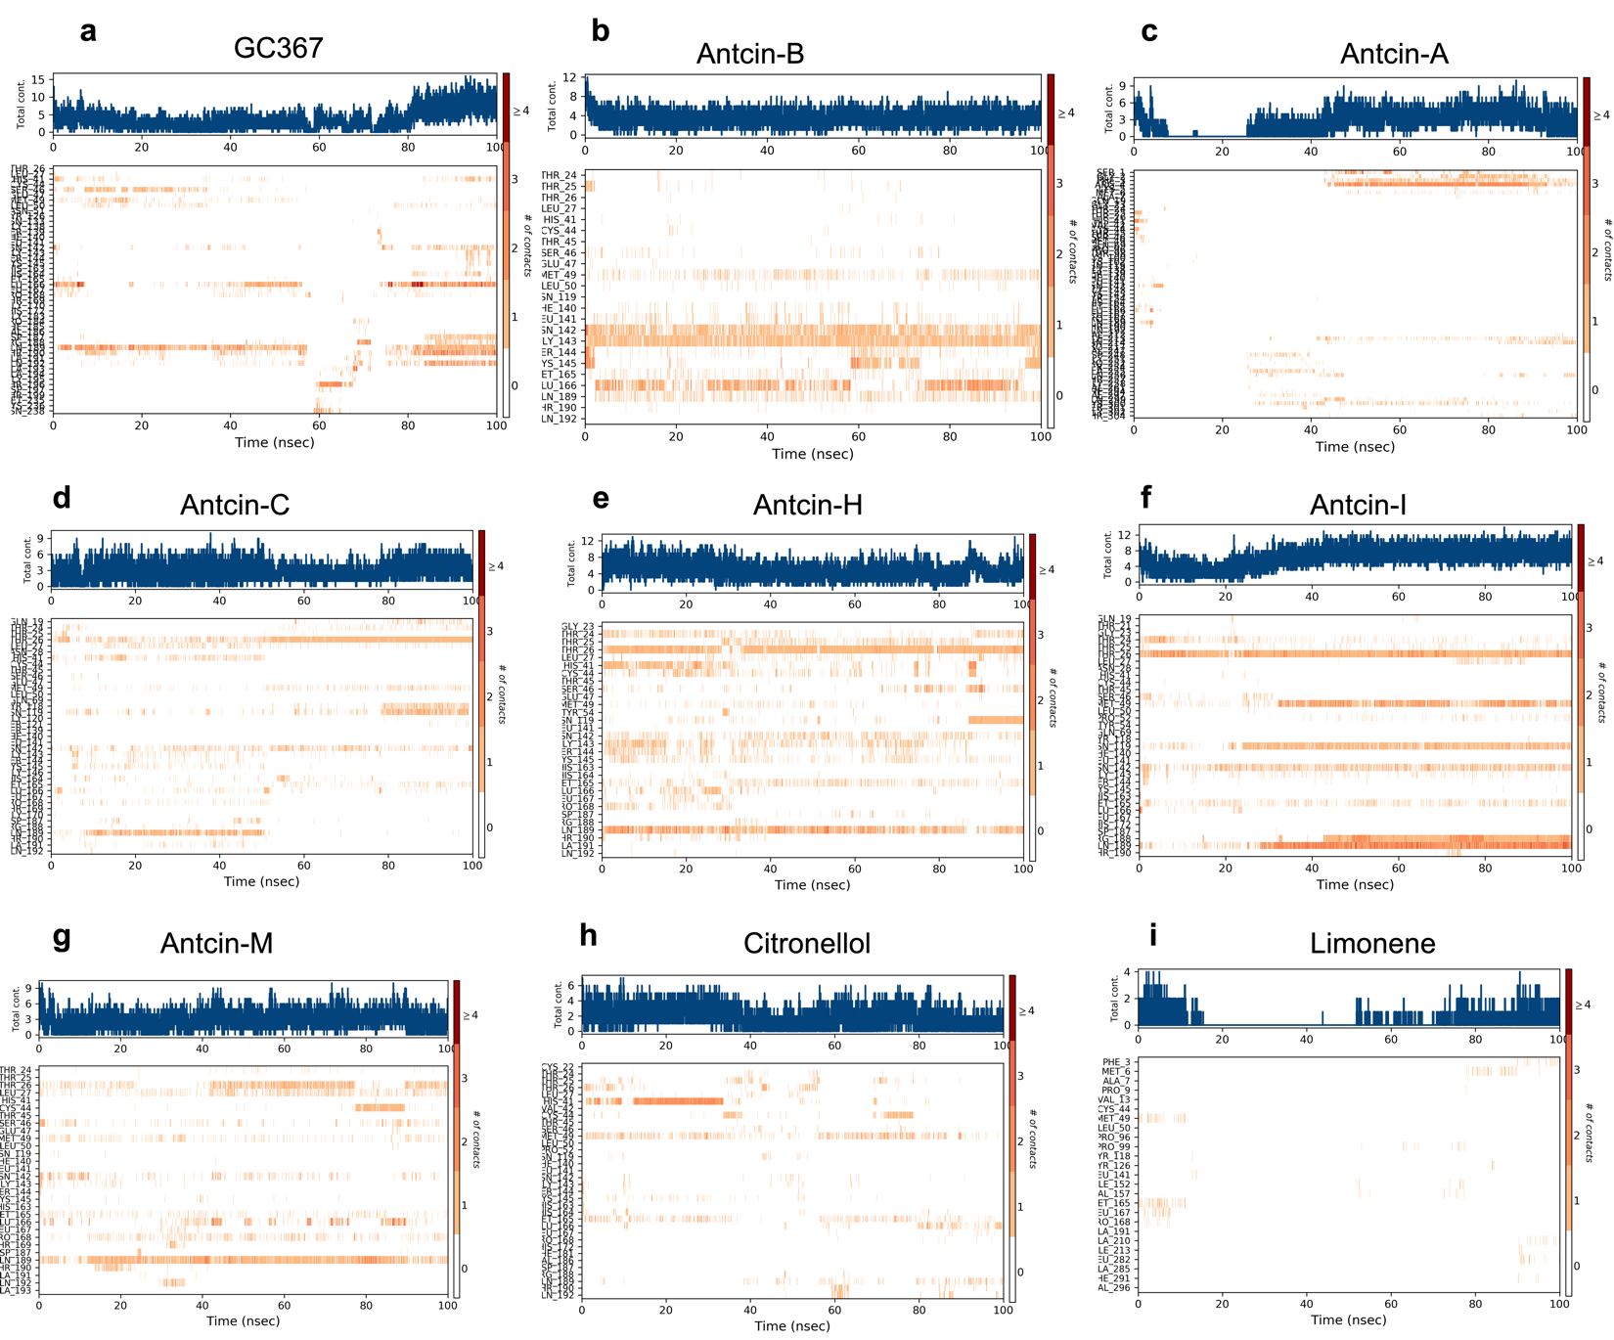

Figure S4. Protein–ligand contact timeline plot during 100 ns MD simulation. Total contact timeline plot of naringin bound to the active inhibitory site at 3CLPpro protein during the 100 ns MD simulation, which is (a) GC376, (b) antcin-A, (c) antcin-B, (d) antcin-C, (e) antcin- H, (f) antcin-I, (g) antcin-M, (h) citronellol, and (i) limonene.

Table S1. ADMET properties of best hits compounds with GC376, ADMET was predicted using the AdmetSAR server2
Class | Properties | Antcin-A | Antcin-B | Antcin-C | Antcin-H | Antcin-I | Antcin-M | Citrollelol | Limonene | GC376
Absoprtion | Caco-2 Permeability | −5.231 | −4.977 | −4.997 | −5.235 | −5.031 | −5.055 | −4.252 | −4.32 | −16.11
 | MDCK Permeability | 1.3x10⁵ | 1.6X10⁵ | 1.3x10⁵ | 6.7X10⁵ | 2.8x-0⁵ | 3.7-10⁵ | 2x0⁵ | 1.9x10⁵ | 0.0001
 | Pgp-inhibitor | 0.259 | 0.01 | 0.459 | 0.485 | 0.004 | 0.959 | 0.006 | 0.002 | 0.001
 | Pgp-substrate | 0.004 | 0.007 | 0.003 | 0.12 | 0.379 | 0.005 | 0.006 | 0 | 0.102
 | HIA | 0.039 | 0.138 | 0.152 | 0.044 | 0.212 | 0.017 | 0.005 | 0.003 | 0.99
Distribution | PPB | 95.86% | 96.40% | 95.88% | 95.23 | 96.92% | 96.30% | 93.47% | 86.38% | 58.82%
 | BBB | 0.835 | 0.799 | 0.848 | 0.41 | -0.806 | 0.201 | 0.948 | 0.989 | 0.341
Metabolism | CYP1A2 inhibition | 0.01 | 0.006 | 0.007 | 0.013 | 0.009 | 0.046 | 0.65 | 0.678 | 0.006
 | CYP1A2 substrate | 0.619 | 0.602 | 0.591 | 0.593 | 0.495 | 0.624 | 0.427 | 0.652 | 0.039
 | CYP2C19 inhibitor | 0.016 | 0.01 | 0.01 | 0.012 | 0.008 | 0.021 | 0.092 | 0.223 | 0.035
 | CYP2C19 substrate | 0.904 | 0.838 | 0.883 | 0.882 | 0.882 | 0.878 | 0.604 | 0.834 | 0.057
 | CYP2C9 inhibitor | 0.169 | 0.06 | 0.078 | 0.044 | 0.046 | 0.113 | 0.052 | 0.06 | 0.056
 | CYP2C9 substrate | 0.7 | 0.271 | 0.472 | 0.673 | 0.497 | 0.708 | 0.765 | 0.804 | 0.915
 | CYP2D6 inhibitor | 0.002 | 0.003 | 0.001 | 0.002 | 0.002 | 0.002 | 0.007 | 0.02 | 0.003
 | CYP2D6 substrate | 0.727 | 0.261 | 0.297 | 0.139 | 0.185 | 0.178 | 0.115 | 0.874 | 0.127
 | CYP3A4 inhibitor | 0.206 | 0.151 | 0.072 | 0.076 | 0.135 | 0.143 | 0.018 | 0.057 | 0.025
 | CYP3A4 substrate | 0.23 | 0.222 | 0.174 | 0.327 | 0.247 | 0.33 | 0.162 | 0.253 | 0.055
Toxicity | Human Hepatotoxicity | 0.316 | 0.461 | 0.453 | 0.745 | 0.612 | 0.568 | 0.573 | 0.69 | 0.07
 | Drug Induced Liver Injury | 0.548 | 0.552 | 0.523 | 0.157 | 0.122 | 0.219 | 0.028 | 0.037 | 0.03
 | carcinogens | 0.067 | 0.095 | 0.053 | 0.092 | 0.0078 | 0.194 | 0.224 | 0.922 | 0.023
 | corrosives | 0.003 | 0.003 | 0.003 | 0.003 | 0.004 | 0.005 | 0.915 | 0.849 | 0.003
 | irritants | 0.009 | 0.01 | 0.009 | 0.012 | 0.01 | 0.018 | 0.985 | 0.981 | 0.007
 | Sensitizer | 0.017 | 0.01 | 0.012 | 0.061 | 0.026 | 0.442 | 0.857 | 0.355 | 0.125
 | Acute oral toxicity  (kg/ mol) | 0.889 | 0.931 | 0.968 | 0.774 | 0.795 | 0.497 | 0.01 | 0.017 | 0.03
NOTE: The Madin-Darby canine kidney (MDCK) permeability, low permeability: < 2 × 10⁻⁶ cm/s, medium permeability: 2–20 × 10⁻⁶ cm/s, and high passive permeability: > 20 × 10⁻⁶ cm/s. Caco-2 Permeability: higher than -5.15 Log unit. Human intestinal absorption (HIA), HIA+( HIA < 30%); Category 0: HIA-( HIA < 30%) and Blood-brain barrier (BBB), If PPB is higher than 90% moderate, 100 % is high, and over 100% is very high. Acute oral toxicity (kg/ mol) Category 0: low toxicity; Category 1: high toxicity.

Table S2. Druglikeness prediction according to Lipinski’s rule of antcins (A, B, C, H, I, and M), non-antcins (citronellol and limonene ), and GC376 using the admetSAR server2
Properties | Antcin-A | Antcin-B | Antcin-C | Antcin-H | Antcin-I | Antcin-M | Citronellol | Limonene | GC376
Molecular Weight | 454 | 468.3 | 470.3 | 486.3 | 470.3 | 472.32 | 156.15 | 136.1 | 485.2
Solubility  (Log S) | −5.6 | −5.26 | −5.21 | −4.81 | −5.11 | −5.34 | −2.15 | −2.54 | −2.75
TPSA (Å) | 71.4 | 88.51 | 91.67 | 111.9 | 91.67 | 91.67 | 20.23 | 0 | 182.3
cLOgP | 4.58 | 5.49 | 5.35 | 4.5 | 4.94 | 5.22 | 3.35 | 3.36 | -2.21
H-Bond  Acceptors | 4 | 5 | 5 | 6 | 5 | 5 | 1 | 0 | 11
H-Bond  Donor | 1 | 1 | 1 | 2 | 2 | 2 | 1 | 0 | 5
Druglikeness | −1.85 | −1.85 | −1.44 | −1.03 | −1.78 | −2.42 | −8.68 | −21.85 | −33.9
Drug score | 0.19 | 0.22 | 0.24 | 0.31 | 0.41 | 0.22 | 0.16 | 0.35 | 0.37
Mutagenic | no | no | no | no | no | no | no | no | no
Tumorigenic | no | no | no | no | no | no | no | no | no
Reproductive  effect | no | no | no | no | no | no | no | no | no
Irritants | no | no | no | no | no | no | no | no | no
Lipinski  Rule | Accepted | Accepted | Accepted | Accepted | Accepted | Accepted | Accepted | Accepted | Accepted
Pfizer Rule | Rejected | Accepted | Accepted | Accepted | Accepted | Accepted | Rejected | Rejected | Accepted
GSK Rule | Rejected | Rejected | Rejected | Rejected | Rejected | Rejected | Accepted | Rejected | Rejected
Golden triangle rule | Accepted | Accepted | Accepted | Accepted | Accepted | Accepted | Rejected | Rejected | Accepted
Lipinski Rule: MW ≤ 500; logP ≤ 5; Hacc ≤ 10; Hdon ≤ 5 are acceptable.
Pfizer Rule:logP > 3; TPSA < 75, Compounds with a high log P (>3) and low TPSA (<75) are likely to be toxic.
Golden triangle rule 200 ≤ MW ≤ 50; -2 ≤ logD ≤ 5, are acceptable.

References

1 Han, S. H. et al. Structure-based optimization of ML300-derived, noncovalent inhibitors targeting the severe acute respiratory syndrome coronavirus 3CL protease (SARS-CoV-2 3CL(pro)). J Med Chem 65, 2880-2904 (2022). https://doi.org:10.1021/acs.jmedchem.1c00598

