Supplementary information for:
Valley-polarized and bipolar quantum Hall phases in the strain-controlled PbSnSe multivalley system
G. Krizman, J. Bermejo-Ortiz, T. Zakusylo, M. Hajlaoui, T. Takashiro, M. Rosmus, N. Olszowska, J. J. Kołodziej, G. Bauer, Y. Guldner, G. Springholz and L.-A. de Vaulchier

This Supplementary Information contains:
- Full k.p calculations of the Landau levels of samples A and B.
- Additional magneto-optical data for the determination of the QW gap versus Sn content.
- Additional magneto-transport data obtained on sample C

- Full k.p calculations of the Landau levels of samples A, B and C
The $k.p$ calculations are performed following our previous work using Eq. (4) of Ref.¹. The results for samples A and B are shown in Fig. S1, while the Landau levels of sample C are plotted in Fig. 4a of the main text. The band parameters are listed in Table SI following the magneto-optical fits. Because samples A and B present similar parameters, calculations presented in Fig. S1 are done using average parameters.
Note that the red and black Landau level series correspond to Landau levels emerging near $\overline{Γ}$ and $\overline{M}$ respectively. Only the two first electron (hole) states are shown for the $\overline{Γ}$-point ($\overline{M}$-points).
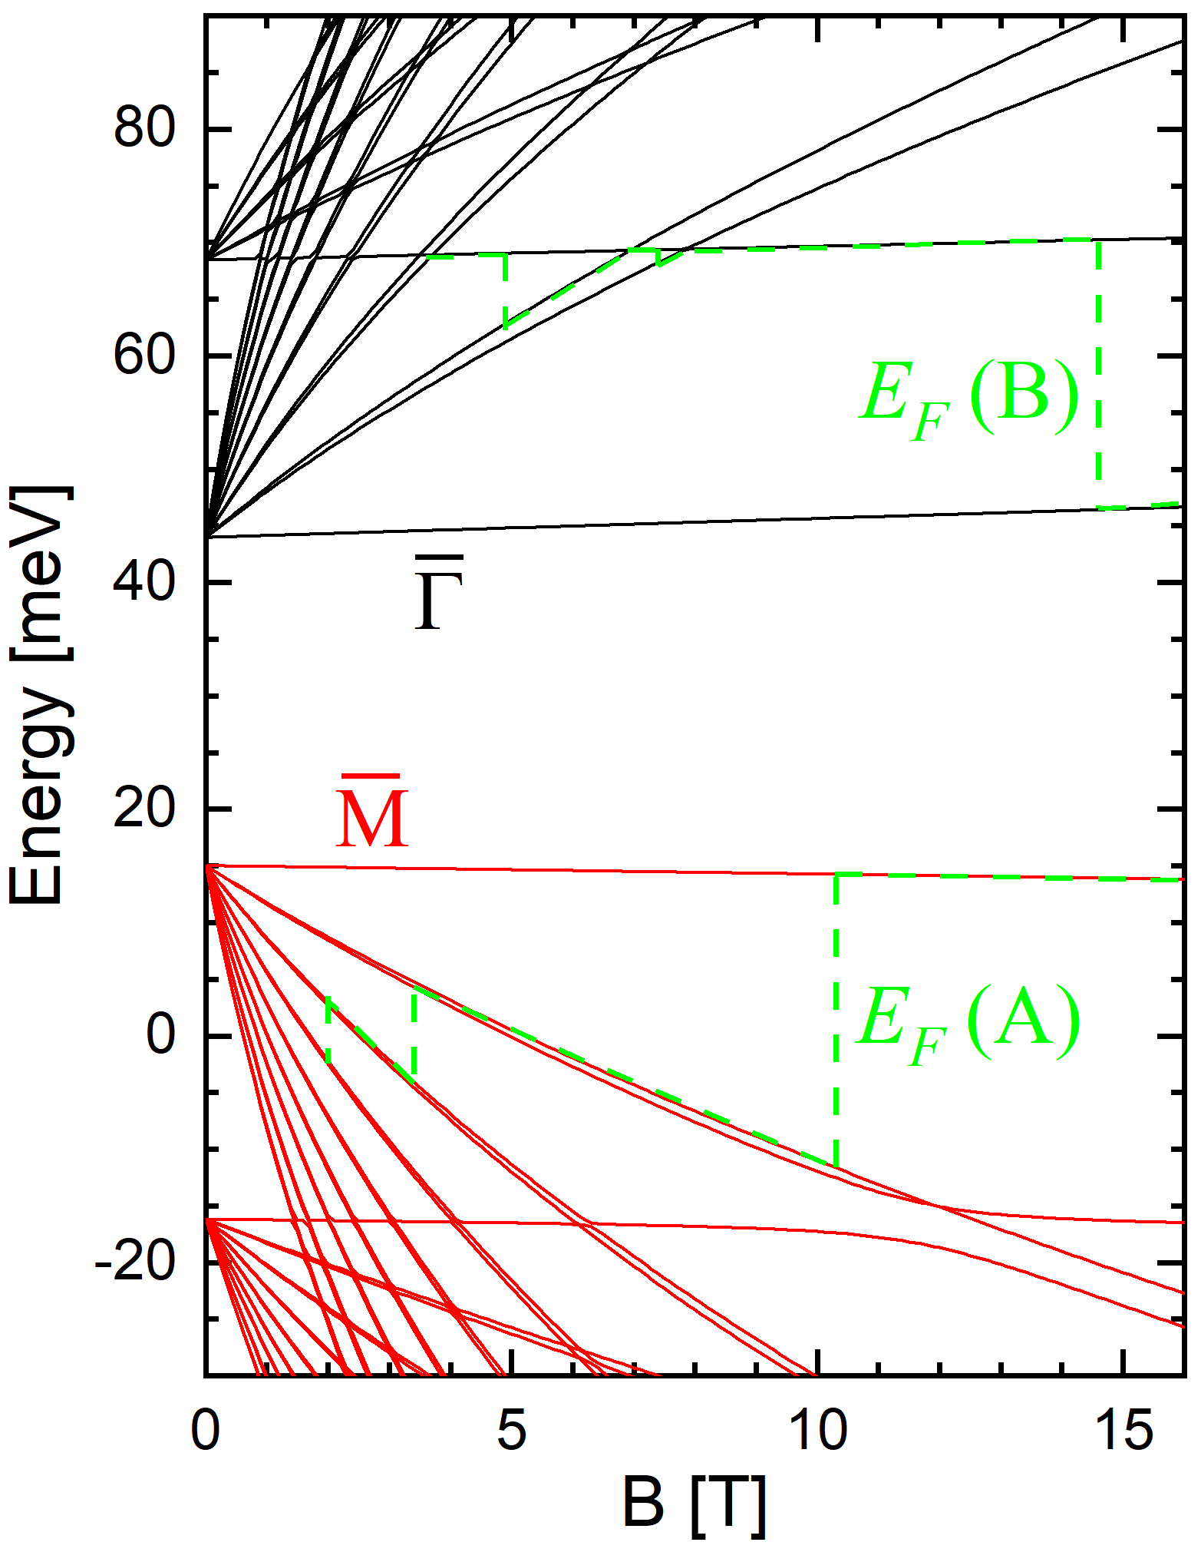
Fig. S1 | Calculated Landau levels of samples A and B, as well as their Fermi levels. The red Landau levels are located in the vicinity of the $\overline{Μ}$ point, and just the two first hole confined states have been plotted. The black Landau levels are located in the vicinity of the $\overline{Γ}$ point, and just the two first electron confined states have been plotted.
- Additional magneto-optical data for the determination of the QW gap versus Sn content
Magneto-optical experiments have been performed on the three investigated samples in the main text. The results for sample B are presented in Fig. 3c of the main text. Figure S2 shows the magneto-optical spectra and fan charts obtained for samples A and C. The fan charts are obtained by plotting the transmission minima observed on the spectra as dots versus magnetic field. These are then fitted by the solid lines. The fits are done considering transitions from Landau levels calculated and given in Fig. S1 for sample A and B, and in Fig. 4a for sample C. The fitting parameters are listed in Table SII. In particular, one can then determine the QW gap $2δ$, which is given by the zero-field extrapolation of the transition series.
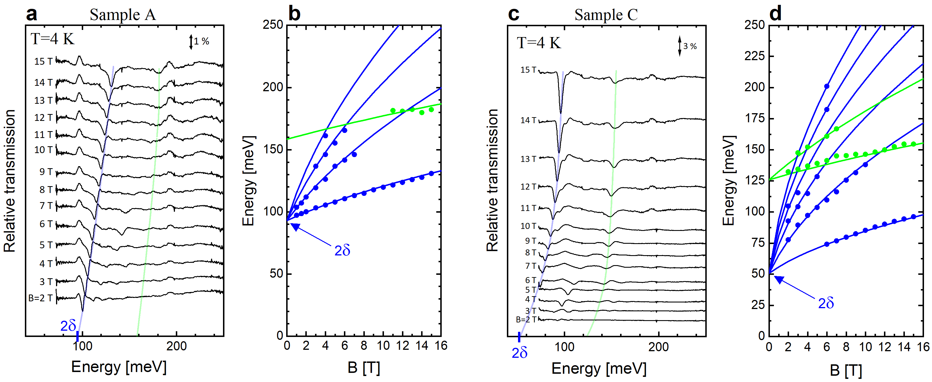
Fig S2 | a Magneto-optical spectra between 2 and 15 T of sample A at T=4 K. Blue and green lines are guide-for-the-eye that show the first transitions between ground states (H1 – E1) and first excited states (H2 – E2), respectively. The absorption scale is indicated at the top right corner. b Fan chart gathering experimental absorptions (dots) observed in a and calculated transitions (lines) occurring between Landau levels. The extrapolations of the two transition series (green and blue) at zero field give the energy spacing H1 – E1 and H2 – E2. The QW gap H1 – E1 is named $2δ$ in our work. c,d Same as a,b with sample C.
Table SI. Dirac parameters of samples A, B and C determined by magneto-infrared spectroscopy.
Samples | A | B | C
$2δ$ [meV] | 92.5±2.5 | 83±2.5 | 50±2.5
$v_{D}$ [x10⁵ m/s] | 5.00±0.05 | 4.80±0.05 | 4.65±0.05
${∆E}_{H2-E2}$ [meV] | 157.5±5 | 145±5 | 125±5

- Additional magneto-transport data on sample C
A two-carrier fit has been performed for sample C, that shows the ambipolar quantum Hall (QH) effect. The fit is done considering²:
$$\left\{\begin{aligned}ρ_{xx}=\frac{1}{e}\frac{\left(n_{h}μ_{h}+n_{e}μ_{e}\right)+\left(n_{e}μ_{e}μ_{h}^{2}+n_{h}μ_{h}μ_{e}^{2}\right)B^{2}}{{\left(n_{h}μ_{h}+n_{e}μ_{e}\right)}^{2}+μ_{h}^{2}μ_{e}^{2}B^{2}{\left(n_{h}-n_{e}\right)}^{2}} \\ ρ_{xy}=\frac{B}{e}\frac{\left(n_{h}μ_{h}^{2}-n_{e}μ_{e}^{2}\right)+μ_{h}^{2}μ_{e}^{2}B^{2}\left(n_{h}-n_{e}\right)}{{\left(n_{h}μ_{h}+n_{e}μ_{e}\right)}^{2}+μ_{h}^{2}μ_{e}^{2}B^{2}{\left(n_{h}-n_{e}\right)}^{2}}\end{aligned}\right.$$
The best fit, shown in Fig. S3, gives the values listed in Table I of the main text.
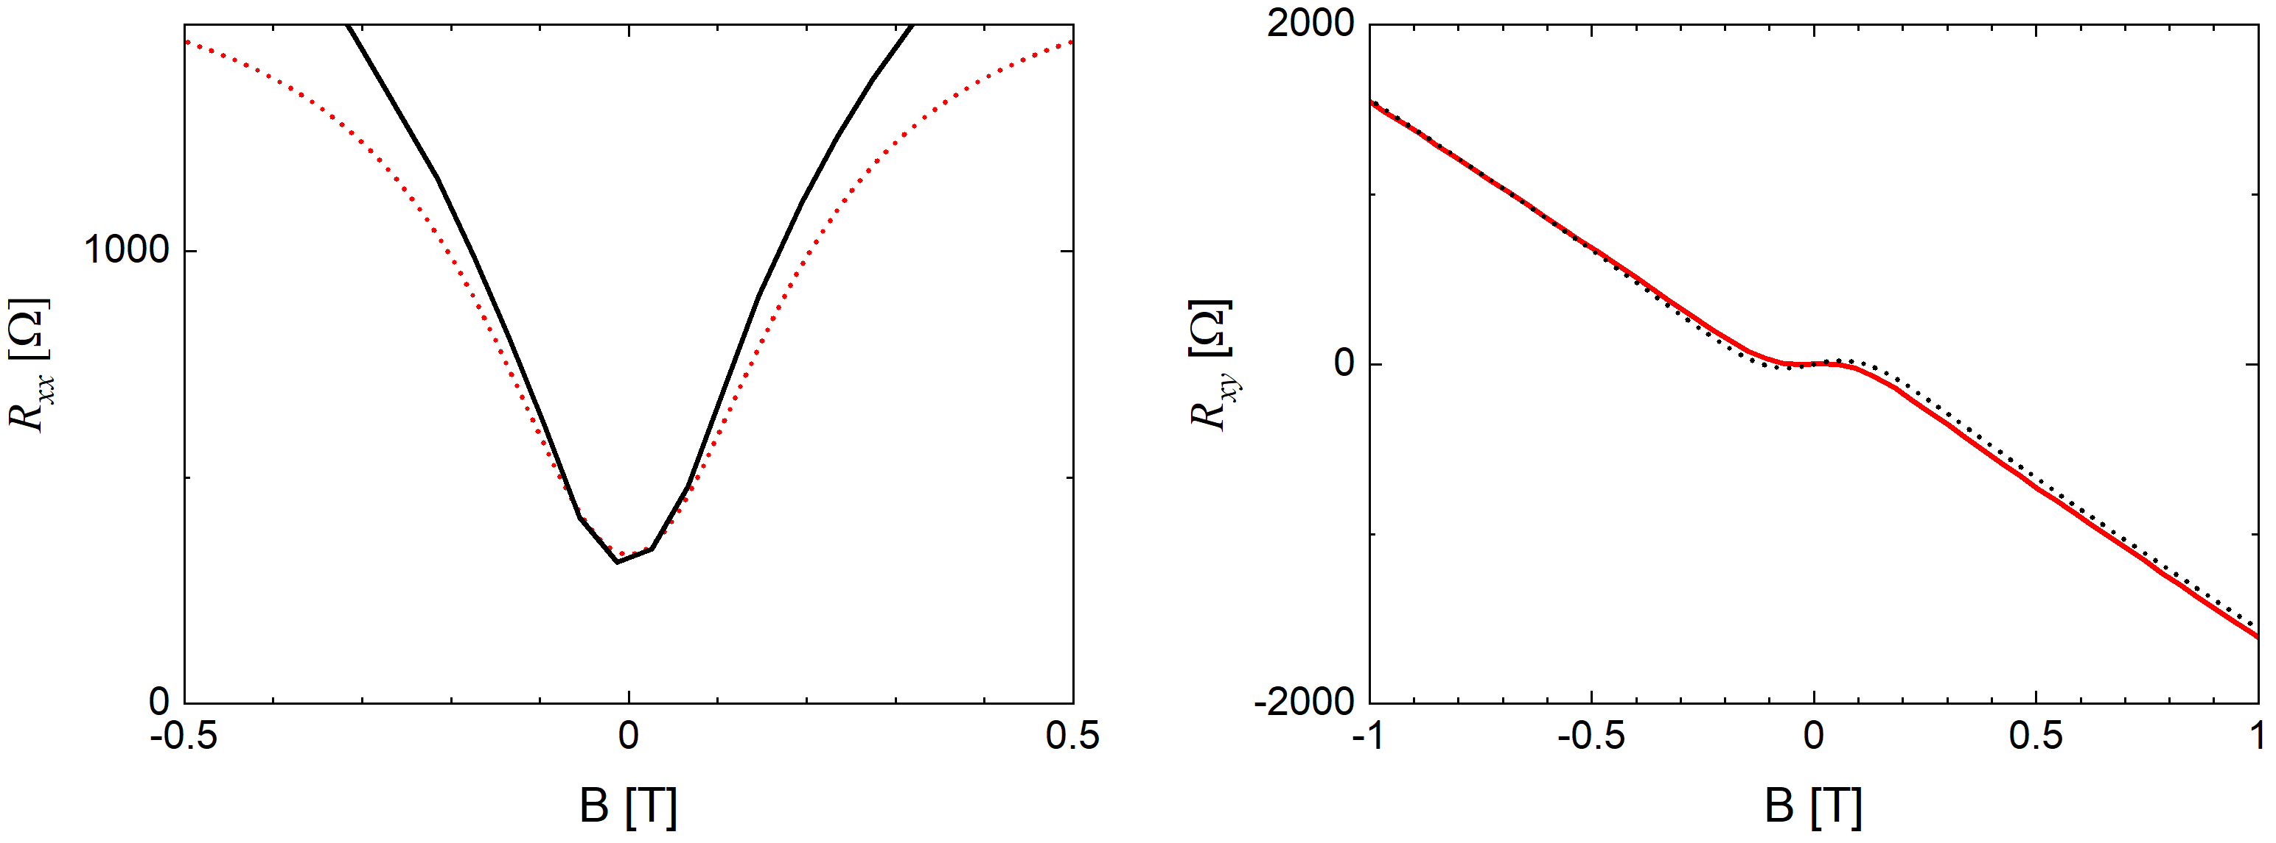
Fig. S3 | Two-carrier fitting procedure for sample C with zoomed transport data (solid lines) close to zero field. The fit is drawn in dotted lines.
Figure S4 shows the ambipolar QH effect of sample C under both magnetic field polarities.
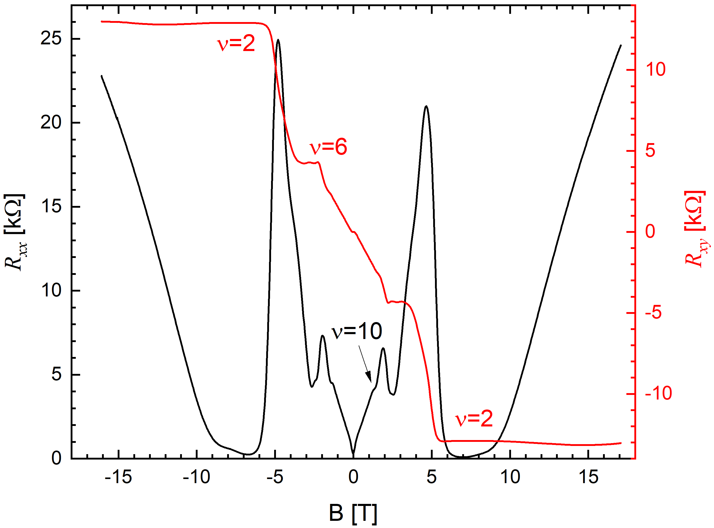
Fig. S4 | Measured QH effect of sample C at T=1.6 K.

References
1. Krizman, G. et al. Interaction between interface and massive states in multivalley topological heterostructures. Phys. Rev. Res. 4, 13179 (2022).
2. Li, C.-Z. et al. Two-Carrier Transport Induced Hall Anomaly and Large Tunable Magnetoresistance in Dirac Semimetal Cd3As2 Nanoplates. ACS Nano 10, 6020–6028 (2016).

