Supplemental Figure 1
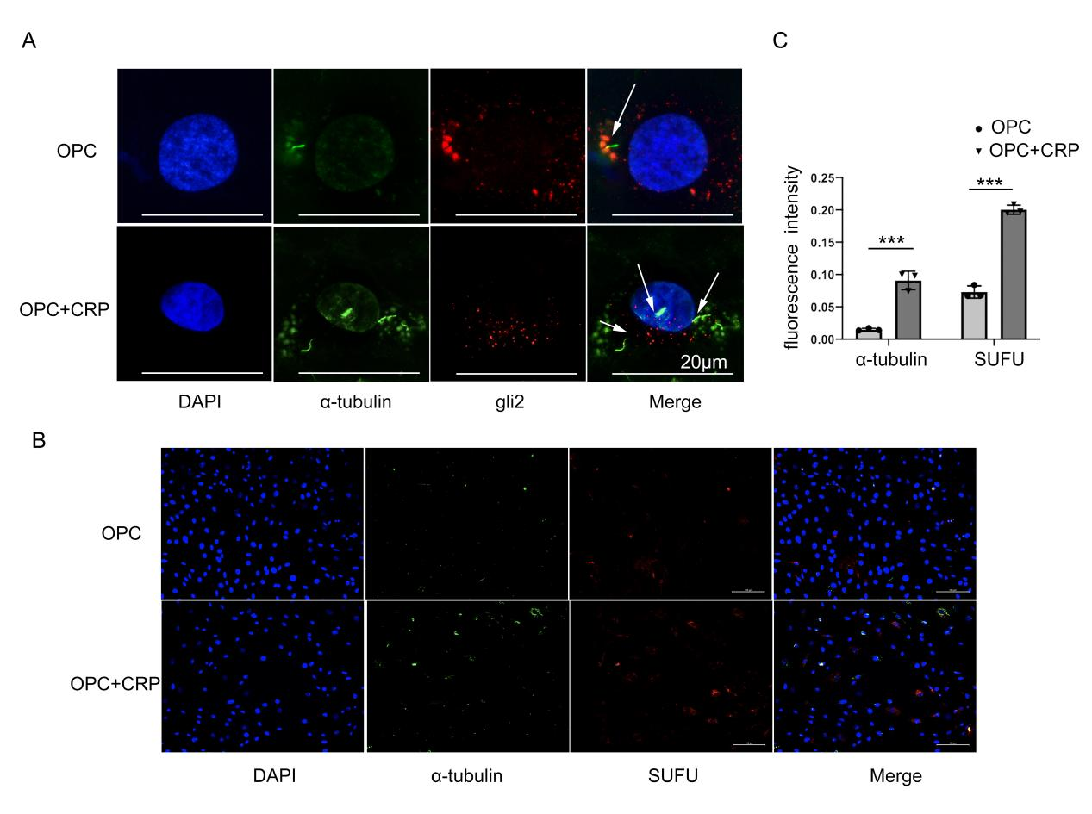
Supplemental Figure 2
