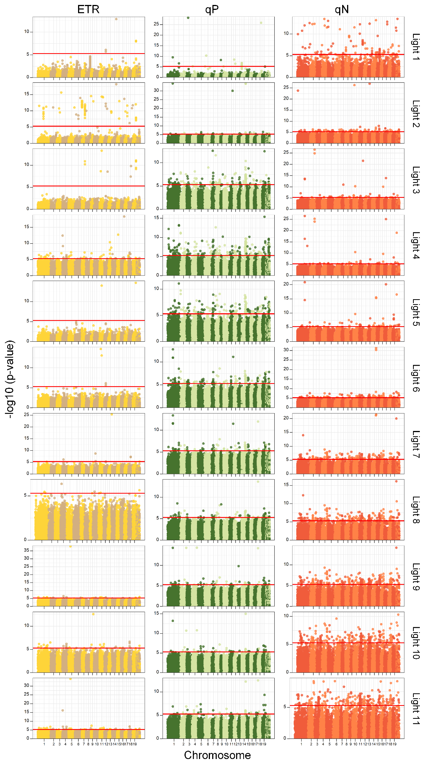
S Fig. 1. Manhattan plots of photosynthetic phenotypes (ETR, qP, and qN) under different light intensities based on static mapping. The red line is the threshold of significance level of 0.05.
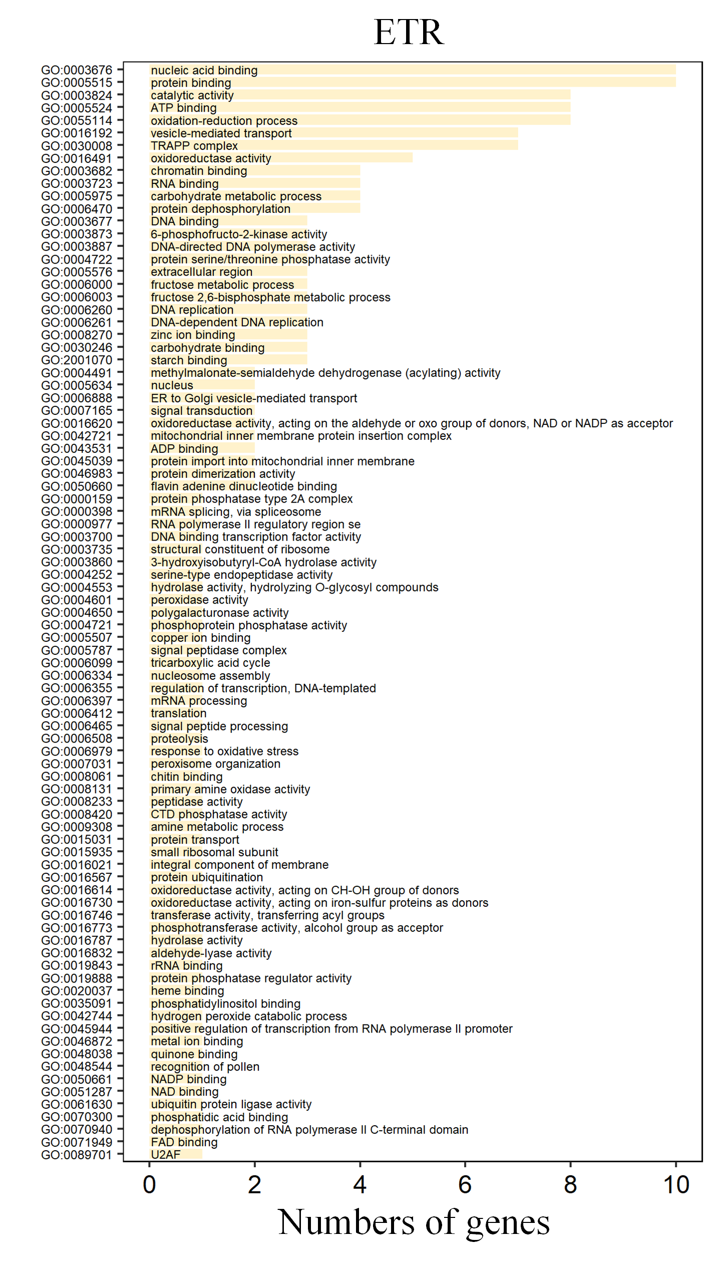
S Fig. 2. Gene function and number of candidate genes belonging to significant QTLs regulating ETR in Populus pilocarpa.

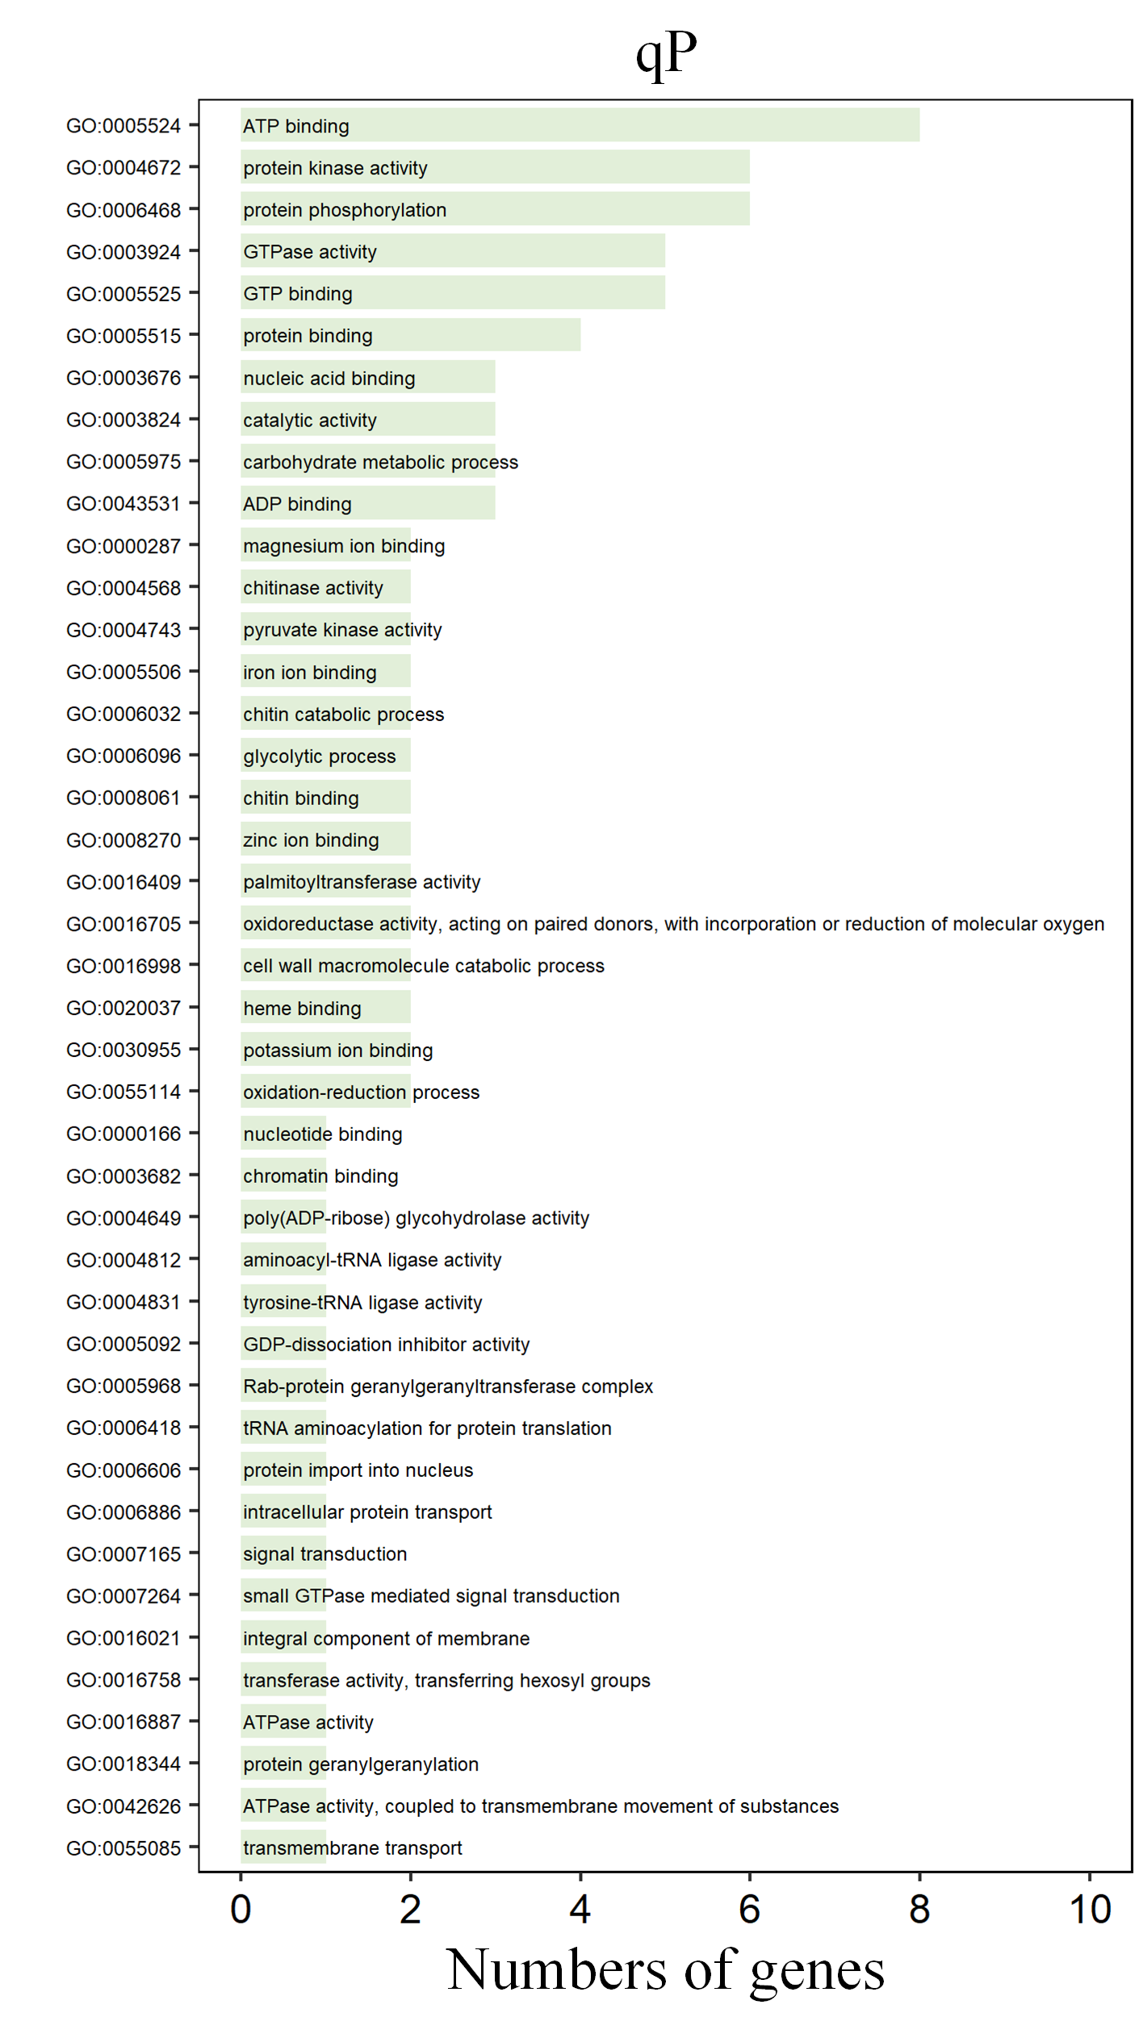
S Fig. 3. Gene function and number of candidate genes belonging to significant QTL regulating qP in Populus pilocarpa.

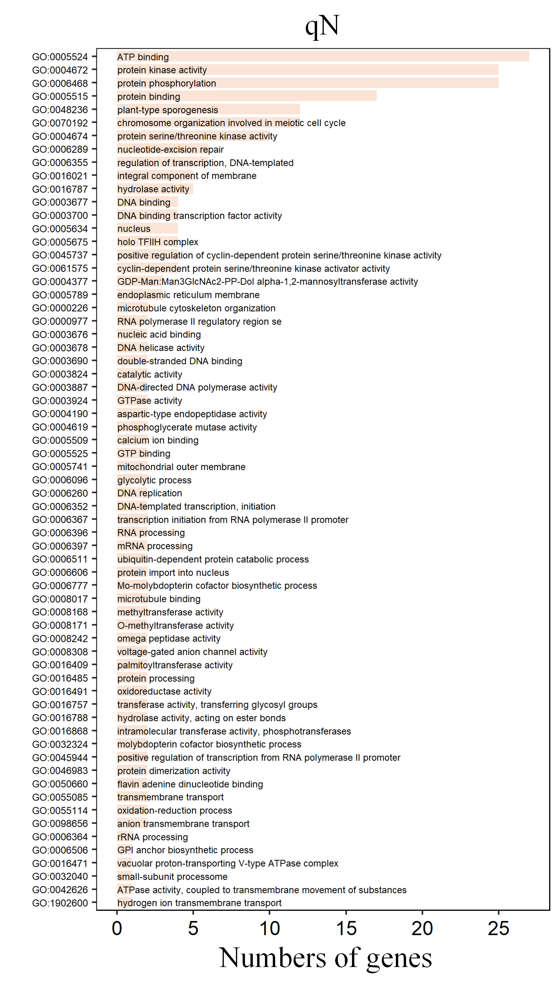
S Fig. 4. Gene function and number of candidate genes belonging to significant QTLs regulating qP in Populus pilocarpa.

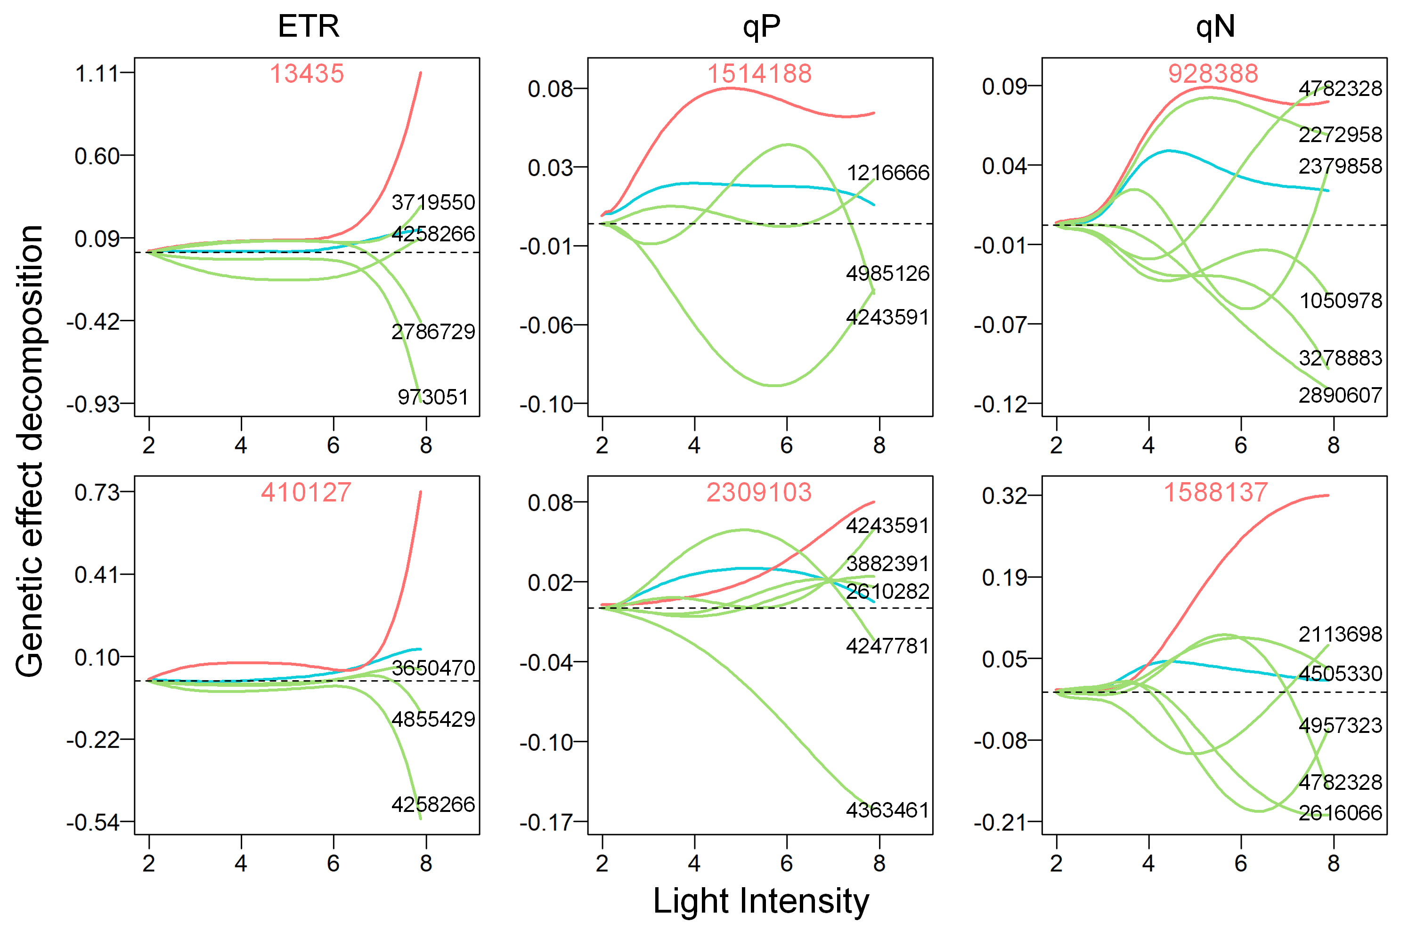
S Fig. 5. Genetic effect curves and decomposition of networks. Overall genetic effects (blue line) are decomposed into independent effects (red line) and dependent effects (green line) due to regulation by other SNPs.

