Supplementary Figure 1
Significantly altered DA values in point-wise of fiber tracts (FDR correction, p < 0.05). Abbreviation: HC, health control; aMCI, amnestic mild cognitive impairment; AD, Alzheimer’s Disease; DA, axial diffusivity.
Supplementary Figure 2 Significantly altered DR values in point-wise of fiber tracts (FDR correction, p < 0.05).

Supplementary Figure 3 The variable importance of disease diagnosis.

Supplementary Table 1
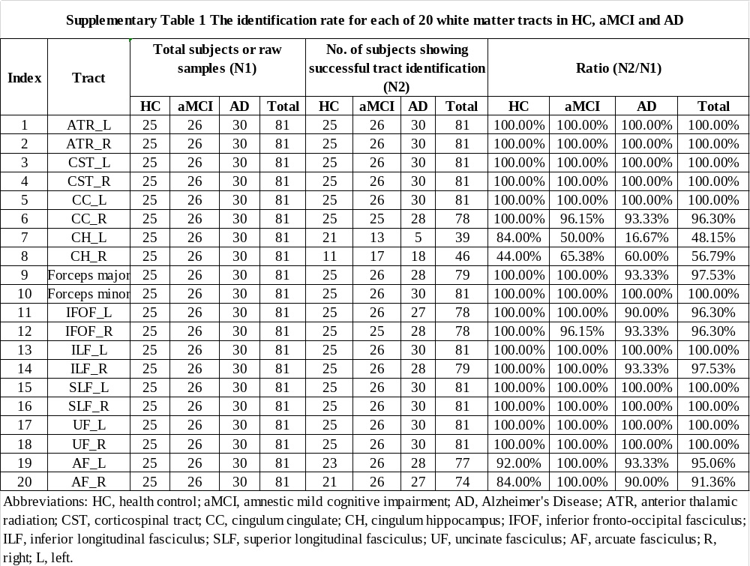

Supplementary Table 2
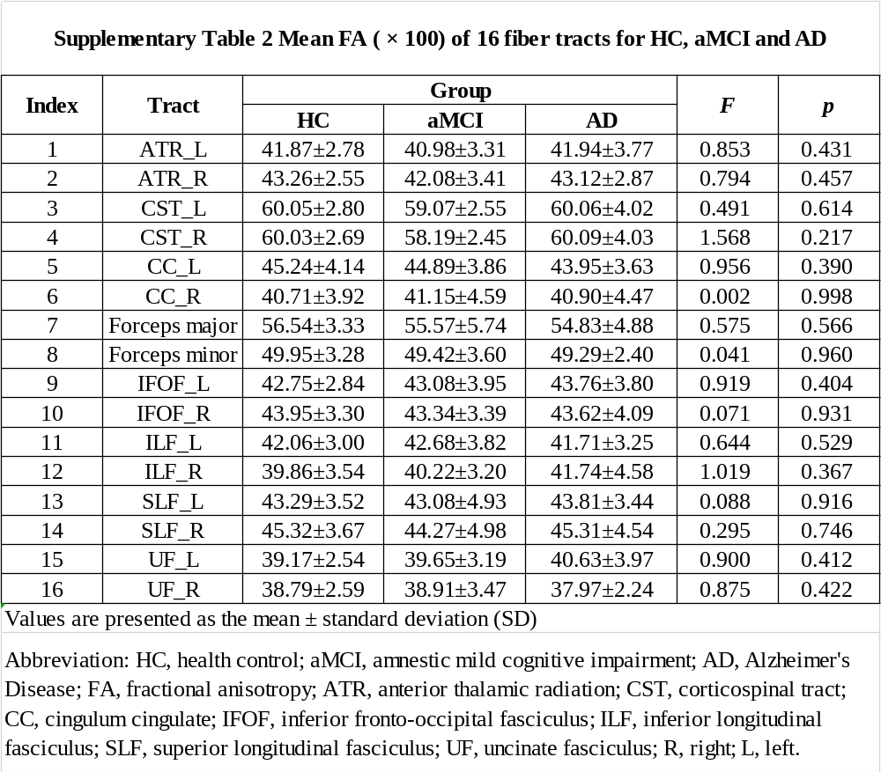

Supplementary Table 3
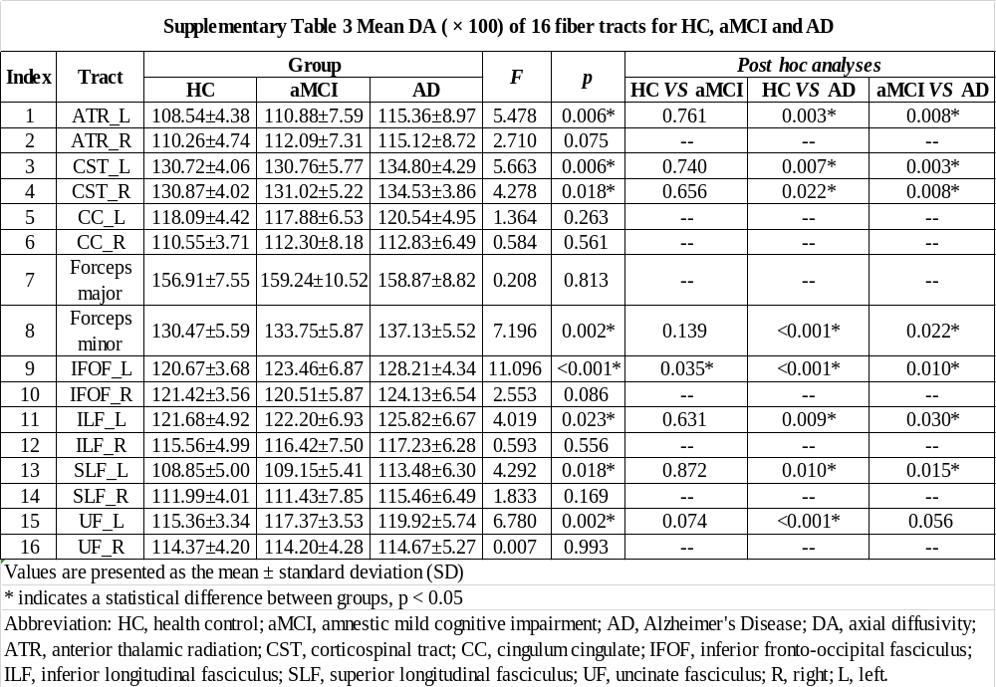

Supplementary Table 4
