Low-temperature giant coercivity in metallic Co_{6.2}Ga_{3.8-x}Ge_{x} (x=2.4 to 3.2) with chemically tunable spin frustration
Supplemental Information

Jiro Kitagawa^{1,*}, Himawari Nomura¹& Terukazu Nishizaki²
¹Department of Electrical Engineering, Faculty of Engineering, Fukuoka Institute of Technology, 3-30-1 Wajiro-higashi, Higashi-ku, Fukuoka 811-0295, Japan
²Department of Electrical Engineering, Faculty of Science and Engineering, Kyushu Sangyo University, 2-3-1 Matsukadai, Higashi-ku, Fukuoka 813-8503, Japan

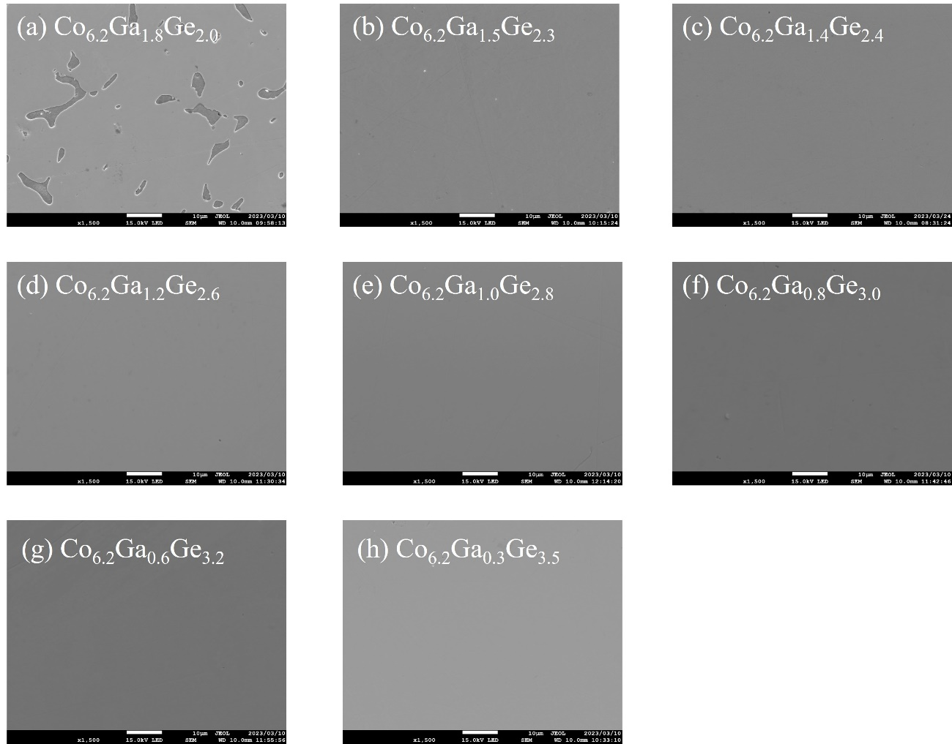
Figure S1: SEM images of (a) x=2.0, (b) x=2.3, (c) x=2.4, (d) x=2.6, (e) x=2.8, (f) x=3.0, (g) x=3.2, and (h) x=3.5 for Co_{6.2}Ga_{3.8-x}Ge_{x}, respectively. The chemical compositions determined by EDX are (a) main phase: Co_{60.0(5)}Ga_{19.2(3)}Ge_{20.8(4)} impurity phase: Co_{62.8(3)}Ga_{27.2(4)}Ge_{10.0(1)}, (b) Co_{60.4(6)}Ga₁₆₍₁₎Ge_{23.7(8)}, (c) Co_{60.7(3)}Ga_{14.6(5)}Ge_{24.8(5)}, (d) Co_{60.6(3)}Ga_{12.3(7)}Ge_{27.1(5)}, (e) Co_{60.9(6)}Ga_{10.4(7)}Ge_{28.7(1)}, (f) Co_{60.7(6)}Ga₈₍₁₎Ge_{30.9(6)}, (g) Co_{60.3(5)}Ga_{6.8(5)}Ge_{32.9(2)}, and (h) Co_{60.4(4)}Ga_{3.5(3)}Ge_{36.0(3)}, respectively.

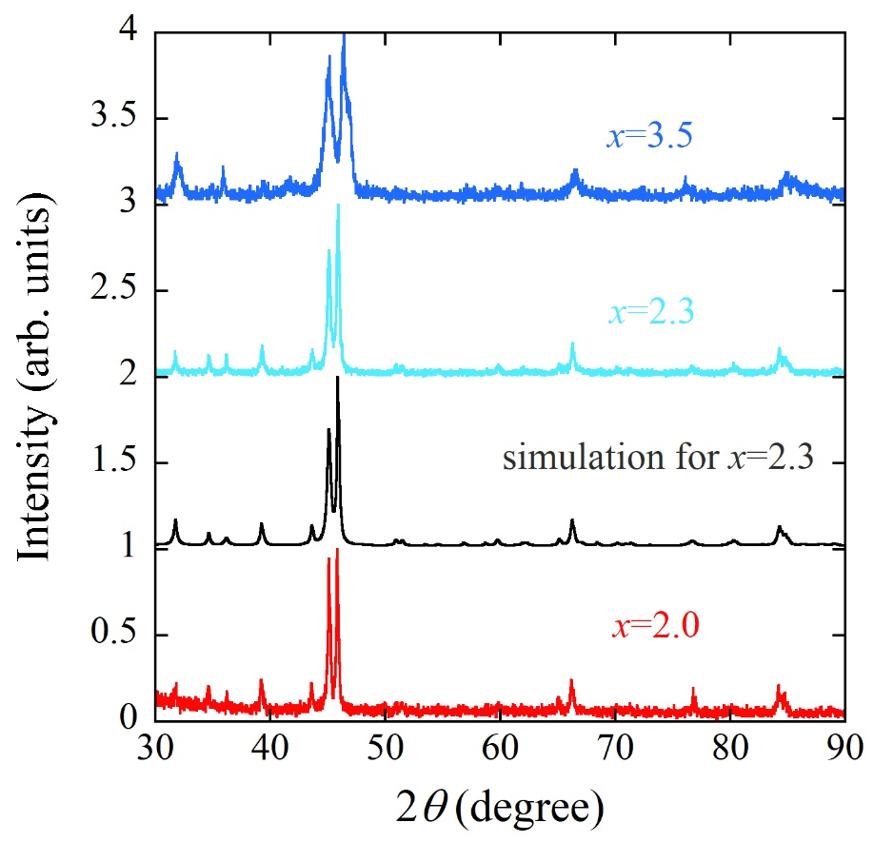
Figure S2: XRD patterns of x=2.0, x=2.3, and x=3.5 for Co_{6.2}Ga_{3.8-x}Ge_{x}. The simulation pattern for x=2.3 sample is also shown. Each origin is shifted by 1 for clarity.

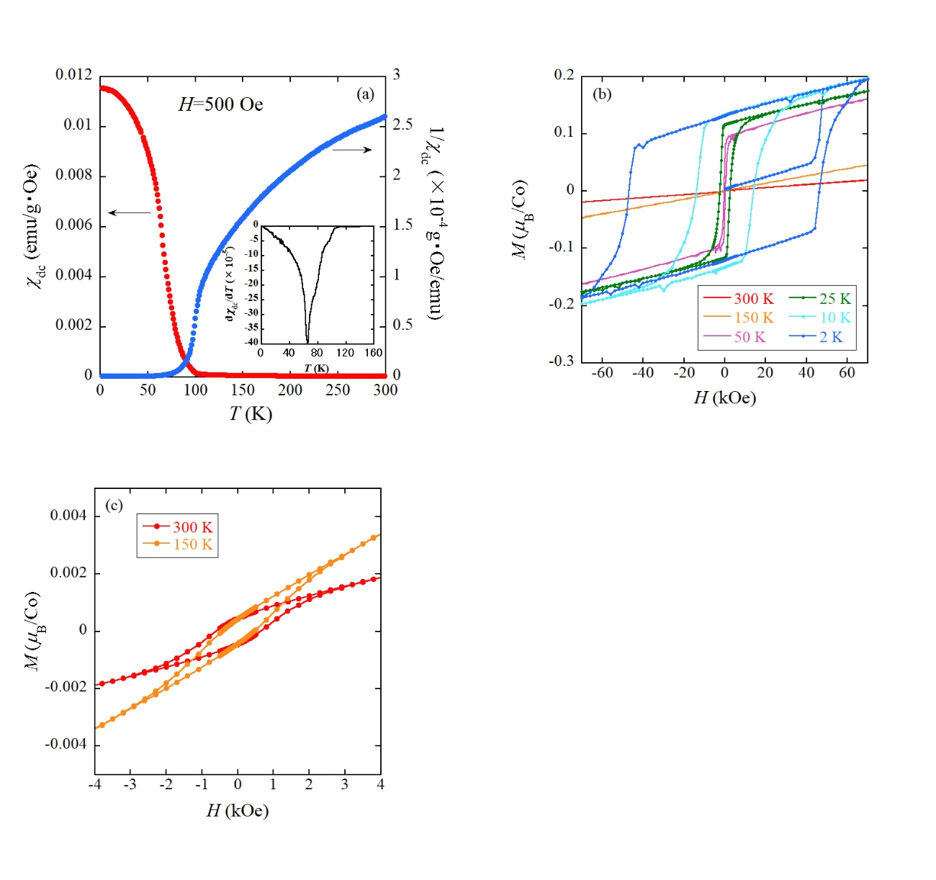
Figure S3: (a) Temperature dependences of χ_{dc} and 1/χ_{dc} of Co_{6.2}Ga_{1.5}Ge_{2.3}. The external field is 500 Oe. The inset is the temperature derivative of χ_{dc.} (b) Isothermal magnetization curves of Co_{6.2}Ga_{1.5}Ge_{2.3} measured at 2K, 10 K, 25 K, 50 K, 150 K, and 300 K. (c) Expanded view of isothermal magnetization curves of Co_{6.2}Ga_{1.5}Ge_{2.3} measured at 150 K and 300 K.

