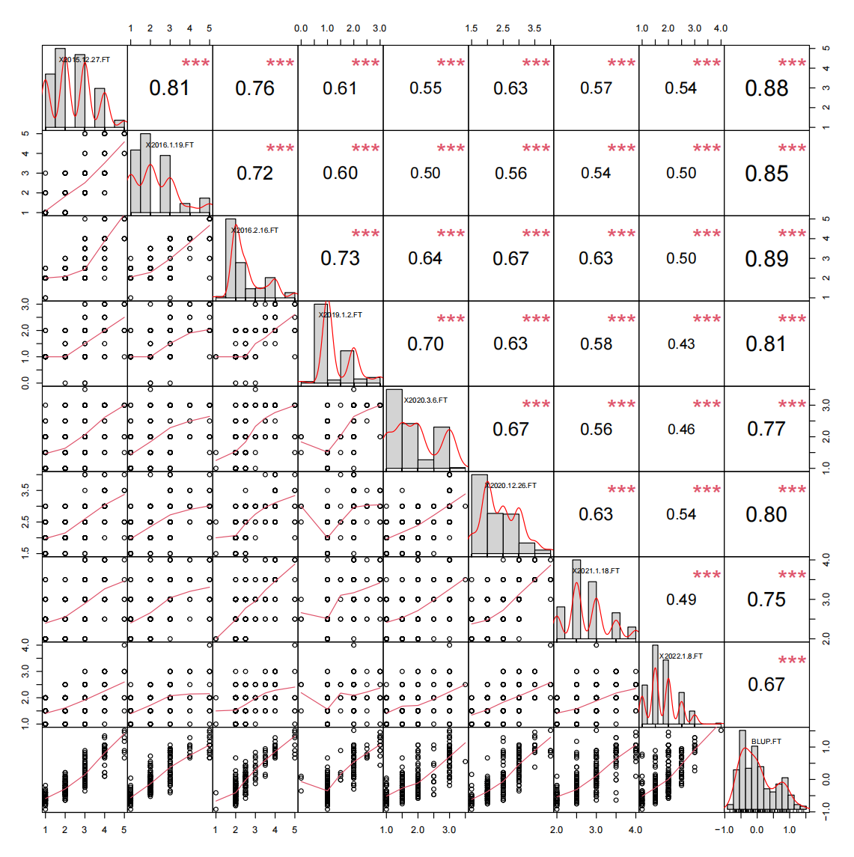
Figure S1. Distributions and correlations of freezing tolerance (FT) of 431 wheat varieties (lines) across different environments. The pair plot shows bivariate scatter plots below the diagonal, histograms on the diagonal, and Pearson correlations between given traits above the diagonal. (*, **, *** indicate significant differences at the P < 0.05, 0.01, 0.001 levels, respectively).
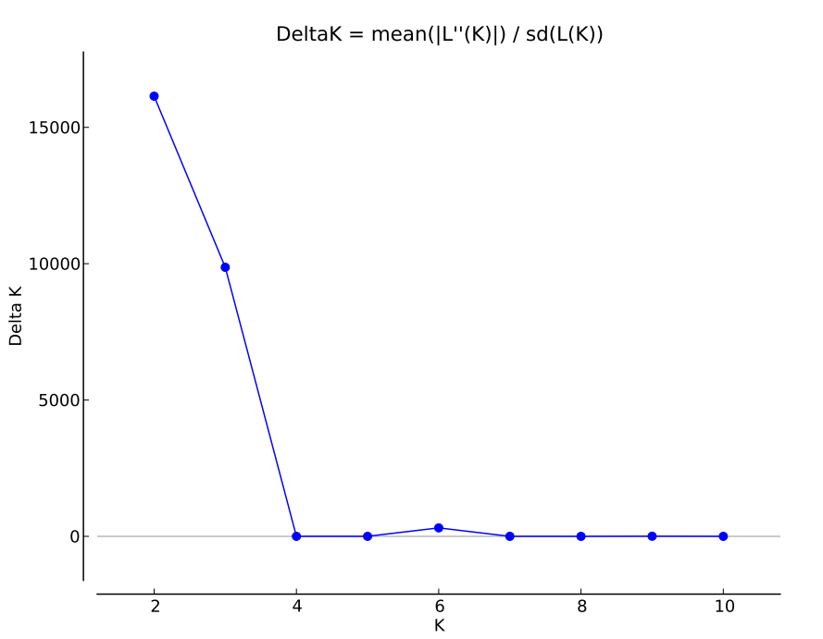
Figure S2. The Δk value used to determine the number of subgroups exceeded 6 iterations, and the presumed K ranged from 1 to 11.

Figure S3. Quantile-quantile (Q-Q) plots and Manhattan plots of freezing tolerance (FT) in 245 wheat varieties (lines) across environments. (a) 2015.12.27-Huaibei (2015.12.27-hb-FT), (b) 2016.1.19-Huaibei (2016.1.19-hb-FT), (c) 2016.2.16-Huaibei (2016.2.16-hb-FT), (d) 2019.1.12-Huaibei (2019.1.12-hb-FT), (e) 2020.3.6-Huaibei (2020.3.6-hb-FT), (f) 2021.1.18-Dezhou (2021.1.18-dz-FT), (g) 2021.1.23-Huaibei (2021.1.23-hb-FT), (h) 2022.1.12-Suzhou (2022.1.12-sz-FT), (i) the best linear unbiased predictions (BLUP-FT). The dashed line represents the significance threshold (-log₁₀P = 4). (j) Quantile-quantile (Q-Q) plot of FT for the 245 wheat varieties (lines) across different environments. The x-axis shows the -log10 transformed expected P-value, and the y-axis represents the -log10 transformed observed P-value.

