Supplementary Information

Oxidative photocatalysis on membranes triggers non-canonical pyroptosis

Chaiheon Lee, Mingyu Park, W.C. Bhashini Wijesinghe, Chae Gyu Lee, Eunhye Hwang, Gwangsu Yoon, Jeong Kyeong Lee, Deok-Ho Roh, Yoon Hee Kwon, Jihyeon Yang, Sebastian A. Hughes, James E. Vince, Jeong Kon Seo*, Duyoung Min*, and Tae-Hyuk Kwon*

*To whom correspondence should be addressed:
jkseo6998@unist.ac.kr (J. K. Seo), dymin@unist.ac.kr (D. Min), kwon90@unist.ac.kr (T-H. Kwon),
Contents

Supplementary Method 1. Synthesis
Supplementary Method 2. Photophysical and electrochemical properties
Supplementary Method 3. Reactive oxygen species (ROS) generation
Supplementary Method 4. Photocatalytic oxidation of biomolecules
Supplementary Method 5. Co-localisation imaging
Supplementary Method 6. Preparation for LC-MS/MS
Supplementary Method 7. Ca²⁺ and K⁺ mobilisation
Supplementary Method 8. Live-SIM imaging of mitochondrial morphology change
Supplementary Method 9. Imaging for cell death morphology change
Supplementary Method 10. Cell viability assay

Supplementary Fig. 1-8. ¹H NMR, ¹³C NMR, HRMS, and FT-IR spectra for compound 3 and BTP
Supplementary Fig. 9. Cell size and granularity for flowcytometry
Supplementary Fig. 10. Western blot for GSDMD^{-/-} iBMDM

Supplementary Method 1. Synthesis. All chemicals used in organic synthesis were purchased from Sigma Aldrich, Alfa Aesar, Tokyo Chemical Industry, Combi-Blocks, and SAMCHUN. In the synthetic process, the newly synthesised chemical compounds were analysed by ¹H, ¹³C NMR (Agilent 400MR-DD2 NMR spectroscopy), FT-IR (Varian Cary 620/670 FT-IR spectrometer) and HRMS (Bruker maXisTM HD Ultra-high-resolution Q-TOF LC-MS/MS system, The Cooperative Laboratory Center of Pukyong National University, Republic of Korea). The synthetic scheme of BTP was referred previously reported paper¹.

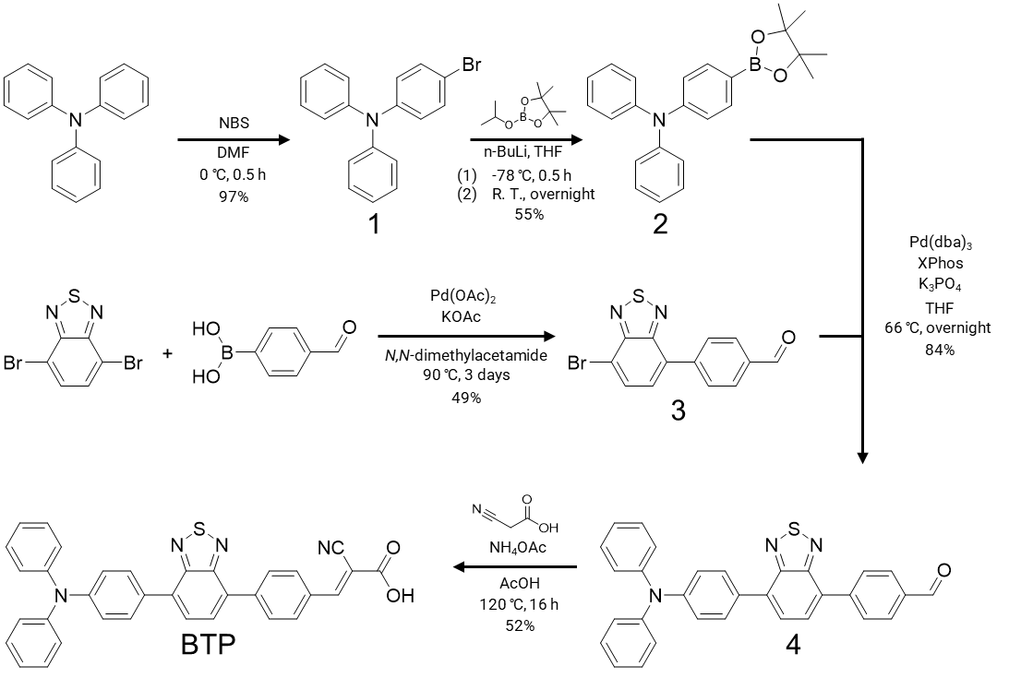
Scheme S1. Synthetic pathway of BTP

  - Synthesis of 4-bromo-N,N-diphenylaniline (1).
A round bottom flask was filled with triphenylamine (1.0 g, 4.1 mmol) and degassed anhydrous DMF. The solution was put in an ice bath and stirred for 30 minutes. After 30 minutes, N-bromosuccinimide was added to the reaction mixture and stirred for 4 hours. After 4 hours, water was added to quench the reaction, and to precipitate a white powder. The white powder was filtered and washed with water, then dried at 70 °C. Yield: 97% (1.3 g, 4.0 mmol). ¹H NMR (400 MHz, d⁶-DMSO): δ (ppm) = 7.42 (d, J = 8.88 Hz, 2H), 7.31 (m, 4H), 7.08 (tt, 7.4 Hz, 1.08 Hz, 2H), 7.02 (dd, 7.52 Hz, 1.12 Hz, 4H), 6.89 (d, J = 8.88 Hz, 2H). ¹³C NMR (100 MHz, d⁶-DMSO): δ (ppm) = 147.17, 132.61, 130.10, 125.04, 124.67, 124.13, 123.97 114.27.

1-2. Synthesis of N,N-diphenyl-4-(4,4,5,5-tetramethyl-1,3,2-dioxaborolan-2-yl)aniline (2).
A round bottom flask was charged with the 1 (2.5 g, 7.7 mmol) and anhydrous 100 mL THF (Ar bubbled), and the reaction mixture was cooled to -78 ºC. Then, the 2.5 M n-BuLi (5.24 mL, 13.11 mmol) was added dropwise over 5 minutes. 30 minutes after stirring, 2-Isopropoxy-4,4,5,5-tetramethyl-1,3,2-dioxaborolane (2.44 g, 13.11 mmol) was slowly added to the reaction mixture. Once the addition was complete, the reaction mixture was slowly warmed to room temperature and stirred overnight. Then, the reaction mixture was quenched by 100 mL water, and transferred to a separatory funnel with ethyl ether. The organic phase was collected and dried over MgSO₄. The product was further purified by column chromatography with hexane/ethyl acetate (EA) (10:1, v/v). Yield: 55% (1.6 g, 4.3 mmol). ¹H NMR (400 MHz, d⁶-DMSO): δ (ppm) = 7.54 (d, J = 8.56 Hz 1H), 7.32 (m, 4H), 7.09 (tt, J = 7.4 Hz, 1.04 Hz, 2H), 7.04 (dd, J = 7.48 Hz, 0.88 Hz, 4H), 6.89 (d, J = 8.56, 2H), 1.26 (s, 12H). ¹³C NMR (100 MHz, d⁶-DMSO): δ (ppm) = 150.59, 147.08, 136.21, 130.09, 125.35, 124.28, 121.08, 83.77, 25.08.

  - Synthesis of 4-(7-bromobenzo[c][1,2,5]thiadiazol-4-yl)benzaldehyde (3).
4,7-dibromobenzo[c][1,2,5]thiadiazole (500 mg, 1.70 mmol), (4-formylphenyl)boronic acid (170 mg, 1.13 mmol), Pd(OAc)₂ (8 mg, 0.034 mmol), and KOAc (167 mg, 1.70mmol) were prepared in a flame dried two-neck round bound flask. Degassed N,N-dimethylacetamide was injected into the flask. The reaction temperature was alleviated at 90 ℃ for 3 days after stirring the mixture for 30 minutes. The raw materials were gained by extraction with 250 mL CH₂Cl₂ and the organic solvent was entirely evaporated by a rotary evaporator. Column chromatography was performed to get only yellow solid products using hexane/CH₂Cl₂ (1:1, v/v) eluent. Yield: 49.4% (177 mg, 0.558 mmol).
¹H-NMR (400 MHz, CDCl₃) δ (ppm): 10.12 (s, 1H), 8.10 (d, J = 8 Hz, 2H), 8.06 (d, J = 8 Hz, 2H), 7.97 (d, J = 4 Hz, 1H, 7.67 (d, J = 8 Hz, 1H). ¹³C-NMR (400 MHz, CDCl3) δ (ppm): 191.78, 153.86, 142.40, 136.01, 132.44, 132.15, 129.98, 129.78, 128.94, 114.64. FTIR (neat, cm^{─1}): 3086, 2816, 2727, 1696, 1603, 1564, 1530, 1506, 1481, 1421, 1386, 1307, 1274, 1216, 1172, 1152, 1108, 1019, 934, 896, 862, 868, 839, 821, 785, 722, 678, 649, 618, 554, 518, 500, 465. HRMS (LC/Q-TOF) calc. for C₁₃H₇BrN₂OS= 317.9462. Found: m/z =317.9461 [(M+H)⁺]. Mass error = 0.55 ppm.

1-4. Synthesis of 4-(7-(4-(diphenylamino)phenyl)benzo[c][1,2,5]thiadiazol-4-yl)benzaldehyde (4).
A round bottom flask was filled with 2 (300 mg, 0.81 mmol), 3 (180 mg, 0.56 mmol), Tris(dibenzylideneacetone)dipalladium(0) (30 mg, 0.033 mmol), 2-Dicyclohexylphosphino-2′,4′,6′-triisopropylbiphenyl (30 mg, 0.066 mmol), potassium phosphate aqueous solution (2 M) (1.8 mL, 3.24 mmol), and degassed THF. The solution was refluxed at 66 ℃ overnight. When the reaction was finished, water was added to quench the reaction. The product was extracted with DCM, and the organic layer was dried over MgSO₄. The crude product was purified by column chromatography using hexane/DCM solution (2:1, v/v) as eluent. Yield: 84% (227 mg, 0.47 mmol). ¹H NMR (400 MHz, d⁶-DMSO): δ (ppm) = 10.11 (s, 1H), 8.26 (d, J = 8.0 Hz, 2H), 8.08 (d, J = 4.0 Hz, 2H), 8.07 (d, J = 4.0 Hz, 1H), 7.99 (d, J = 8.0 Hz, 2H), 7.96 (d, J = 4.0, 1H) 7.37 (m, 4H) 7.12 (m, 8H). ¹³C NMR (100 MHz, d⁶-DMSO): δ (ppm) = 193.22, 153.65, 148.13, 147.24, 143.03, 135.92, 133.32, 130.70, 130.54, 130.49, 130.14, 130.09, 129.84, 127.66, 125.04, 124.11, 122.52

1-5. Synthesis of (E)-2-cyano-3-(4-(7-(4-(diphenylamino)phenyl)benzo[c][1,2,5]thiadiazol-4-yl)phenyl) acrylic acid (BTP).
In a dried two neck round bottom flask, compound 4 (46 mg, 0.095 mmol), ammonium acetate (73 mg, 0.95 mmol) and cyanoacetic acid (162 mg, 1.90 mmol) were added under argon. Degassed acetic acid was used as a solvent, and then the mixture was refluxed at 120 ℃ for 16 hours. After cooling the solution to room temperature, raw materials were extracted by CH₂Cl₂ and washed with brine. MgSO₄ removed some moisture in the organic layer, and the solvent was evaporated by a rotary evaporator. The purification with the remaining crude product was performed by column chromatography using CH₂Cl₂/MeOH (9:1, v/v), resulting bright orange solid compound Yield = 51.9% (27 mg, 0.049 mmol). ¹H-NMR (400 MHz, CDCl₃) δ (ppm): ¹³C-NMR (400 MHz, CDCl₃) δ (ppm): 153.73, 153.68, 148.00, 147.24, 139.33, 133.37, 132.80, 130.81, 130.66, 130.60, 130.13, 129.95, 129.87, 129.21, 127.72, 125.00, 124.06, 122.55, 119.61. FTIR (neat, cm⁻¹): 3391, 2923, 2852, 2256, 2215, 2129, 1626, 1589, 1514, 1483, 1388, 1363, 1332, 1281, 1218, 1193, 1180, 1153, 1122, 1049, 1025, 1003, 888, 824, 788, 755, 731, 696, 679, 655, 621, 590, 554, 522, 510. HRMS (LC/Q-TOF) calc. for C₃₃H₂₃N₄S = 507.1638. Found: m/z = 507.1642 [(M−CO₂+H)⁺]. Mass error = −0.79 ppm.

Supplementary Method 2. Photophysical and electrochemical properties.

2-1. Absorption and photoluminescence spectroscopy.
The aqueous solutions of BTP (20 μM, H₂O:DMF = 99:1 v/v%) was prepared for measuring the absorbance and photoluminescence of BTP. The UV- visible spectrometer (SHIMADZU UV-2600 240V EN, Japan) and fluorescence spectrometer (ISS PC1 photon counting spectrofluorometer, USA) were utilised. The absorption and fluorescence spectra were normalised by maximum point of each spectrum in visible range. Then, we obtained the wavelength of the cross-point of absorbance and fluorescence to set E^{0/0} (525 nm, 2.36 eV).

2-2. Photoinduced electron transfer at steady state.
In the reductive quenching cycle, the excited BTP has proper potential to oxidise water. Thus, photoinduced electron transfer can occur between excited BTP and water molecules, reducing the fluorescence of BTP. To this end, the 20 μM BTP solution (in acetonitrile) was prepared to measure fluorescence change depending on the percentage of H₂O. The fluorescence of BTP was measured by increasing H₂O content from 0% to 12% at 2% interval.

2-3. Time-correlated single photon counting (TCSPC).
The lifetimes of time-resolved photoluminescence (PL) decays of BTP with different water concentration was measured by TCSPC (FluoTime300, PicoQuant). The sample (20 μM BTP) was dissolved in each different ratio of acetonitrile and water (%H₂O = 0, 5, and 10). Photoexcitation of samples was operated through 450 nm ps pulse and a continuous wave diode laser head (LDH-D-C-450) with a PDL 820 laser drive. The photoluminescence from the BTP was detected by TCSPC module (PicoHarp 300E, PicoQuant) with a photomultiplier tube (PMA-C 182-N-M, PicoQuant). The decay signals and the instrument response function were fitted using fitting software (FluoFit, PicoQuant), resulting in the PL lifetime.

Supplementary Method 3. Reactive oxygen species (ROS) generation.

3-1. Singlet oxygen assay (9,10-anthracenediyl-bi(methylene)dimalonic acid, ABDA).
The singlet oxygen (¹O₂) generation was measured by a ¹O₂ indicator, 9,10-anthracenediyl-bi(methylene)dimalonic acid (ABDA) (Sigma Aldrich, USA). 100 mM stock solution of ABDA was added to each 5 µM methylene blue (MB) and BTP to 1:1000 volume ratio (20:1 molar ratio). These solutions were irradiated by LED (λ = 630 nm for MB, λ = 450 nm for BTP) for 0, 0.1, 0.2, 0.3, and 0.4 J/cm², and the ABDA absorbance at 380 nm was measured by microplate reader. The ABDA absorbance decay of each sample was recorded as Abs_{ABDA, 380nm} − Abs_{sample, 380nm} to correct baseline.

3-2. Intracellular ROS assay (2′,7′-Dichloro-dihydrofluorescein diacetate, H₂DCF-DA)
The DCFH₂-DA is well known ROS indicator in cell environment. For intracellular ROS assay, HeLa cells were grown on the cell culture dish for 24 hours (See Supplementary method 5). The HeLa cells (ATCC, USA) were incubated in the 5 μM BTP-containing culture media (media:DMF = 200:1, v/v) for 2 hours and then treated with the 20 μM H₂DCF-DA in serum-free media for 40 min. After PBS washing, the HeLa cells were irradiated by the blue LED light (λ_{max} = 450 nm, 5 J/cm²), then the cells were imaged with Carl Zeiss LSM980 laser-scanning confocal microscopy (Jena, Germany). The 488 nm-laser and 20X objective lens are used to detect DCF. The Emission gain was (500-530 nm) to remove fluorescence of BTP. Three negative controls (BTP+/light-, BTP-/light+, and BTP-/light-) was involved in this experiment, and the cells were imaged with Carl Zeiss LSM980 in the CO₂ incubator at 37 °C under humidified atmosphere and 5% CO₂. Further, the DCF fluorescence of randomly selected 20 individual cells before and after BTP photoactivation was described as dot plot.

3-3. Superoxide radical assay (Dihydroethidium, DHE)
The DHE is a selective superoxide radical indicator, enhancing its fluorescence by intracellular superoxide radicals. The DHE molecules are oxidised by the superoxide radical, then form longer conjugation system. The oxidised form of DHE is intercalate DNA or RNA of cells (nuclear and mitochondrial DNA), emitting strong fluorescence. Thus, HeLa cells were grown on the cell culture dish for the DHE assay, and the cells were treated to 10 μM BTP-containing media for 2 hours. After washing with PBS several times, the cells were further incubated in the 5 μM DHE-containing media in serum-free media. Then, the HeLa cells were irradiated by the blue LED light (λ_{max} = 450 nm, 10 J/cm²), and imaged with confocal microscopy (Carl Zeiss LSM980). The BTP+/light- condition was also involved in this experiment as negative control, and the cells were imaged with Carl Zeiss LSM980 in the CO₂ incubator at 37 °C under humidified atmosphere and 5% CO₂.

Supplementary Method 4. Photocatalytic oxidation of biomolecules

4-1. Photocatalytic amino acid oxidation in oxidative quenching cycle.
For fabrication of the working electrode (BTP@TiO₂/FTO), a fluorine-doped tin oxide (FTO, Nippon Sheet Glass Co., Ltd) substrate was cleaned-up with ultrasonication using acetone, ethanol, and D.I. water sequentially for 10 min each. Mesoporous TiO₂ layer was prepared by screen-printing a TiO₂ paste (30NR-D, Greatcell Solar Materials Pty. Ltd.) on the FTO with a printing area of 1.0 × 0.7 cm². The TiO₂-printed substrate was gradually heated at 150 °C for 10 min, at 325 °C for 5 min, at 327 °C for 5 min, at 450 °C for 15 min, and at 500 °C for 30 min. The TiO₂/FTO was immersed in 0.2 mM solution of BTP in chloroform/ethanol (7:3; v/v) for 18 h at room temperature, under dark condition. After the soaking process, the substrate was washed by acetonitrile to remove unadsorbed BTP molecules, giving the BTP-adsorbed working electrode (BTP@TiO₂/FTO). Chronoamperometry measurements were carried out using Vertex Potentiostat/Galvanostat (IVIUM technologies, Eindhoven, Netherlands) equipped with a standard three-electrode system, consisting of the BTP@TiO₂/FTO as the working electrode, a Pt wire as the counter electrode, and an Ag/AgCl (saturated KCl solution) as the reference electrode. To observe photocatalytic redox reaction of BTP with amino acids, 13 types of electrolytes containing each amino acid (L-tryptophane, L-alanine, arginine·HCl, tyrosine, serine, glutamine, histidine, phenylalanine, proline, lysine·HCl, glutamic acid, methionine, and cysteine) were prepared (0.05 mmol of amino acid in 20 mL degassed 1X PBS). In a glass chamber, all the electrodes connected to the instrument were positioned as shown in the figure below, in which especially the FTO side of the working electrode should face the light source. With an applied potential of 0.0 V vs. NHE (-0.197 V vs. Ag/AgCl), the light on/off chronoamperometry measurements were recorded for each amino acid electrolyte (10 s light-on and 10 s light-off, 450 nm blue LED). The corresponding photocurrent generation under the light-on indicates the amount and rate of amino acid oxidation by the photoexcited BTP molecules.
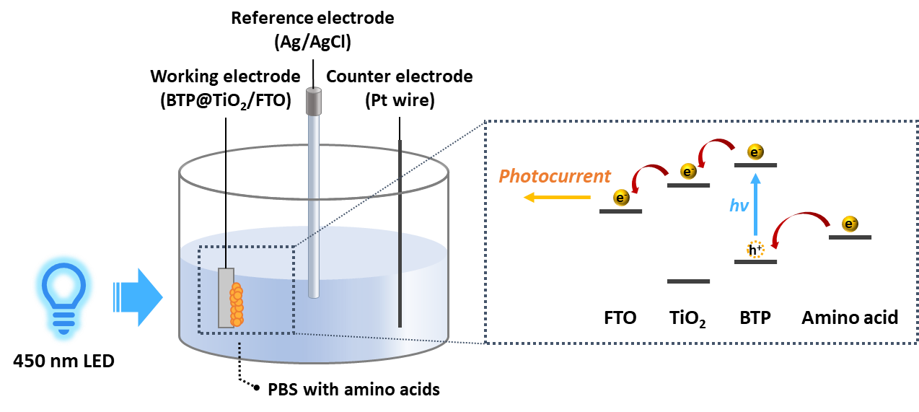

4-2. HRMS for methionine oxidation product.
Methionine is known to be easily oxidised by ROS such as singlet oxygen, superoxide radical, and hydroxyl radical. Thus, methionine oxidation by the BTP photoactivation was confirmed by the high-resolution mass spectroscopy (HRMS) (maxis HD, Bruker). The experimental solution (0.1 mM BTP and 1 mM methionine in PBS:DMF = 99:1, v/v) was prepared to oxidise methionine. The solution was irradiated by the blue LED light (λ_{max} = 450 nm, 16.6 mW/cm² for 2 hours). Then, all solvent was evaporated, and dried by Ar gas to obtain powder sample. The sample was stored at 4 ºC under light-shielding condition before injection to the HRMS. The dried sample was eluted with H₂O, the m/z value was measured by the electrospray ionisation (ESI) in the positive mode. The capillary voltage was 4500 V; charging voltage was 2000 V; dry gas temperature was 200 ºC; and mass range was 50-1000 m/z. The peak with m/z = 166.0532 were assigned as the oxidised methionine (calculated m/z value of [O-Met + H]⁺ is 166.0532). This oxidised methionine peak was not found from the negative control experiment (BTP+/hv-).

4-3. UPLC-HRMS for phosphatidylcholine oxidation product.
The phosphatidylcholine (PC) oxidation by BTP photoactivation were confirmed by UPLC-HRMS analysis. To prepare experimental solution, PC and BTP were dissolved to H₂O:DMF = 8:2 (v/v) solute (0.1 mM BTP and 1 mM PC). Then, the solution was irradiated by the blue LED light (λ_{max} = 450 nm, 16.6 mW/cm² for 2 hours). Then, all solvent was removed under vacuum to obtain sample powder. This sample was stored at 4 ºC under light-shielding condition. Right before injection, the sample was dissolved to methanol to inject ultra-high performance liquid chromatography (UPLC) system (ACQUITY I CLASS, WATERS/Q-TOF). A WATERS BEH C8 column (2.1 X 100, 1.7 μm) was used, and detailed UPLC conditions referred to reported study². After UPLC system, the sample was injected to the HRMS (maxis HD, Bruker), the m/z value was measured by the electrospray ionisation (ESI) in the positive mode. The capillary voltage was 4500 V; charging voltage was 2000 V; dry gas temperature was 200 ºC; and mass range was 50-1000 m/z. The m/z values were assigned as following: 560.5848 = [PC+H]⁺ and 792.5750 = [PC-peroxide+H]⁺.

4-4. Intracellular lipid peroxidation assay.
Lipid peroxidation was confirmed in the cell environment. BODIPYTM 581/591 C11 (Invitrogen, USA) was utilised as lipid peroxide sensor. HeLa cells were grown up on cell culture plates, and treated with BTP (5 μM in media:DMF = 200:1, v/v) for 2 hours. Then, cells were incubated in media containing BODIPYTM 581/591 C11 (2 μM in media:DMF = 500:1, v/v) for 30 min. The cells were imaged with Carl Zeiss LSM980 in the CO₂ incubator at 37 °C under humidified atmosphere and 5% CO₂. Before obtaining fluorescence signal of BODIPYTM 581/591 C11, the cells were pre-irradiated by 450 nm blue laser of LSM980 for 10 min. The BODIPYTM 581/591 C11 was excited by the 488 nm laser, and the fluorescence signal was detected in 500-530 nm emission gain. In images, the pre-irradiated region was marked with a white circle, indicating region where the BTP photoactivation occurs. Further, the fluorescence of randomly selected 20 individual cells in- and out of the white circle was described as dot plot.

Supplementary Method 5. Co-localisation imaging.
To identify subcellular localisation of BTP, the confocal laser scanning microscopy (CLSM) was utilised. One or two days prior to the experiment, HeLa cells were seeded on coverglass-bottom confocal dish. HeLa cells were transfected by Sec61b-mGFP construct and Turbofect® transfection reagent (Thermo Fisher, USA) to stain endoplasmic reticulum (ER) and by Cell Light™ Golgi RFP BacMam2.0 (Thermo Fisher, USA) to stain Golgi apparatus. One day after transfection, the cells were incubated with BTP (5 μM in media:DMF = 200:1, v/v) for 2 hours. Then, the co-localisation images were obtained in the CO₂ incubator at 37 °C under humidified atmosphere and 5% CO₂ by Carl Zeiss LSM980 with 63X lens. (Sec61b-mGFP: λ_{excitation} = 488 nm, emission gain range: 500-530 nm; Cell Light™ Golgi RFP BacMam2.0: λ_{excitation} = 561 nm, emission gain range: 534-630 nm; BTP: λ_{excitation} = 445 nm, emission gain range: 550-620 nm). For co-localisation imaging with mitochondria, the grown HeLa cells were incubated with BTP (5 μM in media:DMF = 200:1, v/v) for 2 hours. After the incubation with BTP, the cells were stained by the 500 nM MitoTrackerTM Deep Red FM (Invitrogen, M22426). Then, the cells were imaged with Carl Zeiss LSM980 in the CO₂ incubator. (MitoTrackerTM Deep Red FM: λ_{excitation} = 647 nm, emission gain range: 650-700 nm; BTP: λ_{excitation} = 445 nm, emission gain range: 550-620 nm). To monitor the location change of BTP by photoactivatton, the HeLa cells stained by BTP and MitoTrackerTM Deep Red FM were irradiated by the 445 nm confocal laser (4%) for 5 min. Further, the time-series CLSM monitored the change in localisation of BTP for 644.4s (50 frames). To support the location change, live structured illumination microscopy (Live-SIM) was used (Carl Zeiss ELYRA S. 1, Germany). For Live-SIM, HeLa cells were incubated with BTP (10 μM in media:DMF = 100:1, v/v) for 2 hours, and then further incubated in culture media containing MitoTrackerTM Deep Red FM. In the CO₂ incubator, 488 nm laser and 642 nm laser with 63X lens were used to excite BTP and MitoTrackerTM Deep Red FM, respectively. To calculate single Live-SIM images, 5 slices of parallel images was used (109.55 nm interval for the z-axis). BTP was photoactivated by the 488 laser (5%) of ELYRA S. 1, then location change of BTP was imaged by Live-SIM in the same method.

Supplementary Method 6. Preparation for LC-MS/MS.
6-1. Preparation of tryptic peptides for LC-MS/MS.
For LC-MS/MS proteomics, samples were prepared from four groups for comparison. (1) hv- / BTP-: The cells were cultured with neither light nor BTP treatment. (2) hv- / BTP+: The cells were treated with the desired volume of BTP but in the absence of light. (3) hv+ / BTP-: Cells were exposed to 450 nm LED (λ_{max} = 450 nm, 10 J·cm⁻²) without BTP treatment. (4) hv+ / BTP+: The cells were incubated with BTP and exposed to 450 nm LED (λ_{max} = 450 nm, 10 J·cm⁻²). HeLa cells were grown in a 100 mm cell culture dish with DMEM supplemented with FBS and antibiotics at 37℃ in a humified atmosphere containing 5% CO₂ environment. For hv+ conditions, the cells were irradiated with 450 nm LED light (5 min, 5 J·cm⁻²). For BTP+ conditions, the cultured cells were incubated with 4 µM BTP for 2 h, and the culture medium was exchanged with fresh DMEM before light irradiation. The cells were washed with DPBS and collected using a cell scraper. After a short centrifugation, the cell pellet was lysed using RIPA buffer:protease cocktail inhibitor solution (=99:1) (4℃, 20 min). Cell debris were eliminated from the lysate by centrifugation (16,000 g, 10 min, and 4℃). On-filter digestion was performed to analyse the whole protein using an S-trapTM mini spin column (PROTIFI, CO2-mini-40). The protein loading quantity was controlled to carry 100 μg of protein for each sample based on the BCA assay. Low protein binding microtubes (Eppendorf, Hamburg, Germany) and LC-MS grade solvents were used for all the following procedures. The protein suspension (100 μg in 25 µL) was diluted by adding the same amount of 2× SDS protein solubilization buffer (10% SDS, 100 mM triethylammonium bicarbonate, pH 7-8 adjusted with phosphoric acid), followed by three repetitions of 10 s of sonication and 10 s of break cycle. The solution was centrifuged at 13,000×g for 10 min, and the supernatant was transferred to a new microtube. Reduction and alkylation were performed to prevent the self-crosslinking of cysteine. A total of 12 μL of reduction solution (100 mM dithiothreitol in water) was added to the microtube and heated for 10 min at 95℃. After cooling for 5 min at RT, 8 μL of 330 mM iodoacetamide was added and incubated for 30 min in the dark. The supernatant was then collected after 13,000×g of centrifugation for 10 min, followed by sequential addition of 7 μL of 12% phosphoric acid and 479 μL of S-trap binding buffer (90% aqueous methanol containing a final concentration of 100 mM triethylammonium bicarbonate, pH 7.1). The solution was transferred to an S-trap mini spin column and centrifuged at 4000×g for 30 s. The unbound flow-through was labelled UB. Using the rotator, the S-trap unit was screwed (3 min, 180°), followed by a washing step with 400 μL of S-trap binding buffer and centrifugation at 4000×g for 30 s. The washing step was repeated three times. The flow-through was labelled as W, and the column unit was transferred to a new microtube. UB and W were maintained at -78℃ in the case of undesired leakage. To digest 100 μg of protein, 5 μg of LC-MS grade trypsin (Promega, #V5280) dissolved in 125 μL of digestion buffer (50 mM Tris) was added to the column. The bottom ejection hole of the column was sealed with parafilm and incubated overnight at 37℃. After the overnight reaction, parafilm was removed, and the column was moved to a new microtube for the following elution step: 1) centrifugation at 1000×g for 1 min after adding 80 μL of digestion buffer, 2) centrifugation at 1000×g for 1 min after adding 80 μL of 0.2% formic acid, and 3) centrifugation at 4000×g for 1 min after adding 80 μL of 50% acetonitrile/0.2% formic acid solution. The total flow-through was collected and dried using a speed-vac yielding peptide powder. The pH fractionation followed to improve the number of identified proteins.

6-2. High-pH reversed-phase chromatography for peptide fractionation.
A Pierce High pH Reversed-Phase Peptide Fractionation Kit (Thermo Scientific, #84868) was used for the chromatography. The spin column was conditioned prior to the elution step. For conditioning, the column was placed in a low-binding microtube and centrifuged at 5000×g for 2 min after removing the bottom cap to remove the flow-through. The top screw cap was then opened, and the column was filled with 300 μL of acetonitrile. After closing the cap, centrifugation (3000 × g) was performed for 1 min, and the flow-through was removed. Then, 300 μL of 0.1% trifluoroacetic acid (TFA) solution was added to the column, followed by centrifugation (3000×g) for 1 min to remove the flow-through. The wash step with 0.1% TFA was repeated. After conditioning the pH fractionation column, the previously prepared peptide powder was dissolved in 300 μL of 0.1% TFA solution and centrifuged in the conditioned column for 1 min at 3000 × g; the flow-through was labelled as FT. The same process was performed for 300 μL of water in a new microtube, which was labelled W. FT and W were maintained at -78℃ in the case of undesired leakage. Further elution steps were performed using different acetonitrile/0.1% triethylamine solutions ranging from 5% to 50% acetonitrile (v/v). Each eluted sample was collected after centrifugation at 3000×g for 1 min in a new tube. A total of eight fractionated samples were dried using a speed-vac to obtain the peptide powder.
Supplementary Method 7. Ca²⁺ and K⁺ mobilisation.

7-1. Time series imaging of mitochondrial Ca²⁺ uptake.
HeLa cells were seeded on the imaging dishes one day prior to the experiment. The cells were incubated in the culture media containing BTP (5 μM in media:DMF = 200:1, v/v) for 2 hours, and loaded with the 500 nM of MitoTrackerTM Deep Red FM and the 3 μM of the mitochondrial Ca²⁺ indicator, Rhod-2 (Invitrogen R1244, USA). Then the Ca²⁺ mobilisation was measured by the time-series confocal microscopy with Carl Zeiss LSM980 in the CO₂ incubator at 37 °C under humidified atmosphere and 5% CO₂. The Rhod-2 was excited by the 561 nm laser, and BTP was excited by the 445 nm laser (0.3 mW). BTP was photo-activated by the 445 nm confocal laser for 60 seconds, during the irradiation, the fluorescence signals of MitoTracker and Rhod-2 were imaged at 10 seconds intervals by 63X lens. To confirm the Ca²⁺ mobilisation depending on irradiation time, the line-cut fluorescence profile was obtained from the co-localisation images at t = 0, 30, and 60 s.

7-2. Flow cytometry for Ca²⁺ and K⁺ mobilisation
HeLa cells of 7–80% confluence in 6-well plate were treated with BTP (10 μM) for 2 h and further incubated with Rhod-2 AM (3 μM) and Ion K+ green-2 (40 μM) for an hour. Then, the cells were irradiated with blue LED (450 nm, 10 J∙cm²). 2 hours after irradiation, the cells were detached using cell scrapper and the fluorescence of cell suspension was detected using flow cytometry (CytoFLEX S, Beckman, USA). We chose cells with positive FSC and positive SSC, and discarded cells with extremely low signal of FSC and SSC. The boundaries of FSC and SSC were 2 × 10⁶ and 1.5 × 10⁶, respectively (Supplementary Fig. 9). The fluorescence of both Rhod-2 and Ion K+ green-2 dyes were analyzed at λ_{ex}=561 nm and λ_{em}=610 nm. The FACS data was processed by CytExpert software (ver. 2.4.0.28).

Supplementary Method 8. Live-SIM imaging of mitochondrial morphology change.
Mitochondrial matrix swelling and morphological change by BTP photoactivation were imaged with the Live-SIM (Carl Zeiss ELYRA S. 1, Germany). Prior to the experiment, HeLa cells were transfected with sec61b-mCherry construct and Turbofect® transfection reagent (Thermo Fisher, USA) for staining endoplasmic reticulum (ER). The cells were incubated with BTP containing culture media (10 μM in media:DMF = 100:1, v/v), and further treated with 500 nM MitoTrackerTM Deep Red FM for 30 minutes. Then, the cells were irradiated (10 mW) by 488 nm laser of ELYRA S. 1 (Carl Zeiss, Germany) and imaged with 63X lens. The 488 (10%), 561 (10%), and 647 nm (1%) laser of ELYRA S. 1 were used to excite BTP, sec61b-mCherry, and MitoTrackerTM Deep Red, respectively. During imaging, the cells were in the CO₂ incubator at 37 °C under humidified atmosphere and 5% CO_{2.} To calculate single Live-SIM images, 5 slices of parallel images was used.

Supplementary Method 9. Imaging for cell death morphology change.
Pyroptotic morphology change of HeLa cells was imaged with Carl Zeiss LSM780 using 63X objective lens. HeLa cells were grown on confocal dishes one day prior to the experiment. The cells were incubated with BTP (5 μM in media:DMF = 100:1, v/v) for 2 hours, and washed several times with PBS. Then the cells were imaged with LSM780 at 37 °C under humidified atmosphere and 5% CO₂. The blue light from 445 nm laser of LSM780 was exposed to the cells to activate BTP, and morphology of the cells before and after BTP photoactivation were imaged respectively. To investigate cell death modality, the morphological change of dying cells treated with Liproxstatin-1 (Sigma Aldrich SML1414, USA) and z-VAD-fmk (Promega G7231, USA) were imaged. The HeLa cells were seeded on the four confocal dishes. One day after seeding, the cells were incubated with a total of four conditions, w/ and w/o Liproxstatin-1 (10 µM) and z-VAD-fmk (4 µM), for 16 hours. Then, the cells were further treated to BTP (8 μM) for 2 hours and propidium iodide (1.5 μM) (Invitrogen P3566, USA) for 30 minutes. After all incubation, the cells were exposed to LED light (λ_{max} = 450 nm, 3 J∙cm⁻²) imaged with 20X lens of LSM780 at 37 °C under humidified atmosphere and 5% CO₂. The Propidium iodide were excited by 561 nm laser. Further, the morphology changes of WT and GSDMD^{-/-} iBMDM by BTP photocatalysis were imaged. The WT and GSDMD^{-/-} iBMDM were grown on the confocal dishes, then incubated with BTP (8 μM) for 2 hours. After incubation, the media was changed, and the cells were exposed to LED light (λ_{max} = 450 nm, 10 J∙cm⁻²). 2 hours after the irradiation, the cells were imaged with 20X lens of LSM780 at 37 °C under humidified atmosphere and 5% CO₂.

Supplementary Method 10. Cell viability assay.

10-1. Live or Dead assay
HeLa cells were grown on the confocal imaging dish one day prior to the experiment. The cells were treated with BTP (10 μM) for 2 hours, then the cells were irradiated by the blue LED (λ_{max} = 450 nm, 3.7 J∙cm⁻²). One day after irradiation, the cells were incubated with 2.5 μM of Calcein AM (Invitrogen, USA) and 1.5 μM propidium iodide (Invitrogen, USA) for 30 minutes. The LSM980 confocal microscopy (Carl Zeiss, Germany) with 20X lens obtained the signals of calcein AM and propidium iodide. The Calcein AM signal were measured by 488 laser and 490-530 nm emission gain to remove green fluorescence of BTP. The experiment was repeated on the negative controls (without BTP and/or light exposure).

10-2. MTT assay
HeLa cells (1.5×10⁵ cells∙mL⁻¹) were seeded into the 96 well plate and incubated for overnight at 37 °C in the humidified CO₂ incubator. The cells were treated with BTP (0, 2, 4, 8, 16, and 32 μM, 1% DMF) for additional 2 h and washed with phenol red-free DMEM (containing 10% fetal bovine serum, 50 units/mL penicillin, and 50 μg/mL streptomycin), followed by photoirradiation (5 J∙cm², 450 nm LED). The cells further incubated for 24 h. Subsequently, 3-(4,5-dimethylthiazol-2-yl)-2,5-diphenyltetrazolium bromide (MTT, 25 μL, 5 mg/mL in PBS) was treated for 3 h and the culture media were replaced with DMSO and shaked for 2 h. The absorbance of Formazan was detected using microplate reader (λ_{abs} = 570 nm, SpectraMax M5e). For pancreatic cancer cells, PANC-1 and Mia paca-2 (2×10⁴ cells/well) were seeded on 96-well plate in hypoxic or normoxic conditions. After overnight allowed to adhere, the cells were treated 0 to 32 μM BTP for 2 h. Changed to culture media, cells were exposed to 450 nm irradiation(5 J∙cm⁻²) and further incubated for 24 h. MTT reagent (MTT-CAS 298-93-1–Calbiochem, Sigma-Aldrich, Cat.No. 475989, USA) was added to 25 μL each well (Final concentration 1mg∙ml⁻¹), and the plates were incubated at 37℃ for 4 h. Following incubation, dissolution of the resulting formazan in 100 μL of DMSO. Then, absorbance was recorded at 570 nm using Infinite MPlex plate reader (Tecan, Mannedorf, Switzerland). Before seeding, cells were cultured under hypoxic (1% O₂, 5% CO₂, and 37℃) and normoxic condition(20% O₂, 5% CO₂, and 37℃) at least cells were cultured two times on those conditions.

Supplementary Figures

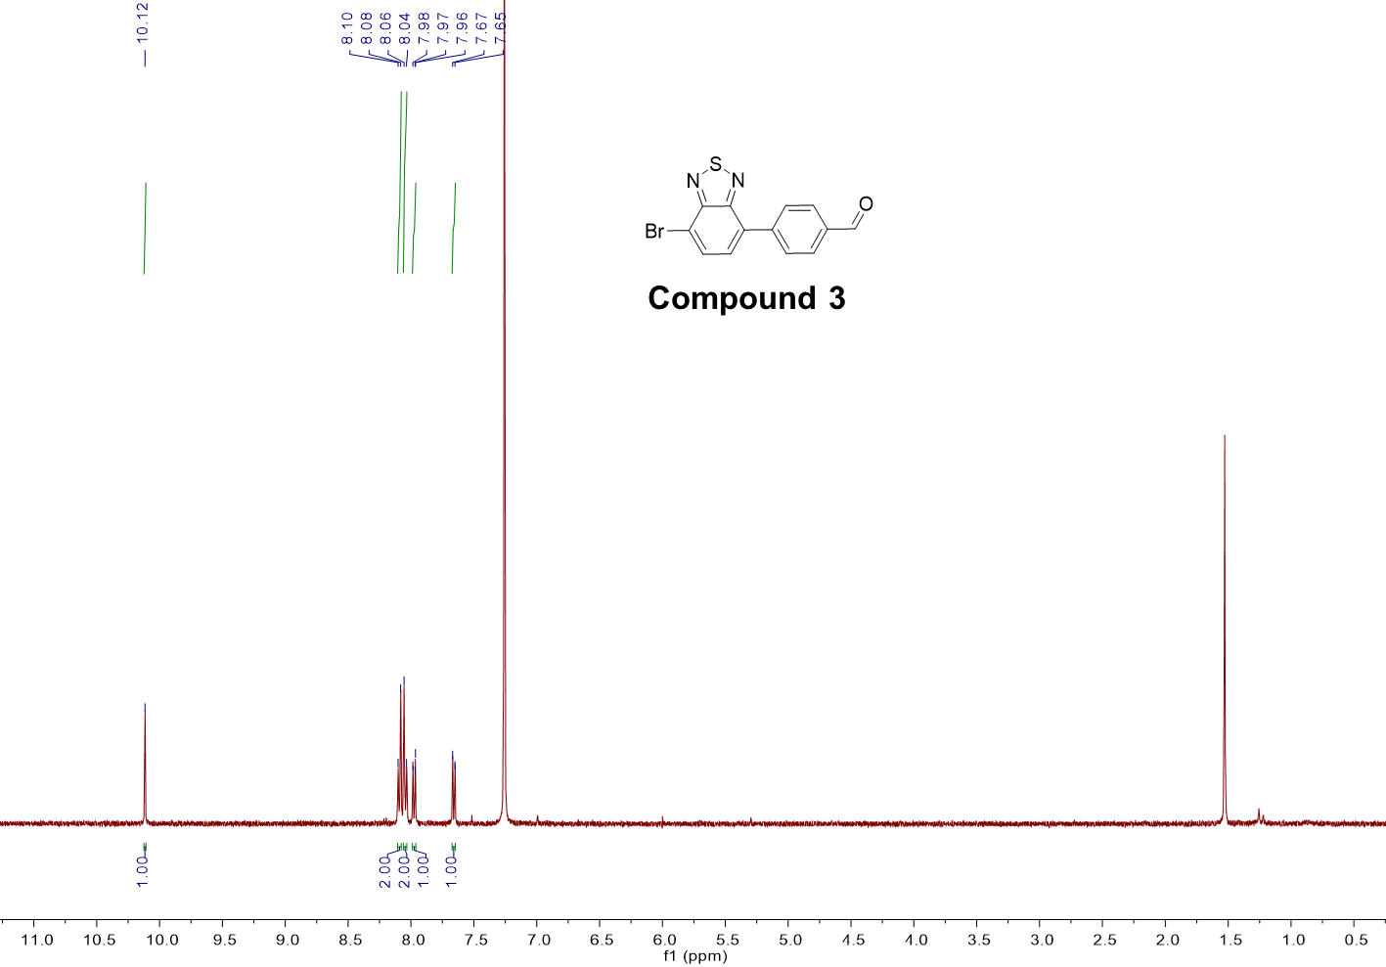
Supplementary Fig. 1. ¹H-NMR of compound 3 (CDCl₃, 400 MHz, 298 K)

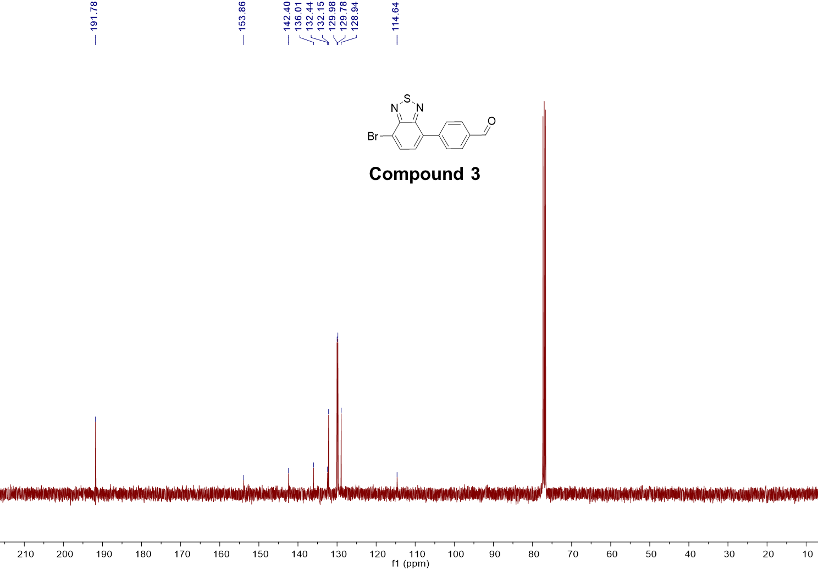
Supplementary Fig. 2. ¹³C-NMR of compound 3 (CDCl₃, 400 MHz, 298 K)

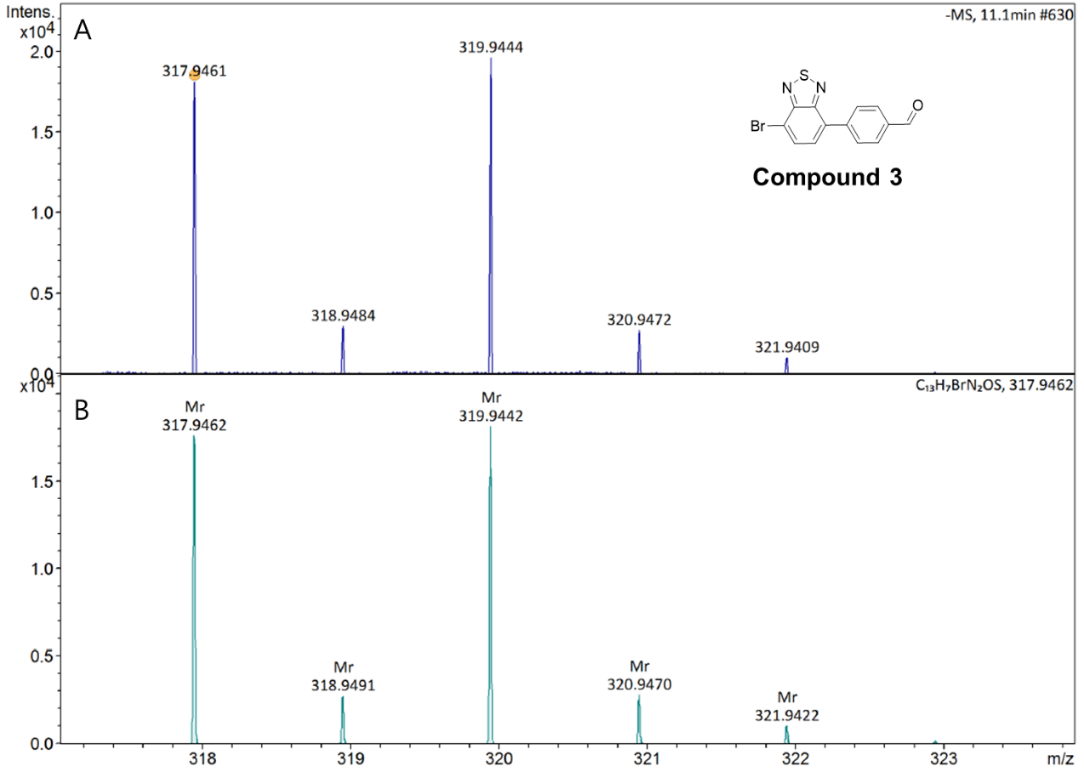
Supplementary Fig. 3. (A) Experimental (B) simulated HRMS spectra of compound 3.

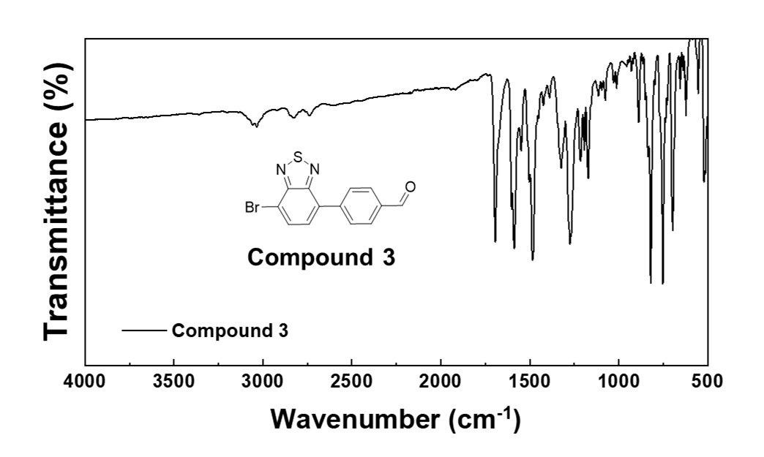
Supplementary Fig. 4. FT-IR of compound 3

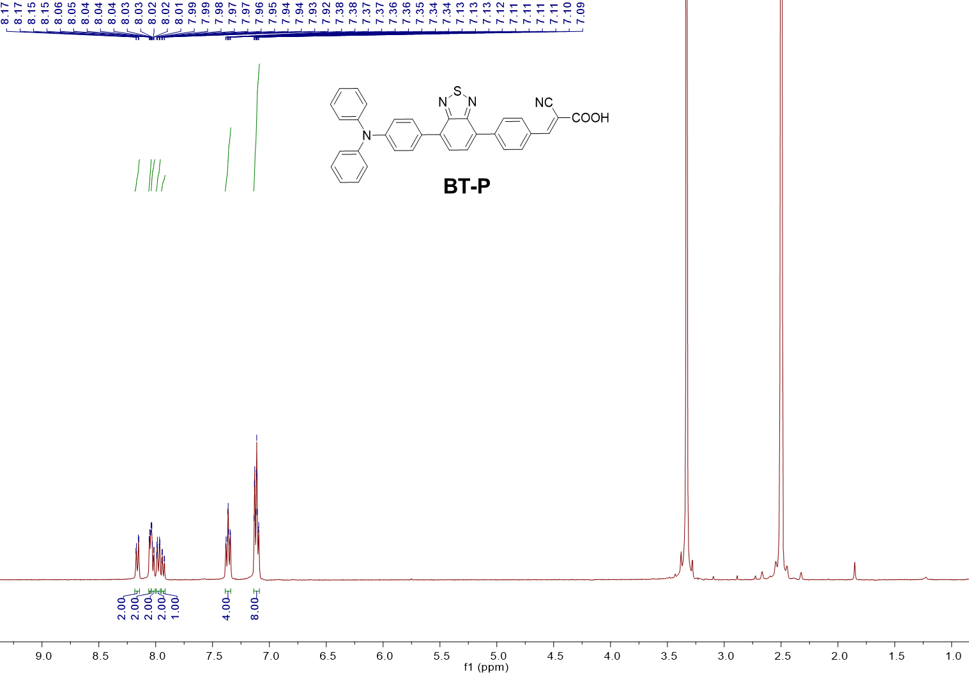
Supplementary Fig. 5. ¹H-NMR of compound BTP (CDCl₃:DMSO = 1:1, 400 MHz, 298 K)

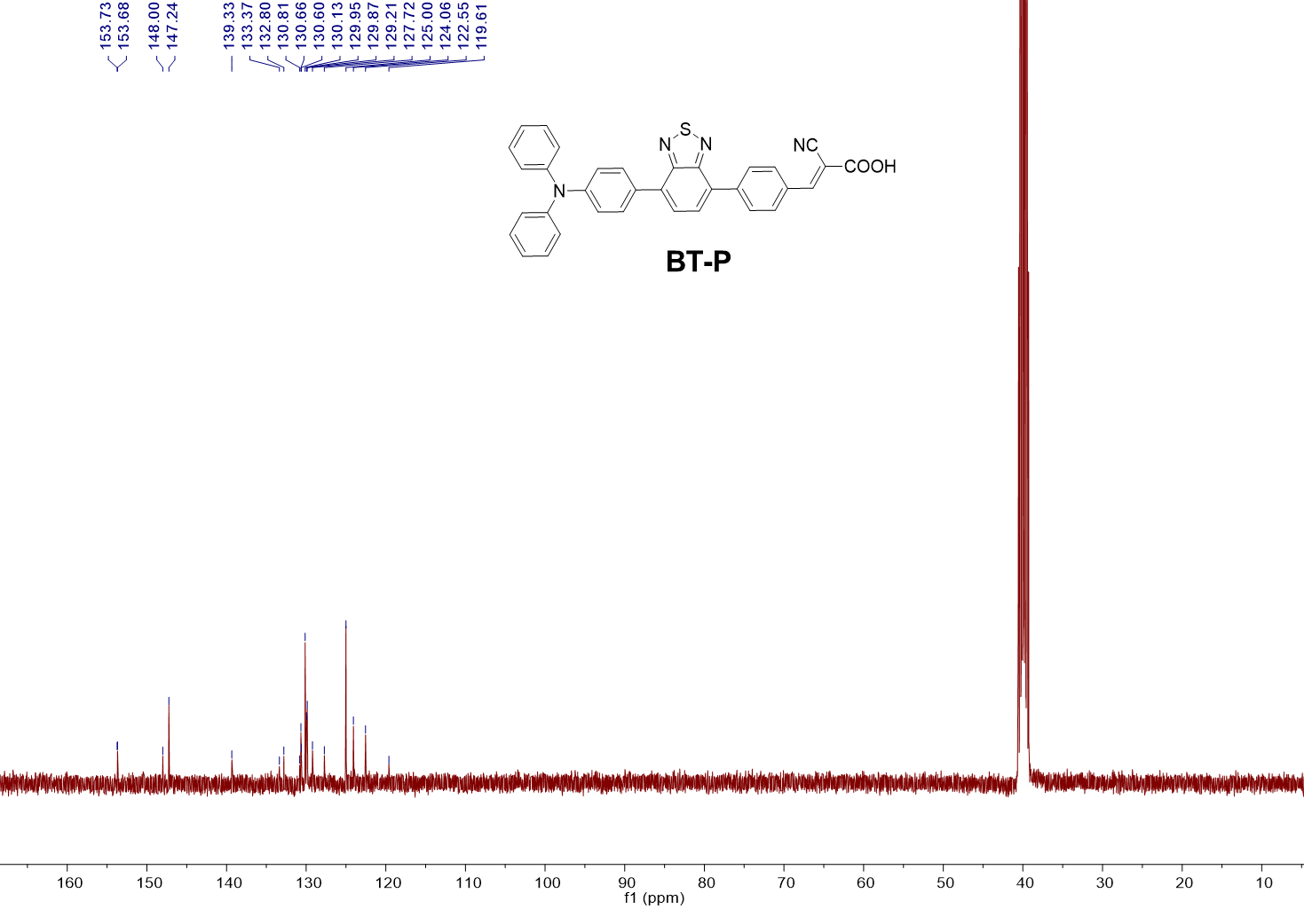
Supplementary Fig. 6. ¹³C-NMR of compound BTP (CDCl₃:DMSO = 1:1, 400 MHz, 298 K)

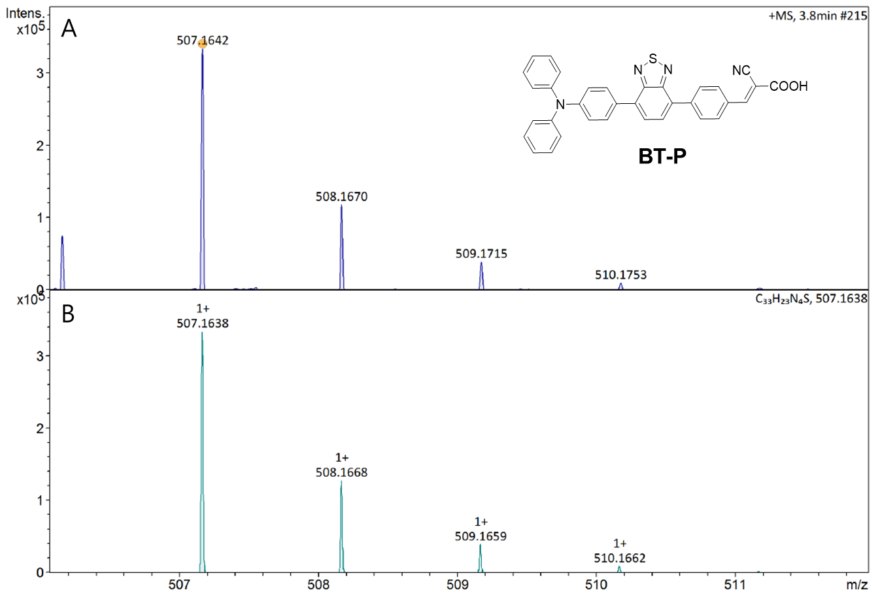
Supplementary Fig. 7. (A) Experimental (B) simulated HRMS spectra of BTP.

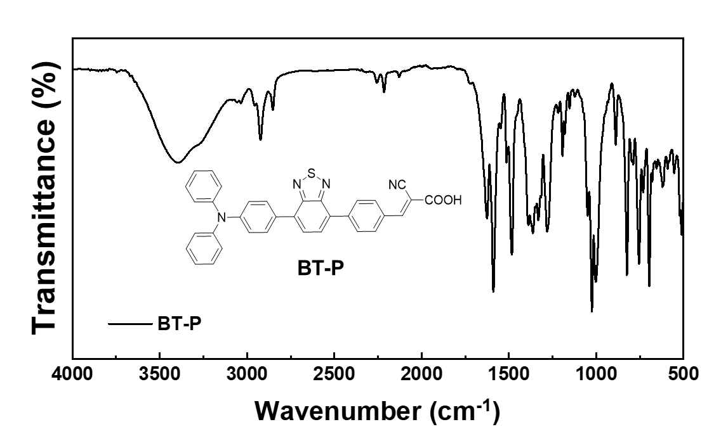
Supplementary Fig. 8. FT-IR of compound BTP

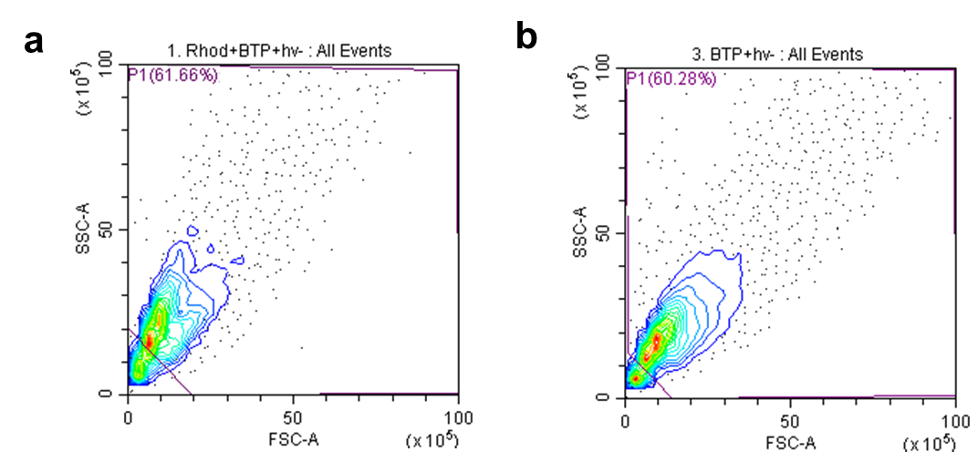
Supplementary Fig. 9. Cell size (forward scattering area, FSC-A) and granularity (side scatter area, SSC-A) were used to filter the cell debris for Rhod-2 assay (a) and Ion K+ green-2 assay (b).

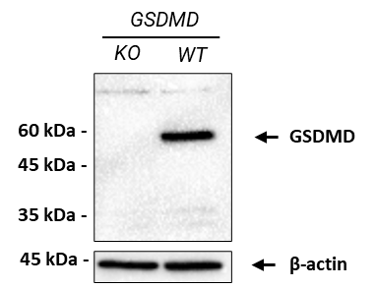
Supplementary Fig. 10. GSDMD expression level of GSDMD knocked-out (left) or wild-type (right) iBMDM was assessed by immunoblot.

Supplementary References
1 Roh, D. H. et al. Strategy for Improved Photoconversion Efficiency in Thin Photoelectrode Films by Controlling pi-Spacer Dihedral Angle. J Phys Chem C 120, 24655-24666 (2016).
2 Wang, C. G., Siriwardane, D. A., Jiang, W. L. & Mudalige, T. Quantitative analysis of cholesterol oxidation products and desmosterol in parenteral liposomal pharmaceutical formulations. Int J Pharmaceut 569 (2019).

