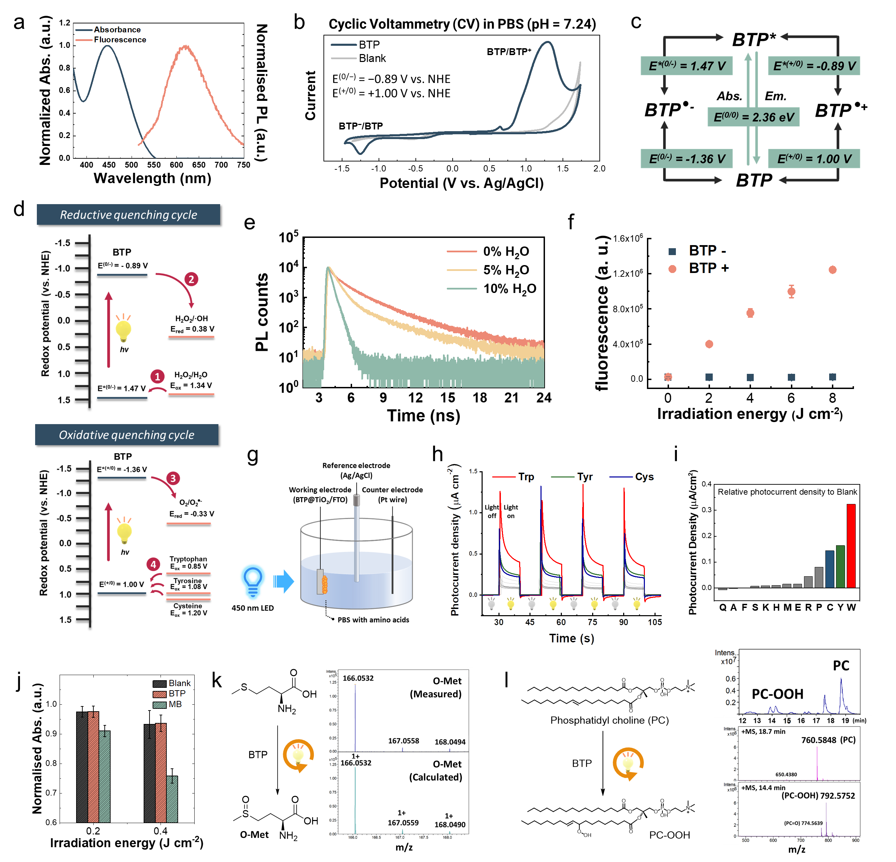
Extended Data Fig. 1 | Photophysical properties of BTP and photocatalytic oxidation reactions. a, Absorption and fluorescence spectra of the aqueous BTP solution. b, Cyclic voltammetry curves of BTP and blank at a scan rate of 10 mV/s in a three-electrode system. c, Ground and excited redox potential of BTP. d, Proposed scheme of electron transfer for reductive and oxidative quenching cycles. e, Time-correlated single-photon counting (TCSPC) spectra of BTP in acetonitrile containing various amounts of H₂O (0, 5, and 10% H₂O). f, ∙OH generation assay using HPF. The results indicated a change in ∙OH generation with irradiation energy (blue LED, λ_{max} = 450 nm, 16.6 mW·cm⁻²) (n = 3). g, A three-electrode system for measuring the photocurrent by photocatalytic amino acid oxidation. (See supplementary information) h, Transient photocurrent responses depending on amino acids. Light exposure was turned on and off every 10 s and repeated. i. Relative photocurrent for each amino acid. j. ¹O₂ generation assay using ABDA. The absorbance of ABDA (λ = 400 nm) was normalised to that observed under non-irradiated condition, and the decrease in the absorbance represents ¹O₂ generation. Methylene blue was used as a positive control. (n = 3) k, Methionine oxidation by BTP photocatalysis. Oxidised methionine (O-Met) was detected by HRMS. l, Phosphatidylcholine (PC) oxidation by BTP photocatalysis. UPLC-HRMS was used to detect peroxidised form of PC. In the UPLC chromatogram, the x-axis corresponds to elution time. For k-l, [BTP] = 100 μM, [Met] = [PC] = 1 mM. A blue LED lamp was used to excite BTP (λ_{max} = 450 nm, 16.6 mW·cm⁻² for 2 h). Data are presented as mean ± s.d. (n = 3). Source data are provided as a Source Data file.
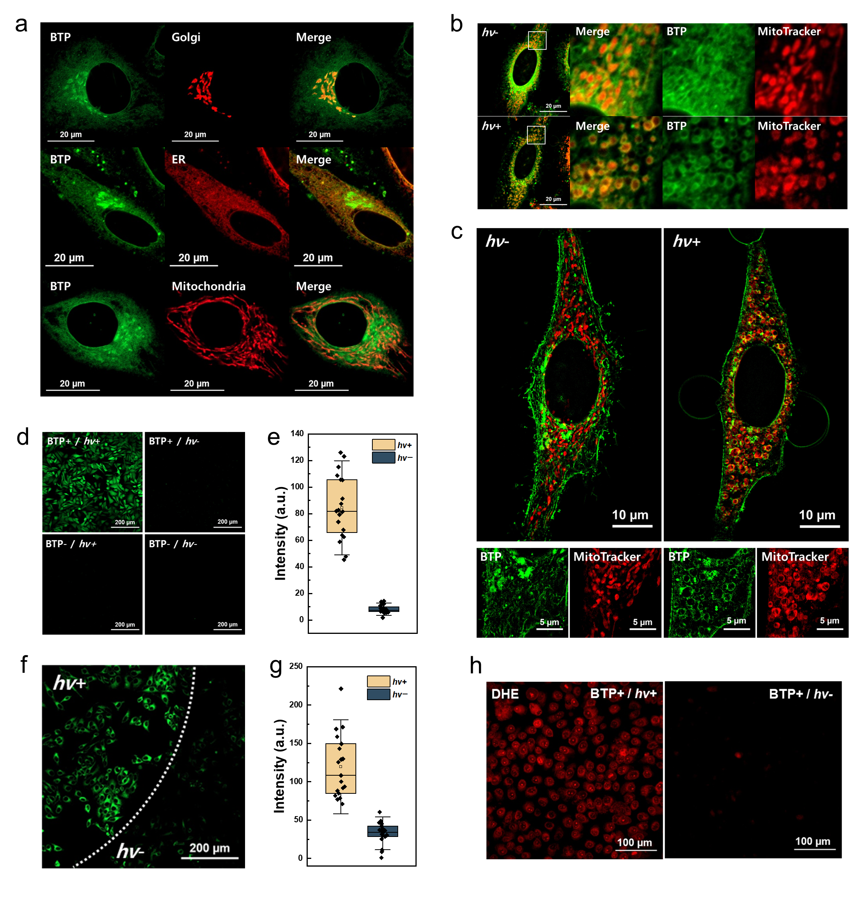
Extended Data Fig. 2 | Co-localisation imaging and intracellular ROS generation. a, Co-localisation of BTP (5 μM). HeLa cells were transfected with CellLight™ Golgi RFP BacMam2.0 and Sec61b-mGFP constructs to stain the Golgi apparatus and endoplasmic reticulum (ER), respectively. MitoTrackerTM Deep Red FM was used to stain mitochondria. Fluorescence signals of GolgiRFP, Sec61b-mGFP, and MitoTracker are represented in red. b, Changes in location of BTP after photocatalysis. The HeLa cells were stained with BTP and MitoTracker and imaged before and after light exposure (confocal laser, λ = 445 nm). Enlarged images of white boxes show that BTP moves to the mitochondrial membrane during photocatalysis. c, Live-structured illumination microscopy (live-SIM) images before and after BTP photocatalysis (λ = 445 nm). The green and red signals correspond to BTP and MitoTracker, respectively. d, H₂DCF-DA assay for intracellular ROS generation. The HeLa cells were incubated with BTP (5 μM) and H₂DCF-DA (20 μM) and irradiated with blue LED light (λ_{max} = 450 nm, 5 J·cm⁻²). The green signal corresponds to the DCF fluorescence. e, Dot plot analysis of DCF signals from randomly selected 20 cells (BTP+/hv+ and BTP+/hv-) (n = 20). f, Lipid peroxidation assay with BODIPYTM 581/591 C11 (2 μM). The white arc indicates the photocatalytic region (λ_{max} = 450 nm) corresponding to BTP (5 μM). The green signals corresponded to the fluorescence of BODIPYTM 581/591 C11. g. Dot-plot analysis of the lipid peroxide signals (n = 20). h. O₂^{−∙} assay using dihydroethidium (DHE). The HeLa cells were treated with DHE (5 μM) and exposed to BTP photocatalysis (λ_{max} = 450 nm, 10 J·cm⁻²). Red signals correspond to DNA-intercalated 2-hydroxyethidium. Live HeLa cells were used for all co-localisation imaging and intracellular ROS generation assays. Data are presented as mean ± s.d. Source data are provided as a Source Data file.
Extended Data Fig. 3 | Single-molecule forced-unfolding assay for control conditions. a, Representative force-extension curves of GlpG in the condition of infrared light exposure (λ_{peak} = 850 nm, 39.51 mW·cm⁻²). Under the infrared light, the C₀ point of the first abnormal unfolding was not observed even after tens of cycles upon BTP addition (for blue light condition as shown in Fig. 2h, average C₀ = 4′ cycles). This result is because the BTP is not able to absorb the energy of infrared wavelength. b, Representative force-extension curves of GlpG for the addition of fresh bicelles. After the C₀ point was observed, the solution of fresh bicelles was injected by buffer exchange. Normal unfolding was not recovered even after the exchange of fresh bicelles. This implies that the damage manifested in the drastic reduction of unfolding forces was mainly on the membrane protein GplG, not the lipid bilayer environment. Source data are provided as a Source Data file.
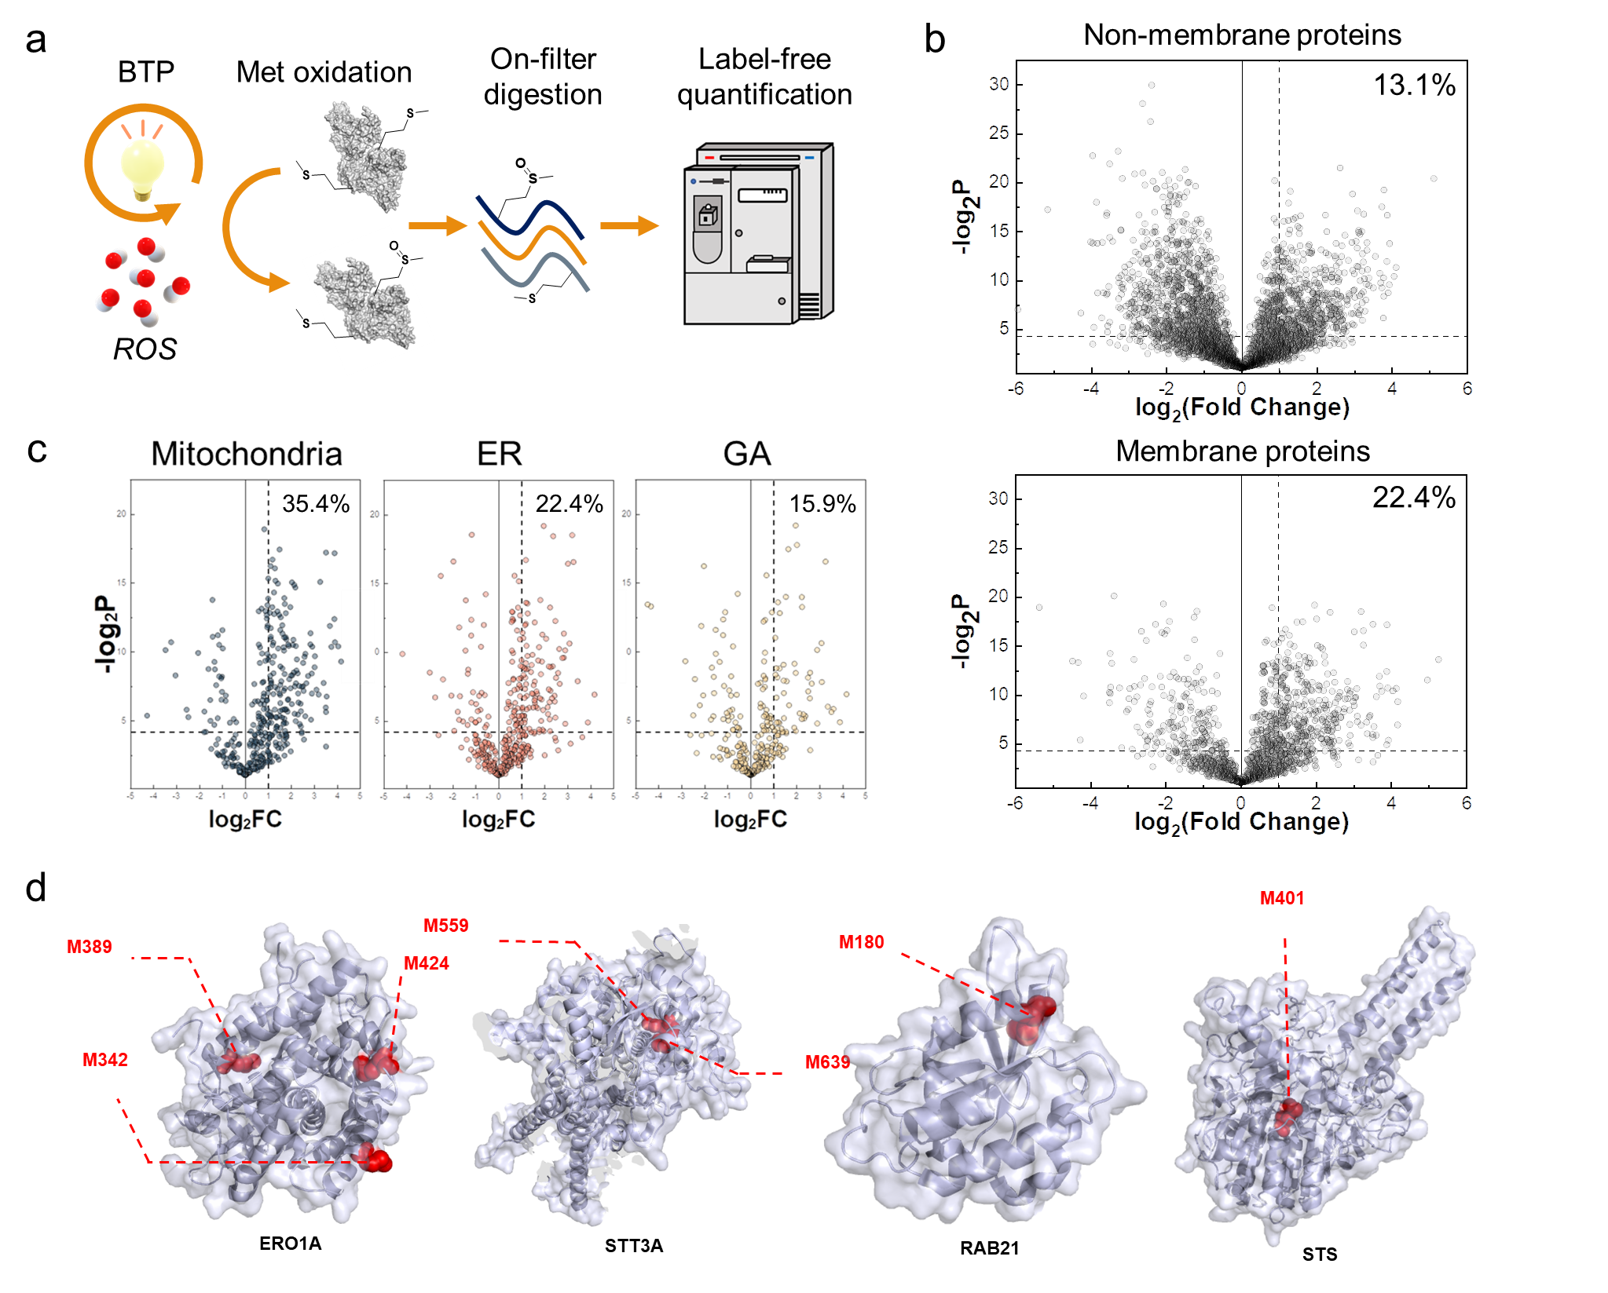
Extended Data Fig. 4 | Proteomic analysis of oxidised proteins. a, Schematic diagram of label-free quantification using LC-MS² tandem mass spectrometry. Methionine oxidation, with or without BTP photocatalysis, was assessed after on-filter digestion combined with high pH fractionation. b, Volcano plots of oxidised non-membrane proteins (top) and oxidised membrane proteins (bottom). More points appeared at positive log₂(Fold Change) for membrane proteins than those for non-membrane proteins. The ratios of significantly oxidised membrane proteins are represented. c, Volcano plots of membrane proteins by cellular localisation. The ratios of significantly oxidised membrane proteins are represented. d, Crystal structures of representative significantly oxidised proteins displayed with Met oxidative sites. Source data are provided as a Source Data file.
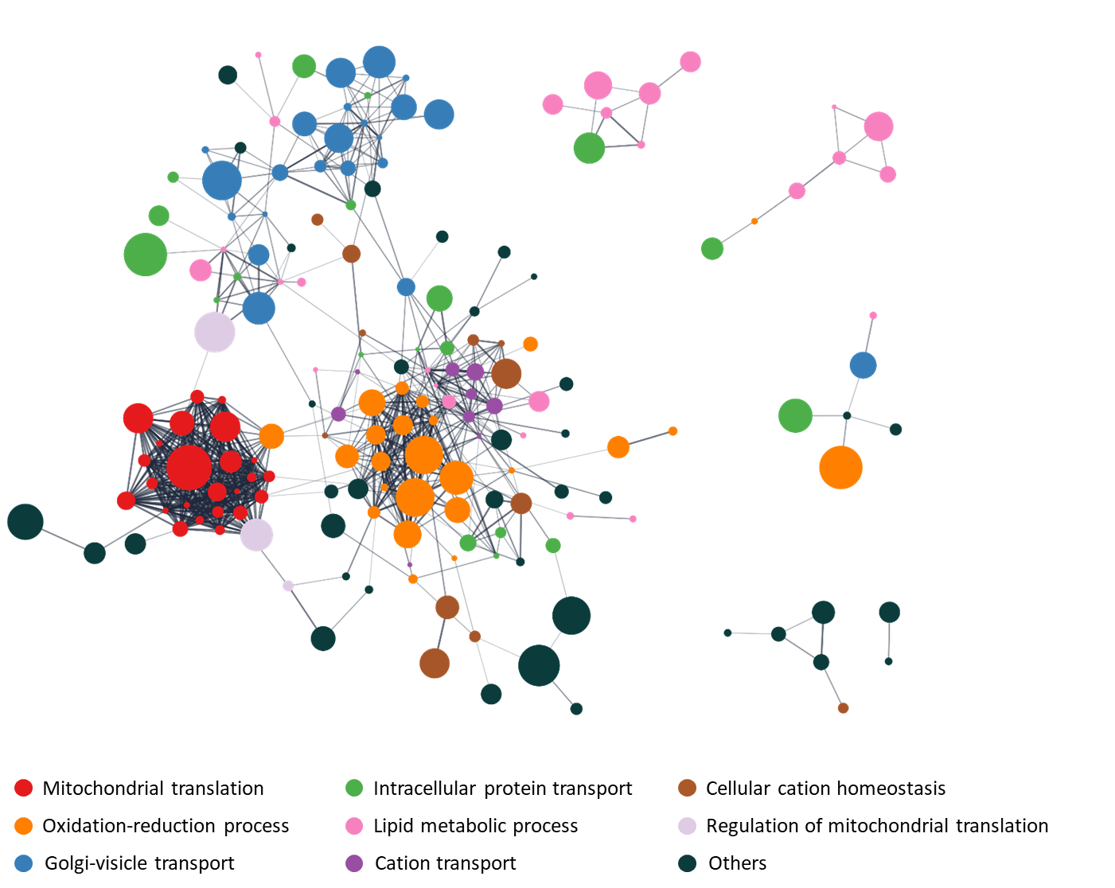
Extended Data Fig. 5 | Oxidised proteome network analysed by GO terms. Oxidised proteome networks showing protein clusters. Each cluster represents a GO biological process. The oxidised proteome network was constructed using the Cytoscape software. Nodes represent annotation terms, and edges are reported as interactions. The node size indicates the relative degree of fold change. The node colours indicate the respective GO biological processes.
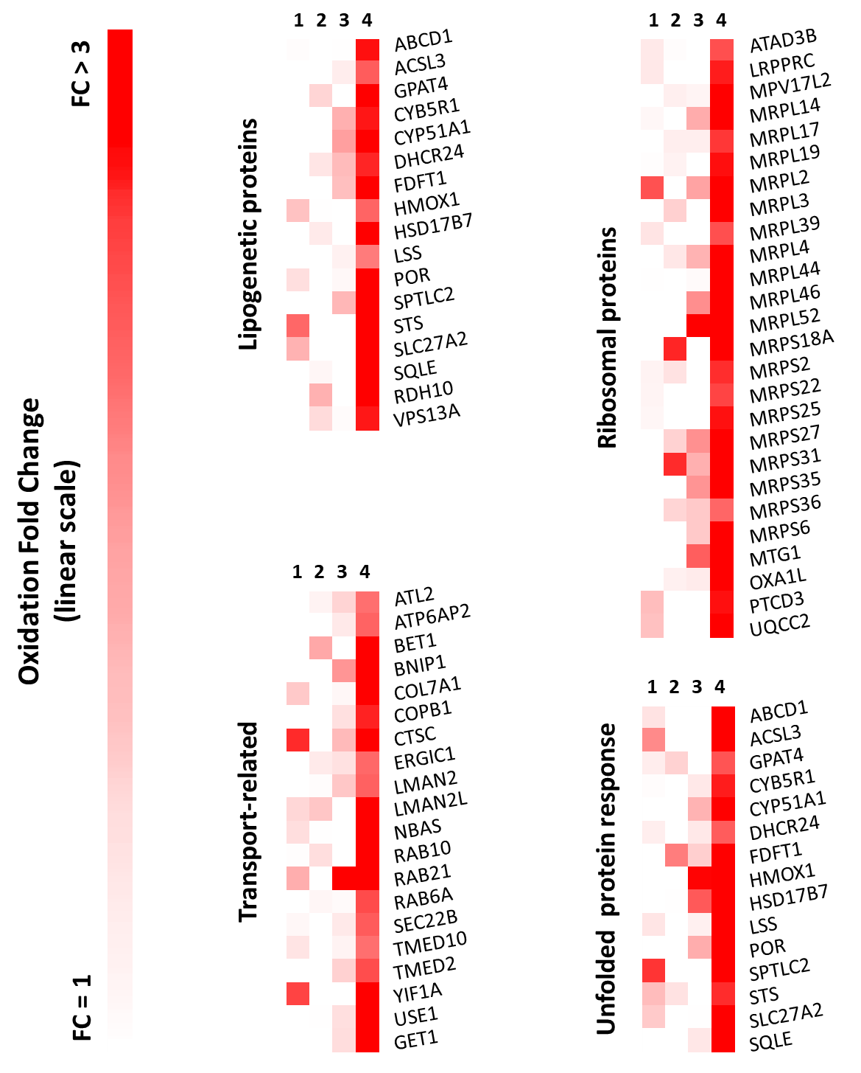
Extended Data Fig. 6 | Methionine oxidation heatmap diagram for proteins involved in protein quality control. 1: BTP−, hv−; 2: BTP−, hv+; 3: BTP+, hv−; and 4: BTP+, hv+. Fold change (FC) values were determined by dividing the FC of each experimental condition by the average FC values of 1, 2, and 3. A higher FC value implies more substantial oxidative damage.
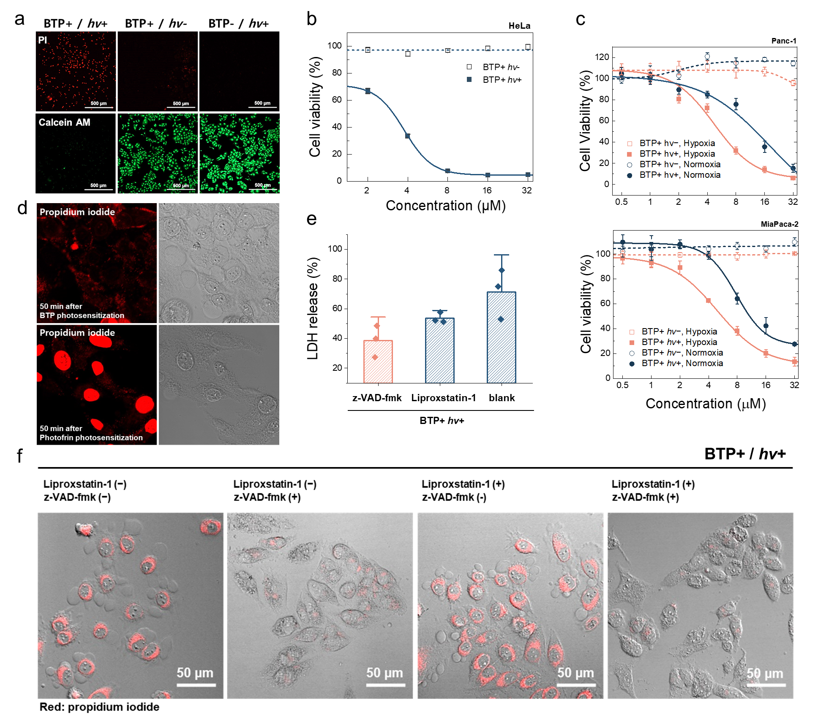
Extended Data Fig. 7 | Cell death induced by BTP photocatalysis. a, Live or dead assay with Calcein AM and propidium iodide (PI). HeLa cells with BTP photocatalysis were stained by Calcein AM and PI 24 h after light exposure (λ_{max} = 450 nm, 3.7 J·cm⁻²). b, MTT assay of HeLa cells with BTP photocatalysis (λ_{max} = 450 nm, 10 J·cm⁻²) (n = 4). c. MTT assays for normoxic/hypoxic pancreatic cancer cells (Panc-1 and MiaPaca-2). (n = 4) d, PI staining after BTP photocatalysis. The PI fluorescence of HeLa cells was not observed in the nucleus 50 min after BTP photocatalysis, implying that the nuclear envelope was intact. During pyroptosis, in which the nuclear membrane is retained, PI could not penetrate the nuclear envelope (top). Photofrin (an apoptosis and necroptosis inducer) was used as the control photosensitiser (bottom). e, LDH assay of HeLa cells with/without liproxstatin-1 (ferroptosis inhibitor, 10 µM) or z-VAD-fmk (pan-caspase inhibitor, 4 µM) 2 hours after BTP photocatalysis (λ_{max} = 450 nm, 3 J·cm⁻²) (n = 3). f, Morphological changes and propidium iodide (PI) staining of HeLa cells with and without liproxstatin-1 or z-VAD-fmk after BTP photocatalysis (λ_{max} = 450 nm, 3 J·cm⁻²). BTP photocatalysis induced pyroptotic blebbing of cells without z-VAD-fmk. Note that PI fluorescence was enhanced in cells with pyroptotic blebbing owing to plasma membrane permeabilisation. All data are presented as mean ± s.d. *P < 0.05. Student’s two-tailed t-test. Source data are provided as a Source Data file.
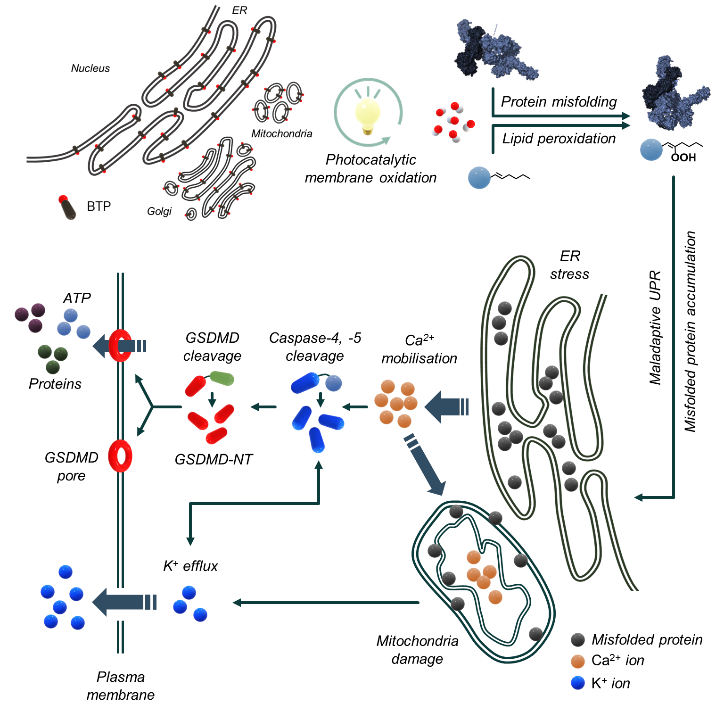
Extended Data Fig. 8 | Proposed mechanism of non-canonical pyroptosis induced by photocatalytic membrane oxidation. The oxidative photocatalysis of BTP generates hydroxyl radicals, hydrogen peroxide, and superoxide radicals on intracellular membranes. Severe oxidative stress on the membrane causes lipid peroxidation and misfolding of membrane proteins in the ER, Golgi apparatus, and mitochondria. Notably, the oxidation of protein quality control (PQC)-related proteins induces ER stress and maladaptive UPR attributed to the accumulation of misfolded proteins. During the maladaptive UPR process, Ca²⁺ is released from the ER lumen. Simultaneously, mitochondrial damage caused by membrane oxidation results in K⁺ efflux. Cation mobilisation and ER stress presumably cleave caspase-4/5, leading to GSDMD pore formation. Through the GSDMD pore, biomolecules are released from the cytosol, triggering non-canonical pyroptosis.

