HBK-15, a multimodal compound, induces procognitive effects through modulating hippocampal LTP and enhancing theta-gamma coupling in mice

Kinga Sałaciak¹, Klaudia Lustyk¹, Małgorzata Szafarz², Sara Inteiro-Oliveira^{3,4}, Maria José Diógenes^{3,4}, Sara Xapelli^{3,4}, Paulina Schnur⁵, Lucy Morton⁵, Erin Moran⁵, Jacques Ferreira⁵, Shuzo Sakata⁵, Karolina Pytka^{1*}

¹Department of Pharmacodynamics, Faculty of Pharmacy, Jagiellonian University Medical College, Krakow, Poland
²Department of Pharmacokinetics and Physical Pharmacy, Faculty of Pharmacy, Jagiellonian University Medical College, 30-688 Krakow, Poland
³Instituto de Farmacologia e Neurociências, Faculdade de Medicina, Universidade de Lisboa, 1649-028 Lisboa, Portugal
⁴Instituto de Medicina Molecular João Lobo Antunes, Universidade de Lisboa, 1649-028 Lisboa, Portugal
⁵Strathclyde Institute of Pharmacy and Biomedical Sciences, University of Strathclyde, Glasgow G4 0RE, UK

Detailed Materials and Methods

Animals
Depending on the experiment, we used naïve adult male BALB/c (Mossakowski Medical Research Institute, Polish Academy of Sciences or Charles River Laboratories (Barcelona, Spain or Edinburgh, UK)) or C57BL/6J (Mossakowski Medical Research Institute, Polish Academy of Sciences) weighing 24 ± 2 g (8-10 weeks old). The animals were kept under standard conditions (19–22°C, humidity 55%, 12:12 h light: dark cycle, food, and water ad libitum) and used only once in each test. Behavioral experiments were performed between 8 am and 4 pm and evaluated by a trained observer blind to the treatments. Mice were handled for one week before starting the experimental procedures. Animals were randomly allocated to the treatment using a computer-generated sequence, and researchers making measurements on the animals or analyzing the results were blind to the allocation. Moreover, experimental groups were distributed across multiple cages, and the location of the mouse cages in the room was changed following each day. All experiments were performed following the European (86/609/EEC; 2010/63/EU; 2012/707/EU) and Polish, Portuguese, or the United Kingdom Animals (Scientific Procedures) Act of 1986 Home Office regulations (approved by either the Local Ethics Committee for Experiments on Animals in Kraków: 485/2021, 547/2021, 548/2021, 549/2021, 550/2021, 591/2022, 604/2022 or by the Home Office: PPL0688994).

Experimental procedures
Behavioral tests

Step-through passive avoidance task
Acquisition phase: mice were placed individually in an illuminated white compartment of the apparatus (20 cm × 21 cm × 20 cm, 1000 lx) with a closed door to a smaller dark compartment (7.3 cm × 7.5 cm × 14 cm, 10 lx) equipped with a grid floor (stainless steel rods through which an electric footshock was delivered; LE872, Bioseb, France). After 30 s, the door opened, and the animals were allowed to enter the dark component. Once the mice entered the dark compartment, the door closed, and an electric foot shock was delivered (0.2 mA for 2 s). The mice which did not enter the dark compartment within 60 s were excluded from the study.
Test phase: the animals were placed again into the illuminated compartment and observed for up to 300 s (retention session). However, no electric foot shock was delivered when the mice entered the dark compartment.
HBK-15 was administered ip 30 min before or immediately after the acquisition session or 30 min before the test phase to verify whether the tested compound affected the learning phases, i.e., encoding, consolidation, or retrieval, respectively (Fig. 1 a, e, and h). MK-801 was injected ip 15 min after the administration of the tested compound. Moreover, we investigated how HBK-15 affected the animals' performance in various time intervals – the gap between the acquisition and test phase was 15 min, 4 h, and 24 h (encoding process) or 4 h and 24 h (consolidation and retrieval processes).

Hot plate test
The animals were tested for their pain sensitivity threshold a day before the experiment. Mice were placed in the apparatus (Hot/Cold Plate, Bioseb, France), which consists of an electrically heated surface with a temperature set up to 55 °C. Only mice with baseline latencies ≤ 30 s were selected for further analysis. 30 min post-injection of HBK-15, the latency to nocifensive reactions (licking hind paws or jumping) was measured. The cutoff time was established (60 s), and animals that did not respond within 60 s were removed from the hot plate apparatus and assigned a score of 60 s.

Object recognition test
Familiarization session: mice were placed individually in the open field (35 cm x 35 cm x 35 cm) with two identical objects (towers of Lego bricks or Falcon tissue culture flasks filled with sand) positioned 5 cm away from the walls. Animals left there until they reached the 20-s criterion of total exploration, but no longer than 10 min.
Test phase: mice were placed again in the open field, but this time one of the objects was replaced with the new one (either a tower of Lego bricks or Falcon tissue culture flasks filled with sand). The position of the novel object (left or right) was randomized between each mouse and each group tested. Mice were again left in the open field until they reached the 20-s criterion of total exploration, but no longer than 10 min. After each test experiment, the objects and the open field were cleaned with the odorless veterinary disinfectant to minimize any olfactory cues. The experiments were video-recorded and scored using Eleven Maze (https://elevenmaze.com) software by a trained observer blind to the treatments. To assess animals' performance in the object recognition test, the means of the novel object exploration time were compared with the chance level (10 s, equal exploration of the objects).
HBK-15 was administered ip 30 min before or immediately after the familiarization session or 30 min before the test phase to verify whether the tested compound affected the learning phases, i.e., encoding, consolidation, or retrieval, respectively (Fig. 2 a, e, and h). MK-801 was injected ip 15 min after the administration of the tested compound. Moreover, we investigated how HBK-15 affected the animals' performance in various time intervals – the gap between familiarization and test phase was 15 min, 4 h, and 24 h (encoding process) or 4 h and 24 h (consolidation and retrieval processes).

Morris water maze
Acquisition phase (days 1-6): Animals were placed in a circular pool (height 60 cm, diameter 120 cm; Panlab-Harvard Apparatus, Spain) filled with opaque water at a temperature of 24±1°C, virtually divided into four parts. In one quadrant of the pool, a round platform (diameter 10 cm) was hidden 1 cm below the water surface. Color geometric figures placed near the pool served as visual cues for the swimming animals. Each day mouse needed to complete four trials separated by 15-min intervals. During each trial, the mouse was placed in different quadrants but never in the one where the platform was located. If the animal did not find the platform within 60 s, it was gently guided to it and left for 15 s. HBK-15 was administered ip 30 min before the first trial for six consecutive days, and MK-801 was injected ip 15 min later (Fig. 3a). The whole experiment was video-recorded and analyzed by Eleven Maze (https://elevenmaze.com) software. The following parameters were collected: the latency to enter the platform (i.e., escape latency), the total distance, and the swimming speed.
Probe test: 24 h after the last training session, no compounds were administered, and the platform was removed from the pool. Each mouse swam during a 60-s trial, and the following parameters were collected and analyzed: the latency and the covered distance to the target zone (a place where the platform was previously located), the percentage of time spent in the target quarter, number of target entries, and the swimming speed.

Barnes maze
The Barnes maze apparatus is a circular platform with 18 equally spaced holes (Panlab-Harvard Apparatus, Spain) with an escape box was placed under one of the holes. The visual cues (boards with colored geometric figures) were placed around the maze. Light (600 lux) and noise (80 dB) were used as aversive stimuli to increase animals' motivation to escape from the circular platform and hide in the box.
Habituation phase (day 0): the mouse was placed in a tube in the middle of the circular maze. 10 s later, the mouse was released from the start chamber, the light and noise were turned on, and the animal could freely explore the maze for 1 min. Then it was gently guided to the escape box, where it remained for the next 1 min. This phase was not preceded by compounds' injection.
Acquisition phase (days 1-4): each mouse was placed individually in a plastic tube in the center of the platform, released after 10 s, and the aversive stimuli were turned on. The trial finished when the mouse entered the escape box or after 3 min have elapsed. Mice were allowed to stay inside the escape box for 1 min. If the mouse did not find the box within 3 min, it was placed there for 1 min. Throughout the trials, the position of the box was the same. Each day animals needed to complete four trials with a 15-min interval between trials. Mice were injected ip with HBK-15 30 min before the first trial for four consecutive days, and MK-801 was administered ip 15 min later (Fig. 4a). The whole experiment was video-recorded and scored using Eleven Maze (https://elevenmaze.com) software by a trained observer blind to the treatments. During this phase, the number of primary errors (i.e., the number of errors before the mouse reached the escape box), total errors (i.e., the number of all errors made during 3 min of the test), primary and total latencies to find the escape box (i.e., the time required to find and time required to enter the escape box, respectively) were measured.
Test phase (days 5 and 12): The escape box was removed and replaced by a closed area (plastic plate). Each mouse was placed in a cylindrical start chamber with no prior compound injections. After its removal, the mouse was allowed to explore the maze for the next 90 s. Primary errors and latency to reach the former target (i.e., the escape box) location were measured.

Rotarod test
Acquisition phase (days 1-4): each mouse was placed on the rotating rod with increasing speed (maximum speed 40 rpm) for 5 min or until they fell off (May Commat RR0711, Turkey). Within a day, each mouse performed four trials. 30 min before the first trial, animals were injected ip with HBK-15 and 15 min later, with MK-801 (Fig. S1a). We measured the latency to fall off the rotating rod.
Probe test: On the fifth day, the animals were again placed individually on a rotating rod with increasing speed (maximum speed 40 rpm). The duration of the experiment was again 5 min; however, no compounds were administered.

Neurotransmitters level

Tissue homogenates
Tissue and homogenates preparation: 30 min after acute administration of the tested compound or saline, naïve mice were sacrificed, and their brains were rapidly removed and chilled in an ice-cold saline solution. The hippocampi were dissected, frozen, and stored at −80 °C until assay. On the day of experiments, tissues were thawed on ice and homogenized (1:10 w/v) in buffer containing 50 mM Tris-HCl, 150 mM NaCl, 2 mM EDTA and 0.32 M sucrose using bead homogenizer (Bead Rupture elite, Omni International, USA).
Analytical method: Concentrations of dopamine (DA), serotonin (5-HT), acetylcholine (ACh), glutamic acid (Glu), histamine (HIS), and norepinephrine (NE) in the selected brain structures were measured by liquid chromatography-tandem mass spectrometry method (LC-MS/MS). Homogenates (50 µL) after the addition of 5 µL of IS mixture (deuterated analogs of analyzed compounds at the concentration of 5 µg/mL) were deproteinized with 150 μL of 0.1% formic acid in acetonitrile. Then samples were shaken for 10 min (IKA Vibrax VXR, Germany) and centrifuged for 5 min at the speed of 8000 x g (Eppendorf miniSpin centrifuge, Germany). Supernatants were transferred into the autosampler vials. Samples with the analyte concentration above the calibration curve range were additionally diluted with water. Analytes were separated on the XBridge HILIC (2.1 x 150 mm, 3.5 µm, Waters, USA) analytical column using an Exion LC AC HPLC system (Sciex, USA). The injection volume was 5 μL and the sample was eluted under the isocratic condition at the flow rate of 0.5 mL/min. The mobile phase consisted of 0.1% formic acid in water and 0.1% formic acid in acetonitrile mixed at the ratio of 30/70 (v/v). A QTRAP 4500 (Sciex, USA) tandem mass spectrometer equipped with an electrospray ionization (ESI) source was used for detection. Spectrometer was operated at unit resolution monitoring the transitions presented in Table S1. Corresponding deuterated internal standards that enable to compensate for potential matrix effects were used for analyte quantification. Mass spectrometric parameters were optimized in positive ionization mode by separate infusion of each standard and internal standard solution into the TurboIonSprayTM interface. The most intense product ions were used in the MRM (multiple reaction monitoring) modes to achieve maximum intensity. The following ESI source parameters were selected: ion source temperature was set to 450ºC; curtain gas to 30 psi and collision gas to medium; ionization voltage was set to 5500V. Data acquisition and processing were performed using Analyst version 1.7 software. The calibration curves were constructed by plotting the ratio of the peak area of the studied compound to IS versus drug concentration and generated by weighted (1/x‧x) linear regression analysis. Due to the high endogenous concentrations of analyzed neurotransmitters and availability of stable isotope standards, calibration curves were constructed based on serial dilutions of the calibrators in water. The stock solutions of analyzed neurotransmitters and deuterated internal standards were prepared in water or methanol at the concentration of 1 mg/mL. Working standard solutions (mixture of all analytes) were prepared at the following concentrations: 0.01; 0.025; 0.05; 0.1; 0.25; 0.5; 1; 2.5; 5 and 10 µg/mL. To prepare samples for the calibration curve, 45 μL of water was spiked with 5 μL of standard solution at an appropriate concentration level, 5 µL of IS mixture, and vortexed for 10 s. Calibration curves were linear in the range from 1 to 1000 ng/mL for Ach, 5-HT, and DA; from 2.5 to 1000 ng/mL for HIS; from 10 to 1000 ng/mL for Glu and from 25 to1000 ng/mL for NE. Then, concentrations of neurotransmitters in the analyzed samples were calculated per g of brain tissue by applying appropriate dilution factors. Calculated values of accuracy and precision were within the limits set by the FDA guidelines for the validation of bioanalytical methods. No significant matrix effect was observed and there were no stability-related problems during the routine analysis of the samples.

Microdialysates
Surgery: Animals were anesthetized with 2.5% isoflurane (5% for induction) and placed in a stereotaxic frame (ASI Instruments, Warren, MI, USA). Analgesia was provided by the administration of lidocaine subcutaneously at the incision site and carprofen (10 mg/kg) subcutaneously in the back. The guide cannulas (MAB 10.8.IC, AgnTho’s AB, Sweden) were implanted over the hippocampus (AP – 1.93 mm; ML + 1.5 mm; DV – 1.8 mm from the bregma; Fig. S2), according to the stereotaxis atlas of Franklin and Paxinos [1] and fixed in place with two additional anchor screws and dental cement. After surgery, mice were housed in a high-roofed cage with ad libitum access to water and food and monitored for recovery (normal eating, drinking, and defecation).

Microdialysis: Following a 3-day recovery period, microdialysis probes (MAB 10.8.1.PES with cut off: 6 kD, AgnTho’s AB, Sweden) were connected to the syringe pump (Univentor 864 Syringe Pump, AgnTho’s AB, Sweden) that delivered aCSF composed of (mM) 147 NaCl, 4 KCl, 2.2 CaCl₂ and 1.0 MgCl₂ at a flow rate 1 μl/min. The monitoring of extracellular levels of neurotransmitters has been performed in freely moving animals. After a 2-h stabilization period, a baseline sample was collected for 30 min. Thereafter, HBK-15 at the dose of 2.5 mg/kg was injected ip and three samples were further collected every 30 min (0-30 min, 30-60 min, and 60-90 min post injection). Placement of dialysis probes was verified post-mortem in coronal sections (Fig. S2b).

Analytical method: Concentrations of acetylcholine (ACh) and glutamic acid (Glu) in microdialysis samples from mouse hippocampus were measured by liquid chromatography tandem mass spectrometry method (LC-MS/MS). The analytical method employed was similar to the one described above with some minor modifications. The sample preparation procedure involved the addition of 3 μL of an internal standard (IS) mixture (deuterated internal standards at a concentration of 500 ng/mL) to 30 μL of dialysate. Then, samples were vortex mixed, transferred to autosampler vials and 5 μL was injected into the LC-MS/MS system. The separation of analytes was carried out using the XBridge HILIC column (2.1 x 150 mm, 3.5 µm, Waters, USA). Since samples had a high salt concentration, a gradient elution method was employed to extend the retention times of the neurotransmitters being analyzed and minimize ion suppression. The initial mobile phase composition consisted of 25 mM ammonium formate (pH= 3.5) in water (A) and acetonitrile (B) in a ratio of 95% B and was pumped for 2 min. Over the next 3 min, the concentration of B was decreased to 60% and maintained for 5 min. Subsequently, B was further reduced to 50% within 1 min and maintained for 3 min. Finally, the mobile phase composition was returned to the initial ratio of 95% B. The entire HPLC operation lasted for 17 min, and the flow rate of the mobile phase was set at 0.3 mL/min. Calibration curves were prepared in the aCSF and were linear in the range from 1 to 1000 ng/mL for Ach and Glu.

Electrophysiology ex vivo
Hippocampal slices preparation: The hippocampus was dissected in ice-cold aCSF composed of (mM): NaCl 124; KCl 3; NaH₂PO₄ 1.25; NaHCO₃ 26; MgSO₄ 1; CaCl₂ 2; and glucose 10, previously gassed with 95% O₂ and 5% CO₂, pH 7.4. Slices (400 μm thick) were cut perpendicularly to the long axis of the hippocampus with a McIlwain tissue chopper and allowed to recover functionally and energetically for 1 h in a resting chamber, filled with the same solution, at room temperature. Slices were transferred to a recording chamber for submerged slices and continuously superfused at 3 ml/min with the gassed bathing solution at 32°C; drugs were added to this superfusion solution in a closed circuit. Recordings were obtained with an Axoclamp 2B amplifier and digitized (Axon Instruments, Foster City, CA). Individual responses were monitored, and averages of six consecutive responses were continuously stored on a personal computer with the LTP software [2].

Field postsynaptic potentials (fEPSPs) recording: fEPSP were recorded through an extracellular microelectrode (4 M NaCl, 2–6 MΩ resistance) placed in stratum radiatum of CA1 area (Fig. S3). Stimulation (rectangular 0.1 ms pulses, once every 10 s) was delivered through a concentric electrode placed on the Schaffer collateral–commissural fibers, in the stratum radiatum near CA3–CA1 border (Fig. S3a). The intensity of the stimulus (180–290 μA) was initially adjusted to obtain a large fEPSP slope with a minimum population spike contamination. Alteration in synaptic transmission induced by drugs was evaluated as the % of the change in the average slope of the fEPSP in relation to the average slope of the fEPSP measured during the 10 min that preceded the addition of drugs as described previously [3]. Recordings were obtained with an Axoclamp 2B amplifier and digitized (Axon Instruments, Foster City, CA). Individual responses were monitored, and averages of six consecutive responses were continuously stored on a personal computer with the LTP software [2].
Long-term potentiation (LTP) induction and quantification: fEPSPs were recorded through extracellular microelectrode (4 M NaCl, 2–6 MΩ resistance) placed in the stratum radiatum of the CA1 area (Fig. S3b). In LTP experiments, stimulation (rectangular 0.1 ms pulses, once every 10 s) was delivered alternatively to two independent pathways through bipolar concentric electrodes placed on Shaffer collateral/commissural fibers in stratum radiatum. LTP was induced by θ-burst protocol consisting of four trains of 100 Hz, and four stimuli, separated by 200 ms (Fig. S3c). The intensity of the stimulus was maintained during the induction protocol. LTP was quantified as the % of the change in the average slope of the fEPSP taken from 60 min after LTP induction in relation to the average slope of the fEPSP measured during the 10 min that preceded the induction of LTP. In each individual experiment, the same LTP-inducing paradigm was delivered to each pathway. To test the effects of the tested drugs upon LTP, each individual drug was added to the superfusing bath at least 15 min before induction of LTP and remained in the bath up to the end of the experiment. In the experiments where both drugs were tested, HBK-15 was added 15 minutes before MK-801 and remained until the end of the experiments.

Electrophysiology in vivo
Surgery: Animals (10 males) were anesthetized with 1-1.5% isoflurane (3-5% for induction) and placed in a stereotaxic frame (SR-5M-HT, Narishige). The body temperature was maintained at 37 ℃ using a feedback temperature controller (50-7221-F, Harvard Bioscience). Animal heads were shaved using electric clippers and cleaned with ethanol (70%) and iodopovidone. Analgesia was provided by the administration of Naropin (0.2%, 0.08 ml) subcutaneously at the incision site and Rimadyl (0.01%, 0.05 ml) subcutaneously in the back. Two bone screws were implanted in the front (AP +1.5 mm from bregma, ML ±1 mm) for cortical electroencephalograms (EEGs) and two over the cerebellum (AP -2 mm from lambda, ML ±2 mm) as a ground and an additional anchor. Two twisted wires were inserted into the neck muscles for electromyography (EMG). After craniotomy (AP -2 mm, ML +1.5 mm from bregma), a bipolar wire electrode (130.3 ± 11.8 kΩ at 1 kHz) (AISI 302, 0.1 mm diameter, GoodFellow) was inserted into the hippocampal CA1 (-1.5 mm deep from the cortical surface) and the site was sealed with biocompatible gel (Kwik-Sil, World Precision Instruments) (Fig. S4). Dental cement was used to secure the electrode and cover the skull surface and screws. After surgery, mice were housed in pairs of two in a high-roofed cage with ad libitum access to water and food.

in vivo pharmacology and electrophysiology: Experiments were performed in a plexiglass plastic box (30 cm width × 30 cm depth × 40 cm height). Electrophysiological signals were monitored using an interface board (C3100, RHD USB Interface Board, Intan Technologies) connected to the mouse via a headstage (C3334, RHD 16-channel headstage, Intan Technologies). All signals were acquired at 1 kHz using freely available software (RHX, Intan Technologies). After multiple days of habituation to the recording condition, 2-hour electrophysiological signals were monitored while the animals received one of the following four pharmacological treatments: 1) saline and saline, 2) saline and MK-801 (0.125 mg/kg), 3) HBK-15 (2.5 mg/kg) and saline, and 4) HBK-15 and MK-801. In each treatment, after 15 minutes of baseline recording, the first injection was given intraperitoneally. The second injection was given intraperitoneally on the contralateral side, 15 min after the first injection. The electrophysiological recording continued for 1.5 hours after the second injection. Four treatments were given to each animal in random order over multiple recording sessions. Each treatment was separated by at least a day.

Histology: After all pharmacological and electrophysiological experiments, animals were deeply anesthetized with a mixture of pentobarbital and lidocaine and perfused transcardially with phosphate buffer saline (PBS) followed by 4% paraformaldehyde/0.1 M phosphate buffer, pH 7.4. The brains were removed and immersed in the same fixative overnight at 4 ℃ and then immersed in 30% sucrose in PBS for at least 2 days. The brains were cut into coronal sections with a sliding microtome (SM2010R, Leica) with a 100 µm thickness. To determine the electrode position, the sections were stained with DAPI (1:1000, Sigma-Aldrich) and cover-slipped with an antifade solution (fluoromount-G, ThermoFisher Scientific). Images were taken under the epifluorescence microscope (Eclipse E600, Nikon) with a custom-written image acquisition program (LabVIEW, National Instruments).
Data analysis: All data analysis was performed offline using custom-written scripts (MATLAB R2022a, MathWorks). To compute theta and gamma power, hippocampal local field potentials (LFPs) were taken from one of two channels and a spectrogram was computed with a 10-s window and 5-s overlap. In each recording, the power of theta (4-10 Hz) and gamma (30-45 Hz) was calculated and normalized by the total power at ≤40 Hz. Using baseline signals between 5 and 15 min from the beginning of each recording, the Z-score of theta and gamma power was computed. The effect of treatments was assessed by calculating the average Z-scored power of theta and gamma oscillations between 30 and 60 min after the second injection.
To estimate the phase-amplitude coupling (PAC) between theta and gamma oscillations, LFPs were bandpass-filtered at 4-10 Hz and 30-45 Hz as theta and gamma oscillations, respectively, using the third-order Butterworth filter. The instantaneous phase of theta oscillations was estimated as the angle of the Hilbert-transformed signals. The amplitude envelope of gamma oscillations was estimated as the absolute value of the analytical signals after the Hilbert transformation. The mean amplitude of gamma oscillations at a certain phase of theta oscillations was computed in every 30-s window and 45° phase bin. The modulation index was defined as the ratio between the maximum and minimum mean amplitudes in each time window. Similar to the frequency band power described above, the Z-score of the modulation index was calculated across time windows using baseline values between 5 and 15 min from the beginning of each recording. The effect of treatments was assessed by computing the average normalized modulation index between 30 and 60 min after the second injection.

Statistical analysis
Results are presented as means ± standard deviation (SD) or standard error of mean (SEM) (parametric analysis) or medians and interquartile ranges (IQR) (non-parametric analysis). The data set's normality and homogeneity were determined using Shapiro-Wilk and Brown-Forsythe tests, respectively. The comparisons between groups were performed by one-way ANOVA, repeated measures one-way ANOVA or repeated measures two-way ANOVA, followed by appropriate post hoc tests: Dunnett's (when comparing means from several experimental groups against a control group mean), Tukey’s (when comparing means between all groups) and Bonferroni (when comparing the means of the preselected pairs of experimental groups). When the assumption of normal distribution was not met, we used the non-parametric Kruskal-Wallis analysis with Dunn's post hoc test. When the homogeneity of variance was violated, we performed the Welch ANOVA test, followed by Dunnett's T3 test. Additionally, we applied the Greenhouse-Geisser correction when the assumption of sphericity was violated for repeated measures ANOVA. To assess animals' performance in the object recognition test, the means of the novel object exploration time were compared with the chance level (10 s, equal exploration of the objects) using a one-sample t-test. In all tests, p<0.05 was considered significant. The statistical analyses were performed using GraphPad software 9.5.0 (GraphPad Software, Inc., La Jolla, CA 92037, USA) or MATLAB (R2022a, MathWorks).

References
1. Paxinos G, Franklin K. Paxinos and Franklin’s the Mouse Brain in Stereotaxic Coordinates. 5th Editio. London: Academic Press; 2019.
2. Anderson WW, Collingridge GL. The LTP Program: a data acquisition program for on-line analysis of long-term potentiation and other synaptic events. J Neurosci Methods. 2001;108:71–83.
3. Diógenes MJ, Fernandes CC, Sebastião AM, Ribeiro JA. Activation of adenosine A2A receptor facilitates brain-derived neurotrophic factor modulation of synaptic transmission in hippocampal slices. J Neurosci Off J Soc Neurosci. 2004;24:2905–2913.

Supplementary Figures
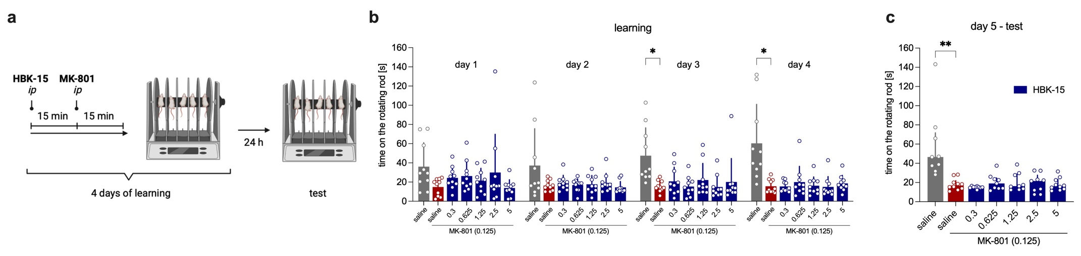

Fig. S1. HBK-15 did not attenuate the MK-801-induced motor learning and memory impairments. a: Experimental scheme: HBK-15 and MK-801 were administered intraperitoneally (ip) 30 min before the first trial for four consecutive days and on the fifth day of the experiment no treatment was administered. b: The effect of HBK-15 on the time spent on the rotating rod during the learning (acquisition) phase. The data are presented as means of 4 trials ± SD. Statistical analysis: two-way ANOVA for repeated measurements with Greenhouse-Geisser correction (Bonferroni post hoc), *p<0.05, n=10 mice per group. c: The influence of HBK-15 on the time spent on the rotating rod during the test phase. The data are presented as medians with IQR. Statistical analysis: Kruskal-Wallis test (Dunn post hoc), **p<0.01, n=9-10 mice per group

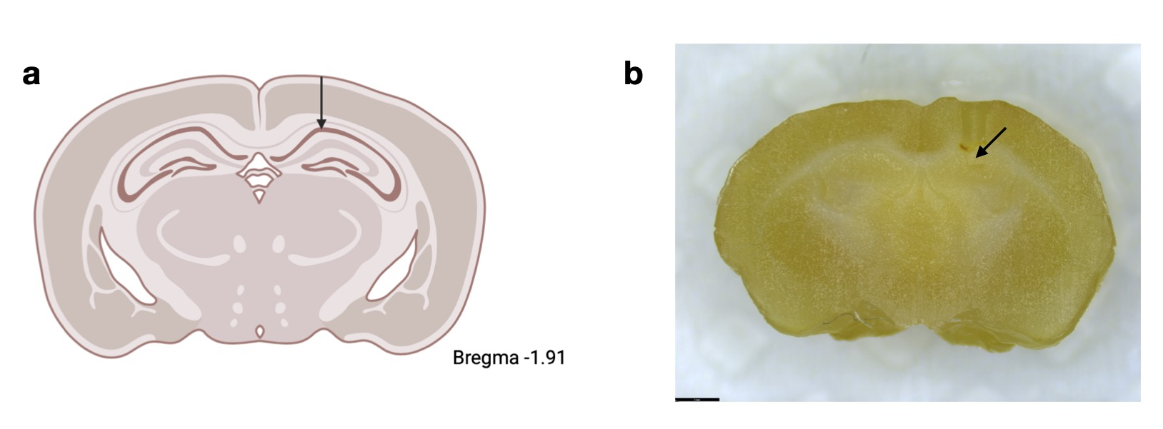

Fig. S2. Microdialysis cannula positions. a: Arrow indicates the representative placement of the cannula. b: Coronal section of brain showing the cannula placement (scale bar – 1 mm).

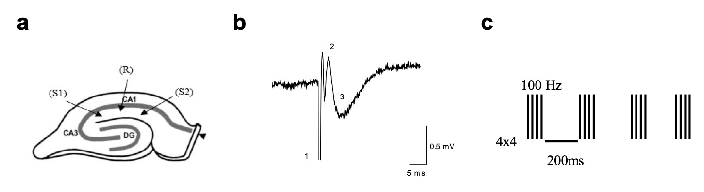

Fig. S3. Extracellular recordings in hippocampal slices. a: Schematic representation of a hippocampal transverse slice preparation showing the recording configuration used to obtain extracellular responses in the CA1 dendritic layer (stratum radiatum) evoked by stimulation of two separate sets of the Schaffer pathway (S1 and S2). b: Examples of representative traces obtained after stimulation are composed of the stimulus artifact (1), followed by the pre-synaptic volley (2), and the field excitatory post-synaptic potentials (fEPSP) (3). c: A schematic representation of the stimulation paradigms used in plasticity experiments.

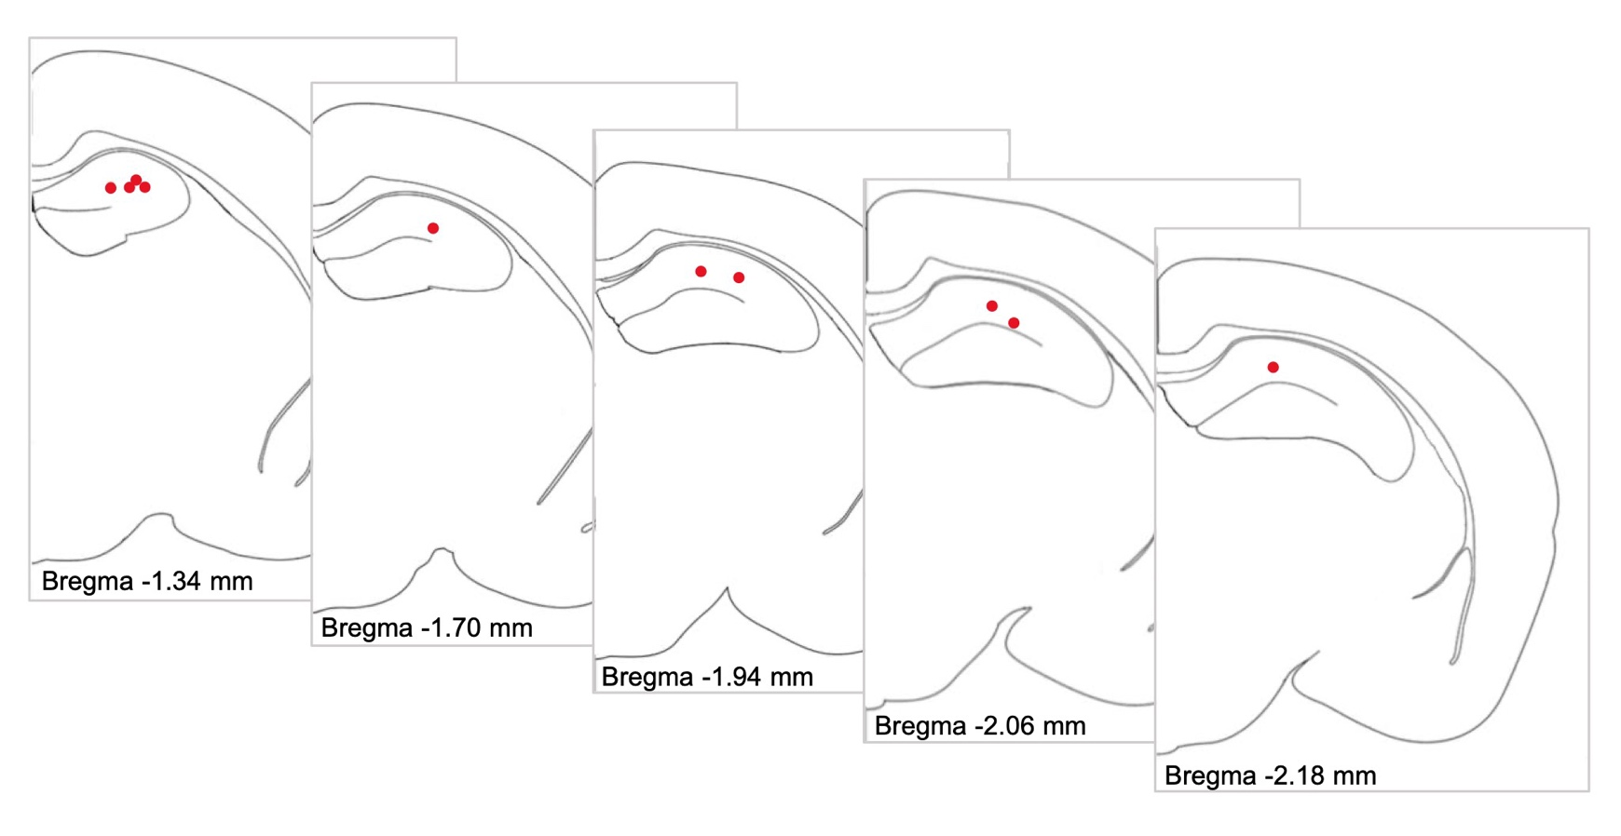
Fig. S4. Electrode positions. Red dots indicate the electrode tip position based on histological analysis.

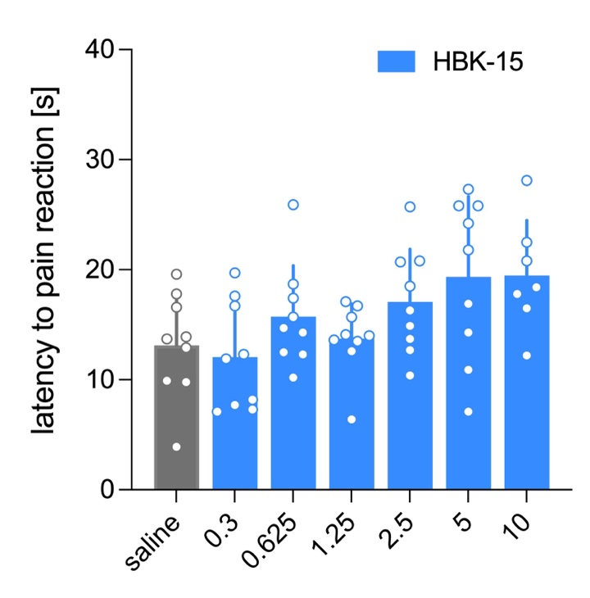

Fig. S5. HBK-15 did not change the nociceptive threshold in the hot plate test. 30 min after intraperitoneal injection of HBK-15 or saline, the effect of the tested compound on the nocifensive responses (i.e., licking hind paws or jumping) was measured. The data are presented as means ± SD. Statistical analysis: one-way ANOVA (Dunnett's post hoc), n=7-9 mice per group

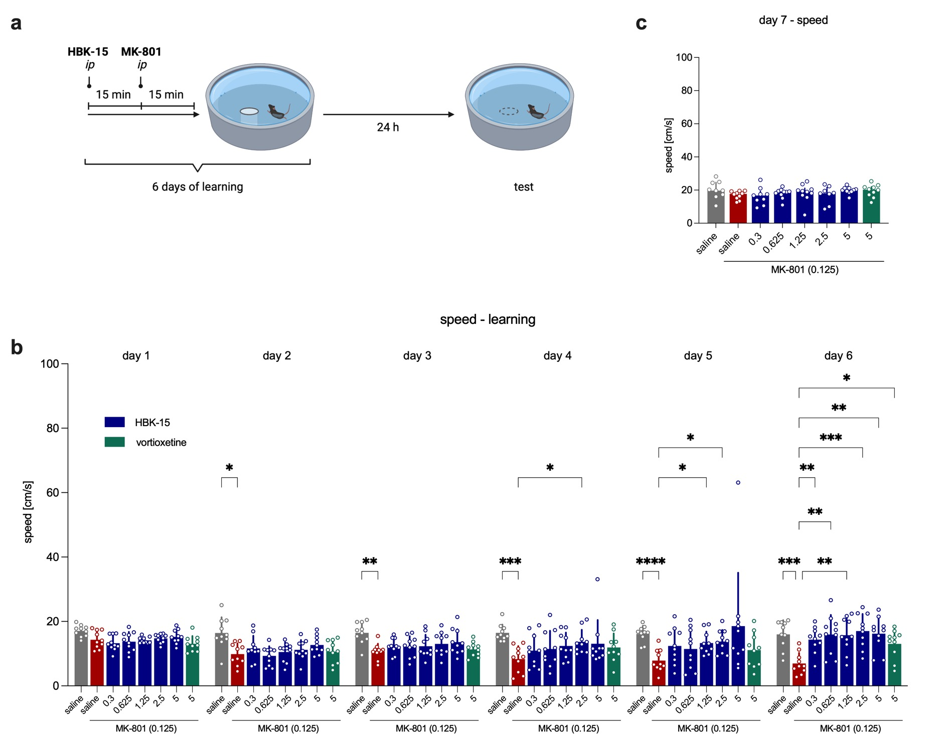
Fig. S6. HBK-15 reversed MK-801-induced spatial learning and memory deficits in the Morris water maze. a: Experimental scheme: HBK-15 and MK-801 were administered intraperitoneally (ip) 30 min before the first trial for six consecutive days and on the seventh day of the experiment no treatment was administered. b: The effect of HBK-15 on the animals' speed in the acquisition phase. The data are presented as means of four trials ± SD. Statistical analysis: two-way ANOVA for repeated measurements with Greenhouse-Geisser correction (Bonferroni post hoc), *p<0.05, **p<0.01, ***p<0.001, ****p<0.0001, n=10 mice per group. c: The influence of HBK-15 on the animals' speed in the probe test (seventh day of the experiment). The data are presented as medians with IQR. Statistical analysis: Kruskal-Wallis test (Dunn post hoc), n=8-10 mice per group

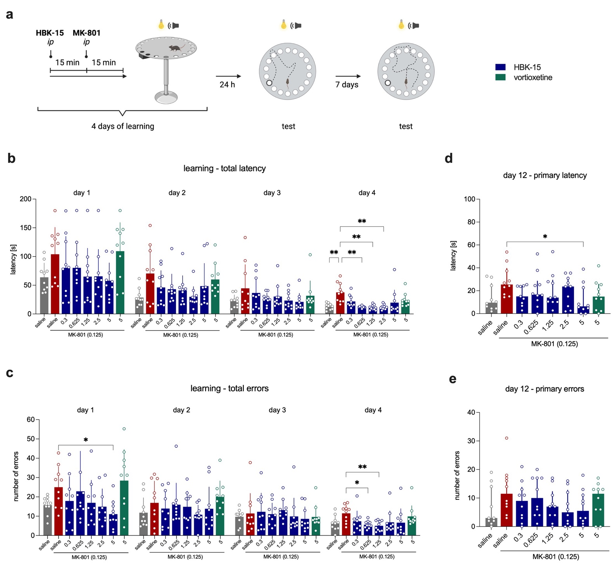
Fig. S7. HBK-15 reversed MK-801-induced spatial learning and memory deficits in the Barnes maze. a: Experimental scheme: HBK-15 and MK-801 were administered intraperitoneally (ip) 30 min before the first trial for four consecutive days and on the fifth and twelfth day of the experiment no treatment was administered. b,c: The influence of HBK-15 on the total latency (b) and number of total errors (c) in the acquisition phase. The data are presented as means of four trials ± SD. Statistical analysis: two-way ANOVA for repeated measurements with Greenhouse-Geisser correction (Bonferroni post hoc), *p<0.05, **p<0.01, n=10 mice per group. d,e: The influence of HBK-15 on the primary latency (d) and number of primary errors (e) in the probe test (the twelfth day of the experiment). The data are presented as medians with IQR. Statistical analysis: Kruskal-Wallis test (Dunn post hoc), *p<0.05, n=8-10 mice per group

Supplementary tables

Table S1. Monitored transitions and ion path parameters of analyzed neurotransmitters and deutereted internal standards.
Analyte | DA | DAd4 | 5-HT | 5-HTd4 | HIS | HISd4 | NE | NEd6 | Glu | Glud5 | ACh | AChd9
Monitored transitions | 154/137 | 158/141 | 177/160 | 181/164 | 112/95 | 116/99 | 170/152 | 176/158 | 148/84 | 153/88 | 146/87 | 155/87
Declustering potential (DP) | 46 | 56 | 131 | 136 | 66 | 6 | 136 | 41 | 26 | 1 | 1 | 1
Collision cell exit potential (CXP) | 10 | 10 | 12 | 12 | 8 | 8 | 10 | 10 | 8 | 8 | 8 | 8
Collision Energy (CE) | 15 | 15 | 11 | 15 | 21 | 25 | 11 | 13 | 21 | 23 | 19 | 19
DA – dopamine, 5-HT – serotonin, HIS – histamine, NE – norepinephrine, Glu – glutamic acid, ACh - acetylcholine

Table S2. The effect of the single administration of HBK-15 on the histamine, serotonin, acetylcholine, noradrenaline, dopamine, and glutamate level in the hippocampus homogenates of naïve mice.

Treatment | Dose [mg/kg] | Level [ng/g] or [μg/g] (glutamate)
Treatment | Dose [mg/kg] | histamine |  |  | serotonin |  |  | acetylcholine | noradrenaline | glutamate |  |  | dopamine
saline | - | 507.7 | ± | 176.0 | 360.6 | ± | 97.54 | 1153 (156.0) | 1337.0 (939.1) | 2145 | ± | 786.7 | < LOQ (20 ng/g)
HBK-15 | 0.3 | 420.9 | ± | 89.36 | 273.1 | ± | 82.82 | 1049 (291.6) | 1003.0 (649.4) | 1793 | ± | 431.0 | < LOQ (20 ng/g)
HBK-15 | 0.625 | 510.8 | ± | 160.7 | 283.9 | ± | 72.19 | 1121 (235.0) | 1195.0 (747.3) | 2220 | ± | 348.5 | < LOQ (20 ng/g)
HBK-15 | 1.25 | 616.0 | ± | 96.16 | 298.9 | ± | 64.93 | 1199 (200.0) | 1154.0 (671.0) | 2131 | ± | 332.4 | < LOQ (20 ng/g)
HBK-15 | 2.5 | 492.5 | ± | 108.9 | 324.1 | ± | 74.72 | 1115 (186.0) | 1055.0 (983.4) | 1844 | ± | 189.9 | < LOQ (20 ng/g)
HBK-15 | 5 | 515.1 | ± | 149.2 | 336.7 | ± | 76.93 | 1092 (295.0) | 878.2 (1893.1) | 1907 | ± | 326.2 | < LOQ (20 ng/g)
30 min after a single administration of HBK-15 or saline (control group), mice were sacrificed, and then the hippocampi were isolated. The level of selected neurotransmitters was determined using high-performance liquid chromatography combined with mass spectrometry. Values ​​are expressed as means ± SD (histamine, serotonin, glutamate) or medians and IQR (acetylcholine, noradrenaline). Statistical analysis: histamine, serotonin: one-way ANOVA (Bonferroni post hoc); acetylcholine, noradrenaline: Kruskal-Wallis test (Dunn post hoc); glutamate: Welch ANOVA (Dunnett's T3 post hoc), n=8-10 mice per group

Table S3. The effect of the single administration of HBK-15 on the acetylcholine and glutamate level in the microdialysates from the hippocampus of naïve mice.

Time post injection of HBK-15 at a dose of 2.5 mg/kg | Level [ng/ml]
Time post injection of HBK-15 at a dose of 2.5 mg/kg | acetylcholine |  |  | glutamate
Baseline (-30-0 min) | 4.417 | ± | 1.318 | 80.68 | ± | 53.40
0-30 min | 4.369 | ± | 1.343 | 89.88 | ± | 72.98
30-60 min | 4.330 | ± | 1.432 | 98.01 | ± | 66.89
60-90 min | 4.146 | ± | 1.212 | 88.13 | ± | 66.26
In vivo microdialysis was used to analyze extracellular acetylcholine and glutamate levels in the hippocampus of naïve, freely moving mice. Four samples were collected every 30 min after the washout period of 2 h (baseline, 30 min, 60 min and 90 min post injection of HBK-15. The level of selected neurotransmitters was determined using high-performance liquid chromatography combined with mass spectrometry. Values ​​are expressed as means ± SD. Statistical analysis: one-way repeated measures ANOVA (Dunnet’s post hoc), n=9-10 mice per group

