Appendices

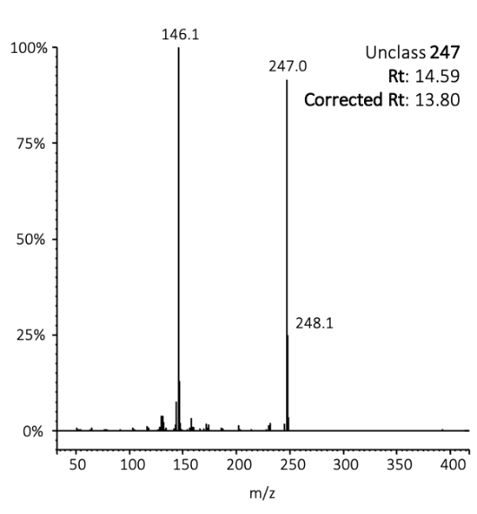

Supplemental Figure 1. Mass spectral data for tentatively new unclassified (Unclass) alkaloid of molecular weight 247 detected in Pseudophryne bibronii. The retention time (Rt) is included, along with an approximate “corrected Rt” to match the retention times in the alkaloid library of Daly et al (2005). Following Garraffo et al (2012) and Jeckel et al (2015), and based on comparisons of Rt’s for previously identified alkaloids in the present study with Rt’s from Daly et al 2005, alkaloids in the present study eluted approximately 0.79 second slower compared to the times listed in Daly et al (2005).

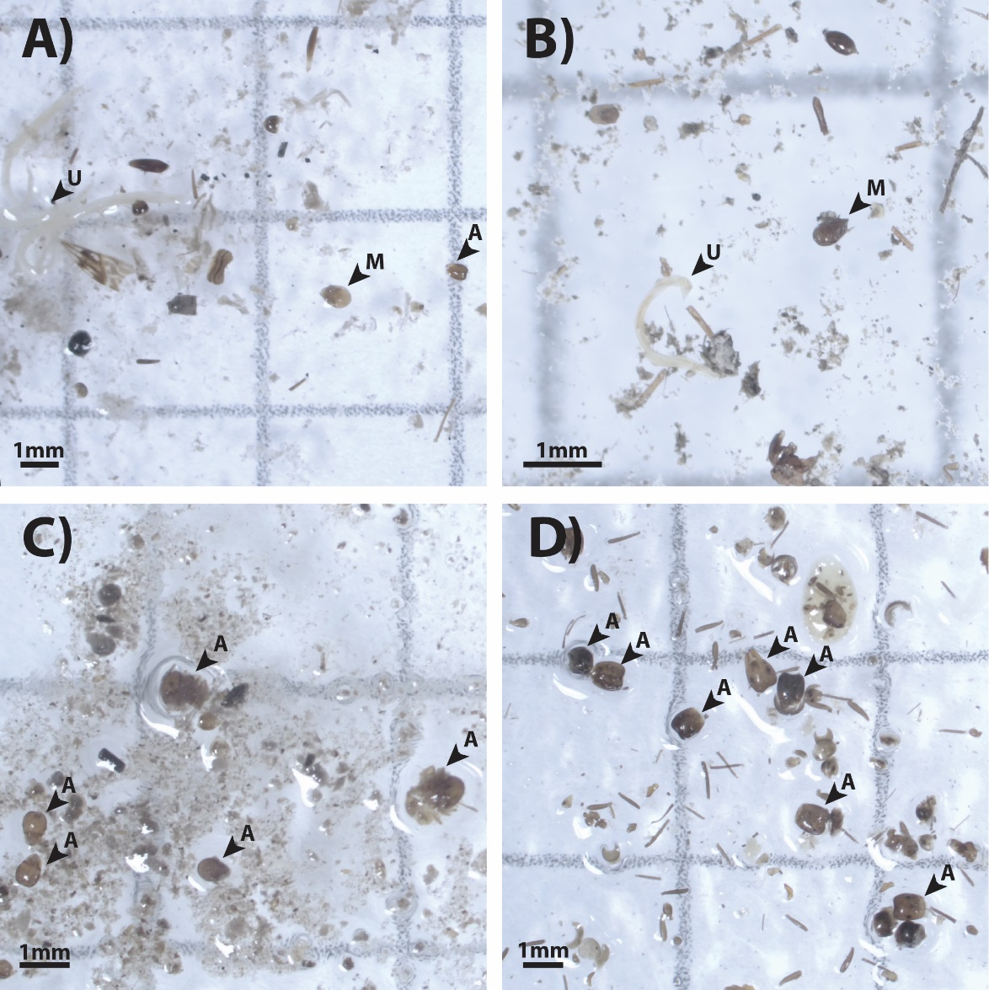

Supplemental Figure 2. Exemplar images from dietary contents analysis for A) P. dendyi, B) P. coriacea, C) P. coriacea, and D) P. guentheri. Dietary contents were broadly classified as either ant, mite, or unknown. Invertebrates identified as such are labeled with an arrow and A (ant), M (mite), or U (unknown), respectively.

