The Median Isn’t the Message: Elucidating Soil Nutrient Hot Spots
Morgan E. Barnes,^{1,2*} Dale W. Johnson,³ and Stephen C. Hart⁴
¹Environmental Systems Graduate Group, University of California, Merced, CA 95343, USA
²Biological Sciences, Pacific Northwest National Laboratory, Richland, Washington 99354, USA
³Natural Resources and Environmental Science, University of Nevada, Reno, NV 89557, USA ⁴Department of Life & Environmental Sciences and Sierra Nevada Research Institute, University of California, Merced, CA 95343, USA
*Corresponding author email: morgan.barnes@pnnl.gov phone: 1-509-371-6482

Supplementary Information

Table S1 Resin deployment information with installation date (MM/DD/YY), removal date, and the total number of days for each sampling period. Resin capsules were not deployed in WY 2015 for either plot and were only deployed in Plot 2 for WY 2016
Water Year | Plot | Season | Install Date | Remove Date | # Days | Precipitation  (mm)
2012 | 1 & 2 | Fall | 08/01/11 | 11/01/11 | 92 | 121
 |  | Spring | 11/01/11 | 05/02/12 | 183 | 875
2013 | 1 & 2 | Fall | 06/06/12 | 11/15/12 | 162 | 95
 |  | Spring | 11/15/12 | 10/02/13 | 321 | 807
2014 | 1 & 2 | Fall | 10/02/13 | 12/03/13 | 62 | 172
 |  | Spring | 12/03/13 | 06/24/14 | 203 | 529
2016 | 2 | Fall | 10/02/15 | 11/10/15 | 39 | 113
 |  | Spring | 11/10/15 | 08/11/16 | 275 | 1103

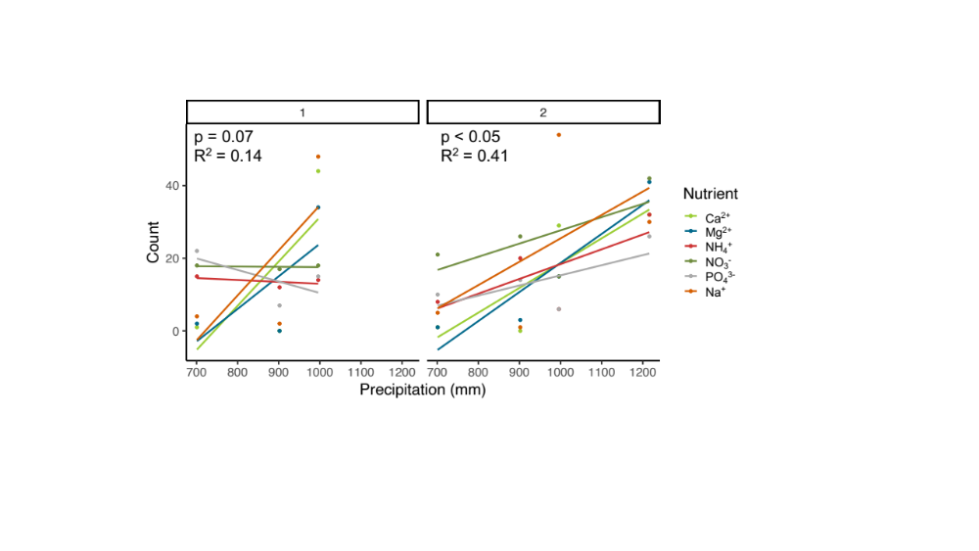
Fig. S1 Relationship between annual precipitation (mm) and total number of hot spots for PO₄³⁻, NH₄⁺, NO₃⁻, Ca²⁺, Mg²⁺, and Na⁺. Regression lines represent individual nutrient counts across all depths at Plots 1 and 2 separately
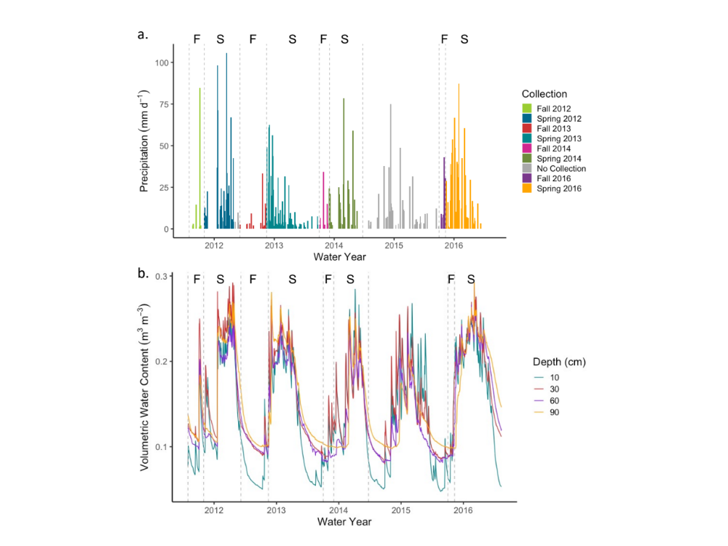
Fig. S2 Precipitation (mm d⁻¹; a.) and soil volumetric water content (m³ m⁻³) at 10-, 30-, 60-, and 90-cm soil depths (b.) and over the sampling periods (F = fall, S = spring, NS = not sampled). Resin capsule collections for each sampling period and deployments for the succeeding sampling period (completed on the same days) are denoted by vertical dashed lines. No data were collected during WY 2015

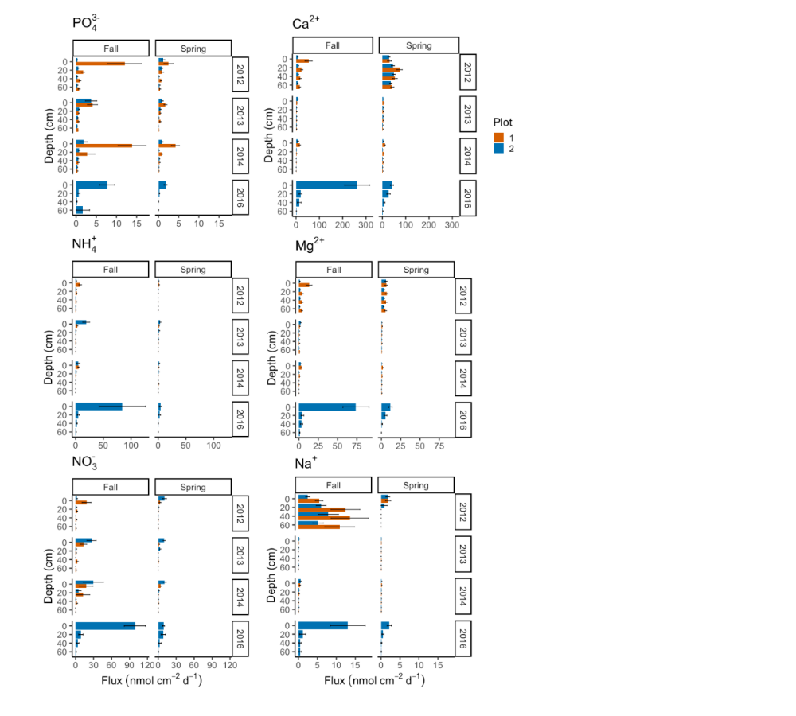
Fig. S3 Mean nutrient fluxes (nmol cm⁻² d⁻¹) for PO₄³⁻, NH₄⁺, NO₃⁻, Ca²⁺, Mg²⁺, and Na⁺ based on water year (WY), season (fall and spring), and soil depth. Each nutrient flux was normalized by number of days resin was deployed (see Table S1). No data were collected for WY 2015 or for Plot 1 during WY 2016. One + standard error of the mean is denoted by horizonal bars

Table S2 Results of mixed-effect models for Plot 1 and Plot 2 for cubed root transformed PO₄³⁻, NH₄⁺, NO₃⁻, Ca²⁺, Mg²⁺, and Na⁺ fluxes (normalized to the number of resin deployment days; nmol cm⁻² d⁻¹) as effected by the fixed effects of water year (categorical, 2012 coded as 0), season (categorical, fall coded as 0), depth (continuous), and season by depth interaction. Model coefficients were determined by restricted maximum likelihood (REML) and standard errors are reported in parentheses. Coefficients in bold indicate significance at p < 0.05. Individual (repeated sampling from same location; n = 60 for Plot 1, n = 63 for Plot 2) and vertically coincident (spatial dependency of 0-, 20-, 40-, and 60-cm; n = 16) sampling locations were included as random effects. The variance is reported for each random effect with standard deviation in parentheses. Water Year 2016 was not collected for Plot 1, therefore the effect is not included in the model and is denoted within the table as no data (ND). Model R² values are reported for the fixed effects only (i.e., marginal) and for the fixed and random effects together (i.e., conditional)

 |  |  |  |  | Fixed Effects |  |  |  |  |  |  |  |  |  |  | Random Effects |  |  | R-Squared
 | 2013 |  | 2014 | 2016 |  |  |  | Season | Depth |  |  | Season x Depth |  |  | Individual |  | Vertical |  | Fixed | Fixed + Random
Plot 1
PO₄³⁻ | -0.10 (0.06) | 0.02 (0.06) |  |  |  | ND | -0.39 (0.08) |  |  | -0.02 (<0.01) | <0.01 (<0.01) |  |  |  | 0.06 (0.24) |  | <0.01 (<0.01) |  | 0.30 | 0.44
NH₄⁺ | -0.21 (0.05) | -0.34 (0.05) |  |  |  | ND | -0.41 (0.07) |  |  | -0.02 (<0.01) | <0.01 (<0.01) |  |  |  | 0.07 (0.27) |  | <0.01 (<0.01) |  | 0.40 | 0.58
NO₃⁻ | -0.29 (0.10) | -0.18 (0.09) |  |  |  | ND | -0.48 (0.12) |  |  | -0.02 (<0.01) | 0.01 (<0.01) |  |  |  | 0.10 (0.31) |  | 0.05 (0.23) |  | 0.24 | 0.42
Ca²⁺ | -1.6 (0.08) | -1.6 (0.08) |  |  |  | ND | 0.17 (0.11) |  |  | -0.01 (<0.01) | <0.01 (<0.01) |  |  |  | 0.05 (0.22) |  | 0.07 (0.62) |  | 0.57 | 0.67
Mg²⁺ | -0.74 (0.05) | -0.77 (0.05) |  |  |  | ND | -0.02 (0.07) |  |  | -0.01 (<0.01) | 0.01 (<0.01) |  |  |  | 0.02 (0.15) |  | 0.05 (0.22) |  | 0.40 | 0.58
Na⁺ | -0.69 (0.08) | -0.57 (0.08) |  |  |  | ND | -0.30 (0.10) |  |  | <0.01 (<0.01) | <-0.01 (<0.01) |  |  |  | <0.01 (<0.01) |  | 0.01 (0.60) |  | 0.25 | 0.30
Plot 2
PO₄³⁻ | 0.15 (0.05) | 0.13 (0.05) |  |  |  | 0.03 (0.05) | -0.18 (0.06) |  |  | -0.01 (<0.01) | <-0.01 (<0.01) |  |  |  | 0.02 (0.13) |  | <0.01 (<0.01) |  | 0.27 | 0.34
NH₄⁺ | 0.13 (0.10) | -0.24 (0.09) |  |  |  | 0.48 (0.09) | -0.56 (0.11) |  |  | -0.02 (<0.01) | 0.01 (<0.01) |  |  |  | 0.06 (0.24) |  | <0.01 (0.03) |  | 0.37 | 0.44
NO₃⁻ | 0.13 (0.11) | 0.02 (0.11) |  |  |  | 0.71 (0.11) | -0.23 (0.13) |  |  | -0.03 (<0.01) | <0.01 (<0.01) |  |  |  | 0.11 (0.33) |  | <0.01 (<0.01) |  | 0.43 | 0.51
Ca²⁺ | -1.1 (0.13) | -1.3 (0.13) |  |  |  | -0.23 (0.13) | -0.07 (0.15) |  |  | -0.02 (<0.01) | 0.01 (<0.01) |  |  |  | 0.02 (0.17) |  | <0.01 (<0.001) |  | 0.34 | 0.36
Mg²⁺ | -0.30 (0.09) | -0.49 (0.09) |  |  |  | 0.07 (0.09) | -0.08 (0.11) |  |  | -0.01 (<0.01) | <0.01 (<0.01) |  |  |  | 0.02 (0.14) |  | <0.01 (0.03) |  | 0.22 | 0.25
Na⁺ | -0.53 (0.10) | -0.44 (0.07) |  |  |  | -0.49 (0.07) | -0.26 (0.08) |  |  | -0.01 (<0.01) | <-0.01 (<0.01) |  |  |  | <0.01 (<0.01) |  | <0.01 (0.04) |  | 0.24 | 0.24

Water Year |  |  |  |  |  |  |  |  |  |  | Season x Depth
 |  | 2012 to  2013 | 2012 to 2014 | 2012 to 2016 | 2013 to 2014 |  | 2013 to 2016 |  | 2014 to 2016 |  |  | 0 | 20 | 40 | 60
Plot 1
PO₄³⁻ |  | 0.10 (0.06) | -0.02 (0.06) | ND | -0.13 (0.06) |  | ND |  | ND |  |  | 0.39 (0.08) | 0.30 (0.05) | 0.20 (0.06) | 0.10 (0.09)
NH₄⁺ |  | 0.21 (0.05) | 0.34 (0.05) | ND | 0.13 (0.05) |  | ND |  | ND |  |  | 0.41 (0.07) | 0.26 (0.05) | 0.11 (0.05) | -0.04 (0.07)
NO₃⁻ |  | 0.29 (0.10) | 0.18 (0.10) | ND | -0.11 (0.10) |  | ND |  | ND |  |  | 0.48 (0.12) | 0.33 (0.08) | 0.17 (0.08) | 0.01 (0.13)
Ca²⁺ |  | 1.6 (0.08) | 1.6 (0.08) | ND | -0.02 (0.08) |  | ND |  | ND |  |  | -0.17 (0.11) | -0.35 (0.07) | -0.54 (0.07) | -0.72 (0.11)
Mg²⁺ |  | 0.74 (0.05) | 0.77 (0.05) | ND | 0.03 (0.05) |  | ND |  | ND |  |  | 0.02 (0.07) | -0.08 (0.05) | -0.18 (0.05) | -0.27 (0.07)
Na⁺ |  | 0.69 (0.08) | 0.57 (0.08) | ND | -0.12 (0.08) |  | ND |  | ND
Plot 2
PO₄³⁻ |  | -0.15 (0.05) | -0.13 (0.05) | -0.03 (0.05) | 0.02 (0.05) |  | 0.12 (0.05) |  | 0.10 (0.05)
NH₄⁺ |  | -0.13 (0.09) | 0.24 (0.09) | -0.48 (0.09) | 0.38 (0.09) |  | -0.34 (0.09) |  | -0.72 (0.09) |  |  | 0.56 (0.11) | 0.42 (0.07) | 0.27 (0.07) | 0.12 (0.11)
NO₃⁻ |  | -0.13 (0.11) | -0.02 (0.11) | -0.71 (0.11) | 0.11 (0.11) |  | -0.59 (0.11) |  | -0.70 (0.11)
Ca²⁺ |  | 1.1 (0.13) | 1.3 (0.13) | 0.23 (0.13) | 0.26 (0.13) |  | -0.84 (0.13) |  | -1.1 (0.13) |  |  | 0.07 (0.15) | -0.19 (0.10) | -0.45 (0.10) | -0.71 (0.16)
Mg²⁺ |  | 0.30 (0.09) | 0.49 (0.10) | -0.07 (0.10) | 0.20 (0.09) |  | -0.37 (0.09) |  | -0.56 (0.09)
Na⁺ |  | 0.53 (0.07) | 0.44 (0.07) | 0.49 (0.07) | -0.10 (0.07) |  | -0.04 (0.07) |  | 0.05 (0.07)

Table S3 Post-hoc findings of mixed-effect models nutrient flux (nmol cm⁻² d⁻¹) of PO₄³⁻, NH₄⁺, NO₃⁻, Ca²⁺, Mg²⁺, and Na⁺ for water years and the season by depth interaction (fixed effects). Model coefficients are displayed with the standard error in parentheses. P values are adjusted with Tukey’s method and are in bold when significant at p < 0.05. Water Year 2016 was not collected for plot 1 (no data; ND). Cells are blank when independent variable was not significant (p > 0.05) in the original mixed effect model (Table S3)

Fig. S4 Penetrometer soil resistance readings (kPa; i.e., soil strength) for Plot 1 (orange; n = 106) and Plot 2 (blue; n = 87) as a function of soil depth. Measurements were collected from non-disturbed locations adjacent to the resin capsule locations and averaged at 2.5-cm depth increments from 0- to 45-cm. The box represents the first and third quartiles (the 25th and 75th percentiles), whiskers are the highest and lowest values within 1.5 times the inter-quartile range, and points outside the box are outliers
