Supplementary material

Name | Value | Source
activationProbability_AEC2 | 0.25 [day-1] | [1]
sim_time_step | 20 [s] | /
sub_resolution | 4 | /
ECM_saturation | 1e-2 [g cm-3] | [1]
$$λ_{TGFβ,IL13}$$ | 1 | [1]
$$λ_{ECM,TGFβ}$$ | 3.65e+3 | Estimated
MMP_ECM_binding | 2.59e+7 [cm3 g-1 day-1] | [1]
MMP_TIMP_binding | 1.04e+9 [cm3 g-1 day-1] | [1]
TIMP_MMP_binding | 4.98e+8 [cm3 g-1 day-1] | [1]
ECM_flat_conc | 3.26e-3 [g cm-3] | [1]
FGF2_flat_conc | 0.00 [g cm-3] | [2]
IL13_flat_conc | 3.20e-8 [g cm-3] | [1]
MCP1_flat_conc | 0.00 [g cm-3] | [1]
MMP_flat_conc | 0.37e-7 [g cm-3] | [1]
PDGF_flat_conc | 0.35e-8 [g cm-3] | [1]
TGFb_ac_flat_conc | 2.51e-12 [g cm-3] | [1]
TGFb_in_flat_conc | 2.51e-12 [g cm-3] | Estimated
TIMP_flat_conc | 5.74e-10 [g cm-3] | [1]
TNFa_flat_conc | 2.50e-8 [g cm-3] | [1]
flat_conc | 0.0 [g cm-3] | /
ECM_D | 0.0 [µm2 day-1] | [1]
FGF2_D | 5.62e+6 [µm2 day-1] | [3]
IL13_D | 1.08e+6 [µm2day-1] | [1]
MCP1_D | 1.73e+7 [µm2 day-1] | [1]
MMP_D | 4.32e+6 [µm2 day-1] | [1]
PDGF_D | 8.64e+6 [µm2 day-1] | [1]
TGFb_ac_D | 4.32e+6 [µm2 day-1] | [1]
TGFb_in_D | 4.32e+6 [µm2 day-1] | Estimated
TIMP_D | 4.32e+6 [µm2 day-1] | [1]
TNFa_D | 1.29e+6 [µm2 day-1] | [1]
ECM_d | 3.70e-1 [day-1] | [1]
FGF2_d | 1.66 [day-1] | [4]
IL13_d | 1.25e+1 [day-1] | [1]
MCP1_d | 1.73 [day-1] | [1]
MMP_d | 4.32 [day-1] | [1]
PDGF_d | 3.84 [day-1] | [1]
TGFb_ac_d | 3.33e+2 [day-1] | [1]
TGFb_in_d | 1.10e+1 [day-1] | Estimated
TIMP_d | 2.16e+1 [day-1] | [1]
TNFa_d | 5.55e+1 [day-1] | [1]
k_FGF2 | 1.72e-9 [g cm-3] | [5]
k_IL13 | 2.00e-7 [g cm-3] | [1]
k_MCP1 | 5.00e-9 [g cm-3] | [1]
k_PDGF | 1.50e-8 [g cm-3] | [1]
k_TGFb_ac | 1.00e-10 [g cm-3] | [1]
k_TGFb_in | 1.00e-10 [g cm-3] | Estimated
$$λ_{FGF2,TGFβ}$$ | 3.00e-10 [g cm-3] | [6]
k_TNFa | 5.00e-7 [g cm-3] | [1]
AEC2_proliferation | 2.63e-2 [day-1] | Estimated
F_proliferation_IL13_TGFb | 2.50e-1 [day-1] | Estimated
$$λ_{F,AEC2}$$ | 1.99 [day-1] | Estimated
M0_basic_prob_production | 4.38e-2 [day-1] | Estimated
AEC2_AEC1_differentiation | 9.80e-3 [day-1] | Estimated
F_MF_PDGF_differentiation | 1.20e-1 [day-1] | Estimated
F_MF_TGFb_ac_differentiation | 1.20e-1 [day-1] | Estimated
M1_M2_differentiation | 1.52e-2 [day-1] | Estimated
M2_M1_TNFa_differentiation | 5.00e-3 [day-1] | [1]
AEC1_apoptosis | 1.65e-2 [day-1] | Estimated
AEC2_apoptosis | 1.65e-2 [day-1] | [1]
Senescent_AEC2_apoptosis | 0.0 [day-1] | Estimated
F_apoptosis | 1.66e-2 [day-1] | [1]
M1_apoptosis | 2.00e-2 [day-1] | [1]
M2_apoptosis | 1.50e-2 [day-1] | [1]
MF_apoptosis | 1.66e-2 [day-1] | [1]
AEC2_FGF2_secretion | 1.93e-14 [g day-1] | Estimated
AEC2_MCP1_secretion | 5.60e-14 [g day-1] | Estimated
AEC2_TNFa_secretion | 2.29e-11 [g day-1] | Estimated
F_TGFb_secretion | 6.30e-17 [g day-1] | Estimated
F_ECM_secretion | 3.50e-11 [g day-1] | Estimated
MF_ECM_secretion | 7.00e-11 [g day-1] | Estimated
M1_TNFa_secretion | 1.30e-15 [g day-1] | Estimated
M2_IL13_secretion | 2.87e-14 [g day-1] | Estimated
M2_MMP_secretion | 1.44e-12 [g day-1] | Estimated
M2_PDGF_secretion | 1.24-13 [g day-1] | Estimated
M2_TGFb_secretion | 9.99e-15 [g day-1] | Estimated
M2_TIMP_secretion | 2.87e-13 [g day-1] | Estimated
K_damage_prob | 4.18 [day-1] | [7]
Infection_radius | 110.00 [µm] | Estimated
NeighboursThreshold | 2 | Estimated
Phagocytic_fraction | 100% | Estimated
Phagocytic_index | 1 | [8] & Estimated
Apoptosis_prob_after_damage | 0.00 [day-1] | Estimated
damage_distance | 23.18 [µm] | Estimated
phagocytic_distance | 15.17 [µm] | Estimated
mesenchymal_speed | 240.00 [µm day-1] | [9]
macrophage_speed | 5760.00 [µm day-1] | [10]
AEC1_speed | 60.00 [µm day-1] | Estimated
AEC2_speed | 600.00 [µm day-1] | [11]
fibr_to_center | 121.49 [µm] | Estimated
macrophage_to_center | 96.21 [µm] | Estimated
alveolus_radius | 110.00 [µm] | [12]
int_cells_volume | 774.00 [µm³] | [13]
alv_macr_diam | 16.00 [µm] | [14]
ep_2_volume | 815.00 [µm³] | [13]
ep_1_volume | 2391.00 [µm³] | [13]
Table S1. Model parameters

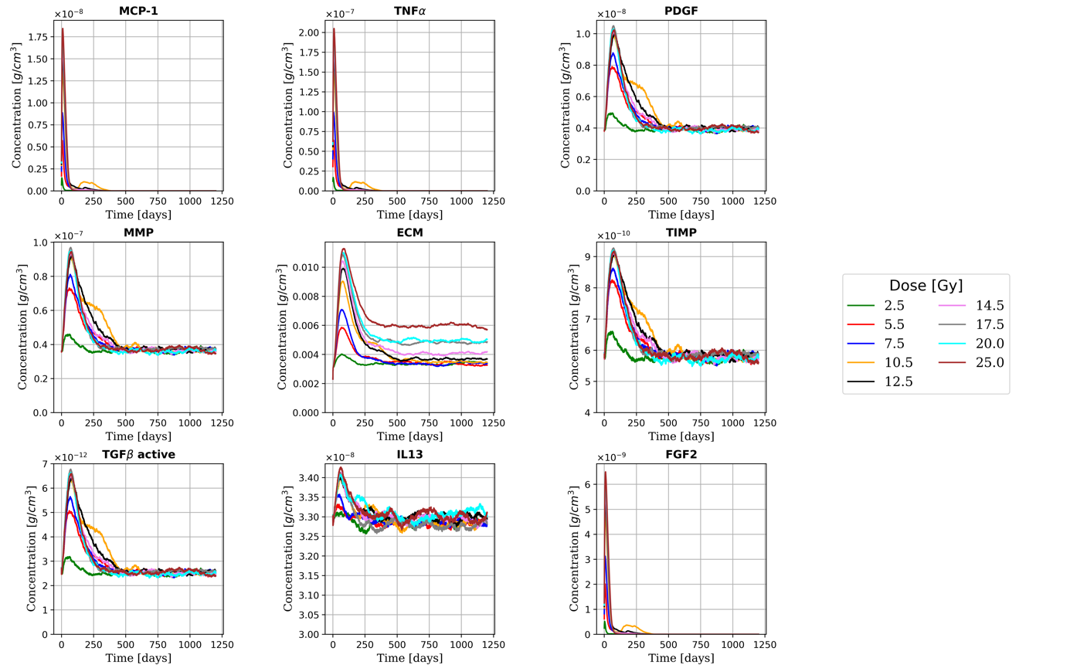
Figure S1. Time evolution of the extracellular substances for multiple doses from the ABM-MC model. Simulation of a single photon fraction with bystander threshold = 2, phagocytic index = 1 and phagocytic fraction = 100%

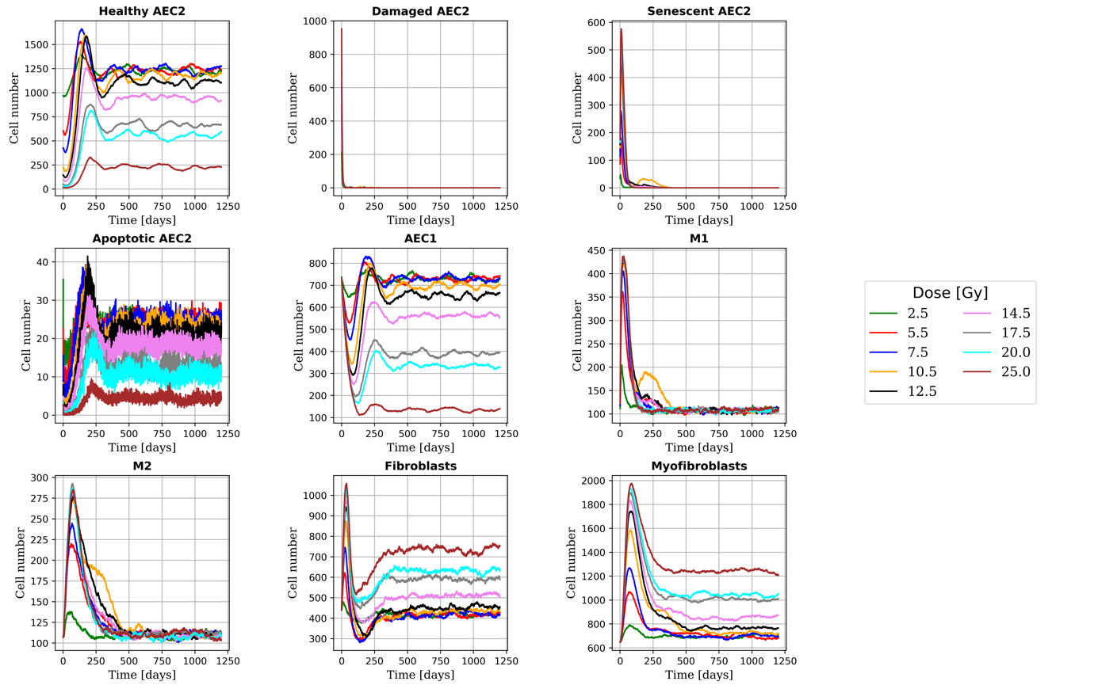
Figure S2. Time evolution of the total number of cells for multiple doses from the ABM-MC model. Simulation of a single photon fraction with bystander threshold = 2, phagocytic index = 1 and phagocytic fraction = 100%

1. Hao W, Marsh C, Friedman A. A mathematical model of idiopathic pulmonary fibrosis. PLoS One (2015) 10:1–19. doi:10.1371/journal.pone.0135097
2. Li CM, Khosla J, Pagan I, Hoyle P, Sannes PL. TGF-β1 and fibroblast growth factor-1 modify fibroblast growth factor-2 production in type II cells. Am J Physiol - Lung Cell Mol Physiol (2000) 279:1038–1046. doi:10.1152/ajplung.2000.279.6.l1038
3. Kołodziej M, Sauer DG, Beck J, Marek WK, Hahn R, Jungbauer A, Dürauer A, Piątkowski W, Antos D. Scale up of a chromatographic capture step for a clarified bacterial homogenate – Influence of mass transport limitation and competitive adsorption of impurities. J Chromatogr A (2020) 1618: doi:10.1016/j.chroma.2020.460856
4. Dvorak P, Bednar D, Vanacek P, Balek L, Eiselleova L, Stepankova V, Sebestova E, Kunova Bosakova M, Konecna Z, Mazurenko S, et al. Computer-assisted engineering of hyperstable fibroblast growth factor 2. Biotechnol Bioeng (2018) 115:850–862. doi:10.1002/bit.26531
5. Grazul-Bilska AT, Luthra G, Reynolds LP, Bilski JJ, Johnson ML, Adbullah SA, Redmer DA, Abdullah KM. Effects of basic fibroblast growth factor (FGF-2) on proliferation of human skin fibroblasts in type II diabetes mellitus. Exp Clin Endocrinol Diabetes (2002) 110:176–181. doi:10.1055/s-2002-32149
6. Xiao L. TGF-beta 1 induced fibroblast proliferation is mediated by the FGF-2/ERK pathway. Front Biosci (2012) 17:2667. doi:10.2741/4077
7. McMahon SJ, Butterworth KT, Trainor C, McGarry CK, O’Sullivan JM, Schettino G, Hounsell AR, Prise KM. A Kinetic-Based Model of Radiation-Induced Intercellular Signalling. PLoS One (2013) 8:15–18. doi:10.1371/journal.pone.0054526
8. Hu B, Sonstein J, Christensen PJ, Punturieri A, Curtis JL. Deficient In Vitro and In Vivo Phagocytosis of Apoptotic T Cells by Resident Murine Alveolar Macrophages. J Immunol (2000) 165:2124–2133. doi:10.4049/jimmunol.165.4.2124
9. Rikard SM, Athey TL, Nelson AR, Christiansen SLM, Lee JJ, Holmes JW, Peirce SM, Saucerman JJ. Multiscale Coupling of an Agent-Based Model of Tissue Fibrosis and a Logic-Based Model of Intracellular Signaling. Front Physiol (2019) 10: doi:10.3389/fphys.2019.01481
10. Pollmächer J, Figge MT. Agent-based model of human alveoli predicts chemotactic signaling by epithelial cells during early Aspergillus fumigatus infection. PLoS One (2014) 9:e111630. doi:10.1371/journal.pone.0111630
11. Legrand C, Gilles C, Zahm JM, Polette M, Buisson AC, Kaplan H, Birembaut P, Tournier JM. Airway epithelial cell migration dynamics: MMP-9 role in cell- extracellular matrix remodeling. J Cell Biol (1999) 146:517–529. doi:10.1083/jcb.146.2.517
12. Ochs M, Nyengaard JR, Jung A, Knudsen L, Voigt M, Wahlers T, Richter J, Gundersen HJG. The Number of Alveoli in the Human Lung. Am J Respir Crit Care Med (2004) 169:120–124. doi:10.1164/rccm.200308-1107oc
13. Stone KC, Mercer RR, Gehr P, Stockstill B, Crapo JD. Allometric relationships of cell numbers and size in the mammalian lung. Am J Respir Cell Mol Biol (1992) 6:235–243. doi:10.1165/ajrcmb/6.2.235
14. Fathi M, Johansson A, Lundborg M, Orre L, Sköld CM, Camner P. Functional and morphological differences between human alveolar and interstitial macrophages. Exp Mol Pathol (2001) 70:77–82. doi:10.1006/exmp.2000.2344

