Supplementary material section 1: Notes about the Stringency Index

The stringency index is a metric developed as part of the Oxford Coronavirus Government Response Tracker (OxCGRT) project [ref]. This project aimed to systematically gather information on policy measures that governments have implemented to combat COVID-19. The index is a composite measure of nine response metrics: school closures; workplace closures; public event cancellations; restrictions on public gatherings; public transport closures; stay-at-home requirements; public information campaigns; internal movement restrictions; and international travel controls. The index for any particular day is calculated as the mean score of these nine metrics, each scoring between 0 and 100. The higher the score, the stricter the measures in place. The evolution of the stringency index throughout the pandemic is shown in figure 1 below.

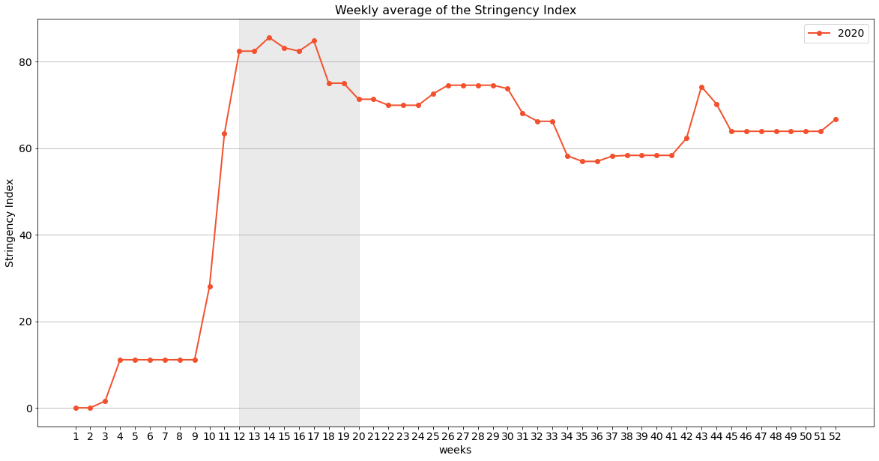
Figure 1. The average weekly Stringency index in the 52 weeks in 2020. The lockdown period is shaded.

Supplementary material section 2: Variables used in the regression analysis
Table 1 Variables included in the regression analysis.
Variable | Description | Source | Mean (SD) | Min-Max
Volume seafood sold | Average daily volume (kg) of seafood sold by a fishing operator, aggregated by week (dependent variable). | Docapesca | 87.18 (242.94) | 0.20-17,273
Restaurant closure period | Binary variable indicating whether the observation was taken at the period where restaurants were closed due to the COVID-19 pandemic restrictions (independent variable for half of the regressions). | Decreto n.º 2-A/2020 | 0.04 (0.20) | 0-1
Stringency index | A numeric variable representing the strictness of the COVID-19 pandemic restrictions (independent variable for half of the regressions). | Oxford Covid-19 Government Response Tracker | 14.34 (27.86) | 0-85.58
Month x | 11 binary variables indicating the calendar month of the observation (using January as the reference month). | N/A | N/A | 0-1
Significant wave height | The average height of the highest third of surface ocean/sea waves generated by wind and swell. It represents the vertical distance between the wave crest and the wave trough, measured at the station nearest to each port. | Portuguese Institute for Sea and Atmosphere and the European Centre for Medium-Range Weather Forecasts | 1.42 (0.74) | 0.23-4.79
Sea surface temperature | The temperature of seawater near the surface measured at the station nearest to each port. |  | 16.55 (2.21) | 10.35-24.88
Mean wave direction | The mean direction of ocean/sea surface waves measured at the station nearest to each port. |  | 280.88 (42.80) | 102.34-340.19
Mean wave period | The average time it takes for two consecutive wave crests on the surface of the ocean/sea to pass through a fixed point, measured at the station nearest to each port. |  | 8.02 (2.14) | 2.73-13.98
Wind speed | The horizontal speed of the 'neutral wind', at a height of ten metres above the surface of the Earth. The units of this parameter are metres per second, measured at the station nearest to each port. |  | 5.29 (1.55) | 1.44-11.15
Wind direction | The direction from which the 'neutral wind' blows, in degrees clockwise from true North, at the height of ten metres above the surface of the Earth, measured at the station nearest to each port. |  | 219.73 (60.83) | 17.51-344.66
Average price/kg past week | Average price per kilogram obtained in the first sale of fish by NUTS region, aggregated per week, with a one-week lag. | Docapesca | 7.69 (2.92) | 0.40-112.50
Stays in hospitality | Stays (No.) in tourist accommodation establishments by NUTS region. Measured monthly. | Portuguese Statistics Institute | 1,073,735 (773,562) | 18,153-3,410,412
Turnover in restaurants | The non-adjusted restaurant turnover rate in Portugal presented a year-on-year change rate. Measured monthly. | Portuguese Statistics Institute | 1,12 (11.76) | -36.50-11.79

Supplementary material 3: Characterization of the NUTS2 regions in Portugal
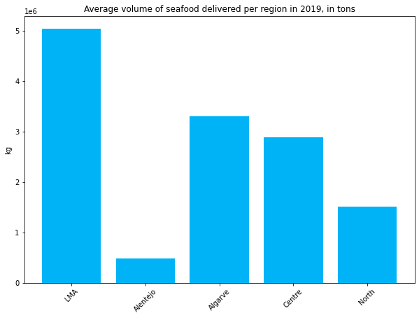
Figure 2. Total volume of seafood delivered per NUTS2 region, in 2019

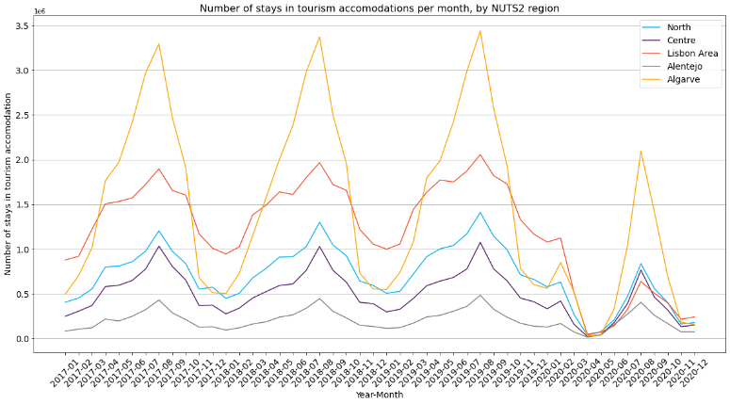
Figure 3 Number of monthly stays in the registered tourism accommodation, from 01/2017 to 12/2020, by NUTS2 region, in millions. Source of data: INE

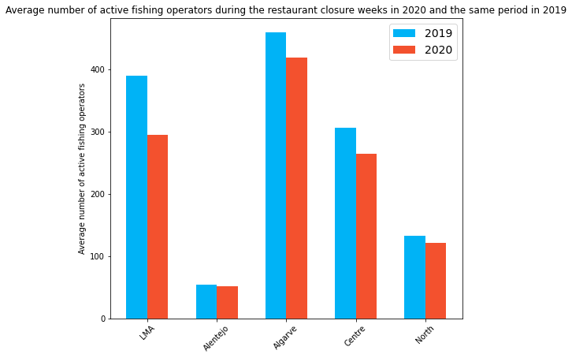
Figure 4 Average number of active fishing operators in the weeks of the restaurant closure in 2020 and the same period in 2019, per NUTS2 region.

Data by region
Our sample for North included 27246 datapoints, corresponding to 514 fishing operators; for Centre, it included 53607 datapoints, corresponding to 975 fishing operators; for LMA, it included 70728 datapoints, corresponding to 1000 fishing operators; for Alentejo, it included 11048 datapoints, corresponding to 161 fishing operators; and for Algarve, it included 87176 datapoints, corresponding to 1065 fishing operators.

Supplementary material section 4: Estimation of differences in the pattern of the first sale of seafood during the COVID-19 pandemic
The unit roots analysis conducted using an augmented Dickey-Fuller test indicated no unit roots present in the data. The augmented Dickey-Fuller test was executed in R, utilizing the punitroot package, which allowed for simultaneous analysis across multiple fishing units. Since the data did not contain unit roots and we had time-series observations for every fishing unit, we proceeded with fixed-effects regressions with port-level error clustering. These regressions were executed using the PanelOLS function from the Python package linearmodels, version 4.19. The equations for the conducted regressions can be represented with the following equation:
ReportedSeafood_{it} = β0 + β₁StringencyIndex_{it} + β₂OperatorType_{it} +
β₃OperatorTypeXStringencyIndex _{it} + γ₁Month2 _{it} + γ₂Month3 _{it} + … + γ₁₀Month11_{it} + γ₁₁SWH_{it} + γ₁₂SST_{it} + γ₁₃MWD_{it} + γ₁₄MWP_{it} + γ₁₅WindSpeed_{it} + γ₁₆WindDirection_{it} + γ₁₇PreviousPriceKg_{it} + γ₁₈StaysHospitality_{it} + γ₁₉RestaurantRevenue_{t} + FishingEntityFixedEffects + u_{it}

Note that i = 1, …, n, where n is the number of distinct fishing operators, and t = 1, …, T, where T is the number of weeks in the dataset.
The regression analysis outputted coefficients estimating the effect of the independent variable (either the flag indicating restaurant closure or the stringency index) on the volume of the seafood delivered per fishing unit, per region, after controlling for the remaining variables. It also outputted the minimum and maximum coefficients, estimated using 95% confidence intervals and the p-value for that confidence level. All reported p-values are for two-sided tests. The complete results are in the regression tables below.

Supplementary material section 5: Regression results

Table 2 Regression table for the effect of the restaurant closure in the North region
 | Coefficient | Std. Error |  | p-value | Lower 95%CI | Upper 95%CI
Restaurant closure period (vessel as the ref. group) | -14.43 | 7.18 |  | 0.04 | -28.50 | -0.35
Restaurant closure period (fisherfolk-on-foot as the ref. group) | 13.10 | 5.53 |  | 0.02 | 2.27 | 23.93
Operator type (vessel ref. group) | 27.01 | 4.35 |  | < .001 | 18.48 | 35.54
Operator x Restaurant closure period | 27.52 | 3.45 |  | < .001 | 20.75 | 34.29
Month 2 | 3.33 | 6.99 |  | 0.63 | -10.38 | 17.03
Month 3 | -2.82 | 5.72 |  | 0.62 | -14.04 | 8.39
Month 4 | 13.91 | 6.61 |  | 0.04 | 0.95 | 26.87
Month 5 | -1.07 | 7.99 |  | 0.89 | -16.73 | 14.59
Month 6 | 3.88 | 5.51 |  | 0.48 | -6.91 | 14.68
Month 7 | 39.20 | 18.86 |  | 0.04 | 2.24 | 76.16
Month 8 | 18.17 | 3.81 |  | < .001 | 10.71 | 25.63
Month 9 | 9.92 | 7.15 |  | 0.17 | -4.09 | 23.93
Month 10 | 1.69 | 5.51 |  | 0.76 | -9.11 | 12.49
Month 11 | 2.33 | 2.64 |  | 0.38 | -2.85 | 7.50
Month 12 | -2.57 | 3.97 |  | 0.52 | -10.35 | 5.21
Significant wave height | -7.03 | 5.48 |  | 0.20 | -17.78 | 3.72
Sea surface temperature | -1.78 | 1.10 |  | 0.10 | -3.93 | 0.37
Mean wave direction | -0.05 | 0.15 |  | 0.76 | -0.33 | 0.24
Mean wave period | 8.32 | 3.92 |  | 0.03 | 0.65 | 16.00
Wind speed | 2.67 | 0.96 |  | 0.01 | 0.79 | 4.54
Wind direction | 0.02 | 0.05 |  | 0.72 | -0.09 | 0.13
Average price/kg past week | -1.73 | 0.27 |  | < .001 | -2.26 | -1.21
Stays in hospitality | 0.00 | 0.00 |  | 0.03 | 0.00 | 0.00
Turnover in restaurants (YoY growth) | 0.54 | 0.20 |  | 0.01 | 0.15 | 0.92
N of observations | 27246
N of entities | 514
Time periods | 202
F-statistic | F(23, 26709) = 3.66
R² (Between) | -0.02
R² (Within) | 0.003
Note: We added an additional line in the regression table to show the effect of the dependent variable when the fisherfolk-on-foot is set as the reference group, given the significant interaction between the dependent variable and the fishing operator (vessel vs. Fisherfolk-on-foot). When fisherfolk-on-foot is defined as the reference group, the statistics of Operator type and Operator x Dependent variable terms are the additive inverses of the statistics presented in the table. All remaining statistics are the same, regardless of the fishing operator reference group. Reported p-values are for two-sided tests. Ref. = Reference.

Table 3 Regression table for the effect of the stringency index in the North region
 | Coefficient | Std. Error | p-value | Lower 95%CI | Upper 95%CI
Stringency index (vessel as the ref. group) | -0.25 | 0.09 | < .001 | -0.43 | -0.08
Stringency index (fisherfolk-on-foot as the ref. group) | 0.06 | 0.11 | 0.61 | -0.16 | 0.27
Vessel flag | 20.83 | 4.23 | < .001 | 12.54 | 29.12
Vessel x Stringency Index | 0.31 | 0.05 | < .001 | 0.21 | 0.41
Month 2 | 4.41 | 7.01 | 0.53 | -9.33 | 18.16
Month 3 | -1.95 | 6.58 | 0.77 | -14.84 | 10.94
Month 4 | 14.46 | 5.40 | 0.01 | 3.88 | 25.04
Month 5 | -1.17 | 6.75 | 0.86 | -14.41 | 12.07
Month 6 | 3.83 | 4.19 | 0.36 | -4.38 | 12.04
Month 7 | 38.65 | 17.92 | 0.03 | 3.53 | 73.77
Month 8 | 16.52 | 2.40 | < .001 | 11.82 | 21.22
Month 9 | 7.66 | 4.91 | 0.12 | -1.97 | 17.29
Month 10 | -0.24 | 4.16 | 0.95 | -8.40 | 7.92
Month 11 | 0.85 | 2.46 | 0.73 | -3.98 | 5.68
Month 12 | -4.36 | 3.87 | 0.26 | -11.94 | 3.22
Significant wave height | -8.28 | 5.77 | 0.15 | -19.60 | 3.03
Sea surface temperature | -1.72 | 1.08 | 0.11 | -3.83 | 0.40
Mean wave direction | -0.05 | 0.14 | 0.73 | -0.33 | 0.23
Mean wave period | 8.53 | 4.07 | 0.04 | 0.55 | 16.51
Wind speed | 2.84 | 1.06 | 0.01 | 0.76 | 4.93
Wind direction | 0.03 | 0.06 | 0.65 | -0.09 | 0.14
Average price/kg past week | -1.73 | 0.27 | < .001 | -2.26 | -1.20
Stays in hospitality | 0.00 | 0.00 | 0.13 | 0.00 | 0.00
N of observations | 27246
N of entities | 514
Time periods | 202
F-statistic | F(22, 26710) = 3.72
R² (Between) | -0.02
R² (Within) | 0.003
Note: We added an additional line in the regression table to show the effect of the dependent variable when the fisherfolk-on-foot is set as the reference group, given the significant interaction between the dependent variable and the fishing operator (vessel vs. Fisherfolk-on-foot). When fisherfolk-on-foot is defined as the reference group, the statistics of Operator type and Operator x Dependent variable terms are the additive inverses of the statistics presented in the table. All remaining statistics are the same, regardless of the fishing operator reference group. Reported p-values are for two-sided tests. Ref. = Reference.

Table 4 Regression table for the effect of the restaurant closure in the Centre region
 | Coefficient | Std. Error | p-value | Lower 95%CI | Upper 95%CI
Restaurant closure period (vessel as the ref. group) | -18.10 | 16.17 | 0.26 | -49.8 | 13.58
Restaurant closure period (fisherfolk-on-foot as the ref. group) | -8.24 | 13.96 | 0.55 | -35.60 | 19.12
Vessel flag | 14.49 | 16.74 | 0.39 | -18.3 | 47.31
Vessel x Restaurant closure period | 9.88 | 2.72 | 0.00 | 4.55 | 15.21
Month 2 | 23.28 | 7.84 | 0.00 | 7.90 | 38.65
Month 3 | 17.02 | 11.42 | 0.14 | -5.37 | 39.41
Month 4 | 28.28 | 23.16 | 0.22 | -17.1 | 73.66
Month 5 | 9.07 | 20.89 | 0.66 | -31.8 | 50.02
Month 6 | 2.88 | 15.56 | 0.85 | -27.6 | 33.38
Month 7 | 26.00 | 19.78 | 0.19 | -12.7 | 64.78
Month 8 | 24.00 | 14.08 | 0.09 | -3.59 | 51.59
Month 9 | 11.00 | 9.47 | 0.25 | -7.57 | 29.56
Month 10 | 15.57 | 8.82 | 0.08 | -1.72 | 32.85
Month 11 | 10.25 | 10.78 | 0.34 | -10.88 | 31.39
Month 12 | 3.33 | 6.68 | 0.62 | -9.76 | 16.43
Significant wave height | -20.46 | 8.40 | 0.01 | -36.9 | -4.01
Sea surface temperature | -4.09 | 1.85 | 0.03 | -7.73 | -0.46
Mean wave direction | 0.13 | 0.06 | 0.02 | 0.02 | 0.25
Mean wave period | 5.32 | 2.52 | 0.04 | 0.37 | 10.26
Wind speed | 2.92 | 0.91 | 0.00 | 1.14 | 4.70
Wind direction | 0.08 | 0.02 | 0.00 | 0.04 | 0.11
Average price/kg past week | 0.66 | 1.31 | 0.62 | -1.91 | 3.22
Stays in hospitality | 0.00 | 0.00 | 0.70 | < .001 | 0.00
Turnover in restaurants (YoY growth) | -0.12 | 0.12 | 0.31 | -0.35 | 0.11
N of observations | 53607
N of entities | 975
Time periods | 202
F-statistic | F(23, 52609) = 6.19
R² (Between) | -0.002
R² (Within) | 0.003
Note: We added an additional line in the regression table to show the effect of the dependent variable when the fisherfolk-on-foot is set as the reference group, given the significant interaction between the dependent variable and the fishing operator (vessel vs. Fisherfolk-on-foot). When fisherfolk-on-foot is defined as the reference group, the statistics of Operator type and Operator x Dependent variable terms are the additive inverses of the statistics presented in the table. All remaining statistics are the same, regardless of the fishing operator reference group. Reported p-values are for two-sided tests. Ref. = Reference.

Table 5 Regression table for the effect of the stringency index in the Centre region
 | Coefficient | Std. Error | p-value | Lower 95%CI | Upper 95%CI
Stringency index (vessel as the ref. group) | -0.04 | 0.10 | 0.65 | -0.24 | 0.15
Stringency index (fisherfolk-on-foot as the ref. group) | -0.13 | 0.16 | 0.43 | -0.44 | 0.19
Vessel flag | 16.77 | 15.35 | 0.27 | -13.31 | 46.85
Vessel x Stringency Index | -0.08 | 0.07 | 0.22 | -0.22 | 0.05
Month 2 | 23.67 | 8.29 | 0.00 | 7.42 | 39.91
Month 3 | 15.75 | 10.98 | 0.15 | -5.76 | 37.27
Month 4 | 25.47 | 22.03 | 0.25 | -17.71 | 68.65
Month 5 | 9.34 | 22.48 | 0.68 | -34.72 | 53.39
Month 6 | 4.87 | 18.65 | 0.79 | -31.69 | 41.42
Month 7 | 28.31 | 23.38 | 0.23 | -17.51 | 74.13
Month 8 | 27.05 | 19.47 | 0.16 | -11.12 | 65.21
Month 9 | 14.28 | 13.31 | 0.28 | -11.81 | 40.38
Month 10 | 18.33 | 12.88 | 0.15 | -6.91 | 43.58
Month 11 | 12.48 | 13.32 | 0.35 | -13.63 | 38.59
Month 12 | 5.33 | 8.24 | 0.52 | -10.83 | 21.48
Significant wave height | -19.50 | 7.86 | 0.01 | -34.91 | -4.09
Sea surface temperature | -3.97 | 1.76 | 0.02 | -7.42 | -0.52
Mean wave direction | 0.18 | 0.10 | 0.07 | -0.02 | 0.39
Mean wave period | 5.33 | 2.60 | 0.04 | 0.22 | 10.43
Wind speed | 2.83 | 0.92 | 0.00 | 1.03 | 4.63
Wind direction | 0.08 | 0.02 | 0.00 | 0.04 | 0.12
Average price/kg past week | 0.85 | 1.43 | 0.55 | -1.95 | 3.66
Stays in hospitality | 0.00 | 0.00 | 0.72 | 0.00 | 0.00
N of observations | 53607
N of entities | 975
Time periods | 202
F-statistic | F(22, 52610) = 5.93
R² (Within) | 0.003
Note: We added an additional line in the regression table to show the effect of the dependent variable when the fisherfolk-on-foot is set as the reference group, given the significant interaction between the dependent variable and the fishing operator (vessel vs. Fisherfolk-on-foot). When fisherfolk-on-foot is defined as the reference group, the statistics of Operator type and Operator x Dependent variable terms are the additive inverses of the statistics presented in the table. All remaining statistics are the same, regardless of the fishing operator reference group. Reported p-values are for two-sided tests. Ref. = Reference.

Table 6 Regression table for the effect of the restaurant closure in the LMA region
 | Coeff. | Std. Error | p-value | Lower 95%CI | Upper 95%CI
Restaurant closure period (vessel as the ref. group) | 11.50 | 11.59 | 0.32 | -11.21 | 34.21
Restaurant closure period (fisherfolk-on-foot as the ref. group) | 78.74 | 24.10 | <.001 | 31.50 | 125.97
Vessel flag | 36.86 | 17.94 | 0.04 | 1.69 | 72.02
Vessel x Restaurant closure period | 67.24 | 22.30 | <.001 | 23.53 | 110.95
Month 2 | -2.01 | 9.32 | 0.83 | -20.27 | 16.26
Month 3 | -11.15 | 5.78 | 0.05 | -22.48 | 0.18
Month 4 | -9.91 | 7.60 | 0.19 | -24.80 | 4.98
Month 5 | -9.59 | 6.42 | 0.14 | -22.16 | 2.99
Month 6 | -4.60 | 9.47 | 0.63 | -23.16 | 13.95
Month 7 | 24.01 | 24.97 | 0.34 | -24.93 | 72.95
Month 8 | 36.04 | 25.18 | 0.15 | -13.31 | 85.39
Month 9 | 15.97 | 13.71 | 0.24 | -10.91 | 42.85
Month 10 | -4.77 | 13.23 | 0.72 | -30.70 | 21.16
Month 11 | 3.30 | 12.76 | 0.80 | -21.71 | 28.31
Month 12 | 2.11 | 10.94 | 0.85 | -19.34 | 23.56
Significant wave height | -15.88 | 12.38 | 0.20 | -40.15 | 8.39
Sea surface temperature | -2.67 | 3.32 | 0.42 | -9.19 | 3.84
Mean wave direction | -0.02 | 0.29 | 0.96 | -0.58 | 0.55
Mean wave period | 3.30 | 5.02 | 0.51 | -6.54 | 13.13
Wind speed | 3.12 | 3.17 | 0.32 | -3.09 | 9.32
Wind direction | 0.14 | 0.08 | 0.08 | -0.02 | 0.29
Average price/kg past week | 0.22 | 2.73 | 0.94 | -5.14 | 5.57
Stays in hospitality | 0.00 | 0.00 | 0.36 | 0.00 | 0.00
Turnover in restaurants (YoY growth) | -1.04 | 0.42 | 0.01 | -1.87 | -0.22
N of observations | 70728
N of entities | 1000
Time periods | 202
F-statistic | F(23, 69705) = 13.25
R² (Within) | 0.004
Note: We added an additional line in the regression table to show the effect of the dependent variable when the fisherfolk-on-foot is set as the reference group, given the significant interaction between the dependent variable and the fishing operator (vessel vs. Fisherfolk-on-foot). When fisherfolk-on-foot is defined as the reference group, the statistics of Operator type and Operator x Dependent variable terms are the additive inverses of the statistics presented in the table. All remaining statistics are the same, regardless of the fishing operator reference group. Reported p-values are for two-sided tests. Ref. = Reference.

Table 7 Regression table for the effect of the stringency index in the LMA region
 | Coeff. | Std. Error | p-value | Lower 95%CI | Upper 95%CI
Stringency index (vessel as the ref. group) | 0.05 | 0.17 | 0.77 | -0.29 | 0.39
Stringency index (fisherfolk-on-foot as the ref. group) | 1.54 | 0.64 | 0.02 | 0.29 | 2.80
Vessel flag | 23.09 | 15.68 | 0.14 | -7.64 | 53.81
Vessel x Stringency Index | 1.49 | 0.65 | 0.02 | 0.21 | 2.77
Month 2 | -3.90 | 9.38 | 0.68 | -22.29 | 14.48
Month 3 | -10.20 | 6.75 | 0.13 | -23.43 | 3.03
Month 4 | -4.71 | 9.83 | 0.63 | -23.99 | 14.56
Month 5 | -1.38 | 7.57 | 0.85 | -16.22 | 13.46
Month 6 | 3.72 | 16.60 | 0.82 | -28.81 | 36.24
Month 7 | 36.66 | 34.31 | 0.29 | -30.59 | 103.91
Month 8 | 51.84 | 36.58 | 0.16 | -19.86 | 123.54
Month 9 | 32.04 | 21.12 | 0.13 | -9.35 | 73.44
Month 10 | 10.11 | 9.20 | 0.27 | -7.92 | 28.13
Month 11 | 14.13 | 12.08 | 0.24 | -9.55 | 37.80
Month 12 | 9.98 | 10.92 | 0.36 | -11.43 | 31.38
Significant wave height | -20.68 | 11.55 | 0.07 | -43.31 | 1.95
Sea surface temperature | -4.37 | 3.46 | 0.21 | -11.16 | 2.42
Mean wave direction | -0.08 | 0.26 | 0.77 | -0.59 | 0.43
Mean wave period | 4.98 | 4.64 | 0.28 | -4.12 | 14.07
Wind speed | 4.05 | 2.93 | 0.17 | -1.69 | 9.79
Wind direction | 0.15 | 0.08 | 0.04 | 0.00 | 0.30
Average price/kg past week | -0.03 | 2.68 | 0.99 | -5.29 | 5.22
N of observations |  | 70728
N of entities |  | 1000
Time periods |  | 202
F-statistic |  | F(21, 69707) = 18.02
R² (Within) |  | 0.01
Note: We added an additional line in the regression table to show the effect of the dependent variable when the fisherfolk-on-foot is set as the reference group, given the significant interaction between the dependent variable and the fishing operator (vessel vs. Fisherfolk-on-foot). When fisherfolk-on-foot is defined as the reference group, the statistics of Operator type and Operator x Dependent variable terms are the additive inverses of the statistics presented in the table. All remaining statistics are the same, regardless of the fishing operator reference group. Reported p-values are for two-sided tests. Ref. = Reference.

Table 8 Regression table for the effect of the restaurant closure in the Alentejo region
 | Coefficient | Std. Error | p-value | Lower 95%CI | Upper 95%CI
Restaurant closure period (vessel as the ref. group) | -5.69 | 3.42 | 0.10 | -12.39 | 1.01
Restaurant closure period (fisherfolk-on-foot as the ref. group) | -11.36 | 0.86 | <.001 | -13.04 | -9.67
Vessel flag | 10.71 | 0.95 | <.001 | 8.84 | 12.57
Vessel x Restaurant closure period | -5.67 | 3.91 | 0.15 | -13.33 | 2.00
Month 2 | -0.12 | 0.67 | 0.86 | -1.44 | 1.19
Month 3 | 3.61 | 1.13 | <.001 | 1.40 | 5.82
Month 4 | 2.12 | 3.38 | 0.53 | -4.49 | 8.74
Month 5 | -20.37 | 3.31 | <.001 | -26.86 | -13.88
Month 6 | -23.14 | 3.79 | <.001 | -30.58 | -15.71
Month 7 | -13.02 | 4.24 | <.001 | -21.34 | -4.71
Month 8 | -10.96 | 4.73 | 0.02 | -20.24 | -1.69
Month 9 | -17.80 | 4.78 | <.001 | -27.18 | -8.42
Month 10 | -19.72 | 2.25 | <.001 | -24.13 | -15.31
Month 11 | -16.11 | 1.24 | <.001 | -18.54 | -13.67
Month 12 | -12.17 | 0.97 | <.001 | -14.08 | -10.27
Significant wave height | 1.32 | 0.65 | 0.04 | 0.05 | 2.60
Sea surface temperature | 1.58 | 0.33 | <.001 | 0.93 | 2.23
Mean wave direction | -0.09 | 0.06 | 0.16 | -0.21 | 0.03
Mean wave period | -2.37 | 0.21 | <.001 | -2.77 | -1.96
Wind speed | -2.01 | 0.36 | <.001 | -2.70 | -1.31
Wind direction | -0.02 | 0.01 | <.001 | -0.03 | -0.01
Average price/kg past week | 0.14 | 0.22 | 0.51 | -0.28 | 0.57
Stays in hospitality | 0.00 | 0.00 | <.001 | 0.00 | 0.00
Turnover in restaurants (YoY growth) | -0.01 | 0.03 | 0.77 | -0.06 | 0.05
N of observations |  | 11048
N of entities |  | 161
Time periods |  | 202
F-statistic |  | F(23, 10864) = 6.62
R² (Within) |  | 0.003
Note: We added an additional line in the regression table to show the effect of the dependent variable when the fisherfolk-on-foot is set as the reference group, given the significant interaction between the dependent variable and the fishing operator (vessel vs. Fisherfolk-on-foot). When fisherfolk-on-foot is defined as the reference group, the statistics of Operator type and Operator x Dependent variable terms are the additive inverses of the statistics presented in the table. All remaining statistics are the same, regardless of the fishing operator reference group. Reported p-values are for two-sided tests. Ref. = Reference.

Table 9 Regression table for the effect of the stringency index in the Alentejo region
 | Coeff. | Std. Error | p-value | Lower 95%CI | Upper 95%CI
Stringency index (vessel as the ref. group) | 0.03 | 0.02 | 0.16 | -0.01 | 0.07
Stringency index (fisherfolk-on-foot as the ref. group) | -0.03 | 0.01 | <.001 | -0.04 | -0.01
Vessel flag | 12.43 | 0.79 | <.001 | 10.89 | 13.97
Vessel x Stringency Index | -0.06 | 0.02 | 0.01 | -0.10 | -0.01
Month 2 | -0.15 | 0.73 | 0.84 | -1.58 | 1.28
Month 3 | 2.44 | 1.02 | 0.02 | 0.44 | 4.44
Month 4 | -0.30 | 2.82 | 0.91 | -5.84 | 5.23
Month 5 | -22.20 | 3.20 | <.001 | -28.47 | -15.92
Month 6 | -24.87 | 3.95 | <.001 | -32.61 | -17.13
Month 7 | -16.21 | 4.40 | <.001 | -24.83 | -7.59
Month 8 | -16.16 | 4.89 | <.001 | -25.75 | -6.57
Month 9 | -22.30 | 4.89 | <.001 | -31.89 | -12.71
Month 10 | -22.18 | 2.39 | <.001 | -26.87 | -17.50
Month 11 | -17.13 | 1.25 | <.001 | -19.59 | -14.68
Month 12 | -12.66 | 0.99 | <.001 | -14.60 | -10.73
Significant wave height | 1.84 | 0.55 | <.001 | 0.76 | 2.93
Sea surface temperature | 1.63 | 0.28 | <.001 | 1.08 | 2.18
Mean wave direction | -0.07 | 0.07 | 0.30 | -0.21 | 0.06
Mean wave period | -2.42 | 0.21 | <.001 | -2.82 | -2.02
Wind speed | -1.97 | 0.36 | <.001 | -2.69 | -1.26
Wind direction | -0.03 | 0.01 | <.001 | -0.04 | -0.02
Average price/kg past week | 0.14 | 0.21 | 0.50 | -0.27 | 0.56
Stays in hospitality | 0.00 | 0.00 | 0.16 | 0.00 | 0.00
N of observations |  | 11048
N of entities |  | 161
Time periods |  | 202
F-statistic |  | F(22, 10865) = 6.85
R² (Within) |  | 0.01
Note: We added an additional line in the regression table to show the effect of the dependent variable when the fisherfolk-on-foot is set as the reference group, given the significant interaction between the dependent variable and the fishing operator (vessel vs. Fisherfolk-on-foot). When fisherfolk-on-foot is defined as the reference group, the statistics of Operator type and Operator x Dependent variable terms are the additive inverses of the statistics presented in the table. All remaining statistics are the same, regardless of the fishing operator reference group. Reported p-values are for two-sided tests. Ref. = Reference.

Table 10 Regression table for the effect of the restaurant closure in the Algarve region
 | Coeff. | Std. Error | p-value | Lower 95%CI | Upper 95%CI
Restaurant closure period (vessel as the ref. group) | 9.62 | 4.49 | 0.03 | 0.81 | 18.43
Restaurant closure period (fisherfolk-on-foot as the ref. group) | 4.77 | 6.62 | 0.47 | -8.22 | 17.75
Vessel flag | 17.08 | 3.77 | 0.00 | 9.68 | 24.48
Vessel x Restaurant closure period | -4.85 | 7.63 | 0.52 | -19.81 | 10.11
Month 2 | 4.52 | 1.68 | 0.01 | 1.22 | 7.82
Month 3 | 6.34 | 1.78 | <.001 | 2.84 | 9.83
Month 4 | 6.73 | 3.28 | 0.04 | 0.29 | 13.16
Month 5 | -5.76 | 4.15 | 0.16 | -13.89 | 2.36
Month 6 | -12.32 | 6.07 | 0.04 | -24.22 | -0.43
Month 7 | -15.52 | 6.96 | 0.03 | -29.17 | -1.87
Month 8 | -12.67 | 8.40 | 0.13 | -29.13 | 3.79
Month 9 | -10.78 | 11.84 | 0.36 | -33.98 | 12.43
Month 10 | -9.72 | 7.82 | 0.21 | -25.05 | 5.61
Month 11 | -5.62 | 3.38 | 0.10 | -12.25 | 1.01
Month 12 | 0.50 | 1.90 | 0.79 | -3.23 | 4.23
Significant wave height | -0.41 | 6.24 | 0.95 | -12.64 | 11.82
Sea surface temperature | 0.56 | 0.40 | 0.16 | -0.22 | 1.34
Mean wave direction | -0.02 | 0.02 | 0.30 | -0.06 | 0.02
Mean wave period | 0.13 | 1.44 | 0.93 | -2.70 | 2.96
Wind speed | -0.88 | 1.58 | 0.58 | -3.99 | 2.22
Wind direction | 0.02 | 0.01 | 0.16 | -0.01 | 0.04
Average price/kg past week | -1.63 | 0.76 | 0.03 | -3.11 | -0.15
Stays in hospitality | 0.00 | 0.00 | 0.51 | 0.00 | 0.00
Turnover in restaurants (YoY growth) | -0.57 | 0.17 | <.001 | -0.90 | -0.25
N of observations | 87176
N of entities | 1065
Time periods | 202
F-statistic | F(23, 86088) = 6.85
R² (Within) | 0.003
Note: We added an additional line in the regression table to show the effect of the dependent variable when the fisherfolk-on-foot is set as the reference group, given the significant interaction between the dependent variable and the fishing operator (vessel vs. Fisherfolk-on-foot). When fisherfolk-on-foot is defined as the reference group, the statistics of Operator type and Operator x Dependent variable terms are the additive inverses of the statistics presented in the table. All remaining statistics are the same, regardless of the fishing operator reference group. Reported p-values are for two-sided tests. Ref. = Reference.

Table 11 Regression table for the effect of the stringency index in the Algarve region
 | Coeff. | Std. Error | p-value | Lower 95%CI | Upper 95%CI
Stringency index (vessel as the ref. group) | 0.32 | 0.06 | <.001 | 0.19 | 0.44
Stringency index (fisherfolk-on-foot as the ref. group) | 0.27 | 0.06 | <.001 | 0.15 | 0.39
Vessel flag | 17.27 | 3.85 | <.001 | 9.73 | 24.81
Vessel x Restaurant closure period | -0.05 | 0.07 | 0.49 | -0.19 | 0.09
Month 2 | 2.60 | 1.89 | 0.17 | -1.11 | 6.30
Month 3 | 3.21 | 2.13 | 0.13 | -0.96 | 7.38
Month 4 | 1.97 | 3.56 | 0.58 | -5.01 | 8.94
Month 5 | -9.69 | 4.13 | 0.02 | -17.80 | -1.59
Month 6 | -16.86 | 5.84 | <.001 | -28.32 | -5.40
Month 7 | -20.49 | 6.34 | <.001 | -32.92 | -8.06
Month 8 | -18.21 | 7.33 | 0.01 | -32.58 | -3.83
Month 9 | -14.30 | 10.48 | 0.17 | -34.85 | 6.25
Month 10 | -11.50 | 6.62 | 0.08 | -24.48 | 1.49
Month 11 | -5.29 | 2.80 | 0.06 | -10.78 | 0.20
Month 12 | 1.96 | 1.99 | 0.32 | -1.94 | 5.86
Significant wave height | -0.82 | 6.22 | 0.90 | -13.00 | 11.37
Sea surface temperature | 0.10 | 0.35 | 0.77 | -0.59 | 0.80
Mean wave direction | -0.02 | 0.02 | 0.40 | -0.06 | 0.02
Mean wave period | 0.42 | 1.45 | 0.77 | -2.43 | 3.27
Wind speed | -0.56 | 1.60 | 0.73 | -3.69 | 2.58
Wind direction | 0.01 | 0.01 | 0.38 | -0.01 | 0.03
Average price/kg past week | -1.56 | 0.71 | 0.03 | -2.94 | -0.17
Stays in hospitality | 0.00 | 0.00 | 0.07 | 0.00 | 0.00
Turnover in restaurants (YoY growth)
N of observations | 87176
N of entities | 1065
Time periods | 202
F-statistic | F(22, 86089) = 18.28
R² (Within) | 0.01
Note: We added an additional line in the regression table to show the effect of the dependent variable when the fisherfolk-on-foot is set as the reference group, given the significant interaction between the dependent variable and the fishing operator (vessel vs. Fisherfolk-on-foot). When fisherfolk-on-foot is defined as the reference group, the statistics of Operator type and Operator x Dependent variable terms are the additive inverses of the statistics presented in the table. All remaining statistics are the same, regardless of the fishing operator reference group. Reported p-values are for two-sided tests. Ref. = Reference.

