Oxytocin increases Negative Interpretation Bias in Adolescent Females with Eating Disorders

Supplementary Materials

Methods

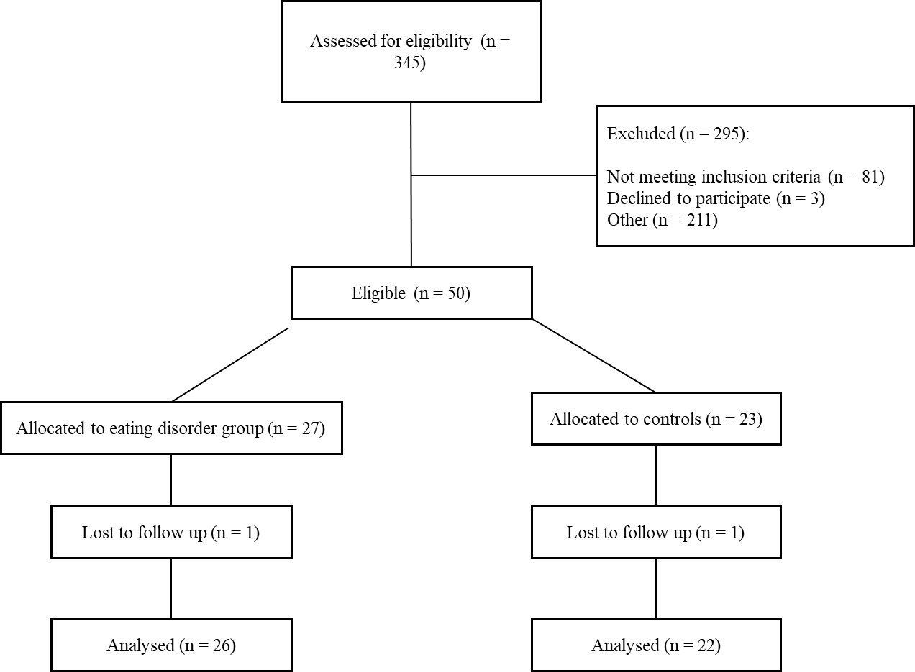
Supplementary Fig 1. Flowchart of participant recruitment
Other - did not complete sign-up form or did not respond to follow-up booking email.
Total run time (mins) | Post-oxytocin time (mins) | Visit 1 | Visit 2
2 | - | Consent | Sham photograph
3 | - | Sham photograph | Sham photograph
8 | - | Pregnancy test | Social Connectedness Scale, VAS 1
9 | - | VAS 1 | Social Connectedness Scale, VAS 1
12 | - | Nasal spray instructions & self-administration of oxytocin/vehicle
20 | 8 | Sociodemographics questionnaire & ECR-RS | RCADS, Cultural Engagement Questionnaire
32 | 20 | Preparing Cyberball / Filler questions
34 | 22 | Cyberball (baseline)
36 | 24 | VAS 2 & NTS 1
41 | 29 | Ambiguous Scenarios Task
44 | 32 | Cyberball (ostracism)
46 | 34 | VAS 3 & NTS 2
54 | 42 | Emotion Recognition Task
57 | 45 | Cyberball (empathy)
59 | 47 | VAS 4 & NTS 3
62 | 50 | Sing-a-Song Stress Test
64 | 52 | VAS 5
Supplementary Table 1. Testing Timeline

Grey shading indicates the tasks and questionnaires that were completed during the peak window of oxytocin’s effects.
ECR-RS = Experiences in Close Relationships—Relationship Structures; NTS = Needs Threat Scale; RCADS = Revised Child Anxiety and Depression Scale; VAS = visual analogue scales.

Results
Blinding
Data from nine participants were missing due to missing records (n = 7) or participants being uncertain and not able to provide a guess (n = 2). In a Chi-square goodness-of-fit test, participants did not differ significantly from the assumed equal frequency of guesses (oxytocin or placebo) [χ² = .641, p = .423].
Interpretations
There were no inter-rater disagreements for interpretations of participant scenario completion: κ = 1.0.
Pleasantness Ratings
No overall difference in the pleasantness ratings between drug condition was found[F(1,46) = 0.63, p = .43, partial η²= .013]. However, participants with ED rated scenarios as significantly less pleasant than participants without an ED with a large effect [F(1,46) = 22.69, p < .001, partial η² = .33] (see supplementary information for descriptive information). The same pattern was found for pleasantness ratings with drug condition and autism status as factors, with no overall difference between drug condition [F(1,46) = 0.70, p = .41, partial η²= .015] but participants reaching threshold-autism rated scenarios as significantly less pleasant than participants not reaching the threshold with a large effect [F(1,46) = 11.20, p = .002, partial η²= .20].

Supplementary Table 2. Means and Standard Deviations for Positive Interpretations
 |  |  | Mean (SD) | n
Oxytocin |  | Controls | 2.82 (1.18) | 22
 |  | Eating Disorder | 1.88 (1.13) | 26
 |  | Total | 2.32 (1.24) | 48
Placebo |  | Controls | 3.05 (1.36) | 22
 |  | Eating Disorder | 1.84 (1.34) | 26
 |  | Total | 2.40 (1.47) | 48

Neutral Interpretations
The ED [M = 1.04, SE = .197] and control [M = 1.25, SE = .340] groups made a similar number of neutral interpretations, so membership of a clinical group did not have a significant main effect: F(1,43) = .299, p = .587, partial η² = .007. Similarly, autism status did not have a significant main effect [F(1,43) = 1.05, p = .312, partial η2 = .024], as those who met the autism threshold [M = 1.34, SE = .363] made a similar number of neutral interpretations to those who did not meet the threshold [M = .941, SE = 1.51]. Oxytocin administration decreased the number of neutral interpretations of ambiguous social scenarios with a large effect, F(1,43) = 6.26, p = .016, partial η² = .127. There was no significant interaction of oxytocin’s effect on participants with ED [F(1,43) = .962, p = .332, partial η² = .022]. However, oxytocin administration had a large interaction effect with threshold-autism status: F(1,43) = 8.27, p = .006, partial η² = .161, such that. There was no three-way interaction between oxytocin administration, clinical group, and threshold-autism status: F(1,43) = 3.37, p = .073, partial η² = .073.

Supplementary Table 3. Means and Standard Deviations for Neutral Interpretations
 |  |  | Mean |  |  | SD |  | n
Oxytocin |  | Controls |  |  | 1.09 |  | 1.15 |  | 22
 |  | Eating Disorder Group |  |  | .840 |  | .987 |  | 26
 |  | Total |  |  | .960 |  | 1.06 |  | 48
Placebo |  | Controls |  |  | 1.00 |  | 1.20 |  | 22
 |  | ED Group |  |  | 1.12 |  | 1.05 |  | 26
 |  | Total |  |  | 1.06 |  | 1.11 |  | 48
ED = eating disorder group, SD = standard deviation
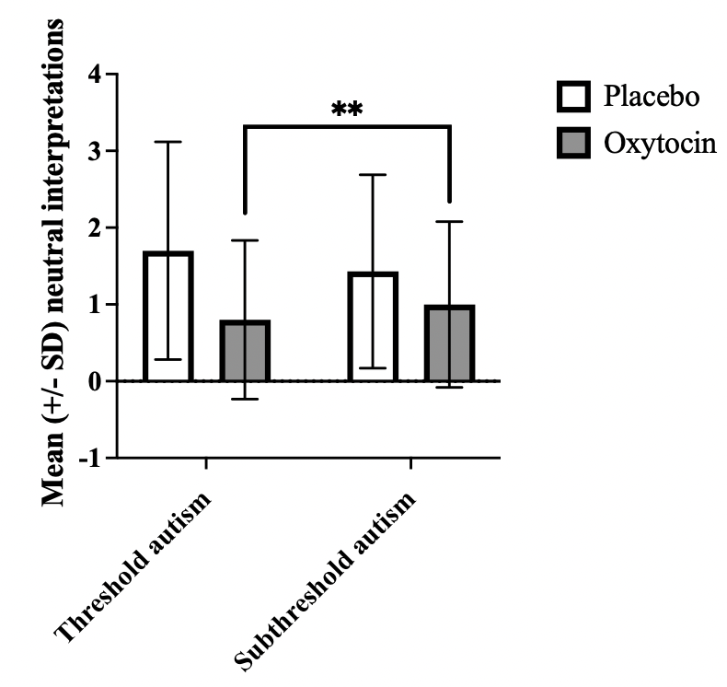
Supplmentary Figure 2. Mean (+/- SD) of Oxytocin Administration and Autism Status on Neutral Interpretations
Sub-threshold autism = threshold not met for autism on Autism Quotient (AQ10); threshold autism = threshold met for autism on Autism Quotient (AQ10); ** p < .01

Pleasantness Ratings
Supplementary Table 4: Means and Standard Deviations for Pleasantness Ratings for Ambiguous Social Scenarios
 |  |  | Mean |  | SD |  | n
Oxytocin |  | Controls |  | 6.51 |  | 1.16 |  | 22
 |  | ED |  | 5.08 |  | 1.24 |  | 26
 |  | Total |  | 5.73 |  | 1.39 |  | 48
Placebo |  | Controls |  | 6.64 |  | 1.05 |  | 22
 |  | ED |  | 5.30 |  | 1.50 |  | 26
 |  | Total |  | 5.91 |  | 1.47 |  | 48
ED = eating disorder group, SD = standard deviation

Menstrual Cycle, Sleep, and Hours Since Last Meal
Supplementary Table 5: Participants’ Menstrual Cycle Phase
 |  | Controls | ED
Visit 1 | Follicular | 13 | 7
Visit 1 | Luteal | 8 | 16
Visit 1 | Unknown | 1 | 3
Visit 2 | Follicular | 9 | 14
Visit 2 | Luteal | 12 | 9
Visit 2 | Unknown | 1 | 3
ED = eating disorder group, SD = standard deviation

Baseline VAS Stress and Confidence
Supplementary Table 6: Means and Standard Deviations for Baseline Stress and Confidence of participants with ED and controls
 |  |  | Mean | SD | n
Visit 1 | Stress | HC | 2.32 | 1.99 | 22
Visit 1 | Stress | ED | 3.77 | 2.52 | 26
Visit 1 | Confidence | HC | 6.18 | 1.53 | 22
Visit 1 | Confidence | ED | 4.50 | 1.86 | 26
Visit 2 | Stress | HC | 2.41 | 1.50 | 22
Visit 2 | Stress | ED | 3.69 | 2.36 | 26
Visit 2 | Confidence | HC | 6.18 | 1.26 | 22
Visit 2 | Confidence | ED | 3.92 | 1.83 | 26
ED = eating disorder group, SD = standard deviation

Supplementary Table 7: Means and Standard Deviations for Baseline Stress and Confidence of sub-Threshold Autism vs Threshold-Autism Participants
 |  |  | Mean | SD | n
Visit 1 | Stress | Sub-threshold Autism | 3.14 | 2.36 | 38
Visit 1 | Stress | Threshold Autism | 2.50 | 2.07 | 10
Visit 1 | Confidence | Sub-threshold Autism | 5.70 | 1.76 | 38
Visit 1 | Confidence | Autism | 4.00 | 1.63 | 10
Visit 2 | Stress | Sub-threshold Autism | 3.16 | 2.01 | 38
Visit 2 | Stress | Autism | 2.50 | 2.17 | 10
Visit 2 | Confidence | Sub-threshold Autism | 5.43 | 1.69 | 38
Visit 2 | Confidence | Threshold Autism | 3.50 | 2.01 | 10
Sub-threshold autism = threshold not met for autism on Autism Quotient; threshold autism = threshold met for autism on Autism Quotient

