APPENDICES
Appendix I
Sensitivity analyses of three trajectory groups comparing results of those individuals who completed all four dental exams versus at least three of the four dental exams versus at least two of the four dental exams
A: 73.0% B: 21.6% C: 5.3%
A: 67.6% B: 24.6% C: 7.8%
D₂₊MFS count
D₂₊MFS count
Age
Age
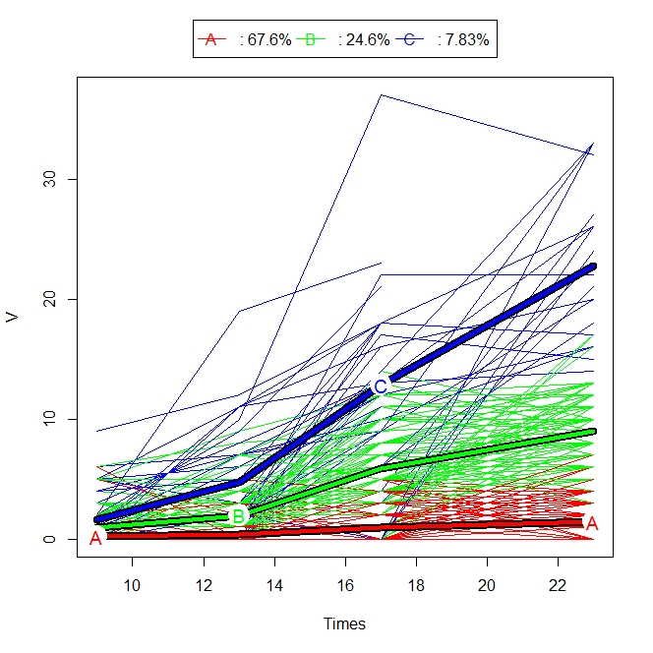
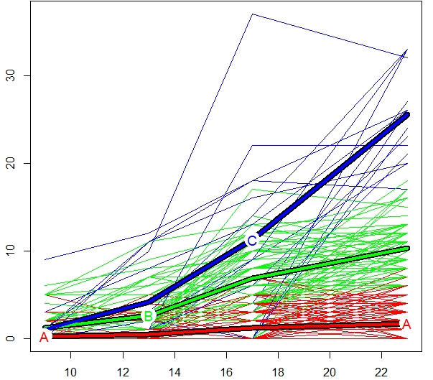
Age
Age
Plot showing the individuals’ trajectories and their trajectory of the centroids (for individuals with a maximum of one missing time points) (N = 447).

Plot showing the individuals’ trajectories and their trajectory of the centroids (for individuals with no missing time points) (N = 282).

Note: The thick blue line represents the trajectory of the centroid for participants with high caries trajectory, the thick green line represents the trajectory of the centroids for participants with medium caries trajectory, and the thick red line represents the trajectory of the centroids for participants with low caries trajectory.

Appendix II
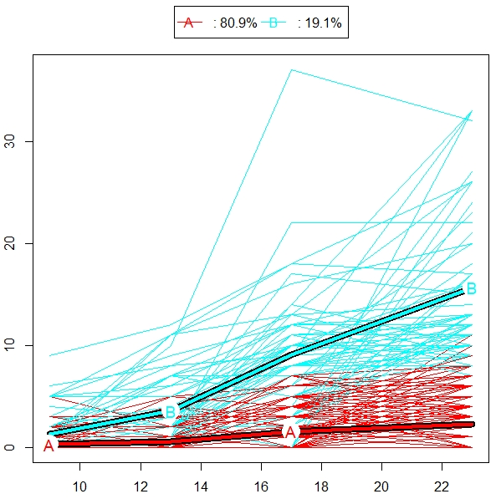
Sensitivity analyses of two trajectory groups comparing results of those individuals who completed all four dental exams versus at least three of the four dental exams versus at least two of the four dental exams.
D₂₊MFS count
D₂₊MFS count
Age
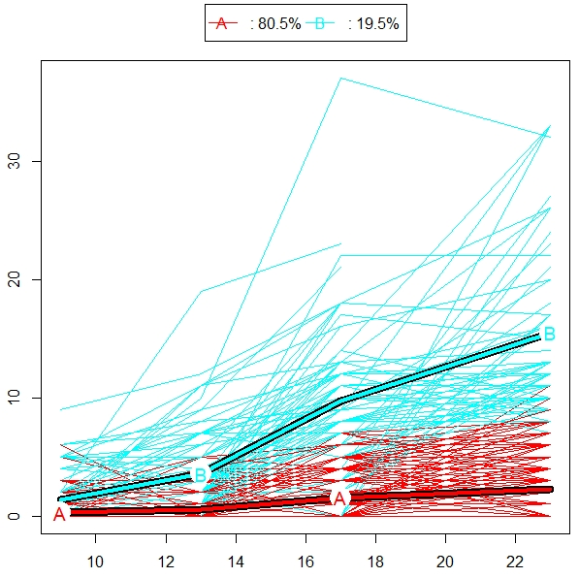
Plot showing the individuals’ trajectories and their trajectory of the centroids (for individuals with no missing time points) (N = 282).

Plot showing the individuals’ trajectories and their trajectory of the centroids (for individuals with a maximum of one missing time points) (N = 447).

Age

Note: The thick blue line represents the trajectory of the centroids for participants with high caries trajectory and the thick red line represents the trajectory of the centroids for participants with low caries trajectory.

