Supporting information

Whitlockite nanoparticle-coated hydroxyapatite granules for bone regeneration in defect of rat calvaria

Won-Bum Lee^{1†}, Caifeng Wang^{2,3†}, Yoon-Seo Jang¹, Ki-Jae Jeong², Hyojin Kang², Ayun Seol⁴, Eun Seo Park⁴, Ho-Jin Lee,⁵ Dae Youn Hwang⁴, Jaebeom Lee²*, Dae-Seok Hwang^{1,6}*

†Won-Bum Lee and Caifeng Wang contributed equally to this work.
*Jaebeom Lee and Dae-Seok Hwang are corresponding authors contributed equally to this work

Correspondence:
Jaebeom Lee
nanoleelab@gmail.com
Dae-Seok Hwang
dshwang@pusan.ac.kr

Supplementary Texts
Table S1. List of antibodies for western blot analyses
Name | Catalog | Company, Location, Nation
Anti-β-catenin antibody  Anti-ERK antibody  Anti-phospho-ERK antibody  Anti-JNK antibody  Anti-phospho-JNK antibody  Anti-p38 antibody  Anti-phospho-p38 antibody  Anti-Smad4 antibody  Anti-β-actin antibody | #9562s  #9102s  #9101s  #9252s  #9231s  #9212s  #9211s  #38454s  #4967s | Cell Signaling, Danvers, MA, USA Cell Signaling, Danvers, MA, USA  Cell Signaling, Danvers, MA, USA  Cell Signaling, Danvers, MA, USA  Cell Signaling, Danvers, MA, USA  Cell Signaling, Danvers, MA, USA  Cell Signaling, Danvers, MA, USA  Cell Signaling, Danvers, MA, USA  Cell Signaling, Danvers, MA, USA

Table S2. Primer sequences for RT-PCR analyses

Primer name | Sequence (from 5’ to 3’) | Product size (bp)
OCN  Forward  Reverse | TGAGG ACCAT CTTTC TGC  GAGCT GCTGT GACAT CCATA C | 89
ALP  Forward  Reverse | CCAGG CCCTA CAATG CTCAT  CTGGG ACCCT GGTGG TCTT | 121
RUNX2  Forward  Reverse | CTCCT TGCCC CTCAT TTCC  TACGC ATCAC AACAG CCACA A | 74
BMP2  Forward  Reverse | TGCTA GTAAC TTTTG GCCAT GATG  GCGTT TCCGC TGTTT GTGTT | 86
Col-I  Forward  Reverse | AGGAA GGGCC ACGAC AAAG  CAGTT ACACA AGGAA CAGAA CAGTC TCT | 105
VEGF  Forward  Reverse | GGAGG CGCAG CGGTT AG  AACCC GGATC AATGA ATATC AAA | 86
β-actin  Forward  Reverse | AGCCA TGTAC GTAGC CATCC  CTCTC AGCTG TGGTG GTGAA | 349

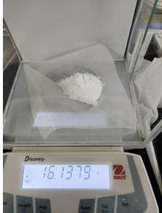
Figure S1. Dry weight of scalable synthesized WH NPs in 1L batch.

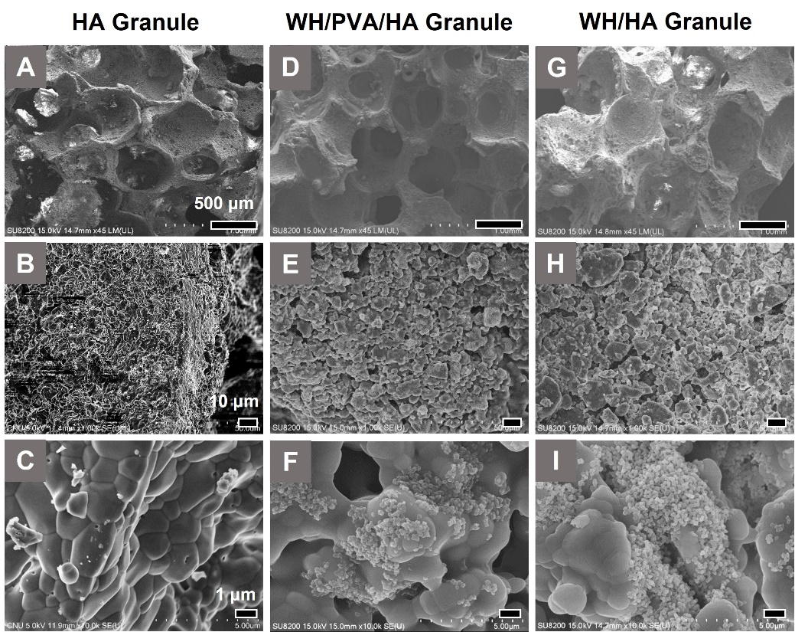
Figure S2. SEM image of HA granule (C-E), WH/PVA/HA granule (F-H), and WH/HA granule (I-K) with different resolution (1 time dipping).
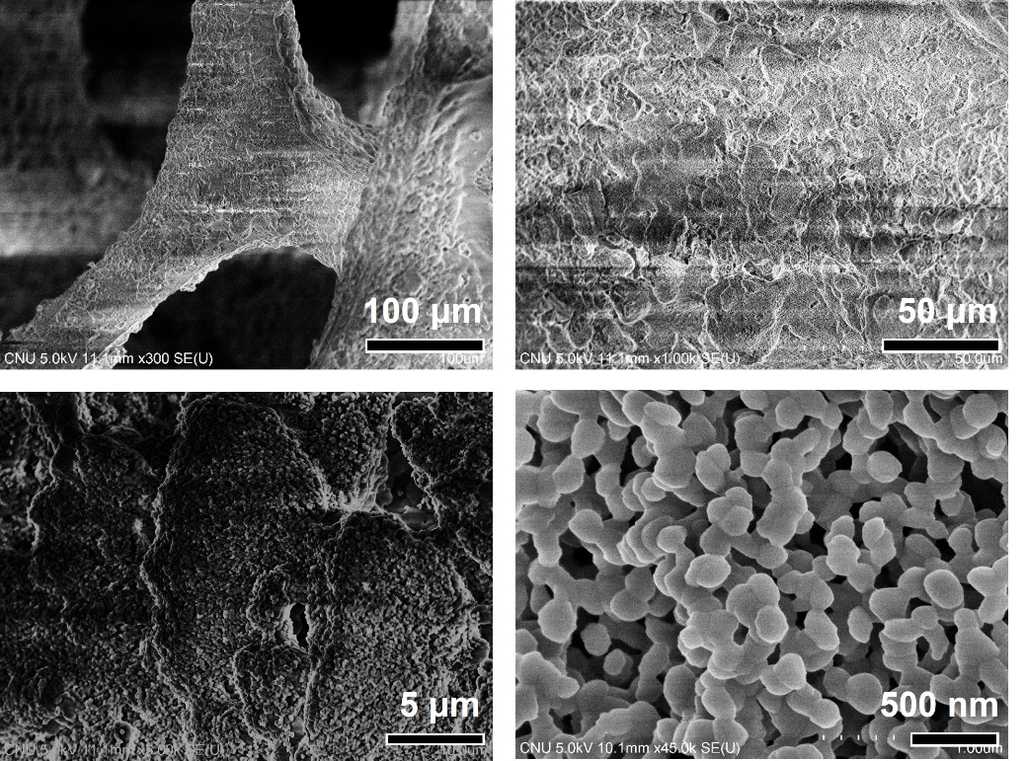
Figure S3. SEM images of WHHAGs (3 times dipping).
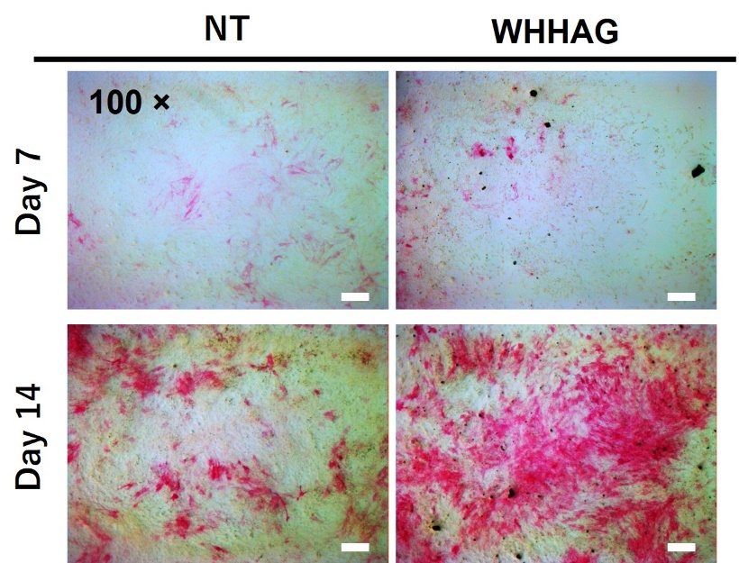

Figure S4. Effect of WHHAG on osteogenic differentiation. ALP staining of NT group and WHHAG50 group after MG63 cell cultured for 7 and 14 days (the scale bar is 100 μm).

