Supplementary Info
“Convergent evolution in Afrotheria and non-afrotherians demonstrates high evolvability of the mammalian inner ear”
Nicole D.S. Grunstra, Fabian Hollinetz, Guillermo Bravo Morante, Frank E. Zachos, Cathrin Pfaff, Viola Winkler, Philipp Mitteroecker, Anne Le Maître

Principal component analysis
The first four principal components (PCs) accounted for 77.3% of total shape variance. Variation along PC 1 (26.9% of variance) corresponded to the size of the semicircular canals (SCC) relative to the cochlea (Fig. S1). PC 1 and 2 combined mainly distinguish between the strictly aquatic species and the rest, showing convergence between the dolphin and the sea cows (manatee and dugong). Bony labyrinth shape features corresponding to an aquatic lifestyle include relatively small semicircular canals, a broader cochlea with a reduced number of turns, as well as a larger and rather round vestibular window. The highly specialist subterranean taxa, such as true moles, golden moles and certain tenrecs, cluster together on PC 3 and 4, another example of convergent evolution (Fig. S2). Shape features of the bony labyrinth associated with a predominantly subterranean lifestyle are a relatively longer common crus, larger vertical semicircular canals (VSC) combined with a smaller lateral semicircular canal (LSC), and a cochlea with more turns than average. Arboreal taxa also tend to converge in labyrinth shape despite being phylogenetically distantly related (with the exception of the tree hyrax and bush hyrax), as evinced by their similarity in PC scores along all of the first four PCs. Bony labyrinth shape in tree-dwelling taxa includes a relatively shorter common crus, smaller and horizontally elongated VSC, a rounder LSC, and a cochlea with a broad base and fewer turns. On the other hand, ground-dwelling taxa (i.e., terrestrial species that are mostly on the ground) show a large range of ear shape variation, which is congruent with the diversity in ground-dwelling behaviours and lifestyles.
Overall, there are no obvious distinctions between afrotherians versus the rest, nor between the platypus (monotreme), opossum (marsupial), and placentals. Phylogenetic signal therefore does not appear to be strong (relative to the ecomorphological/functional signal) in labyrinth shape at the level of higher-order taxa.
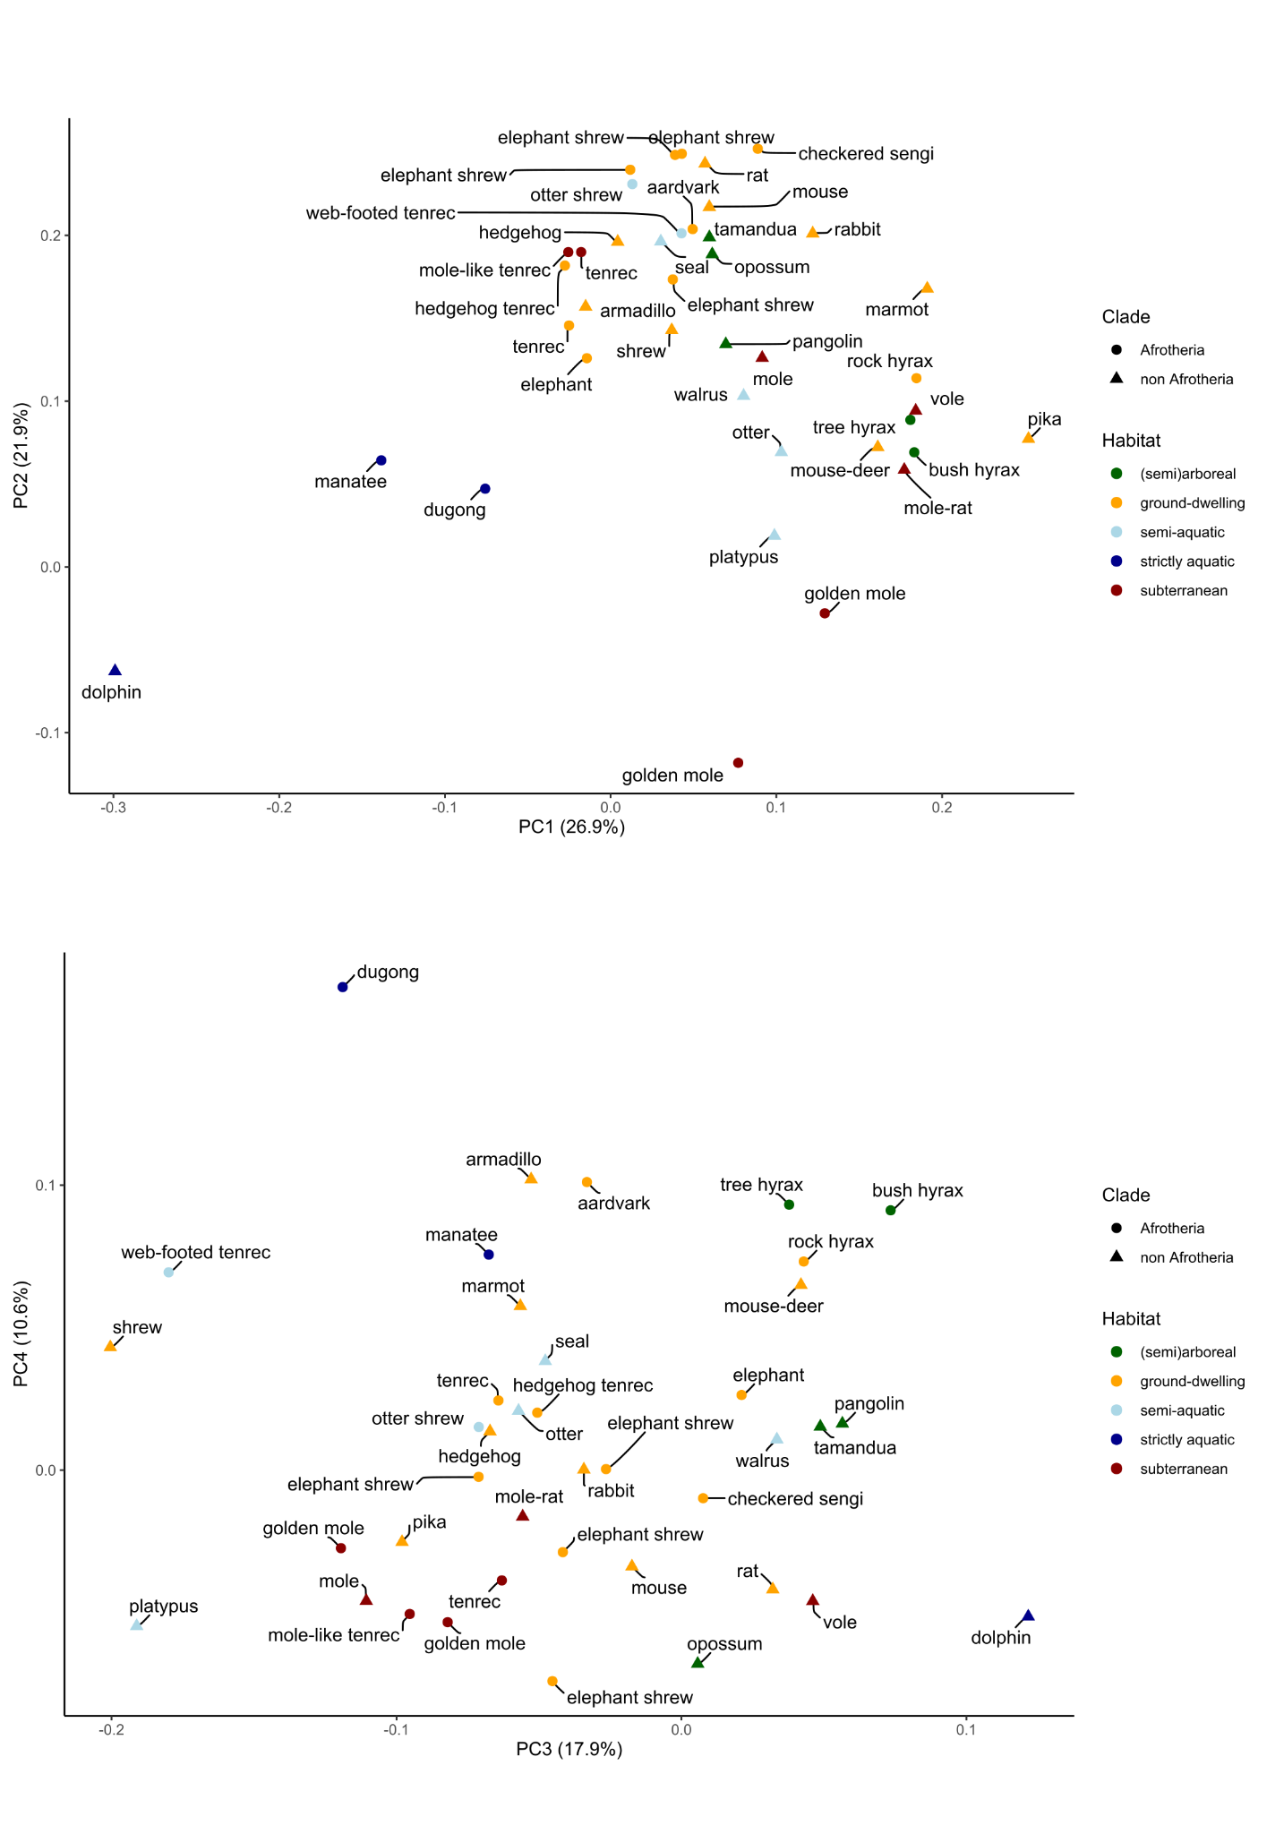
Fig. S1: Scores for the first four principal components of the Procrustes shape coordinates of the bony labyrinth. The scores are colour-coded to correspond to five broadly defined habitat groups for visualisation of a functional signal; group assignment was not used in the computation of the scores. Note that when a species’ common name appears several times, it corresponds to closely related and morphologically and/or ecologically similar species (e.g., golden moles).
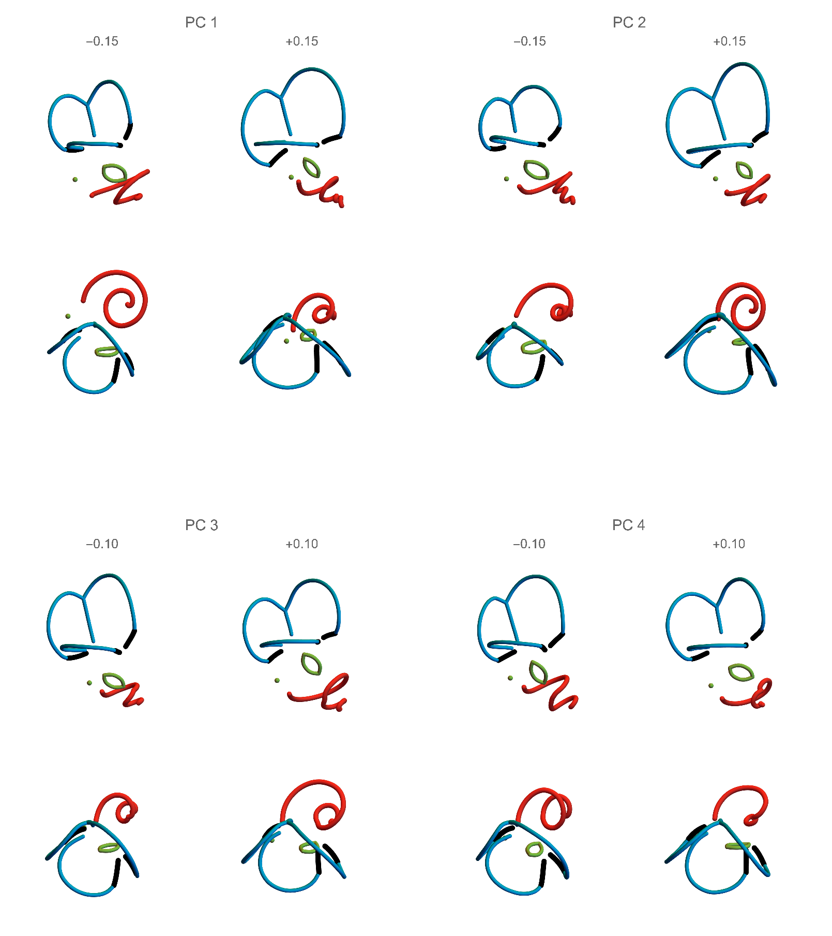
Fig. S2: Shape patterns corresponding to the first four principal components (PC) shown in lateral and superior views (top and bottom rows, respectively). The semicircular canals are in blue, the cochlea is in red, and the vestibular (oval) and cochlear (point) windows are in green.

Phylogenetic partial least squares
In addition to the 2B-PLS analysis in the main text, we conducted a phylogenetic 2B-PLS analysis to assess whether the associations between bony labyrinth shape and the contextual variables were mediated through the species’ phylogenetic relationships. We found that similar associations remain after accounting for phylogeny, though the ecomorphological associations are captured by the four PLS dimensions in slightly different ways.
The first four dimensions together accounted for 90.3% of the summed squared covariances between the two blocks of variables (hierarchical permutation tests against a null hypothesis of no association yielded p-values of 0.02, 0.009, 0.054, and 0.088, respectively, for the four dimensions). Further dimensions accounted for only 2% or less. “Phylogenetic” PLS 1 contrasted aquatic species from terrestrial species (Fig. S3). Aquatic and semi-aquatic species had smaller and rounder semicircular canals associated with a larger, rounder vestibular window, and a broad and flat cochlea with fewer turns. Phylogenetic PLS 2 distinguished arboreal and scansorial taxa from species that were more likely to pursue moving prey, be it in water or on the ground (Fig. S3). The latter had a longer common crus, nearly as high as the vertical (anterior and posterior) semicircular canals, as well as a broader cochlea compared to arboreal and scansorial species.
Phylogenetic PLS 3 contrasted agile species that pursue prey on the ground - and to some extent also agile aquatic species (especially the seal) - with species scoring low on agility (speed and manoeuvrability), i.e. subterraneous, fossorial as well as large-bodied taxa (Fig. S4). Along this dimension, species’ bony labyrinth shape mainly varied in the relative expansion of the semicircular canals and in the shape of the cochlear canal. Phylogenetic PLS 4 was a contrast between slow and to some extent large-bodied species (driven by the elephant and the walrus) on the one hand and agile or fossorial species on the other (Fig. S4). Along this dimension, species varied in the relative length of the common crus, the relative size and shape of the vestibular window, and in cochlear canal shape.

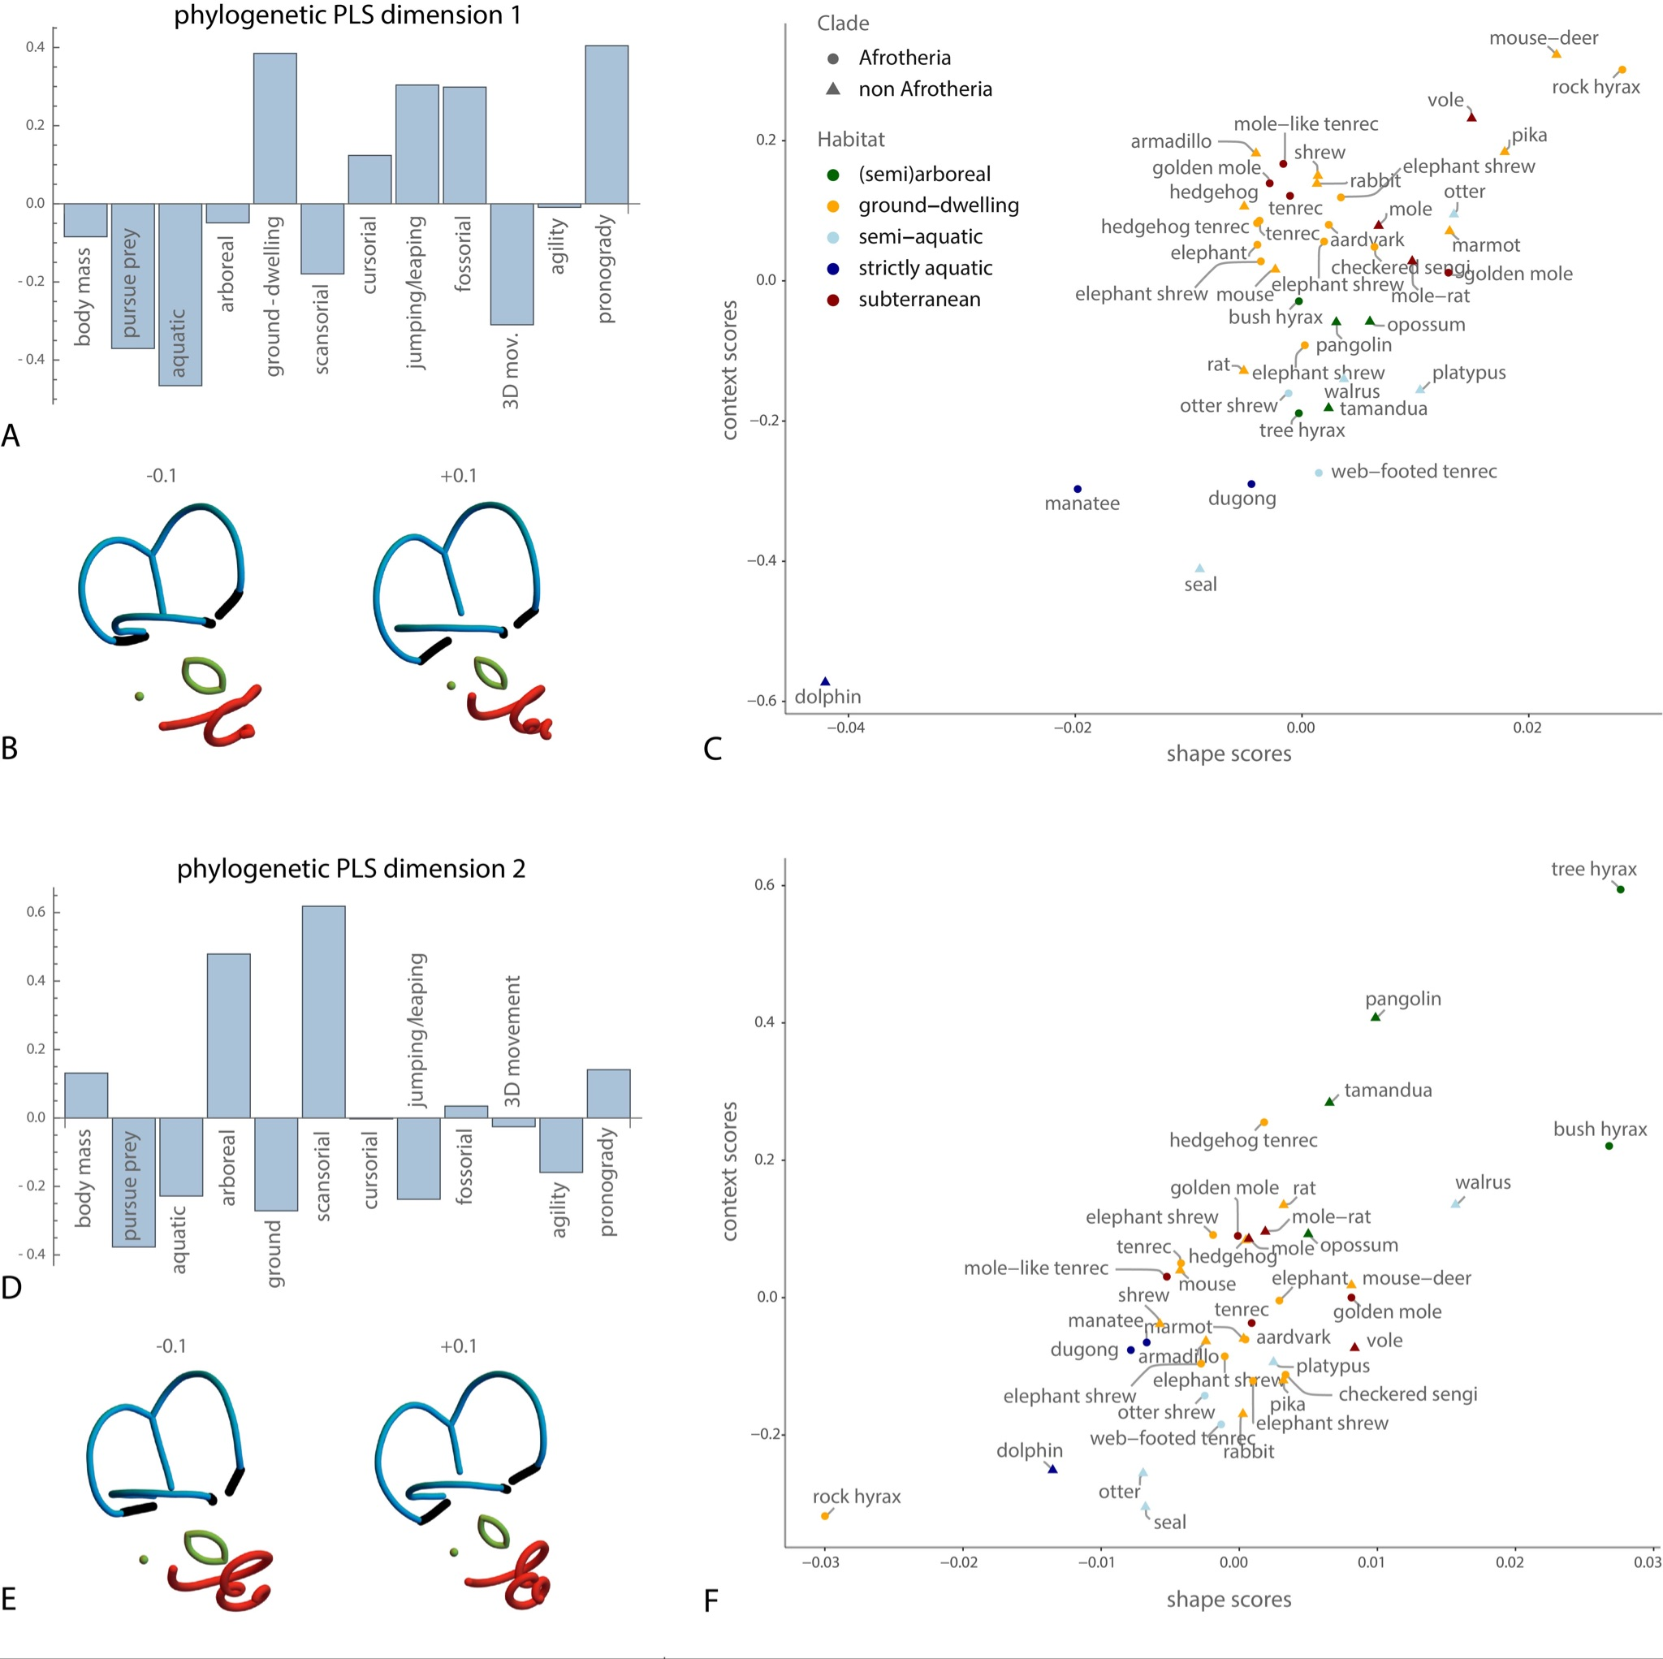
Fig. S3: Results for the phylogenetic partial least squares analysis of bony labyrinth shape and the contextual variables (PLS 1 and 2). First two dimensions of the phylogenetic two-block partial least squares (2B-PLS) analysis between the Procrustes shape coordinates of the bony labyrinth and the 12 contextual variables. Panels A and B show the loadings for the first PLS dimension, representing the shape pattern and the contextual pattern with highest covariance. The semicircular canals are in blue, the cochlea is in red, and the vestibular (oval) and cochlear (point) windows are in green. The orientation of the bony labyrinths is the same as in Fig. 2 (right panel). Panel C shows a scatterplot of the corresponding contextual and shape scores. The colour code corresponds to five habitat groups, but this grouping was not used for computing the PLS. Note that when a species’ common name appears several times, it corresponds to different species. Panels D-F show the loadings and scores for the second PLS dimension.
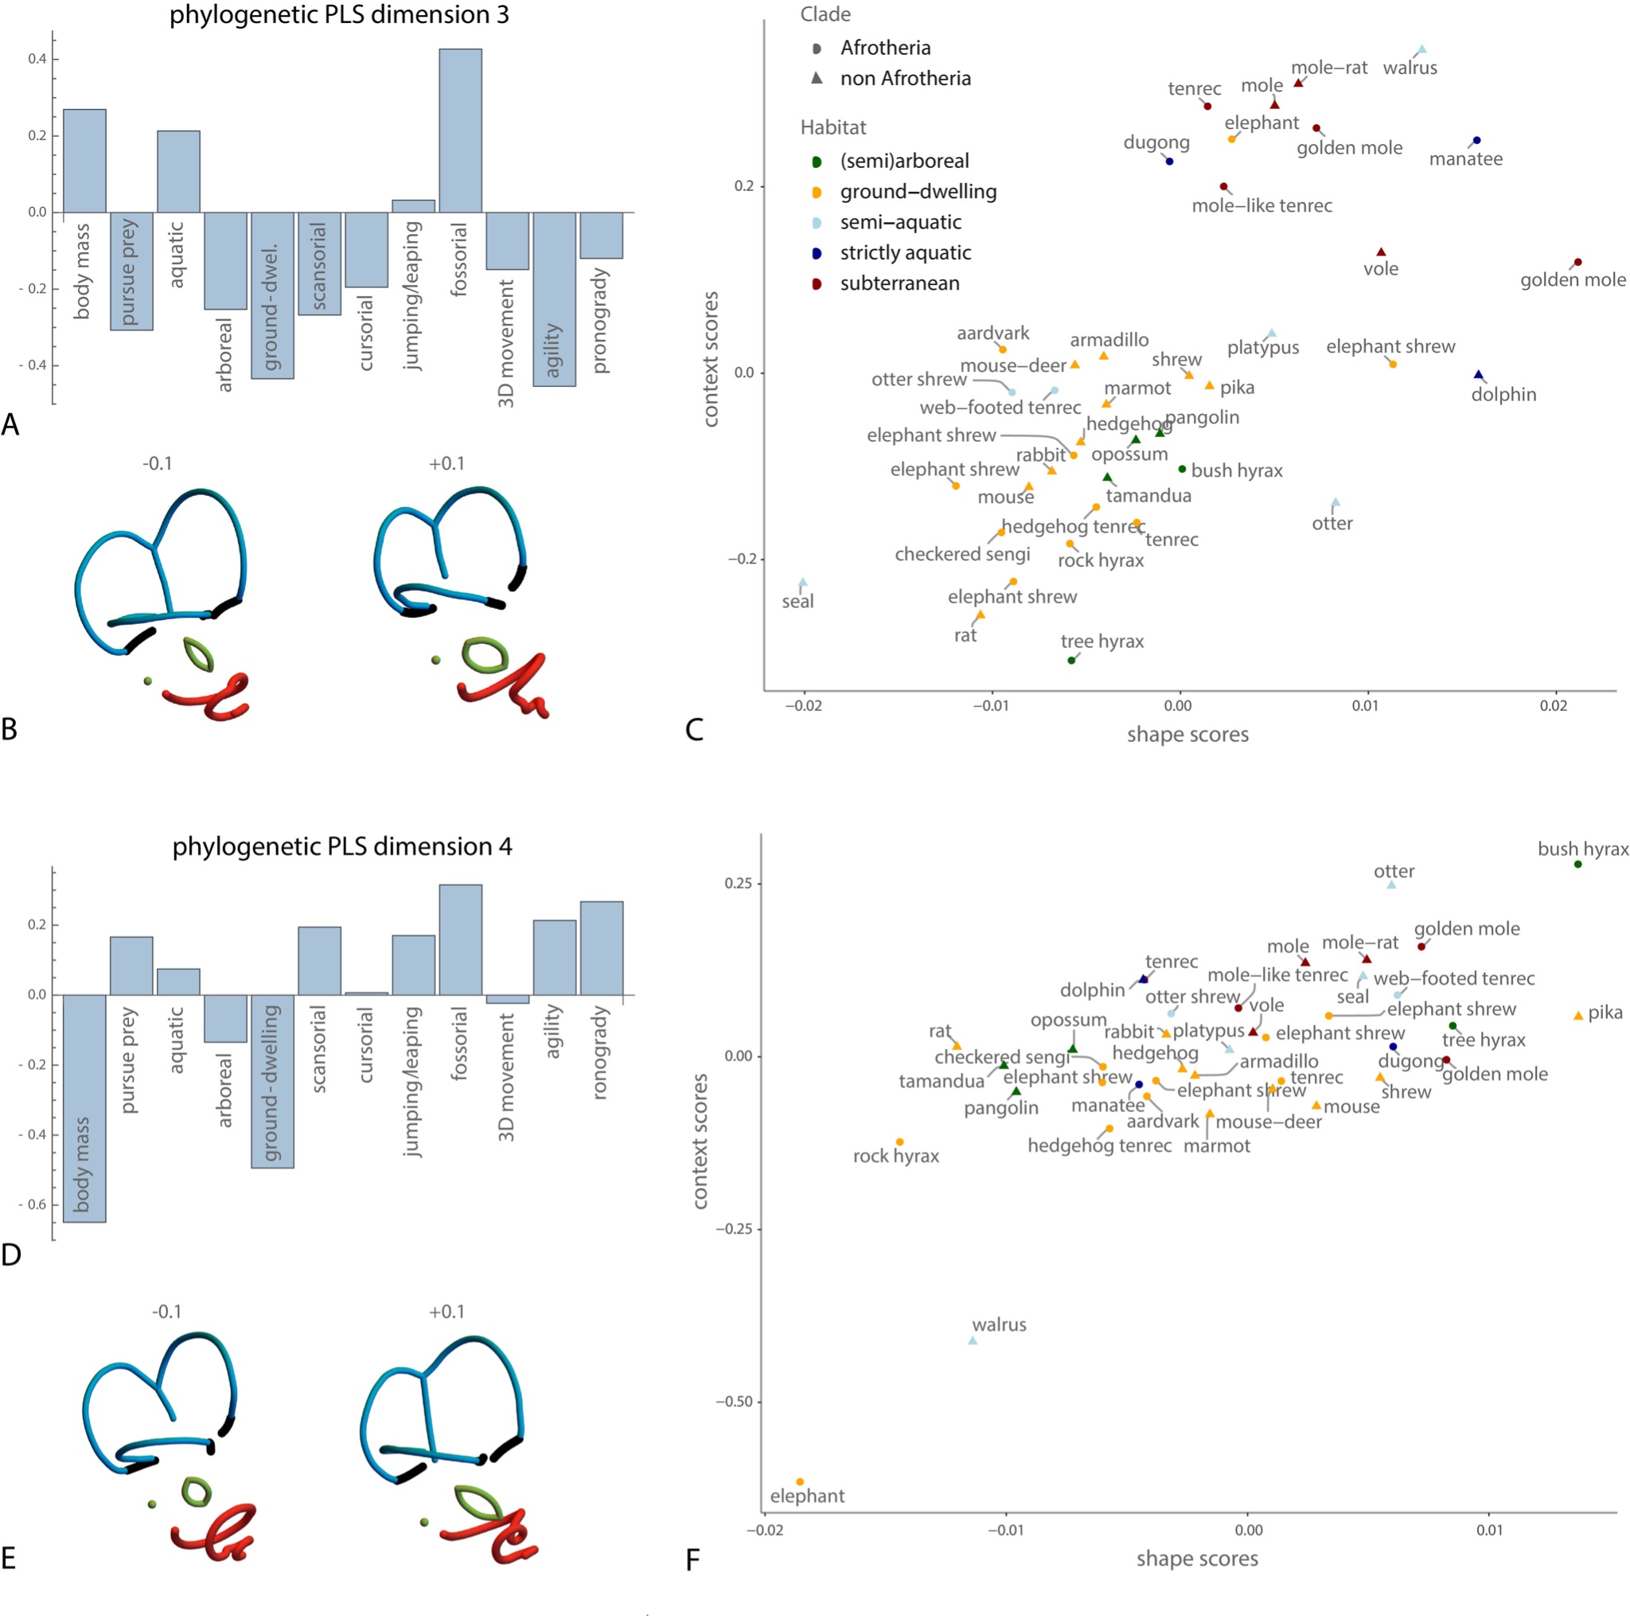
Fig. S4: Results for the phylogenetic partial least squares analysis of bony labyrinth shape and the contextual variables (PLS 3 and 4). Dimensions 3 and 4 of the phylogenetic two-block partial least squares (2B-PLS) analysis between the Procrustes shape coordinates of the bony labyrinth and the 12 contextual variables. Panels A and B show the loadings for the third PLS dimension, and panel C the corresponding scores. The semicircular canals are in blue, the cochlea is in red, and the vestibular (oval) and cochlear (point) windows are in green. The orientation of the bony labyrinths are the same as in Fig. 2 (right panel). Panels D-F show the loadings and scores for the fourth PLS dimension.

