Tool and softwares used for photographing and processing gel images:
Gel doc A.T.P CO., LTD, Compact was used to photograph the gel.
Cropping the images and changing the contrast of the images was done using photo software version 2019.19071.12548.0 and the final editing for some images was done with adobe photoshop CC 2015 software.

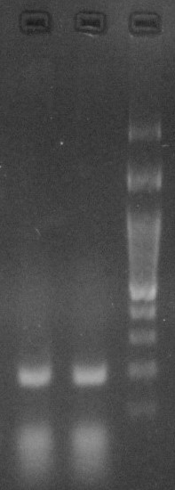
The PCR reaction product from V. tricolor genomic DNA using FVt and RVt primers on 2% agarose gel

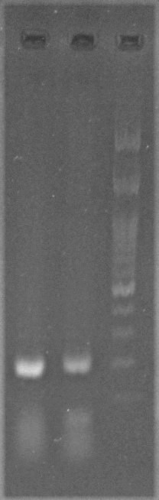
The PCR reaction product from cDNA using FVt and RVt primers on 2% agarose gel
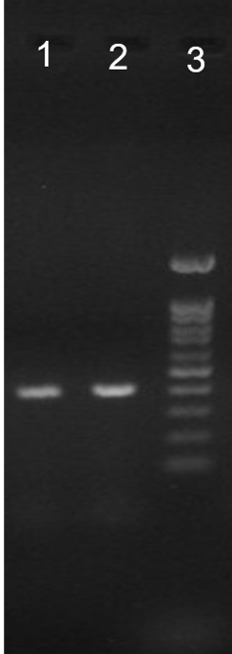
Electrophoresis of 3´- RACE PCR reaction product on 1% agarose gel

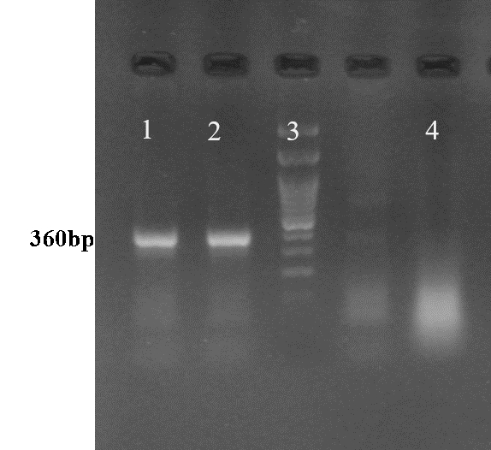
Electrophoresis of semi-nested PCR product on 1% agarose gel

