SUPPLEMENTARY MATERIAL

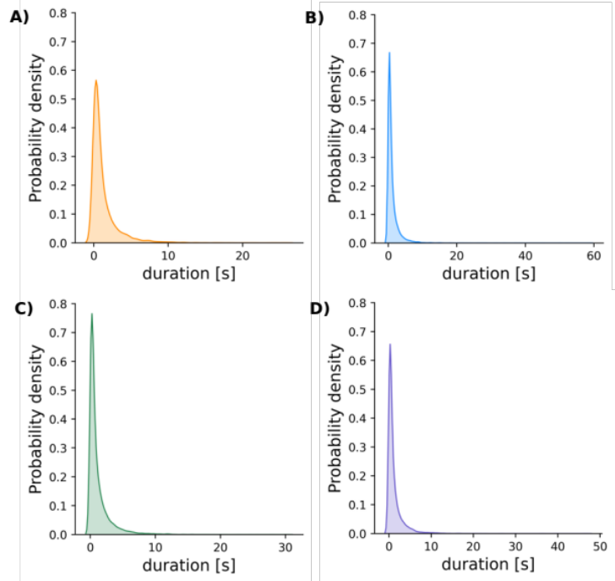
Figure S1. Kernel Density Distribution of flight track duration. The duration of each individual mosquito track was evaluated in the raw data to estimate the amount of noise relevant for males (A), females (B), mixed 50 (C) and mixed 100 (D) groups.
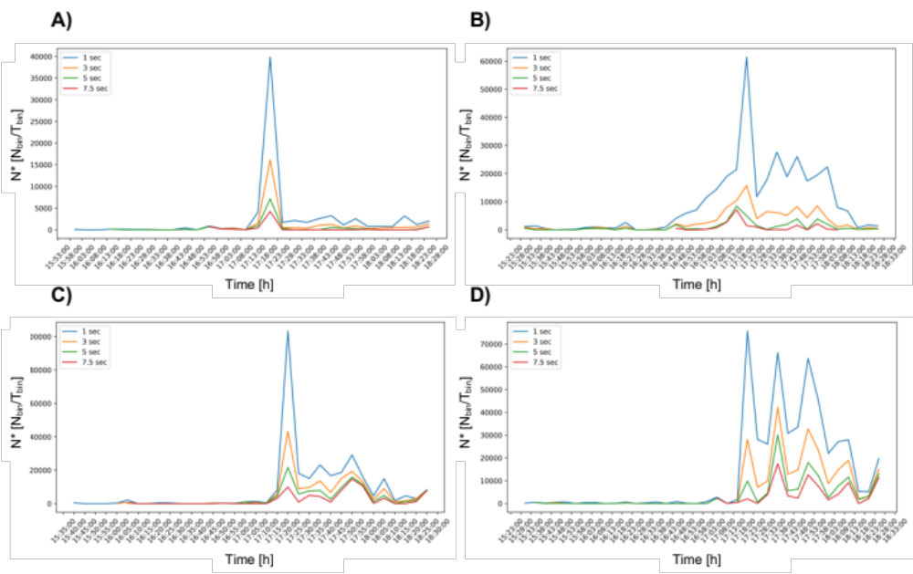
Figure S2. Line plot of mosquito activity based on different duration filters being applied. We tested the amount of noise present in our data by removing tracks shorter than 1, 3, 5 and 7.5 seconds for males (A), females (B), mixed 50 (C) and mixed 100 (D) groups. Based on data shape, we see that a one second duration filter is not sensitive enough to keep only relevant flight data, thus a three second filter was chosen.

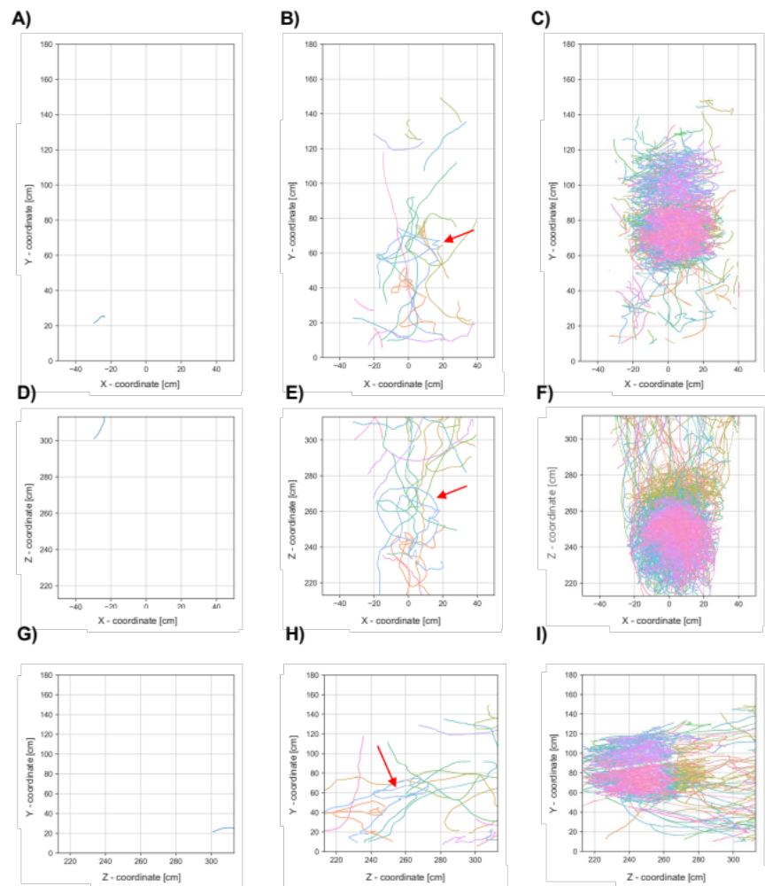

Figure S3. Trajectory plots of male Anopheles coluzzii mosquitoes. The same replicate utilized for performing the sensitivity analysis was analyzed for ‘loop-like’ swarm behavior. Male mosquitoes exhibit no ‘loop-like’ activity during the pre-sunset activity period (A, D, G). First evidence of looping formation is indicated by the red arrow during the post-sunset period (B, E, H). A well-established swarm is visible during the nocturnal activity period (C, F, I).

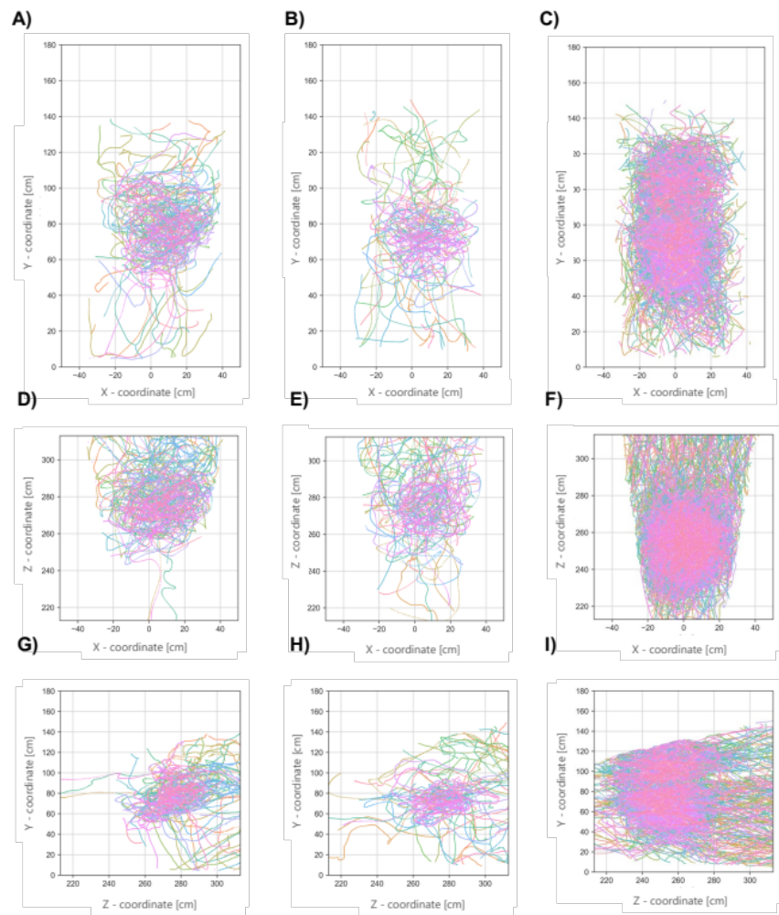

Figure S4. Trajectory plots of female Anopheles coluzzii mosquitoes. The same replicate utilized for performing the sensitivity analysis was analyzed for ‘loop-like’ swarm behavior. Female mosquitoes, unlike males, exhibit ‘loop-like’ activity during the pre-sunset activity period (A, D, G), continuing throughout the post-sunset activity period (B, E, H), and extending to a higher density hotspot during the nocturnal activity period (C, F, I).

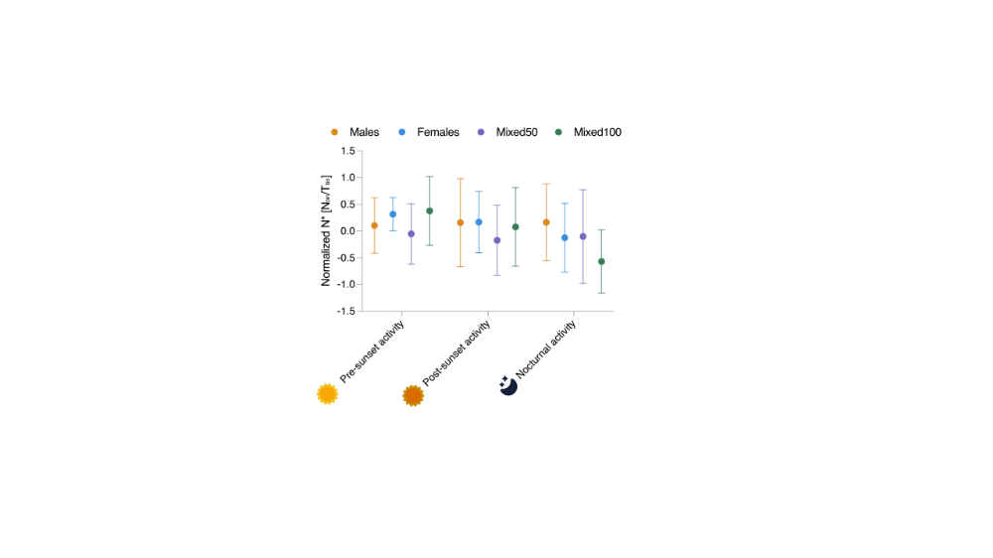

Figure S5. Plots of normalized swarm activity dynamics across time. Five replicate points per experimental group are considered to estimate the variation in activity across time as well as to compare between groups. A Y=sin(Y) transformation was performed to meet normality criteria. A Two-Way ANOVA followed by a Tukey post hoc test was performed, yet not significant difference was found at a group or time level.

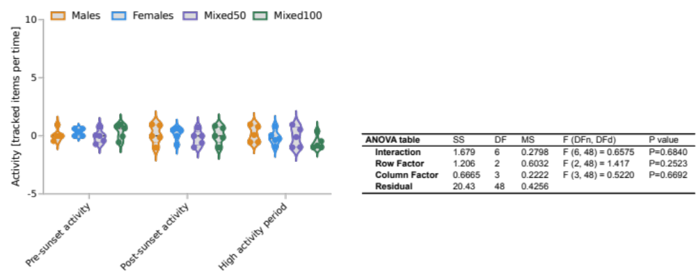
Table S1: Two-Way ANOVA of normalized activity. The interaction between the factor activity period, experimental group, and N* was evaluated using a Two-Way ANOVA. Results suggest no influence of either activity period or experimental group on the value of N*.

