For Molecular Diversity

Supporting information
for
Synthesis, antiproliferative activity, 3D-QSAR and molecular docking studies of novel L-carvone-derived pyrimidine-urea compounds

Yupei Meng¹ · Yunxue Zhang¹ · Wengui Duan^{1, 2} · Guishan Lin^{1, 2} · Yucheng Cui¹ · Baoyu Li¹

The FT-IR, ¹H-NMR, ¹³C-NMR and HRMS data for the synthesized compounds

* Wengui Duan
wgduan@gxu.edu.cn
* Guishan Lin
gslin@gxu.edu.cn
1 School of Chemistry and Chemical Engineering, Guangxi University, Nanning 530004, Guangxi, P. R. China.
2 Guangxi Colleges and Universities Key Laboratory of Applied Chemistry Technology and Resource Development, Nanning 530004, Guangxi, P. R. China.
Contents
1. (6R)-3-Methyl-2-oxo-6-(prop-1-en-2-yl) cyclohex-3-ene-1-carbaldehyde (2) 5
1.1 FT-IR spectrum of (6R)-3-methyl-2-oxo-6-(prop-1-en-2-yl) cyclohex-3-ene-1-carbaldehyde (2) 5
1.2 1H NMR spectrum of (6R)-3-methyl-2-oxo-6-(prop-1-en-2-yl) cyclohex-3-ene-1-carbaldehyde (2) 5
1.3 ¹³C NMR spectrum of (6R)-3-methyl-2-oxo-6-(prop-1-en-2-yl) cyclohex-3-ene-1-carbaldehyde (2) 6
2. (S)-8-Methyl-5-(prop-1-en-2-yl)-5,6-dihydroquinazolin-2-amine (3) 6
2.1 FT-IR spectrum of (S)-8-methyl-5-(prop-1-en-2-yl)-5,6-dihydroquinazolin-2-amine (3) 6
2.2 ¹H NMR spectrum of (S)-8-methyl-5-(prop-1-en-2-yl)-5,6-dihydroquinazolin-2-amine (3) 7
2.3 ¹³C NMR spectrum of (S)-8-methyl-5-(prop-1-en-2-yl)-5,6-dihydroquinazolin-2-amine (3) 7
2.4 HRMS spectrum of (S)-8-methyl-5-(prop-1-en-2-yl)-5,6-dihydroquinazolin-2-amine (3) 8
3. Compound 4a (R=o-F Ph) 8
3.1 FT-IR spectrum of compound 4a (R=o-F Ph) 8
3.2 ¹H-NMR spectrum of compound 4a (R=o-F Ph) 9
3.3 ¹³C-NMR spectrum of compound 4a (R=o-F Ph) 9
3.4 HRMS spectrum of compound 4a (R=o-F Ph) 10
4. Compound 4b (R=m-F Ph) 10
4.1 FT-IR spectrum of compound 4b (R=m-F Ph) 10
4.2 ¹H-NMR spectrum of compound 4b (R=m-F Ph) 11
4.3 ¹³C-NMR spectrum of compound 4b (R=m-F Ph) 11
4.4 HRMS spectrum of compound 4b (R=m-F Ph) 12
5. Compound 4c (R=p-F Ph) 12
5.1 FT-IR spectrum of compound 4c (R=p-F Ph) 12
5.2 ¹H-NMR spectrum of compound 4c (R=p-F Ph) 13
5.3 ¹³C-NMR spectrum of compound 4c (R=p-F Ph) 14
5.4 HRMS spectrum of compound 4c (R=p-F Ph) 14
6. Compound 4d (R=2,4-F Ph) 15
6.1 FT-IR spectrum of compound 4d (R=2,4-F Ph) 15
6.2 ¹H-NMR spectrum of compound 4d (R=2,4-F Ph) 15
6.3 ¹³C-NMR spectrum of compound 4d (R=2,4-F Ph) 16
6.4 HRMS spectrum of compound 4d (R=2,4-F Ph) 17
7. Compound 4e (R=o-Cl Ph) 17
7.1 FT-IR spectrum of compound 4e (R= o-Cl Ph) 17
7.2 ¹H-NMR spectrum of compound 4e (R= o-Cl Ph) 18
7.3 ¹³C-NMR spectrum of compound 4e (R= O-Cl Ph) 18
7.4 HRMS spectrum of compound 4e (R= O-Cl Ph) 19
8. Compound 4f (R=m-Cl Ph) 19
8.1 FT-IR spectrum of compound 4f (R= m-Cl Ph) 19
8.2 ¹H-NMR spectrum of compound 4f (R= m-Cl Ph) 20
8.3 ¹³C-NMR spectrum of compound 4f (R= m-Cl Ph) 20
8.4 HRMS spectrum of compound 4f (R= m-Cl Ph) 21
9. Compound 4g (R=p-Cl Ph) 21
9.1 FT-IR spectrum of compound 4g (R= p-Cl Ph) 21
9.2 ¹H-NMR spectrum of compound 4g (R= p-Cl Ph) 22
9.3 ¹³C-NMR spectrum of compound 4g (R= p-Cl Ph) 22
9.4 HRMS spectrum of compound 4g (R= p-Cl Ph) 23
10. Compound 4h (R=3,4-Cl Ph) 23
10.1 FT-IR spectrum of compound 4h (R= 3,4-Cl Ph) 23
10.2 ¹H-NMR spectrum of compound 4h (R= 3,4-Cl Ph) 24
10.3 ¹³C-NMR spectrum of compound 4h (R= 3,4-Cl Ph) 24
10.4 HRMS spectrum of compound 4h (R= 3,4-Cl Ph) 25
11. Compound 4i (R=o-CH₃ Ph) 25
11.1 FT-IR spectrum of compound 4i (R=o-CH₃ Ph) 25
11.2 ¹H-NMR spectrum of compound 4i (R=o-CH₃ Ph) 26
11.3 ¹³C-NMR spectrum of compound 4i (R=o-CH₃ Ph) 26
11.4 HRMS spectrum of compound 4i (R=o-CH₃ Ph) 27
12. Compound 4i (R=m-CH₃ Ph) 27
12.1 FT-IR spectrum of compound 4i (R=m-CH₃ Ph) 27
12.2 ¹H-NMR spectrum of compound 4j (R=m-CH₃ Ph) 28
12.3 ¹³C-NMR spectrum of compound 4j (R=m-CH₃ Ph) 28
12.4 HRMS spectrum of compound 4i (R=m-CH₃ Ph) 29
13. Compound 4k (R=p-CH₃ Ph) 29
13.1 FT-IR spectrum of compound 4k (R=p-CH₃ Ph) 29
13.2 ¹H-NMR spectrum of compound 4k (R=p-CH₃ Ph) 30
13.3 ¹³C-NMR spectrum of compound 4k (R=p-CH₃ Ph) 30
13.4 HRMS spectrum of compound 4k (R=p-CH₃ Ph) 31
14. Compound 4l (R=2, 6-CH₃ Ph) 31
14.1 FT-IR spectrum of compound 4l (R=2,6-CH₃ Ph) 31
14.2 ¹H-NMR spectrum of compound 4l (R=2, 6-CH₃ Ph) 32
14.3 ¹³C-NMR spectrum of compound 4l (R=2,6-CH₃ Ph) 32
14.4 HRMS spectrum of compound 4l (R=2,6-CH₃ Ph) 33
15 Compound 4m (R=o-CF₃ Ph) 33
15.1 FT-IR spectrum of compound 4m (R=o-CF₃ Ph) 33
15.2 ¹H NMR spectrum of compound 4m (R=o-CF₃ Ph) 34
15.3 ¹³C-NMR spectrum of compound 4m (R=o-CF₃ Ph) 34
15.4 HRMS spectrum of compound 4m (R=o-CF₃ Ph) 35
16 Compound 4n (R=m-CF₃ Ph) 35
16.1 FT-IR spectrum of compound 4m (R=m-CF₃ Ph) 35
16.2 ¹H-NMR spectrum of compound 4m (R=m-CF₃ Ph) 36
16.3 ¹³C-NMR spectrum of compound 4m (R=m-CF₃ Ph) 36
16.4 HRMS spectrum of compound 4m (R=m-CF₃ Ph) 37
17 Compound 4o (R=o-Br Ph) 37
17.1 FT-IR spectrum of compound 4o (R= o-Br Ph) 37
17.2 ¹H-NMR spectrum of compound 4o (R= o-Br Ph) 37
17.3 ¹³C-NMR spectrum of compound 4o (R= o-Br Ph) 38
17.4 HRMS spectrum of compound 4o (R= o-Br Ph) 39
18 Compound 4o (R=p-Br Ph) 39
18.1 FT-IR spectrum of compound 4o (R= p-Br Ph) 39
18.2 ¹H-NMR spectrum of compound 4p (R= p-Br Ph) 40
18.3 ¹³C-NMR spectrum of compound 4p (R= p-Br Ph) 40
18.4 HRMS spectrum of compound 4p (R= p-Br Ph) 41
19 Compound 4q (R=p-OCF₃ Ph) 41
19.1 FT-IR spectrum of compound 4q (R=p-OCF₃ Ph) 41
19.2 ¹H-NMR spectrum of compound 4q (R=p-OCF₃ Ph) 42
19.3 ¹³C-NMR spectrum of compound 4q (R=p-OCF₃ Ph) 43
19.4 HRMS spectrum of compound 4q (R= p-Br Ph) 43
20 Compound 4r (R=3-Cl-4-CH₃ Ph) 44
20.1 FT-IR spectrum of compound 4r (3-Cl-4-CH₃ Ph) 44
20.2 ¹H-NMR spectrum of compound 4r (R=3-Cl-4-CH₃ Ph) 44
20.3 ¹³C-NMR spectrum of compound 4r (R=3-Cl-4-CH₃ Ph) 45
20.4 HRMS spectrum of compound 4r (R=3-Cl-4-CH₃ Ph) 45
21 Compound 4s (R=3-CF₃-4-Cl Ph) 46
21.1 FT-IR spectrum of compound 4s (R=3-CF₃-4-Cl Ph) 46
21.2 ¹H-NMR spectrum of compound 4s (R=3-CF₃-4-Cl Ph) 46
21.3 ¹³C-NMR spectrum of compound 4s (R=3-CF₃-4-Cl Ph) 47
21.4 HRMS spectrum of compound 4s (R=3-CF₃-4-Cl Ph) 47
22 Compound 4t (R=1-Naphthyl) 48
22.1 FT-IR spectrum of compound 4t (R=1-Naphthyl) 48
22.2 ¹H-NMR spectrum of compound 4t (R=1- Naphthyl) 48
22.3 ¹³C-NMR spectrum of compound 4t (R=1-Naphthyl) 49
22.4 HRMS spectrum of compound 4t (R=1-Naphthyl) 49

1. (6R)-3-methyl-2-oxo-6-(prop-1-en-2-yl) cyclohex-3-ene-1-carbaldehyde (2)

1.1 FT-IR spectrum of (6R)-3-methyl-2-oxo-6-(prop-1-en-2-yl) cyclohex-3-ene-1-carbaldehyde (2)
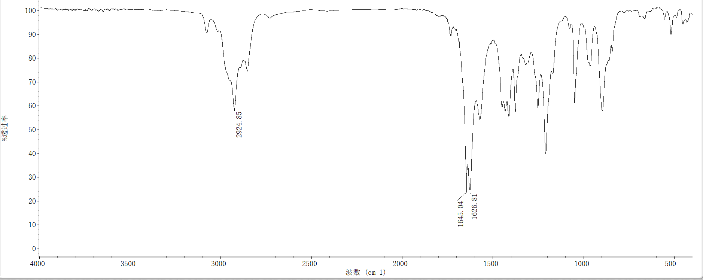

1.2 ¹H-NMR spectrum of (6R)-3-methyl-2-oxo-6-(prop-1-en-2-yl) cyclohex-3-ene-1-carbaldehyde (2)

1.3 ¹³C-NMR spectrum of (6R)-3-methyl-2-oxo-6-(prop-1-en-2-yl) cyclohex-3-ene-1-carbaldehyde (2)

2. (S)-8-methyl-5-(prop-1-en-2-yl)-5,6-dihydroquinazolin-2-amine (3)

2.1 FT-IR spectrum of (S)-8-methyl-5-(prop-1-en-2-yl)-5,6-dihydroquinazolin-2-amine (3)
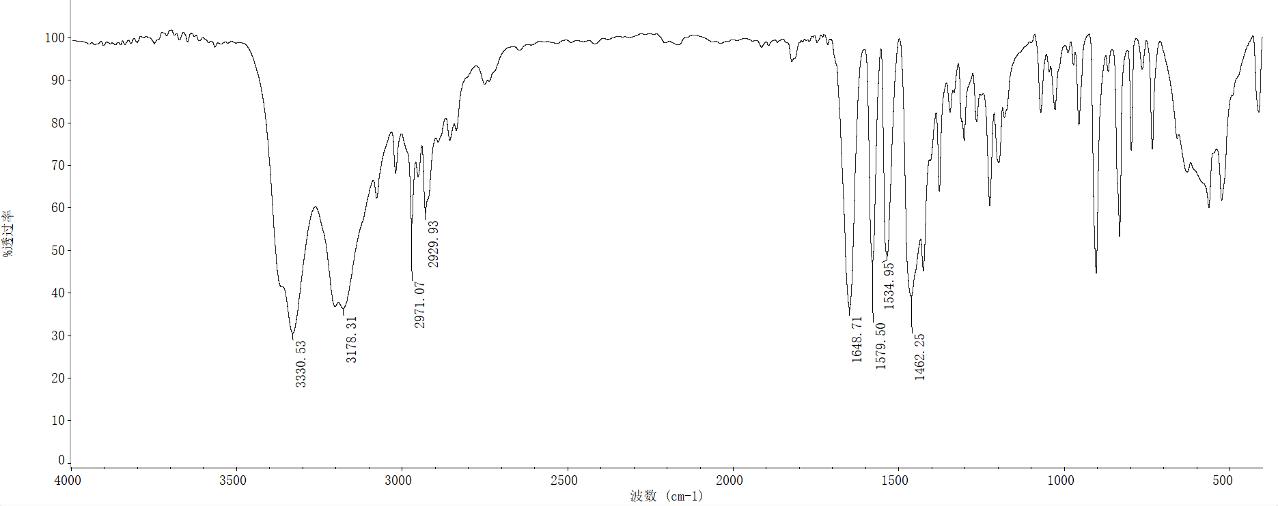

2.2 ¹H-NMR spectrum of (S)-8-methyl-5-(prop-1-en-2-yl)-5,6-dihydroquinazolin-2-amine (3)

2.3 ¹³C-NMR spectrum of (S)-8-methyl-5-(prop-1-en-2-yl)-5,6-dihydroquinazolin-2-amine (3)

2.4 HRMS spectrum of (S)-8-methyl-5-(prop-1-en-2-yl)-5,6-dihydroquinazolin-2-amine (3)

3.Compound 4a (R=o-F Ph)

3.1 FT-IR spectrum of compound 4a (R=o-F Ph)
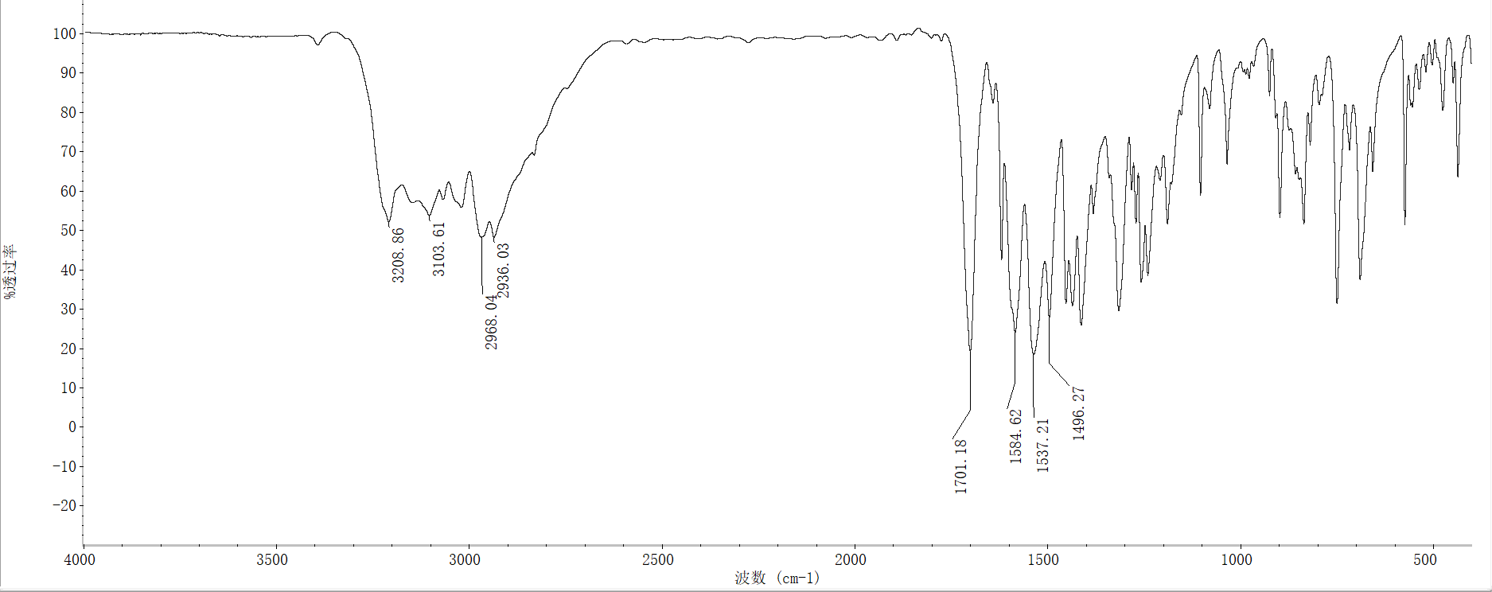

3.2 ¹H-NMR spectrum of compound 4a (R=o-F Ph)

3.3 ¹³C-NMR spectrum of compound 4a (R=o-F Ph)

3.4 HRMS spectrum of compound 4a (R=o-F Ph)

4.Compound 4b (R=m-F Ph)

4.1 FT-IR spectrum of compound 4b (R=m-F Ph)

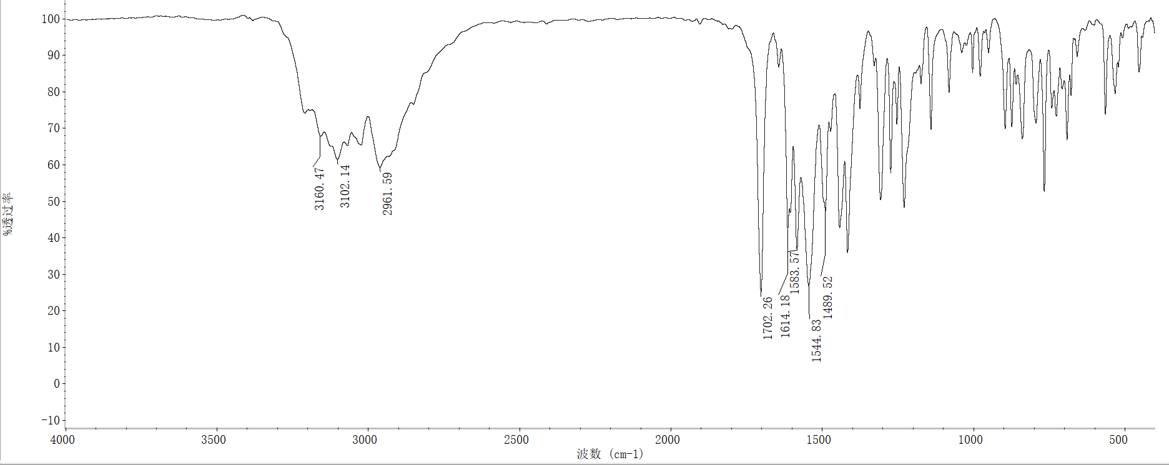

4.2 ¹H-NMR spectrum of compound 4b (R=m-F Ph)

4.3 ¹³C-NMR spectrum of compound 4b (R=m-F Ph)

4.4 HRMS spectrum of compound 4b (R=m-F Ph)

5.Compound 4c (R=p-F Ph)

5.1 FT-IR spectrum of compound 4c (R=p-F Ph)

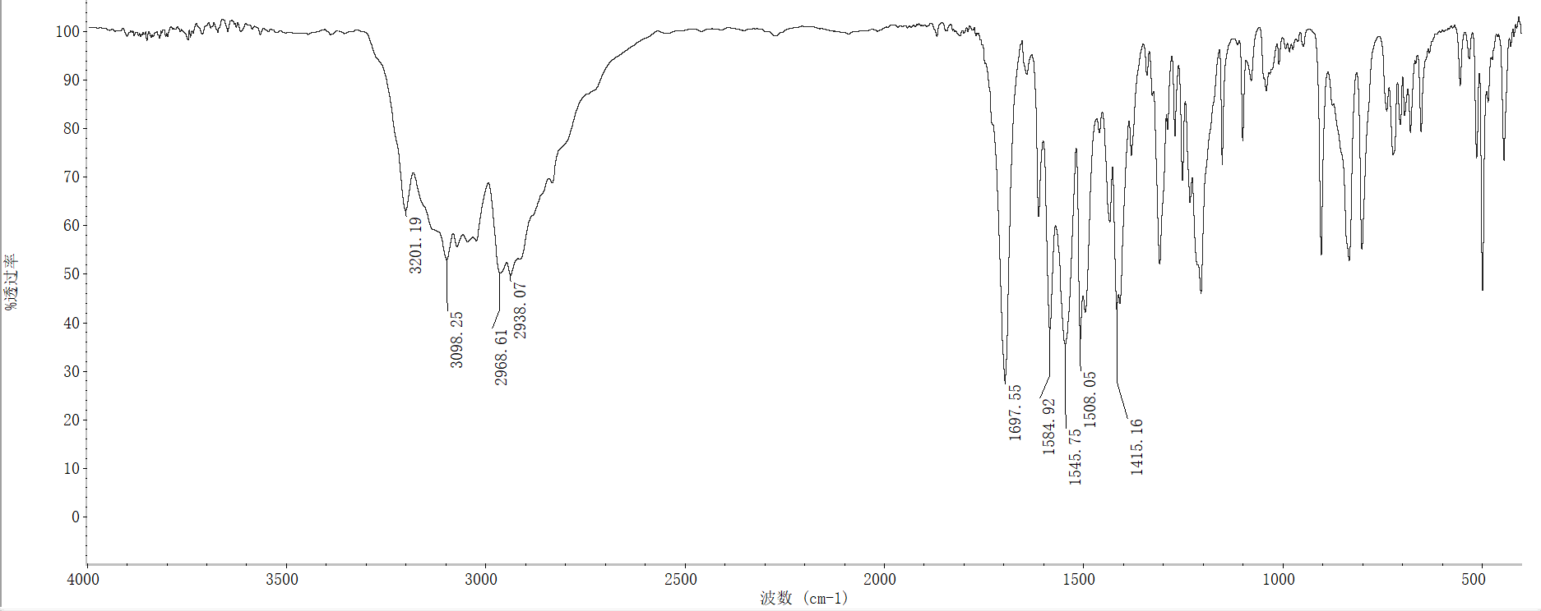

5.2 ¹H-NMR spectrum of compound 4c (R=p-F Ph)

5.3 ¹³C-NMR spectrum of compound 4c (R=p-F Ph)

5.4 HRMS spectrum of compound 4c (R=p-F Ph)

6.Compound 4d (R=2,4-F Ph)

6.1 FT-IR spectrum of compound 4d (R=2,4-F Ph)

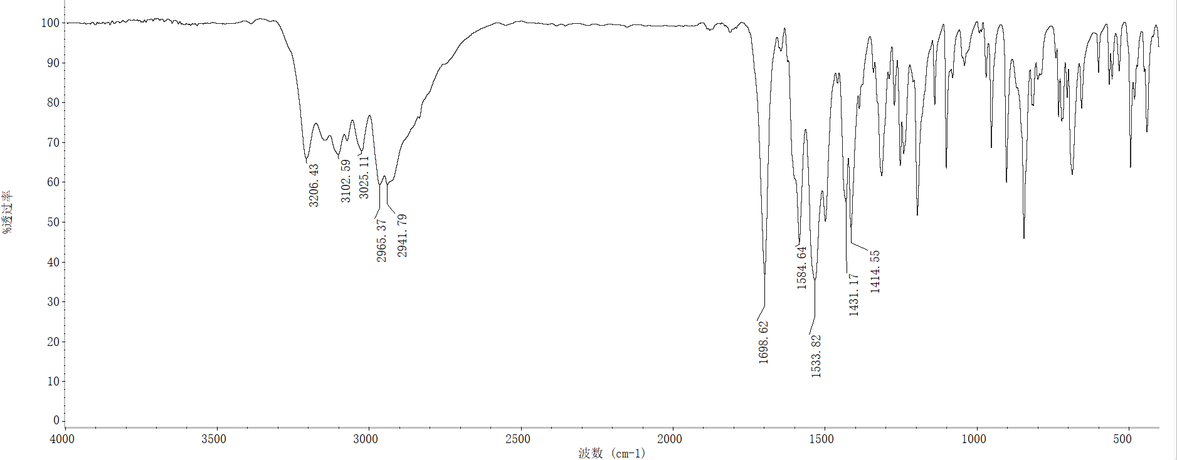

6.2 ¹H-NMR spectrum of compound 4d (R=2,4-F Ph)

6.3 ¹³C-NMR spectrum of compound 4d (R=2,4-F Ph)

6.4 HRMS spectrum of compound 4d (R=2,4-F Ph)

7.Compound 4e (R=o-Cl Ph)

7.1 FT-IR spectrum of compound 4e (R= o-Cl Ph)
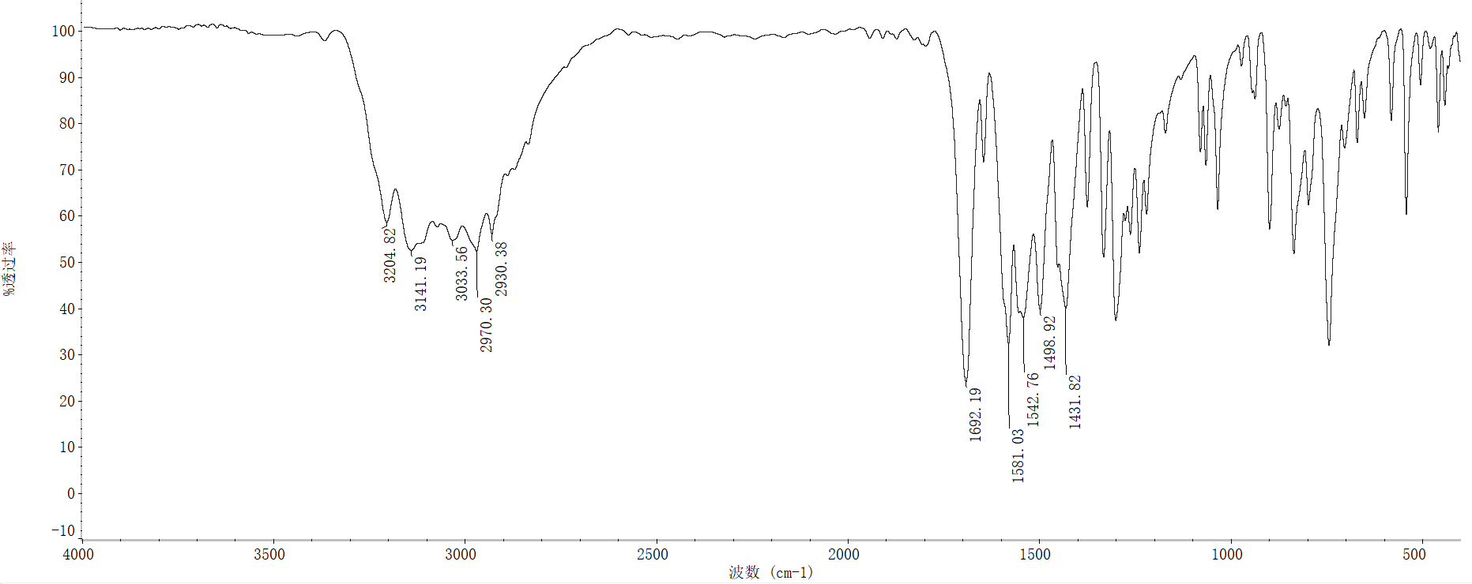

7.2 ¹H-NMR spectrum of compound 4e (R= o-Cl Ph)

7.3 ¹³C-NMR spectrum of compound 4e (R= o-Cl Ph)

7.4 HRMS spectrum of compound 4e (R= o-Cl Ph)

8.Compound 4f (R=m-Cl Ph)

8.1 FT-IR spectrum of compound 4f (R= m-Cl Ph)
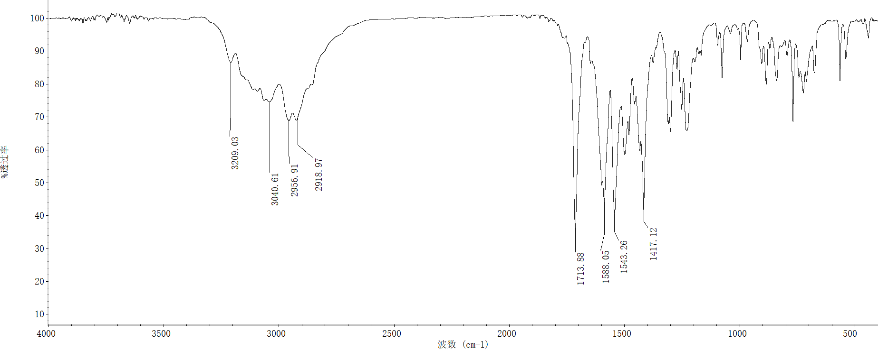

8.2 ¹H-NMR spectrum of compound 4f (R= m-Cl Ph)

8.3 ¹³C-NMR spectrum of compound 4f (R= m-Cl Ph)

8.4 HRMS spectrum of compound 4f (R= m-Cl Ph)

9.Compound 4g (R=p-Cl Ph)

9.1 FT-IR spectrum of compound 4g (R= p-Cl Ph)
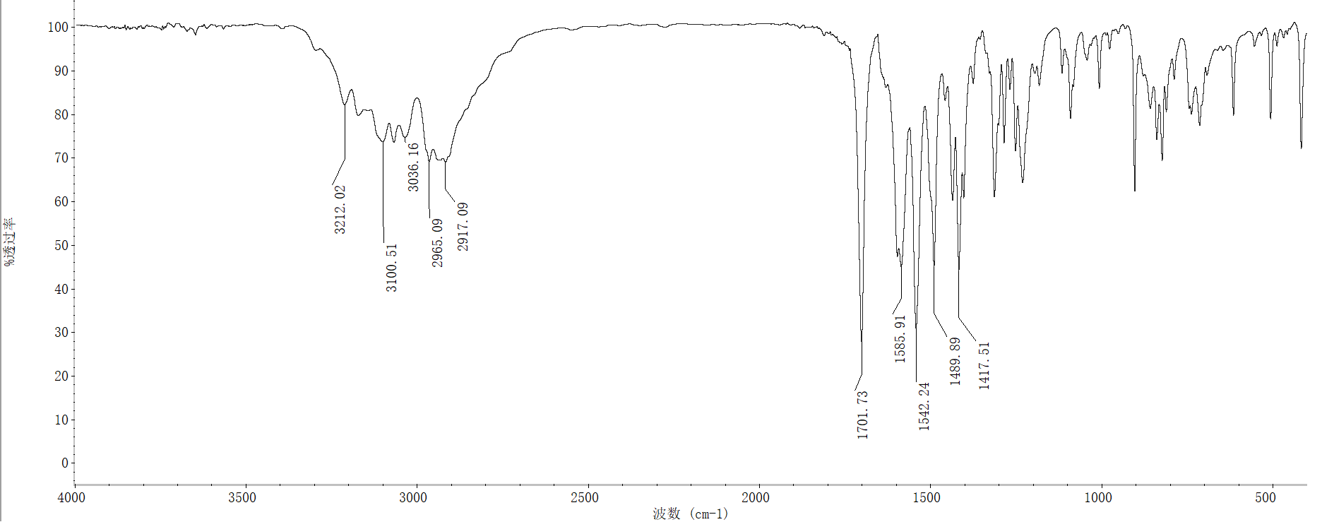

9.2 ¹H-NMR spectrum of compound 4g (R= p-Cl Ph)

9.3 ¹³C-NMR spectrum of compound 4g (R= p-Cl Ph)

9.4 HRMS spectrum of compound 4g (R= p-Cl Ph)

10.Compound 4h (R=3,4-Cl Ph)

10.1 FT-IR spectrum of compound 4h (R= 3,4-Cl Ph)
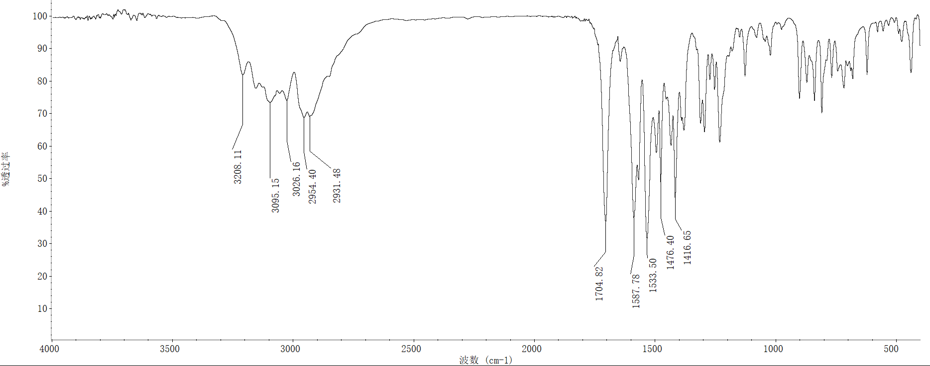

10.2 ¹H-NMR spectrum of compound 4h (R= 3,4-Cl Ph)

10.3 ¹³C-NMR spectrum of compound 4h (R= 3,4-Cl Ph)

10.4 HRMS spectrum of compound 4h (R= 3,4-Cl Ph)

11.Compound 4i (R=o-CH₃ Ph)

11.1 FT-IR spectrum of compound 4i (R=o-CH₃ Ph)

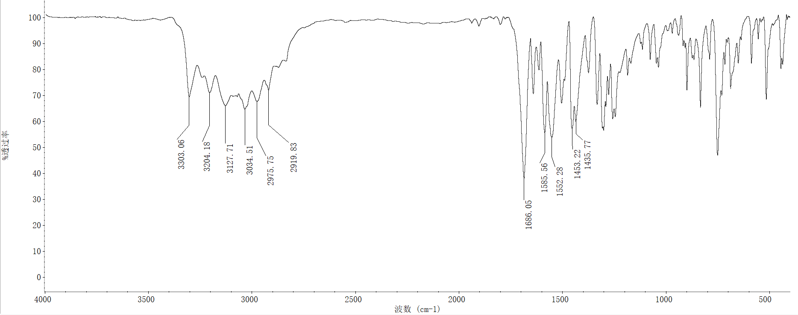

11.2 ¹H-NMR spectrum of compound 4i (R=o-CH₃ Ph)

11.3 ¹³C-NMR spectrum of compound 4i (R=o-CH₃ Ph)

11.4 HRMS spectrum of compound 4i (R=o-CH₃ Ph)

12.Compound 4i (R=m-CH₃ Ph)

12.1 FT-IR spectrum of compound 4i (R=m-CH₃ Ph)

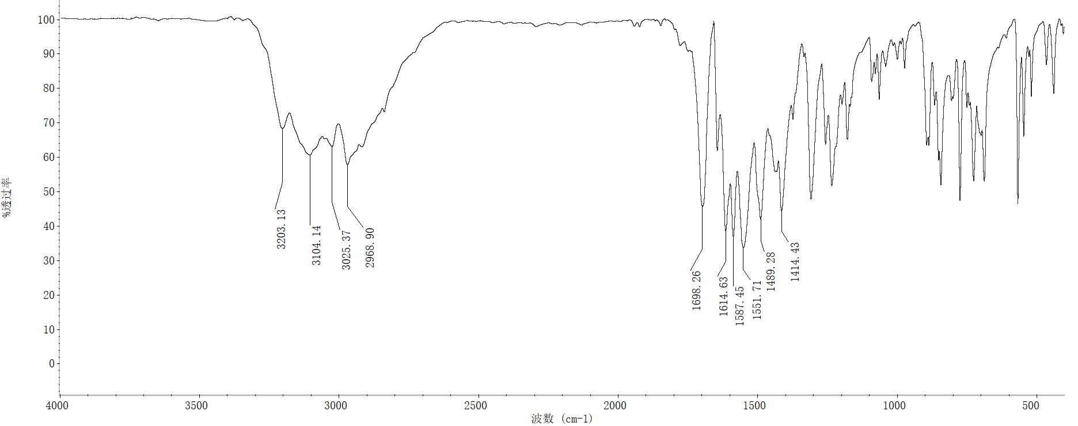

12.2 ¹H-NMR spectrum of compound 4j (R=m-CH₃ Ph)

12.3 ¹³C-NMR spectrum of compound 4j (R=m-CH₃ Ph)

12.4 HRMS spectrum of compound 4i (R=m-CH₃ Ph)

13.Compound 4k (R=p-CH₃ Ph)

13.1 FT-IR spectrum of compound 4k (R=p-CH₃ Ph)
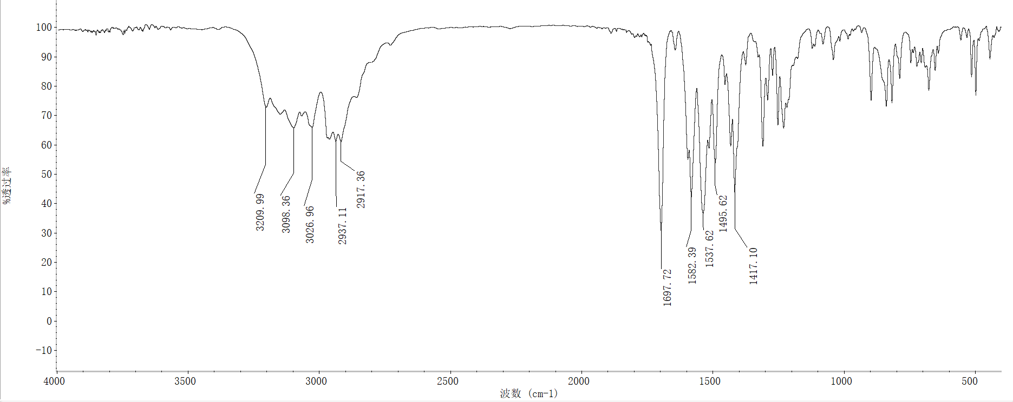

13.2 ¹H-NMR spectrum of compound 4k (R=p-CH₃ Ph)

13.3 ¹³C-NMR spectrum of compound 4k (R=p-CH₃ Ph)

13.4 HRMS spectrum of compound 4k (R=p-CH₃ Ph)

14 Compound 4l (R=2, 6-CH₃ Ph)

14.1 FT-IR spectrum of compound 4l (R=2,6-CH₃ Ph)
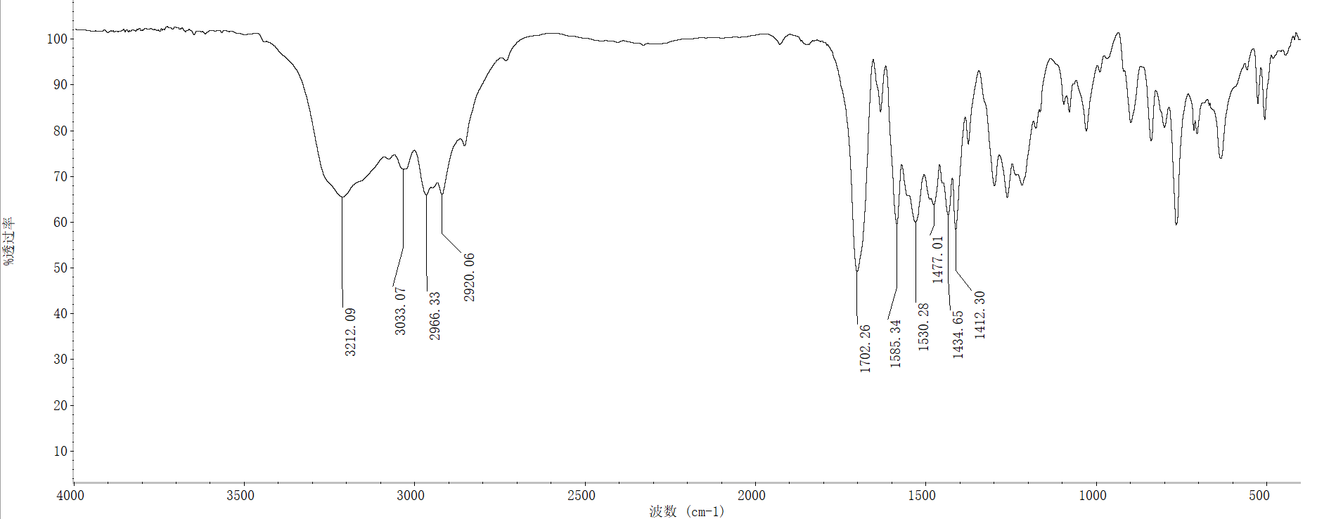

14.2 ¹H-NMR spectrum of compound 4l (R=2, 6-CH₃ Ph)

14.3 ¹³C-NMR spectrum of compound 4l (R=2,6-CH₃ Ph)

14.4 HRMS spectrum of compound 4l (R=2,6-CH₃ Ph)

15 Compound 4m (R=o-CF₃ Ph)

15.1 FT-IR spectrum of compound 4m (R=o-CF₃ Ph)
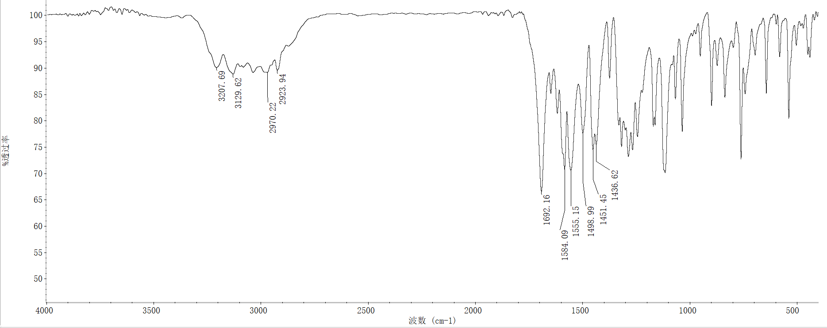

15.2 ¹H-NMR spectrum of compound 4m (R=o-CF₃ Ph)

15.3 ¹³C-NMR spectrum of compound 4m (R=o-CF₃ Ph)

15.4 HRMS spectrum of compound 4m (R=o-CF₃ Ph)

16 Compound 4n (R=m-CF₃ Ph)

16.1 FT-IR spectrum of compound 4m (R=m-CF₃ Ph)

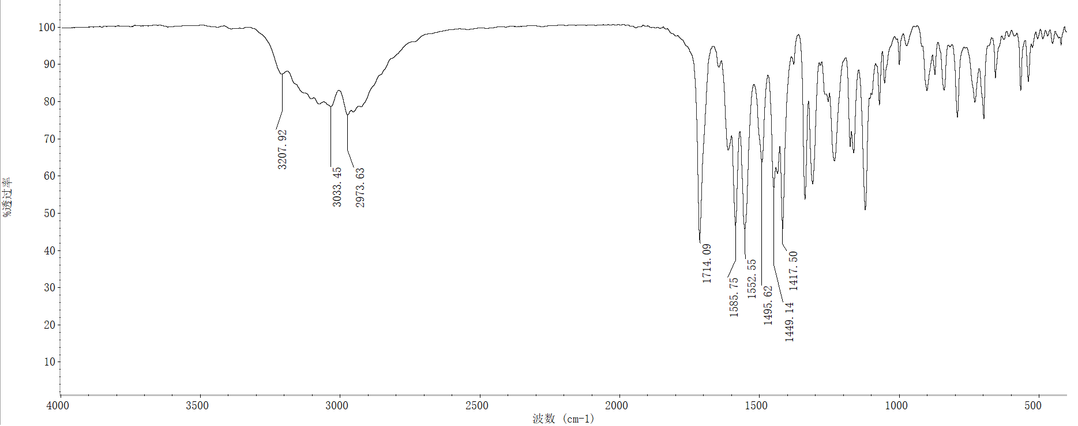

16.2 ¹H-NMR spectrum of compound 4m (R=m-CF₃ Ph)

16.3 ¹³C-NMR spectrum of compound 4m (R=m-CF₃ Ph)

16.4 HRMS spectrum of compound 4m (R=m-CF₃ Ph)

17 Compound 4o (R=o-Br Ph)

17.1 FT-IR spectrum of compound 4o (R= o-Br Ph)
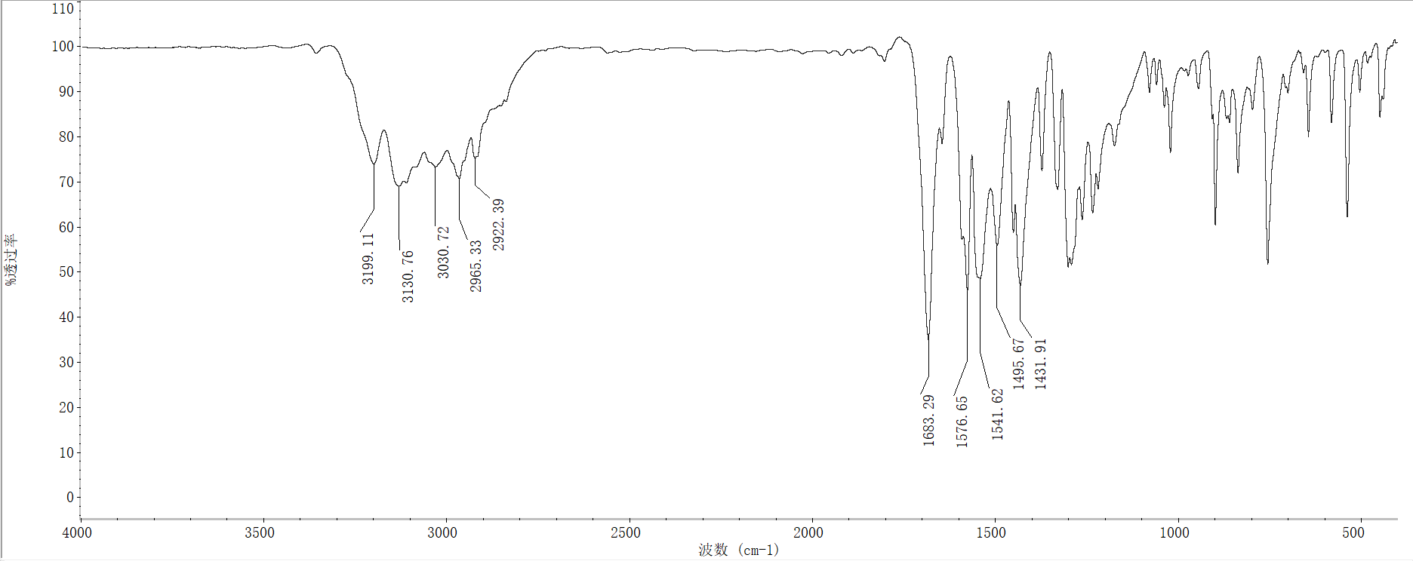

17.2 ¹H-NMR spectrum of compound 4o (R= o-Br Ph)

17.3 ¹³C-NMR spectrum of compound 4o (R= o-Br Ph)

17.4 HRMS spectrum of compound 4o (R= o-Br Ph)

18 Compound 4o (R=p-Br Ph)

18.1 FT-IR spectrum of compound 4o (R= p-Br Ph)
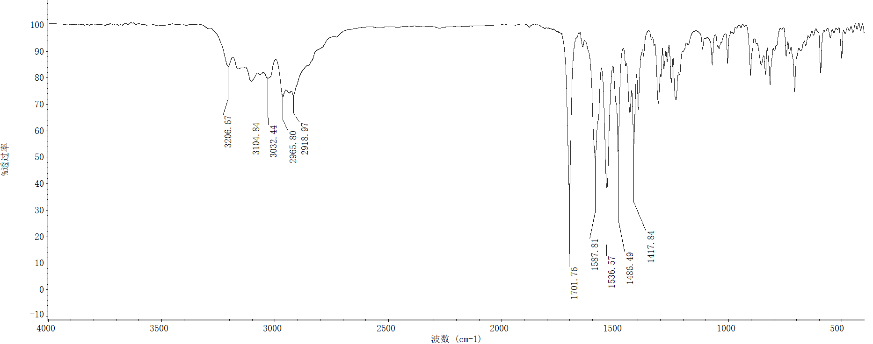

18.2 ¹H-NMR spectrum of compound 4p (R= p-Br Ph)

18.3 ¹³C-NMR spectrum of compound 4p (R= p-Br Ph)

18.4 HRMS spectrum of compound 4p (R= p-Br Ph)

19 Compound 4q (R=p-OCF₃ Ph)

19.1 FT-IR spectrum of compound 4q (R=p-OCF₃ Ph)

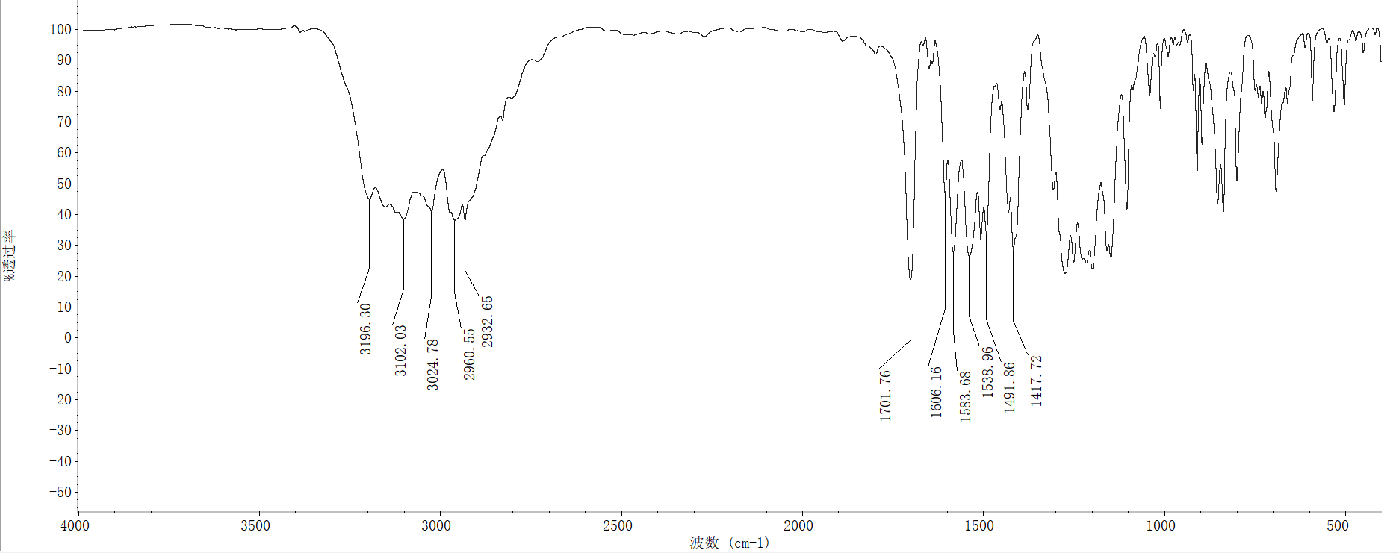

19.2 ¹H-NMR spectrum of compound 4q (R=p-OCF₃ Ph)

19.3 ¹³C-NMR spectrum of compound 4q (R=p-OCF₃ Ph)

19.4 HRMS spectrum of compound 4q (R= p-Br Ph)

20 Compound 4r (R=3-Cl-4-CH₃ Ph)

20.1 FT-IR spectrum of compound 4r (3-Cl-4-CH₃ Ph)

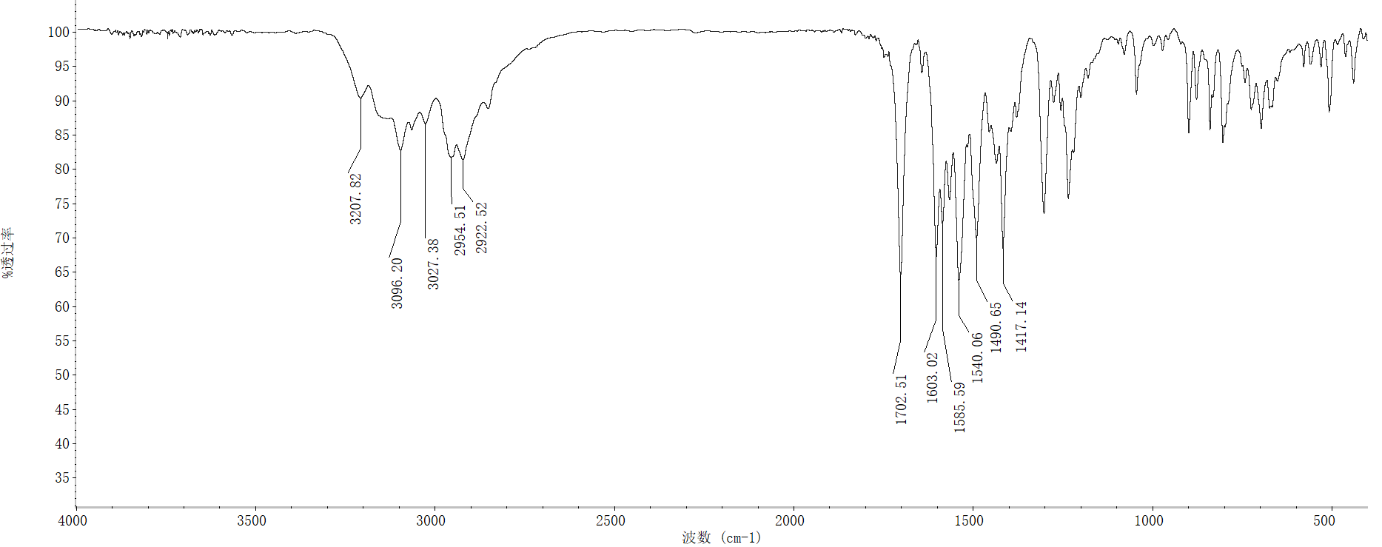

20.2 ¹H-NMR spectrum of compound 4r (R=3-Cl-4-CH₃ Ph)

20.3 ¹³C-NMR spectrum of compound 4r (R=3-Cl-4-CH₃ Ph)

20.4 HRMS spectrum of compound 4r (R=3-Cl-4-CH₃ Ph)

21 Compound 4s (R=3-CF₃-4-Cl Ph)

21.1 FT-IR spectrum of compound 4s (R=3-CF₃-4-Cl Ph)
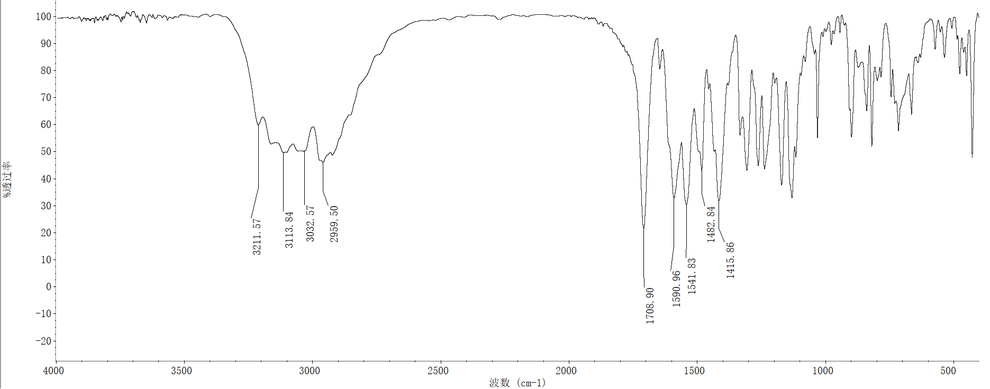

21.2 ¹H-NMR spectrum of compound 4s (R=3-CF₃-4-Cl Ph)

21.3 ¹³C-NMR spectrum of compound 4s (R=3-CF₃-4-Cl Ph)

21.4 HRMS spectrum of compound 4s (R=3-CF₃-4-Cl Ph)

22 Compound 4t (R=1-Naphthyl)

22.1 FT-IR spectrum of compound 4t (R=1-Naphthyl)

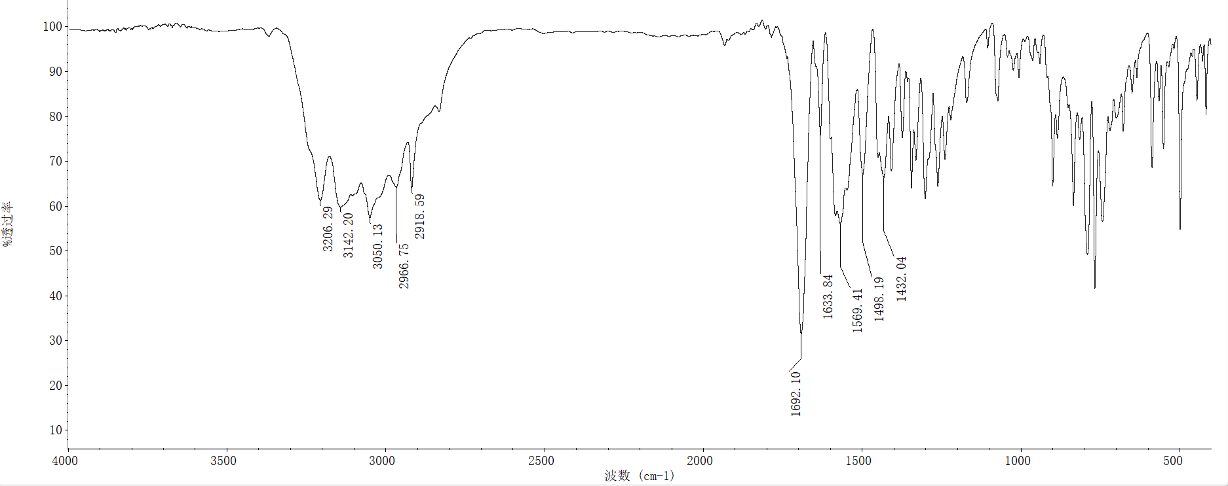

22.2 ¹H-NMR spectrum of compound 4t (R=1- Naphthyl)

22.3 ¹³C-NMR spectrum of compound 4t (R=1-Naphthyl)

22.4 HRMS spectrum of compound 4t (R=1-Naphthyl)

