Supplementary material

Variation of photosynthesis along the canopy profile of sugarcane and energy canes

Larissa P. Cruz^{1,2}, Vinícius S. Pacheco^{1,3}, Cíntia C. M. Nogueira^{1,4}, Maria D. Pissolato^{1,3}, Rafael L. Almeida^{1,2}, Eduardo C. Machado⁵, Rafael V. Ribeiro^{1,*}

¹ Laboratory of Crop Physiology, Department of Plant Biology, Institute of Biology, University of Campinas (UNICAMP), P.O. Box 6109, 13083-970, Campinas, SP, Brazil
² Interinstitutional Graduate Program in Bioenergy (USP/UNICAMP/UNESP), Cidade Universitária, 330 Cora Coralina Street, 13083-896, Campinas SP, Brazil
³ Graduate Program in Plant Biology, Institute of Biology, University of Campinas (UNICAMP), 13083-970, Campinas, SP, Brazil
⁴ Graduate Program in Tropical and Subtropical Agriculture, Agronomic Institute (IAC), 13020-902, Campinas, SP, Brazil
⁵ Laboratory of Plant Physiology “Coaracy M. Franco”, Center for Agricultural and Post-Harvest Biosystems, Agronomic Institute (IAC), P.O. Box 28, 13012-970, Campinas SP, Brazil.

* Corresponding author: rvr@unicamp.br

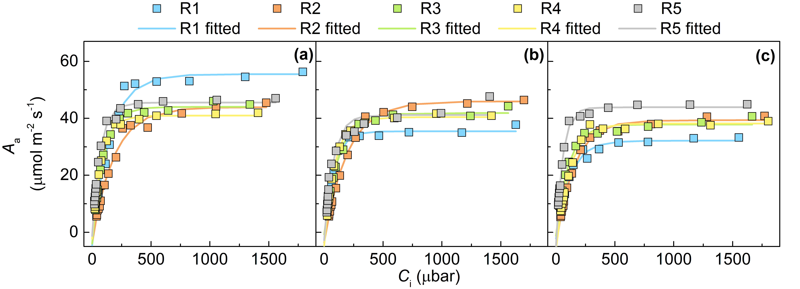

Fig. S1 Response curves of leaf CO₂ assimilation rate based on leaf area (A_{a}) to increasing intercellular CO₂ concentration (C_{i}) of leaf +1 for all replications (symbols) and curve fitting (lines) from Experiment I. (a) Sugarcane IACSP95-5000; (b) Energy cane Vertix 2; and (c) Energy cane Vertix 3. R1 to R5 mean the replications one to five

Table S1 Equation parameters, r² and residual sum of squares (RSS) of leaf CO₂ assimilation response curves to CO₂ (A_{a}-C_{i}) using the fitting equation A_{a}=A_{max}*(1-exp^{-k*(Ci-ΓCO2)}) for sugarcane IACSP95-5000 and energy canes Vertix 2 and Vertix 3 from Experiment I. Values for each replication are shown as well as the average ± SE

Genotype | Rep. | A_{max} | k | ΓCO₂ | r² | RSS
IACSP95-5000 | 1 | 55 | 0.007 | 12.07 | 0.99 | 71
IACSP95-5000 | 2 | 44 | 0.005 | 15.57 | 0.99 | 45
IACSP95-5000 | 3 | 44 | 0.010 | 8.22 | 0.99 | 12
IACSP95-5000 | 4 | 41 | 0.013 | 4.20 | 0.99 | 5
IACSP95-5000 | 5 | 46 | 0.015 | 1.94 | 0.99 | 20
IACSP95-5000 | Avg | 46±2 | 0.010±0.002 | 8.40±2.49 | 0.99 | 31
Vertix 2 | 1 | 35 | 0.013 | 9.71 | 0.99 | 14
Vertix 2 | 2 | 46 | 0.005 | 14.85 | 0.99 | 13
Vertix 2 | 3 | 42 | 0.008 | 2.25 | 0.99 | 15
Vertix 2 | 4 | 40 | 0.011 | 10.01 | 0.99 | 5
Vertix 2 | 5 | 41 | 0.013 | 5.10 | 0.96 | 110
Vertix 2 | Avg | 41±2 | 0.010±0.002 | 8.39±2.17 | 0.99 | 31
Vertix 3 | 1 | 32 | 0.008 | 7.86 | 0.99 | 18
Vertix 3 | 2 | 39 | 0.007 | 17.48 | 0.99 | 13
Vertix 3 | 3 | 38 | 0.010 | 3.46 | 0.99 | 23
Vertix 3 | 4 | 38 | 0.009 | 17.01 | 0.99 | 20
Vertix 3 | 5 | 44 | 0.018 | 6.15 | 0.99 | 16
Vertix 3 | Avg | 38±2 | 0.010±0.002 | 10.39±2.88 | 0.99 | 18

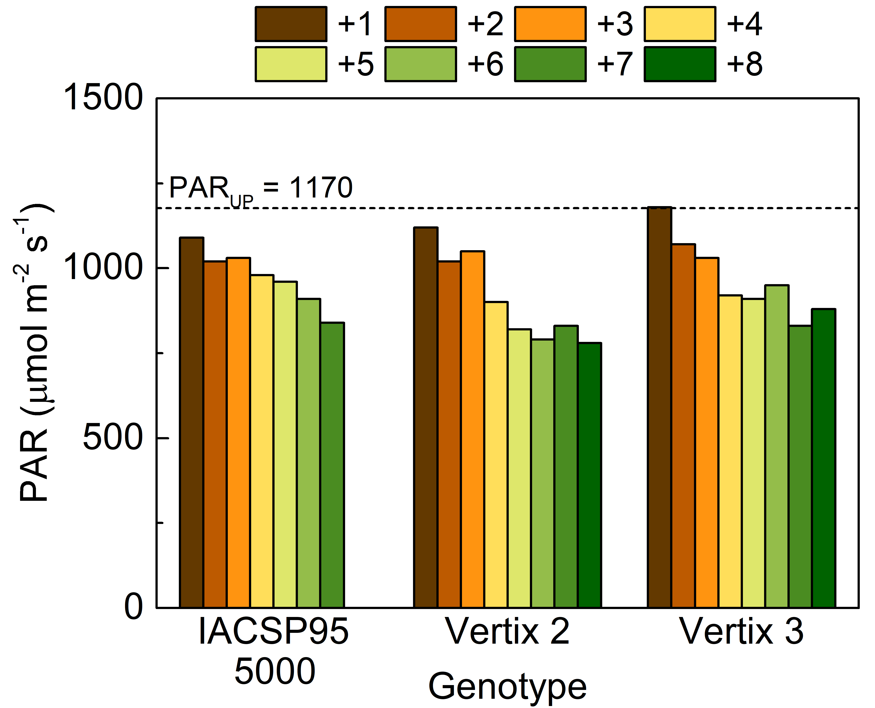

Fig. S2 Photosynthetic active radiation (PAR) measured at the natural position of all green leaves of the main tiller of four-month-old plants of sugarcane IACSP95-5000 and energy canes Vertix 2 and Vertix 3 from Experiment II. PAR_{UP} means the PAR measured above the canopy

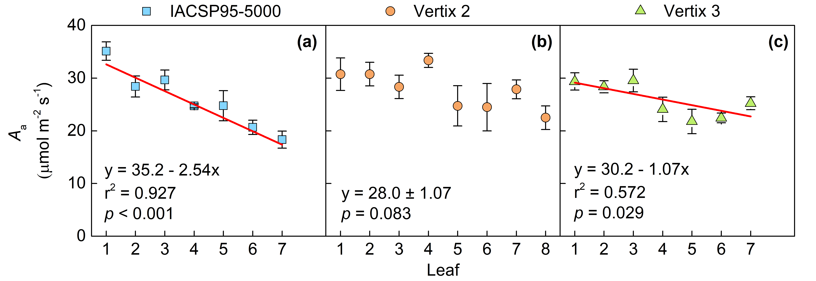

Fig. S3 Leaf CO₂ assimilation rate based on leaf area (A_{a}) considering each leaf of plants from Experiment II. (a) Sugarcane IACSP95-5000; (b) Energy cane Vertix 2; and (c) Energy cane Vertix 3. For the dynamics of Vertix 2 there was no significant trend and ‘y’ represents the mean value of A_{a} (n=39)±SE. Each symbol represents the mean (n=5)±SE

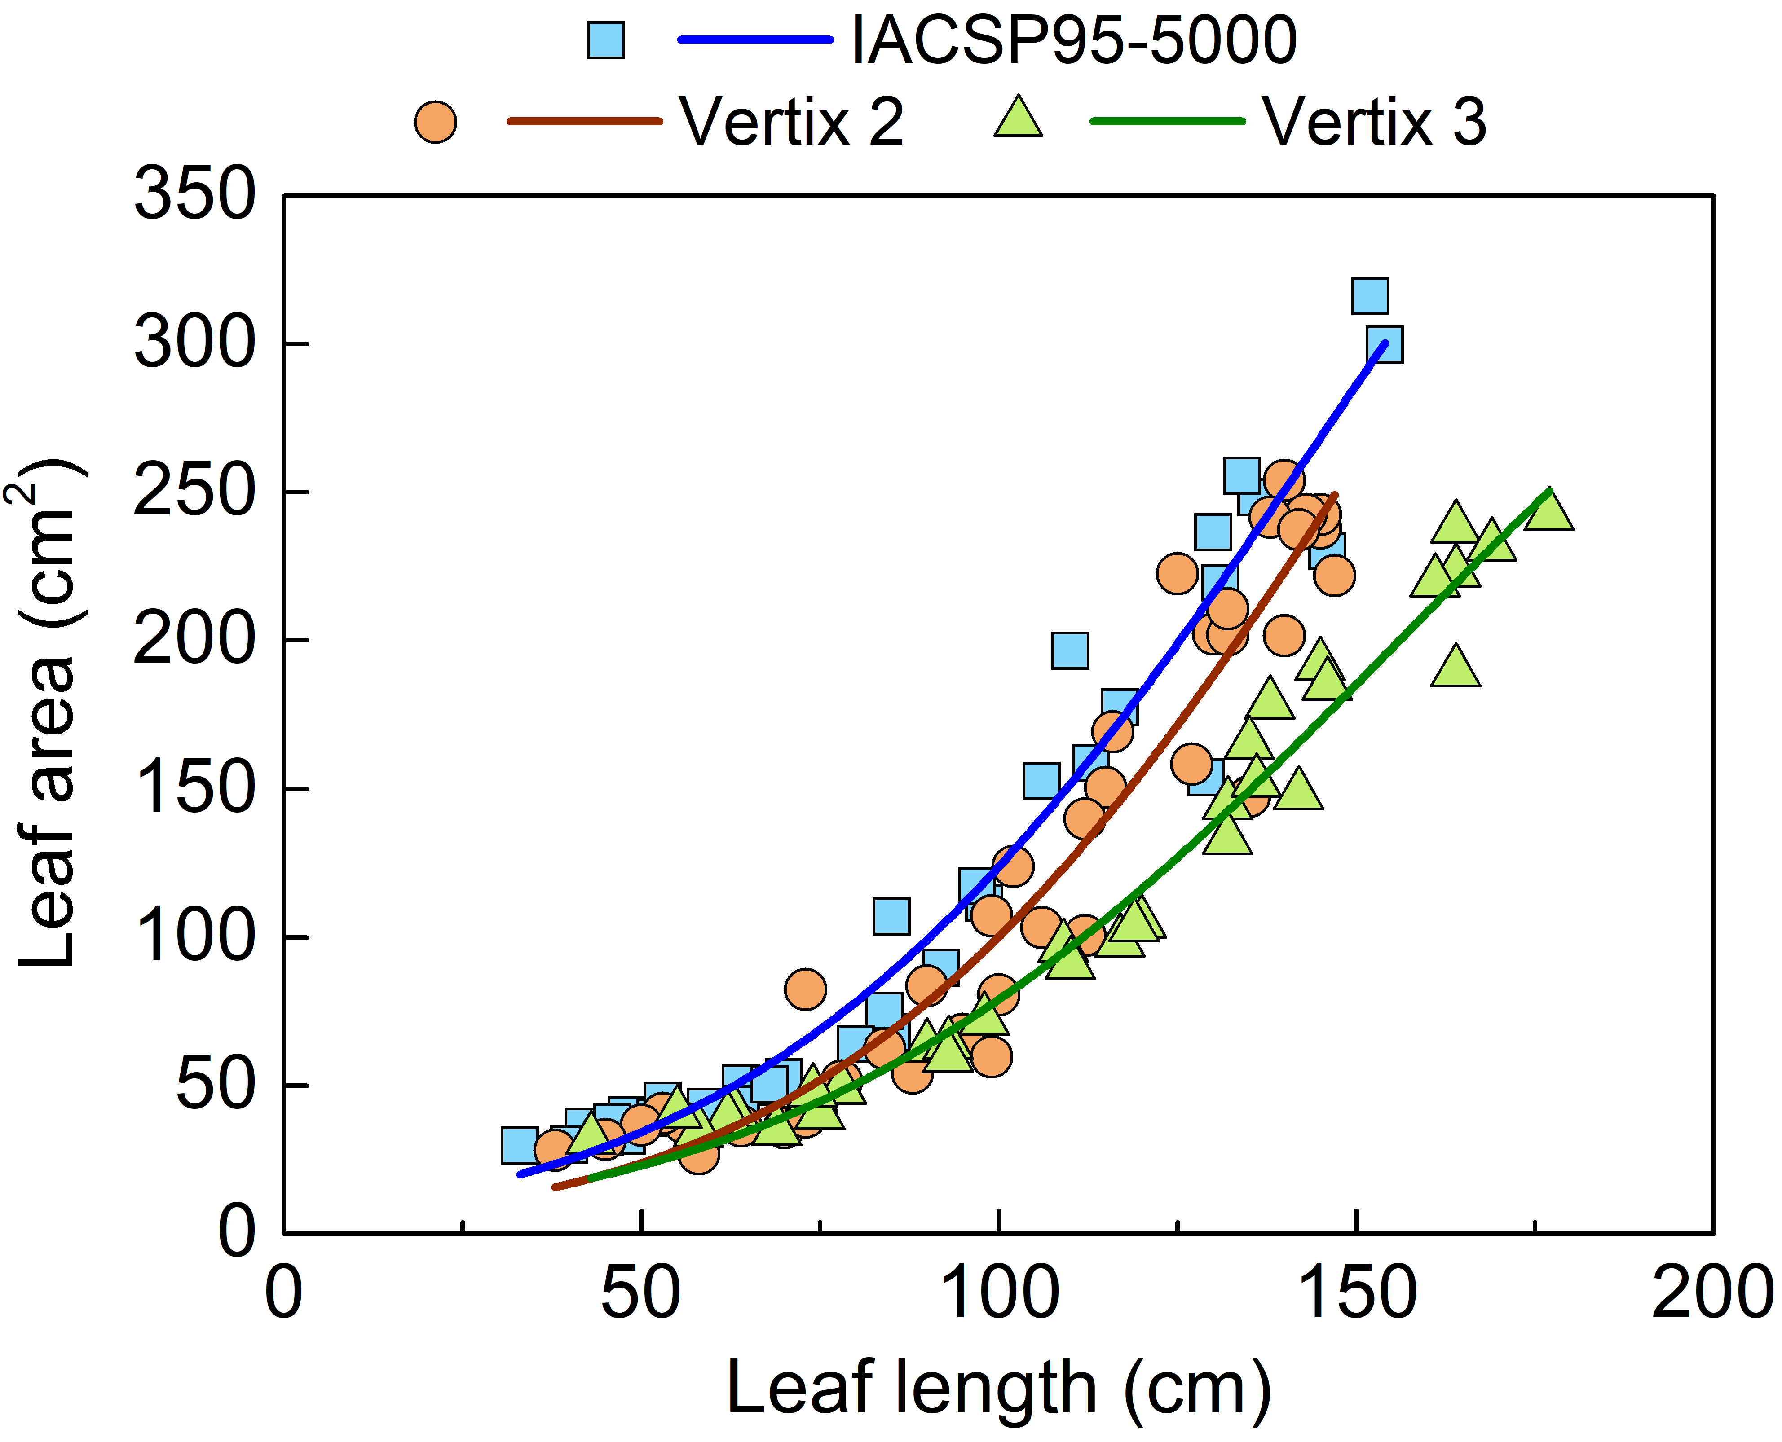

Fig. S4 Leaf area as function of leaf length considering all leaves (symbols) of sugarcane IACSP95-5000 and energy canes Vertix 2 and Vertix 3 from Experiment II. Lines represent the exponential fitting (Table S2)

Table S2 Equation parameters, r² and residual sum of squares (RSS) of total leaf area as function of leaf length using the exponential fitting equation y=exp^{a+bx+cx^2} for sugarcane IACSP95-5000 and energy canes Vertix 2 and Vertix 3 from Experiment II

Genotype | a | b | c | r² | RSS
IACSP95-5000 | 1.81 | 0.039 | -8.9×10⁻⁵ | 0.96 | 11100
Vertix 2 | 1.25 | 0.042 | -9.7×10⁻⁵ | 0.93 | 17000
Vertix 3 | 1.52 | 0.036 | -7.4×10⁻⁵ | 0.97 | 4130

