Supporting information

Bioinspired, Ultra-Light and Sandwich structured cellulose nanofiber-MXene/AgNWs porous film for high-efficiency electromagnetic interference shielding with Joule Heating Performance
Fang Ren^{a,b,}*, Tong Wuª, Jiale Zhangª, Fudong Zhang^{c}, Guoª, Zhengzheng Guoª, Yanling Jinª, Penggang Ren^{a,b,}*
a. The Faculty of Printing, Packaging Engineering and Digital Media Technology, Xi’an University of Technology, Xi’an Shaanxi 710048, People’s Republic of China
b. School of Materials Science and Engineering, Xi’an University of Technology, Xi’an Shaanxi 710048, People’s Republic of China
c. Lightning and Electromagnetic Environmental Laboratory, Xi'an Airborne Electromagnetic Technology Co., Ltd, Xi'an Shaanxi 710077, People’s Republic of China
*Corresponding Author: renfang0824@163.com; rengpg@126.com

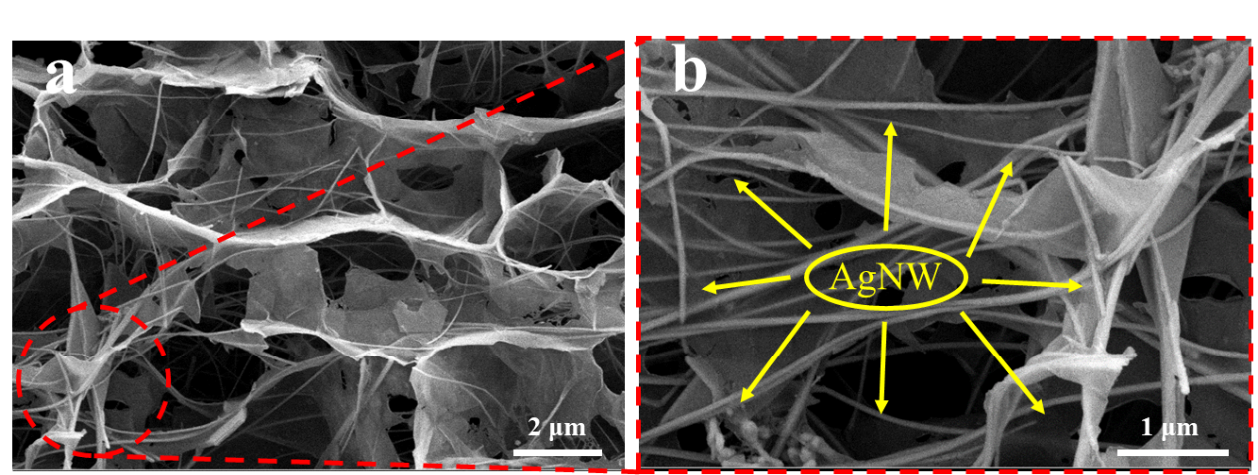
Fig. S1 Cross-sectional SEM images of CM₃A₇C (a) and the corresponding to the high magnification images (b)
The cross-sectional SEM images of CM₃A₇C are depicted in Fig. S1. As can be seen, a large number of AgNWs interwove with each other, and the internal pores decreased significantly due to the reduction of MXene.

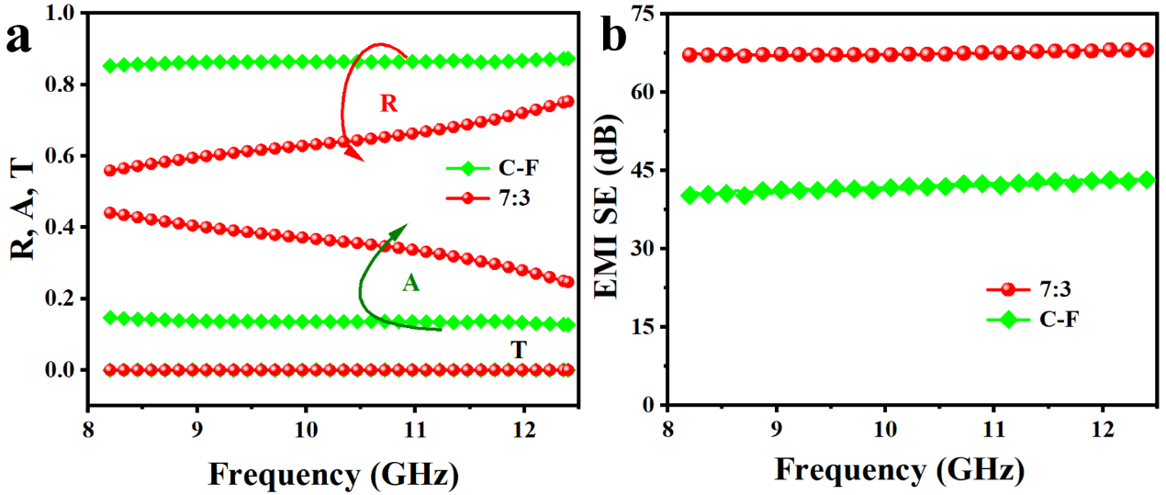
Fig. S2 Power coefficients of the CM₇A₃C at X-band compared with the films with 7:3 ratio of MXene to AgNWs (named C-F).
Fig. S2 plots the power coefficients of the CM₇A₃C at X-band compared with the films with 7:3 ratio of MXene to AgNWs (named C-F) obtained by the conventional vacuum-assisted filtration method. The A coefficient of CM₇A₃C can reach 0.4, which is much higher than 0.1 for C-F.

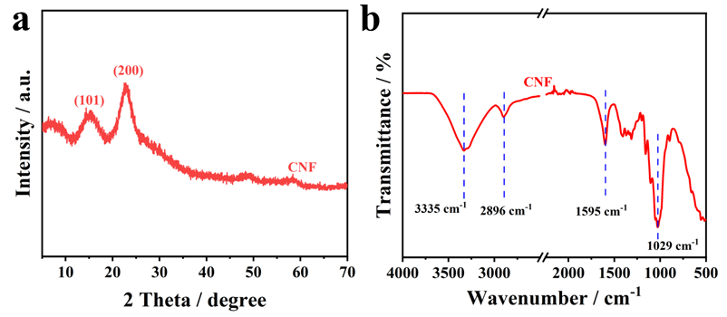
Fig. S3 The FTIR spectrum and XRD pattern of CNF
The XRD pattern of CNF are shown in Fig. S1b. As shown in Fig. S1b, two distinct diffraction peaks at 2θ =15.05° and 22.61° appeared in the CNF film, corresponding to the (110) and (200) planes of cellulose Ⅱ crystalline form, respectively. The chemical structure of CNF was characterized by FTIR spectroscopy. As shown in Fig. S1a, the peak near 1595 cm⁻¹ is assigned to the characteristic vibration of bound water. The primary vibration peaks at 3335 cm⁻¹, 2896 cm⁻¹ and 1029 cm⁻¹ in cellulose nanofibers are assigned to the stretching vibration of O-H, C-H and C-O, respectively. The abundant functional groups of the CNF are also beneficial for chemical crosslinking of the MXene, significantly improving the hydrophobicity and oxidation stability (Wu et al., 2022).

